**“Comparative Study of Waste Glass Powder as Pozzolanic Material in Concrete”**

**Mubarak Husain Dr. Manoj Sharma,**

**\*M. Tech Students, IPS College of Technology & Management Gwalior M.P.**

**\*\* Professor, IPS College of Technology & Management Gwalior M.P.**

**ABSTRACT**

Glass is used in many forms in day-to-day life. It has limited life span and after use it is either stock piled or sent to landfills. Since glass is non-biodegradable, landfills do not provide an environment friendly solution. Hence, there is strong need to utilize waste glasses.

Many efforts have been made to use waste glass in concrete industry as a replacement of coarse aggregate, fine aggregate and cement. Its performance as a coarse aggregate replacement has been found to be non-satisfactory because of strength regression and expansion due to alkali-silica reaction. The research shows that there is strength loss due to fine aggregate substitution also.

The aim of the present work was to use glass powder as a replacement of cement to assess the pozzolanic activity of fine glass powder in concrete and compare its performance with other pozzolanic materials like silica fume and fly ash.

A series of tests were conducted to study the effect of 15% and 30% replacement of cement by silica fume, fly ash and glass powder on compressive strength and durability in the form of capillary absorption. The particle size effect was evaluated by using glass powder of size 150µm-100µm and glass powder of size less than 100µm.

**Keywords** - waste glasses, fine aggregate, cement, alkali-silica, compressive strength, fly ash, Tensile strength, Concrete.

**INTRODUCTION**

Concrete is the mostly used man made construction material in the world and is second only to water as the most utilized substance on the planet. It is obtained by cementing material, water and aggregates and admixtures mixing together in required proportion. The mixture of all ingredients when placed in forms and allowed to cure it hardens into a rock like mass which is known as concrete.

The hardened concrete may be considered as an artificial rock in which the voids of coarse aggregates are to be filled by fine aggregates and the voids of fine aggregates are to be filled with cement. In a concrete mix the cementeous material and water make a paste which is called as cement-water paste, this also coats the surface of coarse and fine aggregates in addition to filling the voids of aggregates and binds the all aggregates as it cures and make a compact mass. The attractiveness of concrete is due to the truth that from the normal ingredient, the required properties of concrete are modified to meet the demand of different application. In last few decade incredible infrastructure development has taken place in over the country and making concrete of higher strengths M30, M60, M80, etc are common practice now adays. Due to globalization the practice in the making of high performance concrete(HPC) is taking place. In the current position India is the second largest producer of cement in the world after Chinaas first.

useful material in construction industry and discovery of concrete is very valuable in this field and used continuously from many years and various experiment and researches are done to know the change in important properties of concrete and replacement of its constituent. Concrete has become In construction industry the most important constitution to make concrete is cement and required in very large quantity the process of making concrete is hazardous to environment and a source of pollution. In the production process of concrete very large amount of CO2 and other greenhouse gases, from the previous experience production of oneton concrete produce about one ton CO2 and other greenhouse gases.

Concrete is a blend of cement, sand, coarse aggregate and water. The key factor that adds value to concrete is that it can be designed to withstand harshest environments significant role. Today global warming and environmental devastation have become manifest harms in recent years, concern about environmental issues, and a changeover from the mass-waste, mass- consumption, mass-production society of the past to a zero-emanation society is now viewed as significant. Normally glass does not harm the environment in any way because it does not give off pollutants, but it can harm humans as well as animals, if not dealt carefully and it is less friendly to environment because it is non-biodegradable.

**Objective -**

As this study can have done various ways with various parameter but according to next part some definite objective of this study are as follows:

(i)To evaluate the pozzolanic activity of waste glass powder as a partial replacement of cement and recyclability of waste glass powder.

(ii)A comparative study of waste glass powdered cement mortar and conventional cement mortar.

(iii)A comparative study of waste glass powdered concrete and conventional concrete.

**LITERATURE REVIEW-**

Many works have been done to explore the benefits of using pozzolanic materials in making and enhancing the properties of concrete.

**(i)P.Manoj Kumar, S.Aishwariya (2017) ,** Now a day’s global consumption of natural aggregates have been increased. At the same time production of solid wastes from the manufacturing units and demolitions are also very high. Concrete is a composite material made with cement, aggregates and water in construction industry. In civil engineering construction, using alternative materials in place of natural aggregate in concrete production makes concrete as sustainable and environment friendly. Hence there is a necessity in innovation of new natural products for the replacement of fine and coarse aggregate.

**(ii)R.Ranjith.et.al (2017) concluded** that use of coconut shells in cement concrete can help in waste reduction and pollution reduction. It is also expected to encourage hosing developers in investigating these materials in house construction. It is also concluded that the coconut shells are more suitable as low strength and giving light weight aggregate when used to replace the common coarse aggregate in concrete production.

**(iii)Dabiri, H., Sharbatdar, M.K., Kavyani, A. and Baghdadi, M. (2018),** The influence of replacing sand with waste glass particle on the physical and mechanical parameters of concrete.

**(iv)Singh, Bhupinderjeet and Jain, Ritesh** (2018) , Use of waste glass in concrete : A review. J. Pharmacogonosy &Phytochemistry

**(v) Bhupinderjeet Singh and Ritesh Jain, (2019)** The utilization of glass powder in the present days as a substitute for cement is to enhance the strength of concrete. The glass powder was supplanted by 0 per cent, 5 per cent, 10 per cent, 15per cent and 20 per cent for 7 and 28 days for cubes for compressive strength. The utilization of concrete and generation of cement makes considerably more ecological issues and costlier. To maintain a strategic distance from such conditions, the substance of cement is decreased and replaced by glass powder which lessens cost and builds quality and durability of cement. Concrete is the most broadly utilized and adaptable structure material which is commonly used to resist compressive powers. By the addition of some pozzolanic materials, the different properties of cement.

**(vi)KIM Ibrahim (2020)** In this study, WG was used as partial substitution of basalt (coarse aggregate), with 0%, 5%, 10%, 15% , 20%, 25%, 30%, 35%, 40%, 45% and 50% ratios by weight of basalt. Some mechanical and other concrete properties have been investigated at both hardened and fresh stages. The investigational results that were taken from the tested specimens illustrated that with WG using as a coarse aggregate occurred a loss in a slump, density, and water absorption.

**(vii)Shreeram Patidar , Rahul Sharma, (2023)** The mix design has been performing for M30 grade of concrete according to IS: 10262-2000 and IS: 456-2000. Proportion of cement, sand and aggregate is 1:1.57:3.18 and .42 w/c ratio, cube and beam has been casted for testing compressive and flexural strength. Standard size of cube is 150* 150* 150 mm and beam size is 100*100*500 mm. First of all, the optimum dosage of plastic fibers is calculated by casting cubes and tested for 7 days and 28 days. 24 cubes and 24 beams have been casted by replacing both glass powder and plastic. In this way all cubes and beams has been testing for compressive strength and flexural strength. 53 grade of ordinary Portland cement as per IS: 8112-2013 and locally available sand which belong to zone3 FM 3.172 and maximum 20mm size angular aggregate were used for making concrete.

**Materials-**

**(a)-Cement** A cement is a binder, a chemical substance used for construction that sets, hardens, and adheres to other materials to bind them together. The cement conforms to 43 Grade ordinary Portland cement as specified by the Indian Standard specification IS 12269:1987, for which minimum strength of 43 Mpa at 28 days is stipulated. Cement is manufactured through a closely controlled chemical combination of calcium, silicon, aluminum, iron and other ingredients. Common materials used to manufacture cement include limestone, shells, and chalk or marl combined with shale, clay, slate, blast furnace slag, silica sand, and iron ore.

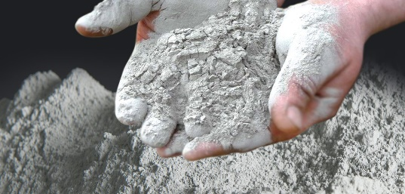

Fig. no. 1Cement

Portland cement is made up of four main compounds: tricalcium silicate (3CaO · SiO2), dicalcium silicate (2CaO · SiO2), tricalcium aluminate (3CaO · Al2O3), and a tetra-calcium aluminoferrite (4CaO · Al2O3Fe2O3).

**(b) Fine aggregate** - Fine aggregates are essentially any natural sand particles won from the land through the mining process. Fine aggregates consist of natural sand or any crushed stone particles that are ¼” or smaller. This product is often referred to as 1/4'” minus as it refers to the size, or grading, of this particular aggregate.

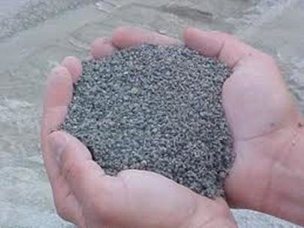

Fig. no. 2 fine aggregate

Naturally available sand from **Saank** river bed passed through 4.75mm IS sieve is used as fine aggregate is in the present work. As per IS383 the sand falls under zone 4. The specific gravity of sand is 2.82 and fineness modulus of 2.5.

**(c) Coarse aggregate-**  The Coarse aggregate are obtained from a local quarry is used. The coarse aggregate with a maximum size 20mm having a specific gravity 2.91 and fineness modulus of 1.9.

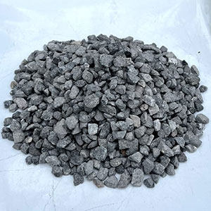

Fig no. 3 Coarse aggregate

**(d) Glass Powder-**  The most familiar form of glass is the silica-based material used for windows, containers and decorative objects. Glass is biologically inactive material that can be found with very smooth and impervious surfaces. The specific gravity of glass powder is 2.58.

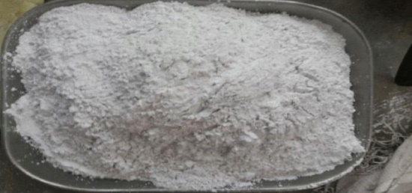

Fig. no. 4 glass powder

**Methodology-** A nominal mix of concrete of proportion 1:2:4 was adopted for the present study. The first mix MC1 is control mix having only cement as binder. The MCF series had fly ash as replacement of cement. The MCS & MCG series had silica fume and glass powder as replacement of cement. The compressive strength test were conducted to monitor the strength development of concrte containing 15% & 30% of these pozzolana as cement replacement. The particle size effect of glass powder studied by using glass powder of size (150-100)µ and (50-100)µ. Capillary absorption test is conducted to study the effect of alkali aggregate reaction.

The EDS analysis and SEM analysis of the mixes were done to study the change in the morphological characteristics of concrete mixes.

* The tests were conducted in two series.
* In first Series 30 % of pozzolana were used as partial replacement of cement.
* In second series 15% of pozzolana were used as partial replacement of cement.
* Eleven numbers of standard cubes (150x150x150 mm) were cast to measure the
* compressive strength after 28days and 52 days. Two cube were retained to measure capillary absorption after 28 days and 52 days respectively.
* The EDS analysis and SEM analysis of the mixes were done after 28 days and 52 days to study the change in the morphological characteristics of concrete mixes.

**Compressive Strength Test-**

For each series five set were cast to determine compressive strength. Each set comprises of eleven standard cubes out of which nine cubes were cast to measure the compressive strength after 28days and 52 days. The size of the cube is as per the IS code 10086 – 1988.

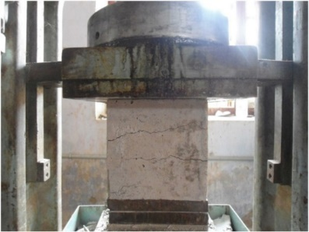

Fig.no. 5 Compressive Strength Test

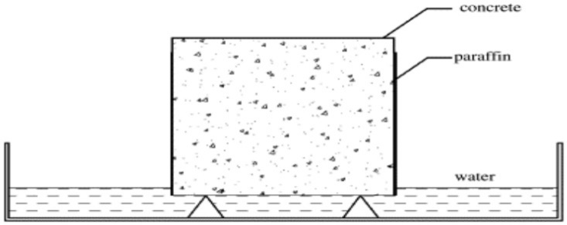**Capillary absorption Test -** Out of eleven standard cubes two cubes were retained to measure capillary absorption coefficients after 28 days and 52 days curing respectively. This test is conducted to measure the capillary absorption which indirectly measures the durability.

Fig. no. 6 capillary absorption test

**Procedure:**

* The sample was dried in oven at 105ºC until constant mass was obtained.
* Sample was cool down to room temperature for 6hr.
* The side of the sample was coated with paraffin to attain unidirectional flow.
* The sample was exposed to water on one side by placing it on a pan filled with the water.
* The water in the pan was kept about 5mm above the base of the specimen as shown in the figure below.
* The weight of the sample was measured at 15 and 30 minutes intervals.

The capillary absorption coefficient (k) was calculated by using formula:

k= Q/A* sqrt (t)

where, Q= amount of water absorbed

A = cross sectional area in contact with water

t = time

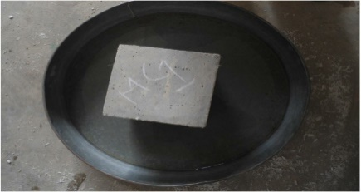

fig.no**. 7** Sample

**RESULTS –**

**Compressive Strength**

The results of compressive strength testing of laboratory-cured cubes are presented in Table no. 5.2. and Table no.5.3 for First series with 30% cement replacement and Second series with 15% cement replacement respectively. The strength values reported are the average of three test results. Fig. and Fig. are graphical representation of strength development of concrete cubes of various mixes for the First series and second series respectively.

Compressive Strength of series after 28 days and 52 days were tabulated below:

Table no. 1 First Series

|  |  |  |
| --- | --- | --- |
| DESIGN MIX | 28 days (N/mm²) | 52 days (N/mm²) |
| MC1 | 21.03 | 25.33 |
| MCS1 | 21.48 | 23.41 |
| MCF1 | 14.96 | 17.48 |
| MCG11 | 12.88 | 14.57 |
| MCG12 | 14.22 | 17.05 |

Where, Mix MC1= Only OPC cement

Mix MCS1= cement + 30% silica fume

Mix MCF1= cement + 30% fly ash

Mix MCG11= cement+ 30% glass powder (150-100) micron

Mix MCG12= cement + 30% glass powder (<100) micron

Table no. 2 Second Series

|  |  |  |
| --- | --- | --- |
| DESIGN MIX | 28 days(N/mm2) | 52 days (N/mm) |
| MC2 | 21.03 | 25.33 |
| MCS2 | 22.88 | 24.788 |
| MCF2 | 15.56 | 18.815 |
| MCG21 | 13.77 | 14.67 |
| MCG22 | 15.11 | 19.57 |

Where, Mix MC2= Only PPC cement

Mix MCS2= cement + 15% silica fume

Mix MCF2= cement + 15% fly ash

Mix MCG21= cement+ 15% glass powder (150-100) micron

Mix MCG22= cement + 15% glass powder (100-50) micron

**Conclusions-**

1. Optimum Strength is seen at 20-30 % replacement of cement with glass fibers.
2. Reduction in Cost of construction about 10%.
3. Avoid disposal problem of plastic waste and glass powder.
4. Compared to fly ash concrete, fiber glass powder concrete had slightly higher early strength as well as late strength.
5. The smaller particle size of the glass powder has higher activity with lime resulting in higher compressive strength in the concrete mix.
6. Avoid disposal problem of plastic waste and glass powder.
7. The coefficient of capillary absorption test also indicates that incorporation of fiber glass powder improves durability.
8. Micro structural examination shows that glass powder produces a denser matrix which improves the durability property of concrete.

**REFERENCES-**

1. **Kumar Animesh, Jeet Tiwari, Kapil Soni (2017)** “Partial Replacement of  
   Fine Aggregate & Coarse Aggregate by Waste Glass Powder & Coconut  
   Shell”. (IRJET)
2. **Dabiri, H., Sharbatdar, M.K., Kavyani, A. and Baghdadi, M. (2018).** “The influence of replacing sand with waste glass particle on the physical and mechanical parameters of concrete”.
3. **Olomo Rachael O, Alao Matthew O, Popoola Oyinade C, Ogundare  
   Damilola A (2019)** “Partial Replacement of Coarse Aggregate with Waste Glass in Concrete Production” Journal of Mechanical and Civil Engineering.
4. [**Erfan Najaf**](https://www.researchgate.net/profile/Erfan-Najaf?_tp=eyJjb250ZXh0Ijp7ImZpcnN0UGFnZSI6InB1YmxpY2F0aW9uIiwicGFnZSI6InB1YmxpY2F0aW9uIn19)**,** [**Hassan Abbasi**](https://www.researchgate.net/profile/Hassan-Abbasi?_tp=eyJjb250ZXh0Ijp7ImZpcnN0UGFnZSI6InB1YmxpY2F0aW9uIiwicGFnZSI6InB1YmxpY2F0aW9uIn19) **(2022)** “Using Recycled Concrete Powder, Waste Glass Powder, and Plastic Powder to Improve the Mechanical Properties of Compacted Concrete.”
5. **Shreeram Patidar1, Rahul Sharma (2023) “**A Research Paper on Use of Waste Glass Powder and Plastic Fibers in Concrete”.International Journal of Research Publication and Reviews.
6. IS 2720(III/SEC-I): 1980 Methods of Test for Soils, Determination of specific gravity
7. IS 2720(IV):1985 Methods of Test for Soils, determination of grain size analysis.
8. IS: 456. 2000. Indian Standard “Plain and Reinforced Concrete” - Code of practice. Bureau of Indian Standards, New Delhi.
9. IS 2720(III/SEC-I): 1980 Methods of Test for Soils, Determination of specific gravity.
10. IS 2720(IV):1985 Methods of Test for Soils, determination of grain size analysis.