**AUTOMATED BREATH ANALYZER FOR ETHANOL DETECTION AND MONITORING**

Jai Ganesh S1, Nagarajan V2

1. II MCA, Sri Muthukumaran Institute Of Technology, Mangadu, Chennai.

2. Professor, MCA, Sri Muthukumaran Institute of technology, Mangadu, Chennai.

**ABSTRACT**

This project aims to develop a system for detecting alcohol levels in a vehicle driver's breath using an MQ-3 alcohol sensor interfaced with an ESP8266 NODEMCU microcontroller. The system's primary function is to prevent the ignition from starting if alcohol is detected above a certain threshold, thereby enhancing road safety. Concurrently, it ensures continuous power supply to critical systems like power steering and braking through a 4-channel relay module, regardless of the alcohol detection status. This dual-functionality design seeks to mitigate the risks associated with drunk driving by integrating real-time sensing and control mechanisms into the vehicle's operational framework

The ESP8266 NodeMCU establishes a Wi-Fi connection to host a webpage, displaying real-time alcohol level readings. Users can access this webpage via the ESP8266's IP address, facilitating monitoring and management. This integration enhances vehicle safety by combining alcohol detection with continuous system operation and accessibility through a web interface.

**Keywords :-** ESP8266 NodeMCU microcontroller, MQ-3 sensor, ignition interlock devices (IIDs).

1. **INTRODUCTION**

Alcohol consumption poses significant public health challenges, leading to numerous accidents, health issues, and social problems. Traditional alcohol detection methods, such as breathalyzers, require manual operation and lack integration with modern technologies. This project aims to develop an IoT-based alcohol detection system using the MQ-3 sensor and ESP8266 NodeMCU, providing a real-time monitoring solution. By leveraging IoT capabilities, the system can detect alcohol levels and transmit data to a local server, allowing for remote access and analysis. This approach offers significant potential for enhancing public safety and health by enabling proactive monitoring in various contexts such as driving safety, workplace environments, and recovery programs. The primary objectives include designing a reliable hardware setup, developing a software solution for data collection and transmission, and creating a user-friendly interface for data visualization.

The primary objectives of this project include designing a reliable hardware setup that accurately measures alcohol levels, developing a software solution that seamlessly collects and transmits this data, and creating a user-friendly interface for real-time data visualization. Additionally, the project aims to ensure the system operates consistently and delivers precise readings. The integration of IoT technology in alcohol detection not only modernizes traditional methods but also provides a scalable and accessible solution for diverse applications, ultimately contributing to a safer and healthier society.

1. **RELATED WORK**

Development of a Breath Alcohol Detection System Based on Electrochemical Sensor[1].

Development of a Wireless Alcohol Breath Sensor for Personal and Automotive Applications[2].

Design and Implementation of a Breath Alcohol Detection System Using a Microcontroller[3].

A Smart Breath Alcohol Detection System for Driver Safety[4].

Integration of IoT with Breath Alcohol Detection: A Case Study[5].

1. **SYSTEM SIMULATION DIAGRAM**

The system simulation diagram for the alcohol detection project involves several interconnected components. The MQ-3 alcohol sensor detects the alcohol concentration in exhaled air and sends an analog signal to the ESP8266 NodeMCU. The NodeMCU processes this signal, compares it to a preset threshold, and controls a relay module based on whether the alcohol level exceeds the limit. The relay can cut off the ignition, such as a warning beeping system , but it only cut off the ignition, so braking system and power steering will be always works during this process. Additionally, the NodeMCU hosts a web server that provides real-time monitoring of alcohol levels through a remote interface, allowing users to view the data using Wi-Fi connection of ESP8266 NodeMCU through access point of esp8266 IP address. This integrated system ensures effective alcohol detection and remote management capabilities.

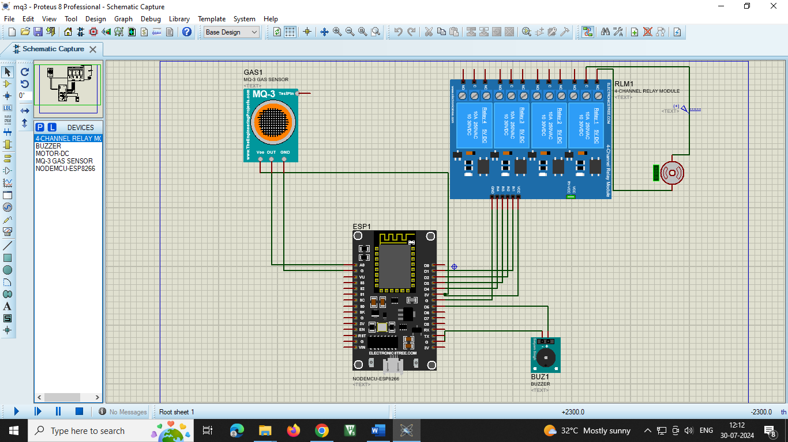

* 1. **MODULE DESCRIPTIONS:-**

The front-end development of the system using web technologies such as HTML, CSS, and JavaScript but this coding are written in an Arduino (embedded C++) within the microcontroller ESP8266 NodeMCU. The project involves interfacing an MQ-3 alcohol sensor with an ESP8266 NodeMCU to detect alcohol levels. The system includes a threshold comparison module to determine when alcohol levels exceed predefined limits. The ESP8266 NodeMCU is programmed to process sensor data and control a relay based on the comparison results. A web server module allows remote monitoring of alcohol levels, providing real-time updates through a user-friendly web interface. This setup enables effective alcohol detection and management with both local and remote control capabilities.

* + 1. **ALCOHOL DETECTION SYSTEM:-**

The system is designed to be accessible via the web application, allows seeing the level of intoxication content in air and the hardware components are used to detect the accurate level of ethanol content in exhaling air of driver and co-passengers and beeps the sound if the alcohol is detected and ignition will be cut off.

**MQ-3 Alcohol Sensor Interface Module:**

Interface the MQ-3 alcohol sensor with the ESP8266 NODEMCU to detect alcohol levels in the driver's breath.

**Components and Steps:**

* MQ-3 Alcohol Sensor: Connect the sensor to the NODEMCU using its analog output pin.
* Analog-to-Digital Conversion (ADC): Use NODEMCU's built-in ADC to read analog voltage levels from the sensor.
* Calibration and Sensitivity Adjustment: Implement calibration routines and adjust sensor sensitivity using the onboard potentiometer is required.

**Threshold Comparison Module:**

Compare the alcohol sensor readings with predefined threshold values to determine if the detected alcohol level is safe or exceeds the limit.

**Components and Steps:**

* + **Threshold Setting:** Define and set threshold values for alcohol concentration (e.g., in parts per million, ppm) that indicate safe and unsafe levels.
  + **Comparison Logic:** Write code to compare the sensor readings (converted to ppm or similar units) with the defined threshold values.
  + **Decision-Making:** Based on the comparison, trigger actions such as preventing ignition or enabling warning indicators.

**ESP8266 NODEMCU Programming:**

Develop firmware to control sensor readings, threshold comparison, and system actions.

**Components and Steps:**

* + **Setup and Initialization:** Initialize GPIO pins, ADC, and other necessary configurations in the setup() function.
  + **Loop Operation:** Continuously read sensor data in the loop() function, perform threshold comparisons, and update system status.
  + **Communication:** Implement Wi-Fi communication for hosting a web server and providing real-time data updates to connected devices.

**Relay Control Module:**

Control power to critical vehicle systems (e.g., power steering, braking) based on alcohol detection status.

**Components and Steps:**

* + **4-Channel Relay Module:** Connect the relay module to NODEMCU's GPIO pins for switching power circuits.
  + **Relay Logic:** Write code to control relay states based on alcohol detection results (e.g., enable power when alcohol level is safe, disable power when unsafe).
  + **Safety Considerations:** Ensure fail-safe mechanisms and proper handling of relay switching to prevent unintended consequences.

**Web Server and Remote Monitoring Module:**

Host a web server on the ESP8266 NODEMCU for monitoring of alcohol levels and system status.

**Components and Steps:**

* + ESP8266WebServer Library: Utilize this library to create web pages and handle HTTP requests.
  + Real-Time Updates: Display sensor readings, threshold status, and system actions on a web interface accessible via the NodeMCU's IP address.
  + User Interface: Design an intuitive web interface using HTML, CSS, and Javascript for interactive features.

1. **PROJECT IMAGE**

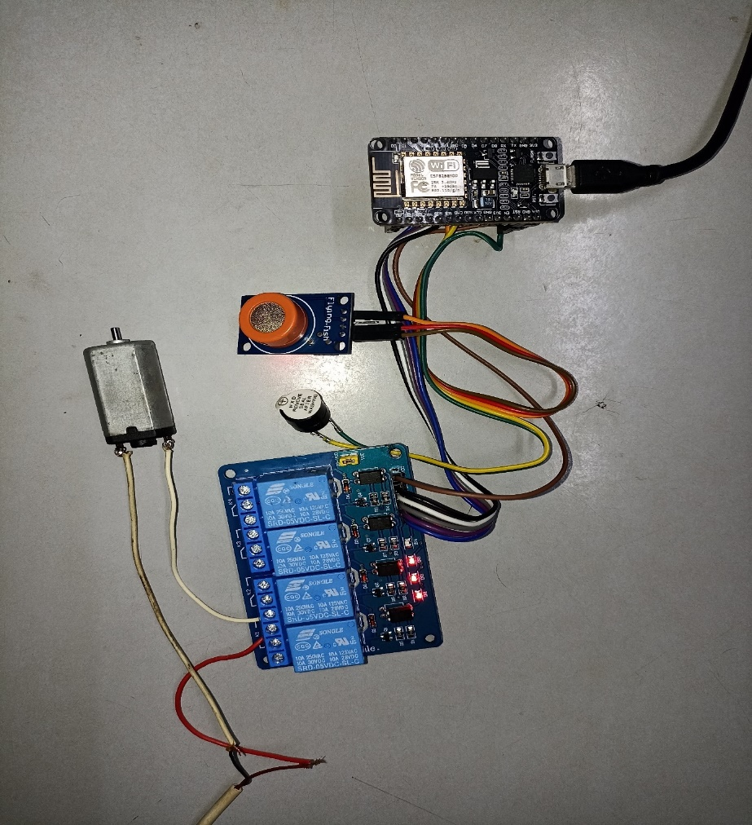

1. **APPLICATION SCREENSHOTS**



 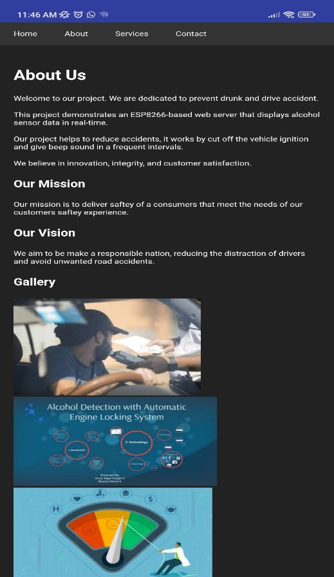

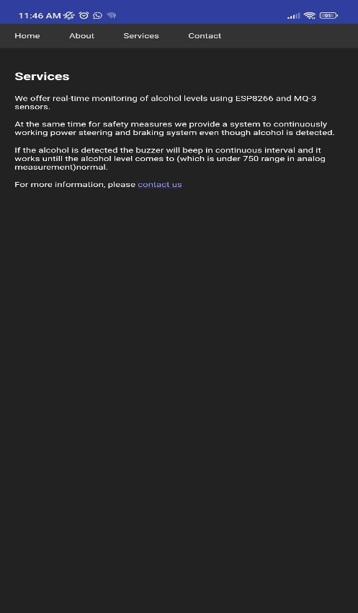 

1. **CONCLUSION AND FUTURE WORK**

As This project is deployed with MQ3 project aimed to enhance road safety by integrating an alcohol detection system using an MQ-3 sensor with an ESP8266 NodeMCU microcontroller. Through this project, we successfully developed a system capable of detecting alcohol levels in a vehicle driver's breath, leveraging the sensitivity of the MQ-3 sensor. The sensor, interfaced with the ESP8266 NodeMCU, enabled real-time monitoring and control of alcohol levels, offering a robust solution for preventing drunk driving. By utilizing the WiFi capabilities of the ESP8266 NodeMCU, we ensured that the system could wirelessly transmit data to a web server, making the information accessible globally. This wireless connectivity facilitated the creation of an intuitive web interface, allowing users to conveniently view alcohol levels and other relevant data through any web browser. Sensor , ESP8266 NodeMCU microprocessor, we can enhance the output of the project by employing ESP32-CAM, LDR sensor, Rest Monitor to detect sleep, LUX sensor for high-beam and low-beam light control, we can enhance this alcohol detecting process more reliable and automatic calibration, Machine Learning for Better Detection.

**REFERENCES**

[1]. B. S. Lee, D. H. Kim, J. H. Park, and H. K. Lee, "Development of a Breath Alcohol Detection System Based on Electrochemical Sensor," IEEE Sensors Journal, vol. 10, no. 10, pp. 1695-1700, Oct. 2010.

[2]. A. M. Loeb, P. A. Harnett, and C. A. Smiddy, "Development of a Wireless Alcohol Breath Sensor for Personal and Automotive Applications," IEEE Transactions on Instrumentation and Measurement, vol. 60, no. 6, pp. 2138-2146, June 2011.

[3]. T. T. Lee and K. S. Tan, "Design and Implementation of a Breath Alcohol Detection System Using a Microcontroller," IEEE Access, vol. 7, pp. 101900-101908, 2019.

[4]. S. S. K. Pathak, P. M. Patel, and R. S. Mishra, "A Smart Breath Alcohol Detection System for Driver Safety," IEEE International Conference on Electronics, Computing and Communication Technologies (CONECCT), pp. 1-4, June 2015.

[5]. R. M. Silva, J. B. S. Silva, and P. S. Santos, "Integration of IoT with Breath Alcohol Detection: A Case Study," IEEE International Conference on Industrial Technology (ICIT), pp. 567-572, March 2020.