**Smart Toilet Using Microcontroller**

**Tejas Gajanan Zine1, Rohit Ravindra Muley2, Simita Tukaram Gawai3,**

**Akanksha Jagdish Sonawane4, Hemant S. Ambhore5**

**Department of Electronics and Telecommunication**

**Shreeyash College of Engineering & Technology, Aurangabad,**

**Maharashtra**

**Abstract:** In our nation, sanitation has always been a major issue. Most significantly, this issue is not just concentrated to the rural areas but is also wide spread in urban and semi urban areas. People do not show the same level of concern when it comes to keeping the public sanitation systems clean as they show towards the ones at their homes. However, in India, the scenario of public toilets is still dismal. One of the reasons for this is that the people do not bother to clean up after they use the toilet. These places are thus the breeding grounds of bacterial germs like Escherichia coli and many deadly diseases. Many people sometime prefer discomfort to using these toilets. Looking at such troubles, the decision to construct a self-flushing toilet was made that simply utilizes the weight of the person using it as its working mechanism. The system consists of a platform supported on springs and the lever arrangement that flushes after use. The lever is pivoted in such a way that it will lower itself when weight is applied downward and when the load is released, this will strike the flush and hence in this way water is flushed out to clean the toilet. The design is robust and cost effective. Sensors or any kind of electrical transducers are not required in the construction of these toilets. As the old saying goes "cleanliness is next to godliness", this is a public welfare project which aims to propagate a cleaner and hygienic society and hence, take our nation to the heights of glory.

**Keywords: Smart toilet, IR sensor, switches, battery, servo motor.**

1. **INTRODUCTION**

Some automatic flushing systems do exist in the market, but they are too expensive due to their complex construction. They generally use some optical or electrical sensors to detect the presence of a person using the toilet and accordingly they operate. They are found to be used in airports, shopping malls, multiplex etc. But their use in the public toilets is not possible due to the excessive cost and frequent maintenance. Smart toilet technology has rapidly evolved, offering a range of features focused on health monitoring, water efficiency, and user convenience. These toilets come equipped with sensors to analyze urine and stool for health indicators, sending readings to health apps or professionals for analysis. They often incorporate water-saving mechanisms like dual-flush systems and self-cleaning functions using UV light or electrolyzed water. Additionally, they provide personalized comfort through seat heating, bidet functions, and customizable settings for water temperature and pressure. Connectivity to smartphones and smart home systems allows control via dedicated apps or voice assistants, while some models integrate air purification and LED lighting for added convenience. These toilets continually advance, aiming to enhance hygiene, efficiency, and user experience.

1. **EXISTING SYSTEM**

The integration of smart technology into household devices has transformed how we interact with everyday objects, making them more efficient and user-friendly. One notable advancement in this domain is the development of smart toilet systems. These systems leverage microcontrollers to automate and enhance various functions, improving hygiene, comfort, and user experience. Smart toilets incorporate a variety of sensors, actuators, and communication modules, enabling features such as automatic flushing, heated seats, bidet functions, and even health monitoring. This paper explores the architecture and components of smart toilets, reviews existing systems, and discusses the challenges and future prospects of these innovative devices.

1. **PROPOSED SYSTEM**

The intelligent toilet, also known as an "electronic toilet" or "smart toilet," was first invented by Americans in 1964 and later introduced to Japan by Japanese businessmen. After undergoing design optimizations, the product gained popularity in Japan during the 1980s and 1990s. In the early 1990s, Japanese businessmen brought the intelligent toilet to China, marking the beginning of its domestic market. The development of intelligent toilets in China can be roughly divided into three stages. The first stage, known as the birth period, spanned from 1990 to 1995 and marked the initial introduction and adoption of intelligent toilets in China. This period laid the foundation for future growth. The second stage, from 1995 to 2015, was characterized by significant growth as intelligent toilets saw wider acceptance and technological advancements. The third stage began after 2015, a milestone year that marked the maturation of the domestic intelligent toilet industry, with a surge in innovation and adoption. The evolution of intelligent toilets underscores the growing emphasis on hygiene, convenience, and technological integration in restroom facilities, exemplifying how innovation can enhance everyday life.

AINIT 2020

Journal of Physics: Conference Series 1684 (2020) 012038

IOP Publishing

doi:10.1088/1742-6596/1684/1/012038

Elderly people, as well as people with disabilities, face many

mobility problems due to either bone system degradation or various

afflictions they suffer. Therefore, any solution that improves the

quality of life of these people is more than welcome. This paper

aims to present an approach for developing a smart toilet system

for ageing people and persons of all ages with

impairments/disabilities. Toilet4me is one of the most significant

projects that involve smart toilet development especially for senior

population and those with different disabilities who need an

intelligent toilet outside their homes. Unlike the previous solution

developed in iToilet project which led to a prototype for home-use

(including the ability to adjust the height and position of the toilet

and other auxiliary means by using several different technologies,

Toilet4me is now exploring the concept and viability of adapting

these technologies to semi-public spaces

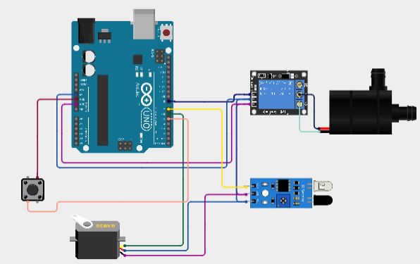

Fig.1: Circuit diagram

The smart toilet system utilizes an IR sensor, switches, a battery, a servo motor, a water pump, and a relay module to automate the flushing process. The IR sensor detects the presence of a user by emitting and receiving infrared light, sending a signal to the microcontroller when a person is detected. The microcontroller processes this signal and, based on programmed logic, activates the relay module. The relay module is responsible for controlling the water pump, which flushes the toilet by delivering water when triggered by the relay. The servo motor may be used to adjust or control a mechanical component such as a lever or gate that facilitates the flushing action. Manual switches are included to allow users or maintenance personnel to manually override the system, enabling direct control of the flushing mechanism if needed. The entire system is powered by a battery, which provides the necessary voltage to the microcontroller, sensors, servo motor, relay module, and water pump, ensuring seamless operation of the smart toilet.

**Technical Specification:**

**Arduino Uno:**  A Microcontroller is used ATmega328P. Its operating voltage is 5V. Digital I/O Pins is 14 (of which 6 provide PWM output) and Analog Input pins: 6. A Flash Memory is32 KB (of which 0.5 KB is used by the bootloader) and Clock Speed is 16 MHz.

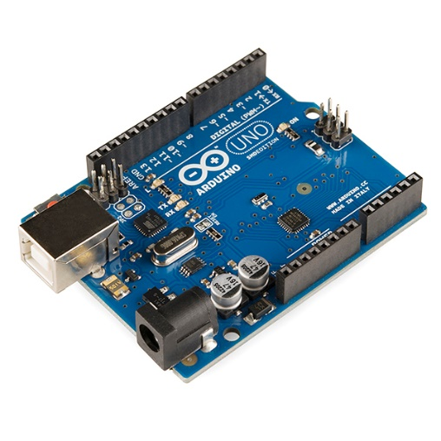

Fig.2: Arduino Uno

**Battery with BMS:** The battery used in the system is either Lithium-Ion with typical voltages of 3.7V depending on the configuration. Its capacity varies, with common options including 2000mAh or 3000mAh. The Battery Management System (BMS) includes crucial protection features such as overcharge protection, over-discharge protection, and short-circuit protection.

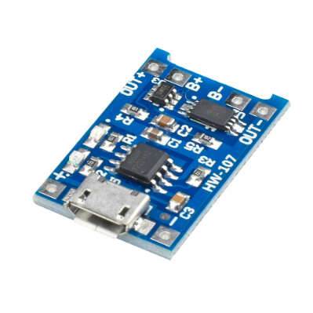

Fig.3: Battery with BMS

**IR sensor:** When selecting and integrating IR sensors into smart toilet systems, understanding their specifications is crucial to ensure optimal performance and compatibility. Typical Range: 850 nm to 950 nm (infrared light). Typical Range: 10 cm to 15 cm (adjustable). Operating voltage is Typical Range: 3.3V to 5V.

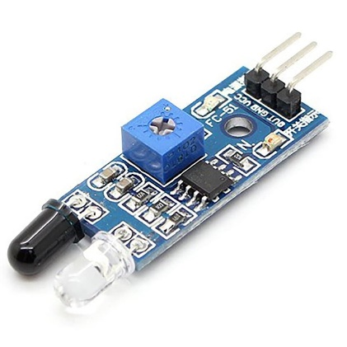

Fig.4: IR sensor

**Servo Motors:** servo motors are used to control the position of objects, rotate objects, move legs, arms or hands of robots, move sensors etc. An Operating Voltage: 4.8V to 7.2V. Servo motors have three wires: power, ground, and signal.



Fig.5: Servo motor

**Limit switch:** Limit switches are used to detect the presence or absence of an object. A limit switch is an electromechanical device operated by a physical force applied to it by an object.



Fig.6: Limit switch

**Water Pump:** A 12V DC water motor is a versatile and compact device designed for low-voltage applications. It typically features a flow rate between 0.5 to 3 liters per minute and can handle pressures up to 3 bar.

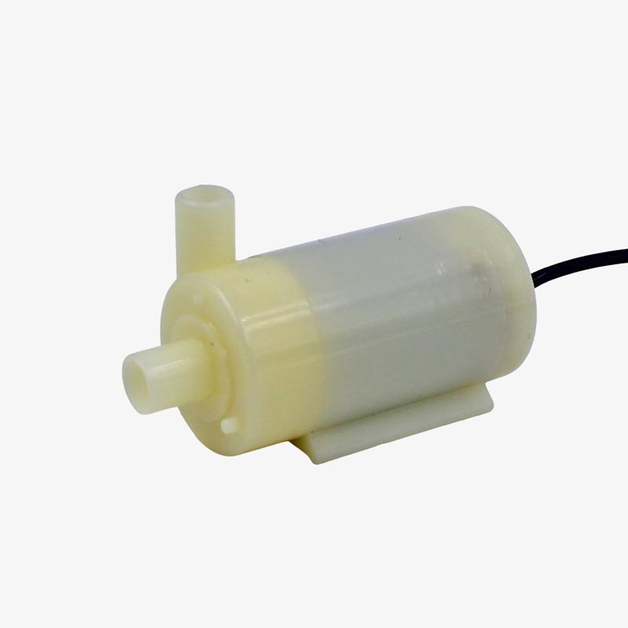

Fig.7: Water pump

**Relay Module**: A 12V relay module is designed to control high-voltage devices using a 12V DC control signal. It features electromechanical relays capable of handling currents up to 10A and voltages up to 250V AC or 30V DC. The module typically comes with multiple relays, ranging from 1 to 8, allowing for versatile switching capabilities. It is often used in automation systems and can be controlled by low-voltage signals from microcontrollers or other digital circuits. Indicator LEDs on the module provide visual feedback on the relay status.

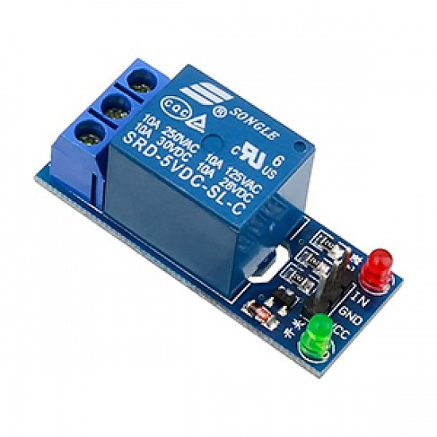

Fig.8: Relay Module

1. **WORKING**

When a person approaches or uses the toilet, the IR sensor detects their presence. The sensor continuously emits infrared light and measures the reflected signal to determine if someone is in the vicinity. The IR sensor sends a signal to the microcontroller based on the presence of the user. The microcontroller is programmed to process this input and determine when to activate the flushing mechanism Once the microcontroller receives the signal from the IR sensor, it sends a command to the relay module. The relay module acts as a switch that controls the high-power water pump. The relay module closes its circuit, allowing current to flow to the water pump. The water pump is activated to deliver water into the toilet bowl, initiating the flushing process. If a servo motor is included in the design, it can be used to adjust a mechanical component such as a lever or gate that helps control the flow of water. The microcontroller can send commands to the servo motor to move it into the desired position for effective flushing.



Fig.9: Final project

When a person approaches the toilet, the IR sensor detects their presence. This sensor emits infrared light and measures the reflected signal to confirm that a person is near. Upon detecting a person, the IR sensor sends a signal to the microcontroller. The microcontroller processes this input and sends a command to the servo motor. The servo motor, in response, moves to open the entry door, allowing the person to enter the toilet. After entering the toilet, the user must press a limit switch, which is positioned inside the toilet area. This limit switch acts as a confirmation that the toilet has been used and signals the system to proceed with the flushing process. When the limit switch is pressed, it sends a signal to the microcontroller. The microcontroller then activates the water pump, which starts delivering water into the toilet bowl to flush it. Once the flushing process is complete, the microcontroller sends a signal to the servo motor to open the exit door. This allows the user to leave the toilet. If the user does not press the limit switch (indicating they did not flush), the limit switch remains inactive. As a result, the microcontroller does not activate the water pump and prevents the exit door from opening. This design encourages users to flush the toilet before leaving, ensuring proper hygiene and cleanliness.

**CONTROL SIGNAL FLOW DIAGRAM**

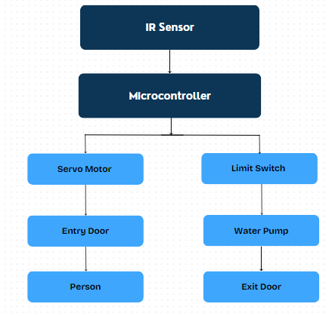

Fig.10: Flow diagram

* IR Sensor -> Detects person -> Sends signal to Microcontroller
* Microcontroller -> Processes IR signal -> Activates Servo Motor to open the door
* Person uses toilet -> Completes usage -> Presses Limit Switch
* Limit Switch -> Sends signal to Microcontroller
* Microcontroller -> Activates Water Pump for flushing
* Flushing completes -> Microcontroller activates Servo Motor to open the exit door

**FLOW CHART**

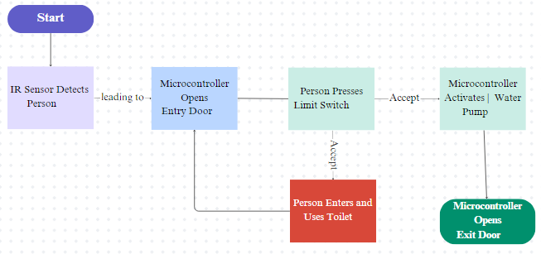

Fig.11: Flow chart

* Start: Initial state: System is idle.
* IR Sensor Detects Person: If Person presence then sends signal to Microcontroller
* Microcontroller Opens Entry Door: Signal from IR Sensor then Activates Servo Motor and Door opens.
* Person Enters and Uses Toilet: if Person inside toilet then completes usage.
* Person Presses Limit Switch: Limit Switch pressed then sends signal to Microcontroller and Microcontroller processes signal
* Microcontroller Activates Water Pump: Signal from Limit Switch then Activates Water Pump and Toilet flushes.
* Microcontroller Opens Exit Door - Input: Flushing completes, Action: Activates Servo Motor, Response: Exit door opens
* Person Exits: Person outside toilet and system resets to initial state
* End: System idle, ready for next use

1. **CONCLUSION**

The project "Development of a Smart Toilet for Automatic Flushing" aims to create a cleaner and more hygienic public toilet system in rural, semi-urban, and urban areas. Our goal is to promote this project as a public welfare initiative. Given the scarcity of electric power in rural areas, our design is particularly suitable, as it utilizes the user's weight to activate the flushing mechanism, making it both simple and efficient. This project supports the Central Government's "Swachh Bharat Abhiyan" scheme, striving to ensure that every citizen of the nation has access to cleaner and more hygienic sanitation facilities.

**Advantages**

* Hygiene and Sanitation: Smart toilets feature automated flushing, hands-free faucets, and touchless controls, reducing the spread of germs and promoting better hygiene.
* Resource Efficiency: Designed to be water-efficient, these toilets use sensor-based flushing to optimize water usage, contributing to water conservation efforts.
* Maintenance and Monitoring: Equipped with sensors that monitor usage, smart toilets enable proactive maintenance and quicker response times for repairs or cleaning needs.
* Accessibility: Smart public toilets accommodate people with disabilities by offering features like grab bars, wider entryways, and accessible controls, ensuring inclusivity for all users.
* Innovative Features: Modern amenities such as bidet functions, self-cleaning mechanisms, air purification systems, and ambient lighting enhance user comfort and experience.
* Safety and Security: Some smart toilets include security features like emergency call buttons or occupancy sensors to ensure user safety, especially in secluded or less frequented areas.
* Environmental Sustainability: By using eco-friendly materials, energy-efficient systems, and solar power, smart public toilets aim to reduce their environmental impact and promote sustainable practices.

**Applications**

* Residential Use
* Public and Commercial Facilities
* Healthcare Settings
* Transportation
* Smart Cities

**REFERENCES**

[1] F Zakaria, J Ćurko, A Muratbegovic et al. (2018) Evaluation of a smart toilet in an emergency camp. International Journal of Disaster Risk Reduction.vol. 27, pp. 512-523.

[2] H Katano, K Yokoyama, Y Takei, H Matsuki et al. (2011) The study of the bacterial contamination in the spray water of electronic toilets and in the gluteal and inguinal regions due to splashing following spray water. Microbial Ecology in Health and Disease. vol. 25, pp. 8-14.

[3] Ying Huang et al. (2019) A novel multidimensional analysis of writing styles of editorials from China Daily and The New York Times. Lingua. vol. 235, pp. 87-96.

[4] Andreas Schumacher et al. (2016) A maturity model for assessing Industry 4.0 readiness and maturity of manufacturing enterprises. Elsevier B.V.Vol 52,pp. 161-166.

[5] KorhanKo et al. (2020) Is Support Vector Regression method suitable for predicting rate of penetration. Journal of Petroleum Science and Engineering.Vol 194,pp. 19-24.