**Formulation and Evaluation of Antimicrobial**

**Polyherbal Gel by Utilizing Plant Extracts**

**Vaishnavi Mali*, Dr. N. B. Chougule1 Vaishnavi Patil2, Samradnyee Sawant3,**

**Prachi Khochage4**

1Principal, 4Assistant Professor

Department of Pharmacognosy

Ashokrao Mane Institute of Pharmacy, Ambap, Kolhapur 416112

Maharashtra, India

***Abstract:*** This study focuses on the formulation and evaluation of an antimicrobial polyherbal gel utilizing extracts from Acacia nilotica and Ocimum sanctum plants. With the escalating threat of antimicrobial resistance, there is an urgent need for novel therapeutic agents, particularly those derived from natural sources. The objective of this research is to develop a topical gel formulation that harnesses the combined antimicrobial potential of Acacia nilotica Bark extract and Ocimum sanctum leaf extracts for potential applications in wound healing and dermatological infections. The formulation process involved the extraction of bioactive compounds from Acacia nilotica and Ocimum sanctum leaves and bark using suitable solvents. These extracts were then incorporated into a gel base following standard procedures. The resulting polyherbal gel was characterized for its physical properties, including appearance, pH, spreadability, and viscosity, to ensure suitability for topical application. The antimicrobial activity of the polyherbal gel was evaluated against a panel of pathogenic microorganisms, including both Gram-positive and Gram-negative bacteria, as well as fungi. The agar well diffusion method and broth microdilution assay were employed to determine the inhibitory effects of the gel against the test microorganisms. The results revealed significant antimicrobial activity, with notable inhibition zones and minimum inhibitory concentrations against the tested pathogens. Furthermore, the cytotoxicity of the polyherbal gel was assessed using in vitro cell viability assays to ensure its safety for topical use. The results demonstrated negligible cytotoxic effects on mammalian cells, highlighting the potential biocompatibility of the formulation. In conclusion, the formulation and evaluation of the antimicrobial polyherbal gel utilizing Acacia nilotica and Ocimum sanctum extracts offer a promising strategy for the development of natural antimicrobial agents. The synergistic action of these plant extracts provides a valuable alternative to synthetic antibiotics, contributing to the ongoing efforts in combating antimicrobial resistance and promoting sustainable healthcare solutions.

***Keywords****: Ocimum sanctum*, *Acacia nilotica*, Anti-microbial activity, Herbal gel, Zone of inhibition, Phytochemical, Evaluation.

* **INTRDUCTION:**

Tulsi (*Ocimum sanctum*) is one of the most valuable and holistic medicinal plants that has medicinal value and has been used to prepare traditional medicines for many years in India. Tulsi has been described as the 'queen of herbs' and the 'mother of nature's medicine' due to its many useful medicinal properties.[10] This plant grows in India and many other countries of Southeast Asia. In India, O. sanctum is usually referred to as Tulsi. It is a traditionally important medicinal herb containing many useful compounds [11].

Ocimum sanctum Linn Known as Holy Basil is a medicinally important plant from the family Lemiaceae. O. sanctum is straight, about 75 cm tall, and heavily branched, with hairy stems and simple opposite green leaves that are quite aromatic. The oval, up to 5 cm long, somewhat serrated leaves typically have petioles. [1, 2, 3]

*Acacia nilotica / Vachellia nilotica* (Wild) is a genus of shrubs and trees belonging to the subfamily Mimosoideae [4], from the family *Fabaceae* or *Leguminosae* [5]. A. nilotica (Wild) has been traditionally used for decades in the treatment of many diseases such as diarrhoea, dysentery, leprosy, cancer, ulcers, burns, ulcers, canker sores and diabetes [6].

Parts of this plant are also used against inflammation, ophthalmia, hemorrhoids, bleeding piles, and leucoderma [7]. Due to the increase in bacterial resistance to common antibiotics, attention has focused on finding new or alternative agents that will have broad-spectrum activity and that will also be readily available and affordable to the common rural population, who are mostly victims of microbial infections. infection.[8]

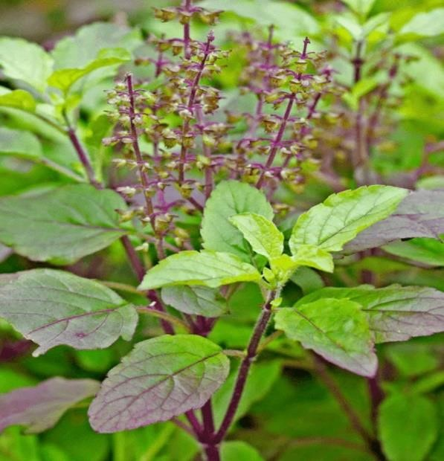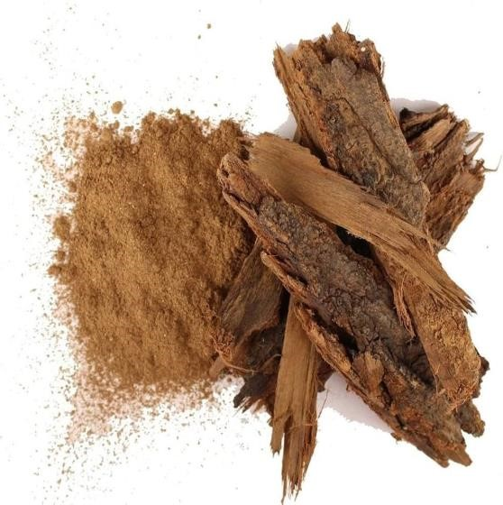

**Fig 1*:* Tulsi (*Ocimum tenuiflorum* ) Fig 2: Babul (*Vachellia nilotica* )**

Along with other medicinal forms, herbal medicines are also formulated in the form of herbal gels. The antimicrobial activity of any substance is defined as its ability to either kill bacteria or inhibit the growth of bacteria. Antimicrobial activity is important for the human body in the prevention of diseases and skin infections [9].

Antiseptic gel is aimed at destroying or inhibiting the growth of bacteria. An earlier study reported that medicinal plants are very beneficial in wound care because they promote the speed of wound healing with minimal pain, discomfort and scarring for the patient.[13]

The objective of this study was to prepare an herbal gel formulation using extracts from Ocimum Sanctum and Acacia nilotica to investigate the antimicrobial activity of the extracts against common organisms. Furthermore, the stability and phytochemical properties of the generated formulations will be evaluated so that they can be standardized and commercially used.

**Plant profile**

**PLANT PROFILE OF TULSI**

**Botanical Name:** Ocimum tenuiflorum

**Family:** Lamiaceae

**Kingdom:** Plantae

**Order:** Lamiales

**Genus:** Ocimum

**Fig 1 : Tulsi (*Ocimum tenuiflorum* )**

**Common name:** 1. English: Holy Basil or Tulsi 6. Hindi: तुलसी (Tulsi)

2. Bengali: তুলসী (Tulsi) 7. Tamil: துளசி (Tulasi)

3. Telugu: తులసి (Tulasi) 8. Kannada: ತುಳಸಿ (Tulasi)

4. Malayalam: തുളസി (Tulasi) 9. Gujarati: તુલસી (Tulsi)

10. Marathi: तुळशी (Tulshi) 13. Punjabi: ਤੁਲਸੀ (Tulsi)

11. Urdu: تلسی (Tulsi) 14. Nepali: तुलसी (Tulasi)

12. Sanskrit: तुलसी (Tulasi) 15. Sinhala: තුල්සි (Tulasi)

**Chemical constituent :**

1. **Eugenol:** A phenolic compound with a characteristic spicy smell. Eugenol has antioxidant, anti-inflammatory and antimicrobial properties.
2. **Ursolic acid:** This compound is known for its anti-inflammatory, antimicrobial and antioxidant properties. It is also thought to have potential anti-cancer properties.
3. **Rosmarinic acid:** Polyphenol with antioxidant properties. It absorbs free radicals and protects cells from oxidative stress. Rosmarinic acid also has anti-inflammatory effects.
4. **Apigenin:** A flavonoid known for its antioxidant and anti-inflammatory properties. It is also thought to have potential anti-cancer effects.
5. **Orientin:** Flavonoid with antioxidant properties. It helps in removing free radicals and reduces oxidative stress in the body.
6. **Vicenin:** Another flavonoid with antioxidant properties. Contributes to the overall antioxidant activity of holy basil.
7. **Beta-sitosterol:** A plant sterol that can help lower cholesterol and has anti-inflammatory properties.
8. **Luteolin:** A flavonoid with antioxidant and anti-inflammatory properties. It may also have neuroprotective effects.
9. **Quercetin:** Flavonoid with antioxidant properties. Quercetin absorbs free radicals and exhibits anti-inflammatory effects.
10. **Caffeic acid:** Phenolic acid with antioxidant properties. It helps neutralize free radicals and protect cells from oxidative damage.

**Medical use:**

1. Antimicrobial properties of O. sanctum aqueous extract: Holy basil or *Ocimum sanctum* has been investigated for various pharmacological properties such as antitoxic, antioxidant, anticancer, antimicrobial, antihypertensive, anti-inflammatory, anticoagulant analgesic and antithyroid [18,19] Phenolic constituents of O. sanctum leaf extract as isothymusin, apigenin, rosmarinic acid, cirsineol and eugenol. [20] Aqueous extracts of O. sanctum leaves are more effective against pathogens compared to methanolic extract.[21, 22]
2. Antifungal properties: Aqueous and acetone extract of Tulsi (O. sanctum) has been found to have antifungal activity against many fungi such as Curvularia penniseli, Alternaria tenuis and Helminthosporium spp. [23]
3. Antiviral properties: Different types of holy basil (O. sanctum) extract contain many useful secondary metabolites (such as eugenol, urosolic acid, apigenin, linalool, etc.) that act as antiviral agents against various viruses. Tulsi (O. sanctum) aqueous extract and essential oil have been evaluated in patients suffering from viral encephalitis.[24]
4. Antioxidant properties: Tulsi extract and essential oil are natural antioxidants. The antioxidant activity of O. sanctum extract and essential oil has been found by many researchers. [25, 26]

**PLANT PROFILE OF BABUL:**

**Botanical Name:** Acacia nilotica

**Family:** Fabaceae

**Kingdom:** Plantae

**Order:** Fabales

**Genus:** Acacia **Fig 2:** **Babul (*Vachellia nilotica*)**

**Species:** nilotica

**Common Name:**

1. English: Nile acacia, Egyptian thorn, Gum arabic tree 6. Tamil: காட்டு தொட்டி (Kaatu Thotti)

2. Arabic: سنط, سنط أبيض, سمر (Sunt, Sant Abiad, Samr) 7. Kannada: ಬಬ್ಬುಗಿಡ (Babbu Gida)

3. Hindi: बबूल (Babool) 8. Malayalam: ബാഭൂൽ (Baabhool)

4. Bengali: বাবল (Babal) 9. Gujarati: બાવળ (Baval)

5. Telugu: నల్ల తుమ్ము (Nalla Tumma) 10. Marathi: बबूळ (Babul)

**Chemical constituent:**

1. **Tannins:** Tannins are polyphenolic compounds known for their astringent properties. They help heal wounds, treat diarrhea and have antioxidant effects.
2. **Flavonoids:** Flavonoids are antioxidants that help scavenge free radicals, reduce inflammation, and promote cardiovascular health.
3. **Alkaloids:** Alkaloids have various pharmacological effects, including analgesic, anti-inflammatory and antimicrobial properties. They can also have effects on the nervous system.
4. **Saponins:** Saponins have detergent-like properties and are often used for their expectorant and anti-inflammatory effects. They also have potential immunomodulatory properties.
5. **Glycosides:** Glycosides are compounds that are often metabolized to active forms in the body. They can have different pharmacological effects depending on their structure.
6. **Phenolic compounds:** Phenolic compounds include a wide range of antioxidants that help in scavenging free radicals and reduce oxidative stress in the body.
7. **Proteins:** Proteins found in the bark of Acacia nilotica may have various biological activities, including antimicrobial and wound healing properties.
8. **Terpenoids:** Terpenoids are secondary metabolites with various pharmacological properties, including antimicrobial, anti-inflammatory and antioxidant effects.
9. **Chewing gum:** Chewing gum is a complex polysaccharide that has adhesive and thickening properties. They can be used in traditional medicine for their calming effects.
10. **Resins:** Resins are hydrophobic substances produced by plants. They may have antimicrobial and wound healing properties and are often used in traditional medicine for their protective effects.

**Medicinal use:**

1. Antihypertensive and antispasmodic effects: Reduction of arterial blood pressure is reported with the use of methanolic extract of A. nilotica pods and provides evidence of antihypertensive effects independent of muscarinic receptor stimulation. In in vitro studies, A. nilotica has an inhibitory effect on the force and rate of spontaneous contractions in paired guinea pig atria and rabbit jejunum. A. nilotica also inhibits K + -induced contractions in rabbit jejunum, arguing for an antispasmodic effect of A. nilotica that is mediated by calcium channel blockade, and this may also be responsible for the blood pressure-lowering effect of A. nilotica observed in in vivo studies.
2. Anti-diabetic activities: Studies have confirmed anti-diabetic activities. However, the pods and tender leaves are considered very beneficial in the treatment of diabetes mellitus in folk medicine. [27]
3. Antibacterial and antifungal activities: Tests of extracts from the stem bark confirm antimicrobial activity against Streptococcus viridans, Staphylococcus aureus, Escherichia coli, Bacillus subtilis and Shigella sonnei using the agar diffusion method. A. nilotica could be a potential source of antimicrobial agents.[28] A. nilotica shows the highest activity against three bacterial (E. coli, S. aureus and Salmonella typhi) and two fungal strains (Candida albicans and Aspergillus niger).[29]
4. Antiplasmodium activity: Ethyl acetate extract has the highest activity against Plasmodium falciparum. Phytochemical analysis showed that the most active phase contained terpenoids and tannins and was free of alkaloids and saponins.[30] Crude methanolic extracts of the root of A. nilotica reveal significant activity against a chloroquine-susceptible strain of Plasmodium berghei in mice.[31]
5. Antioxidant activity: Aqueous extract/fractions of A. nilotica (L.) in the lipid peroxidation test have the ability to scavenge peroxyl radicals and the results demonstrate the antioxidant activity of the plant. Bark powder of plant extracts with various solvents found cleansing activity by maceration extractio.[32]

* **Material and methods:**

**Collection of plant materials and other chemicals:**

The study used an in vitro experimental design. Tulsi leaves were obtained from yards and Babul bark powder was obtained from local market vendors. White wax, white petroleum, and methylparaben were used from a university laboratory. Authenticity of the plant by Vijaysinha Yadah Arts and Science College, Department of Botany, Peth Vadgaon.

**Drying:**

The leaves were separated from the stem, washed in clean water and dried until dry enough to be ground (dried for 7 days). The dried leaves were separately pulverized in an electric grinder until a homogeneous powder was obtained. [12]

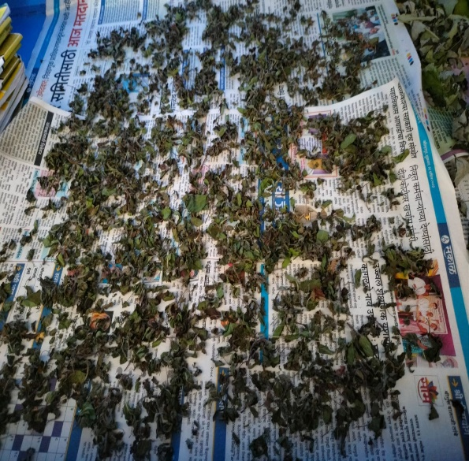

**Fig 3: Drying process**

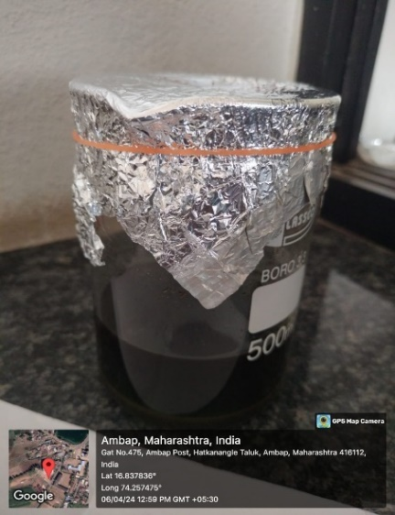

**Preparation of ethanol extract from polyherbs:**

The ethanolic extract was prepared from the powder obtained using the “maceration extraction method” [16]. 100 grams of finely ground Ocimum sanctum (Linn.) was used to prepare the extract.

• 40 g of Tulsi powder dissolved in 150 ml of ethanol.

• Cover this mixture using aluminum foil.

• Leave for 72 hours for the maceration process.

• It was then filtered with Whatman filter paper to yield a clean filtrate.

**Fig 4: Extraction process (Macration method)**

**Formulation of Placebo Gel (Control formulation):**

To prepare the gel formulation, first take carbopol 940, which was then dispersed in distilled water along with methylparaben, propylparaben and glycerin, which was left overnight. Take Ocimum sanctum leaf extract and Acacia nilotica bark extract in propylene glycol which was then added in polymer dispersion. The remaining amount of water was then added and neutralized to pH 7 with triethanolamine with constant stirring for 10 min.[14] The composition of the control batch is shown in Table 1.

**Development of herbal gel formulations**

To prepare the gel formulation, first take carbopol 940, which was then dispersed in distilled water, then methylparaben, propylparaben and glycerin were added and left overnight. Take Ocimum sanctum leaf extract and Acacia nilotica bark extract in propylene glycol which was then added in polymer dispersion. The remaining water was then added and neutralized to pH 7 with triethanolamine while constantly stirring.

[14]

**Table 1: Control batch formulation of herbal gels**

|  |  |
| --- | --- |
| **Ingredients** | **Quantity** |
| Carbopol 940 | 1.0 gm |
| Propylene glycol | 10 ml |
| Methyl paraben (0.5 %) | 0.2 ml |
| Propyl paraben (0.2 %) | 0.1 ml |
| Glycerin | 1 ml |
| Triethanolamine (to maintain pH) | q.s. |
| Distilled water | 100 ml |

**Table 2: Development of Herbal gel formulations**

|  |  |  |  |
| --- | --- | --- | --- |
| **Ingredients** | **F1** | **F2** | **F3** |
| *Ocimum sanctum* Extract | 0.5 gm | 1.0 gm | 1.5 gm |
| *Acacia nilotica* Extract | 0.5 gm | 1.0 gm | 1.5 gm |
| Carbopol-940 | 1.0 gm | 1.0 gm | 1.0 gm |
| Propylene Glycol | 10 ml | 10 ml | 10 ml |
| Methyl paraben (0.5 %) | 0.2 ml | 0.2 ml | 0.2 ml |
| Propyl paraben (0.2 %) | 0.1 ml | 0.1 ml | 0.1 ml |
| Glycerine | 1 ml | 1 ml | 1 ml |
| Triethanolamine (to adjust pH) | q.s. | q.s. | q.s. |
| Distilled Water | 100 ml | 100 ml | 100 ml |

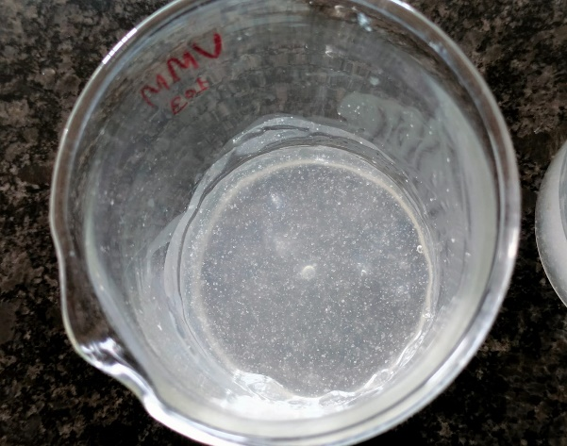

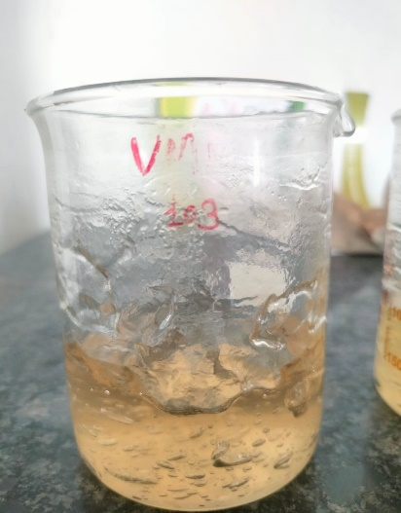

Herbal gel formulation base Herbal gel formulation

**Fig 5: Herbal gel formulation of plant extract**

* **Evaluation of Herbal gels:**

1. **Physical evaluation:** All the formulated herbal gels were checked for color and homogeneity by visual observation.
2. **pH:** The pH of all the formulated herbal gels was measured by using digital pH meter.[15]

1. **Viscosity:** Viscosity of herbal gels was determined by using Brookfield rotational viscometer at 100 rpm using spindle no.64. [15]
2. **Spreadability:** The spreadability of gel formulations was determined by measuring the spreading diameter of 1g of gel between two horizontal plates. [16]
3. **Antibacterial activity:** The antibacterial screening of herbal gels was performed using the disc diffusion method. The gels were evaluated against bacterial agents, specifically Staphylococcus aureus and Aspergillus niger. A loop of pure bacterial culture was suspended in nutritional broth and cultured for 24 hours. The nutrient agar media was sterilized and placed into petri dishes. After solidification, 0.1ml of the inoculum was equally distributed across the agar with a stick. A 6 mm diameter cavity was created, and the formed gel was inserted within. The usual antibiotic was employed as a control. The inoculation plates are incubated for 24 hours. Later, the zone of inhibition around the disc was measured and recorded. [17]

Antimicrobial activity refers to the ability of a substance to inhibit the growth or kill microorganisms, including bacteria, viruses, fungi, and protozoa. Antimicrobial agents can be classified based on their spectrum of activity, mechanism of action, and origin.

* **Antibacterial Agents:** These substances target bacteria and can be further classified based on their mechanism of action:
* **Cell Wall Inhibitors:** Drugs like penicillins and cephalosporins interfere with bacterial cell wall synthesis, leading to cell lysis and death.
* **Protein Synthesis Inhibitors:** Antibiotics like macrolides, tetracyclines, and aminoglycosides target bacterial ribosomes, disrupting protein synthesis.
* **DNA Gyrase Inhibitors:** Fluoroquinolones inhibit the bacterial enzyme DNA gyrase, interfering with DNA replication and leading to cell death.
* **Metabolic Inhibitors:** Drugs like sulfonamides and trimethoprim block essential metabolic pathways in bacteria, preventing their growth.

The antibacterial screening of herbal gels was performed using the disc diffusion method. The gels were evaluated against bacterial agents, specifically, Staphylococcus aureus*.* A loop of pure bacterial culture was suspended in nutritional broth and cultured for 24 hours. The nutrient agar media was sterilized and placed into petri dishes. After solidification, 0.1ml of the inoculum was equally distributed across the agar with a stick. A 6mm diameter cavity was created, and the formed gel was inserted within. The usual antibiotic was employed as a control. The inoculation plates are incubated for 24 hours. Later, the zone of inhibition around the disc was measured and recorded. [33]

**ANTIMICROBIAL ACTIVITY IN VITRO TECHNIQUES**:

1. Diffusion method
   1. Agar disk diffusion method
   2. Anti-microbial gradient method
   3. Other diffusion method

i)Agar well diffusion method

ii)Agar plug diffusion method

iii)Cross streak method

iv)Poisoned food method

1. Thin-layer chromatography (TLC)–bioautography
   * 1. Agar diffusion
     2. Direct bioautography
     3. Agar overlay bioassay
2. Dilution methods
3. Broth dilution method
4. Agar dilution method
5. Time-kill test (time-kill curve)
6. ATP bioluminescence assay
7. Flow cytofluorometric method

**Agar well diffusion method**

The agar well diffusion method is commonly used to assess the antibacterial properties of plants or microbial extracts. Similarly to the disk-diffusion method, the agar plate surface is infected by spreading a volume of microbial inoculum across the entire surface. Then, a 6 to 8 mm diameter hole is punched aseptically with a sterile cork borer or tip, and a volume (20-100 mL) of the antimicrobial agent or extract solution at the specified concentration is put into the well. The agar plates are next incubated under conditions appropriate for the test microorganism. The antimicrobial drug diffuses across the agar medium, inhibiting the growth of the microbiological strain tested.

**PRINCIPAL:**

This approach is based on the idea that an antibiotic-impregnated disk placed on agar previously inoculated with the test bacterium absorbs moisture and the antibiotic diffuses radially outward through the agar medium, resulting in an antibiotic concentration gradient. The antibiotic concentration along the disk's edge is high and steadily decreases as the distance from the disk increases, until it is no longer inhibiting to the organism, which then grows freely. If the antibiotic suppresses bacterial growth, a clear zone or ring forms around it following incubation.

**MEDIA:**

The disk diffusion method employs Mueller-Hinton Agar (MHA), which is the optimum medium for routine susceptibility tests because to its high repeatability, low concentration of sulfonamide, trimethoprim, and tetracycline inhibitors, and adequate growth of most bacterial pathogens. The inoculum for the disk diffusion method is made from a suitable broth, such as tryptic soy broth. This medium is made according to the manufacturer's instructions, dispensed in tubes of 4-5 mL, and sterilized. Sterile 0.9% salt solution can also be utilized. If the media is meant for marine species, it should contain 1-2% sodium chloride (NaCl).

**MATERIAL AND METHOD:**

**MATERIAL**:  
Nutrient agar: This is the solidifying agent derived from seaweed.

Nutrient broth: Nutrient broth or specific ingredients depending on the type of medium required (e.g., blood agar, MacConkey agar).

Distilled water.

Nutrient broth

Balance machine

Autoclave

Biological safety cabinet

Incubator

Cotton swab stick

Millimetre scale

**PREPARATION OF AGAR MEDIUM**

Procedure:

1. Measure out the appropriate amount of agar powder according to the desired concentration. Typically, agar is used at a concentration of around 1.5% to 2% (w/v) for solid agar medium.
2. Measure out the appropriate amount of nutrient broth or other ingredients required for the specific medium. The amount may vary depending on the type of medium being prepared.
3. Add distilled water to a clean flask or beaker. The volume of water will depend on the final volume of agar medium needed.
4. Heat the water to near boiling while stirring to dissolve the agar powder completely. Avoid prolonged heating to prevent evaporation.
5. Once the agar powder is completely dissolved, add the nutrient broth or other ingredients to the agar solution. Stir well to ensure uniform mixing.
6. Adjust the pH of the medium if necessary. The optimal pH for most microbial growth is around 7.0, but it may vary depending on the microorganism being cultured.
7. After the ingredients are thoroughly mixed, distribute the medium into containers (petri dishes, tubes, or bottles) as needed for storage and use.
8. Sterilize the medium by autoclaving at 121°C (250°F) for 15-20 minutes. Ensure that the containers are tightly sealed to prevent contamination during sterilization.
9. After sterilization, allow the medium to cool sufficiently to solidify before use. Agar solidifies at temperatures below 45°C (113°F) but remains molten at temperatures above this.
10. Once cooled and solidified, the agar medium is ready for use in culturing microorganisms. Store any unused medium in a cool, dry place.

It's essential to maintain proper aseptic techniques throughout the preparation process to prevent contamination of the agar medium with unwanted microorganisms. Additionally, follow any specific protocols or recipes required for preparing specialized agar media, such as selective or differential media.[34, 35]

**AGAR WELL DIFFUSION METHOD:**

The agar well diffusion method, also known as the agar disk diffusion method or the Kirby-Bauer method, is a widely used technique in microbiology to evaluate the antimicrobial activity of various substances such as antibiotics, plant extracts or synthetic compounds. Here's an overview of the process:

Materials and Reagents:

1. Agar plates: Prepared with a suitable growth medium (e.g., Mueller-Hinton agar for bacteria).
2. Microorganisms: Test strains of bacteria or fungi.
3. Sterile swabs or inoculating loops.
4. Antimicrobial agent: This could be an plant extract
5. Sterile forceps.
6. Sterile cork borer or pipette tip: Used to create wells in the agar.
7. Incubator.[36]

Procedure:

1. Prepare agar plates by pouring the sterile agar medium into petri dishes and allowing it to solidify.
2. Streak the surface of the agar plates with a standardized inoculum of the test microorganism using a sterile swab or inoculating loop. Ensure even distribution of the inoculum.
3. Allow the inoculum to dry on the agar surface for a few minutes to prevent excess moisture.
4. Using sterile forceps, place the antimicrobial agent onto the surface of the inoculated agar plates. This could be in the form of antibiotic disks or small volumes of liquid solutions (e.g., plant extracts).
5. If using a cork borer or pipette tip, create wells in the agar around the antimicrobial agent. Wells should be evenly spaced and sufficiently away from the edge of the plate to prevent overlap of inhibition zones.
6. Incubate the plates inverted (agar side up) in an incubator at the appropriate temperature for the test microorganism. Incubation time and temperature vary depending on the microorganism being tested (e.g., 37°C for bacteria, 25-30°C for fungi).
7. After the incubation period, examine the plates for zones of inhibition around the wells containing the antimicrobial agent. Measure the diameter of the zones using a ruler or caliper.
8. Interpret the results based on the diameter of the inhibition zones and compare them with established standards or breakpoints for the specific microorganism and antimicrobial agent being tested.[37]

The agar well diffusion method provides a qualitative assessment of the antimicrobial activity of the test agent against the target microorganism. It's important to note that factors such as inoculum density, incubation conditions, and the diffusion rate of the antimicrobial agent can influence the results and should be standardized for accurate interpretation.[38]

**RESULTS AND DISCUSSION:**

**Extraction of Powders:**

**Table no.4: Extractive values of Tulsi and Babul**

|  |  |  |  |  |
| --- | --- | --- | --- | --- |
| **Sample** | **Extraction method** | **Solvent used** | **Wt. of sample** | **Extraction value (%w/w)** |
| Ocimum sanctum | Maceration extraction | Ethanol | 40 gm | 10% w/w |
| Acacia nilotica | Maceration extraction | Ethanol | 40 gm | 10% w/w |

The results of physical parameters of formulated herbal gels like colour, homogeneity, pH, viscosity and spredability were shown in below Table 3.

Figure 6 depicts the spredibility of prepared herbal gels.

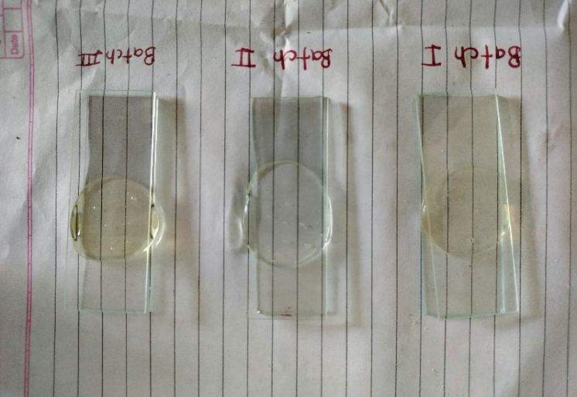

**Fig 6: Spreadability of formulated herbal gels**

**Table 3: Physical properties of all prepared herbal gels**

|  |  |  |  |  |  |
| --- | --- | --- | --- | --- | --- |
| **Formulation Code** | **Colour** | **Homogeneity** | **pH** | **Viscosity (cp)** | **Spreadability (mm)** |
| F1 | Light Yellowish | Homogeneous | 6.8/**±**0.03 | 3615 ±0.11 | 16.15/±0.005 |
| F2 | Yellowish | Homogeneous | 7.0 /**±** 0.03 | 3714 ±0.21 | 15.40/±0.005 |
| F3 | Dark Yellowish | Homogeneous | 7.1 /**±** 0.03 | 4137 ±0.43 | 15.39/±0.005 |

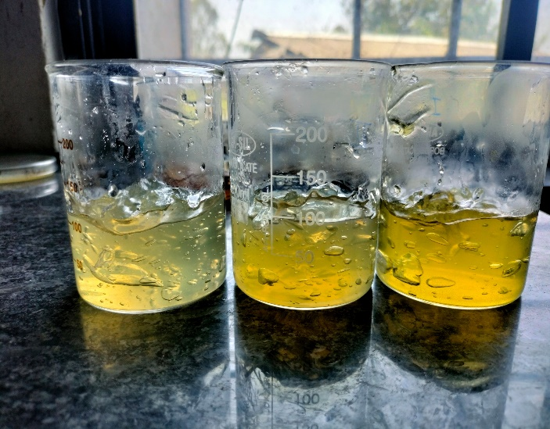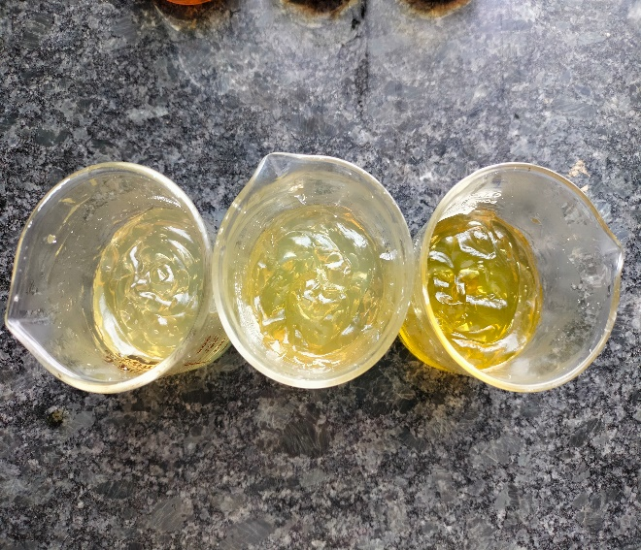

**Fig 7: Batches of Polyherbal Gel**

**Antibacterial Activity:**

The findings of antibacterial activity of all formulated herbal gels against some pathogenic microorganisms are reported in Table 4, and the results of zone of inhibition of all formulated herbal gels against the pathogens are depicted graphically in Figure 3.

**Table No. 4: Zone of Inhibition**

|  |  |  |  |  |
| --- | --- | --- | --- | --- |
| **Micro-organism culture** | **Zone of inhibition of Herbal gels (mm)** | | | |
| **Standard drug**  **Gentamicin (0.80) [C]** | **F1 [A]**  **(Conc. %- 10)** | **F2 [B]**  **(Conc. %- 5)** | **F3 [D]**  **(Conc. %- 100)** |
| ***S. aureus*** | 10 | 8 | No zone | 20 |

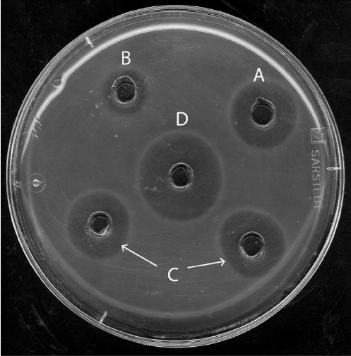

**Fig. 8: Antibacterial activity of formulated herbal gels**

**CONCLUSION:**

The data show that the leaves extract of *Ocimum sanctum* and bark extract of *Acacia nilotica* GEL had a 95%-100% inhibitory effect on the development of bacteria in agar-diffusion tests and a 100% inhibitory effect on fungi in atmospheric-diffusion trials.In conclusion, the research on the "Formulation and Evaluation of Antimicrobial Polyherbal Gel by Utilizing Plant Extracts" underscores the potential of herbal medicine in addressing microbial infections. Through systematic formulation and rigorous evaluation, the study has demonstrated the efficacy and safety of the polyherbal gel against a spectrum of pathogens, including bacteria and fungi.The incorporation of various plant extracts known for their antimicrobial properties has yielded a synergistic effect, enhancing the overall effectiveness of the gel. Moreover, the gel's favorable characteristics such as stability, skin compatibility, and ease of application make it a promising candidate for topical antimicrobial therapy.The findings of this research contribute to the growing body of evidence supporting the use of herbal remedies in modern medicine. By harnessing the therapeutic potential of natural plant compounds, the polyherbal gel offers a sustainable and potentially cost-effective alternative to conventional antimicrobial agents.However, further studies are warranted to optimize the formulation, elucidate the mechanisms of action, and evaluate the long-term safety and efficacy of the polyherbal gel in clinical settings. Additionally, considerations regarding standardization, quality control, and scalability should be addressed to ensure the reproducibility and commercial viability of the product.Overall, the formulation and evaluation of the antimicrobial polyherbal gel represent a significant step forward in the development of herbal-based therapies for microbial infections, with the potential to complement existing treatment modalities and address emerging challenges in antimicrobial resistance.

**REFERENCES:**

1. Jirovetz, L., Buchbauer, G., Shafi M.P. and, Kaniampady M. M. Chemotaxonomical analysis of the essential oil aroma compounds of four different Ocimum species from southern India. European Food Research and Technology, 2003; 217(2):120-124.
2. Malima, S. M., Massaga, J. J., Malecela, M. N. and Andrew, Y. Repellence effectiveness of essential oils from some Tanzanian Ocimum and Hyptis plant species against afrotropical vectors of malaria and lymphatic filariasis. Journal of Medicinal Plants Research, 2013; 7(11):653-660.

1. Kaya, I., Yiğit N and Benli, M. Antimicrobial activity of various extracts of Ocimum basilicum L. and observation of the inhibition effect on bacterial cells by use of scanning electron microscopy. African Journal of Traditional, Complementary and Alternative Medicines, 2008; 5(4):363-369.
2. Mohammed S. Auwal, Sanni Saka, Patrick A, Onyeyili Ismail, Alhaji Mairiga, Abdullahi Shuaibu, Amina Ibrahim, Fatima AL, Ahmad Bello Thaluwa, Abdulhamid B. Njobdi. Glycemic activity of the aqueous pod extract of *Acacia nilotica* (Fabaceae) in normoglycemic and alloxan induced diabetic on wister strain albino rats Journal of Medicinal Sciences. 2013;13(8): 761-766.
3. Khare CP. Indian medicinal plants, an illustrated dictionary. Springer, Stuttgart; 2007.
4. Scallan E, Hoekstra RM, Angulo FJ, Tauxe RV, Widdowson MA, Roy SL, Jones JL, Griffin PM. Food borne illess acquired in united State, S- Major pathogens. Emergence Infectious Diseases. 2011; 17(1):7-15.
5. Joshi C, Mathur P, Khare SK. Degradation of phorbol esters by *Pseudomonas aeruginosa* PSEA during solid state fermentation of deoiled *Jatropha curcas* seed cake. Biores. Technol. 2011;102(7): 4815-4819.
6. Wang L, Weller CL. Recent advances in extraction of nutraceuticals from plants. Trend in Food Science and Technology (Elsevier). 2006;17:300-312.
7. Ikegbunam M. N., Metuh R. C., Anagu L. O., Awah N. S. Antimicrobial activity of some cleaning products against selected bacteria.Int. Res J Pharm. App Sci.; 2013; 3(4):133-135.
8. K. Anbarasu and G. Vijaylakshami, Improved shelf life of protein-rich tofu using *Ocimum sanctum* (Tulsi) extracts to benefit Indian rural population, J. Food Sc., 2007, 72: M300-M305.
9. P. Pattanayak, P. Behera and D. Das, *Ocimum sanctum* Linn. A reservoir plant for therapeutic applications: An overview, Phcog. Rev., 2010, 4: 95-105.
10. Mallikarjun S, Rao A,Rajesh G, Shenoy R, Pai M. Antimicrobial efficacy of Tulsi leaf (*Ocimum sanctum*) extract on periodontal pathogens: An *in vitro* study. J Indian Soc Periodontol; 2016; 20:145-50
11. Odimegwu, D.C., Ibezim, E.C., Esimone, C.O., Nworu, C.S., Okoye, F.B.C., 2008. Wound Healing and Antibacterial Activities of The Extract of *Dissotis Theifolia* (Melastomataceae) Stem Formulated in A Simple Ointment Base. J Medicinal Plant Res 2(1): 011-016.
12. Jadhav VD, Talele SG, Bakliwal AA, Chaudhari GN. Formulation and evaluation of herbal gel containing *Tridax procumbens*. J Pharma Bio Sci. 3 (2); 2015: 165-172.
13. Deepak PA, Prashanth BS. Formulation and evaluation of herbal gel containing *Lanata camara* leaves extract. Asian J Pharm Clini Res. 6 (3); 2013: 122-124.
14. Ajinkya MB, Manjusha ND. Formulation and evaluation of herbal antimicrobial gel containing *Musa acuminata* leaves extract. J Pharamcog Phytochem. 5 (1); 2016: 1-3.
15. Vidya V, Aleykutty NA, Jayakar B, Subin MZ. Development and evaluation of antimicrobial herbal formulations containing the methanolic extract of *Samadera indica* for skin diseases. J Adv Pharm Technol Res. 3 (2); 2012: 106-111.
16. H. Skaltsa, S. Philians and M. Singh, Phytochemical study of the leaves of *Ocimum sanctum*, Fitoterapia, 1987, 8: 286.
17. N. Dev, A. K. Das, M. A. Hossain and S. M. M. Rahman, Chemical Compositions of Different Extracts of *Ocimum basilicum* Leaves, J Sci Res., 2011, 3: 197- 206.
18. P. Bhattacharyya and Bishayee, An *Ocimum sanctum* Linn. (Tulsi): an ethno medicinal plant for the prevention and treatment of cancer, Anticancer Drugs, 2013, 24: 659-666.
19. V. D. M. Geeta, R. Kedlaya, S. Deepa and M. Ballal, Activity of *Ocimum sanctum* (the traditional meditional plant) against the enteric pathogens, Ind. J. Med. Sci., 2001, 55: 434-438.
20. N. Singh, P. Verma, B. R. Pandey and M. Bhalla, Therapeutic Potential of *Ocimum sanctum* in Prevention and Treatment of Cancer and Exposure to Radiation: An Overview, Int J Pharm Sci Drug Res., 2012, 4: 97-104.
21. A. Kumar, A. Rahal and A. K. Verma, In−vitro antibacterial activity of hot aqueous extract (HAE) of *Ocimum sanctum* (Tulsi) leaves, Ind. J. Vety. Medicine, 2011a, 31(2): 96-97.
22. S. Rajeshwari, *Ocimum sanctum*: The Indian home remedy, In: Current Medical Scene, Cipla Ltd., Bombay Central, Bombay, 1992.
23. P. Govind, An overview on certain anticancer natural products, J. Pharm. Res., 2009, 2(12): 1799-1803.
24. R. K. Geetha and D. M. Vasudevan, Inhibition of lipid peroxidation by botanical extracts of *Ocimum sanctum*: In vivo and in vitro studies, Life Sci., 2004, 76: 21–28.
25. Gilani AH, Shaheen F, Zaman M, Janbaz KH, Shah BH, Akhtar MS (1999). Studies on antihypertensive and antispasmodic activities of methanol extract of *Acacia nilotica* pods. Phytother. Res., 13: 665-669.
26. Banso A (2009). Phytochemical and antibacterial investigation of bark extracts of *Acacia nilotica*. J. Med. Plants Res., 3: 082-085.
27. Kalaivani T, Mathew L (2010a). Free radical scavenging activity from leaves of *Acacia nilotica* (L.) Wil. ex Delile, an Indian medicinal tree. Food Chem. Toxicol., 48: 298-305.
28. El-Tahir A, Satti GM, Khalid SA (1999). Antiplasmodial activity of selected sudanese medicinal plants with emphasis on *Acacia nilotica*. Phytother. Res., 13: 474-478.
29. Jigam AA, Akanya HO, Dauda BEN, Okogun JO (2010). Polygalloyltannin isolated from the roots of *Acacia nilotica* Del. (Leguminoseae) is effective against Plasmodium berghei in mice. J. Med. Plants Res., 4(12): 1169-1175.
30. Del WE (2009). *In vitro* evaluation of peroxyl radical scavenging capacity of water extract / fractions of *Acacia nilotica* (L.). Afr. J. Biotechnol., 8(7): 1270-1272.
31. Vidya V, Aleykutty NA, Jayakar B, Subin MZ. Development and evaluation of antimicrobial herbal formulations containing the methanolic extract of *Samadera indica* for skin diseases. J Adv Pharm Technol Res. 3 (2); 2012: 106-111.
32. Antimicribial Activivity Techniques :Mounyr Balouiri n , Moulay Sadiki, Saad Koraichi Ibnsouda
33. Prescott, L.M., J.P. Harley and D.A. Klein. 1993. Microbiology, Second Edition. Wm C Brown Publishers, England, pp. 325-343.
34. AGAR WELL METHOD : <https://chemistnotes.com/biochemistry/antimicrobial-activity-by-agar-well-diffusion/>NCCLS. 2002.
35. Performance Standards for Antimicrobial Disk and Dilution Susceptibility Tests for Bacteria Isolated from Animals; Approved StandardSecond Edition. NCCLS document M31-A2 (ISBN 1-56238-461-9).
36. NCCLS, 940 West Valley Road, Suite 1400, Wayne, Pennsylvania 19087-1898, USA
37. Alderman, D.J. and P. Smith. 2001. Development of draft protocols of standard reference methods for antimicrobial agent susceptibility testing of bacteria associated with fish diseases. Aquaculture, 196: 211- 243.
38. Samie A, Obi CL, Bessong PO, Namrita L. Activity profiles of fourteen selected medicinal plants from Rural Venda communities in South Africa against fifteen clinical bacterial species. African Journal of Microbiology Research. 2005;1(3):46-50.
39. Oyeleke BS, Manga SB. Essentials of laboratory practicals in microbiology. First edition. Topbest publisher S.W.225 Hospital Road Minna-Niger State, Nigeria. 2008; 18:22-23,42-45.
40. Abdullahi H, Lawal SA. Antimicrobial activity of methanolic extracts of treama genesis used in Nigeria herbal medicinal practice. Biological Research and biotechnology. 2010;2(1):39-40.
41. Hassan LG, Muhammad S, Dangoggo SM, Hassan SW, Umar KJ, Aliyu RU. Acute and subchronic toxicity studies of kernel extract of *Sclerocarya birrea* in rats. Science Word Journal. 2011;6(3).
42. Khandelwal K.R. Practical pharmacognosy Techniques and experiments. 9th edition. Pune, Nirali Prakashan; 2002: 149-160.
43. <https://upload.wikimedia.org/wikipedia/commons/7/7c/Classification_of_Gels.jpg>
44. Recio MC (1983) A review of some antimicrobial compounds isolated from medicinal plants reported in the literature 1978-1988. Phytotherapy Research 3: 1445-1453.
45. Vidya V, Aleykutty NA, Jayakar B, Subin MZ. Development and evaluation of antimicrobial herbal formulations containing the methanolic extract of *Samadera indica* for skin diseases. J Adv Pharm Technol Res. 3 (2); 2012: 106-111.
46. Antimicrobial Activity Techniques: Mounyr Balouiri n , Moulay Sadiki, Saad Koraichi Ibnsouda
47. Prescott, L.M., J.P. Harley and D.A. Klein. 1993. Microbiology, Second Edition. Wm C Brown Publishers, England, pp. 325-343.
48. AGAR WELL METHOD: <https://chemistnotes.com/biochemistry/antimicrobial-activity-by-agar-well-diffusion/>
49. NCCLS. 2002. Performance Standards for Antimicrobial Disk and Dilution Susceptibility Tests for Bacteria Isolated from Animals; Approved StandardSecond Edition. NCCLS document M31-A2 (ISBN 1-56238-461-9). NCCLS, 940 West Valley Road, Suite 1400, Wayne, Pennsylvania 19087-1898, USA
50. Alderman, D.J. and P. Smith. 2001. Development of draft protocols of standard reference methods for antimicrobial agent susceptibility testing of bacteria associated with fish diseases. Aquaculture, 196: 211- 243.
51. Kalaivani T, Mathew L (2010a). Free radical scavenging activity from leaves of *Acacia nilotica* (L.) Wil. ex Delile, an Indian medicinal tree. Food Chem. Toxicol., 48: 298-305.
52. El-Tahir A, Satti GM, Khalid SA (1999). Antiplasmodial activity of selected sudanese medicinal plants with emphasis on *Acacia nilotica*. Phytother. Res., 13: 474-478.