**Enhancing Community Safety with RED ALERT SOS: A User-Centric Emergency Response App**

**Abstract**

In state-of-the-art speedy-paced global, timely reaction throughout emergencies can extensively effect consequences. This paper explores the concept, design, and social necessity of the RED ALERT SOS app, a user-friendly and interactive platform that offers a one-button emergency alert system. The app also capabilities specialized buttons for one of a kind sorts of emergencies and integrates social media elements to foster network engagement and help. Additionally, it gives a registration machine for volunteers who desire to assist in the course of crises. The primary consciousness of this research is the app's capacity to enhance network protection and emergency reaction through user-centric layout and social integration.

**1. Introduction**

In emergency situations, timely and accurate communication can save lives. Mobile applications can serve as essential tools for users to quickly alert authorities and share their location in real time. This research focuses on the creation of "Red Alert SOS," a mobile application developed with Flutter. The app aims to be intuitive, user-friendly, and highly functional, ensuring users can depend on it in critical situations.

1. **Related works**

The ubiquity of smartphones has brought about the proliferation of numerous emergency alert packages. Previous studies have highlighted the effectiveness of mobile programs in emergency management, underscoring the importance of real-time communique and region monitoring. However, many current answers lack user-pleasant interfaces and incorporated social features, which can be vital for extensive person engagement and performance.

**2.1 Existing Emergency Alert Systems**

Current emergency alert structures range notably in capability, ranging from basic SMS-based totally indicators to state-of-the-art packages with actual-time monitoring and multimedia skills. Applications like "MySOS" and "Life360" provide a few emergency reaction features, consisting of place sharing and panic buttons. Nevertheless, these programs regularly suffer from complex person interfaces, restricted capability, or high costs for top rate features.

**2.2 The Social Need For One-Button Emergency Alerts**

**Current Challenges In Emergency Response**

* Complexity and Delays: Existing emergency response systems regularly involve dialling numbers, explaining the situation, and looking forward to help, which can be inefficient and disturbing.
* Lack of Immediate Support: In many cases, instant help from close by individuals can be lifesaving but is not facilitated by means of modern systems.
* Fragmented Communication: Emergency contacts and primary responders might not be right away informed, leading to delays in response.

**2.3 Addressing the Need with RED ALERT SOS**

The RED ALERT SOS app simplifies the technique with a one-button alert system, designed to be reachable and short. By urgent a single button, users can alert their pre-set emergency contacts, close by volunteers, and emergency services, providing their place and vital statistics immediately. User engagement is a essential thing in the effectiveness of emergency packages. Studies indicate that applications with social functions, along with sharing updates and network guide, generally tend to have better person engagement. Integrating social media-like features into emergency alert systems can help users sense more related and informed, thereby improving the general effectiveness of the device.

1. **Methodology**

The "Red Alert SOS" application was advanced using Flutter because of its pass-platform skills and sturdy widget library. The improvement process involved numerous key degrees:

* 1. **Requirement Analysis**

Identifying the middle functions required for an effective emergency alert gadget changed into the initial step. This concerned know-how consumer desires, studying current solutions, and defining the app's functionality. Essential features recognized included person registration, OTP verification, profile management, real-time location tracking, and a social media-like platform for sharing updates.

* 1. **Design and Prototyping**

Designing an intuitive and person-friendly interface became important. Wireframes and prototypes have been created to visualise the app’s interface and person go with the flow. Tools like Figma and Adobe XD were used for developing unique layout prototypes, making sure that the app's format become each functional and aesthetically attractive.

* 1. **Implementation**

The implementation segment worried coding the utility, integrating APIs for location monitoring, and setting up a backend for consumer management and OTP verification. The utility changed into developed the usage of the Dart programming language, with Flutter presenting the necessary tools and libraries. Firebase was selected for backend services because of its real-time database competencies, authentication offerings, and stable storage.

* 1. **Testing**

Extensive testing changed into conducted to make sure the application's functionality, performance, and security. Automated exams have been written the usage of Flutter’s trying out framework, and manual trying out changed into completed on diverse devices to discover and connect any bugs or usability issues.

* 1. **Performance Evaluation**

**Response Time Comparison**

One of the vital factors of emergency alert packages is the reaction time. The faster an alert is sent and obtained, the higher the possibilities of mitigating the emergency efficaciously. To compare the performance of the RED ALERT SOS app, we carried out a reaction time assessment with different popular emergency alert programs. The outcomes are summarized inside the following chart.

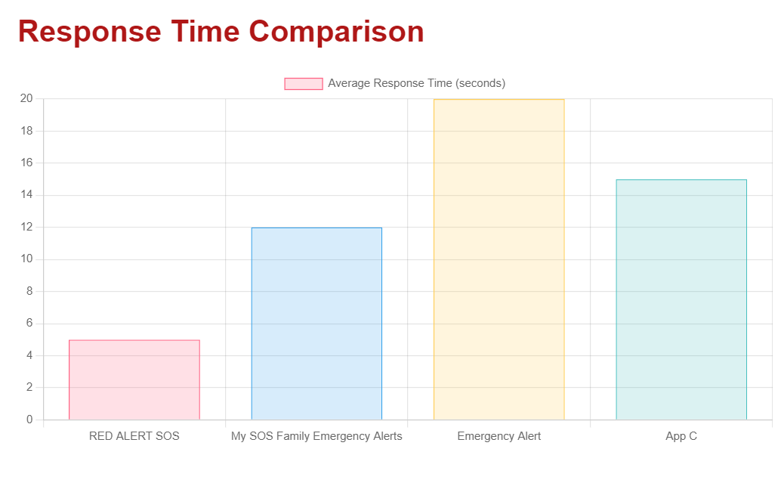

1. **Application Architecture**

The structure of the "Red Alert SOS" software is divided into numerous additives:

* 1. **Frontend**

The front cease is constructed using Flutter, which allows for a steady appearance and feel across both Android and iOS structures. Key monitors consist of:

* + 1. **Entry Screen**

The initial display screen features the app’s brand and a set off to proceed to registration. This display screen uses animations to make the app more engaging and visually appealing.



* + 1. **Registration Screen**

This screen carries person enter fields for the mobile variety and nation. It consists of form validation to ensure users input legitimate records.

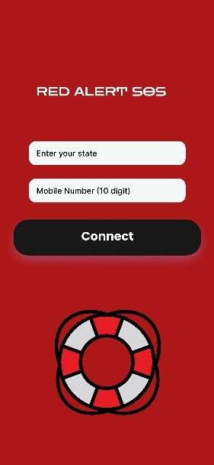

* + 1. **OTP Verification Screen**

This screen is for getting into the acquired OTP to confirm the user. Firebase Authentication handles OTP technology and verification securely.

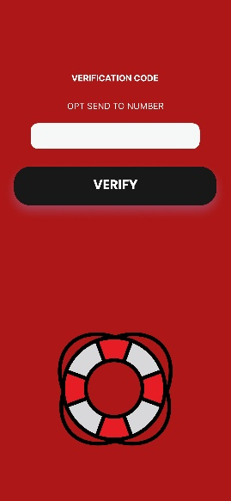

**4.1.4 Profile Screen**

This form lets in customers to go into non-public information and emergency contacts. This statistics is stored securely within the Firebase database and can be up to date by means of the user at any time.

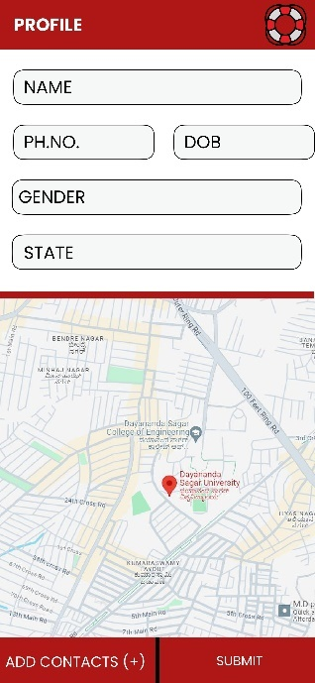

**4.1.5 Home Screen**

The predominant dashboard includes an emergency alert button and a social media feed. The alert button, whilst pressed, sends an emergency message at the side of the person’s real-time vicinity to pre-special contacts.

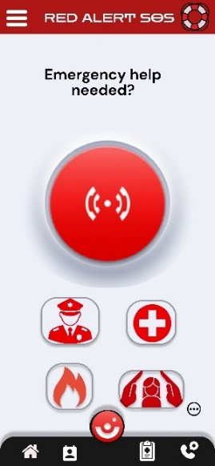 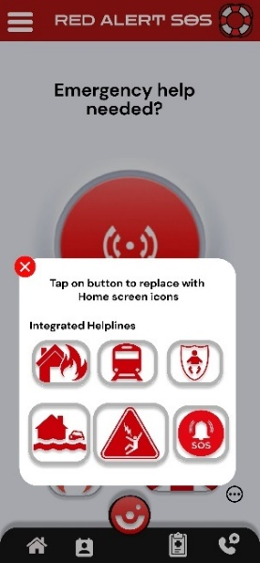

**4.1.6 Social Media Screen**

This platform permits customers to submit and view updates. This characteristic permits users to share real-time facts and updates with their community, fostering a feel of connection and assist. To enhance community help and engagement, the app consists of social media features:

* Emergency Posts: Users can put up updates approximately their scenario, which might be visible to their contacts and volunteers inside the app.
* Community Feed: A feed just like Instagram lets in customers to share safety guidelines, reviews, and guide messages, fostering a feel of community.

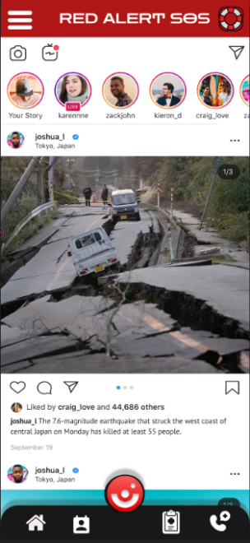

**4.1.7 Volunteer Registration**

RED ALERT SOS additionally consists of a gadget for volunteers to sign in and provide their help at some point of emergencies. Volunteers can:

* Receive Alerts: Registered volunteers inside a positive radius acquire indicators and can provide instant help.
* Profile Management: Volunteers can control their availability and areas of understanding (e.g., clinical aid, firefighting).

**4.2 Backend**

The backend is applied the usage of Firebase, providing real-time database competencies, authentication offerings, and steady storage. The backend handles person authentication, OTP verification, and information control. Firebase's actual-time database guarantees that any updates made by way of customers are at once pondered throughout all devices.

**4.3 APIs**

APIs are integrated for place monitoring, permitting the app to send the person’s actual-time region to emergency contacts and government. The Geolocator package deal in Flutter is used to acquire unique vicinity statistics, that's then shared with emergency contacts.

1. **Development Challenges and Solutions**

**5.1 Cross-Platform Compatibility**

Ensuring regular overall performance across both Android and iOS gadgets turned into a primary undertaking. Flutter's complete widget library and hot reload function significantly mitigated this problem, taking into consideration speedy prototyping and trying out.

**5.2 Secure OTP Verification**

Implementing stable OTP verification turned into important for person authentication. Firebase Authentication changed into used to generate and verify OTPs, ensuring a sturdy and secure verification method. The integration of Firebase also provided extra security capabilities which include two-element authentication and account healing options.

**5.3 Real-Time Location Tracking**

Accurate and real-time vicinity tracking is important for the app's effectiveness. The Geolocator package deal in Flutter become utilized to acquire unique location information, that's then shared with emergency contacts. To ensure privateness, customers are knowledgeable approximately region monitoring and may enable or disable this selection as wished.

**5.4 User Interface Design**

Designing an intuitive and available consumer interface was paramount. The use of Google Fonts and custom subject matters ensured a visually appealing and consumer-friendly revel in. Additionally, the app turned into designed to be responsive, providing a continuing enjoy on each smartphones and capsules.

**5.5 Handling Large User Data**

As the app scales, coping with and retrieving consumer facts successfully turns into a project. Firebase's actual-time database was chosen for its ability to deal with big volumes of statistics and provide actual-time synchronization. Indexing and question optimization strategies have been implemented to make sure rapid records retrieval.

**5.6 Ensuring App Security**

Security is a important element of any emergency alert gadget. Various security measures had been implemented, along with encrypted records storage, steady communique channels, and sturdy authentication mechanisms. Regular protection audits and updates make sure that the app stays secure towards capacity threats.

**6. Results and Discussion**

The "Red Alert SOS" application correctly integrates crucial capabilities required for an powerful emergency alert gadget. User trying out indicated high pleasure costs with the app’s ease of use, performance, and reliability. The social media function enhances person engagement, making an allowance for network-driven updates and assist throughout emergencies.

**6.1 User Testing and Feedback**

User trying out turned into carried out with a diverse organization of participants to gather remarks on the app's functionality and usability. Participants liked the intuitive interface, actual-time vicinity monitoring, and the capacity to proportion updates with their community. Constructive comments was used to make similarly enhancements, which include enhancing the alert button's visibility and optimizing the app's performance.

**6.2 Performance Metrics**

The app's overall performance become evaluated based totally on several metrics, inclusive of response time, statistics synchronization velocity, and battery utilization. The consequences confirmed that the app performs correctly underneath various conditions, with minimal effect on battery life and rapid data synchronization.

**6.3 Impact on Emergency Response**

The implementation of the "Red Alert SOS" utility has the capability to significantly enhance emergency reaction times and person safety. By imparting real-time area records and instantaneous alerts, the app enables authorities and emergency contacts to respond extra quickly and correctly. The social media feature additionally facilitates in disseminating vital information rapidly, fostering a sense of network assist at some point of emergencies.

**7.Conclusion**

The improvement of the "Red Alert SOS" software demonstrates the capacity of the use of Flutter to create a strong and consumer-pleasant emergency alert system. The app’s comprehensive functions, coupled with a continuing user experience, make it a valuable tool for reinforcing public protection. Future work will recognition on integrating superior functions which includes machine studying-based totally alert prediction and multi-language aid to cater to a broader audience.

**8. Future Enhancements**

Future enhancements to the "Red Alert SOS" software will attention on leveraging superior technology to offer even extra capability and person engagement. Potential areas for improvement consist of:

**8.1 Machine Learning Integration**

Integrating machine getting to know algorithms to are expecting ability emergencies based totally on consumer behaviour and environmental elements. This may want to assist in imparting pre-emptive alerts and recommendations to users.

**8.2 Multi-Language Support**

Expanding the app's accessibility with the aid of adding assist for a couple of languages. This will ensure that customers from different linguistic backgrounds can use the app correctly.

**8.3 Enhanced Social Features**

Adding greater social functions, inclusive of group alerts, network boards, and actual-time chat, to foster extra user engagement and aid.

**8.4 Offline Functionality**

Implementing offline functionality to make sure that the app can still be used successfully in regions with restrained or no internet connectivity. This ought to consist ofCapabilities along with offline location tracking and stored emergency contacts.

**8.5 Integration with Wearable Devices**

Exploring the integration of the app with wearable gadgets, such as smartwatches and health trackers, to provide extra approaches for customers to send alerts and song their vicinity.

**References**

1.Google Flutter. (n.D.). Flutter - Beautiful local apps in document time. Retrieved from Flutter

2.Firebase. (n.D.). Firebase Authentication. Retrieved from Firebase

3.Geolocator. (n.D.). Geolocator plugin for Flutter. Retrieved from Geolocator

4.Life360. (n.D.). Life360 - The New Family Circle. Retrieved from Life360

five.MySOS. (n.D.). MySOS - Safety and emergency app. Retrieved from MySOS

6.Michał Kubalczyk for Netguru Callert - Emergency name

7.Huang, Y.,