## STUDY ON ADOPTION OF EFFICIENT CONSTRUCTION MANAGEMENT TECHNIQUES AND TOOLS

**Debasish Mohapatra¹**

** *1M.Tech. Scholar, School of Civil Engineering, Faculty of Engineering and Technology*

*Madhyanchal Professional University Bhopal, M.P*\*\*

**Dr. Ashish Kant Ahirwar²**

**\*\*** *2Assistant Professor, School of Civil Engineering, Faculty of Engineering and Technology*

*Madhyanchal Professional University Bhopal, M.P* **\*\***

**Abstract**

In contemporary construction practices, the adoption of efficient construction management techniques and tools has become imperative, particularly with the escalation of project scales. The complexity inherent in large-scale projects presents a significant challenge to the industry, as the multitude of tasks, parameters, and constraints amplifies interactions, thereby heightening complexity. While the quest for techniques and tools to adeptly navigate this complexity remains ongoing, Building Information Modeling (BIM) has emerged as a notable approach that substantially enhances the management of complexity.

BIM facilitates the creation of a 3D digital representation of buildings or structures. Beyond capturing geometric data, BIM stores crucial semantic data pertaining to the project, including element functions, material properties, construction specifics, and schedules. The objective is to maintain a unified model accessible to all stakeholders across all project phases.

This study delves into an analysis of the primary challenges encountered in current project management practices and discusses the contributions of BIM-based project management in addressing these challenges. The thesis explores the application of BIM methodologies in project management and the process of information gathering for constructing a BIM model. Additionally, it examines the benefits of BIM-based scheduling (4D), cost estimation (5D), sustainability considerations (6D), facility management (7D), and structural analysis within the realm of project management. A case study is presented to corroborate the utilization of computer-aided programs for BIM during the construction phase.

.

**Keywords:** BIM-based scheduling (4D), cost estimation (5D), sustainability considerations (6D), facility management (7D)

**Introduction**

Building Information Modeling (BIM) indeed revolutionizes the construction industry by offering a digital approach to planning, designing, constructing, operating, and maintaining various types of infrastructure. The following points highlight the essential aspects and applications of BIM. BIM's comprehensive approach to managing information throughout the lifecycle of a built asset makes it an indispensable tool in modern construction and infrastructure projects. BIM supports the entire lifecycle of a building or infrastructure, from initial design to demolition or repurposing. It ensures that accurate and up-to-date information is available at every stage, facilitating informed decision-making. BIM aids in designing and constructing sustainable buildings by enabling energy analysis and optimization. It helps in achieving sustainability goals and certifications such as LEED and BREEAM. Detailed models and simulations reduce the risk of errors and discrepancies, improving the overall quality of the project. BIM streamlines workflows, making the construction process more efficient and cost-effective. By providing a shared digital environment, BIM enhances collaboration among all project participants. It enables real-time updates and seamless communication, leading to better coordination.

**LITERATURE REVIEW**

The team of Project Designers typically comprises architects, civil engineers, mechanical engineers, and electrical engineers. Their primary responsibility is to analyze the project's structure and develop alternative designs that meet the owner's requirements. BIM technology proves invaluable for Project Designers across various stages of the project, including schematic design, detailed design, and construction. The advantages of BIM for project designers can be succinctly summarized as follows (Azhar, Khalfan, and Maqsood, 2012)

* Enhanced design quality and coordination
* Facilitation of project visualization and simulation
* Access to detailed project information provided by owners
* Improved compliance through clash detection capabilities
* Simplified creation of drawings, elevations, and schedules
* Integration of sustainability analysis into the design process
* Facilitation of building performance analysis

These benefits highlight how BIM technology empowers project designers to optimize their workflows, improve collaboration, and deliver superior design outcomes that align with the owner's objectives.

**R. Grys et al (2023 )** Integrating project schedules with BIM elements enhances the ability to produce visual representations that align with construction goals. This integration facilitates the interpretation and production of construction drawings using computer-aided drafting (CAD) and BIM software. In the United States, Integrated Project Delivery (IPD) has become the preferred approach for major BIM-related projects, reflecting the growing emphasis on collaborative and efficient project execution. The government actively promotes and supports the application of BIM to increase productivity, conserve resources, and improve the quality of construction activities. By doing so, it aims to enhance project operation management and overall efficiency in the construction industry. A BIM model offers significant potential in streamlining data collection and storage for projects, serving as a comprehensive repository for all project-related data. Utilizing BIM in facility management leverages this data throughout the entire lifecycle of a facility, ensuring a safe, healthy, efficient, and productive work environment. The overarching goal is to maximize the value of facility data to support effective management and maintenance practices.

**METHODOLOGY**

The implementation of Building Information Modeling (BIM) presents several notable advantages, yet it is not without its limitations and risks, many of which are influenced by national contexts, business factors, and human considerations.

Clash detection is a crucial process aimed at identifying conflicts before the construction phase begins. Traditional workflows based on 2D drawings often result in issues only surfacing at the construction site. However, with BIM-based clash detection, these conflicts can be addressed and resolved prior to construction commencement, thereby preventing additional costs and time delays (Bagdonas, 2014). BIM-related software is equipped with clash detection tools, enabling the identification of intersections between various elements within the model (Aziz, Nawawi, and Ariff, 2016). Clash detection can encompass different project disciplines, allowing for the identification of conflicts between structural systems and plumbing, for instance, thus mitigating clashes between foundations and pipes (Bagdonas, 2014). Table 2.12 provides a summary of the types of clashes that can be automatically detected through clash detection.

**Table 1. Types of clashes**

|  |  |  |
| --- | --- | --- |
| **Type of clashes** | **Function** | **Example** |
| Hard Clash / Soft Clash | Detection of conflicts between two  elements which are in the same position | If a concrete column overlaps above a concrete slab. |
| Clearance Clash | Clash for inadequate space | If a ventilation pipe cannot  install in the ceiling. |
| Duplicates | The duplication of elements | If a floor is copied  inattentively. |

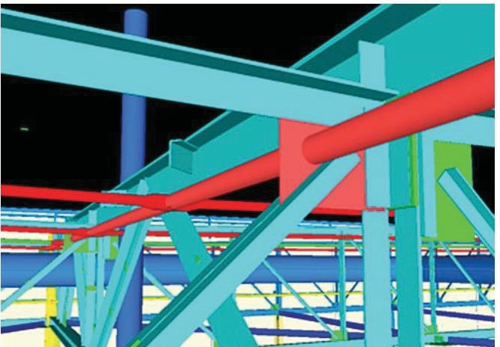

**Figure 1. Clash detection**

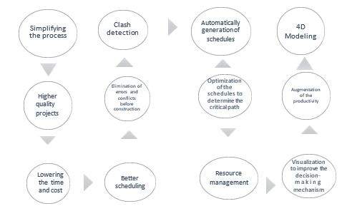

**Figure 2 The advantages of 4D modeling**

In summary, the distinction of 4D modeling from the 3D model lies in its ability to link time-based activity sequences for generating project schedules and visualizing the construction project. A competent BIM Manager is responsible for regularly updating 4D schedules with each fabrication progress to generate progress reports (Aram, Eastman, and Sacks, 2013).

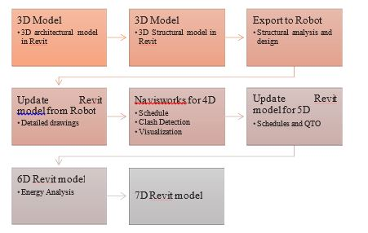

**Figure 3 Case study flow diagram**

**RESULT AND DISCUSSION**

This study presented a BIM-based concept for construction projects to investigate how BIM processes impact project management. For this reason, a three storey building was selected as a case study. The case study demonstrates how BIM allows effective sharing of a 3D model of a project that includes necessary semantic data for all processes that were investigated within the scope of the study. However, it should be noted that generation of the model with all the required information presents challenges for inexperienced users. It can be clearly said that once the model is complete with all details about the model, creating Floor Plans; Ceiling Plans, 3D Views, Perspectives, Elevations, Sections, Renders, Schedules and Quantities can be generated automatically. Furthermore, the ability to detect clashes, errors or defects of the project in the early design stages, before construction, helps managers avoid unnecessary costs.

The aim of this case study was to investigate how project management thinking and BIM could be integrated within a database and the answers were explored during the previous chapters based on literature studies and case study. This project identified different BIM activities as 3D modeling, clash detection, 4D modeling; scheduling, visualization, simulation, 5D modeling; quantity take-offs, cost estimation, 6D modeling, 7D modeling and structural analysis based on construction management. The better way to cope with these uncertainties and circumstances is to prefer BIM models during the construction phase.

BIM facilitates the design and implementation of construction projects and provides a collaborative platform. Several researches show that BIM - based models are time - saving and cost - effective when compared with conventional construction methods. This study provides an insight about how BIM technology can be and will be employed effectively with using different softwares. The benefits of the BIM technology begin at the conceptual design stage and cover the entire lifecycle.

The state-of-the-art of Chapter 2 outlined a literature review about project management requirements and BIM applications. PM methodologies underline the processes that can be followed to achieve the success. By adopting BIM into these methodologies, it emphasis an interaction and make powerful the project manager as knowledge and domination of project. Chapter 3 demonstrated the capability of BIM tools and the validity of the integration between project management functions and BIM according to a case study. To conclude this study, a discussion was conducted to verify if BIM authoring, review and spreadsheet programs were met the requirements of project management. These selected programs demonstrated modeling, clash detection, scheduling, visualization, simulation, estimation, sustainability, management with regard to several analyses. As a result of these functions, some of these corresponded completely and some were not fulfilled exactly. Table 4.1shows the capabilities of BIM to handle with project management knowledge areas.

It can be clearly emphasized that almost all the project management stages and knowledge areas are theoretically and experimentally are totally supported by BIM technology. The "YES" column classification demonstrates the support of the BIM and the "NO" column shows that BIM is not sufficient. Contrary to the traditional project management methods, BIM-based project management facilitates the changes of the project (Velasco 2013).

On the other hand, BIM software applications do not help sufficiently to select qualified project stakeholder or to make risk analysis and assign the resource allocations. And also, it should be noted that generation of the model with all the required information presents challenges for inexperienced users for education and training to learn the BIM software. Even if adopting BIM to a project will increase the cost in the first instance due to the BIM software, education and training costs. But this increase will remain insignificant against the benefits of BIM.

In essence, this case study demonstrated the workflow to adopt BIM technology into the construction projects. Briefly, the underlying theory of BIM is to store and share information throughout the building life cycle and to improve of all the communication, especially communication with owner and work flow of the construction system by combining and tracking in a simple way.

**CONCLUSION**

It is evident that BIM holds tremendous potential in streamlining construction processes by addressing key project constraints such as time and cost. By facilitating the storage and sharing of information among project stakeholders, BIM creates a collaborative environment aimed at enhancing project management practices. This thesis sought to elucidate how BIM models can be seamlessly integrated into project management methodologies through the utilization of BIM authoring, project management, and structural software.

The findings of this study underscore the utility of BIM authoring systems in meeting the requirements of BIM-based project management, allowing various project stakeholders to coordinate information effectively. Through the integration of different 3D models, material quantity takeoffs with cost estimation, sustainability analysis, and structural assessments, virtual visual models of construction projects in progress can be generated. Moreover, the proliferation of smartphone and tablet technology further enhances communication and collaboration among stakeholders.

In conclusion, BIM represents an innovative approach that is rapidly evolving. Its adoption is poised to bring about significant changes in the construction industry. By embracing nD modeling, including 4D, 5D, 6D, and 7D modeling, BIM offers improved management across various facets of construction projects, ranging from schedule and cost management to sustainability and facility management. Ultimately, the implementation of BIM models is expected to elevate the quality of construction projects by minimizing risks and errors.

The construction industry is continuously propelled forward by technological advancements, and BIM stands out as not just a software innovation, but also as a paradigm shift in thinking and knowledge integration across multiple project management domains. As the momentum behind BIM adoption continues to build, it is clear that its influence will only grow stronger in shaping the future

**REFERENCES**

1. Abanda, F. H., B. Kamsu-Foguem, and J. H. M. Tah. 2017. "BIM – New rules of measurement ontology for construction cost estimation." Engineering Science and Technology, an International Journal 20 (2):443-459. doi: 10.1016/j.jestch.2017.01.007.
2. Abdirad, Hamid. 2015. "Advancing in building information modeling (BIM) contracting-Trends in the AEC/FM industry." AEI 2015: Birth and Life of the Integrated Building, Milwaukee, Wisconsin, March 24-27, 2015.
3. Bagdonas, Petras 2014. "How does BIM influence CDM work flow?" Dissertation Dissertation, Bachelor of Architecture Technology and Construction Management, VIA University College.
4. Bhusar, Arpit A. , and Ashish R. Akhare. 2014. "Application of BIM in Structural Engineering." SSRG International Journal of Civil Engineering 1 (5):12-20.
5. Candelario-Garrido, Alonso, Justo García-Sanz-Calcedo, and Antonio Manuel Reyes Rodríguez. 2017. "A quantitative analysis on the feasibility of 4D Planning Graphic Systems versus Conventional Systems in building projects." Sustainable Cities and Society 35:378-384. doi: 10.1016/j.scs.2017.08.024.
6. Eastman, Chuck, Paul Teicholz, Rafael Sacks, and Kathleen Liston. 2008. BIM Handbook: A Guide to Building Information Modeling for Owners, Managers, Designers, Engineers and Contractors. 1st ed. New Jersey: John Wiley & Sons Inc.
7. Major, Maciej , Izabela Minda, Krzysztof Kuliński, and Izabela Major. 2017. "Comparative numerical analysis of obtained stress and displacement results fromFEM programs - robot structural analysis and Adina in example of a steel footbridge subjected to the dead load." Transactions of the VŠB – Technical University of Ostrava Civil Engineering Series 17 (2):51-58.
8. Rumane, Abdul Razzak 2017. Handbook of Construction Management: Scope, Schedule, and Cost Control, Industrial innovation series: CRC Press Taylor&Francis Group Boca Raton, FL.
9. Sciences, National Institute of Building. 2007. United States National Building Information Modeling Standard. In Version 1 - Part 1 : Overview, Principles and Methodologies: National Institute of Building Sciences.