**ANALYSING ARTIFICIAL INTELLIGENCE'S EFFECT ON CONSUMER AWARENESS AND ONLINE SHOPPING INTENTION**

**ABSTRACT**

In this study, a quantitative survey was employed to analyse the effect of Artificial Intelligence (AI) technologies on consumer reactions in online shopping. A structured questionnaire was used to gather data from 500 respondents.

The dataset collected was analysed using Python’s Jupyter Notebook and its libraries. This aided the analysis and visualization of the results. The purpose of this analysis was to assess the implication of AI-driven recommendation systems, AI-driven chatbots, and personalized marketing on different aspects of consumer behaviour.

Results showed a significant positive effect of AI technologies on consumer awareness, purchase intention, and customer satisfaction in an online shopping environment. The study revealed that individuals with over ten years of shopping experience are the most users of this technology. The gender distribution charts revealed that females tend to use technology more than males. The study highlights the importance of these AI tools in influencing buying decisions and personalized marketing through consumer awareness

Keywords: AI technologies, Consumer Awareness, Artificial Intelligence

**1.0 INTRODUCTION**

The introduction of Artificial Intelligence (AI) has dramatically transformed online shopping by reshaping customer interactions with digital retail environments. AI technologies such as recommendation systems, personalized marketing, and chatbots have altered how customers engage with online stores, enhancing their overall shopping experience (Du and Xie, 2021). AI-driven recommendation systems leverage consumer data to provide tailored product suggestions, increasing the likelihood of purchases by addressing individual preferences (Ahn and Park, 2022). Similarly, chatbots offer real-time assistance and streamline online interactions, improving purchase intent by making the shopping process more seamless. The study aims to use data analysis to evaluate the impact of AI-powered systems on consumer awareness in online shopping.

**2.0 LITERATURE REVIEW**

Artificial intelligence (AI) aims to replicate and enhance human intelligence, significantly transforming e-commerce by changing customer engagement dynamics (Bawack et al., 2022). AI technologies, including recommendation systems and chatbots, personalize the shopping experience and improve product discovery and customer support (Ahn & Park, 2022; Adam et al., 2021). These AI-driven tools not only simplify interactions but also influence consumer attitudes and buying intentions through tailored marketing strategies. Consumer awareness is critical in the online buying process, and the implementation of AI has resulted in significant advances in this area. Concerns over client data and its use are developing as AI in marketing continues to advance quickly Hironde (2023). AI has a wide range of legal implications, especially as it may extract data straight from consumers' computers and mobile phones Bianca (2022).

Afroz et al. (2022) discuss how artificial intelligence (AI) focuses on creating intelligent systems capable of performing tasks requiring human-like intelligence, such as learning, reasoning, and self-correction. The study highlights AI's significant role in e-commerce, where machine learning is used to analyze vast data, reduce fraud, streamline processes, and improve customer satisfaction, aiming to identify key AI applications in the field through a survey of research articles. Adam et al. (2020) discuss the growing use of AI-based chatbots in online retail for real-time customer service, highlighting their role in replacing human representatives to prevent fraud, streamline operations, and enhance customer experience. Their study found that while these chatbots offer potential cost and time savings, they often fall short of user expectations, and their effectiveness in gaining user compliance improves significantly with anthropomorphic design cues and consistency, as demonstrated through a randomized online experiment. Beyari and Garamoun (2022) investigated how various AI tools and consideration sets influence online purchasing intentions among Saudi Arabian consumers, focusing on machine learning, purchase duration, social product recommendations, and social media reliance. Using structural equation modelling to analyze data from 148 online survey respondents, their study found a correlation between these AI technologies and customer purchase decisions, demonstrating the impact of consideration sets on end-user purchasing behaviour.

Patnaik et al. (2023) noted that Industry 5.0, which integrates advanced technology with customization, aims to reintroduce a human touch in response to consumer desire for uniqueness. Their study developed a conceptual model and conducted an online survey, finding a positive correlation between personalized product recommendations and user satisfaction, highlighting practical implications for both scholars and retailers. Jangra (2022) highlighted the rapid growth of the e-commerce sector over the past decade and the importance of understanding online customers' preferences and behaviours. AI technology has been integrated by e-commerce companies to track customer choices, tastes, and shopping patterns, enabling businesses to tailor products and services to individual needs and enhance purchasing decisions through personalized recommendations and offers. Aggarwal et al. (2024) discussed how artificial intelligence (AI) is revolutionizing online shopping by providing personalized recommendations based on browsing and purchase histories, enhancing convenience, and ensuring secure transactions through fraud detection. AI also improves customer service with chatbots, streamlines supply chain management, and supports virtual try-on technology, all of which contribute to a more satisfying and efficient online shopping experience.

**3.1 Methodology**

The research strategy and methodologies used to examine the influence of artificial intelligence (AI) on online buying behaviour were outlined in the chapter of this study. The population, sampling strategy, data collection techniques, data analysis, validity, reliability, and ethical considerations were all covered in this chapter to guarantee the validity and morality of the study process.

**Figure 3: Data Analysis Cycle**

3.1 Data Collection

Data was collected through the use of Surveys using Google Forms and questionnaires. This approach facilitated an organized and thorough investigation of the study on online buying behaviour, ensuring effective and methodical data collection. For this study, a convenience sampling strategy was employed to efficiently access a large number of online buyers within time and resource constraints. This method facilitated participant involvement by selecting individuals based on their accessibility. While convenience sampling can introduce bias, the large sample size of 500 respondents helped mitigate this limitation and enhanced the generalizability of the findings.

3..2 Data Pre-Processing

Data was collected via Google Forms and saved in a Google Spreadsheet, which facilitated exporting it in CSV format. The data was then cleaned by removing missing values, duplicates, outliers, and errors, and was accessed using Python for further analysis.

3.3 Data Analysis & Data Visualization

For the data analysis, the needed libraries were imported which includes the dominant ones like Pandas, NumPy, Seaborn, SciPy, and Matplotlib. These libraries were used to analyse the data obtained through the questionnaire. A wide number of analytical methods appropriate for the quantitative data analysis were provided by Python. Python was selected based on its ability to run numerous statistical analyses and produce insights into the correlations of different variables.

3.4 Ethical Consideration

Strict ethical principles were adhered to throughout this research, including obtaining ethical approval from the institutional review board and ensuring informed consent from all participants. The study guaranteed participants' privacy and confidentiality, explained the study's goals and data usage, and complied with data protection regulations to safeguard their rights and welfare.

**4.1 Result and Discussion**

This research highlights the analysis and discussion of how AI impacts consumer awareness and online shopping intentions. Data visualization plays a crucial role in interpreting the collected information, allowing for the identification of patterns, trends, and relationships that reveal the influence of AI. Table 1 shows that the online questionnaire was sent to 500 respondents, all of whom completed it, resulting in a 100% response rate and indicating strong engagement and interest in the study.

|  |  |  |  |  |  |
| --- | --- | --- | --- | --- | --- |
|  | | Frequency | Per cent | Valid Percent | Cumulative Percent |
|  | Returned/Completed | 500 | 100.0 | 100.0 | 100.0 |
| Not Returned/Not Completed | 0 | 0 | 0 |  |
| Total | 500 | 100.0 | 100.0 | 100.0 |

**Table 1: Number of Respondent**

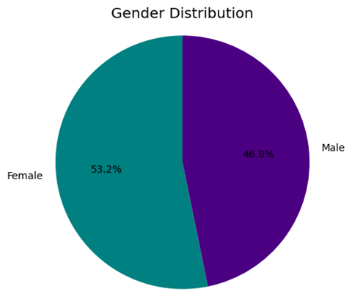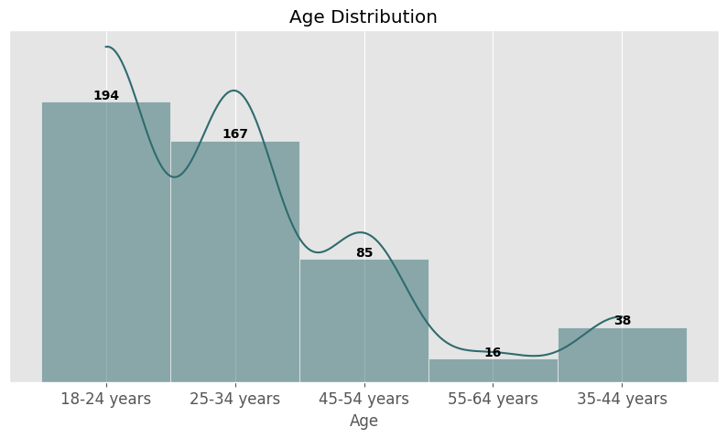

**Figure 1: Age Distribution Chart****Figure 2: Gender Distribution Chart**

Figure 1, the age distribution chart, illustrates the demographic structure of the dataset, highlighting the concentration of younger individuals with the 18–24 age group being the largest at 194 people, followed by 167 in the 25–34 group. The data shows a decrease in older age groups, with only 38 in the 35–44 category and 85 in the 45–54 group, while the smallest group, 55–64, consists of just 16 people. This suggests that marketing and product development should focus on younger demographics while addressing the reasons behind the lower participation of older adults. Figure 2, the gender distribution chart, shows a slight female majority with 53.2% females compared to 46.8% males, indicating nearly equal gender representation.

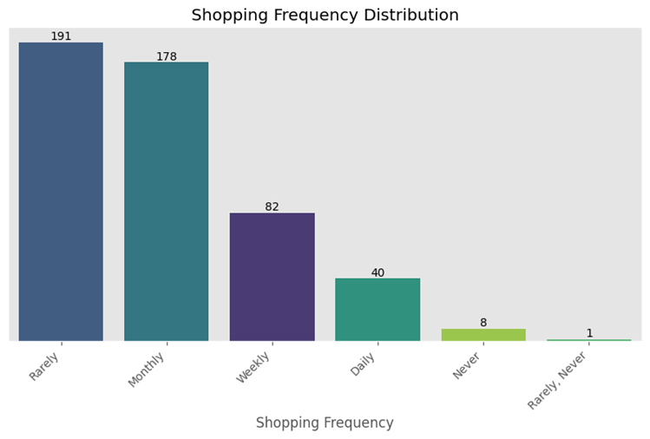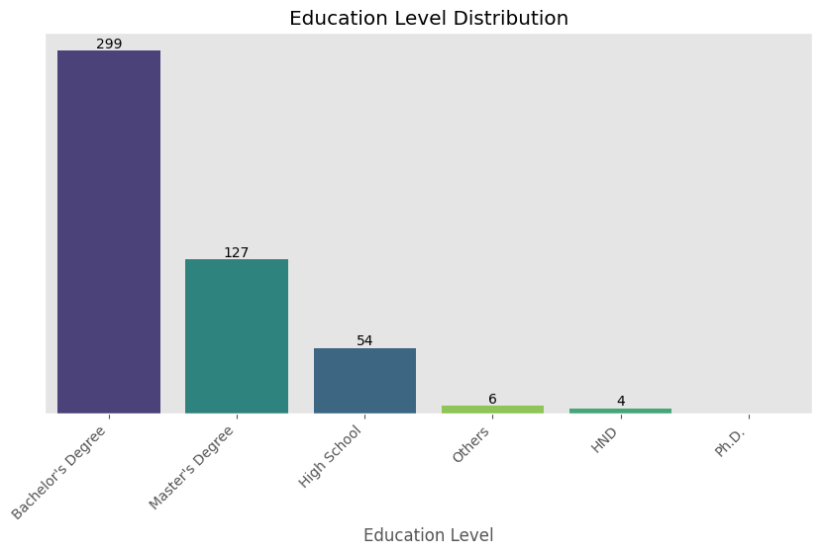**Figure 3: Education Level Distribution Figure 4: Shopping Frequency Distribution**

In Figure 3, the education level distribution chart shows that the majority of people in the dataset are bachelor's degree holders, with a count of 299, indicating that most members have undergraduate degrees, significantly higher than any other educational attainment level. The next largest group comprises 127 individuals with a Master's degree, followed by 54 individuals with a high school diploma, with "Others," "HND," and "PhD" categories having the lowest tallies with six, four, and two individuals respectively.

In Figure 4, the chart shows the distribution of respondents' shopping frequency, with 191 participants indicating they shop "Rarely," making it the most common frequency, closely followed by 178 respondents who shop "Monthly," suggesting these two groups represent a significant portion of the population's purchasing habits. Additionally, 82 respondents shop once a week, indicating a smaller but notable segment that shops more frequently, possibly to meet specific needs or requirements.

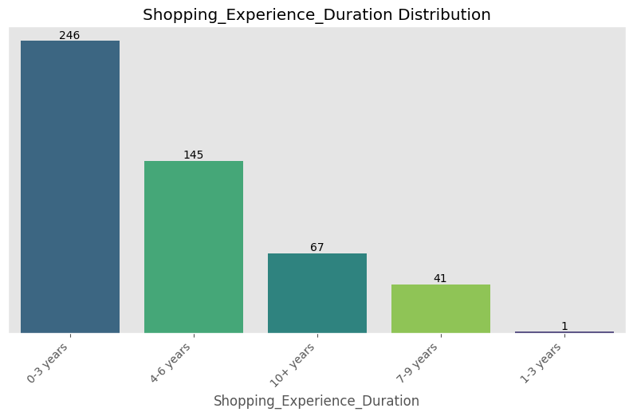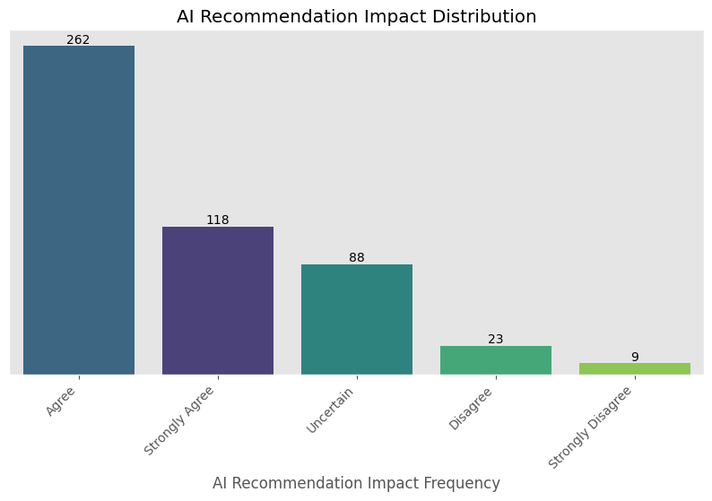

**Figure 5: Shopping Experience Figure 6: AI Recommendation Frequency**

Figure 5, the chart shows the distribution of respondents' shopping experience durations, with 246 respondents having zero to three (0–3) years of experience, indicating a significant number of new or less experienced shoppers. The second-largest category consists of those with four to six (4–6) years of experience, with 145 respondents. Only 67 respondents have more than ten years of shopping experience, highlighting a smaller, seasoned cohort with extensive expertise.

In Figure 6, the "AI Recommendation Impact Distribution" chart displays the frequency of survey responses regarding the impact of AI recommendations, categorized into "Agree," "Strongly Agree," "Uncertain," "Disagree," and "Strongly Disagree." The majority of respondents, 262, "Agree" with the positive influence of AI recommendations, followed by 118 who "Strongly Agree," reflecting a generally favourable view. However, 88 respondents are "Uncertain," indicating a need for further education and information, while the smallest groups, "Disagree" (23) and "Strongly Disagree" (9), suggest minimal resistance to AI recommendations.

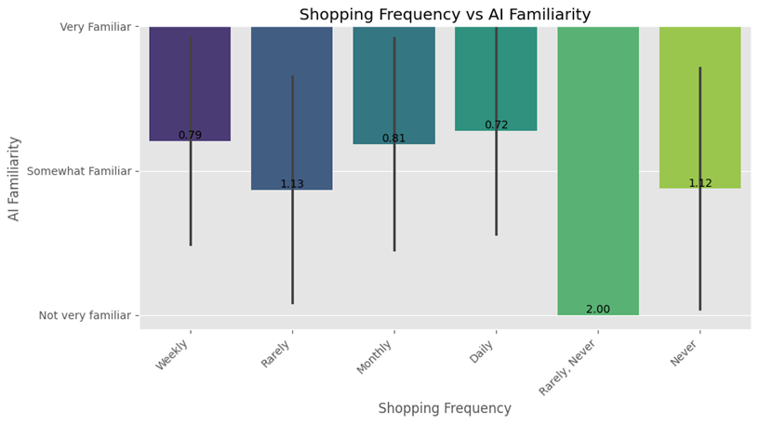

**Figure 7: Shopping Frequency Vs AI Familiarity Chart**

In Figure 7, the "Shopping Frequency vs. AI Familiarity" chart depicts the relationship between shopping frequency and knowledge of artificial intelligence (AI). The vertical axis categorizes AI familiarity as "Very Familiar," "Somewhat Familiar," and "Not very familiar," while the horizontal axis shows shopping frequency categories such as "Weekly," "Monthly," "Daily," "Rarely/Never," and "Never." The chart reveals that frequent shoppers, particularly daily and weekly, tend to have a higher familiarity with AI, while those who shop rarely or never are generally less knowledgeable about AI.

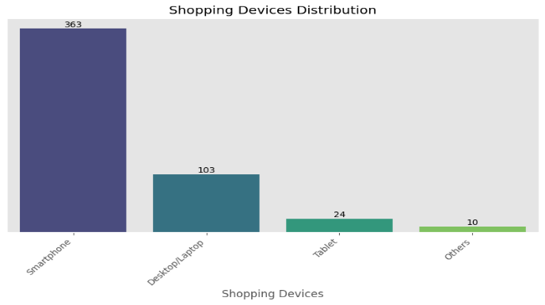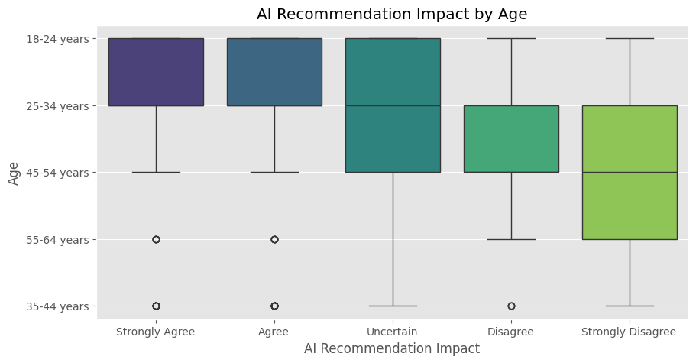

**Figure8: AI Recommendation Impact by Age** **Figure9 : Shopping Devices Distribution**

In **Figure 8** above The "AI Recommendation Impact by Age" figure shows varying perceptions of AI suggestions across different age groups. The age groups included are 18-24 and 55-64 years old, with responses categorized into Agree, Strongly Disagree, Agree, Uncertain, and Disagree. The 35-44 age range exhibits the highest agreement with AI advice, indicating greater openness among middle-aged individuals. Conversely, the 55-64 age group shows more disagreement and uncertainty, suggesting older individuals are less trusting of AI recommendations.

In Figure 9, the "Shopping Devices Distribution" chart shows the usage frequency of various devices for shopping, including smartphones, tablets, desktops/laptops, and other categories. With a frequency of 363, the data reveals that smartphones are the most popular shopping device, highlighting the convenience and accessibility of mobile shopping. Desktops and laptops follow with a frequency of 103, indicating that while mobile shopping is prevalent, a significant number of users still prefer traditional computer equipment

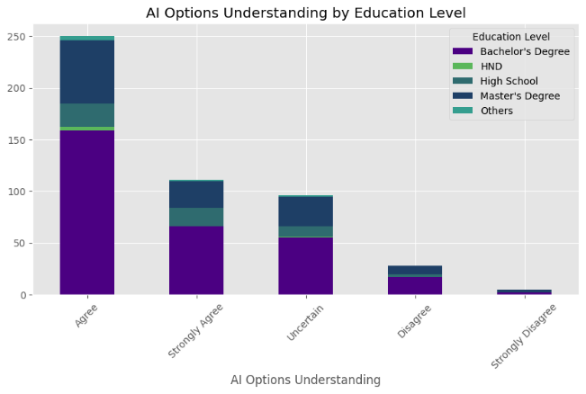

**Figure 10: AI options understanding by Education Level Chart**

Figure 10, "AI Options Understanding by Education Level," shows how respondents perceive their

understanding of AI across various education levels. Doctorate holders predominantly fall into the "Agree" category, indicating confidence in their AI comprehension, while those with master’s degrees also largely fall into "Agree" and "Strongly Agree," though some uncertainty remains. Conversely, respondents with bachelor's degrees show a mix of "Agree" and "Uncertain," and those with HND or high school education mostly fall into "Uncertain," reflecting lower confidence in their understanding of AI.

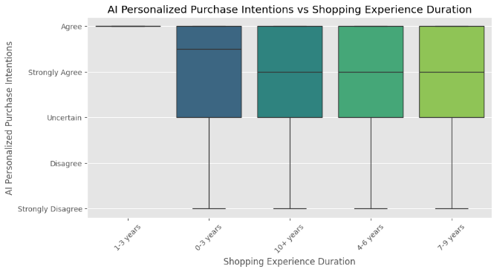

**Figure 11: AI Personalized Intentions vs Shopping Experience**

The chart "AI Personalized Purchase Intentions vs. Shopping Experience Duration" compares agreement levels with AI personalization across different shopping experience durations: 3–6 years, 6–10 years, and 10 or more years. The data shows that individuals with over ten years of shopping experience are the most accepting of AI personalization. In contrast, those with only 1–3 years of shopping experience display more uncertainty and disagreement, indicating lower confidence in or familiarity with AI customization.

Top of Form

Bottom of Form

Overall, the graph shows a tendency where less experienced shoppers are more apprehensive and longer shopping experiences are correlated with increased acceptance of AI-personalized buy intents.

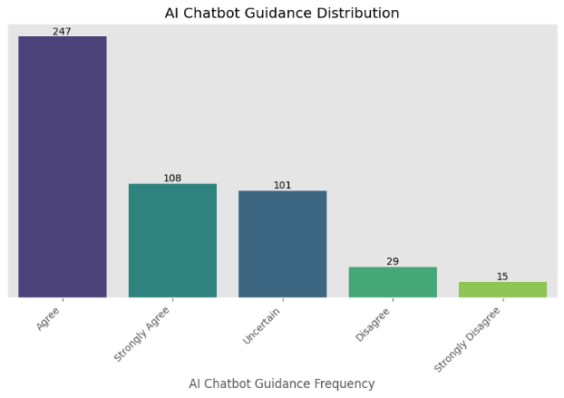

**Figure 11: AI Chatbot Guidance Distribution Chart**

The chart "AI Chatbot Guidance Distribution" shows that 247 respondents (the majority) "Agree" with AI chatbot advice, while 108 "Strongly Agree," reflecting a generally positive opinion. 101 respondents were "Uncertain," suggesting some lack of knowledge or confidence in AI chatbots. The smallest groups, "Disagree" and "Strongly Disagree," with 29 and 15 respondents respectively, indicate minimal resistance to the advice provided.Top of FormBottom of Form Analysis indicates that respondents had a generally positive opinion of AI chatbot advice

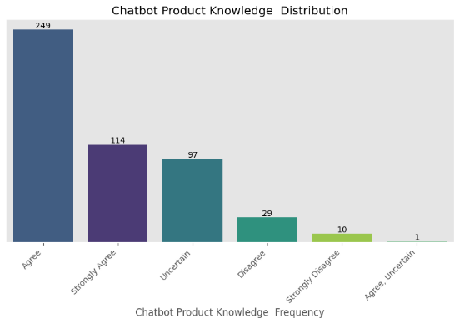

**Figure 12: Chatbot Product Knowledge Distribution**

Top of Form

Bottom of Form

The "Chatbot Product Knowledge Distribution" chart displays survey responses on chatbot product expertise across several categories: "Agree," "Strongly Agree," "Uncertain," "Disagree," "Strongly Disagree," and "Agree/Uncertain." The majority, 249 respondents, agreed with the chatbot's product expertise, indicating a generally positive perception. This positive sentiment is reinforced by 114 respondents who strongly agreed. However, 97 respondents were uncertain, suggesting some ambiguity or lack of sufficient knowledge to form a firm opinion.

**5.0 Conclusion**

This research highlights the profound impact of artificial intelligence (AI) on consumer awareness and intentions during online shopping. Using a structured quantitative methodology, data was gathered from 500 participants via an online survey. This approach allowed for a comprehensive analysis of AI's role in boosting consumer engagement. Insights revealed through Python’s Jupyter Notebook showed that AI tools, such as chatbots and personalized recommendation systems, significantly enhance consumer awareness. AI-driven recommendation systems provide tailored product details, improving the shopping experience and increasing purchase likelihood. Chatbots facilitate seamless customer interactions, offering real-time assistance and enhancing satisfaction. The study also emphasizes the effectiveness of AI in delivering personalized marketing messages, which resonate more with consumers and influence their purchase decisions. The findings suggest that e-commerce businesses should continuously advance their AI strategies to further elevate consumer satisfaction and engagement

# 

**REFERENCES**

1. Du, S., & Xie, C. 2021. Paradoxes of artificial intelligence in consumer markets: Ethical challenges and opportunities. *Journal of Business Research*, 129, 961-974.
2. Ahn, H., & Park, E. 2022. For sustainable development in the transportation sector: Determinants of acceptance of sustainable transportation using the innovation diffusion theory and technology acceptance model. *Sustainable Development (Bradford, West Yorkshire, England)*, 30(5), 1169-1183.
3. Bawack, R. E. et al. 2022 Artificial intelligence in E-Commerce: a bibliometric study and literature review, Electronic Markets, 32(1), pp. 297–338.
4. 2, Adam, M., Wessel, M. and Benlian, A. 2021. AI-based chatbots in customer service and their effects on user compliance, Electronic Markets, 31(2), pp. 427–445.
5. Hironde, J.-B. (2023). AI's Impact on The Future of Consumer Behaviour and Expectations. Forbes.
6. Bianca Kronemann, H. K. 2022. How AI encourages consumers to share their secrets? The role of anthropomorphism, personalisation, and privacy concerns and avenues for future research. Emerald
7. Afroz Lari, H., Vaishnava, K. and K S, M. (2022). Artificial Intelligence in E-commerce: Applications, Implications and Challenges, Asian Journal of Management, pp. 235–244.
8. Beyari, H. and Garamoun, H. 2022 *The Effect of Artificial Intelligence on End-User Online Purchasing Decisions: Toward an Integrated Conceptual Framework*, *Sustainability*.
9. Patnaik, P., Nayak, P. and Misra, S. 2023. Personalized Product Recommendation and User Satisfaction, Advanced Research and Real-World Applications of Industry 5.0, pp. 102–128.
10. Jangra, G. and Jangra, M. (2022) Role of Artificial Intelligence in Online Shopping and its Impact on Consumer purchasing behaviour and Decision, 2022 Second International Conference on Computer Science, Engineering and Applications (ICCSEA).
11. Aggarwal, D., Sharma, D. and Saxena, A. B. 2024. Enhancing the Online Shopping Experience of Consumers through Artificial Intelligence, Feb-Mar 2024, (42), pp. 1–5.