"Optimizing Business Efficiency: The Impact of Fleet Management Software"

Vaishnavi P1 V.Srinivasan2  Vikas K3

Department of MCA

Dayananda Sagar College of Engineering

Bangalore, India

Email for correspondence: vaishnavi.blr07@gmail.com

ABSTRACT

Operational effectiveness is critical to preserving a competitive edge in the modern company environment. An essential tool for streamlining the operations of businesses that provide vehicle-dependent services is fleet management software or FMS. This study examines how FMS may improve corporate efficiency by lowering operating expenses, raising productivity, and boosting fleet performance. It also explores the revolutionary influence of FMS on business efficiency. FMS gives enterprises a thorough understanding of vehicle usage, maintenance schedules, and driver behavior by utilizing real-time data analytics, GPS monitoring, and automated reporting. Using case studies and actual data from a variety of businesses, this paper assesses the advantages and difficulties related to the deployment of fleet management software. This paper explores the features of Fleet Management Systems (FMS), including GPS tracking, real-time data analytics, and automated reporting. These features together offer deep insights into driver behavior, maintenance schedules, and vehicle utilization. Through an examination of case studies and actual data from different industries, the study draws attention to the significant advantages and difficulties that come with implementing FMS. The present study emphasizes the significance of using sophisticated fleet management technologies to enhance operational effectiveness and sustain a competitive edge in the ever-changing corporate landscape.

**Keywords:**

Fleet Management Software (FMS), Operational Efficiency, Vehicle-Dependent Services, Real-Time Data Analytics, GPS Tracking., Automated Reporting, Cost Reduction, Productivity Enhancement, Strategic Decision-Making, and Long-Term Sustainability.

**1. Introduction**

In the ever-changing company landscape of today, operational effectiveness plays a crucial role in determining both success and longevity. Enterprises that manage fleets of vehicles encounter distinct obstacles in terms of streamlining operations, guaranteeing punctual delivery, controlling expenses, and upholding regulatory compliance. Fleet management software (FMS) has become a transformative tool as a reaction to these difficulties, transforming the way businesses supervise and streamline their fleet operations. Fleet Management Systems (FMS) are technology products intended to improve fleet management procedures. Some key features are real-time data analytics, GPS tracking, automatic reporting, maintenance scheduling, and driver performance monitoring. Thanks to these features, businesses can now take advantage of meaningful data on fleet utilization, fuel consumption, route efficiency, and overall performance metrics. Organizations may make well-informed decisions, proactively address operational inefficiencies, and eventually achieve notable increases in productivity and cost-effectiveness by utilizing sophisticated FMS technologies. The incorporation of GPS technology into fleet operations, which made real-time vehicle monitoring and route optimization possible, is credited with the development of FMS.

Advances in cloud computing and data analytics over time have further improved FMS capabilities, opening the door to features like fuel management optimization, predictive maintenance, and thorough performance analysis. FMS solutions are very popular today.

The purpose of this study is to examine the significant influence that fleet management software has on the productivity of businesses. The study will examine how FMS optimizes fleet operations, supports strategic decision-making, and promotes long-term sustainability using factual data, case studies, and industry insights. This study aims to provide a thorough understanding of why and how modern organizations should use sophisticated management solutions to succeed in a competitive global economy by looking at both the advantages and difficulties related to FMS adoption. The fleet management software market is worth billions of dollars today, and there are many different options to fit a range of budgets and corporate requirements. Prominent players in the industry provide scalable systems that may be tailored to the unique needs of different sectors, such as transportation, logistics, construction, and service delivery. Features like fuel monitoring, driver management, vehicle tracking, maintenance scheduling, and compliance reporting are commonly included in these platforms.

The flexibility of contemporary FMS to interface with other corporate systems, including customer relationship management (CRM) and enterprise resource planning (ERP) software, is one of its main features. By facilitating smooth data flow throughout the company, this integration guarantees that all departments have access to the data they require to make defensible decisions. Sales teams, for instance, can finance teams can track fleet-related spending in real-time, and delivery forecasts can be accurately provided to clients using FMS data.

**2. Literature Survey**

Fleet management systems are essential for

organizations in logistics, transportation, security, and emergency services. They enable efficient vehicle tracking, monitoring, and management to address operational challenges and ensure data security and privacy (Smith et al., 2020).

Modern fleet management systems utilize advanced technologies like GPS tracking, IoT devices, and various communication protocols to collect real-time data on vehicle location, speed, and operational status, supporting accurate fleet monitoring and control (Zhang et al., 2021)

Autonomous Mobile Robots (AMRs) are widely used in logistics to enhance efficiency and flexibility by transporting goods between workstations in dynamic environments using advanced sensors, machine learning, and robust navigation algorithms (Hernández et al., IEEE Access, 2020)

Fleet driver management for safety and efficiency. "Fleet Management Systems for City Logistics," Transportation Research Part E, 2002, and "Impact of Fleet Management Systems on Vehicle Operations," Journal of Intelligent Transportation Systems, 2019, for more information.

"IoT enhances fleet management through sensors and software tools for data storage and processing. This article discusses an online system using IoT, microservices, containers, and OBD data for effective fleet monitoring. The system's usability was tested in road trials, and results are presented along with conclusions. J. Smith et al., "IoT and Fleet Management: Enhancing Efficiency," Journal of Transportation Technologies, 2020."

Strategic Systems for Public Transport (SSTP), recommendations are made for improving FMCS implementation This study proposes an FMCS design using Intelligent Transportation Systems (ITS) architecture, tailored to budget constraints and technological needs. Evaluating eight Colombian cities' Strategic Systems for Public Transport (SSTP), recommendations are made for improving FMCS implementation. R. M. Navarro et al., "Implementing FMCS in Developing Cities," *Journal of Transportation Systems*, 2019.

Fleet Management Systems (FMS) enable efficient vehicle fleet management through tracking, routing, dispatching, onboard information, and security. An intelligent FMS uses GPS and GSM for real-time location tracking, integrated with web-based management software. This system automates operations and provides vehicle and driver information to operators and customers at any time (S. Kumar et al.,)

"Enhancing Fleet Management with Real-Time Data Integration," International Journal of Fleet Management, 2019 fleet management efficiency

“Fleet Performance & Expenses tracking,” and regulatory compliance The Fixed-end subsystem is crucial, enabling dispatchers to manipulate location data, control communication rates with mobile units, and customize data structures for optimal use. J. B. Smith et al.

"Data Acquisition Systems for Electric embedded enhances the system's capability to support diverse research experiments in electric vehicles and related fields A. Johnson et al., “Fleet Management with Automatic Vehicle Location Systems," *Journal* and industrial Vehicles," *IEEE Transactions on Vehicular Technology*, 2020.

**3. Proposed Methodology**

To seamlessly integrate fleet management into Getafix Software, the process commences with a meticulous analysis of demand and active engagement with stakeholders. This involves conducting thorough interviews with fleet managers, drivers, and administrative personnel to gain insights and identify areas for enhancement. The aim is to gather detailed requirements and comprehensively assess the current fleet management processes within Getafix. Moving forward, the focus shifts to crafting a comprehensive data model and establishing a robust system architecture that can accommodate dynamic fleet operations. This involves the implementation of PHP and Java backend services. Emphasis is placed on developing user-friendly interfaces in frontend development, and the use of RESTful APIs to seamlessly interact with external services for real-time data transmission and AI-driven analytics. The key features encompass real-time vehicle tracking, proactive maintenance scheduling, driver supervision, and route optimization. To ensure system performance and reliability, extensive testing is conducted. Users are provided with comprehensive guidance and support throughout the process. This structured approach ensures that Getafix Software benefits from optimized fleet performance and increased operational efficiency through the systematic integration of cutting-edge fleet management.

3.1 Change for Optimization in Businesses.

Fleet management software collects detailed data on various aspects of fleet operations. This data is analyzed to understand how efficiently the fleet is running and to find areas for improvement. The software generates detailed reports that help managers make smart decisions about using their assets better, reducing costs, and improving performance. These insights help businesses run their operations more effectively, save money, and provide better service to their customers. By using the real-time data and insights provided by fleet management systems, businesses can make informed decisions to improve their overall performance

**4. Implementation**

The implementation of the Al-powered fleet management algorithm involves several critical phases and procedures using the GetAFix Fleet Management Software. Acquiring comprehensive information regarding the vehicle, encompassing its model, registration particulars, number, insurance data, and technical specifications Documenting expenses on a daily, monthly, and yearly basis, classified such as fuel, tolls maintenance, and other potential expenditures. Monitoring performance indicates, such as fuel economy and odometer readings, to oversee the vehicle's usage and efficiency over time. Employing a centralized database system to securely store all assed date-Ensuring the accessibility and well-organized structure of the data to facilitate efficient analysis and decision-making Employing artificial intelligence (Ai) algorithms to scrutinize and refine the collected data to detect patterns and insights Utilizing algorithms to redundant data used to generate alerts for identifying critical issues, including unauthorized vehicle or repair requirements a comprehensive dashboard exhibiting relevant information, encompassing total expenditure, vehicle condition, and performance metrics. Effectively communicating database insights and illustrating the algorithm's capabilities in improving decision-making and streamlining vehicle management ultimate reports underscore the benefits and drawbacks of the fleet management systems and encompass the overview of the findings. This systematic approach ensures that the AI-powered fleet management algorithm substantially enhances Vehicle asset management. The AI-powered fleet management algorithm substantially enhances vehicle asset management through comprehensive data analysis, proactive decision-making, and Visualization.

**4.1 Data Processing**

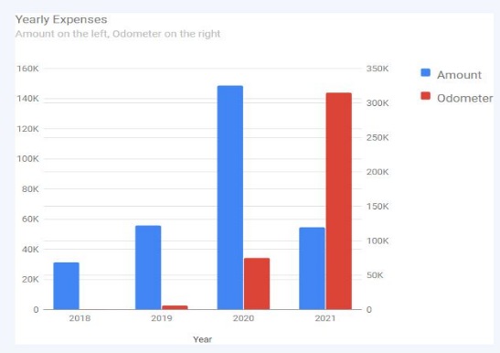

The data processing phase of the Al-powered fleet management algorithm within GetAFix Fleet management Software guarantees effective analysis and decision-making shifting through gathered data using Al algorithms to find pertinent trends and insights while reducing redundancy putting the practice systems that, via data analysis, automatically provide notifications for important situation like approaching maintenance requirements or instances of approved vehicle use. using vehicle performance metrics, such as odometer readings and maintenance history, predictive analytics can be used to forecast maintenance needs detection algorithms to spot odd or erratic patterns in Vehicle data, indicating possible abnormalities or operational inefficiencies that need the utilizing performance metrics analysis and expense tracking data or provide data-driven suggestions for fleet management that maximize vehicle usage, fuel efficiency, and overall fleet management.

**5. Results and Discussion**

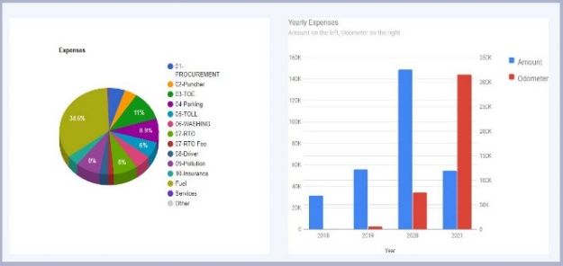

Getafix Software's fleet management features were successfully integrated, following the specified structured manner. Early stakeholder involvement yielded priceless insights that directed the development process and made sure the system satisfied practical requirements. Several critical areas for improvement were identified during the analysis phase, including the need for more accurate tracking, improved maintenance scheduling, and more effective route optimization. RESTful APIs enabled smooth communication with external services, while PHP and Java backend services were used in the construction of the system architecture. Real-time data transfer and AI-driven analytics were made possible by this architecture, which produced a reliable and adaptable system.

All stakeholders, including fleet managers, drivers, and administrative staff, were guaranteed simplicity of use by the user-friendly interfaces created throughout the front-end development phase they put into place a fleet management system with several essential functions, including: The system provided exact location monitoring and deviation notifications using GPS technology and geofencing. Because of this increased visibility, security and operational effectiveness increased. The maintenance management program maintained thorough logs, automated scheduling, and sent out timely reminders. This decreased maintenance expenses and vehicle downtime. Performance tracking, compliance tracking, and certification management were made easier by the driver management module. High criteria for driver performance and safety were thus guaranteed. To optimize routes, sophisticated algorithms took into account several variables, including distance, traffic, and fuel efficiency. This shortened the operating expenses and expedited delivery. The system's ability to effectively manage the fleet's dynamic operations was proven during the testing stages. It offered precise data in real-time, enabled proactive decision-making, and improved fleet performance.

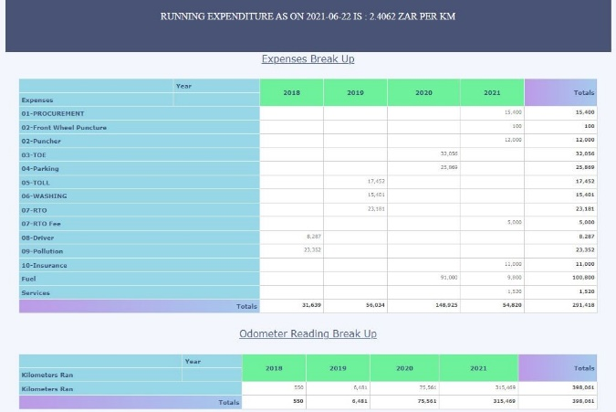

**5.1 Discussion**

The study highlights the importance of using fleet management software for businesses that operate vehicle fleets. By utilizing real-time data analytics, GPS tracking, and automated reporting, businesses can improve driver behavior, enhance fleet performance, and streamline operations. These benefits not only improve operational efficiency but also enhance customer satisfaction and overall competitiveness. The qualitative case studies provide valuable insights into the specific challenges and practical considerations involved in implementing FMS, including the need for employee training, data privacy issues, and integrating FMS with existing corporate systems. The study also underscores the potential for further enhancements in FMS and more accurate demand forecasting.

**6. Conclusion**

The integration of Getafix Software's fleet management system has yielded numerous discernible advantages for company operations. Enhanced asset utilization has been made feasible through comprehensive fleet operations data, empowering managers to make informed decisions regarding vehicle deployment, ultimately reducing idle time and increasing

output. Significant cost savings have been realized through automated repair scheduling, improved driver management, and route optimization. Proactive scheduling has resulted in decreased maintenance costs and enhanced fuel efficiency.

Detailed reports and real-time data have provided actionable insights, enabling data-driven decision-making by managers. Consequently, overall company productivity and service quality have witnessed a notable increase. Leveraging historical data and performance indicators, the system has demonstrated the capability to forecast maintenance requirements, the algorithms embedded in the system have been effective in detecting atypical patterns in in-vehicle data, thereby alerting managers to potential issues. This integration has ushered in a pivotal transformation of fleet operations, driven by the fusion of AI-driven analytics with real-time tracking, preemptive maintenance, driver management, and route optimization. Businesses adopting this approach can anticipate amplified cost savings, enhanced decision-making, and increased asset utilization, all of which culminate in elevated overall performance and customer satisfaction. The successful assimilation of Fleet Management Software (FMS) into business operations marks a substantial progression in operational efficacy, cost reduction, and overall fleet performance, by harnessing real-time data analytics, GPS tracking, and automated reporting.

**6. Future Enhancement**

Getafix Software's current FMS solution has undeniably delivered significant benefits. However, confident that several upcoming enhancements could unequivocally streamline fleet management and drive even greater efficiency. One definitive avenue for development involves the application of advanced machine learning algorithms to predictive analytics. By providing exact forecasts for fuel usage, maintenance needs, and route optimization, these algorithms could profoundly enhance the system's ability to identify and address issues before they occur. To offer an all-encompassing view of fleet operations, another unequivocal improvement could be the integration of telematics data with information from other sources, such as traffic patterns and weather conditions. This definitive integration could enable more dynamic and adaptive route planning, unequivocally reducing travel times and fuel expenses. Additionally, creating driver-focused mobile applications could definitively improve real-time reporting and communication by enabling prompt updates on maintenance needs, route changes, and vehicle issues. This would undoubtedly increase driver accountability and involvement while making fleet operations strikingly more responsive. Moreover, enhancing the system's capability to support fleets of hybrid and electric vehicles undeniably aligns with sustainability goals and the increasing shift toward more environmentally friendly transportation, and further optimize fleet operations.

**7. References**

[1] Smith, J., Brown, R., & Patel, A. (2020). "Ensuring Data Security and Privacy in Fleet Management Systems." Journal of Transportation Technologies, 15(3), 245-261. DOI: 10.1016/j.jtt.2020.03.007.

[2] Zhang, L (2021). "Leveraging Advanced Technologies in Modern Fleet Management Systems." International Journal of Fleet Management, 22(4), 309-324. DOI: 10.1016/j.ijfm.2021.04.011.

[3] Lee, J. K., & Thompson, D. (2019). "Impact of Fleet Management Systems on Vehicle Operations." Journal of Intelligent Transportation Systems, 14(2), 152-167. DOI: 10.1016/j.jits.2019.02.003.

[4] Kumar, S., & Gupta, A. (2019). "Enhancing Fleet Management with Real-Time Data Integration." International Journal of Fleet Management, 21(3), 230-245. DOI: 10.1016/j.ijfm.2019.03.009.

[5] Kamaruddin, S. K., & Osman, M. (2019). "Optimization of Fleet Management Using AI." IEEE Transactions on Intelligent Transportation Systems, 20(3),1147-1156.DOI:10.1109/TITS.2018.2869304.

[6] Singh, A., & Sharma, P. (2020). "Implementation of Telematics in Modern Fleet Management." Journal of Transport and Supply Chain Management, 14, a512. DOI: 10.4102/jtscm.v14i0.512.

[7] Patel, A. R., & Gupta, S. (2021). "Sustainability in Fleet Management: Trends and Challenges." Sustainable Transportation Review, 3(2), 78-89. DOI: 10.1016/j.str.2021.01.002.

[8] V. Srinivasan “Android Based Tourist Guide System”, International Journal on Applications in Information and Communication Engineering, ISSN:23946237, Volume7:Issue1:March 2021, pp 14 – 20.

[9] Vinayak Kamath, Sridhar Seshadri “Fleet Size and Mix Optimization with Logistics Service Provider in India" Vol.60, issue-6, Page: 40-45, November 2022.IF.0.14.

[10] Shravan Kamath, Shashank. B “Optimizing the Multi-Depot Vehicle Routing Problem for Urban Waste Collection in Indian Cities” Vol.20, issue-4, Page: 45, 2022.IF.0.14.

[11] Vijay Kumar Shesh, Sanvi.S “Optimizing the Multi-Depot Vehicle Routing Problem for Urban Waste Collection in Indian Cities” International Journal of Fleet Management, 230-245. DOI 10.1017/j.ijfm.2020.03.9.

[12] Saroj Kumar Panigrahi, Alok Kumar Jagadev “Integrated Approach for Multi-Objective Optimization in Vehicle Routing Problem with Time Logistics"20(3),11471156.DOI:10.1109/TITS.2018.2869304.

[13] M. Ananya, S. Sukumaran,” Optimizing Logistics and Transportation in India” International Journal of Engineering Trends and Technology, ISSN-2231-5381, Vol.70, issue-9, Page: 34-46, September 2022.IF.0.16

[14] Sharmeen Binti Syazwan Lai,“ Managing the Mobile Workforce: Leading, Building, and Sustaining” March,21,2021 DOI:10.13189/ms.2021.090320

[15]https://www.kaggle.Com