**Fitness in the Digital Age**

*A research paper about fitness website-UNDER THE GUIDANCE OF REKHA MA’AM

Sanjay S Srivathsa

*dept of CSE*

*RNS Institue of Tecnology* Bangolore,India [srivathasa2003@gmail.com](mailto:srivathasa2003@gmail.com)

***Abstract*—A fitness website is an online resource that offers data, tools, and resources pertaining to physical health and wellness. Users have access to workout plans and exercise demos to support their fitness objectives. The website caters to consumers of various fitness levels by abstracting straightforward fitness topics into simple-to-understand content.**

**Fitness website mainly focus on helping people to exercise without searching for the right exercise for them.It focus on majorly all the parts of the body.It contains specific exercises for each part and people need not worry on how much reps and sets to do.This website is suitable for all stages of people for example if someone is more experienced he can go for advanced level directly and if someone is a beginner he can opt for beginner.In this way they can refer and do the exercises of their choice.Database is usedto store users details and users routine for the entire week.**

***Index Terms*—Database,fitness website.**

1. INTRODUCTION

Welcome to our fitness website, your one-stop shop for everything related to your health and well-being. You’ve come to the perfect site if you’re interested in fitness, a fitnessfanatic, trying to start a better lifestyle, or just curious about different fitness-related topics. Our website is made to offer you thorough and current knowledge to assist you in achievingyour fitness objectives and leading a balanced life.

Mission and Goals: At our fitness website, we firmly think that maintaining a healthy body and mind is necessary for leading a happy life. Our goal is to provide people with the information, motivation, and inspiration they need to improve their lives for the better.

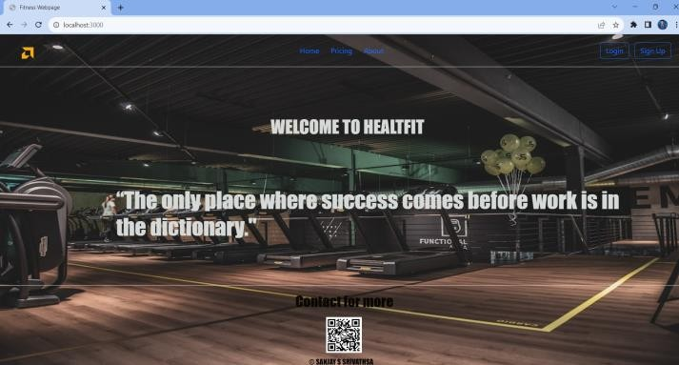Our website offers exercise routines and exercise manuals: Regardless of your level of fitness or your athletic experience, we provide a choice of workout plans that are suited to your needs. Our exercise guidelines include exercise to all parts of the body and it also provides gifs for all the exercise present in the website,by this they can see the exercise visually and avoid making mistakes while exercising.This gifs also shows on which body part the exercise focuses on.it’s highlighted using red colour.

This website contains following features:

1. *Main page*

Meta tags: These tags offer information about the website, like the character encoding and viewport options.

Title: The name of the webpage as it appears in the title bar or tab of the browser.

JavaScript and CSS Imports:External CSS stylesheets are imported using the link¿ tags.For styling and interactivity, the script¿ tags import external JavaScript files, notably Bootstrap. Body:The body¿ tag contains the webpage’s primary content. Section heading:The webpage’s navigation header is included in this section. On the left side of the header, you may see the logo or emblem. The navigational links, such as ”Home,” ”Pricing,” and ”About,” are listed in an unordered list (ul¿) in the header.

Links to Other Sites:The navigation links are stylized as hyperlinks (a¿ tags) and are list items (li¿) within the ul¿.

Buttons to Log In and Sign Up:For user authentication, these buttons are present on the right side of the header. quotable textTwo heading components in this section have inspirational quotes. Users are welcomed to the fitness websitein the opening quote. The second quotation is focused and motivating. the bottom section contains contact details and credit information are provided in the footer section.A header with the identifier ”h2” indicates the contact details.There is a picture (img¿),showing a QR code. The copyright informationfor the website is visible.

1. *Pricing section*

Pricing is a crucial section on a fitness website as it informs visitors about the cost of membership or services offered.Apart from this we can also get 7 days free trial for the users which is followed by user login.Users can contact the developers by clicking email/mobile no button.If user is accessing this website through mobile phone he can click mobile number or email.If user is accessing through laptop or computer then user can press email button.

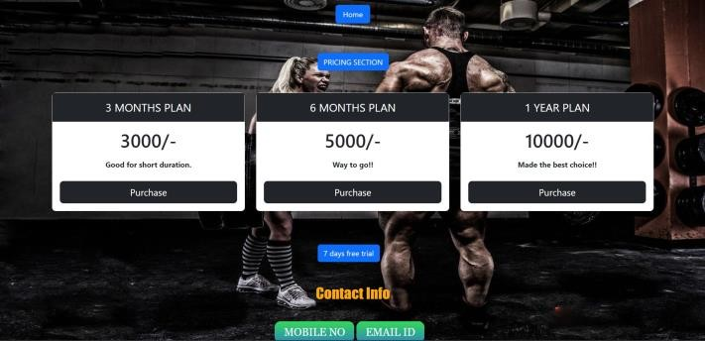

1. *Sign-in section*

As the name suggests, user has to sign up his/her details to keep track and for further login purpose.And its followed by user routine page where you fill the routine of users choice.Eg: for Monday user can select any day in the following options Chest, Arm, Tricep, Back, Abs, Leg Workout.

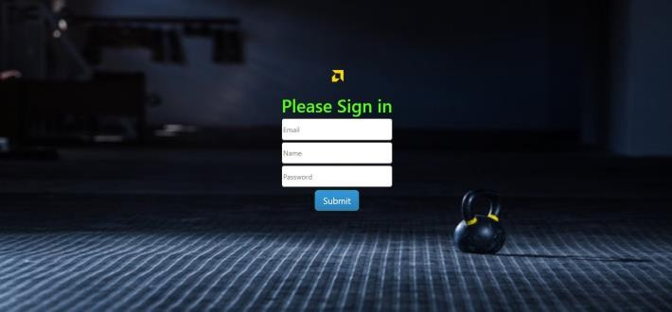

For sustaining general health and wellbeing, exercise is crucial. It provides a wide range of emotional, mental, and physical advantages that raise life quality. The following are somemajor arguments in favor of exercise: Physical Fitness:Weight management: Regular exercise boosts metabolism and burns calories, which helps control body weight.

Cardiovascular Health: Exercise increases circulation, strengthens the heart, and lowers the risk of heart problems. Weight-bearing exercises increase bone density and lower the risk of osteoporosis, which is good for your bones.

Strengthening muscles through resistance exercise helps maintain joint stability and functional mobility.

Flexibility and balance are improved by stretching and yoga, which lowers the chance of injuries.

Mental Wellness: Reduced stress and anxiety: Exercise

releases endorphins, which are organic mood boosters that lessen tension and anxiety.

Improved Mood: Regular exercise is associated with less depressive symptoms and a generally happier mood.

Enhanced Cognitive Function: Exercise improves cognitive function by boosting blood flow to the brain and encouraging the development of new neurons.

Better Sleep: Regular exercise can increase the quantity and quality of your sleep, which will leave you feeling more refreshed.

Self-Esteem and Confidence:Body Image: By encouraging a sense of success and physical well-being, regular exercise can enhance body image and self-esteem.

It’s crucial to remember that the kind and degree ofexercise might change depending on personal preferences, level of fitness, and health issues. Finding activities you enjoy and can stick with consistently is the key. A healthcare practitioner or fitness expert should be consulted before beginning a new workout regimen, especially if you have underlying health issues, to verify that the exercises you select are secure and suitable for your requirements.

1. *Login section*

Login section contains user name and password upon ver- ification of the user it directs to a page about importance of exercises and then to an intermediate stage where the user can select the levels of his choice.If the user is starting freshly he can opt for Beginner where the exerices for each body part contains less reps and sets and totally 3 exercises foreach part.If the user is above average level he can opt for Intermediate where the exerices for each body part contains little more reps and sets and totally 4 exercises for each part.If the user is capable of doing more than both the levels then he can opt for Advanced where the exerices for each body part contains more reps and sets and totally 5 exercises for each part.

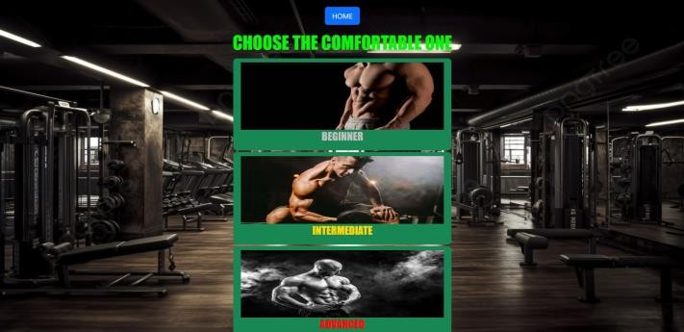

1. *Working section*

Here user can see the workouts name how many reps and sets for each one of them with an animated gifs for their convince. This gifs helps a lot because user can easily see the right way to do these exercises.Because of this there is less prone to damaging of bones or muscles which is the

disadvantage of exercising. You can see gifs for parts included in this website.And there is a back button which redirects user to the page where user can select the difficulty level.

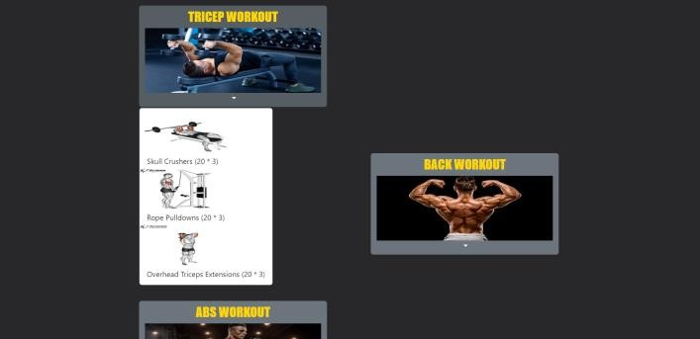

* 1. Understandably, you’re busy. Working out your back, chest, biceps, and triceps twice a week is not something you have time for. Relax, we can handle this. But before we go any further, let’s all agree that these workouts are more than just time- saving devices. They are also excellent strength boosters when used properly. According to Silverman, ”What a lot of people get wrong is someone builds up their legs or buildsup their upper body, and they don’t realise that the othermuscles in the body will actually contract at the same time,so if you don’t strengthen those or if you don’t get to grips with how to control them you may find that your strengthgoes down elsewhere.” The finest full-body workouts will incorporate complex movements, or actions that utilize many muscle groups, whether it comes to putting together a workout or knowing what to look out for in a program. To go through the range of motion, exercises like deadlifts, kettlebell swings, thrusters, and burpees all require at least three repetitions.

1. ALGORITHM
   1. An algorithm is a process used to carry out a computation or solve a problem. In either hardware-based or software-based routines, algorithms function as a detailed sequence of instruc- tions that carry out predetermined operations sequentially.

All aspects of information technology employ algorithms extensively. An algorithm in mathematics, computer science, and programming typically refers to a brief process that re- solves a recurring issue. Algorithms are essential to automated systems because they serve as specifications for processing data.

In this website I have used Linear Search for user authen- tication.The fundamental searching strategy used to locate a specific element within a list or array is known as linear search, often referred to as sequential search. Until the target element is located or the full list has been searched, each element in the list must be individually scanned.

Here’s how the linear search algorithm works: Start from the beginning of the list (or array).

Compare the target element with the current element in the list.

If the current element matches the target element, the search

is successful; return the index of the current element.

If the current element does not match the target element, move to the next element in the list.

Repeat steps 2 to 4 until the target element is found or the end of the list is reached.

If the target element is not found after searching the entire list, return a ”not found” indicator.

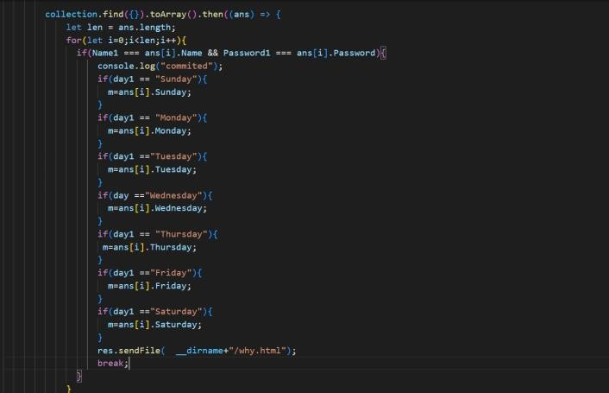

1. Pseudocode

procedure linearsearch (list, value) for each item in the list

if match item == value return the item’s location end if

end for

end procedure

The reason why I have used Linear search is because

,it is more easier to implement and when compared with binary search its time complexity is O(log N) which is more than O(N) and we should give in sorted order in order to perform Binary search.

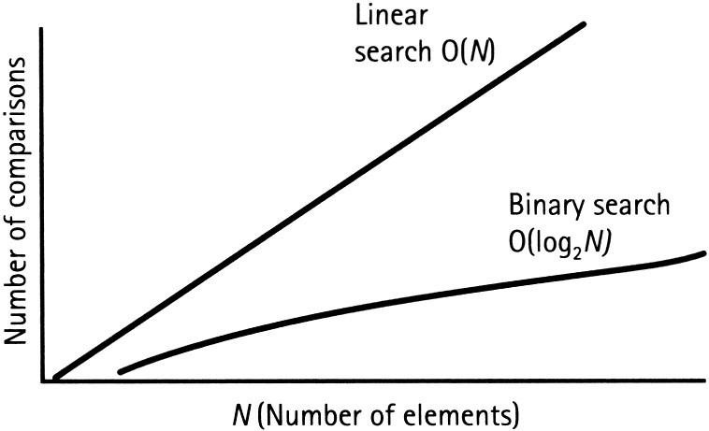

*A. Database : MongoDB*

A database is a structured collection of data that has been arranged, maintained, and stored to facilitate effective information retrieval, manipulation, and querying. Databases are used to store several forms of data in a structured and organized way, including simple text and rich multimedia information. They are an important element of contemporary information systems and are used in numerous apps, websites, enterprises, and other settings.

Key characteristics of a database include:

Structured Format: Data in a database is organized into tables, rows, and columns, which define the structure of the data and its relationships.

Efficient Storage: Databases optimize the storage of data to ensure efficient use of resources and quick access to information.

Data Integrity: Databases enforce rules and constraints to maintain the accuracy and consistency of data. This helps prevent errors and ensure the reliability of stored information. Data Retrieval and Manipulation: Databases provide tools and languages (such as SQL) to retrieve, insert, update, and delete data in a controlled and systematic way.

Scalability: Databases can handle various scales of data, from small datasets to large enterprise-level systems.

The MongoDB database was created and is run by Mon- goDB.Inc under the terms of the Server Side Public License. It was first made available in February 2009. It offers official driver support for all of the widely used programming lan- guages, including C, C++, Java, Node.js, and Python. such that you can use any of these languages to construct an application.

In mongoDb we first create a database here it is called as fitness and inside that we can create n number of collections and here we have named it as verification1.

In this collection there a few documents here namely user email-id, name, password and all days of the week. All these details entered by the user will be stored under one id generated.We will fetch thedata of all the users using in this format we will get it as an array and we can index on it to fetch the individual users data.Here we are fetching thedata from mongoDB to verify the user name and password.

CONCLUSION

In conclusion, maintaining a healthy and meaningful lifestyle requires being physically fit. Overall wellness and vitality are influenced by frequent physical activity, eating a balanced diet, and putting mental health first. Fitness has advantages that go beyond physical health and include mental and emotional health as well.

1. It is important to maintain health and fitness of not just our physical self but our mental self as well, to have a happy and fulfilled life. The maintenance of these should be taught to children at a young age so that they are used todoing certain activities and are motivated to continue doing them as they grow up.

Here are some key takeaways:

Physical Health: Regular exercise helps in managing weight, improving cardiovascular health, enhancing musclestrength, promoting flexibility, and supporting bone health. It also plays a crucial role in preventing chronic diseases and boosting the immune system.

Mental Health: Exercise is a powerful tool for reducing stress and anxiety, improving mood, and promoting better sleep.It enhances cognitive function and supports brain health, contributing to a positive and resilient mindset.

Lifestyle and Longevity: Adopting a fitness-focused lifestyle increases energy levels, stamina, and overall vitality. Regular exercise and healthy habits contribute to a longer, more active life.

Personal Growth: The discipline and dedication required for fitness journeys often spill over into other areas of life, fostering personal growth and resilience.

Customization: Fitness is not a one-size-fits-all approach. It’s important to find activities that align with personal preferences, interests, and fitness goals.

Consistency: Consistency is key to reaping the benefits of fitness. Setting achievable goals and maintaining a regular routine will yield the best results over time.

Keep in mind that starting a fitness program doesn’t call for overnight radical changes. Small, enduring moves in the direction of healthy routines can have a big impact. Prioritize balance and fun in your approach while beginning a fitness regimen, making changes to an existing one, or looking to improve your general well-being. You can reach your fitness objectives and live a full, active life with the correct attitude, commitment, and support

REFERENCES

* 1. https://wpamelia.com/fitness-websites/
  2. [https://www.menshealth.com/uk/building-muscle/a28433729/full-body-](http://www.menshealth.com/uk/building-muscle/a28433729/full-body-) workouts/
  3. [https://www.](http://www.techtarget.com/whatis/definition/algorithm)techta[rget.com/whatis/definition/algorithm](http://www.techtarget.com/whatis/definition/algorithm)
  4. [https://www.](http://www.thewisdompost.com/essay/health-and-fitness-essay)the[wisdompost.com/essay/health-and-fitness-essay](http://www.thewisdompost.com/essay/health-and-fitness-essay)