# Improvement of Power Quality Using Fuzzy Based Interline Power Flow Controller [IPFC]

1 Alka Rani, 2 Sitaram Pal

# 1,2 DEPARTMENT OF ELECTRICAL & ELECTRONICS ENGINEERING

# Rabindranath Tagore University, Bhopal

# ABSTRACT

The renewable energy resources (RERs) have brought green revolution in mitigation of greenhouse gaseous emission resulted from traditional energy resources (TERs). Moreover, the effective utilization of these resources is influenced by pricing schemes which have limitations. Therefore, this paper aims at optimization modeling for dynamic price-based demand response (DR) which includes flexible and inflexible loads along with the effective utilization of RERs i.e. photovoltaic (PVs) and wind turbines (WTs) in a microgrid (MG). This Thesis primary purpose is to use a multi-agent system (MAS) to develop a distributed microgrid automation model to realize complex organize or distributed microgrid energy management. This article introduces the energy-saving smart grid control system for network and island state control. A new concept is proposed to use distributed production (D.G.) to improve the power quality (P.Q.) in low-voltage networks. Compared to the traditional method, the conventional method requires using the committed property to recompense for power quality disturbances. The proposed idea is to form a microgrid (M.G.) that can be isolated from the public network operate on islands when disruptions occur. This article discusses the conditions for creating islands and proposes a control strategy for a small active network of micro turbines, renewable energy, loads, or storage systems.

**Keyword** : Renewable energy resources (RERs), traditional energy resources (TERs), photovoltaic (PVs) and wind turbines (WTs) in a microgrid (MG).

# INTRODUCTION

The power system consists of four sections: power generation, power transmission, power conversion, and power consumption. In remote farms, forest farms, and islands, it is not easy to set up transmission and transmission systems for small power demands. In addition, storms and other catastrophic events will cause power outages to continue to the plate. Global warming is of great concern, and shifting energy production based on renewable energy production is an excellent way to reduce fossil fuel emissions. Therefore, for these reasons, it is necessary to build a renewable energy system outside the grid. One of the benefits of mixing different power sources is to provide sustainable power in areas that conventional power grids cannot supply. They are instrumental in many applications, but due to their non-linearity, hybrid energy systems have been proposed to overcome this problem and make essential improvements.

# 1.1 The Need for Renewable Energy

Renewable energy is power derived from natural possessions, such as solar, wind, waves, or geothermal energy. These resources are renewable and can be recycled naturally. Therefore, compared to the depletion of traditional fossil fuels [1], these sources of information are considered inexhaustible. The global power crunch provides a new impetus for the development or maturity of clean or renewable energy. [2]. In addition to the decline in fossil fuel transportation worldwide.

# 1.2 Different Sources of Renewable Energy

## **1.2.1 Wind Power**

Wind turbines can be used to harness the power generated by the airflow [3]. The power of turbines used per day is around 600 kW to 5 MW [4]. Because power output is a function of wind speed, it amplifies hastily as wind speed increases. Recent advances have become wind turbines, which are more resourceful than better aerodynamic construction.

**1.2.2 Solar Power**

The evolution of solar energy came from the British astronomer John Herschel [5], who used solar collectors for cooking food during his travels to Africa. Solar power can be used in two main ways. First, the extracted heat can be used as energy from the sun and heat the atmosphere

# 1.3 Renewable Energy Trends across the Globe

The current trend in the developing economy has led to the expansion of renewable power. Over the past three years, Figure 1.1 shows that renewable energy and biomass energy account for a significant part of current renewable energy consumption. The recent development of solar photovoltaic

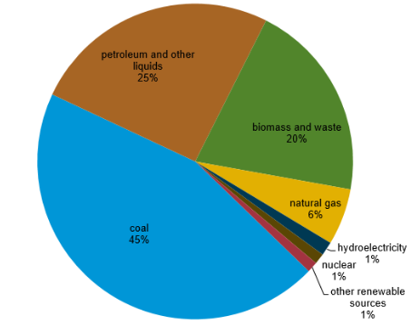

Figure 1.1: Global energy consumption

# 1.2 BESS Technology

The battery technologies have been in practice for more than 100 years. However, only rechargeable or secondary batteries are preferred in power system application. The battery technologies are gaining popularity in power system application due to their ability of providing operational flexibility, rapid response, and reduction in price/kWh [24] and technological advancement in recent battery technologies. The batteries are widely used at all voltage levels in power systems.

# METHODOLOGY

This chapter covers that the primary purpose of transmission lines is to transmit power to various substations. Through the transformer station, power is transmitted to the distribution transformer, which reduces the current to an appropriate value that suits the users and realizes a smart grid through an energy storage system and distributed generators. And design stable control with different sources and load conditions .A multi-agent system (MAS) is a disseminated organization consisting of several software agents

SOLAR

Battery

DC LINE

Fuel cell

Wind

AC BUS

DG3

DAB

Solar

DG2

AC Grid

DG1

#### Fig 1.2 Modern MEG architecture

Modern MEG architecture supposes that dispersed power generation, storeroom systems, and cargo collection provide energy and heat. Most micro sources must have an interface based on electrical power to ensure the prescribed operation and the required capacity. Figure 1 shows a typical MEG architecture. MEG architecture's main features include an interface, micro source control (MC), load regulator (LC), and load-sharing distribution are the three main occupations of architecture. That ensure robust governance, the MEG control classification is based on a hierarchical control architecture microgrid monitoring and operation: Industrial solutions that expect to have various renewable energy sources operate in a "plug and play" mode. All possible scenarios during the process should be measured in advance, and there should be a monitoring algorithm that may deal with specific situations. This property is called plug and play. Researchers have tried to develop appropriate control strategies for dissimilar microgrid systems. The management system's central function is to distribute the load between the various microbial sources in the state of mains communication, maintain the quality of electricity, and control the energy there between small wires and large networks. micropower sources: The microgrid microstructure of particular interest is a small device (approximately 100 kW) with an electronic connection.These power sources include a small turbine, wind generator, photovoltaic system, photovoltaic system, and fuel cell on the customer's website. They have the characteristics of low cost, low power, high efficiency, and low emissions. Despite the gains, it was pointed out that the rate of access (DER) of distributed energy did not meet expectations.

Small turbine: A microbial turbine is a simple mechanical device that has a fuel system. The engine is a long-acting engine whose rotational speed is typically between 50,000-100,000 rpm. The variable power generation system is connected to the electrical system utilizing electrical and electronic devices

# Modeling of Solar System

A solar- system consists of PV array, battery bank, inverter, controller and cables. The PV array and wind turbine work together to satisfy the load demand. When energy sources (solar-) are abundant, the generated power from the solar, in the day time will continue to charge the battery until it is fully charged. On contrary the when energy sources are poor, the battery will release energy to assist the PV array and wind turbine to cover the load requirements until the storage is depleted.

# Modules

* Solar power
* MPPT Algorithm
* Boost converter
* Bidirectional converter
* Battery
* Dual active Bridge
* Wind
* PWM Switching

# 1.3 Solar System

The solar Microgrid system is designed to operate in two modes; Grid-connected mode and Islanded mode. In grid-connected mode, the battery system operates in parallel with the PV system. The PV system usually operates as a typical grid-tied solar PV system. During peak sun hours of the day, the battery system is less active. Still, when the PV system is not utilizing the majority of the inverter capacity (i.e., at night), it can actively participate in fast-response frequency regulation.

## **1.3.1 Boost Converter**

The boost converter is a switch-mode DC-to-DC converter whose output voltage is greater than the input voltage. It is also called a boost converter. The Boost converter gets its name because the input voltage, like the boost transformer, is boosted to a level greater than the input voltage. According to the law on energy saving, input power must be equal to the output power (provided that there is no loss in the circuit) Input power (Pin) = output power (Pout)

SinceVin< Vout in a boost converter, it follows then that production current is less than the input current than in boost converter

Vin< Vout and Iin>Iout

Principle of operation of Boost converter: The primary working attitude of the booster converter is that the inductor in the input circuit can withstand sudden changes in the input current. When the switch is open, the inductor stores energy in magnetic power or releases it when the switch is closed. It is assumed that the capacitor in the output circuit is large enough to make the time invariable of the RC circuit in the output stage higher. Compared to the switching period, a larger time constant can ensure a constant production voltage Vo (t) = Vo (constant).

**Circuit diagram of Boost converter:** The circuit diagram of the boost converter is shown in the figure below

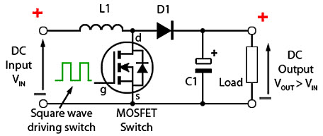

Figure 1.3: Boost Converter

**Operation:**

**Step 1**

When the switch is closed, the present flows through the inductor clockwise, or the inductor stores some energy by producing a magnetic field. The polarity on the left side of the inductor is positive.

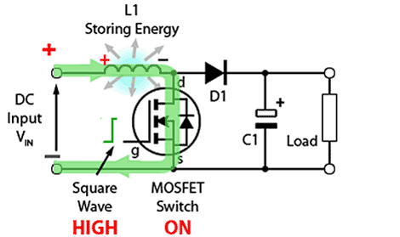

Figure 1.3: Boost Converter Switch Close

**Step 2**

When the switch is off, the current drops as impedance increases, the previously generated magnetic field will be destroyed to maintain current flowing to load. Therefore, the polarity is overturned (which means that the left side of the inductor becomes negative). As a result, two power supplies will be connected in series, causing a higher voltage to charge the capacitor through diode D.

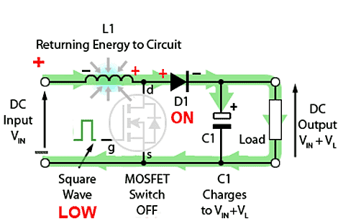

Figure 1.4: Boost Converter Switch Open

Working mode for boost converter

The boost converter can operate in two modes

a) Continuous conduction state where current flowing throughout the inductor is never zero, i.e.,that the inductor is partly discharged before the start of the button cycle.

b) Discontinuous wire condition where the current flowing through the inductor is zero, i.e., the inductor is completely discharged at the end of the switching cycle.

## **1.3.2 Battery**

A battery is a device containing one or more electrochemical cells. The battery has an external connection and can transmit electricity such as lights, mobile phones, and electric cars. When the battery is running, the cathode is its positive terminal, and the negative terminal is the anode. The terminal with a negative mark is the electron source, which flows to the positive electrode through an external circuit.

# 3.3 Mppt Algorithm

Maximum power point tracking (MPPT) is an algorithm applied to photovoltaic (PV) to continuously adjust the impedance detected by the photovoltaic system to keep the photovoltaic system close to the photovoltaic system under changing conditions—sunlight, temperature, and load. Engineers creating solar inverters use the MPPT algorithm to increase the power generated by photovoltaic systems. The algorithm monitors the power to ensure that the system operates at the “maximum power point” (or maximum load) on the power processing line, as shown below. The MPPT algorithm is often used in the design of controllers of photovoltaic systems

# INITIAL DESIGN PARAMETERS Solar panel

* Short circuit current--10
* Open circuit voltage-----11.05
* Open circuit voltage-----11.05
* Voltage at Pmax 12

**Fuel cell** **Voltage (V)** =**65**

* Maximum operating point (V,I)=133.3 -45
* Number of Cell= 65

**Micro grid**

* Nominal Power-->1000
* Frequency----->60Hz
* Active power------>10e3(W)

**Table 1.1 Simulation Parameters**

|  |  |
| --- | --- |
| **SIMULATION PARAMETERS VALUE** | |
| KP | 40 |
| Turbine time constant, | 0.05 |
| Governor time constant, | 0.025 |
| electrical generator (V.A.): | 8.5e3/0.9 |
| Engine time delay Td (s) | -0.024 |
| Nominal power | 2e+006 |
| Voltage | 400 |
| Frequency | 50 |
| Field current | 100 |
| Open circuit voltage, Voc | 0.62 |
| Short circuit current, | 7.57 |
| PV output | 230Kw/44I |
| Wind power | 4.5 |
| Base wind speed (m/s): | 12 |
| Load power  P (W) | 100 |

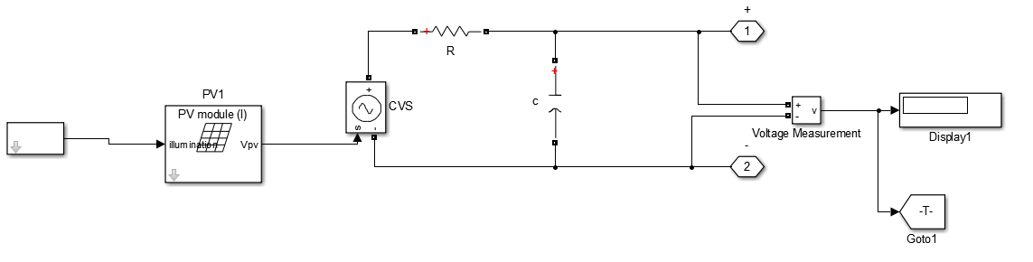

Figure.1.5 Solar Panel

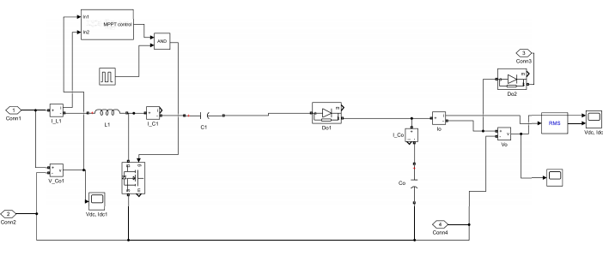

Figure 1.6: Incremental MPPT for wind system

# 4.5 SIMAULTION RESULT

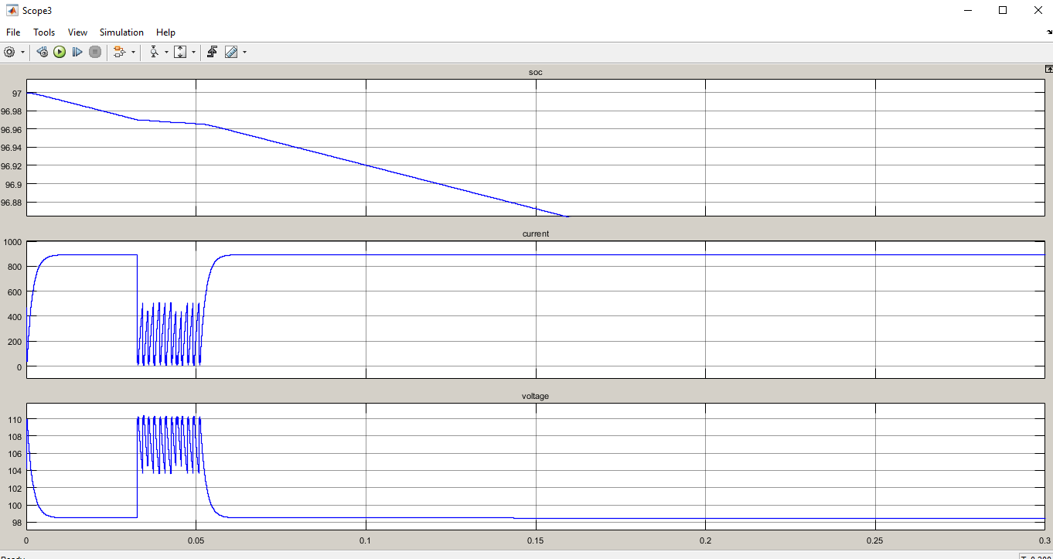

Figure 1.7 Battery Output

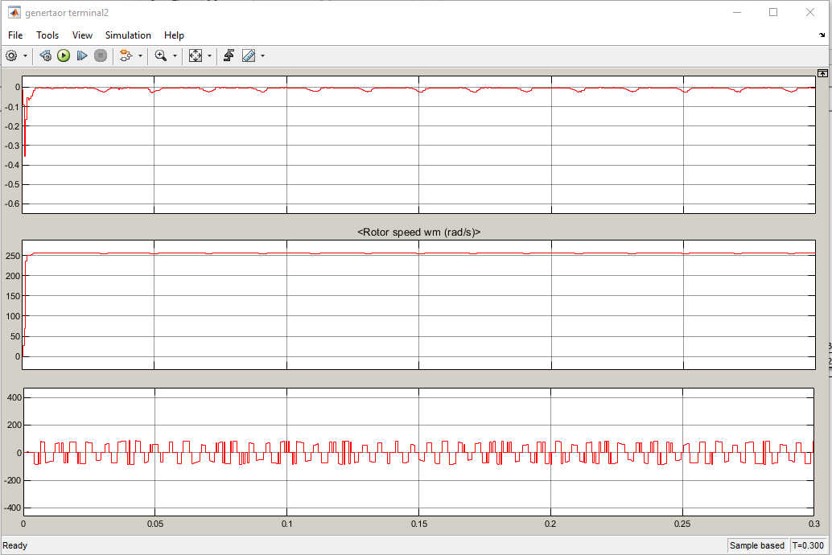

Figure 1.8 Wind and Rotor Speed

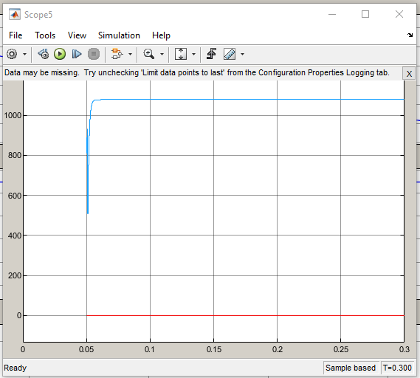

Figure 1.9: Solar Output

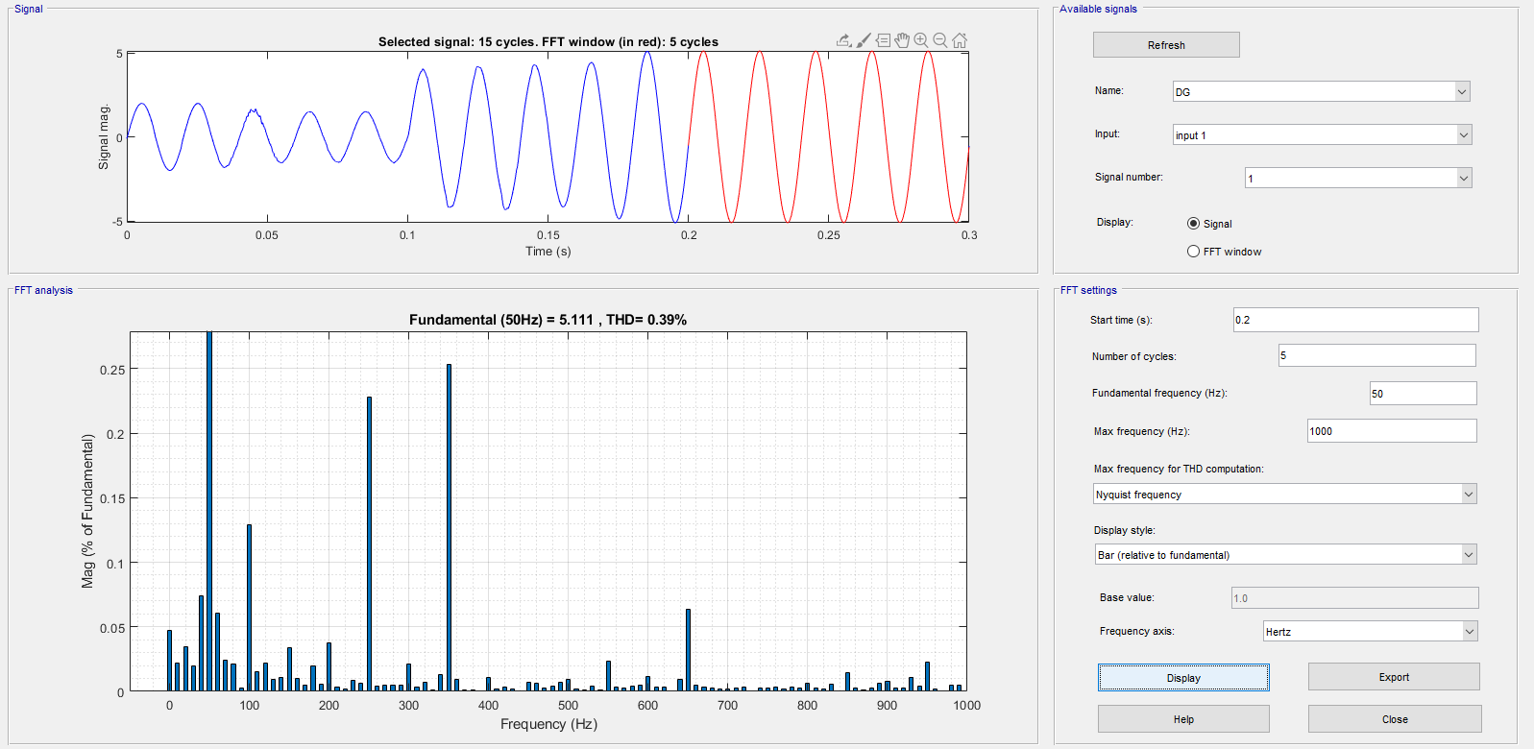

Figure 2.1 THD performan

# Conclusions

Renewable energy is an alternate source of energy for conventional energy resources. Renewable energy sources are the primary energy sources in remote areas where traditional energy cannot be transmitted. The MPPT based solar-wind hybrid energy system with boost converter is studied in this paper. To increase the conversion efficiency of the hybrid system, an MPPT algorithm is utilized. Perturb and observe algorithm and incremental conductance provide the required duty ratio to control the boost converter with unpredictable weather conditions.

**REFERENCE**

1. M. Zeeshan Tariq; Syed Rahman; Irfan A. Khan; Faisal Nadeem Khan PV Fed Battery and Ultra-Capacitor Based Hybrid Energy Storage for Powering Marine Loads 2021 International Conference on Digital Futures and Transformative Technologies (ICoDT2) Year: 2021
2. Kai Han; Jili Tao; Liang Xie; Ridong Zhang Rule and MPC based Hybrid Energy Allocation System for Hybrid Electric Vehicle 2019 Chinese Automation Congress (CAC) Year: 2019
3. N. Saravanan, S. HosiminThilagar, “Ultracapacitor Aided Performance Enhancement of Battery Powered Electric Vehicles 2018 IEEE International Conference on Power Electronics, Drives and Energy Systems (PEDES) Year: 2018
4. Chen Zhao; He Yin; Chengbin Ma Equivalent Series Resistance-based Real-time Control of Battery-Ultracapacitor Hybrid Energy Storage Systems IEEE Transactions on Industrial Electronics Year: 2020
5. Bin Wang; Qiao Hu; Zhiyu Wang Improving Power Output of Battery and Mode Switching Frequency Based on Real-Time Average Power Method for Multi-Mode Hybrid Energy Storage System in Electric Vehicles IEEE Access Year: 2020
6. Krishna ChaithanyaBandla; M.V. Gururaj; Narayana Prasad Padhy Decentralized and Coordinated Virtual Synchronous Generator control for Hybrid AC-DC Microgrids 2020 IEEE International Conference on Power Electronics, Smart Grid and Renewable Energy (PESGRE2020) Year: 2020
7. Albert Ayang; Mohamad Saad; MohandOuhrouche; Rene Wamkeue Modeling, P&O MPPT and PI controls and performance analysis of PV/Energy storage hybrid power system 2018 4th International Conference on Renewable Energies for Developing Countries (REDEC) Year: 2018
8. Mohammad Jasim Usmani; Ahteshamul Haque; V S Bharath Kurukuru; Mohammed Ali Khan Power Management for Hybrid Energy Storage System in Electric Vehicles 2019 International Conference on Power Electronics, Control and Automation (ICPECA) Year: 2019