**Strategic Pathways for Enterprise Success for Organizational Excellence: A UAF Approach**

**Iqtiar Md Siddique**

Department of Mechanical Engineering, the University of Texas at El Paso, USA.

Email: iqtiar.siddique@gmail.com.

**Abstract:**

This comprehensive paper investigates the application of the Unified Architecture Framework (UAF) in the strategic planning processes of modern enterprises. UAF provides a structured methodology that aligns business objectives with IT infrastructure, facilitating a cohesive and integrated approach to strategic planning across various organizational levels. By employing UAF, enterprises can systematically address complex interdependencies and ensure that all aspects of the business are synchronized towards common goals. The study begins by outlining the fundamental principles of UAF, emphasizing its role in bridging the gap between business strategy and IT capabilities. It highlights how UAF's modular and flexible framework allows enterprises to tailor their strategic planning processes to their unique needs, ensuring that all relevant stakeholders are involved and that their inputs are considered in the decision-making process. Through detailed case analyses, the paper demonstrates the practical benefits of UAF implementation. It showcases how leading enterprises have utilized UAF to enhance their decision-making processes, optimize resource allocation, and improve organizational agility. These case studies provide valuable insights into the challenges faced during UAF adoption and the strategies employed to overcome them, offering a roadmap for other enterprises to follow. bThe paper also explores best practices for integrating UAF into existing strategic planning processes. It discusses the importance of a holistic approach that considers not only the technological aspects but also the human and cultural dimensions of the organization. By fostering a collaborative environment and encouraging cross-functional communication, enterprises can leverage UAF to drive innovation and continuous improvement. Finally, the study presents a forward-looking perspective on the future of enterprise strategic planning with UAF. It discusses emerging trends and technologies that are likely to shape the strategic landscape and examines how UAF can evolve to meet these new challenges. By staying ahead of these trends, enterprises can maintain a competitive edge and achieve sustainable growth in an ever-changing market environment. In conclusion, this paper underscores the critical role of UAF in strategic enterprise planning. By adopting UAF principles, enterprises can create a robust and adaptable strategic framework that aligns business and IT, enhances decision-making, and drives long-term success.

**Keywords**: Unified Architecture Framework, strategic planning, business-IT alignment, organizational agility, decision-making optimization

**Introduction**

This paper explores the implementation of the Unified Architecture Framework (UAF) in strategic planning for enterprises, highlighting its critical role in aligning business objectives with IT infrastructure. UAF offers a structured methodology that facilitates a cohesive and integrated approach to strategic planning across various organizational levels. The framework helps enterprises systematically address complex interdependencies, ensuring that all aspects of the business are synchronized toward common goals [1].

We begin by outlining the fundamental principles of UAF, emphasizing its ability to bridge the gap between business strategy and IT capabilities. UAF's modular and flexible structure allows enterprises to tailor their strategic planning processes to their unique needs, ensuring that relevant stakeholders are involved and their inputs are considered in the decision-making process.

Through detailed case analyses, the paper demonstrates the practical benefits of UAF implementation. It showcases how leading enterprises have utilized UAF to enhance their decision-making processes, optimize resource allocation, and improve organizational agility. These case studies provide valuable insights into the challenges faced during UAF adoption and the strategies employed to overcome them, offering a roadmap for other enterprises to follow [2]. The paper also explores best practices for integrating UAF into existing strategic planning processes. It discusses the importance of a holistic approach that considers not only the technological aspects but also the human and cultural dimensions of the organization. By fostering a collaborative environment and encouraging cross-functional communication, enterprises can leverage UAF to drive innovation and continuous improvement.

Furthermore, the study presents a forward-looking perspective on the future of enterprise strategic planning with UAF. It examines emerging trends and technologies that are likely to shape the strategic landscape and discusses how UAF can evolve to meet these new challenges. By staying ahead of these trends, enterprises can maintain a competitive edge and achieve sustainable growth in an ever-changing market environment. In conclusion, this paper underscores the critical role of UAF in strategic enterprise planning. By adopting UAF principles, enterprises can create a robust and adaptable strategic framework that aligns business and IT, enhances decision-making, and drives long-term success. This comprehensive approach not only addresses current organizational needs but also prepares enterprises for future challenges, ensuring their continued growth and competitiveness [3,4].

The paper delves deeper into the specifics of UAF, detailing its various components and how they interact to form a comprehensive strategic planning tool. The framework is divided into different viewpoints, such as operational, systems, and service, each providing a unique perspective on the organization’s architecture. These viewpoints enable enterprises to analyze and design their systems comprehensively, ensuring that every aspect of the organization is considered in the planning process. One of the key strengths of UAF is its ability to support decision-making through a well-defined and standardized approach. The framework provides a set of tools and techniques that help enterprises make informed decisions based on accurate and timely information. By utilizing UAF, organizations can reduce uncertainties and risks associated with strategic planning, leading to more reliable and effective outcomes.

The paper also highlights the importance of continuous monitoring and evaluation in the UAF-driven strategic planning process. By regularly assessing the performance and effectiveness of their strategies, enterprises can identify areas for improvement and make necessary adjustments. This iterative approach ensures that the organization remains agile and responsive to changes in the market environment, maintaining its competitive edge [5].

Moreover, the study explores the role of technology in enhancing UAF implementation. Advances in data analytics, artificial intelligence, and automation are transforming the way enterprises approach strategic planning. By integrating these technologies with UAF, organizations can enhance their analytical capabilities, streamline their processes, and gain deeper insights into their operations. This technological synergy enables enterprises to make more accurate predictions, optimize their resource allocation, and improve overall efficiency. In addition to technological advancements, the paper discusses the human aspect of UAF implementation. Successful strategic planning requires a collaborative effort from all levels of the organization. The study emphasizes the need for strong leadership, clear communication, and a culture of continuous learning and innovation. By fostering an environment that encourages collaboration and open dialogue, enterprises can ensure that their UAF-driven strategies are well-supported and effectively executed [6].

In summary, this paper provides a comprehensive analysis of UAF as a strategic planning tool for enterprises. It underscores the framework’s ability to align business objectives with IT infrastructure, enhance decision-making processes, and improve organizational agility. By adopting UAF principles and integrating emerging technologies, enterprises can create a robust and adaptable strategic framework that drives long-term success. The study’s insights and recommendations offer valuable guidance for organizations looking to leverage UAF in their strategic planning efforts, ensuring sustainable growth and a competitive advantage in the dynamic business landscape.

**Background**

The background section of this paper provides an in-depth exploration of the origins, development, and foundational principles of the Unified Architecture Framework (UAF), setting the stage for its application in strategic enterprise planning. UAF emerged as a response to the growing complexity of enterprise architecture and the need for a comprehensive framework that could integrate various architectural domains, including business, data, applications, and technology. It was developed by the Object Management Group (OMG), a leading consortium that creates standards for interoperable enterprise applications, in collaboration with experts from diverse industries. The historical context of enterprise architecture frameworks reveals an evolution from early, fragmented approaches to more integrated and holistic models. Initially, organizations relied on siloed frameworks that focused on specific aspects of enterprise architecture, such as business processes or IT infrastructure. These early frameworks, while useful, often failed to provide a unified view of the organization, leading to inefficiencies and misalignments between business and IT strategies [7].

Recognizing these limitations, the OMG introduced UAF as a comprehensive and modular framework designed to address the full spectrum of enterprise architecture needs. UAF builds on the strengths of previous frameworks, such as the Department of Defense Architecture Framework (DoDAF) and the Ministry of Defense Architecture Framework (MODAF), while incorporating additional viewpoints and perspectives to offer a more complete picture of the enterprise with coding algorithm and programming [15-19]. This modularity allows organizations to adopt UAF incrementally, focusing on the area’s most relevant to their strategic objectives. The core principles of UAF are centered around its ability to provide a structured methodology for aligning business objectives with IT infrastructure. This alignment is achieved through a series of interconnected viewpoints, each representing a different aspect of the enterprise architecture. The operational viewpoint, for example, focuses on the organization's business processes and workflows, while the systems viewpoint addresses the technical infrastructure and applications that support these processes. Other viewpoints, such as the service and security viewpoints, provide additional layers of detail, ensuring a comprehensive and integrated approach to strategic planning.

One of the key innovations of UAF is its emphasis on interoperability and standardization. By adhering to common standards and practices, UAF enables organizations to develop architectures that are not only internally coherent but also compatible with external partners and systems. This interoperability is crucial in today's interconnected business environment, where collaboration and information sharing are essential for success. Furthermore, UAF's structured approach to strategic planning facilitates improved decision-making and resource allocation. The framework provides a set of tools and techniques that help organizations analyze their current state, identify gaps and opportunities, and develop actionable plans to achieve their strategic goals. This systematic approach reduces uncertainty and risk, enabling organizations to make more informed and effective decisions [8,9].

In addition to its technical merits, UAF also addresses the human and cultural dimensions of enterprise architecture. Successful implementation of UAF requires a collaborative effort from all levels of the organization, from executive leadership to front-line employees. The framework promotes a culture of continuous learning and innovation, encouraging organizations to adapt and evolve in response to changing market conditions and technological advancements. Overall, the background section underscores the significance of UAF as a transformative tool for strategic enterprise planning. By providing a comprehensive, structured, and interoperable framework, UAF enables organizations to align their business and IT strategies, enhance decision-making processes, and improve overall agility and responsiveness. This foundational understanding sets the stage for the subsequent sections of the paper, which delve into practical applications, case studies, and best practices for leveraging UAF to achieve enterprise success.

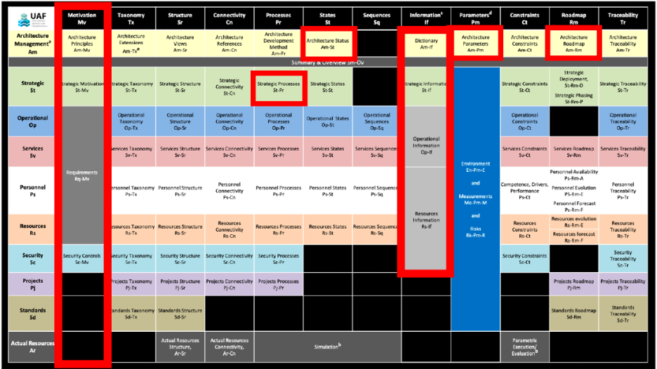

Figure 1. UAF approach [10]

**Technical Aspects**

The technical aspects of implementing the Unified Architecture Framework (UAF) are pivotal to understanding how the framework can be effectively utilized to enhance enterprise strategic planning. This section delves into the specific technical components, methodologies, and tools associated with UAF, illustrating how they contribute to a cohesive and comprehensive enterprise architecture [11].

UAF Viewpoints and Models

UAF is structured around a series of viewpoints, each offering a different perspective on the enterprise architecture. These viewpoints are essential for capturing the complex interdependencies within an organization and aligning various components with the overall business strategy. The primary viewpoints in UAF include:

Operational Viewpoint: Focuses on the organization’s business processes, workflows, and operational activities. It provides a detailed understanding of how the business functions and interacts with its environment, identifying key processes and their dependencies.

Systems Viewpoint: Addresses the technical infrastructure and applications that support the operational activities. It includes the design and integration of IT systems, highlighting their roles, interactions, and dependencies.

Service Viewpoint: Concentrates on the services provided by the enterprise, both internally and externally. It defines service contracts, service interfaces, and service delivery mechanisms, ensuring that services are aligned with business needs and customer expectations.

Security Viewpoint: Focuses on the security aspects of the enterprise architecture, including data protection, access control, and risk management. It ensures that security measures are integrated into the architecture from the outset, rather than being an afterthought [20-21].

Information Viewpoint: Deals with the data and information assets of the organization. It includes data models, information flows, and data governance policies, ensuring that information is managed effectively and used to support decision-making. Each viewpoint is supported by a set of models and artifacts that provide detailed representations of the specific aspects of the enterprise architecture. These models help in visualizing, analyzing, and communicating the architecture to various stakeholders, facilitating a common understanding and collaboration.

UAF Methodologies

UAF employs a variety of methodologies to guide the development and implementation of the enterprise architecture. These methodologies are designed to be flexible and adaptable, allowing organizations to tailor them to their specific needs. Key methodologies include:

Architecture Development Method (ADM): A step-by-step process for developing and managing enterprise architecture. It includes phases such as architecture vision, business architecture, information systems architecture, technology architecture, opportunities and solutions, and implementation governance.

Capability-Based Planning: Focuses on identifying and developing the capabilities required to achieve the organization’s strategic objectives. It involves assessing current capabilities, identifying gaps, and planning for the development of new capabilities.

Model-Based Systems Engineering (MBSE): Uses models to support the specification, analysis, design, verification, and validation of systems. MBSE enhances the ability to manage complexity, improve communication, and ensure consistency across the architecture.

Risk Management: Integrates risk assessment and mitigation strategies into the architecture development process. It involves identifying potential risks, analyzing their impact, and implementing controls to reduce their likelihood and consequences [12].

Tools and Technologies:

Implementing UAF requires a range of tools and technologies to support the modeling, analysis, and management of the enterprise architecture. These tools facilitate the creation and maintenance of UAF models, ensuring that they are accurate, up-to-date, and accessible. Key tools and technologies include:

Architecture Modeling Tools: Software applications that support the creation of UAF models. Examples include Sparx Systems Enterprise Architect, IBM Rational System Architect, and No Magic Cameo Enterprise Architecture. These tools provide capabilities for visual modeling, simulation, and analysis, enabling architects to develop and manage complex architectures [23,24].

Collaboration Platforms: Tools that support communication and collaboration among stakeholders. Examples include Microsoft Teams, Slack, and Confluence. These platforms enable real-time collaboration, document sharing, and project management, ensuring that all stakeholders are engaged and informed throughout the architecture development process.

Data Management Tools: Technologies that support the management and governance of data assets. Examples include data catalogs, data integration platforms, and data quality tools. These tools ensure that data is accurate, consistent, and accessible, supporting effective decision-making.

Security Tools: Technologies that support the implementation and management of security measures. Examples include identity and access management (IAM) systems, security information and event management (SIEM) solutions, and encryption tools. These tools ensure that security is integrated into the architecture and that risks are managed effectively.

Integration and Interoperability:

One of the key technical challenges in implementing UAF is ensuring integration and interoperability across various systems and components. UAF promotes the use of standardized protocols, data formats, and interfaces to facilitate seamless integration. Key strategies for achieving integration and interoperability include:

Service-Oriented Architecture (SOA): An architectural pattern that enables different systems and components to communicate and collaborate through standardized service interfaces. SOA promotes flexibility and reusability, allowing organizations to integrate new services and technologies without disrupting existing systems.

Application Programming Interfaces (APIs): Standardized interfaces that enable different systems to interact and exchange data. APIs provide a flexible and scalable way to integrate systems, ensuring that they can work together seamlessly.

Data Standards: Use of common data standards and formats to ensure that data can be easily shared and understood across different systems. Examples include XML, JSON, and industry-specific standards such as HL7 for healthcare and ACORD for insurance.

Middleware Solutions: Software that acts as an intermediary between different systems, enabling them to communicate and share data. Middleware solutions provide connectivity, data transformation, and messaging services, ensuring that systems can interoperate effectively.

Continuous Improvement and Adaptation:

The technical implementation of UAF is not a one-time effort but an ongoing process of continuous improvement and adaptation. As the business environment evolves and new technologies emerge, organizations must regularly review and update their enterprise architecture to ensure that it remains aligned with their strategic objectives. Key practices for continuous improvement include:

Regular Architecture Reviews: Conducting periodic reviews of the enterprise architecture to assess its effectiveness and identify areas for improvement. These reviews should involve key stakeholders and use metrics and performance indicators to evaluate the architecture.

Feedback Mechanisms: Establishing mechanisms for collecting feedback from stakeholders, including employees, customers, and partners. This feedback should be used to inform updates and enhancements to the architecture.

Agile Practices: Adopting agile methodologies and practices to enable rapid and flexible responses to changes in the business environment. Agile practices promote iterative development, continuous feedback, and incremental improvements.

Technology Watch: Keeping abreast of emerging technologies and trends that could impact the enterprise architecture. This involves monitoring industry developments, participating in professional networks, and investing in research and development.

In summary, the technical aspects of UAF implementation are critical to its success in enhancing enterprise strategic planning. By leveraging UAF's structured methodologies, comprehensive viewpoints, and advanced tools and technologies, organizations can develop a robust and adaptable enterprise architecture that aligns business and IT, improves decision-making, and drives long-term success. Continuous improvement and adaptation ensure that the architecture remains relevant and effective in a dynamic business environment, supporting sustainable growth and competitive advantage [10].

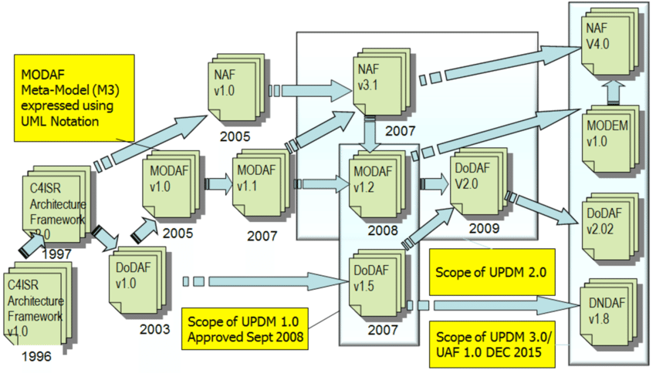

Figure 2. A Simplified History of DoDAF, MODAF and NAF [13]

**Applications of UAF**

The Unified Architecture Framework (UAF) is a powerful tool for addressing a wide range of challenges in enterprise strategic planning. This section explores the diverse applications of UAF, demonstrating how it can be leveraged to improve business-IT alignment, enhance decision-making, and drive organizational agility and innovation.

Business-IT Alignment

One of the primary applications of UAF is to align business objectives with IT infrastructure, ensuring that technological investments support the strategic goals of the organization. This alignment is crucial for maximizing the value derived from IT initiatives and avoiding misalignment that can lead to wasted resources and missed opportunities.

Strategic Alignment Models: UAF helps in developing models that illustrate the relationship between business strategies and IT capabilities. These models enable organizations to identify gaps and redundancies in their IT landscape, ensuring that every technological investment directly supports business objectives.

Capability Mapping: By mapping business capabilities to IT systems and services, UAF provides a clear view of how technology supports key business functions. This capability mapping helps in prioritizing IT projects that have the greatest impact on business performance and strategic goals.

Portfolio Management: UAF supports the management of IT portfolios by providing a structured approach to evaluate, select, and prioritize IT investments. This ensures that IT resources are allocated efficiently and aligned with the organization’s strategic priorities.

Decision-Making Enhancement

UAF enhances decision-making by providing a comprehensive framework for analyzing and understanding the enterprise architecture. This leads to more informed and effective decisions that drive organizational success.

Scenario Planning: UAF enables organizations to create and analyze different scenarios to understand the potential impact of various strategic decisions. This helps in identifying risks and opportunities, allowing decision-makers to choose the best course of action.

Impact Analysis: Through detailed models and simulations, UAF helps organizations assess the impact of changes in the architecture on business operations. This impact analysis is crucial for understanding the implications of strategic decisions and minimizing unintended consequences.

Performance Metrics: UAF provides a set of performance metrics and indicators that help organizations measure the effectiveness of their architecture and strategic initiatives. These metrics support continuous improvement by identifying areas for enhancement and tracking progress towards strategic goals.

Organizational Agility

In today’s rapidly changing business environment, organizational agility is essential for maintaining a competitive edge. UAF supports agility by providing a flexible and adaptable framework that can quickly respond to changes in the market and technology landscape.

Modular Architecture: UAF’s modular approach allows organizations to develop and implement architectural components incrementally. This modularity supports quick adaptation to new requirements and changes, enabling organizations to stay agile and responsive.

Continuous Integration and Delivery: UAF supports practices such as continuous integration and continuous delivery (CI/CD), which are essential for maintaining agility in IT development and operations. These practices ensure that new features and improvements are delivered rapidly and reliably.

Change Management: UAF includes methodologies for managing change within the enterprise architecture. By providing a structured approach to change management, UAF helps organizations implement changes smoothly and minimize disruption.

Risk Management and Compliance

Risk management and compliance are critical aspects of enterprise strategic planning, particularly in industries with stringent regulatory requirements. UAF supports these areas by providing comprehensive frameworks and tools for identifying, assessing, and mitigating risks.

Risk Assessment Models: UAF includes models for assessing risks across various domains, including operational, financial, and technological risks. These models help organizations identify potential threats and vulnerabilities, enabling proactive risk management.

Compliance Frameworks: UAF supports the development of compliance frameworks that ensure the organization meets regulatory requirements and industry standards. These frameworks provide a structured approach to compliance, reducing the risk of non-compliance and associated penalties.

Security Architecture: The security viewpoint in UAF focuses on integrating security measures into the enterprise architecture. This ensures that security is considered from the outset, rather than being an afterthought, reducing the risk of security breaches and enhancing overall resilience.

Innovation and Digital Transformation

UAF plays a vital role in supporting innovation and digital transformation initiatives by providing a structured approach to exploring and implementing new technologies and business models.

Innovation Management: UAF helps organizations develop and manage innovation portfolios, ensuring that innovative ideas are evaluated, prioritized, and implemented effectively. This supports a culture of continuous innovation and improvement.

Digital Twin Modeling: UAF supports the creation of digital twins – virtual replicas of physical systems – to simulate and analyze real-world scenarios. Digital twin modeling helps organizations explore new business models and optimize existing processes.

Emerging Technologies Integration: UAF provides a framework for integrating emerging technologies such as artificial intelligence, blockchain, and the Internet of Things (IoT) into the enterprise architecture. This integration ensures that new technologies are aligned with business goals and deliver maximum value.

Strategic Planning and Execution

Finally, UAF supports the overall process of strategic planning and execution by providing a comprehensive framework that guides organizations from strategy development to implementation and monitoring.

Strategic Roadmaps: UAF helps organizations develop strategic roadmaps that outline the steps needed to achieve their strategic objectives. These roadmaps provide a clear path from the current state to desired future state, ensuring alignment and coherence.

Program and Project Management: UAF includes methodologies for managing programs and projects that support strategic initiatives. This ensures that projects are delivered on time, within budget, and aligned with strategic goals.

Performance Monitoring and Feedback: UAF supports continuous monitoring of performance and feedback mechanisms to ensure that strategic initiatives are on track and delivering the expected benefits. This continuous monitoring enables organizations to make necessary adjustments and improvements in real-time.

In summary, the applications of UAF in enterprise strategic planning are diverse and far-reaching. By leveraging UAF, organizations can achieve better alignment between business and IT, enhance decision-making processes, improve agility, manage risks effectively, drive innovation, and ensure successful strategic planning and execution. The comprehensive and adaptable nature of UAF makes it an invaluable tool for organizations looking to thrive in a complex and dynamic business environment.

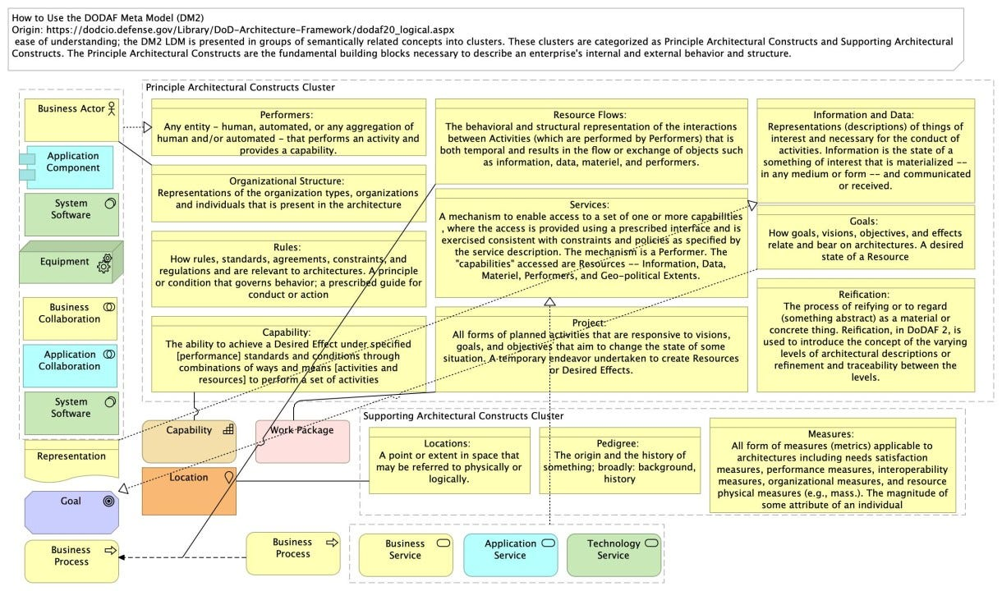

Figure 4. Applications of UAF [14]

**Limitations and Future Perspectives**

The Unified Architecture Framework (UAF) offers numerous benefits for enterprise strategic planning, but it also comes with certain limitations that organizations need to be aware of. Understanding these limitations is crucial for effective implementation and maximizing the framework's potential. Additionally, looking ahead, the future perspectives of UAF can provide insights into how the framework can evolve to address emerging challenges and opportunities in healthcare as well [26].

Limitations of UAF

Complexity and Learning Curve: UAF is a comprehensive and detailed framework, which can make it complex to understand and implement. Organizations, especially those with limited experience in enterprise architecture, may find the learning curve steep. This complexity can lead to extended implementation times and require significant training and expertise.

Resource Intensive: Implementing UAF can be resource-intensive in terms of time, money, and human resources. The development and maintenance of detailed architectural models requires skilled personnel, which can be costly. Smaller organizations with limited resources may struggle to fully leverage the framework.

Rigidity in Fast-Paced Environments: While UAF provides a structured approach, it can sometimes be perceived as too rigid, especially in fast-paced environments where rapid changes are common. The detailed nature of UAF can slow down the response to urgent changes if not managed properly.

Integration Challenges: Integrating UAF with existing systems and processes can be challenging. Organizations with established frameworks or those using different architectural methodologies might find it difficult to align UAF with their current practices without significant adjustments.

Scalability Issues: For very large organizations with highly complex structures, UAF might need additional customization to scale effectively. The framework’s predefined viewpoints and models may not cover all the unique needs of such organizations, necessitating bespoke extensions and adaptations.

Stakeholder Buy-In: Achieving buy-in from all relevant stakeholders can be challenging. UAF requires collaboration across different departments and levels of the organization. Resistance to change or lack of understanding among stakeholders can hinder successful implementation.

Future Perspectives of UAF

Despite these limitations, the future of UAF looks promising, with several opportunities for evolution and enhancement. Addressing current limitations and incorporating new trends and technologies can make UAF even more effective and relevant.

Simplification and Accessibility: To address complexity and the steep learning curve, future iterations of UAF could focus on simplification without losing depth. Developing more intuitive tools, providing better documentation, and offering comprehensive training programs can make UAF more accessible to a broader range of organizations.

Enhanced Tool Support: Advancements in technology can lead to the development of more sophisticated tools that support UAF implementation. These tools could offer enhanced automation, better integration capabilities, and more user-friendly interfaces, reducing the resource burden and increasing efficiency.

Agile and Lean Adaptations: Integrating agile and lean principles into UAF could make it more flexible and responsive to changes. By incorporating agile methodologies, UAF can support iterative development and continuous improvement, allowing organizations to adapt quickly to new challenges and opportunities.

Integration with Emerging Technologies: As emerging technologies such as artificial intelligence (AI), machine learning, blockchain, and the Internet of Things (IoT) become more prevalent, UAF can evolve to better integrate these technologies into enterprise architectures. This integration can help organizations leverage cutting-edge technologies for strategic advantage. Saha et al. (2024) describes in his four different paper how steel technology can have significant impact [22,23,25].

Customization and Scalability: Future versions of UAF could offer more customizable options to better suit the unique needs of different organizations. Enhancing scalability features will ensure that UAF remains effective for both small businesses and large enterprises with complex structures.

Stakeholder Engagement: Improving methods for engaging stakeholders can enhance buy-in and collaboration. Future developments could include better communication tools, more inclusive planning processes, and mechanisms for continuous feedback and involvement from all levels of the organization.

Sustainability and Social Responsibility: As sustainability and corporate social responsibility (CSR) become increasingly important, UAF can incorporate these aspects into its framework. Developing viewpoints and models that focus on sustainability metrics and CSR initiatives can help organizations align their strategic planning with broader societal goals.

Global Standards and Interoperability: To facilitate better integration and interoperability, UAF can work towards aligning more closely with global standards and industry-specific frameworks. This alignment can make it easier for organizations operating in different regions and sectors to adopt UAF.

**Conclusion:**

The Unified Architecture Framework (UAF) stands as a powerful tool in the realm of enterprise strategic planning, offering a structured methodology for aligning business objectives with IT infrastructure. Its comprehensive set of viewpoints and methodologies facilitates a deep understanding of organizational dynamics, enabling improved decision-making, enhanced agility, and effective risk management. UAF’s strength lies in its ability to integrate various architectural domains, providing a cohesive view that supports strategic alignment and drives organizational success. Despite its advantages, UAF is not without limitations. The framework’s complexity can present a steep learning curve, and its resource-intensive nature may be challenging for organizations with limited resources. Additionally, the rigidity of UAF in fast-paced environments and integration challenges with existing systems highlight areas where adaptability and customization are needed. Achieving stakeholder buy-in remains a crucial factor for successful implementation. Looking ahead, the future of UAF is promising, with several opportunities for evolution and enhancement. Simplification of the framework, advanced tool support, and integration with emerging technologies will address current limitations and make UAF more accessible and effective. Incorporating agile practices, customization options, and focusing on sustainability and global standards will further enhance its relevance and utility in a rapidly changing business environment. nIn conclusion, UAF offers significant benefits for organizations seeking to achieve strategic alignment and operational excellence. By addressing its limitations and embracing future developments, UAF can continue to be a vital asset in navigating the complexities of modern enterprise architecture. Organizations that leverage UAF effectively will be well-positioned to drive innovation, maintain agility, and achieve sustainable growth in an ever-evolving landscape.

**References:**

1. Aguilar, M. I. (2004). HPLC of Peptides and Proteins (Vol. 251, pp. 3-8). Springer New York.
2. Moros, E. E., Darnoko, D., Cheryan, M., Perkins, E. G., & Jerrell, J. (2002). Analysis of xanthophylls in corn by HPLC. Journal of agricultural and food chemistry, 50(21), 5787-5790.
3. Kalili, K. M., & de Villiers, A. (2011). Recent developments in the HPLC separation of phenolic compounds. Journal of separation science, 34(8), 854-876.
4. Dong, M. W. (2006). Modern HPLC for practicing scientists. John Wiley & Sons.
5. Christou, C., Agapiou, A., & Kokkinofta, R. (2018). Use of FTIR spectroscopy and chemometrics for the classification of carobs origin. Journal of Advanced Research, 10, 1-8.
6. Bonoli, M., Pelillo, M., Toschi, T. G., & Lercker, G. (2003). Analysis of green tea catechins: comparative study between HPLC and HPCE. Food Chemistry, 81(4), 631-638.
7. Nivitha, M. R., Prasad, E., & Krishnan, J. M. (2016). Ageing in modified bitumen using FTIR spectroscopy. International Journal of Pavement Engineering, 17(7), 565-577.
8. Zapata, M., Rodríguez, F., & Garrido, J. L. (2000). Separation of chlorophylls and carotenoids from marine phytoplankton: a new HPLC method using a reversed phase C8 column and pyridine-containing mobile phases. Marine Ecology Progress Series, 195, 29-45.
9. Wolfender, J. L. (2009). HPLC in natural product analysis: the detection issue. Planta medica, 75(07), 719-734.
10. Zuo, Y., Chen, H., & Deng, Y. (2002). Simultaneous determination of catechins, caffeine and gallic acids in green, Oolong, black and pu-erh teas using HPLC with a photodiode array detector. Talanta, 57(2), 307-316.
11. Jayaprakasha, G. K., Jagan Mohan Rao, L., & Sakariah, K. K. (2002). Improved HPLC method for the determination of curcumin, demethoxycurcumin, and bisdemethoxycurcumin. Journal of agricultural and food chemistry, 50(13), 3668-3672.
12. Schneider, A., Gerbi, V., & Redoglia, M. (1987). A rapid HPLC method for separation and determination of major organic acids in grape musts and wines. American Journal of Enology and Viticulture, 38(2), 151-155.
13. Zhang, Z., Kou, X., Fugal, K., & McLaughlin, J. (2004). Comparison of HPLC methods for determination of anthocyanins and anthocyanidins in bilberry extracts. Journal of Agricultural and Food Chemistry, 52(4), 688-691.
14. Mant, C. T., Chen, Y., Yan, Z., Popa, T. V., Kovacs, J. M., Mills, J. B., ... & Hodges, R. S. (2007). HPLC analysis and purification of peptides. Peptide characterization and application protocols, 3-55.
15. Hoque, R., Das, S., Hoque, M., & Haque, E. (2024). Breast Cancer Classification using XGBoost. World Journal of Advanced Research and Reviews, 21(2), 1985-1994.
16. Hoque, R., Maniruzzaman, M., Michael, D. L., & Hoque, M. (2024). Empowering blockchain with SmartNIC: Enhancing performance, security, and scalability. World Journal of Advanced Research and Reviews, 22(1), 151-162.
17. Amit Deb Nath, Rahmanul Hoque, Md. Masum Billah, Numair Bin Sharif, Mahmudul Hoque . Distributed Parallel and Cloud Computing: A Review. International Journal of Computer Applications. 186, 16 ( Apr 2024), 25-32. DOI=10.5120/ijca2024923547
18. Maniruzzaman, M., Sami, A., Hoque, R., & Mandal, P. (2024). Pneumonia prediction using deep learning in chest X-ray Images. International Journal of Science and Research Archive, 12(1), 767-773.
19. Hoque, R., Billah, M., Debnath, A., Hossain, S. S., & Sharif, N. B. (2024). Heart Disease Prediction using SVM. International Journal of Science and Research Archive, 11(2), 412-420.
20. E. B. Snider, R. K. Saha, C. Dominguez, J. Huang, and D. A. Bristow, “Embedding Fiber Optic Sensors in Metal Components via Direct Energy Deposition,” in 34th Annual International Solid Freeform Fabrication Symposium – An Additive Manufacturing Conference, 2023, pp. 1070–1079.
21. Mekala, Y. R., Inalegwu, O. C., Saha, R. K., Mumtaz, F., Gerald II, R. E., Smith, J. D., ... & O’Malley, R. J. (2024). Enhanced Bottom Anode Monitoring in DC Electric Arc Furnaces Using Fiber-Optic Sensors. In AISTech 2024—Proceedings of the Iron & Steel Technology Conference.
22. R. K. Saha. Muhammad A. Nazim, M. Buchely, R. O’Malley, J. Huang, and A. Emdadi, “A Lab-Scale Mold Simulator Employing an Optical-Fiber-Instrumented Mold to Characterize Initial Steel Shell Growth Phenomena,” in AISTech 2024 — Proceedings of the Iron & Steel Technology Conference, 2024, doi: 10.33313/388/100.
23. Mekala, Y. R., Saha, R. K., Inalegwu, O. C., Roman, M., Mumtaz, F., II, R. E. G., ... & O’Malley, R. J. (2024). Improved Monitoring of the Water-Cooled Upper Shell of an Electric Arc Furnace Using Fiber-Optic Sensors. In AISTech 2024—Proceedings of the Iron & Steel Technology Conference.
24. Inalegwu, O. C., Mekala, Y. R., Saha, R. K., Mumtaz, F., Alla, D. R., Neelakandan, D. P., ... & Huang, J. (2024). Femtosecond Laser–Inscribed Fiber Bragg Grating Sensors: Enabling Distributed High-Temperature Measurements and Strain Monitoring in Steelmaking and Foundry Applications. In AISTech 2024—Proceedings of the Iron & Steel Technology Conference.
25. K. Dey et al., “Releasing Residual Stress in Metal-Coated Fibers Through Heat Treatment Process for Distributed High-Temperature Sensing Applications,” in 2024 Conference on Lasers and Electro-Optics (CLEO), 2024, pp. 1–2.
26. Fahmudur Rahman, Denesh Das, Anhar Sami, Priya Podder and Daniel Lucky Michael, “Liver cirrhosis prediction using logistic regression, naïve bayes and KNN”, International Journal of Science and Research Archive, 2024, 12(01), 2411–2420.