**Transforming Enterprises through UAF Strategic Planning: Frameworks and Best Practices**

**Iqtiar Md Siddique**

Department of Mechanical Engineering, the University of Texas at El Paso, USA.

Email: [iqtiar.siddique@gmail.com](mailto:iqtiar.siddique@gmail.com).

**Abstract:**

This research investigates how the Unified Architecture Framework (UAF) can be leveraged to transform enterprise strategic planning, focusing on the application of UAF frameworks and best practices to drive organizational success. It provides an overview of UAF’s comprehensive methodology, detailing its various viewpoints and models that facilitate alignment between business objectives and IT infrastructure. The paper examines how UAF supports effective decision-making, enhances organizational agility, and improves risk management through a structured approach. Through case studies and practical examples, the paper illustrates successful implementations of UAF, highlighting the benefits and challenges encountered. It offers actionable insights into best practices for integrating UAF into existing strategic planning processes, including strategies for overcoming common obstacles and maximizing the framework’s potential. The discussion extends to future perspectives, addressing emerging trends and technological advancements that could influence UAF's evolution and application. Overall, the paper underscores the transformative impact of UAF on enterprise strategic planning, providing a roadmap for organizations seeking to leverage the framework to achieve strategic alignment, innovation, and long-term success. The paper also delves into the practical aspects of adopting UAF, including the steps required for successful implementation. It covers critical considerations such as the need for comprehensive training and stakeholder engagement, the importance of tailoring UAF to fit specific organizational contexts, and the integration of UAF with existing tools and methodologies. Through detailed analysis, the paper identifies key success factors and common pitfalls, offering guidance on how to navigate these challenges effectively. Furthermore, the paper explores the future trajectory of UAF, emphasizing the potential for further refinement and adaptation in response to evolving business and technological landscapes. It highlights how emerging technologies, such as artificial intelligence and advanced data analytics, can be integrated into the UAF framework to enhance its capabilities. By addressing these future perspectives, the paper aims to provide a forward-looking view of how UAF can continue to drive enterprise transformation and innovation in an increasingly complex and dynamic environment.

**Keywords**: Unified Architecture Framework, strategic planning, enterprise transformation, business-IT alignment, emerging technologies

**Introduction**

In today’s rapidly evolving business environment, organizations face increasing pressure to remain competitive, agile, and aligned with ever-changing market demands. Strategic planning has become a critical process for navigating these complexities, ensuring that enterprises not only respond to current challenges but also proactively shape their future. The Unified Architecture Framework (UAF) emerges as a vital tool in this context, providing a structured and comprehensive approach to enterprise architecture that facilitates strategic alignment between business goals and IT infrastructure [1]. UAF, developed by the Object Management Group (OMG), represents a significant advancement in the field of enterprise architecture. It integrates various architectural domains into a unified model, allowing organizations to capture and analyze the complex interrelationships within their operations. The framework’s modular and viewpoint-based approach offers a holistic perspective, enabling organizations to understand and manage their business processes, information flows, technology infrastructure, and security measures in a coherent manner [2]. At its core, UAF addresses the need for a common language and methodology for enterprise architecture. This is particularly crucial in an era where organizations operate across diverse geographies and industries, often using disparate systems and processes. By providing standardized viewpoints and models, UAF facilitates communication and collaboration among stakeholders, ensuring that all parts of the organization are aligned with the overarching strategic objectives [3].

The significance of UAF in strategic planning lies in its ability to enhance decision-making and drive organizational agility. Through its structured methodologies, UAF enables enterprises to create detailed architectural models that support scenario planning, impact analysis, and performance monitoring. This structured approach helps organizations make informed decisions, optimize resource allocation, and respond swiftly to changes in the business environment. Furthermore, UAF’s emphasis on aligning IT capabilities with business needs ensures that technological investments contribute effectively to strategic goals, avoiding misalignment and redundancy [4].

Despite its strengths, the implementation of UAF is not without challenges. Organizations may encounter difficulties related to the complexity of the framework, the resource demands of detailed architectural modeling, and the integration with existing systems and practices. Additionally, achieving stakeholder buy-in and adapting UAF to fit specific organizational contexts are critical factors for successful implementation. Addressing these challenges requires careful planning, effective communication, and a commitment to continuous improvement [5].

As the business landscape continues to evolve, UAF also faces opportunities for enhancement and adaptation. The integration of emerging technologies such as artificial intelligence, machine learning, and advanced data analytics presents new possibilities for expanding UAF’s capabilities. These advancements can further support strategic planning by providing deeper insights, improving predictive accuracy, and enhancing overall agility [6].

This paper aims to provide a comprehensive exploration of how UAF can transform enterprise strategic planning. It will examine the framework’s methodologies, best practices for implementation, and real-world case studies that illustrate its impact. By offering insights into both the practical applications and future perspectives of UAF, the paper seeks to equip organizations with the knowledge needed to leverage this powerful framework for achieving strategic alignment, driving innovation, and ensuring long-term success [7].

The evolving nature of global markets and technological advancements further underscores the importance of a robust framework like UAF for strategic planning. Organizations are increasingly required to navigate a complex web of competitive pressures, regulatory requirements, and technological disruptions. UAF's comprehensive approach provides the tools necessary to address these multifaceted challenges by aligning business strategies with IT infrastructure and operational processes. This alignment not only enhances operational efficiency but also fosters innovation by ensuring that technological capabilities are fully leveraged to support strategic initiatives [8]. Moreover, the integration of UAF with other strategic frameworks and methodologies can amplify its effectiveness. For instance, combining UAF with Agile practices can enhance the framework’s adaptability, allowing organizations to respond more dynamically to market changes. Similarly, incorporating UAF into risk management and compliance strategies helps ensure that all aspects of the enterprise architecture are aligned with regulatory requirements and risk mitigation measures. This holistic approach enables organizations to build resilient and adaptable architectures that support long-term strategic objectives [9].

Looking ahead, the continued evolution of UAF will likely involve greater emphasis on data-driven decision-making and enhanced interoperability with other frameworks and technologies. As enterprises increasingly adopt digital transformation strategies, UAF can be instrumental in integrating emerging technologies such as blockchain, IoT, and big data analytics into the enterprise architecture. This evolution will ensure that UAF remains a relevant and valuable tool for organizations seeking to navigate the complexities of the digital age, drive innovation, and maintain a competitive edge in an ever-changing business landscape [10].

**Background**

In the dynamic and complex landscape of modern enterprises, strategic planning has become a crucial process for aligning business objectives with operational and technological capabilities. The Unified Architecture Framework (UAF), developed by the Object Management Group (OMG), provides a comprehensive approach to enterprise architecture that facilitates this alignment. UAF offers a standardized methodology for integrating various architectural domains, including business processes, information systems, and technology infrastructure [11].

UAF's development is rooted in the need for a unified approach to managing and understanding enterprise architecture. Traditional architectural frameworks often struggled with fragmentation and inconsistency, leading to inefficiencies and misalignment between business strategies and IT systems. UAF addresses these challenges by providing a cohesive framework that integrates multiple viewpoints, offering a holistic perspective on organizational structures and processes.

The framework is designed to support strategic decision-making by providing detailed models and methodologies for analyzing and optimizing enterprise architecture. By aligning IT capabilities with business goals, UAF helps organizations improve operational efficiency, enhance agility, and drive innovation. Its structured approach also supports risk management and compliance, ensuring that all aspects of the enterprise architecture are aligned with regulatory requirements and risk mitigation strategies.

As businesses continue to face rapid technological advancements and evolving market conditions, UAF remains a vital tool for navigating these changes. Its ability to integrate emerging technologies and adapt to new business needs makes it an essential component of modern strategic planning and enterprise transformation. UAF’s relevance extends beyond its immediate application in enterprise architecture. In a world where organizations are increasingly interconnected and reliant on technology, UAF provides a critical framework for managing the complexities of digital transformation. It helps organizations create a cohesive strategy that aligns their IT infrastructure with evolving business needs, facilitating seamless integration and optimization across various systems and processes [12]. Furthermore, UAF’s adaptability to different organizational contexts and its alignment with global standards make it a versatile tool for enterprises operating in diverse industries and geographies. The framework’s structured methodologies and standardized viewpoints allow organizations to tailor their architectural approaches to meet specific requirements while maintaining consistency and coherence. This flexibility ensures that UAF can be effectively applied across various sectors, from manufacturing and healthcare to finance and telecommunications.

Looking to the future, UAF is poised to evolve in response to emerging trends and technological advancements. The increasing adoption of advanced technologies such as artificial intelligence, machine learning, and blockchain presents new opportunities for enhancing UAF’s capabilities. By integrating these technologies into its framework, UAF can support more sophisticated data analysis, improve predictive modeling, and facilitate innovation. As enterprises continue to navigate a rapidly changing business landscape, UAF will remain a vital tool for achieving strategic alignment, operational efficiency, and sustained competitive advantage [13].

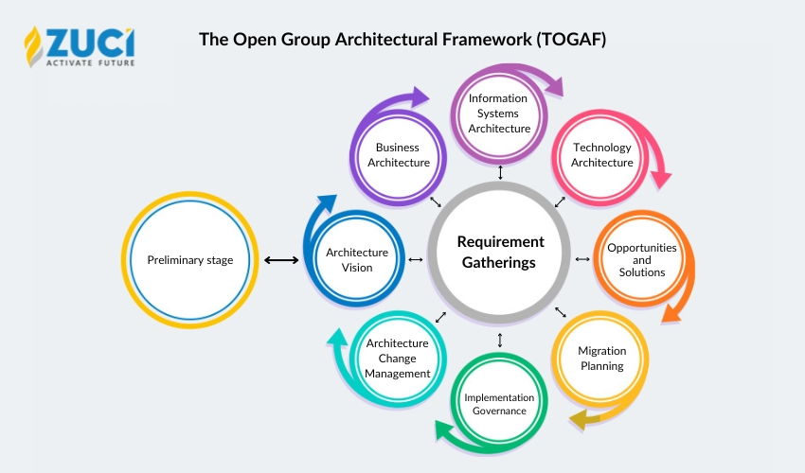

Figure 1. UAF approach details [10]

**Technical Aspects**

The Unified Architecture Framework (UAF) encompasses several technical aspects that are integral to its functionality and effectiveness in enterprise architecture. These technical components facilitate comprehensive modeling, alignment, and analysis of organizational structures and processes. Below are the key technical aspects of UAF:

1. Viewpoints and Models

UAF employs a variety of viewpoints and models to provide a holistic perspective on enterprise architecture. Each viewpoint represents a specific aspect of the architecture, allowing stakeholders to address different concerns and requirements. encompass a broad spectrum of advanced research topics, illustrating significant progress in various fields such as healthcare, blockchain technology, distributed computing, additive manufacturing, and steelmaking applications. These studies demonstrate innovative methodologies and their implications for practical applications, offering valuable insights for both academia and industry [15-19].

Business Viewpoint: Focuses on the organization’s business processes, goals, and organizational structure. It includes models such as business process diagrams and organizational charts, which help in understanding and optimizing business operations.

Information Viewpoint: Addresses the organization’s data and information flows, including data models and information architectures. This viewpoint ensures that data management practices align with business needs and supports effective information exchange.

Technology Viewpoint: Covers the technology infrastructure, including hardware, software, and network components. It involves technical models such as system architecture diagrams and technology maps, which support the planning and management of IT resources [20-24].

Security Viewpoint: Focuses on the security aspects of the enterprise architecture, including risk management, security policies, and compliance requirements. This viewpoint includes models such as security architecture diagrams and threat assessments.

2. Meta-Models and Framework Integration

UAF utilizes meta-models to define the structure and relationships of the architectural elements within the framework. These meta-models provide a common language and set of definitions that facilitate the integration and interoperability of various architectural components.

Meta-Model Structure: Defines the fundamental elements and their relationships within the UAF framework. It includes classes, attributes, and associations that describe the architecture’s components and their interactions.

Framework Integration: UAF can be integrated with other architectural frameworks and standards, such as TOGAF (The Open Group Architecture Framework) and ArchiMate. This integration allows organizations to leverage existing methodologies and tools while adopting UAF’s structured approach.

3. Modeling Techniques and Tools

UAF employs various modeling techniques and tools to create and analyze architectural models. These techniques support visualization, simulation, and analysis of the enterprise architecture, aiding in decision-making and strategic planning.

Modeling Techniques: Includes graphical notations and diagrams such as UML (Unified Modeling Language) and SysML (Systems Modeling Language) to represent different architectural aspects. These techniques facilitate clear communication and understanding of complex architectural structures.

Modeling Tools: Software tools that support UAF modeling and analysis, such as enterprise architecture modeling tools and integrated development environments (IDEs). These tools provide features for creating, managing, and analyzing architectural models, improving efficiency and accuracy.

4. Governance and Compliance

UAF incorporates governance and compliance mechanisms to ensure that the enterprise architecture aligns with regulatory requirements and organizational standards. This includes:

Governance Framework: Defines roles, responsibilities, and processes for managing and overseeing the enterprise architecture. It includes policies and procedures for maintaining consistency, quality, and alignment with strategic objectives.

Compliance Mechanisms: Ensures that the enterprise architecture adheres to relevant regulations and standards, such as data protection laws and industry-specific requirements. This includes compliance checks, audits, and reporting processes. They have discussed healthcare activities [25,26] and coding knowledge which is our further direction for our research extension.

5. Scalability and Adaptability

UAF is designed to be scalable and adaptable, accommodating the needs of different organizations and evolving business environments.

Scalability: Allows the framework to be applied to organizations of varying sizes and complexities, from small businesses to large enterprises. This scalability ensures that UAF remains effective regardless of the organization’s scale.

Adaptability: Supports customization and adaptation to fit specific organizational contexts and requirements. This adaptability enables organizations to tailor UAF to their unique needs, enhancing its relevance and utility. In summary, the technical aspects of UAF encompass a range of viewpoints, models, meta-models, and tools that facilitate comprehensive enterprise architecture management. By leveraging these technical components, organizations can effectively align their business objectives with IT infrastructure, drive strategic planning, and achieve operational excellence [10].

6. Interoperability and Integration

Interoperability is a critical technical aspect of UAF, ensuring that it can function seamlessly with various systems and frameworks. UAF's design allows for integration with other enterprise architecture standards and tools, facilitating a cohesive approach to managing diverse architectural elements.

Standards Alignment: UAF aligns with established standards such as ISO/IEC 42010 (Architecture Description) and ISO/IEC 42020 (Architecture Governance), which provide guidelines for documenting and managing enterprise architecture. This alignment ensures that UAF’s methodologies are compatible with global best practices and can be easily integrated into existing architectural frameworks.

System Integration: UAF supports integration with other enterprise systems, including business process management (BPM) tools, customer relationship management (CRM) systems, and enterprise resource planning (ERP) systems. This integration enables a unified view of organizational processes and data, improving overall efficiency and coordination.

7. Performance and Optimization

UAF also addresses performance and optimization concerns, ensuring that the enterprise architecture remains effective and efficient in supporting organizational goals.

Performance Metrics: UAF includes mechanisms for defining and monitoring performance metrics related to architectural components. This allows organizations to assess the effectiveness of their architecture in meeting strategic objectives and identify areas for improvement.

Optimization Techniques: The framework supports optimization techniques that enhance the performance of architectural elements. This includes analyzing resource utilization, streamlining processes, and implementing best practices to maximize efficiency and reduce costs.

8. Change Management and Evolution

Change management is an essential aspect of UAF, given the dynamic nature of business environments and technological advancements.

Change Management Processes: UAF incorporates processes for managing changes to the enterprise architecture, including version control, impact analysis, and stakeholder communication. These processes ensure that changes are implemented smoothly and align with strategic objectives.

Evolution and Continuous Improvement: UAF supports continuous improvement by allowing organizations to evolve their architecture in response to new challenges and opportunities. This includes updating architectural models, adopting new technologies, and refining methodologies to adapt to changing business needs. In summary, the technical aspects of UAF provide a comprehensive framework for managing enterprise architecture. By focusing on interoperability, performance, and change management, UAF ensures that organizations can effectively align their architecture with strategic goals, optimize performance, and adapt to evolving requirements. This robust technical foundation supports organizations in achieving operational excellence and maintaining a competitive edge in a complex and dynamic business landscape [14].

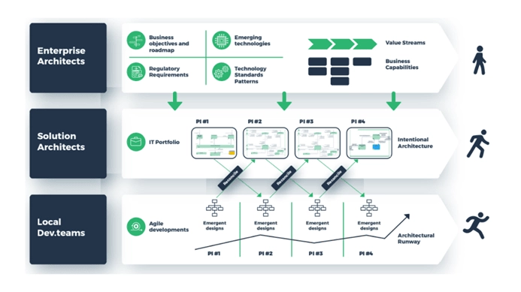

Figure 2. Enterprise architecture framework [13]

**Applications of UAF**

The Unified Architecture Framework (UAF) provides a versatile and structured approach to enterprise architecture that can be applied across various organizational contexts and industries. Its comprehensive methodology and detailed viewpoints facilitate numerous applications, enhancing strategic planning, operational efficiency, and innovation. Below are key applications of UAF:

1. Strategic Alignment and Planning

UAF plays a crucial role in aligning IT infrastructure with business strategies, ensuring that technological investments support organizational goals. By providing a holistic view of enterprise architecture, UAF helps organizations:

Develop and Refine Strategic Plans: UAF enables organizations to create detailed architectural models that align with strategic objectives, supporting scenario planning and impact analysis. This alignment ensures that IT resources and initiatives are directly contributing to business goals.

Optimize Resource Allocation: Through comprehensive modeling, UAF helps organizations assess their current resources, identify gaps, and allocate resources more effectively. This optimization improves the efficiency of IT investments and supports strategic initiatives.

2. Operational Efficiency and Improvement

UAF’s structured approach facilitates improvements in operational efficiency by providing insights into business processes, information flows, and technology infrastructure.

Process Optimization: UAF’s business viewpoint helps organizations map and analyze their business processes, identifying inefficiencies and opportunities for improvement. This leads to streamlined operations and enhanced productivity.

Integration and Coordination: UAF supports the integration of various systems and processes, improving coordination across departments and reducing duplication of efforts. This integration enhances overall operational efficiency and reduces costs.

3. Risk Management and Compliance

Effective risk management and compliance are critical for organizations operating in regulated industries. UAF assists in these areas by:

Identifying and Mitigating Risks: UAF’s security viewpoint provides tools for assessing and managing risks related to IT infrastructure and data security. By modeling potential threats and vulnerabilities, organizations can develop strategies to mitigate risks and protect sensitive information.

Ensuring Regulatory Compliance: UAF supports compliance with industry regulations and standards by incorporating relevant security and governance models. This ensures that the enterprise architecture adheres to legal and regulatory requirements, reducing the risk of non-compliance.

4. Digital Transformation and Innovation

As organizations undergo digital transformation, UAF provides a framework for integrating new technologies and processes into existing architectures.

Adopting Emerging Technologies: UAF helps organizations evaluate and integrate emerging technologies such as artificial intelligence, machine learning, and blockchain. This integration supports innovation and enhances the organization’s technological capabilities.

Supporting Agile Development: By aligning IT infrastructure with business needs, UAF facilitates agile development practices, allowing organizations to respond quickly to market changes and customer demands. This agility fosters innovation and competitive advantage.

5. Project and Program Management

UAF’s comprehensive modeling and analysis capabilities are valuable for managing complex projects and programs.

Project Planning and Execution: UAF provides a structured approach to project planning, including the definition of project scopes, objectives, and deliverables. This helps in managing project timelines, resources, and risks effectively.

Program Coordination: For large-scale programs involving multiple projects, UAF supports coordination and integration, ensuring that all projects align with strategic goals and deliver expected outcomes.

6. Organizational Change Management

Managing organizational change effectively is essential for maintaining stability and achieving desired outcomes.

Facilitating Change Implementation: UAF supports change management by providing a clear view of how changes to the enterprise architecture will impact various components. This helps organizations plan and implement changes smoothly, minimizing disruption.

Supporting Communication and Engagement: UAF’s structured approach facilitates communication among stakeholders, ensuring that all parties are informed and engaged throughout the change process. This engagement is crucial for gaining buy-in and ensuring successful implementation.

7. Customer and Stakeholder Engagement

Engaging customers and stakeholders is vital for aligning enterprise architecture with external expectations and requirements.

Enhancing Customer Experience: UAF helps organizations design and implement IT solutions that improve customer experience, by mapping customer journeys and aligning IT systems with customer needs.

Aligning with Stakeholder Needs: By providing a comprehensive view of enterprise architecture, UAF enables organizations to address stakeholder concerns and align IT initiatives with their expectations.

In summary, UAF’s diverse applications span strategic planning, operational efficiency, risk management, digital transformation, project management, change management, and stakeholder engagement. Its structured methodology and comprehensive viewpoints make it a valuable tool for organizations seeking to optimize their enterprise architecture and drive success in a complex and evolving business environment.

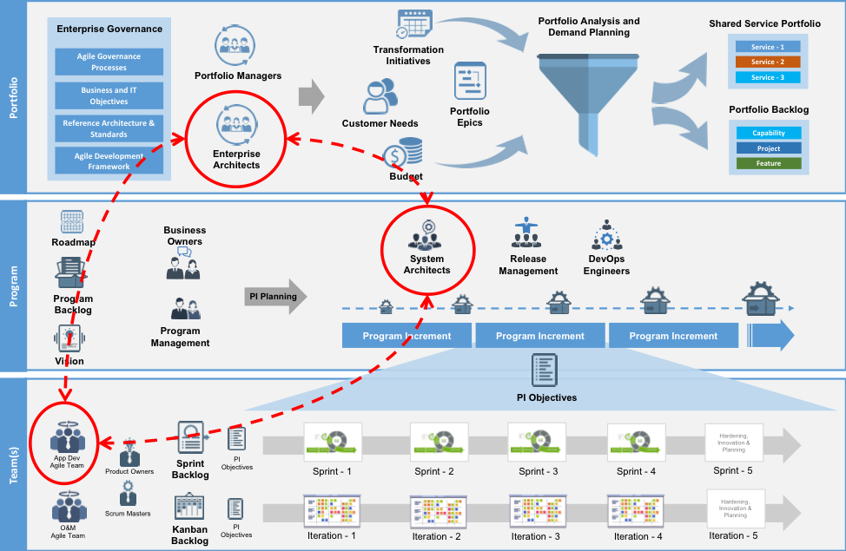

Figure 4. Do Common Platforms and Enterprise Architecture stifle innovation in an Agile Enterprise [14]

**Limitations and Future Perspectives**

The Unified Architecture Framework (UAF) offers significant benefits for managing enterprise architecture, but it also presents certain limitations that organizations must consider. Understanding these limitations is essential for effective implementation and maximizing UAF’s potential. Additionally, exploring future perspectives can provide insights into how UAF might evolve to address emerging challenges and opportunities.

Limitations of UAF

Complexity and Learning Curve

UAF is a sophisticated framework with numerous viewpoints, models, and methodologies. This complexity can result in a steep learning curve for organizations new to enterprise architecture or UAF itself. The detailed nature of UAF may require substantial training and expertise, potentially leading to increased implementation time and costs.

Resource Intensity

Implementing and maintaining UAF can be resource-intensive. Organizations may need significant investments in skilled personnel, software tools, and training programs. Smaller organizations, in particular, may find it challenging to allocate the necessary resources, which could hinder their ability to fully leverage the framework.

Rigidity in Dynamic Environments

UAF’s structured approach, while beneficial for standardization and consistency, can be perceived as rigid in rapidly changing environments. The detailed and comprehensive nature of UAF may slow down the organization’s ability to adapt quickly to urgent changes or new opportunities, potentially impacting agility.

Integration Challenges

Integrating UAF with existing systems and processes can be complex, especially for organizations with established frameworks or different architectural methodologies. Aligning UAF with pre-existing tools and systems may require significant adjustments, which can be time-consuming and costly.

Scalability Issues

For very large and complex organizations, UAF may require additional customization to scale effectively. The predefined viewpoints and models may not fully address the unique needs of such organizations, necessitating bespoke extensions and adaptations to meet their specific requirements.

Stakeholder Buy-In

Achieving buy-in from all relevant stakeholders can be challenging. UAF requires collaboration across different departments and levels of the organization. Resistance to change or lack of understanding among stakeholders can impede successful implementation and adoption.

Future Perspectives of UAF

Despite these limitations, UAF holds promise for future development and adaptation to meet evolving business and technological needs.

Simplification and Accessibility

Future iterations of UAF could focus on simplifying the framework to reduce the learning curve and make it more accessible. This might involve developing more intuitive tools, enhancing documentation, and offering targeted training programs to facilitate easier adoption and implementation.

Enhanced Tool Support

Advancements in technology could lead to the development of more sophisticated tools that support UAF implementation. Enhanced automation, better integration capabilities, and user-friendly interfaces could streamline the modeling and analysis processes, reducing the resource burden and improving efficiency.

Agile and Adaptive Practices

Integrating agile and adaptive principles into UAF could enhance its flexibility and responsiveness. By incorporating agile methodologies, UAF can support iterative development, continuous improvement, and rapid adaptation to changing business conditions, thereby improving organizational agility.

Integration with Emerging Technologies

As new technologies such as artificial intelligence (AI), machine learning, and blockchain continue to evolve, UAF can integrate these innovations into its framework. This integration could provide deeper insights, enhance predictive capabilities, and support advanced data analytics, further driving strategic alignment and innovation.

Customization and Scalability Enhancements

Future developments could include greater customization options to better address the unique needs of diverse organizations. Enhancing scalability features will ensure that UAF remains effective for organizations of all sizes and complexities, from small businesses to large enterprises.

Improved Stakeholder Engagement

Future iterations of UAF could focus on improving stakeholder engagement and communication. This might involve developing better tools for collaboration, incorporating feedback mechanisms, and ensuring that all levels of the organization are actively involved in the architectural planning process.

Focus on Sustainability and Social Responsibility

Incorporating sustainability and social responsibility into UAF could align the framework with broader societal goals. Developing viewpoints and models that address sustainability metrics and corporate social responsibility initiatives can help organizations align their strategic planning with environmental and social objectives.

Alignment with Global Standards

To facilitate better interoperability, UAF could align more closely with global standards and industry-specific frameworks. This alignment would make it easier for organizations operating in different regions and sectors to adopt and integrate with UAF effectively.

**Conclusion:**

The Unified Architecture Framework (UAF) represents a robust and versatile approach to enterprise architecture, offering significant advantages for organizations seeking to align their IT infrastructure with business objectives. Its comprehensive set of viewpoints and methodologies facilitates a thorough understanding of organizational structures and processes, supporting effective strategic planning, operational efficiency, and risk management. UAF's structured approach enables organizations to create detailed models that drive alignment between business goals and technological capabilities, enhancing decision-making and resource optimization. By integrating various architectural domains—business processes, information systems, technology infrastructure, and security measures—UAF provides a cohesive framework that supports innovation, agility, and strategic alignment. However, UAF is not without its challenges. The complexity of the framework can lead to a steep learning curve, requiring significant resources for training and implementation. Additionally, its detailed and structured nature may limit flexibility in rapidly changing environments, and integration with existing systems can be complex. Achieving stakeholder buy-in and addressing scalability issues are also critical factors for successful implementation. Looking forward, the evolution of UAF will likely focus on addressing these limitations and embracing new developments. Simplification of the framework, enhanced tool support, and integration with emerging technologies such as AI and machine learning will contribute to its continued relevance and effectiveness. Incorporating agile practices, and customization options, and focusing on sustainability will further enhance UAF's adaptability and value. In conclusion, UAF provides a powerful framework for managing enterprise architecture and supporting strategic goals. By recognizing and addressing its limitations while leveraging future advancements, organizations can harness the full potential of UAF to drive innovation, maintain agility, and achieve long-term success in a dynamic and complex business environment.

**References:**

1. Aguilar, M. I. (2004). HPLC of Peptides and Proteins (Vol. 251, pp. 3-8). Springer New York.
2. Moros, E. E., Darnoko, D., Cheryan, M., Perkins, E. G., & Jerrell, J. (2002). Analysis of xanthophylls in corn by HPLC. Journal of agricultural and food chemistry, 50(21), 5787-5790.
3. Kalili, K. M., & de Villiers, A. (2011). Recent developments in the HPLC separation of phenolic compounds. Journal of separation science, 34(8), 854-876.
4. Dong, M. W. (2006). Modern HPLC for practicing scientists. John Wiley & Sons.
5. Christou, C., Agapiou, A., & Kokkinofta, R. (2018). Use of FTIR spectroscopy and chemometrics for the classification of carobs origin. Journal of Advanced Research, 10, 1-8.
6. Bonoli, M., Pelillo, M., Toschi, T. G., & Lercker, G. (2003). Analysis of green tea catechins: comparative study between HPLC and HPCE. Food Chemistry, 81(4), 631-638..
7. Nivitha, M. R., Prasad, E., & Krishnan, J. M. (2016). Ageing in modified bitumen using FTIR spectroscopy. International Journal of Pavement Engineering, 17(7), 565-577.
8. Zapata, M., Rodríguez, F., & Garrido, J. L. (2000). Separation of chlorophylls and carotenoids from marine phytoplankton: a new HPLC method using a reversed phase C8 column and pyridine-containing mobile phases. Marine Ecology Progress Series, 195, 29-45.
9. Wolfender, J. L. (2009). HPLC in natural product analysis: the detection issue. Planta medica, 75(07), 719-734.
10. Zuo, Y., Chen, H., & Deng, Y. (2002). Simultaneous determination of catechins, caffeine and gallic acids in green, Oolong, black and pu-erh teas using HPLC with a photodiode array detector. Talanta, 57(2), 307-316.
11. Jayaprakasha, G. K., Jagan Mohan Rao, L., & Sakariah, K. K. (2002). Improved HPLC method for the determination of curcumin, demethoxycurcumin, and bisdemethoxycurcumin. Journal of agricultural and food chemistry, 50(13), 3668-3672.
12. Schneider, A., Gerbi, V., & Redoglia, M. (1987). A rapid HPLC method for separation and determination of major organic acids in grape musts and wines. American Journal of Enology and Viticulture, 38(2), 151-155.
13. Zhang, Z., Kou, X., Fugal, K., & McLaughlin, J. (2004). Comparison of HPLC methods for determination of anthocyanins and anthocyanidins in bilberry extracts. Journal of Agricultural and Food Chemistry, 52(4), 688-691.
14. Mant, C. T., Chen, Y., Yan, Z., Popa, T. V., Kovacs, J. M., Mills, J. B., ... & Hodges, R. S. (2007). HPLC analysis and purification of peptides. Peptide characterization and application protocols, 3-55.
15. Hoque, R., Das, S., Hoque, M., & Haque, E. (2024). Breast Cancer Classification using XGBoost. World Journal of Advanced Research and Reviews, 21(2), 1985-1994.
16. Hoque, R., Maniruzzaman, M., Michael, D. L., & Hoque, M. (2024). Empowering blockchain with SmartNIC: Enhancing performance, security, and scalability. World Journal of Advanced Research and Reviews, 22(1), 151-162.
17. Amit Deb Nath, Rahmanul Hoque, Md. Masum Billah, Numair Bin Sharif, Mahmudul Hoque . Distributed Parallel and Cloud Computing: A Review. International Journal of Computer Applications. 186, 16 ( Apr 2024), 25-32. DOI=10.5120/ijca2024923547
18. Maniruzzaman, M., Sami, A., Hoque, R., & Mandal, P. (2024). Pneumonia prediction using deep learning in chest X-ray Images. International Journal of Science and Research Archive, 12(1), 767-773.
19. Hoque, R., Billah, M., Debnath, A., Hossain, S. S., & Sharif, N. B. (2024). Heart Disease Prediction using SVM. International Journal of Science and Research Archive, 11(2), 412-420.
20. E. B. Snider, R. K. Saha, C. Dominguez, J. Huang, and D. A. Bristow, “Embedding Fiber Optic Sensors in Metal Components via Direct Energy Deposition,” in 34th Annual International Solid Freeform Fabrication Symposium – An Additive Manufacturing Conference, 2023, pp. 1070–1079.
21. Mekala, Y. R., Inalegwu, O. C., Saha, R. K., Mumtaz, F., Gerald II, R. E., Smith, J. D., ... & O’Malley, R. J. (2024). Enhanced Bottom Anode Monitoring in DC Electric Arc Furnaces Using Fiber-Optic Sensors. In AISTech 2024—Proceedings of the Iron & Steel Technology Conference.
22. R. K. Saha. Muhammad A. Nazim, M. Buchely, R. O’Malley, J. Huang, and A. Emdadi, “A Lab-Scale Mold Simulator Employing an Optical-Fiber-Instrumented Mold to Characterize Initial Steel Shell Growth Phenomena,” in AISTech 2024 — Proceedings of the Iron & Steel Technology Conference, 2024, doi: 10.33313/388/100.
23. Mekala, Y. R., Saha, R. K., Inalegwu, O. C., Roman, M., Mumtaz, F., II, R. E. G., ... & O’Malley, R. J. (2024). Improved Monitoring of the Water-Cooled Upper Shell of an Electric Arc Furnace Using Fiber-Optic Sensors. In AISTech 2024—Proceedings of the Iron & Steel Technology Conference.
24. Inalegwu, O. C., Mekala, Y. R., Saha, R. K., Mumtaz, F., Alla, D. R., Neelakandan, D. P., ... & Huang, J. (2024). Femtosecond Laser–Inscribed Fiber Bragg Grating Sensors: Enabling Distributed High-Temperature Measurements and Strain Monitoring in Steelmaking and Foundry Applications. In AISTech 2024—Proceedings of the Iron & Steel Technology Conference.
25. K. Dey et al., “Releasing Residual Stress in Metal-Coated Fibers Through Heat Treatment Process for Distributed High-Temperature Sensing Applications,” in 2024 Conference on Lasers and Electro-Optics (CLEO), 2024, pp. 1–2.
26. Fahmudur Rahman, Denesh Das, Anhar Sami, Priya Podder and Daniel Lucky Michael, “Liver cirrhosis prediction using logistic regression, naïve bayes and KNN”, International Journal of Science and Research Archive, 2024, 12(01), 2411–2420.