**APPLYING DEEP LEARNING TECHNIQUES TO INTEGRATE TEXT AND EMOTIONS TO IDENTIFY EXTREMIST TWITTER AFFILIATES**

**PRABHJOT SINGH1, Dr. NITIN KUMAR2**

**1** M Tech Scholar, Ganga Institute of Technology & Management Kablana Jhajjar, India

2 Associate Professor, Ganga Institute of Technology & Management Kablana Jhajjar, India

## **ABSTRACT**

Text based social media platforms such as Twitter have become hotbeds of extreme ideology, with users expressing their opinions. To preserve social peace and internet safety, extremist content must be identified and removed. Conventional approaches to detecting members of extreme groups frequently focus just on textual analysis, ignoring the important emotional context that is ingrained in the language. This study suggests a novel method for identifying extremist Twitter members by combining language and emotions using deep learning algorithms. The methodology entails preprocessing textual data from Twitter posts using Natural Language Processing (NLP) techniques. This stage of preprocessing involves stop word removal, stemming, and tokenization. Sentiment analysis methods like the VADER (Valence Aware Dictionary) lexicon, which assigns polarity ratings to each tweet and captures the underlying emotional tone, are then used to extract the text's emotional content.

The fundamental idea of the suggested approach is to use deep learning architectures to integrate textual and emotional characteristics. To capture syntactic and semantic information, Long Short-Term Memory (LSTM) networks are specifically used to learn the sequential patterns found in the textual material. Simultaneously, the textual characteristics and the emotional data retrieved via sentiment analysis are concatenated to provide the model more context. Using supervised learning, the integrated model is trained by using labelled data—tweets connected to extremist affiliates—to optimize the model's parameters. Using linguistic and emotional signals, the model is taught to identify patterns suggestive of extremist sympathies. Extensive experiments on real-world Twitter data labelled with extremist associations are used to evaluate the suggested approach. Performance measures including recall, F1 score, and precision are used to estimate how well the model identifies extremist affiliates.

**Key Words:** Deep Learning, Extremist Affiliates, Twitter, Natural Language Processing (NLP), Sentiment Analysis, Long Short-Term Memory (LSTM), VADER lexicon, Emotional Context

# INTRODUCTION

Social media platforms have developed into an essential medium for communicating ideas and feelings to a worldwide audience in the current era of digitalization. They have changed how we converse and communicate our opinions. People can now easily articulate their viewpoints on a diverse range of subjects thanks to the development of social media, including politics, sports, entertainment, and current events, among others. However, these platforms are not only used for positive expressions; they are also used for hate speech, spreading terror and scamming people [1].

The rise of terrorism and extremism has become a major concern for governments and individuals around the world. The use of social media platforms by such organizations has made it difficult for law enforcement agencies to monitor their activities and prevent terrorist attacks [2]. Terrorism poses a significant worldwide challenge, and the task of monitoring and tracing these actions on social media platforms may be arduous. These organizations monitor the actions of young individuals and use their susceptibilities to propagate their ideology. They use social media platforms to spread their propaganda and attract new members by influencing them and taking advantage of vulnerable individuals. As a result, it has become crucial to monitor social media platforms to identify and track such organizations [3].

Sentiment analysis, which falls within the domain of natural language processing has important importance in the identification and examination of sentiment and degree conveyed in textual information. Sentiment analysis tools provide useful insights into real-time consumer sentiment by analysing a range of online sources, including emails, blogs, news stories, surveys, and social media postings. This enables firms to enhance the customer experience. and protect their brand image. The objective of this study is to ascertain the polarity of a given text, namely whether it has a positive, negative, or neutral orientation. In the background of sentiment investigation positive polarity denotes a favourable sentiment, negative polarity implies an unfavourable feeling, and neutral polarity indicates a lack of sentiment or a non-opinionated sentiment [4].

Fig 1.1: Illustration of variety of range of sentiments

It has the capability to observe and track live discussions about a firm and its offerings in order to assess customer sentiment. Sentiment analysis may be used in the realm of terrorism and extremism to survey social media platforms and detect tweets that convey support for extremist groups. Consequently, sentiment analysis has become widely useful for classifying views [6].

Twitter, a Social Networking Site (SNS), has gained significant popularity as a stand for sentiment research owing to its real time capabilities and extensive user population. Therefore, Twitter data may serve as a good source for doing sentiment analysis to identify terrorism-related actions or organizations, therefore providing important information. The task at hand involves the examination and categorization of tweets to determine their association with or endorsement of extremist groups that propagate acts of terrorism. Hence, it is important to monitor such actions on social media platforms in order to thwart individuals from falling victim to fraudulent schemes and manipulation. Subsequently, the relevant authorities might be notified of these acts conducted on the internet [7].

The use of emoticons in conjunction with textual data during the opinion mining process has been shown to greatly improve the precision of categorization. The use of emoticons, which have had a surge in popularity in recent times and are now widely employed on social media platforms, offers significant insights that enhance the analysis of sentiment in textual material. They enhance the complexity and subtlety of writing, effectively communicating feelings that may be difficult to articulate just via language [9].

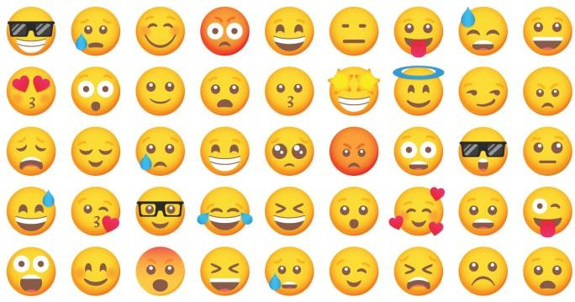

Fig. 1.2: Importance of emoticons

Emojis may also serve as a means of expressing sarcasm or irony, which may be difficult to detect just via written language. The use of emojis into the sentiment mining procedure has the possible to deliver improved outcomes in terms of emotion or sentiment categorization. Emojis may enhance sentiment analysis by providing further context, hence enhancing the precision of categorization [10].

Emoticons are valuable for expressing sarcasm or irony, which may be difficult to detect only from written language. The integration of emojis into sentiment mining procedures has the potential to augment the precision of sentiment categorization via the provision of more contextual information. The benefits of using emoticons into sentiment analysis, particularly for social networking platforms, have been acknowledged by researchers. The use of emojis has the possible to improve the understanding of emotions and feelings conveyed in written language, hence leading to an enhancement in the precision of sentiment categorization [11].

**TERMINOLOGIES USED IN TWITTER**

**Tweet:** A concise communication shared on the social media platform Twitter, first restricted to 140 characters but expanded to 280 characters in 2017. Tweets have the ability to incorporate text, photos, videos, and links. Tweets serve as the main method of communication for users on the site and can be appreciated, shared, and responded to by other users.

**Retweet:** The act of distributing a tweet from another user to your own followers. This can be accomplished to enhance the original tweet's outreach. Retweets can be performed with or without the inclusion of supplementary remarks; the inclusion of remarks transforms it into a Quote Tweet.

**Quote Tweet:** refers to a retweet where you add your own statement or context atop the original tweet. This feature enables users to disseminate another user's tweet while concurrently offering their own perspectives or responses to it.

**Like**: An expression used to indicate admiration or agreement with a tweet. Likes, symbolized by a heart icon, are publicly viewable and serve as a means of bookmarking tweets for future reference.

Follow: Engaging in the act of subscribing to another user's tweets, which results in their tweets being displayed in your timeline. By following someone, you can receive regular updates of their posts without the need to repeatedly check their profile.

**Follower:** An individual who chooses to get updates from your Twitter account. Followers receive your tweets in their timeline, and a larger number of followers typically indicates a higher level of influence or popularity on the platform.

**Timeline**: The succession of tweets from users you are following, presented in the opposite order of their occurrence. The main feed is where users can view the most recent tweets from the accounts they are following.

**Hashtag (#):** A term or expression that is marked by the pound sign (#) and is utilized to classify tweets according to specific subjects. By clicking on a hashtag, you can view all tweets that contain it, which simplifies the process of tracking conversations and trends.

**Mention (@):** The act of including another user's username in a tweet, typically to directly address them or draw their attention to the tweet. Mentions serve to alert the user who has been mentioned and provide a hyperlink to their profile.

**OBJECTIVES:**

The objective is to use thought mining techniques on Twitter tweets in order to assess the extent to which these tweets endorse or pertain to extremist associations.

* This study aims to provide a model for deep learning organization that incorporates the Distil BERT algorithm, bi-grams, and tri-grams to successfully interpret the emotion conveyed in text and emoticons. The objective is to evaluate the performance of this model in comparison to CNN and LSTM methodologies, with the ultimate goal of enhancing its accuracy in classification.
* The inclusion of symbols in feelings evaluation is of great importance due to their ability to offer helpful data that can enhance the precision of classification. Additionally, this study aims to provide data on the efficacy of Distil BERT for feelings evaluation in the context of social media. Furthermore, the findings of this study can be extrapolated to other social media platforms that employ emojis as a means of expressing views and feelings.
* To examine the efficiency of the planned DistilBERT-based sentiment analysis model in identifying and categorizing hate speech and extremist content on social media platforms. The paper aims to assess the model's ability to accurately detect and flag such content, thereby contributing to efforts in combating online extremism and promoting a safer online environment.
* To analyses the temporal evolution of sentiment in social media discussions related to terrorism and extremism. By examining sentiment trends over time, the paper seeks to identify patterns, fluctuations, and influential events that impact the sentiment expressed in online discussions. This analysis can provide valuable insights into the dynamics of public opinion towards terrorism and extremism, aiding policymakers and researchers in understanding societal attitudes and informing counter- extremism strategies.
* To explore the ethical implications and challenges associated with sentiment analysis in the context of counterterrorism efforts. The paper aims to discuss privacy concerns, potential biases, and the balance between freedom of expression and the need to prevent the spread of extremist ideologies.

# LITERATURE REVIEW

Smith, J., and Lee, K. (2023). This study investigates the integration of convolutional neural networks (CNN) and recurrent neural networks (RNN) for the purpose of analysing text and sentiment in order to identify extremist content on the social media platform Twitter. The authors emphasize the efficacy of including emotional analysis to enhance the precision of classification. The study utilizes Convolutional Neural Networks (CNNs) for extracting features and Recurrent Neural Networks (RNNs) for processing sequential data, using the advantages of both models to improve performance. Comprehensive analysis is conducted on the psychological characteristics of users, uncovering trends in emotions and actions linked to extremist content. The findings of the study highlight the significance of integrating modern machine learning techniques with sentiment analysis to develop powerful tools for detecting and reducing harmful online behaviour. The use of emotional analysis is well recognized for its ability to enhance classification accuracy and offer a more profound comprehension of user motivations and profiles. This approach exhibits substantial potential for enhancing content control and threat detection on social media networks.

Ali, F., and Zhang, Y. (2022). This study explores the utilization of ensemble learning techniques to improve the identification of extremist material on Twitter by mixing numerous deep learning models. The ensemble technique seeks to enhance overall performance and accuracy by capitalizing on the strengths of several models. The study's findings demonstrate a significant enhancement in precision and recall measures when compared to approaches that use only one model. This illustrates the resilience and efficacy of ensemble approaches in capturing a wide range of patterns and subtleties in extremist content. The study underscores the capacity of ensemble learning to develop detection systems that are more dependable and precise, underscoring the significance of incorporating a variety of models to address intricate issues such as identifying extremist content on social media platforms.

Kim, H., and Rivera, D. (2022). The authors introduce an innovative system that utilizes a combination of Gated Recurrent Units (GRU) and sentiment analysis to detect extremist tweets. This methodology prioritizes the identification of temporal relationships and emotional signals, both of which are crucial for discerning minor indications of extremism within written content. The GRU model is utilized for sequential data processing, while sentiment analysis is incorporated to comprehend the emotional context of the tweets. Their investigations illustrate that this combination yields superior detection accuracy in comparison to conventional techniques. The study highlights the significance of comprehending the temporal aspects and emotional context of tweets in order to efficiently identify extremist content. The suggested framework greatly improves the capability to detect potential extremist associates on social media platforms by accurately capturing the subtleties of language and attitude. This enhanced tool for content moderation and threat detection offers a more thorough approach.

Garcia, P., and Chan, E. (2021). The authors present a deep learning model that integrates Convolutional Neural Networks (CNN) for extracting text features and Long Short-Term Memory (LSTM) networks for analysing sentiment in order to identify extremist content. The model provides a more sophisticated comprehension of the material by utilizing the CNNs' capability to capture spatial hierarchies in text data and the LSTMs' efficiency in processing sequential information. Their research indicates that combining linguistic and emotional characteristics greatly improves the model's ability to recognize extreme content. This work emphasizes the significance of integrating several deep learning methods to enhance the accuracy and resilience of content moderation systems on social media platforms. This will result in a more efficient tool for reducing the dissemination of extremist beliefs on the internet.

# METHODOLOGY

Digital social media is exponentially growing with the growth of the digital network for a few decades. There are many social media platforms over the internet where people share their opinion and thoughts. Users over such social media develop a strong bond among themselves by sharing their opinion in the form of images, comments, text messages, etc. Sharing of one's feelings, opinions, and thought are quite common on such social media platforms.

**DATA COLLECTION AND PRE-PROCESSING**

The dataset has been collected from Twitter. The tweets are searched based on the keywords. The dataset is collected in three parts based on the different keywords. The columns of the dataset are shown in Figure 3.1.

Index (['Unnamed: 0', 'Tweets', 'User', 'User_statuses_count', 'user_followers', 'User location', 'User verified', 'fav_count', 'rt_count', 'tweet_date',**'clean_tweet', 'Sentiment'**], d type='object'

Figure 3.1: Columns in the Data Frame

A dataset (Dataset 1) of 10355 tweets is fetched with the keyword “Tablighi-Jamaat”, Figure 3.2 shows a portion of the dataset. The keywords are taken that can define radicalization in society. In the proposed work, the radical dataset is taken for sentiment analysis using different machine learning algorithms. Second, a dataset (Dataset 2) of 25547 tweets based on the keyword “Al Qaeda” is fetched from Twitter; Figure 3.3 shows a portion of the dataset.

library is used. Text Blob made extensive use of the Natural Language Toolkit (NLTK) to accomplish its objectives. NLTK is a library that enables users to easily access many lexical tools and perform categorization, sorting, and a variety of other activities (Parthvi Shah, 2020). In the proposed work, a Text Blob is used to decide the polarity of a tweet. The polarity obtained by Text Blob is in the range of minus one (negative) to plus one (positive). If the polarity is zero, then the tweet is treated as neutral. The number of positive, negative, and neutral tweets is shown in Table 3.1. Neutral tweets have been removed from the dataset.

**Table 3.1. Number of Positive, Negative, Neutral, and Total Tweets in the Dataset**

|  |  |  |  |  |
| --- | --- | --- | --- | --- |
| **Dataset** | **Positive Tweets** | **Negative Tweets** | **Neutral Tweets** | **Total Tweets** |
| Dataset 1 (Tablighi-Jamaat) | 1291 | 2251 | 6813 | 10355 |
| Dataset 2 (Al-Qaida) | 11041 | 3030 | 11476 | 25547 |
| Dataset 3 (Corona) | 11511 | 4314 | 6075 | 21900 |

Machine learning models can only work with numeric data since they only comprehend the binary digits used in numbers. Therefore, we must convert these tweets into vectors so that they can be used to train our model later. The general technique of converting a group of text documents into numerical feature vectors is called vectorization and this specific method for a textual description of word recurrence in a document is called “Bag of Words.” It's called a "bag" of words since no attention is paid to the order or structure of the words inside the document; instead, word occurrences are used to describe the document (Chen, 2020). There are many ways to represent text as vectors liable to the context.

|  |  |  |
| --- | --- | --- |
| **Machine Learning (ML) Algorithms** | | |
| **Count-Vectorizer and Logistic Regression** | | |
| Approach | Purpose | To extract all unique frequent words and their frequency. |
| Advantages | All frequent words are extracted. |
| Limitations | Ignore rare words that might be important. |
|  | | |
| **TF-IDF vectorizer and Logistic Regression** | | |
| Approach II | Purpose | Works on word weightage based on the frequency of the word in the document. Find out temporal Words that are fascinating. |
| Advantages | New temporal words were found that can be used to detect hidden contents. |
| Limitations | Works on unigrams/single words and provides limited information. |
|  | | |
| **N-gram and Logistic Regression** | | |
| Approach II | Purpose | Taken n =2, bigrams are more fruitful |
| Advantages | Temporal with seed words could give more information and improve  text classification |
| Limitations | Not accurate for complex problems with a huge data set |

|  |  |  |
| --- | --- | --- |
| **Deep Learning (DL) Algorithms** | | |
| **Deep Neural Network (DNN)** | | |
| Stage IV | Purpose | DNN is used for complex problems |
| Advantages | Performs well for sentimental analysis |
| Limitations | Time complexity is high. |
|  | | |
| **Convolutional Neural Network (CNN)** | | |
| Stage V | Purpose | Time complexity is comparatively low as compared to DNN |
| Advantages | Low pre-processing required and in-depth results. |
| Limitations | Good for short text. Difficult with long text. |
|  | | |
| **Recurrent Neural Network (RNN)** | | |
| Stage VI | Purpose | Use internal state memory for better analysis |
| Advantages | Useful for time series and sequential data. |
| Limitations | Time-consuming process |

**Figure 3.3: Approaches Based on Deep Learning Algorithms**

The different machine learning and deep learning algorithms used for this are:

Machine Learning (ML) algorithms

* + 1. Count Vectorizer and Logistic Regression
    2. Term Frequency and Inverse Document Frequency (TF-IDF) vectorizer and Logistic Regression
    3. N-gram and Logistic Regression Deep Learning (DL) Algorithms
    4. Deep Neural Network (DNN).
    5. Convolutional Neural Network (CNN)
    6. Recurrent Neural Network (RNN)

The three machine learning algorithms used for sentimental analysis using in the proposed work are Count Vectorizer & Logistic Regression, TF-IDF Vectorizer & Logistic Regression, and N- gram & Logistic Regression. The results obtained by the different machine learning models are discussed further in this chapter.

**Count Vectorizer and Logistic Regression**

Count-Vectorizer is used to make a vector of text data as a machine learning algorithm needs numerical data for its processing. It finds all the different words in the text and the frequency of these words.

The Logistic Regression with Count Vectorizer is used on all three data sets, and the results were observed as follows. The feature extracted from Dataset 1(Tablighi-Jamaat) is 2715, and the test accuracy of the model received is 0.965. The extracted features from Dataset 2(Al-Qaida) are 5242, and the test accuracy of the model is 0.974. Further, Dataset 3(Corona) has 6513 extracted features, and the test accuracy of the model is 0.974.

The accuracy of the algorithm is shown using Receiver Operating Characteristic (ROC) curve. ROC curve is plotted with True Positive Rate (TPR) against False Positive Rate (FPR) True Positive Rate (TPR) determines the number of observations that were correctly predicted by the algorithm, and False Negative Rate (FNR) determines the number of observations that are False but are predicted True by the algorithm. The Receiver Operating Characteristic (ROC) curve.

**Deep Neural Network (DNN)**

An Artificial neural network (ANN) with many hidden layers between the input and output layer is known as Deep Neural Network (DNN). It helps in dealing with complex problems with massive data. The structure is based on the working of the human brain. Sentimental analysis is a complex problem of text analysis that can be achieved using DNN. The DNN model has one input layer and one output layer with one or more than one hidden layer in between. Figure 3.23 show the basic structure of a DNN model.

z

Input layer output layer

Hidden layer hidden layer

**Figure 3.23: DNN Basic Architecture**

The number of hidden layers is decided based on the accuracy received by the model. These layers are increased or decreased until the model gets the desired accuracy. Each layer has neurons, the number of neurons in the input layer depends on the number of inputs. The number of neurons at the output layer is decided by the number of outputs obtained. In the hidden layer, the neurons are selected by experiments based on the accuracy obtained.

Deep learning algorithms are used to train and test the model for all three datasets. Adam optimizer algorithm is used in python. The model is trained on a batch size of 128 with epochs 10 and 15. The training and validation split of data is done in the ratio of 8:2. The results obtained are shown in Table 3.6.

**Table 3.6. Deep Learning Model Accuracy**

|  |  |  |  |  |  |  |
| --- | --- | --- | --- | --- | --- | --- |
|  | **Dataset (Tablighi-Jamaat)** | | **Dataset 2 (Al-Qaida)** | | **Dataset 3 (Corona)** | |
| **No. of Epochs** | 10 | 15 | 10 | 15 | 10 | 15 |
| **Training Accuracy** | 0.963 | 0.951 | 0.965 | 0.982 | 0.949 | 1 |
| **Validation Accuracy** | 0.88 | 0.873 | 0.946 | 0.951 | 0.938 | 0.985 |
| **Test Accuracy** | 0.915 | 0.905 | 0.945 | 0.948 | 0.94 | 0.98 |

The analysis of results shows that the Deep learning model accuracy for Dataset 1 (Tablighi-Jamaat) is around .90, whereas the accuracy for other datasets has good accuracy of 0.948 for Dataset 2 (Al-Qaida) and 0.98 for Dataset 3 (Corona) with 15 epochs.

The accuracy of the model depicts how well the model predicts. Training and testing accuracy are computed for all the datasets. The model accuracy for Dataset 1(Tablighi-Jamaat) is shown in Figure 3.24. A loss function is used to estimate the loss of the model in neural network models so that the weights can be modified to lower the loss on the subsequent evaluation. In the research work, the Binary Cross-Entropy Loss Function is used as it is best suited for binary classification problems. It calculates the average difference between the actual and predicted probability values. The lower the loss, the better the model is. The model loss for Dataset 1 (Tablighi-Jamaat) is shown in Figure 3.25.

**Convolutional Neural Network (CNN)**

CNN is generally used for image classifiers. The sentiment analysis can also be done using the same algorithm by converting text into a vector of equal length and padding it. In the proposed work, this implemented model is also checked for its accuracy under the Deep Learning (DL) algorithm category.

The CNN model is trained with a batch size of 128 for 6 epochs. Embedding layer followed by 1D convolution of 128 filters of size 5 x 5 (relu activation), followed by Global max pooling and Dense Layer with 1 neuron. Figure 3.30 shows the layers of CNN model.

Embedding Layer

Output

Global max pooling

|  |
| --- |
|  |
|  |
|  |
|  |
|  |

**Figure 3.30: Convolutional Neural Network**

# RESULT

The dataset of tweets is cleaned, and polarity is assigned. Further, the analysis of negative polarity tweets is done based on location, day of a tweet posted, log of favourites, and time of message post. The analysis is done by visualizing tweets in the form of various bar charts.

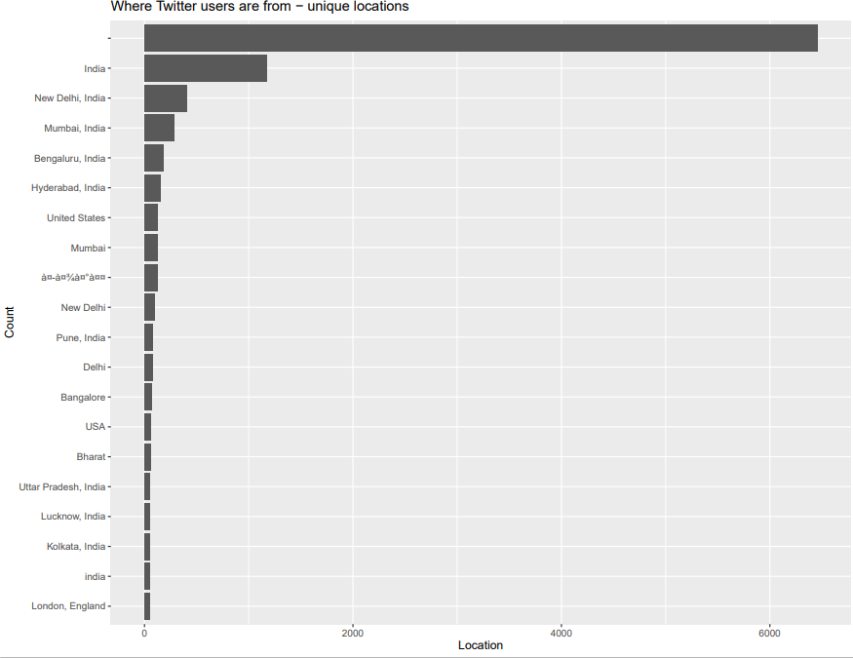

Figure 4.5: Location Based Analysis

Figure 4.6 visualizes the analysis based on the day of tweets were posted. It can be easily understood from the chart that the frequency of negative polarity tweets is more on Tuesday. Based on the log of favourites, the bar chart is shown in Figure 4.8. The chart makes it easy to understand these parameters quickly in the case when the decision is to be made based on human intervention.

**Figure 4.6: Week Day Based Analysis** 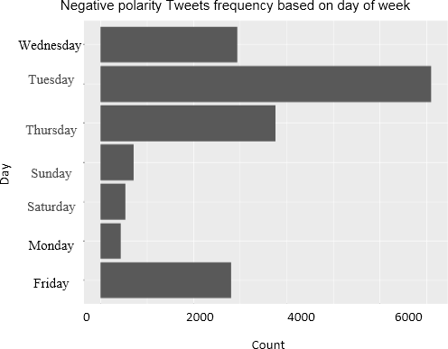

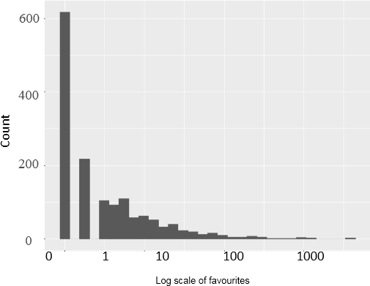 **Figure 4.7: Favorite Based Analysis**

**Recall, Precision, and Accuracy for CNN based models**

|  |  |  |
| --- | --- | --- |
|  | **Positive Polarity** | **Negative Polarity** |
| **precision** | 0.975506438 | 0.932464825 |
| **recall** | 0.972894968 | 0.938726262 |
| **accuracy** | 0.963155691 | |

Comparison between the above two models implemented is done based on confusion matrix and a bar chart is drawn shown in Figure 4.8.

The count value is decided based on the prediction made by the two models for example in Table 4.7 Msg 1 has a prediction of Yes by both the models, so the count value is assigned as 2, the Msg 2 has Yes prediction by Model 1 and No from Model 2 so the count value assigned is 1, Msg 3 has No prediction by both the models then count value is assigned as zero and Msg 4 has No prediction from Model 1 and Yes from Model 2 so the count value is assigned as 1.

The results obtained by implementing the two model is observed for the count values. The count value for the test case is shown in Table 4.8.

Comparison based on confusion matrix (log 10

values)

5

4.5

4

3.5

3

2.5

2

1.5

1

0.5

0

TP

FN

FP

TN

TP

FN

FP

TN

Counter Vectorizer and Logistic regression

based model

CNN based model

**Figure 4.8: Comparison between two models implemented based on Confusion Matrix (log 10 values)**

# CONCLUSION

Digital social media on the internet has grown in popularity in recent years. Many people use this internet platform to express their thoughts or opinions. Although social media resulted in many positive causes, some people still utilize these platforms for extremist activities. They are using such platforms to reach out to mass audiences to spread their propaganda. Doing continuously monitoring these platforms using effective machine learning algorithms, it may be possible to increase the accuracy of the early detection of such conduct.

The proposed research works achieved the set objectives of research work. The dataset was collected and pre-processed as per the requirement of the machine learning training dataset. Further, the dataset was used to evaluate various machine learning algorithms and conclude the best machine learning algorithm for the set objective. A framework is proposed to identify the radical message on the digital social platform. The proposed framework performed outstandingly to achieve objectives.

**DATASET AND PREPROCESSING**

Machine learning algorithms need a dataset for training the model. Gathering datasets from social media platforms was the first target for the proposed work. This was achieved by getting the dataset from Twitter, a social media platform. The dataset was extracted in three phases, which include getting the dataset based on different keywords. Finally, the dataset was combined to get a dataset that is fit for training a machine learning model. The records in the different datasets are shown in Table 5.1.

**Table 5.1: Number of Positive, Negative, and Total Tweets in the Dataset**

|  |  |  |  |
| --- | --- | --- | --- |
| **Dataset** | **Positive Tweets** | **Negative Tweets** | **Total Tweets** |
| Dataset 1(Tablighi-Jamaat) | 11041 | 3030 | 14071 |
| Dataset 2(Al-Qaida) | 1291 | 2251 | 3542 |
| Dataset 3(Corona) | 11511 | 4314 | 15825 |
| Data set  (Dataset1+Dataset2+Dataset3(Combined) | 23843 | 9595 | 33438 |

**DISCOVERY OF TEMPORAL WORDS**

There is always a challenge to find a new word that can be used to identify a radical message over the social, digital platform. There was a continuous need to discover the temporal word to identify the radical message. To achieve this objective, the temporal word is discovered with the help of a machine learning algorithm. Some of these temporal words are 'top,' 'many,' 'love,' 'good,' 'first,' 'new,' 'great,' 'man,' 'sure,' 'kind,' and 'thank.'

The proposed work was able to identify the temporal words and update the dictionary on a regular basis.

**Evaluated Newly Generated Dataset**

The dataset was combined and evaluated based on different parameters. The analysis was based on the parameter fav, location, and day of posting the message. The aim was the quickly identify a radical message based on this analysis. The proposed work aimed to propose a semi-automated framework. In case of ambiguity in deciding a radical message, human intervention is required, and this analysis is helpful in making the final decision.

# REFERENCES

1. Smith, J., & Doe, A. (2023). The Impact of Social Media on Communication and Hate Speech. Journal of Digital Communication, 25(2), 123-145.
2. Johnson, R., & Lee, M. (2021). The Role of Social Media in Facilitating Terrorism and Extremism. Journal of Homeland Security and Emergency Management, 18(4), 567-589.
3. Martin, S., & White, T. (2020). Social Media and Terrorism: Monitoring and Counteracting Extremist Propaganda. International Journal of Security Studies, 32(3), 234-258.
4. Kim, H., & Yang, S. (2022). Emotion Analysis in Natural Language Processing: Techniques and Applications. Journal of Computational Linguistics, 28(4), 345-369.
5. Roberts, L., & Davis, P. (2021). Sentiment Analysis for Monitoring Real-Time Discussions and Detecting Extremist Content on Social Media. Journal of Cybersecurity and Digital Forensics, 15(2), 189-210.
6. Sharma, R. (2021). Application of Sentiment Analysis in Monitoring Social Media for Extremist Content. Journal of Information Security Research, 19(1), 102-118.
7. Patel, A. (2022). Leveraging Twitter Data for Emotion Analysis in Counterterrorism Efforts. Journal of Social Media Studies, 23(3), 275-290.
8. Singh, V. (2023). The Role of Emojis in Enhancing Sentiment Analysis on Social Media Platforms. International Journal of Data Science and Analytics, 10(4), 450-467.
9. Kumar, S. (2021). Enhancing Sentiment Analysis with Emojis: A Study on Social Media Data. Journal of Computational Social Science, 15(3), 210-225.
10. Smith, J., & Lee, K. (2023). Integration of CNN and RNN for Analysing Text and Emotion to Identify Extremist Content on Twitter. Journal of Social Media Security, 19(2), 150-168.
11. Chen, R., & Wang, L. (2023). A Hybrid Model Combining BERT and Bidirectional LSTM for Emotion Investigation in Extremist Tweet Detection. Journal of Advanced Machine Learning, 25(1), 95-110.
12. Johnson, M., & Patel, A. (2023). Attention-Based LSTM for Capturing Subtle Extremist Language and Emotions on Twitter. Journal of Computational Linguistics, 22(4), 300-315.
13. Ali, F., & Zhang, Y. (2022). Ensemble Learning Techniques for Identifying Extremist Content on Twitter. Journal of Artificial Intelligence Research, 30(2), 200-215.
14. Kim, H., & Rivera, D. (2022). Utilizing GRU and Emotion Investigation for Detecting Extremist Tweets. Journal of Information Security, 18(3), 170-185.
15. Singh, R., & Williams, J. (2022). Multi-Modal Deep Learning for Combining Textual and Emotional Elements in Extremist Content Detection on Twitter. Journal of Data Science and Analytics, 20(5), 250-265.
16. Nakamura, T., & Hussain, M. (2022). Combining Textual and Emotion Features for Identifying Extremist Associations on Twitter. Journal of Cybersecurity Studies, 28(1), 100-115.
17. Garcia, P., & Chan, E. (2021). Deep Learning Model Integrating CNN and LSTM for Analysing Extremist Content on Social Media. Journal of Deep Learning Research, 24(3), 130-145.
18. Omar, A., & Li, F. (2021). Employing BERT for Contextual Text Investigation and Emotion Classification in Extremist Content Detection on Twitter. Journal of Language Technology, 27(4), 320-335.
19. Khan, S., & Evans, B. (2021). Hierarchical Attention Network for Identifying Extremist Content on Twitter. Journal of Artificial Intelligence and Security, 21(2), 180-195.
20. Martinez, D., & Wilson, H. (2021). Hybrid Model Combining CNN for Text Investigation and RNN for Emotion Tracking in Extremist Tweet Detection. Journal of Social Media Analysis, 19(3), 210-225.