**A Review: Radioactive contamination And Radioprotection of Medicinal Herbs**

**Vaishnavi Patil1, Vaishnavi Mali2, Samradhnyee Sawant3, Shital Devkar4,**

**Prachi Khochage5, Dr. N. B. Chougule6.**

1,2,3,4Final Year Student, Department of Pharmacognosy, Ashokrao Mane Institute of pharmacy, Ambap.

Assistant Professor5, Ashokrao Mane Institute of pharmacy, Ambap.

Pricipal6, AshokraoMane Institute of Pharmacy, Ambap,

Maharashtra, India

**Abstract:** Dangerous contamination that can be resultant into nuclear accident. The WHO incorporation with other several international organizations has been developed guidelines for widely spreading contamination by radionuclides resulting into nuclear accident. It is recommended that deterrent measures be implemented to prevent radionuclide contamination of herbal materials by the WHO (2009) and EMA (2011) guidelines. Calculations are made for activity per mass unit and spectrum analysis to determine the counting rates of each detected photo peak and detected nuclide. Using duplicate analysis and the reference sample provided by the IAEA, quality control procedures were implemented. Through exposure to gamma radiation, the outdoor Dout and indoor Din absorbed gamma dose rates in nGyh1 assess the radiological hazard of naturally occurring radionuclides. To protect, an internal hazard index (Hin) 26 has been used for determination of internal radon exposition and Its descendants’ items. Because of the high levels of organic radionuclides in the screened materials that emit external γ radiation, there is a favorable association between gamma index I and the annual dose rate. The protection methods for Radioactive contaminations of medicinal herbs used like Neutron Activation Analysis, Geiger muller counter, Isotope dilution analysis, Radiometric titration.

**Keywords: Material and Methods, Graphs and Calculations, Protection methods, Decontamination effect on herb quality.**

* **Introduction**: Natural radioactive materials (NORM) can be found in various parts of environment. The degradation chains of uranium (238U) and torium (232T) in the nature are the primary source of NORMs. Radionuclides found in soil are mostly moved to palatable plant matter and subsequently up the food web for humans. This procedure is referred to as the "soil-plant transfer factor" (TF), and it is significant that mostly utilized factors in environmental protection analysis that determines an estimated dosage impact on human health and the potential radioactivity level in agricultural crops3. Radionuclides like uranium, thorium, radium, and radon are transported through the soil to the herbs at different rates and are distributed differently in the various parts of the herbs depending on the fertilizers applied and the composition of the soil. Since the latter raises the quantity of uranium and thorium among agricultural settings, partly explains the growing use of medicinal herbs, they are thought to be naturally occurring radiation that has been technologically enhanced. Due to their greater accessibility and lower cost compared to modern medications in developing nations. Other research indicates that, regardless of their financial status, people who use alternative medicine opt to take medicinal herbs as they align more closely with their personal beliefs, worth, and theoretical positions regarding life as well as health. Research indicates that different kinds of plants ingest different kinds of radionuclides. Medicinal plants are used both explicitly and informally in the manufacturing of numerous medications as well as dietary supplements. Consequently, the effective dose taken internally is increased by the presence of radionuclides in medicinal herbs, which releases alpha particles that increase the risk of lung cancer. Radon gas, which has a half-life of 3.8 days, is produced by the radiological decomposition of radium-226 in the uranium transition decomposition in the layers of the land. As a result, prolonged use of these plants may be detrimental to the health of the general public. linked to cancers of the bone, lung, breast, thyroid, and 11 other organs, including leukaemia, the majority of blood cancers, and it is essential to calculate the radioactivity of different medicinal plants and to have a passion for medical physics12. This study's objectives are to evaluate the natural radioactivity (238U, 226Ra, 232T, 40K, 222Rn, and 220Rn) and radiological dangers in several regularly used medicinal herbs, as well as to look into the radionuclides and dangerous substances have a link in certain of the sample studies.
* **Material and Method:**

**1)** **Sample collection**: The local market provided 17 kinds of therapeutic botanical herbs that were available for purchase. For the purposes of the study, those kinds, which are sold economically that they crushed or powdered herbal material, were coded P1 through P17. The plants under investigation were selected because they are regularly used for either open at the physics department at Ain-Shams University in Cairo, Egypt, or at the Women's Faculty of Arts, Science, and Education, with email addresses hayam168@yahoo.com and hayam.ahmed@women.asu.edu, respectively. Especially after the COVID-19 pandemic's appearance, for preventative or curative purposes in an unconventional medical setting. P5, P7, P14, P1, P16, and P11seeds, P12, P17, as well as P3 roots, and P8, P10, P4, P6, P2, P13, P15, and P9 leaves were the three groups of medicinal plants that were the subject of the study. The term used in science was assigned by a department of botany specialists (by their binomial names). 200 mesh was the size at which the samples under investigation were sieved. To prevent radon from possibly escaping, weighted samples were placed in 250-cm3 plastic bottles to achieve long-term equilibrium between 226Ra and 232T in accordance with the corresponding progenies13–15.

**2)Measurements**: Selected samples associated with 238U, 226Ra, 232T, and 40K were examined for their natural radioactivity content utilizing the germanium detection technique of high purity. an electronic circuit used to connect the detector were connected to the supply of power, amp, and preamp. For the 60Co 1332.2 keV γ-ray line, the Te detector's resolution (FWHM) is 1.85. A 226Ra point source was used for the HPGe detector's efficiency calibration. With the concentration of chemically pure KCl solution in distilled water, the relative efficiency graph for the 250 ml beakers was adjusted for normalcy. Identical kinds sizes were employed for acquiring a curve of total effectiveness. Lead shielding has been used to protect the detector from ambient rays’ interference. The concentrations of activity were determined using the formula below:

* The concentrations of 238U were determined by measuring the 295.1 (19.2%), 352 (37.2%), 609.3 (46.1%), as well as 1120.3 (15.1%) keV rays from 214Pb, 214Bi, and 214Cl, respectively.

* The peaks of 212Pb at 238.6 (43.6%), 911.2 (29.0%), and 969.0 keV were used to calculate the 232T activity. 583.0 (31.0%) keV rays from 208Tl and 228.8 (23.2%) keV keV from ac.
* The 1460 (10.7%) keV line's 40K concentration was detected.
* The measurement of the 226Ra concentration involved taking a reading of the 186 (3.3%) peaks.

The computation of count rates for all discovered radionuclides requires the determination of the religious balance between 238U as well as 232T and that decaying materials. Each sample's radiological activity levels were monitored for roughly 48 hours.

**3)Radon measurement**: Poly allyl carbonate of diglyol (CR-39), a detector of nuclear tracks with a thickness out of five hundred m, a chemical composition of C12H18O7, and The thickness of 1.31g/cm1, have been used in this piece of writing. A detector for radioactive gauges has weak carbon bonds that melt in the presence of ionizing radiation, which allows it to recording the gauges of protons, alpha particles, and fission fragments due to its extraordinary sensitivity. Because of its accessibility and accuracy, the nuclear track detector is a practical instrument for radiation absence detection that doesn't require costly electrical equipment or radioactive material (17). In plastic containers with average diameters of 4 cm and heights of 8.5 cm, a weighed portion of each sample was put inside each one. Included in the sample was a 1 cm2 surface area CR-39 detector piece. Simultaneously, another detector piece of CR-39 has been arranged at the lid of the vessel. The vessels have been exposed for three months while kept at room temperature. During this time, Thoron as well as Radon and their childrens decay, bombarding the CR-39 with alpha particles. The radioactive gauge sensors are included into the vessels afterwards being made public. The sensors has been scientifically carved in NaOH of 6.25N at 70 degrees Celsius for six hours, revealing the gauges, which a magnifying glass was then used to count. This trial design made certain that the bulk sample's detector recorded the presence of thoron, radon, and any of their offspring material found into materials under investigation. On the other hand, the top detector only detected the 222Rn component. Consequently, the sample's content of the track density difference between the two detector daughters of 220Rn. It was anticipated that the count of tracks would correspond with the exposure to 220,222 registered nurses. An estimate of the specific radon activity was made for the samples that were being studied. Bqm-3- = ρRn ηt = CRn.

where "" denotes the CR-39 track detector's efficiency factor, "t" is the time of exposition (90 days) as well as Rn is the thickness of radon gauge (gauge cm2). This factor is dependent on how well the detector picks up the α particles released by radon and its by-products.

**4)Atomic absorption measurements**: Cu, Zn, Cd, Pb are the four hazardous metals found into 6 kinds of botanical herbs. This work's analysis was conducted utilizing the commonly used atomic absorption spectrometry to measure depicts of components in a variety of kinds. A light beam passes through the material in the technique of atomic absorption spectrometry. Some light is absorbed depending on the concentration of the element. By contrasting the intensities observed in an initial light and the light when crossing the material, one can ascertain a maximum amount of the element. An atomic absorption spectrometry technique has different sources of light for every component because every component absorbing beam of light at a different range of wavelength. Often, Atomic absorption spectrometry is used to identify a single element per analysis.

**5)** **Statistical investigation**: SPSS 10.0 software (SPSS, Chicago, IL, USA) was used to statistically analyse the data in accordance with accepted statistical procedures. Every measurement was made three times, and the average results (standard deviation) were calculated.

**6)Analytical method**: The powdered samples of the Thai medicinal herb plant were taken out of their plastic capsules. They spent six hours in an oven, drying at 80 °C. The natural radionuclides were identified using two distinct analytical methods: gamma spectrometry of 40K, alpha, 226Ra, and 228Ra 210Po spectroscopy.

**7)Gamma spectrometry**: The activities concentrations of 40K, 228Ra, also 226Ra were measured into each sample with gamma ray analysis. The value of dry mass and concentration were utilized for the determination for identity of the radioactive nuclide. Every dried species, weighing roughly 100 g, has been placed into a plastic container that is cylindrical and has a diameter of 2.5 inches as well as height of three inches. The samples were kept for a minimum of thirty days in a sealed container. Before using a gamma spectrometric measurement approach, make sure the radioactive secular equilibrium is present. One of two high-purity germanium detectors has been utilized to detect the activity concentrations into the samples in a low background configuration, with relative efficiencies of 30 and 60%. 40K has been determined by utilizing the Gamma line at 1460 keV by analysing the gamma emitter daughters of the 226Ra and 228Ra. Additionally, measurements of (214Bi) 609 keV and (228Ac) 911.1 keV were made. The International Atomic Energy Agency, supplied the RGU, RGTH, and RGK reference samples which have been utilized in the efficiency calibration. For 226Ra, the lower detection thresholds for the baseline measurements after a full day produced naturally occurring radionuclides of 0.2 Bq kg1.

**8)Alpha spectrometry**: The silver disc technique, which is the accepted method, was used to measure the 210Po. 5gm baseline measurements after a full day of dry weight of the material have been mixed into 0.2 Bq of 208Po (provided by Amersham International, UK; PoCl2 in 0.1 mol L-1 HCl) as an indicator of produce. For at least 24 hours, the food was broken down in each specimen using nitric acid; H2O2 have been additionally added to assist oxidize the natural molecules. When the sample mixture has been nearly dry and apparent, it has been gradually vaporized. After that, the remaining material has been dissolved in 100 millilitres of 0.5 mol L-1 HCL. After that, C6H8O6 was used to heat the solution to 80 °C, which caused 210 Po to impulsively plate onto a spinning silver disc iron decrease. Following the C6H8O6 reduction of the iron, the sample mixture has been evaporated at 80 °C, at which point 210 Po impulsively plated into a rotating silver disc iron decrease. (208Po) 5.15 MeV and (210Po) 5.3 MeV alpha counting has been carried out by utilizing a silicon detector with passive ion implantation and an alpha spectrometer (ORTEC technology). 300 mm2 of the active region, with a 100 mm minimum depletion thickness and daily background counts of 3.6. Since the sampling, 210Po activity has been resolved for wellness, produce marker, and decay of radioactive material. moment by comparing the measured 210Po activity to the 208Po activity. The technique's lowest detection threshold was set at 0.4 Bq kg-1.

* **Techniques for quality control:** Utilizing duplicate analyses and reference samples from the IAEA, quality control techniques were used. All techniques and labs employed in this investigation are also described in accordance with the literature.
* **Graphs and Calculation**
* **Radionuclide and annual committed effective dose calculation:** Each of the has a different activity per mass unit identified radioactive elements and rate of counting for each photo peak are calculated after the spectrum analysis. As expressed in Bq/kg, the expression (1) denotes the specific activity.

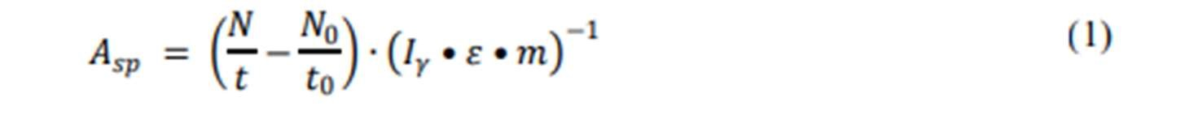

The given peak's net counts are denoted by N, the sample counting time is t = 48 hours, the peak's background is N, the background counting time is t0 = 48 hours, is the identification potency, no. of γ photons per disintegration is I, weight of the calculated material is m in kg. If there are multiple peaks in various forms of energy evaluations of a radioactive element, the mean of the result of calculating the activities is the average nuclide activity weighted. utter value of unknown is made up of errors that are both random and systematic among whole processes leading to the final product listing of nuclide concentrations. The annual average committed the appropriate dose, Eave, intension of ingesting naturally occurring radioactive materials (NORMs) in the Thai medicinal herb plants was determine by measuring an amount for individual organically found radioactive substance specific activity concentrations in the medicinal plants computed using a value from expression (2).

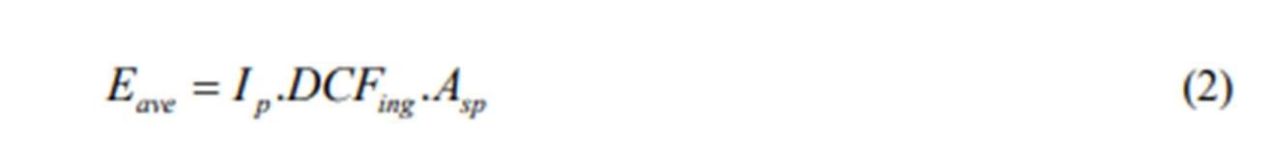

For every radionuclide (e.g., 2.810-4 mSvBq-1, 6.710-4 mSvBq-1), the factor of dose changing for consumption is represented by DCFing. 6.2 10-6 mSvBq-1 and 1.2 Sv Bq-1, respectively, for 40k, 226 Ra, 210 Po, and 228 Ra (Ip denotes the adult's rate of NORM ingestion from pharmaceutical products). The plant sample's ASp stands for activity concentration.

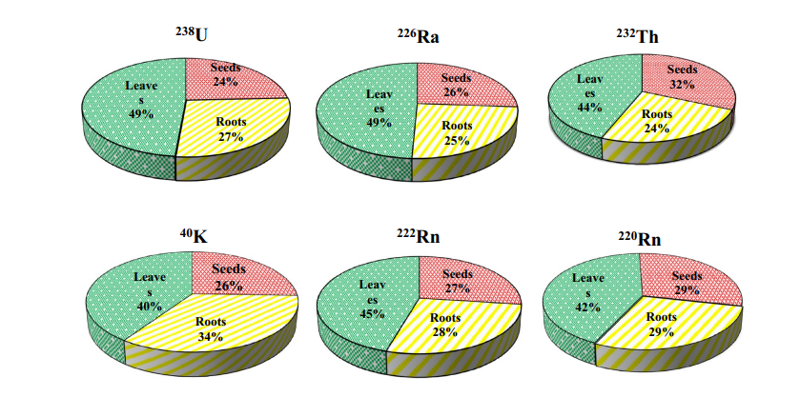**Radium Equivalent Activity:** Radiation exposure has been defined in terms of radium equivalent activity (in Bqkg1), which is characterized as the total of the actions of 238U, 232T, and 40K. This allows one to contrast the distinct activity of substances comprising varying values of 232T, 226Ra, 40K in an individual figure. The recommended upper limit for radium equivalent (Raeq) was found in seed, root, and leaf samples to be 147.152.7, 161.753.0, and 370 Bqkg121; however, figures 4, 5, and 6 display values which are lower at 245.934.6 Bqkg1.

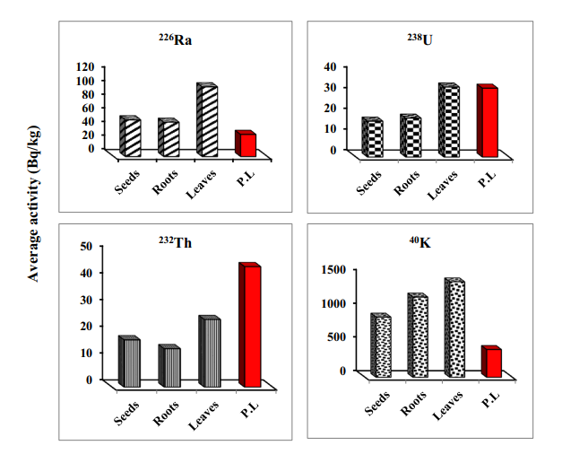

**Figure 4.1: Radionucleoids' average specific gravity (Bqkg-1) in herbal plants Fig.4.2: Contribution of radioactive materials in certain medicinal plants under investigation materials in certain medicinal plants underinvestigation**

**Determination of the absorbed γ dose rate both indoors as well as outdoors:** In order to evaluate the radiological risk of organically occurring radionuclides, the indoor and outdoor Dout absorbed gamma dose rates in nGyh1 as a result of exposure to γ radiation (emitted by 238U, 232T, and 40K) were calculated (10, 22).The leaf samples that were collected during the summer had the highest values (118.182.3 and 235.344.4 nGyh1, respectively). (84 nGyh1 indoors and 59 nGyh1 outdoors) are greater than thec mean amount of 10 for the global.

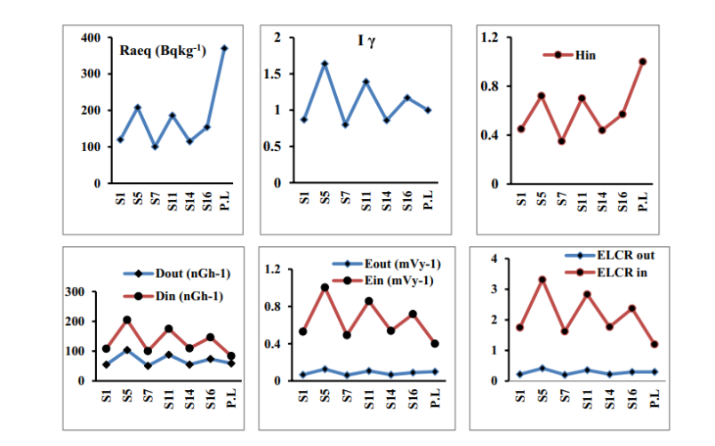**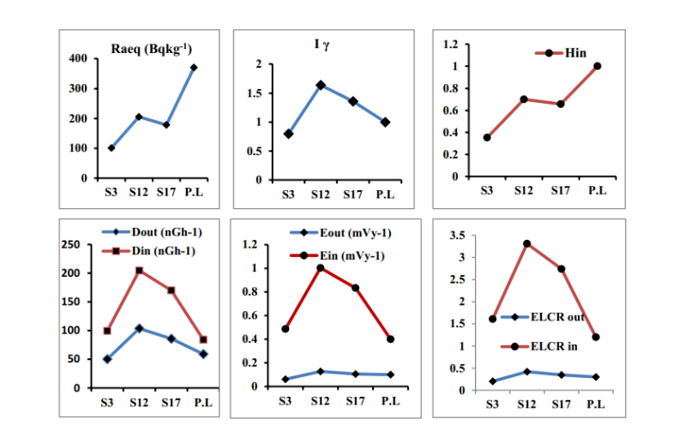The annual effective dose rates both indoors and** **outdoors:** The annual dose that individuals inside and outside of the body receive is referred to as an annual effective dose equivalent, or AEDE. A transforming factor of 0.7 Sv Gy1 was used to calculate the estimated dosage that individuals inside and outside would deliver.

**Fig.4.4: Radiological hazard indices in Fig.4.3: Radiological hazard indices in seeds sample. leaves sample.**

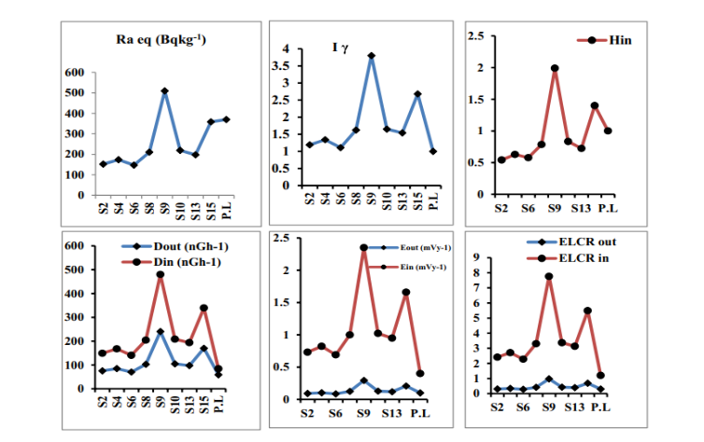

**Fig.4.5: Radiological hazard indices in root samples.**

Individuals usually use up 20% of their time indoors and 80% of their time outdoors. Consequently, 0.2 and 0.8 were chosen as the utilization variables for the indoor and outdoor spaces, resp. AEDEout and AEDEin were estimated using equation 10, 23:

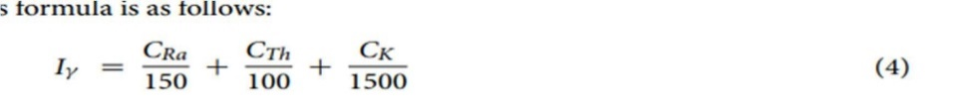**Index of gamma (I):** The γ radiation concentration index or I, have been designated by the European Commission27 as an extra gauge of radiation hazard. It is defined as the risk from γ radiation associated with radioactive natural nuclei in the investigated samples and is determined using the formula based on activity concentrations of 226Ra, 232T, and 40K. The following is the recipe:

Because of the high levels of external gamma radiation from radioactive element in the samples that have been screened, there is a positive correlation between the gamma index I and the annual dose rate. 1.860.06 was found to be the largest value in leave samples in the current investigation, as the safety value for this index is 1.

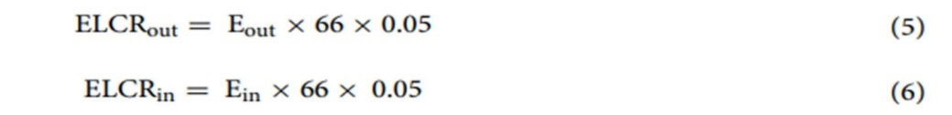**Excess lifetime cancer risk in both outside and indoors:** To calculate the probable cancer risk from radiation exposure indoors and outdoors while taking into account the 70-year-old human average, the following formulas were used:

Furthermore, the highest average lifetime cancer risk values for outdoor and interior exposure, respectively, were found in leave samples to be 0.470.008 and 3.800.07. which are higher than the 0.2910-3 recommended values.

**Protection of radioactive contamination of herb*:***

**1)** **Analysis of neutron activation**: Neutron activation analysis (NAA) is a method for quantifying the gamma rays released by the material following its exposure to neutron radiation. The rate at which a component of a material emits gamma rays corresponds exactly to its concentration. The following are the main benefits of NAA:

- It is a process including various elements that can find up to minimum 70 elements among various types of samples at once.

- Since, it does not cause damage, it is impervious to the errors related to yield calculations.

- For the most of elements as they can be recognized using NAA, it has extremely high sensitivities; the range of detection limits is 0.03 ng to 4 μg.

- It can achieve in general mistakes of 2-4 percent in comparison average deviation for numerous components, demonstrating its high accuracy and precision.

- NAA is capable of analysing samples down to a few micrograms.

**Principle:** Irradiating samples with a neutron source is a phase of the process of NAA analysis. The Material elements absorb neutrons to produce unstable radioactive isotopes or radioactive elements. As the radioactive elements decay, beta particles and, majority of the time, gamma rays are released. High-resolution semiconductor detectors can be used to measure since the energies of these electromagnetic waves are usually distinct for a given nuclide, the rate at which these photons are released with a specific energy. Measurement of elements can be increased by adjusting the irradiation and decomposition times i.e., how long the material is near a neutron source and when the material is analysed, as the preparation and decomposition rate of γ radiation depend on the half-lives of the nuclide.

**Procedure:** The most popular method for NAA is to simultaneously irradiate and heat-seal polyethylene or quartz vials containing the samples and appropriate standards. To ensure that the neutron flux is the same for both the standards and the samples., it is ideal to irradiate the samples in a "Lazy Susan" facility that rotates around the core. Analysis of every standard sample by using high resolution germanium detectors connected to a multi-channel analyser system after successive decay periods. Photopeak’s are created when γ ray counts build up in an energy region above background counts. In order to smooth the spectral data and determine the net areas of gamma rays, these data are processed using sophisticated computer programs then the photopeak's after counting analysis is finished. The area is then converted by the program into count rates, also known as counts per minute. These initiatives have the ability to resolve complex photopeak energy regions that overlap. To determine the sample's elemental abundance, additional data is needed for decomposition time differences, losses from electronic dead time, and Incomplete disputes. The conventional data (cpm/μg) and the test results (cpm/weight) are contrasted.

**Limitations of Detection:** The elemental detection limits for NAA vary because some components become extremely radioactive and can be detected at very low levels, while other elements do not become very radioactive or have very short half-lives (less than 10 seconds). An entire mass for an element in a sample can be found using activation analysis. For an element, such as arsenic, to be detected, a specific concentration must exist in the sample. Under ideal circumstances, 5 ng are needed for arsenic. It takes 1 g of sample to detect 5 ppb of arsenic. It takes 10gm of sample to detect 0.5 ppb of arsenic, etc. The sections across which the particular elements determine how radioactive nuclides are produced. The quantity of gamma rays a radionuclide emits is also significant. There are situations where gamma rays make up very little of a nuclide's overall emissions. Elevations in the concentration of readily activated elements such as Na and Sc and release a lot of gamma rays, can lead to elevated rates of background checks and increase the limitations of detection for the interest-worthy element or elements. The best-case minimum detection levels (MDL) for each of the 70 elements that NAA can detect are displayed.

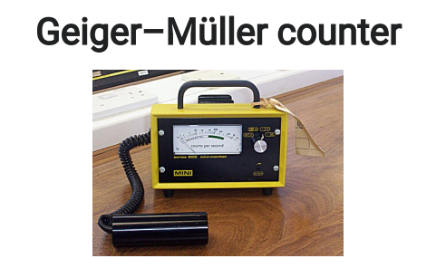 **2)Gieger counter:** A Geiger counter is an electrical device utilized for measuring as well as detecting radiation that is ionizing. It is also known as a Geiger-Müller counter or GM counter. It is mostly utilized in the dose measurement of radiation, nuclear industry, Physics in experiment, and radiological protection. An instrument able to identify ionizing radiation, like beta, gamma, and alpha rays because of the ionization impact generated by the Geiger-Müller tube, which provides the device's name. It is one of the most well-known radiation detection instruments in the world and is employed as a portable radiation survey tool with great frequency.

**Principle:** 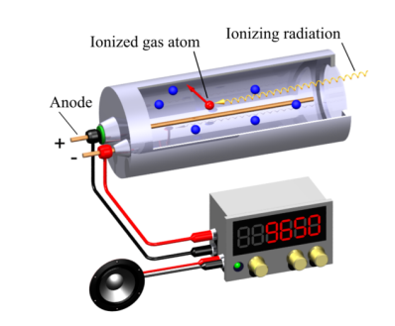A Geiger counter consists of a Geiger-Müller tube, which is the radiation sensor component, and processing electronics that display the result. Before being exposed to a high voltage, an inert gas, like argon, the neon, or helium—is pumped into the Geiger-Müller tube at a low pressure. The tube momentarily conducts an electrical charge when the gas is ionized and made conductive by gamma radiation or high-energy particles. The tube's ionization is greatly amplified by the Townsend discharge effect, resulting in a detectably measurable detection pulse supplied to the display and processing circuits. The strong pulse of the tube and the resulting significant simplification of the electronics allow the Geiger counter to be produced at a relatively low cost. The electronics are also responsible for producing the elevated current (roughly 400-900 volts) required for power the Geiger-Müller tube.

**Readout:** Two types of radiation readout is observed counts and radiation dose.

The most fundamental display is the count, which shows the total count of ionized that have been found. Either the total number of counts over a predetermined period of time, or counts per unit of time, like "counts per minute" or "counts per second," can be displayed. The count readout is usually used to search for alpha or beta particles.

Units like the sievert, which are frequently used to measure gamma or X-ray dose rates, are more difficult to use to construct a representation of radiation dosage rate. The ability of radiation to ionize matter is impacted by the fact that a Geiger Müller tube can identify radiation when it is present, but not its energy. For equipment monitoring dose rate, energy-related compensation Geiger-Müller tubes are required to ensure that the recorded dosage corresponds with the counts found. This conversion, which varies depending on the design and calibration of each instrument, will be carried out by the electronics, using predetermined parameters.

**Limitations:**

The Geiger counter has the following two primary limitations:

- A Geiger-Müller tube is unable to discriminate between various forms of radiation because its output pulse is always the same magnitude, regardless of the energy of the input radiation.

-Because there is a "dead time," or insensitive interval between each ionization event and which any additional incident radiation does not cause a count, the tube is less accurate at high radiation rates. The indicated count rates are usually reduced from 104 to 105 counts per second by the dead period, depending on the characteristics of the tube being used. Ion chamber instruments provide more accurate data and are therefore preferred for high radiation rates, although some counters have circuitry that can account for this.

**Applications:**

**Particle detection:** Detecting particles was one of the Geiger principle's original historical applications, and this is still the instrument's primary function today. Low-energy particles must be handled with the "end-window" version of a Geiger-Müller tube because their short range and rapid stopping by a solid material dictate this. In order to introduce as many of these particulates as possible into the fill gas, the tube must have a window as thin as is practical. Mica typically has a density of 1.5–2.0 mg/cm2, which is used to construct windows.

1. Because of particle attenuation, particles have the shortest range, so the window should ideally be placed within 10 mm of the radiation source in order to detect them. However, a Geiger counter with an end window tube cannot discriminate between different particles because the Geiger-Müller tube produces a pulse output with the same magnitude for all detected radiation. A skilled operator can distinguish between high-energy and low-energy particles by varying the distance from a radiation source.
2. The "pancake" Geiger-Müller tube is an end-window probe variant that has a larger detection area to expedite verification. But because the window membrane's strength is limited by the atmosphere's pressure in comparison to the fill gas's low pressure, the size of the window is constrained.
3. Certain particulates can be found using a thin-walled, "windowless" Geiger-Müller tube, which permits particles with high energy to flow through the walls but lacks an end window. Even though the tube walls are more robust than a thin end-window, these more energetic particles are still able to enter the fill gas.
4. Close the pane in particular with high-energy particles, Geiger counters are still utilized as portable, all- objective, radioactive pollution monitoring and recognition devices because of their robustness, generally affordable and with a comparatively high detection effectiveness. However, it is best to utilized proportional counters or scintillation counters. to distinguish between particles or to provide information on particle energy.
5. Because they have significantly bigger detector areas than Geiger counters, those instrument types can check for surface contamination more quickly.

* **Effect of Decontamination techniques on the quality of Herbs:** It is important to evaluate the microbiological contamination of MAPs produced in different locations besides their chemical and physical characteristics. The most important studies on MAP decontamination and the effects of various techniques on the microbiological and qualitative traits of processed plants are summarized in choosing the best technology for the type of product is crucial since it not only reduces the microbial load but also affects the qualitative features of the product. The product's qualitative and microbiological qualities must, however, be in an ideal relationship. As a result, minimal damage to the product's qualitative features is also achieved, along with a lowering of the microbial load.
* **Conclusion:**

Through an in-depth exploration of sources and mechanisms of radioactive contamination in medicinal herbs, as well as the various radioprotective strategies and techniques, we have gained a comprehensive understanding of the subject.

The research outlined in this review underscores the significance of thorough quality control measures and rigorous testing protocols in the herbal industry. The exploration of natural radioprotective compounds and the potential for their integration into herbal formulations offers a promising avenue for enhancing the safety and therapeutic value of traditional medicines.

* **Result:**

Medicinal herbs can become contaminated with radioactive isotopes through various means, such as airborne radioactive particles, soil **contamination, or water sources that contain radioactive substances. Nuclear accidents, like the Chernobyl disaster or Fukushima Daiichi incident, can also lead to radioactive contamination of plants, including medicinal herbs.**

Ingesting herbs contaminated with radioactive isotopes can lead to radiation exposure in humans. Health risks can include increased risk of cancer, radiation sickness, and other long-term health issues, depending regarding the particular isotopes involved as well as the degree of contaminants.It's crucial to monitor the radiation levels in medicinal herbs, particularly in regions where there's a risk of contamination. Regulatory authorities and organizations often conduct monitoring and testing to ensure that herbs remain safe for consumption.To protect medicinal herbs from radioactive contamination, various measures can be taken.

* **Reference:s**

1.Najam, L. A., AL-Jomaily, F. M. & AL-Farha, W. M. Natural radioactivity levels of limestone rocks in northern Iraq using gamma spectroscopy and nuclear track detector. J. Radioanal. Nucl. Chem. 289(3), 709–715 (2011).

2. Garboś, S. & Święcicka, D. Human health risk assessment of uranium in drinking water sampled from drilled wells located in rural areas of the Lower Silesian region (Poland). Arch. Environ. Protect. 41(2), 21–27 (2015).

3. Saenboonruang, K., Phonchanthuek, E. & Prasandee, K. Soil-to-plant transfer factors of natural radionuclides (226Ra and 40K) in selected Tai medicinal plants. J. Environ. Radioact. 1–5, 184–185 (2018).

4. Shyamal, R. C., Rezaul, A., Rahman, A. R. & Sarker, R. Radioactivity concentrations in soil and transfer factors of radionuclides from soil to grass and plants in the Chittagong City of Bangladesh. J. Phys. Sci. 24(1), 9 (2013).

5. Chan, K. Some aspects of toxic contaminants in herbal medicines. Chemosphere 52(9), 1361–1371 (2003).

6. Astin, J. A. Why patients use alternative medicine: Results of a national study. JAMA 279(19), 1548–1553 (1998).

7. Kozhakhanov, T. E., Lukashenko, S. N. & Larionova, N. V. Accumulation of artifcial radionuclides in agricultural plants in the area used for surface nuclear tests. J. Environ. Radioact. 137, 217–226 (2014).

8. Brown, K. Medicinal plants, indigenous medicine and conservation of biodiversity in Ghana. In Working Paper GEC: 92–36, Centre for Social and Economic Research on Global Environment (CSERGE), Norwich, UK (1992).

9. Vandenhove, H., Vanhoudt, N., Duquène, L., Antunes, K. & Wannijn, J. Comparison of two sequential extraction procedures for uranium fractionation in contaminated soils. J. Environ. Radioact. 137, 1–9 (2014).

10. UNSCEAR (United Nations Scientifc Committee on the Efects of Atomic Radiation). Efects of Atomic Radiation to the General Assembly. New York: United Nations (2000).

11. Lordford, T.-L., Emmanuel, O., Darko, C., Schandorf, A. & Ampomah, A. Natural radioactivity levels of some medicinal plants commonly used in Ghana. Springer Plus 2, 157 (2013).

12. Al-Omari, S. Radioactivity measurement of 222Rn, 226Ra and 238U in pharmaceuticals and evaluation of cancer risk. Int. J. Low Radiat. 10(1), 61–73 (2015).

13. Abdel-Ghany, H. A. & Eman, M. I. Unexpected radiation hazard in dyes of textiles. Isotopes Environ. Health Stud. 50(4), 546–554 (2014).

14. Ajayi, T. R., Torto, N., Tchokossa, P. & Akinlua, A. Natural radioactivity and trace metals in crude oils: Implication for health. Environ. Geochem. Health 31, 61–69 (2009).

15. Freitas, A. & Alencar, A. S. Gamma dose rates and distribution of natural radionuclides in sand beaches-Ilha Grande, Southeastern Brazil. J. Environ. Radioact. 75, 211–223 (2004).

16. Jibiri, N. N., Farai, P. I. & Alausa, K. S. Estimation of annual efective dose due to natural radioactivity elements in ingestion of foodstufs in tin missing area of Jos-Plateau-nigeria. J. Environ. Radiat. 94, 31–40 (2007).

17. Durrani, S. A. & Bull, R. K. Solid State Nuclear Track Detection Principles, Method, and Applications (Pergamon Books, 1987).

18. Abel-Ghany, H. A. Te association between indoor radon and tobacco smoke. Indoor Built. Env. 15, 289–293 (2006).

19. Hafez A. F., Hussein, A. S. & Rasheed, N. M. Radon measurements in underground metro stations in Cairo City, Egypt. In 7th conf., Nucl Sci Appl, Cairo (2000).

20. Abdel Ghany, H. A. Study of radon, thoron and toxic elements in some textile dyes. J. Radioanal. Nucl. Chem. 295(2), 1365–1370 (2013).

21. Kranrod C, Chanyotha S, Pornnumpa C, Kritsananuwat R and Sriploy P 2015 Radiat. Prot. Dosimetry 167(1-3) 270.

22. Flynn WW 1968 Anal. Chim. Acta. 43 221.

23. C Kranrod, S Chanyotha, R Kritsananuwat, T Ploykrathok, P Pengvanich, Y Tumnoi, T Thumvijit and S Sriburee 2017 J. Phys.: Conf. Ser. 860 012001

24. World Health Organization (WHO) 2007 WHO guidelines for assessing quality of herbal medicines with reference to contaminants and residues (WHO Press Spain) p 118.

25. United Nations Scientific Committee on the Effects of Atomic Radiation 2000 Sources and effects of ionizing radiation (New York: United Nations) p.

26. International Commission on Radiological Protection (ICRP) 1996b Age-dependent doses to members of the public for intakes of radionuclides: Part 5. Compilation of ingestion and inhalation dose coeffi cients. ICRP Publication 72. Annuals ICRP 26(1). (Oxford Elsevier Science Ltd.)

27. Qureshi, A. A. et al. Evaluation of excessive lifetime cancer risk due to natural radioactivity in the river’s sediments of Northern Pakistan. J. Radiat. Res. Appl. Sci. 7(4), 438–447 (2014).

28. Hassan, S. F., Mahmoud, M. A. M. & El-Rahman, M. A. Efect of radioactive minerals potentiality and primordial nuclei distribution on radiation exposure levels within muscovite granite, Wadi Nugrus, Southeastern Desert, Egypt. J. Geosci. Environ. Protect. 4(3), 62 (2016).

29. ICRP. Recommendations of the international commission on radiological protection. In ICRP publication 60. Annex. ICRP 21 1–3 (1990).

30. Gbenu, S. T. et al. Assessment of radiological hazard of quarry products from southwest Nigeria. J. Radiat. Res. Appl. Sci. 9, 20–25 (2015).

31. Ramasamy, V., Paramasivan, K., Suresh, G. & Jose, M. T. Function of minerals in the natural radioactivity level of Vaigai River sediments, Tamilnadu, India—spectroscopical approach. J. Spectrochim. Acta Part A Mol. Biomol. Spectrosc. 117, 340–350 (2014).

32. European Commission Radiation Protection, 112-radiological protection principles concerning the natural radioactivity of building materials Directorate General Environment. Nuclear Safety and Civil Protection (1999).

33.’’Geiger Muller Tubes; issue 1’’ published by Centronics Ltd, UK.

34. Glenn F Knoll. Radiation Detection and Measurement, third edition 2000. John Wiley and Sons, ISBN 0-471-07338-5.

35."G-M detector function and measuring methods" (https://xn--messgert-test-hfb.d e/geigerzaehler/. Retrieved 2017-03-07.

36.(http://files.site-fusion.co.uk/webfusion117640/file/instrumentsirp7.pdf.pdf)Archived (https://web.archive.org/web/20180730235921/http://files.sitefusion.co.uk/webfusion117640/file/instrumentsirp7. pdf.pdf) 2018-07-30 at the Way back Machine Selection, use and maintenance of portable monitoring instruments. UK HSE

37. Hassan, S. F., Mahmoud, M. A. M. & El-Rahman, M. A. Efect of radioactive minerals potentiality and primordial nuclei distribution on radiation exposure levels within muscovite granite, Wadi Nugrus, Southeastern Desert, Egypt. J. Geosci. Environ. Protect. 4(3), 62 (2016).

38. ICRP. Recommendations of the international commission on radiological protection. In ICRP publication 60. Annex. ICRP 21 1–3 (1990).

39. Gbenu, S. T. et al. Assessment of radiological hazard of quarry products from southwest Nigeria. J. Radiat. Res. Appl. Sci. 9, 20–25 (2015).

40. Ramasamy, V., Paramasivan, K., Suresh, G. & Jose, M. T. Function of minerals in the natural radioactivity level of Vaigai River sediments, Tamilnadu, India—spectroscopical approach. J. Spectrochim. Acta Part A Mol. Biomol. Spectrosc. 117, 340–350 (2014).

41. European Commission Radiation Protection, 112-radiological protection principles concerning the natural radioactivity of building materials Directorate General Environment. Nuclear Safety and Civil Protection (1999).

42. Aladeniyia, K. et al. Evaluation of radiometric standards of major building materials used in dwellings of South-Western Nigeria. Radiat. Phys. Chem. 178, 109021 (2020).

43. ICRP (International Commission on Radiological Protection). Lung cancer risk from radon and progeny and statement on radon. Ann. ICRP 40(1), 1–64 (2010).

44. Varier MK 2009 Nuclear radiation detection: Measurements and analysis (New Delhi India: Narosa Publishing House).

45. Brígido FO, Montalván EA, Barreras CA and Fabelo BO 2015 Polonium-210 concentration of cigarettes traded in Cuba and their estimated dose contribution due to smoking Proceedings of the XV Workshop on Nuclear Physics and IX International Symposium on Nuclear and Related Techniques WONP-NURT'2015, Havana, Cuba.

46. World Health Organization (WHO) 2011 Information on nuclear accidents and radioactive contamination of foods International Food Safety Authorities Network (Geneva).

47. Colangelo CH, Huguet MR, Palacios MA and Oliveira AA 1992 J. Radioanal. Nucl. Chem. 166 195.

48. Chandrashekara K and Somashekarappa HM 2016 J. Radia.t Res. App.l Sci. 9 68.

49. Jevremovic M, Lazarevic N, Pavlovic S and Orlic M 2011 Isot. Environ. Healt. S. 47 87.

50. Njinga RL, Jonah SA and Gomina M 2015 J. Radiat. Res. App.l Sci. 8 208.

51. Desideri D1, Meli MA and Roselli C 2010 J. Environ. Radioact. 101(9) 751.

52. Scheibel V and Appoloni CR 2007 Braz. Arch. Biol. Technol. 50 901.