**“DYNAMIC ANALYSIS OF MULTI DEGREES OF FREEDOM SYSTEM WITH AND WITHOUT BRACED IN RCC STRUCTURE”**

**Kulendra Misru Dewasea, Vinay Kumar Singh Chandrakarb**

**M.Tech. Scholara, Assistant Professorb **Madhyanchal Professional University**, Faculty of engineering & Technology, School of civil engineering Bhopal, M.P., India. **

**ABSTRACT**

The seismic analysis of multi-story buildings has seen significant growth in recent decades. In the past, these buildings were often designed without considering seismic excitation, leading to unreliable structures. However, it has become apparent that modern multi-story buildings designed to withstand lateral loads, such as those from earthquakes and wind, perform much better when dynamic loads are considered in the analysis.

In regions like India, particularly in seismically active areas like the Himalayan region, evaluating natural hazards due to seismic activity is crucial. This paper focuses on conducting a nonlinear dynamic analysis of a multi-storied reinforced concrete (RC) building, considering various seismic intensities observed in the seismically. This method provides a more comprehensive understanding of the building's behaviour under seismic loads, leading to improved design and structural integrity. In this paper we consider braced G+6 Story R.C.C building and find out story displacement and story drift and find braced structure system showing better result in compare to normal rcc structures. In regions with high wind or seismic activity, braced systems are often incorporated into the design of residential buildings to enhance their structural integrity and safety. However, in areas with less extreme environmental conditions, this structural systems may be more appropriate or cost-effective.

**Keywords:** -Story drift, Displacement, RCC Structure, Structural Integrity, Braced Structure

**Introduction:**

A braced reinforced concrete (RCC) structure is a type of building or structural system that incorporates bracing elements made of reinforced concrete. These structures are designed to resist lateral loads such as wind or seismic forces. Bracing systems in RCC structures can be in the form of shear walls, diagonal braces, or moment-resisting frames.

The primary purpose of bracing in RCC structures is to provide stability and resist lateral forces that can cause the building to sway or deform excessively during earthquakes, windstorms, or other lateral loading conditions.

**Types of Bracing Systems**:

**Shear Walls**: These are vertical concrete walls designed to resist lateral loads by shear action. They are typically placed strategically in the building plan to provide stiffness and prevent lateral movement.

**Diagonal Braces**: Diagonal braces are inclined members that connect two points in the structure diagonally. They are effective in transferring lateral loads to the foundation.

**Moment-Resisting Frames**: These frames provide resistance to lateral loads by flexural action. They are composed of beams and columns that are rigidly connected to resist lateral movements.

**Design Considerations**: The design of braced RCC structures involves considerations such as the magnitude and direction of lateral loads, the location and spacing of bracing elements, and the overall structural stability.

**LITERATURE RERVIEW:**

**Mr K lova Raju et al (2022)** the study aims to determine the most effective placement of shear walls in a multi-story building. The building under consideration is an eight-story structure located in seismic zones II, III, IV, and V, according to the seismic design code IS1893-2002. This implies that the study investigates the structural behavior and effectiveness of shear walls under seismic loading conditions in different seismic zones.

The objective seems to be assessing how the placement of shear walls affects the overall seismic performance and stability of the building frame under earthquake loads. The non-linear analysis suggests that the study delves into the behavior of the structure beyond linear assumptions, considering factors like material non-linearity, large displacements, and potentially plastic behavior of structural elements.

Overall, the paper aims to provide insights into optimizing the location and configuration of shear walls in multi-story buildings to enhance seismic resistance and structural performance.

**Methods**

Seismic design methods, which are techniques used in engineering to design structures that can withstand earthquake forces. Seismic design aims to ensure that buildings and infrastructure can endure the potentially destructive effects of seismic activity.

Here are some common seismic design methods:

**Building Codes**: Most regions prone to earthquakes have specific building codes that dictate seismic design requirements. These codes provide guidelines and regulations for architects and engineers to follow when designing structures.

**Dynamic Analysis**: Dynamic analysis involves studying the behaviour of structures under dynamic loads, such as earthquakes. This analysis helps engineers understand how a structure will respond to seismic forces and allows them to make necessary design modifications to enhance its seismic performance.

**Response Spectrum Analysis**: This method evaluates the response of a structure to ground motion by considering the dynamic characteristics of both the structure and the earthquake ground motion. Engineers use response spectrum analysis to determine the likely maximum displacements, velocities, and accelerations that a structure will experience during an earthquake.

**Equivalent Lateral Force Method**: The Equivalent Lateral Force (ELF) method is a simplified approach used to estimate the seismic forces acting on a building. It involves calculating an equivalent lateral force based on the building's mass, stiffness, and other parameters, which is then applied to the structure as a lateral load.

**Pushover Analysis**: Pushover analysis, also known as nonlinear static analysis, evaluates the seismic performance of a structure by gradually applying lateral forces until failure occurs. This method helps engineers identify potential weak points in a structure and assess its overall seismic resistance.

**Base Isolation**: Base isolation involves decoupling a structure from the ground using isolation bearings or other damping devices. This technique allows the building to move independently of the ground motion during an earthquake, reducing the forces transmitted to the structure and improving its seismic resilience.

**Ductile Design**: Ductile design focuses on ensuring that structures exhibit ductile behaviour during earthquakes, meaning they can deform significantly without losing their ability to support loads. This approach involves using materials and structural configurations that can absorb and dissipate seismic energy without catastrophic failure.

**Method of analysis**

1. Equivalent Static analysis
2. Equivalent dynamic analysis
3. Equivalent non- static analysis
4. Equivalent non dynamic analysis

**Equivalent Static analysis**

Equivalent Static Analysis (ESA) is a simplified method used in structural engineering to determine the approximate response of a structure subjected to dynamic loads, such as seismic or wind forces, by converting these dynamic loads into equivalent static loads. This approach is employed when a more detailed dynamic analysis is not feasible or necessary, typically for simpler or less critical structures.

**Identification of Equivalent Static Loads**: Dynamic loads acting on the structure are converted into equivalent static loads. This conversion is based on various factors such as mass distribution, mode shapes, damping characteristics, and response spectra.

**Application of Equivalent Static Loads**: The equivalent static loads are then applied to the structure in different load combinations to simulate the effect of dynamic forces. These loads typically include lateral forces, overturning moments, and torsional effects.

**Analysis of Structural Response**: The structure's response to the equivalent static loads is analyzed using conventional static analysis techniques, such as the finite element method or classical hand calculations. This analysis assesses the structural stresses, deformations, and stability under the simulated static loads.

**Verification and Adjustment**: The results obtained from the equivalent static analysis are verified against design criteria and safety standards. Adjustments may be made to the analysis parameters or load assumptions to ensure that the structural design meets the required performance objectives.

**Table 1 Structure Configuration**

|  |  |
| --- | --- |
| Types of structure | RCC |
| No of story | G+6 |
| Size of beam | 400mm*500mm |
| Size of column | 500mm*600mm |
| Thickness of slab | 125mm |
| No of bay in X - Directions | 4 |
| No of bay in Y - Directions | 4 |
| Spacing Between in bay | 3m |
| Floor Height | 3.5m |
| Live Load | 2.5Kn/m2 |
| Grade of concrete | M25 |
| Grade of steel | Fe500 |
| Zone | V |
| Importance factor | 1 |
| Soil Types | Hard soil |
| IS Code | 1893- 2002 part-I |

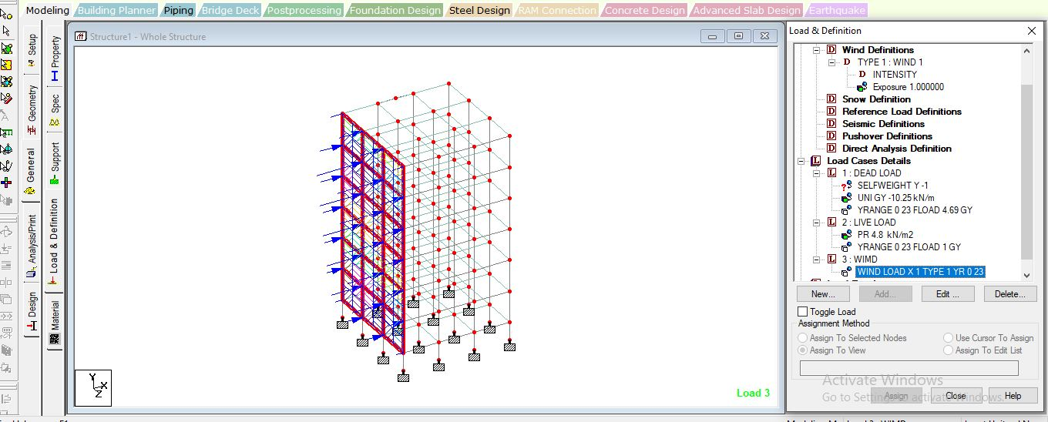

**Figure 1 Structure after apply load**

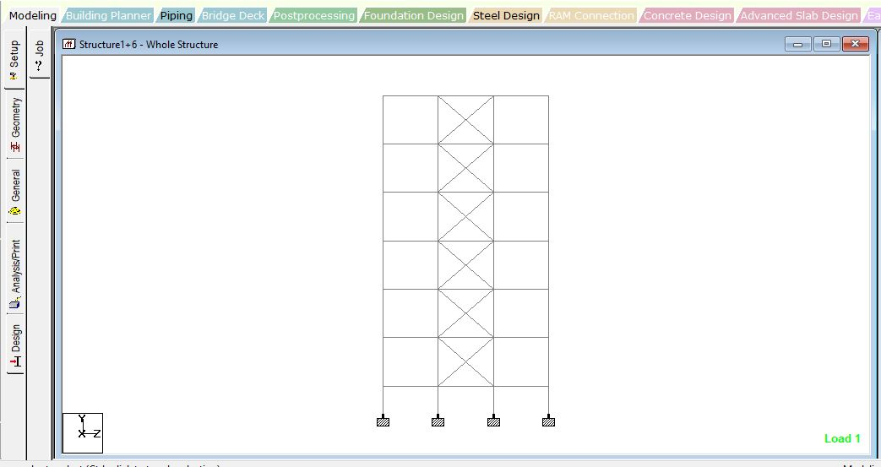

**Figure 2 Model of braced structure**

**RESULT ANLYSIS**

**Story Displacement**

Story displacement in structural design involves careful analysis and coordination between architects and engineers to ensure structural integrity and compliance with building codes and regulations. Techniques such as vertical step-backs, transfer beams, and shear walls can be employed to mitigate the effects of story displacement and maintain structural stability throughout the building. In a building with story displacement.

**Table 2 Story displacement in mm**

|  |  |  |  |
| --- | --- | --- | --- |
| **Story** | **Story Displacement Normal Structure** | **Story Displacement Braced Structure** | **% Reductions** |
| Sixth Story | 20.94 | 3.42 | 83.67 |
| Fifth Story | 14.65 | 2.87 | 80.41 |
| Fourth Story | 9.58 | 1.91 | 80.06 |
| Third Story | 4.32 | 0.80 | 81.48 |
| Second Story | 1.63 | 0.06 | 96.31 |
| Frist Story | 0.84 | 0 | 100 |
| Base | 0 | 0 | **-** |

Table 4.1 clearly shown the value of displacement. Without braced structure shown higher displacement value in compare to braced structure. If we discussed in terms of percentages on as average percentages reduction of all story is 86.99% which is average values of all the six story of structure.

**Figure 3 Story Displacement of normal structure and braced structure**

**Story Drift**

Story drift is essential for ensuring the safety and functionality of structures during seismic events or other lateral loading conditions. Excessive story drift can lead to structural damage, compromised functionality, or even collapse in extreme cases. Therefore, structural engineers incorporate story drift considerations into their designs to mitigate risks and ensure that buildings can withstand the forces they may encounter throughout their lifespan.

**Table 3 Story Drift in mm**

|  |  |  |
| --- | --- | --- |
| **Story** | **Story Drift Normal Structure** | **Story Drift Braced Structure** |
| Sixth Story | 3.41 | 1.45 |
| Fifth Story | 2.89 | 1.23 |
| Fourth Story | 2.61 | 0.99 |
| Third Story | 1.89 | 0.76 |
| Second Story | 1.21 | 0.0083 |
| Frist Story | 0.42 | 0.0032 |
| Base | 0 | 0 |

This table presents the relationship between the number of stories in a structure and the corresponding story drift values .Story drift is a basically ratio of story when we increased number of story. Story drift value increases when story increased. We used braces system in structure we control the value of story drift in certain level.

**Figure 4 Story Drift of normal structure and braced structure**

**Conclusion**

* Braced frames consist of diagonal bracing members that are designed to carry lateral loads and dissipate seismic energy. They provide stiffness and strength to the structure, minimizing lateral displacement.
* Two conditions are being compared: one without bracings and another with X bracing. Bracings are structural elements used to provide lateral stability and reduce the sway of a building under lateral loads such as wind or seismic force.
* This indicates that the building experiences less movement or deformation under lateral loads when bracings are installed compared to when they are not.
* Story drift refers to the relative lateral displacement between different floors or stories of a building under lateral loads. Lower values of story drift indicate less lateral movement and potentially better performance in terms of occupant comfort, structural integrity, and functionality during seismic events or high winds**.**

.

**REFERENCES**

1. [R. Martino](https://www.researchgate.net/scientific-contributions/R-Martino-2058855231?_sg%5B0%5D=aAIJbXyRiGGHTVNkuRf55v1Ls51g7flt5D5JTYye95BBOcnHTbm5NzYFAMwNpc4rlwn1vo8.y5bXQZWovJEI4vPKeB9hcDRHY6PLs8wRTcbijduNnt8kTUSyoRVfckSdQN5D5vDTx8PvQeBIetT2FHl_I-kSFA&_sg%5B1%5D=SNnv3OycpnhiRuseVt76YS_B_fxW28040YV6v5bXb6cFZgnj4Hy_avHH4MgL2QtzVFqhBfs.j3FrgZMfaK7QFSQ_a4p2veXWUFm-ImnrNnJZNTv1ESVXonDFAxcQUpRfIzuPUq4VRvYw71ks1bJDChOR9pXVCg&_tp=eyJjb250ZXh0Ijp7ImZpcnN0UGFnZSI6InB1YmxpY2F0aW9uIiwicGFnZSI6InB1YmxpY2F0aW9uIiwicG9zaXRpb24iOiJwYWdlSGVhZGVyIn19), [Enrico Spacone](https://www.researchgate.net/profile/Enrico-Spacone?_sg%5B0%5D=aAIJbXyRiGGHTVNkuRf55v1Ls51g7flt5D5JTYye95BBOcnHTbm5NzYFAMwNpc4rlwn1vo8.y5bXQZWovJEI4vPKeB9hcDRHY6PLs8wRTcbijduNnt8kTUSyoRVfckSdQN5D5vDTx8PvQeBIetT2FHl_I-kSFA&_sg%5B1%5D=SNnv3OycpnhiRuseVt76YS_B_fxW28040YV6v5bXb6cFZgnj4Hy_avHH4MgL2QtzVFqhBfs.j3FrgZMfaK7QFSQ_a4p2veXWUFm-ImnrNnJZNTv1ESVXonDFAxcQUpRfIzuPUq4VRvYw71ks1bJDChOR9pXVCg&_tp=eyJjb250ZXh0Ijp7ImZpcnN0UGFnZSI6InB1YmxpY2F0aW9uIiwicGFnZSI6InB1YmxpY2F0aW9uIiwicG9zaXRpb24iOiJwYWdlSGVhZGVyIn19), [Gregory Kingsley](https://www.researchgate.net/profile/Gregory-Kingsley?_sg%5B0%5D=aAIJbXyRiGGHTVNkuRf55v1Ls51g7flt5D5JTYye95BBOcnHTbm5NzYFAMwNpc4rlwn1vo8.y5bXQZWovJEI4vPKeB9hcDRHY6PLs8wRTcbijduNnt8kTUSyoRVfckSdQN5D5vDTx8PvQeBIetT2FHl_I-kSFA&_sg%5B1%5D=SNnv3OycpnhiRuseVt76YS_B_fxW28040YV6v5bXb6cFZgnj4Hy_avHH4MgL2QtzVFqhBfs.j3FrgZMfaK7QFSQ_a4p2veXWUFm-ImnrNnJZNTv1ESVXonDFAxcQUpRfIzuPUq4VRvYw71ks1bJDChOR9pXVCg&_tp=eyJjb250ZXh0Ijp7ImZpcnN0UGFnZSI6InB1YmxpY2F0aW9uIiwicGFnZSI6InB1YmxpY2F0aW9uIiwicG9zaXRpb24iOiJwYWdlSGVhZGVyIn19) “Nonlinear Pushover Analysis of RC Structures” DOI: [10.1061/40492(2000)38](http://dx.doi.org/10.1061/40492(2000)38).
2. Poleswara Rao. Kovela1, Balaji. K.V. G. D 2, Gopal Raju S. S. S.V 3, Srinivasa Rao S “www.ijraset.com Volume 5 Issue III, March 2017 IC Value: 45.98 ISSN: 2321 International Journal for Research in Applied Science & Engineering Technology (IJRASET) ©IJRASET: All Rights are Reserved Nonlinear Pushover Analysis for PerformanceBased Engineering Design – A Revie.
3. Mohamad Najim Mahmood*, Halla Jasem Mohamad” dynamic and pushover analysis of multi-storey reinforced concrete building using different load distribution pattern” Journal of Applied Engineering ScienceVol. 20, No. 4, 2022 Original Scientific Paper Paper number: 20(2022)4, 1037, 1325”
4. Chhagan Kumar Jangir*1, Dr. A. K. Dwivedi “Pushover analysis of rc framed structure with varying moment of inertia in seismic zone v” e-ISSN: 2582-5208 International Research Journal of Modernization in Engineering Technology and Science Volume:03/Issue:04/April-2021 Impact Factor- 5.354 [www.irjmets.com](http://www.irjmets.com).
5. Rakshe Rahul, Kalwane Uttam; “Incremental dynamic analysis and static pushover analysis of existing RC framed buildings using the seismic structure software” International Journal of Advance Research, Ideas and Innovations in Technology.
6. Ahmed Abdi Hassan1* and Ahmed Adan Yasin “Pushover Analysis of Multi-Story Reinforced Concrete Frame Structure” Journal of Economics & Management Research February 24, 2023; Accepted: March 09, 2023; Published: March 20, 2023
7. Ramli, M.Z. and Adnan, A., 2014. Seismic Performance of East Malaysia Bridge under Sulawesi subduction zone and shallow crustal zone. Australian Earthquake Engineering Society 2014 Conference, Nov 21-23, Lorne, Victoria. Rebelo, J., 2014.Evaluation of Test Methods for Determining the Water to Cement Ratio of Fresh and Hardened Concrete. Master of Science in Civil Engineering. University of Toronto
8. Zulkefli, M.U., 2010. The Seismic Analysis of Malaysian Bridges. Management in Construction Researchers Association 9* Annual Conference and Meeting. pp.1-1
9. Adiyanto, M.I. and Majid, T.A., 2014. Seismic Design Of Two Storey Reinforced Concrete Building In Malaysia With Low Class Ductility. Journal of Engineering Science and Technology, 9(1), pp. 28-30
10. Boria Anya a , Tamal Ghosh “A Study on Effect of Shear Wall in Seismic Analysis of Building” IOP Conf. Series: Earth and Environmental Science 796 (2021) 012049 IOP Publishing doi:10.1088/1755-1315/796/1/012049