Design and Implementation of Arduino based Hydrogen Peroxide Sensor Integrated System

# Abstract

Developing an affordable and portable system to detect hydrogen peroxide presents exciting opportunities for disease diagnosis and environmental monitoring. For this project, we utilized Arduino, a platform well-regarded for its combination of integrated software, hardware, and numerous open-source sensor libraries. We engineered a homemade Arduino-based potentiostat, an electrochemical device used to measure hydrogen peroxide. This potentiostat is cost- effective and highly adaptable. It is capable of performing essential functions like chronoamperometry and cyclic voltammetry, which are methods for determining chemical concentrations. Our system is both precise and accurate, achieving detection capabilities comparable to those of commercial potentiostats. We believe this research could pave the way for developing a range of other electrochemical sensing systems, potentially advancing medical and environmental applications.

*Keywords:* Low coast sensing system ,portable integrated sensing, Hydrogen Peroxide detection, Disease Diagnosis, Environmental Monitoring, Arduino platform, Open source sensor libraries, Homemade Potentiostat, Cyclic voltammetry ,Accurate sensing, Electrochemical sensing system.

# Introduction

This abstract highlights the creation of a cost-effective and portable system for detecting hydrogen peroxide and presenting promising applications in both environmental monitoring as well as disease diagnosis [1-2]. The platform used for this innovative system is Arduino, renowned for its integrated hardware and software, along with a vast array of open-source sensor libraries[3-5]. The researchers have developed a homemade potentiostat, an essential device for electrochemical measurements, using the Arduino uno platform.

A potentiostat is crucial in various electrochemical techniques, primarily used for studying electrochemical cells by controlling the voltage between working and reference electrodes and

measuring the current that flows. In this study, the Arduino-based potentiostat was designed with an emphasis on low cost and flexibility. These features make it accessible for a wide variety range of applications, particularly in settings in which resources are limited or portability is necessary.

The newly developed system can perform chronoamperometry and cyclic voltammetry, two critical techniques in electrochemistry. Chronoamperometry involves applying a constant potential to an electrochemical cell and measuring the resulting current over time. This technique is vital for studying reaction kinetics and diffusion processes. Cyclic voltammetry, This technique entails gradually altering the potential of the working electrode over time while recording the resulting current. It yields comprehensive insights into the electrochemical characteristics of the analyte, including its redox potentials and reaction mechanisms.

In terms of performance, the Arduino-based potentiostat has demonstrated high accuracy and precision in sensing hydrogen peroxide. Hydrogen peroxide is an important analyte in various fields, including medical diagnostics, where it serves as a biomarker for oxidative stress, and environmental monitoring, where it is a common pollutant[6-8]. The precise detection of the hydrogen dioxide is therefore crucial for these applications. Remarkably, the detection capabilities of the homemade potentiostat are almost equivalent to those of commercial potentiostats. This accomplishment highlights the potential of the Arduino-based system to act as a cost-effective alternative to pricier commercial devices.[9-11].

The implications of this study are far-reaching. By demonstrating that a low-cost, flexible, and portable system can achieve detection performance on par with commercial devices, this research opens with a new possibilities for which the development of various potentiometric sensor systems. These systems could be tailored for specific applications, enhancing their utility in both environmental and medical fields. For instance, in remote or resource-limited areas, such an affordable and portable system could facilitate on-site diagnostics and environmental monitoring, which would otherwise be challenging due to the lack of sophisticated equipment.

Furthermore, the purpose of Arduino, a platform with a large community of users and developers, ensures that the system can be easily adapted and improved

upon by others. The open-source nature of Arduino libraries means that researchers and hobbyists alike

can build on this work, creating new sensors or enhancing existing ones to meet their specific needs.

In conclusion, the development of a low-cost, flexible, and portable Arduino-powered potentiostat for hydrogen detection

peroxide sensing represents a significant advancement in electrochemical sensor technology. This study not only provides a viable alternative to commercial potentiostats but also paves the way for future innovations in electrochemical sensing, with potential applications spanning from advanced medical diagnostics to comprehensive environmental monitoring.

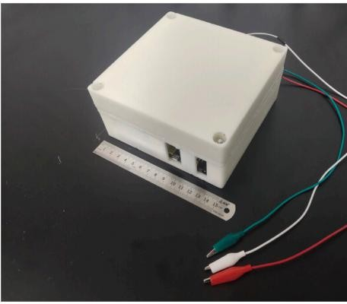

**Fig. 1. A photographic image of the Arduino-powered potentiostat system.**

*2.Experimental*

* 1. *1.1 Equipment and Reagents*

Essential equipment and reagents are utilized in the development of the Arduino-based potentiostat for hydrogen peroxide detection.The main apparatus includes the Arduino microcontroller, chosen for its printed wiring board (PWB). We also designed a 3D case using Cinema 4D and Magics software, which was printed with a Vistar 3D printer. The PWB, The software for the potentiostat was written using the Arduino IDE, and the code was uploaded to the Arduino. Data from the experiments were collected via the Arduino serial port monitor and analyzed using Microsoft Excel or Matlab.

integrated hardware and software capabilities, and open-source sensor libraries. Essential components include the working electrode, reference electrode (Ag/AgCl), and counter electrode (platinum or gold), which are critical for electrochemical measurements.

Hydrogen peroxide (H₂O₂) is the primary analyte tested at various concentrations. Supporting electrolytes like phosphate-buffered saline (PBS) maintain ionic strength and pH, ensuring consistent electrochemical conditions. These electrolytes facilitate ion conduction in the solution, necessary for efficient electrochemical reactions.

This setup enables the Arduino-based potentiostat to perform chronoamperometry and cyclic voltammetry, essential techniques for measuring hydrogen peroxide concentration and behavior. The combination of Arduino hardware, specialized electrodes, and selected chemicals resulted in a low- cost, flexible, and precise sensing system that matches the performance of commercial potentiostats, opening new possibilities for environmental as well as medical applications.

# Building the Arduino-based potentiostat

To build the Arduino-based potentiostat, we first designed the wiring diagram using Fritzing software. We then created the wire layout and component arrangement on a breadboard to test its performance in chronoamperometry and cyclic voltammetry. After successful testing, we transferred the design to a two-layer

Arduino Uno, and power source were assembled into this 3D case to form an integrated system.

For sensing measurements, we used an external DAC to generate a step voltage and compared its performance with a traditional design using PWM waves. An oscilloscope was used to collect and analyze the data.

We tested the cyclic voltammetry function of our Arduino potentiostat using a glassy carbon electrode as the working electrode, an Ag/AgCl reference electrode, and a platinum counter electrode. The potential was scanned between - 0.5V and 1V at different rates, and the sensor was placed in a solution containing potassium ferricyanide and potassium chloride.

# 2.3. Sensing measurements

Researchers used an Arduino-based potentiostat equipped with an external DAC to create precise voltage steps ranging from -1 V to 1 V. They compared its performance with a traditional design that uses PWM (Pulse Width Modulation) waves, using an oscilloscope to analyze the data. The Arduino potentiostat was tested in two main scenarios:

1. Cyclic Voltammetry: They evaluated how well the Arduino potentiostat performed compared to a commercial CHI660E potentiostat. This test involved using a glassy carbon electrode as the working electrode, an Ag/AgCl electrode as the reference electrode, and a platinum electrode as the counter electrode. They scanned the electrode potential from -0.5 to 1 V in steps of 20 mV, at different scanning rates (0.05, 0.08, 0.1, and 0.16 V/s). The solution contained potassium ferricyanide and potassium chloride.
2. Chronoamperometry: They tested the potentiostat's performance again against the CHI660E model, this time using a screen-printed electrode. A constant potential of 600 mV was applied between the working and reference electrodes at room temperature (24°C). They placed a droplet of phosphate buffer (100 mM, pH 7.2) over the electrode and sequentially added hydrogen peroxide solutions with concentrations ranging from 20 mM to 200 mM. This measured how the current changed with varying concentrations of hydrogen peroxide.

These tests aimed to assess how well the Arduino- based potentiostat performed in comparison to established commercial equipment in electrochemical sensing applications.

# The design of the arduino-based potentiostat

We also tested the chronoamperometry function using a screen-printed electrode. A potential of 600mV was applied at room temperature, and different concentrations of hydrogen peroxide were added to a phosphate buffer droplet on the electrode. The performance of our Arduino potentiostat was compared with that of a commercial CHI660E potentiostat for both types of measurements.

# The function design of the Arduino potentiostat system

As shown in Figure 2a, focuses on two main tasks: applying a voltage to an electrochemical sensor and accurately measuring the resulting current. In the top part of the diagram, the process begins with a computer connected to an Arduino via USB. The Arduino controls a DAC (Digital-to-Analog Converter), which produces a precise analog voltage. This voltage is smoothed out by a low-pass filter to minimize any electrical noise. Then, an inverting circuit and another DAC adjust the voltage to match the required measurement conditions. Finally, the three-electrode setup applies this voltage between the working and reference electrodes of the sensor.

On the bottom part of the diagram, the system measures the current generated by the electrochemical sensor. A current-to-voltage converter translates the tiny current from the working electrode into a measurable voltage. This voltage signal is also smoothed by a low-pass filter to improve accuracy. An ADC (Analog-to-Digital Converter) then samples this voltage and sends it back to the Arduino via an IIC bus. The Arduino processes the data and sends it to the computer via USB for analysis and display using widely available software like Microsoft Excel, MATLAB, or Arduino IDE.

This design offers several advantages: it leverages common computer and software resources, ensuring compatibility across different operating systems. The USB connection facilitates easy data transfer, and the system can be easily expanded with Bluetooth for wireless communication or customized with Python or Labview for specialized data visualization and analysis tasks.

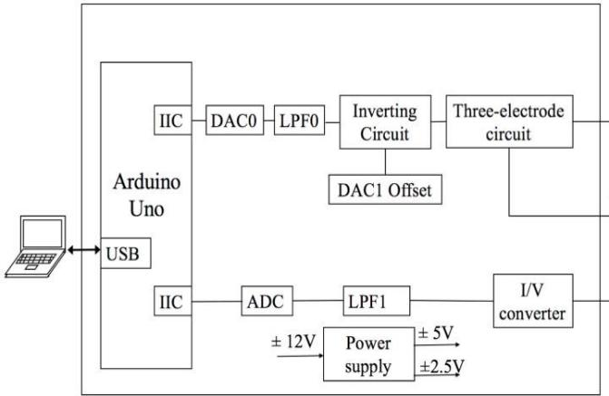

**Fig. 2.** A schematic illustration of the components in the Arduino-based sensing system. USB: Universal Serial Bus, IIC: Inter-Integrated Circuit Bus, DAC: Digital-to Analog Converter, LPF: Low-Pass Filter, I/V: Current-to-Voltage, ADC: Analog-to-Digital Converter.

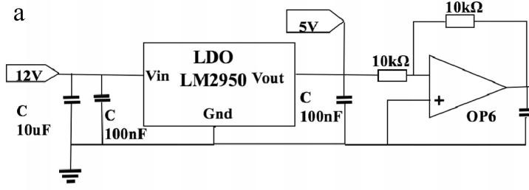

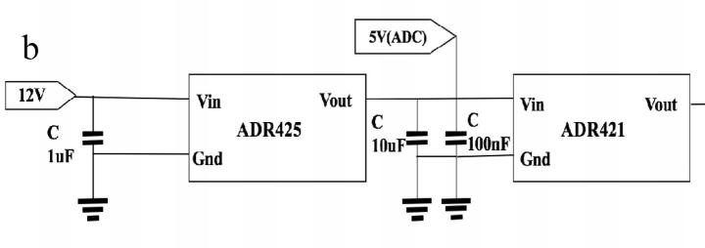

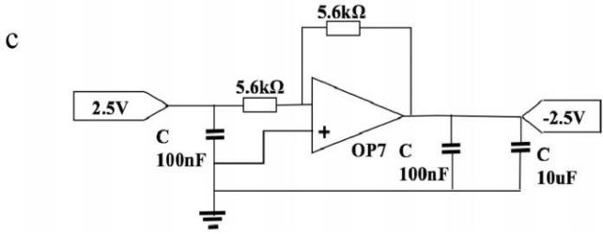

**Fig. 3.** Design of the power supplies. (a) The design of the power supply for the Op-Amp and

the Arduino. (b) The design of the power supply for the ADC and the DAC. (c) The I/V converter offset voltage design for the ADC.

# power supply

The power supply system for the Arduino potentiostat, detailed in Figure 3, is crucial for ensuring stable and accurate measurements. It provides power to various components: the Arduino Uno (requiring 5 V), Op-Amps (needing 5 V, -5 V, and sometimes ±12 V), ADC (operating at 5 V), DAC (at 2.5 V), and the I/V converter (requiring -2.5 V).

In Figure 3a, the power supply for Op-Amps and the Arduino Uno is generated. A LM2950 converts 12 V to 5 V, ensuring stable operation. For the Op- Amp requiring -5 V, a reverse circuit (OP6) further adjusts the voltage.

Figure 3b focuses on supplying power to the ADC (at 5 V) and DAC (at 2.5 V). To achieve a stable reference voltage of 2.5 V, multilevel low drop regulators (ADR425 and ADR421) are employed. ADR425 first converts 12 V to 5 V, followed by ADR421 which precisely produces 2.5 V.

Figure 3c details the design for the I/V converter offset voltage needed by the ADC. Here, a reverse circuit (OP7) is used to obtain -2.5 V from the output of ADR421. These carefully designed power supply circuits ensure that each component receives the correct and stable voltage, crucial for maintaining the stability and accuracy of the entire potentiostat system during electrochemical measurements.

# 3.3. Circuit design of the Arduino potentiostat

Figure 4 depicts the schematic design of the Arduino potentiostat circuit, organized into five main sections corresponding to its functional parts as seen in Figure 2. Here’s a simplified breakdown of each section:

1. DAC0 Part: The Arduino communicates with DAC0 via IIC (I2C) to send a digital signal. DAC0 then converts this signal into an analog voltage ranging from 0 to 2.5 V.
2. Inverting Circuit and DAC1 Part: OP1, functioning as an inverting circuit, takes the output from DAC1 after noise reduction (LPF0). This setup allows for the generation of a voltage spanning from -2.5 V to 5 V.
3. Three-Electrode Circuit Part: OP2, OP3, and OP4 are utilized to apply the voltage outputted by OP1 to the working electrode and reference electrode in the electrochemical setup.
4. I/V Converter Part: OP4 converts the current flowing through the working electrode into a voltage signal that can be measured.
5. ADC Part: An ADS1115 ADC samples the voltage signal after additional noise reduction and sends the sampled data to the Arduino via IIC for further processing.

This circuit design facilitates precise control of voltage applied to the electrochemical sensor and accurate measurement of resulting currents, critical for reliable performance in experiments such as cyclic voltammetry and chronoamperometry.

# 3.4 Arduino uno

The Arduino Uno serves as the central processor for the Arduino potentiostat, providing several key advantages. Firstly, it supports a wide range of open-source device libraries, making it straightforward to integrate components like the DAC (MCP4725) and ADC (ADS1115) into

embedded systems. This simplifies development by leveraging existing software resources tailored for Arduino platforms. Secondly, the Arduino IDE offers a user-friendly environment for programming in C language, accessible even to beginners. It includes tools like a serial-port monitor and plotter, which aid in real-time data analysis and visualization via the serial port, facilitating efficient data handling and equipment control.

The Arduino Uno is equipped with an ATmega328 microcontroller, featuring digital and analog input/output pins essential for interfacing with sensors and actuators. Pins with PWM (Pulse Width Modulation) capability enable the generation of analog voltages from digital outputs. The onboard memory stores program instructions and data, supporting the execution of complex tasks. The IIC bus (I2C) enables communication with peripherals such as the DAC and ADC, ensuring seamless integration and data exchange within the potentiostat system. Overall, these features make the Arduino Uno an ideal choice for developing sophisticated yet accessible electronic systems like the Arduino potentiostat.

# 3.5 DCAO and LPFO

Figure 5 illustrates the setup of DAC0 and LPF0 in the Arduino potentiostat system. A high-precision

MCP4725 DAC, capable of 12-bit resolution, is employed. Its reference voltage is stabilized by an operational amplifier (Op1) to ensure consistent output accuracy. Connected to the Arduino via IIC (I2C), the DAC operates with a reference voltage of 2.5 V, enabling it to generate voltages within the range of 0 to 2.5 V. Each bit of the DAC corresponds to 0.61 mV of output resolution.

The output voltage from the DAC undergoes further refinement through a second-order Sallen- Key filter (Op2). This filter configuration, with a cutoff frequency set at 1.141 kHz, effectively attenuates high-frequency noise and signals. Detailed parameters for setting up the filter can be found in the supplementary material, particularly in the "Signal Sampling" section, ensuring optimal performance in signal processing and stability for electrochemical measurements.

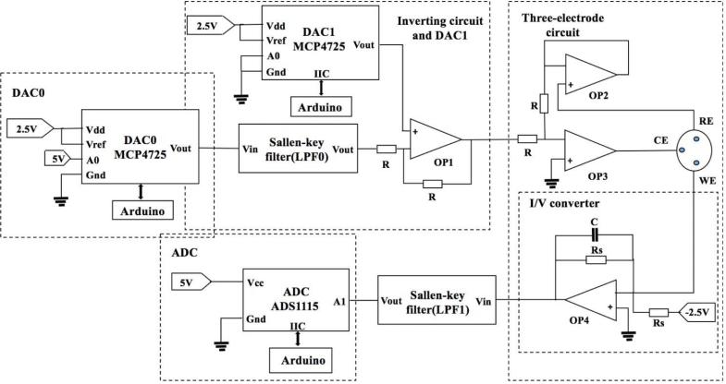

**Fig. 4.** The schematic circuit of Arduino-based potentiostat. Each highlighted mark corresponds to the Fig. 2.

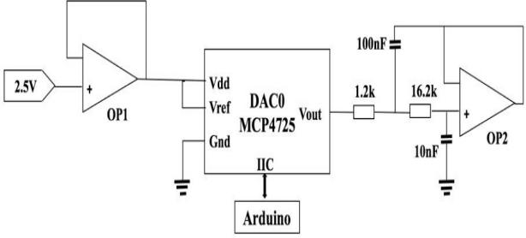

**Fig. 5.** A schematic illustration of the “DAC0 and LPF0” circuit design.

# 3.6. Inverting circuit and DAC1

To adjust the voltage output for cyclic voltammetry and chronoamperometry experiments, the Arduino potentiostat uses an inverting circuit and an offset voltage from DAC1, as depicted in Figure 6. DAC0

and DAC1 are capable of generating voltages between 0 and 2.5 V. OP1, functioning as an inverting circuit, takes the output from DAC1 and adjusts it to produce a voltage ranging from -2.5 V to 5 V. This transformation ensures that the potentiostat can apply the required voltage levels accurately for electrochemical measurements. For more detailed technical specifics, refer to the supplementary material section on "Inverting Circuit and DAC1 offset."

# 3.7 The three- electrode circuit

Figure 7 illustrates the circuit design for the three- electrode-based sensor used in the Arduino potentiostat system. This section is crucial as it enables the potentiostat to apply and measure voltages between the electrodes in electrochemical experiments. Here's how it works in simple terms

1. Powering the Sensor: The potentiostat applies the measuring voltage between the working electrode (WE) and the reference electrode (RE). The current flowing between the working electrode and the counter electrode (CE) is then measured.
2. Virtual Ground Setup: In this design, the working electrode is set as the virtual ground. When a negative voltage is applied to the reference electrode, it meets the voltage requirements for the measurement.
3. Circuit Operation: OP3 acts as a reversing circuit. The voltage applied to the counter electrode is controlled by OP3, creating a closed circuit loop between the counter electrode and the working electrode. The current flowing through this loop is read from the working electrode.
4. Voltage Adjustment: By controlling the outputs of DAC0 and DAC1 through the Arduino, the potentiostat can adjust the voltage between the working electrode and the reference electrode. This adjustment ensures that the potential between the working electrode and the reference electrode remains at the desired level, such as 0.6 V.
5. Benefits of the Design: The high impedance of OP2 ensures that negligible current flows into the reference electrode, maintaining accuracy. OP3's role as a reversing circuit allows precise control over the voltage applied to the electrodes, crucial for reliable electrochemical measurements.

For more technical details, refer to the "Inverting circuit and DAC1 offset" section in the supplementary material for specifics on how DACs and operational amplifiers are configured to achieve these functions.

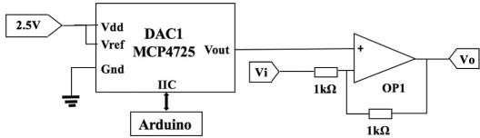

**Fig. 6.** A schematic illustration of the “inverting circuit and DAC1” circuit design.

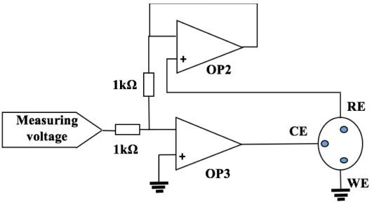

**Fig. 7.** A schematic illustration of the circuit design for the three-electrode based sensor.

# 3.8. I/V converter, LPF1 and ADC

In simpler terms, the signal sampling circuit works like this: it first converts an electric current into a voltage using a current-to-voltage converter (OP4). Because the device used to measure the signal (ADS1115) can only handle positive voltages, a negative bias voltage of -2.5V is added to the signal to ensure it's always positive.

Next, the signal goes through a low-pass filter (OP5), which is a type of filter that blocks out high- frequency noise above 1.010 kHz, allowing only the important part of the signal to pass through. Finally, the ADS1115 samples this filtered signal, and it can measure currents ranging from -250 mA to 250 mA, with a resistor value (Rs) of 10KΩ. For more detailed information, you can refer to the supplementary material section on "Signal sampling.”

# 3.9. PCB and 3D shell

When the design is complete, the wires and components are arranged on a two-layer printed circuit board (PCB) as shown in Figure S2 in the supplementary material. The components are then manually attached to the PCB. The board measures

13.2 cm by 8.7 cm. Some components, like the operational amplifiers (Ops), digital-to-analog converters (DACs), and analog-to-digital converters (ADCs), are installed using plug-in adapters, while all other components are soldered directly onto the PCB. The plug-in adapters are useful because if a component fails, only the faulty one needs to be replaced, making maintenance easier.

Figure 9b shows the PCB, along with an Arduino Uno, the power source, and a 3D-printed box. Finally, all these parts are assembled into one integrated system, as shown in Figure 1. This Arduino-based potentiostat performs very well. Its detailed characteristics are compared with a

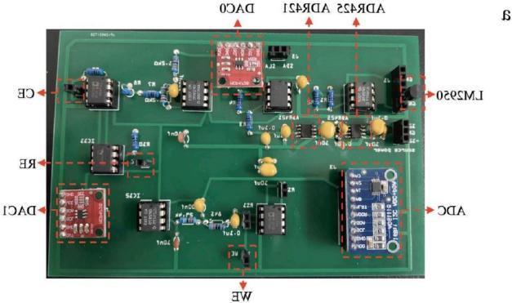

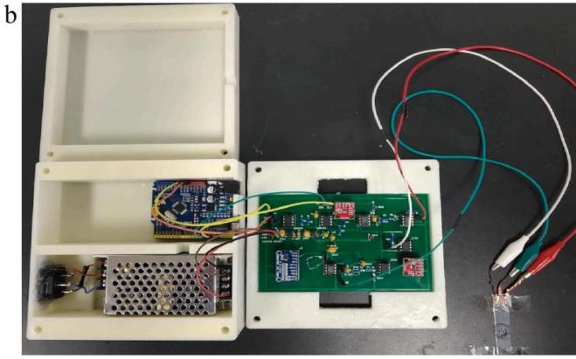

**Fig. 9.** (a) The PCB with the circuit components after manually soldering. (b) The integrated Arduino-based potentiostat with the PCB, the Arduino Uno, the source power, and the 3D- printed shell, before the assembly.

# Results of sensing measurements

* 1. Comparison *of two methods for generating analog voltage*

commercial potentiostat called CHI660E in Table S1 of the supplementary material. While the CHI660E offers many testing technologies and high accuracy, the Arduino-based potentiostat can handle common tests like cyclic voltammetry and chronoamperometry. Moreover, our designed potentiostat is smaller, lighter, and costs only 1% of a commercial CHI660E potentiostat.

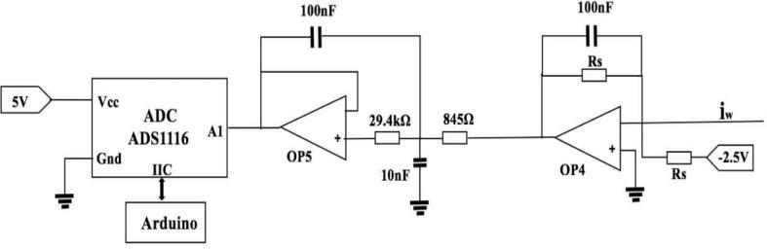

**Fig. 8.** A schematic illustration of the “signal sampling” circuit design.

Since the Arduino doesn't have a built-in digital-to- analog converter (DAC), the previous design used a method to create analog voltages from the Arduino's pulse-width modulation (PWM) signal. The current design uses an external DAC controlled by the Arduino Uno for this purpose.

In Figure 10, two methods for generating a triangular voltage ranging from -1V to 1V with a scan rate of 200 mV/s for a cyclic voltammetry (CV) test are compared.

First Method: PWM to Analog Conversion

1. Circuit Description (Fig. 10a): The circuit has two parts:
   * Red Dotted Block: Converts the PWM signal to an analog signal using an RC low-pass filter and an amplifier, producing a voltage range of 0 to 5V.
   * Blue Dotted Block: Converts this 0 to 5V range to a -1V to 1V triangle voltage.
2. Output (Fig. 10b): Shows the triangular voltage generated using PWM.
3. Zoomed View (Fig. 10c): Shows a detailed view of the voltage range from 0V to -0.5V in 10 mV steps.

Second Method: External DAC

1. Circuit Description (Fig. 10d): Uses an external DAC controlled by the Arduino Uno.
2. Output (Fig. 10e): Shows the triangular voltage generated by the DAC.
3. Zoomed View (Fig. 10f):Shows a detailed view of the voltage range from 0V to -0.5V in 10 mV steps.

Both methods produce the required voltage range for sensing tests, but the PWM-based method has more noise and less smooth output compared to the external DAC method. The signal generated by the DAC is smoother and more precise, making it a better choice for creating accurate currents and precisely adjusting current changes.

# Cyclic voltammetry performance

The Arduino-based potentiostat was tested to see how well it performs cyclic voltammetry, a common electrochemical measurement technique. In this test, the voltage applied to the working electrode was varied between -0.5V and 1.0V, and the resulting current was measured.

As shown in Figure 11a, both the Arduino-based potentiostat and a commercial CHI660 potentiostat were used under the same conditions, and the results from the second scan cycle were compared. The curve obtained from the Arduino-based device (shown in blue) closely matched the curve from the CHI660 potentiostat at a scan rate of 0.08V/s. This indicates that the Arduino-based potentiostat can perform cyclic voltammetry accurately.

Different scan rates were also tested (additional results are in the supplementary material). The relationship between the peak current and the square root of the scan rate was examined, revealing two linear curves. These curves align with theoretical expectations for diffusion- controlled processes, further validating the accuracy of the Arduino-based device.

Overall, the Arduino-based potentiostat produced results that were very similar to those of the commercial CHI660 potentiostat. This demonstrates that the Arduino-based potentiostat performs excellently for cyclic voltammetry and

can be a reliable, cost-effective alternative to commercial devices.

# Amperometric sensing of H2O2

The performance of the Arduino-based potentiostat was tested for chronoamperometry, a technique where the current is measured over time to study reactions at an electrode. This test used a screen- printed sensor and compared the results with a commercial CHI660 potentiostat. A buffer solution was placed on the sensor, and hydrogen peroxide (H2O2) was added. The current was measured at a voltage of 0.6V.

When H2O2 was added, the current increased and then stabilized after about a minute. The current measured by the Arduino-based potentiostat closely matched the current measured by the commercial potentiostat. Initially, the concentration of H2O2 at the electrode surface is highest, causing a peak in current. As the H2O2 diffuses into the solution, the concentration and current decrease until equilibrium is reached.

Further testing involved plotting calibration curves of current versus H2O2 concentration. The Arduino-based potentiostat showed an excellent linear relationship, with sensitivity nearly identical to the CHI660 potentiostat. Detection limits were also similar, showing that the Arduino system can accurately measure low concentrations of H2O2.

These results demonstrate that the Arduino-based potentiostat is effective for amperometric sensing and can be used to detect various important substances in healthcare, such as glucose and cholesterol.

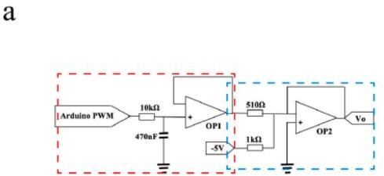

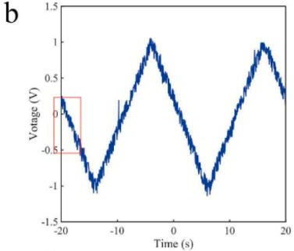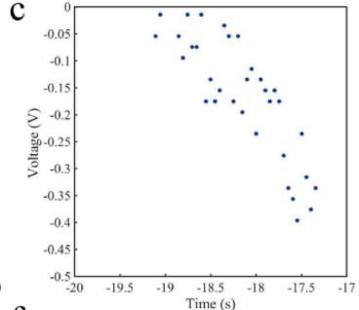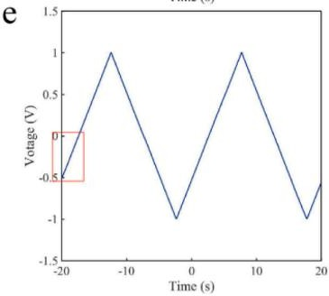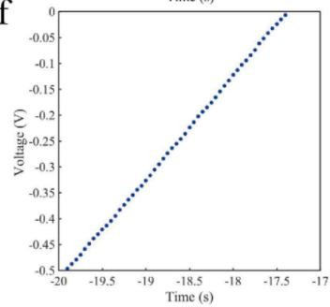

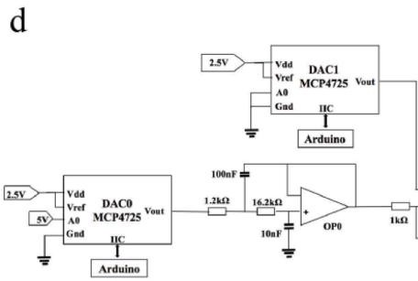

# Conclusions

In this study, we developed an integrated potentiostat based on the Arduino platform for detecting hydrogen peroxide (H2O2). This system, built using open-source Arduino technology, demonstrates excellent accuracy, stability, and cost-effectiveness. Our Arduino-based potentiostat delivers outstanding sensing performance,

**Fig. 10.** Two ways of generating analog voltage (range − 1 V to 1 V, scan rate 200 mv/s, interval voltage 10mv) with the Arduino. (a) The circuit by using a PWM. (b) The step voltage from – 1 V to 1

V based on using the PWM. (c) A magnified voltage range from 0 V to − 0.5 V. (d) The circuit by using an external DAC. (e) The step voltage from – 1 V to 1 V based on using the external DAC.

(f) A magnified voltage range from − 0. 5 V to 0 V

providing precise and accurate H2O2 measurements that align closely with results from commercial potentiostats. We believe that this work can pave the way for creating new sensing systems for various healthcare applications, including monitoring diabetes, diagnosing kidney diseases, gout, and heart diseases.

# Reference

1. G. Hanrahan, D.G. Patil, J. Wang, Electrochemical sensors for environmental monitoring: design, development and applications, J. Environ. Monit. 6 (2004)657–664.
2. R.Y. Lai, E.T. Lagally, S.-.H. Lee, H. Soh, K.W. Plaxco, A.J. Heeger, Rapid, sequence-specific detection of unpurified PCR amplicons via a reusable, electrochemical sensor, P. Natl. Acad. Sci. 103 (2006) 4017– 4021.
3. R. Wadhwa, C.F. Lagenaur, X.T. Cui, Electrochemically controlled release of dexamethasone from conducting polymer polypyrrole coated electrode, J. Control. Rel. 110 (2006) 531–541.
4. H. Jin, Y. Qin, S. Pan, A.U. Alam, S. Dong, R. Ghosh, M.J. Deen, Open-source lowcost wireless potentiometric instrument for pH determination experiments, J. Chem. Educ. 95 (2018) 326–330.
5. L. Chen, Arduino Programming Basics, Beihang University Press, Beijing, February 2015.
6. S. Chen, R. Yuan, Y. Chai, F. Hu, Electrochemical sensing of hydrogen peroxide using metal nanoparticles: a review, Microchim. Acta 180 (2013) 15–32.
7. B. Halliwell, M.V. Clement, L.H. Long, Hydrogen peroxide in the human body, FEBS Lett. 486 (2000) 10–13.
8. T.-.C. Chou, K.-.Y. Wu, F.-.X. Hsu, C.-.K. Lee, Pt-MWCNT modified carbon electrode strip for rapid and quantitative detection of H2O2 in food, J. food drug anal. 26 (2018) 662–669.
9. X. Luo, L. Guo, Y. Liu, W. Shi, W. Gai, Y. Cui, Wearable tape-based smart biosensing systems for lactate and glucose, IEEE Sensor. J. 20 (2020) 3757–3765.
10. X. Luo, W. Shi, Y. Liu, P. Sha, Y. Chu, Y. Cui, A smart tongue depressor-based biosensor for glucose, Sensors (2019) 19.
11. X. Luo, H. Yu, Y. Cui, A. Wearable, Amperometric biosensor on a cotton fabric for lactate, IEEE Electr. Device L. 39 (2018) 123–126.