**Smart Parking System**

Mrs T Rohini, Assistant.Professor  
CSE(IoT)  
ACE Engineering CollegeHyderabad, India  
 [rohini.aceec@gmail.com](mailto:%20rohini.aceec@gmail.com)

Biswas Thapa,Student  
CSE(IoT)  
ACE Engineering CollegeHyderabad, India  
[biswasthapa1035@gmail.comK](mailto:biswasthapa1035@gmail.comK) Krishna Saketh,Student  
CSE(IoT)  
ACE Engineering College  
Hyderabad, India  
krishnasaketh[@gmail.com](mailto:eshwarsatish9@gmail.com)

T Koushik,Student  
CSE(IoT)  
ACE Engineering CollegeHyderabad, India  
[koushik@gmail.com](mailto:koushik@gmail.com)

**Abstract:**

Urbanization has led to a surge in the number of vehicles on city roads, exacerbating the already pressing issue of parking congestion. Traditional parking management systems are often inefficient and fail to address the growing demand for parking spaces in urban areas. As a result, drivers face challenges in finding available parking spots, leading to increased traffic congestion, wasted time, and environmental pollution. To address these challenges, this paper proposes a solution in the form of a Smart Parking System powered by Internet of Things (IoT) technology. This system aims to optimize parking management, enhance urban mobility, and improve the overall parking experience for drivers. The Smart Parking System utilizes IoT sensors installed in parking spaces to accurately detect the presence or absence of vehicles in real-time. These sensors communicate with a centralized system or cloud platform, providing real-time visibility into parking space availability. Additionally, data analytics algorithms analyze parking data to derive valuable insights into parking patterns, peak hours, and occupancy rates. These insights enable parking operators to make informed decisions regarding space allocation, pricing strategies, and resource optimization. Furthermore, user-friendly interfaces, such as mobile applications or digital signage, provide drivers with real-time information about available parking spaces and navigation assistance, enhancing the overall parking experience. By harnessing the power of IoT technology, the Smart Parking System offers a promising solution to optimize parking management, reduce congestion, and improve urban mobility.

Keywords: urbanization, traffic jam, IR sensors, sensor integration,

Servo motor, real time monitoring

**I. INTRODUCTION**

Thirty percent of traffic jams in cities are said to be caused by drivers looking for parking. Cities, companies, and real estate developers have always made an effort to balance the availability of parking spots with the rising demand for parking. However, it has become evident that adding more parking spots alone will not solve the congestion issue. Smart parking systems are being used in new ways that aim to give a more balanced perspective on parking and improve supply and demand management. Everyone in our nation has a smartphone and an internet connection due to the rise in internet users, and as a result, they want to be able to do all of their work from one location, whether it be

shopping, purchasing movie tickets, or scheduling a parking spot. All of these issues can be resolved with smart parking. We can create parking stations that are faster to operate, more secure, and require less human labor. People no longer need to waste money, time, or gasoline looking for parking spots. Through their smartphone, people may quickly locate the closest parking spot that is open; they don't need to go check each parking station to look for vacant spaces. Additionally, they can reserve parking spaces through the app. This will assist the parking station owner in verifying the figures derived from the analysis of historical data. This can also address the fundamental problems, which are primarily brought on by vehicles parked illegally on the road. The ability to access, gather, evaluate, distribute, and act upon information regarding parking utilization is known as the "smart parking" idea. More and more, real-time access to this data is made possible by clever gadgets that allow parking managers and drivers to make the best use of available parking space. Every day, around a million barrels of oil are burned in parking lot searches. Finding the best parking solution will cut down on driving time, which will reduce daily vehicle emissions and, in turn, the environmental footprint of the world. Employees and security personnel working in parking lots have access to real-time data about the lot, which can help stop parking infractions and suspicious activities. Cameras that recognize license plates can capture relevant video. Reducing spot-search traffic on the streets can also lessen accidents brought on by drivers getting sidetracked while looking for parking.

A smart parking system can provide data over time that reveals patterns and correlations between users and lots. Lot owners might find great value in these trends when it comes to enhancing and modifying drivers.

**II. LITERATURE SURVEY**

Nowadays, a new technology has emerged known as the Internet of Things (IoT), enabling intelligent connectivity between devices without requiring human interaction. This advancement allows tasks to be completed more efficiently. Smart communication facilitates effective interaction among various objects such as parking spaces, vehicles, and sensors. Consequently, users can control devices through touch, gestures, or voice commands. This paper focuses on the application of IoT in a smart parking system.

A smart parking system uses IoT to manage parking spaces efficiently by monitoring availability and guiding drivers to vacant spots. This technology is implemented in various settings including commercial, residential, and public areas. Initially, smart parking systems were designed primarily to provide real-time parking information. However, recent advancements have made these systems more interactive by predicting parking space availability based on historical data and current usage patterns.

Smart parking systems offer significant benefits across different sectors. In urban areas, they optimize parking space utilization, reduce traffic congestion, and improve air quality by minimizing unnecessary vehicle movements. In commercial settings, such systems enhance customer satisfaction and operational efficiency by ensuring convenient parking access.

This study reviews forty literature sources on smart parking system applications, categorizing them based on their implementation in different sectors. The majority of studies (57.5%) focus on general applications, with fewer studies examining applications in specific sectors such as medical, academic, and sports fields (5% each).

As future work, smart parking systems can be further enhanced for applications in distance learning and integrated into a unified platform for seamless navigation within parking facilities. These advancements demonstrate the evolving capabilities and potential of IoT in transforming traditional parking management into smart and efficient systems.

**III. PROBLEM STATEMENT**

In today's urban environments, the demand for efficient parking solutions is escalating as cities grow denser and vehicle ownership rises. Traditional parking management systems often struggle to meet the needs of modern urban dwellers, lacking real-time data insights and user-friendly interfaces. Therefore, there is a critical need for the development of IoT-based Smart Parking Systems that leverage Internet of Things (IoT) technology to redefine parking management. These systems should address the following key challenges:

* **Limited Efficiency** - Conventional parking systems fail to provide drivers with accurate, real-time information on parking availability, leading to inefficiencies, increased congestion, and environmental impacts in urban areas where parking is scarce.
* **Integration Complexity** - Integrating IoT capabilities into parking systems requires overcoming technical challenges related to sensor deployment, data management, connectivity protocols, and backend infrastructure. Ensuring seamless integration while maintaining reliability and scalability poses a significant hurdle.
* **User Experience Optimization** - The success of IoT-based Smart Parking Systems hinges on delivering intuitive, user-friendly interfaces and experiences. Designing interfaces that provide clear guidance, real-time updates, and seamless payment options is crucial for enhancing user satisfaction and adoption.
* **Scalability and Interoperability** - Building IoT-based Smart Parking Systems that can integrate with existing urban infrastructure, IoT platforms, and transportation networks requires addressing interoperability challenges and ensuring scalability to accommodate future growth and technological advancements.
* **Affordability and Accessibility** - Balancing the integration of advanced IoT functionalities with cost-effectiveness and accessibility is essential to democratize access to Smart Parking Systems across diverse demographic groups and socioeconomic backgrounds, thereby improving urban mobility and sustainability.

**IV. EXISTING SYSTEM**

The current landscape of smart parking systems comprises various solutions and prototypes that integrate IoT technology with traditional parking management approaches. These systems represent notable advancements in the field of parking management; however, they encounter several limitations that impact their widespread adoption and operational efficiency.

Top of Form

Bottom of Form

**V. PROPOSED SYSYTEM**

The proposed system of an IoT-based Smart Parking System aims to address the challenges inherent in traditional parking management systems by leveraging Internet of Things (IoT) technology to enhance efficiency, user experience, and urban mobility. This next-generation smart parking system offers several advantages over conventional parking solutions:

**Enhanced Efficiency** - The IoT-based Smart Parking System provides real-time data on parking space availability, reducing the time spent by drivers searching for parking spots. This capability helps alleviate traffic congestion and improves overall traffic flow in urban areas.

**Optimized Space Utilization** - By dynamically monitoring and managing parking spaces, the system optimizes the utilization of available parking spots, maximizing the efficiency of parking facilities and reducing environmental impact.

**Seamless Integration with IoT Ecosystem** - The smart parking system integrates seamlessly with existing IoT devices, urban infrastructure, and transportation networks. This integration facilitates comprehensive data sharing and interoperability, enabling enhanced service delivery and operational efficiency.

**User-Friendly Interfaces** - With intuitive interfaces and user-friendly mobile applications, the smart parking system provides drivers with real-time updates on parking availability, navigation assistance to vacant spots, and convenient payment options. This enhances user satisfaction and encourages broader adoption of the system.

**Scalability and Adaptability** - Designed to scale with growing urban populations and technological advancements, the smart parking system accommodates future expansions and upgrades. It adapts to changing urban landscapes and evolving user needs, ensuring long-term viability and sustainability.

**Cost-Effectiveness and Accessibility** - Balancing advanced IoT functionalities with cost-effectiveness, the system aims to democratize access to smart parking solutions across diverse demographic groups and socioeconomic backgrounds. This affordability fosters widespread adoption and equitable benefits for urban communities.

**VI. HARDWARE AND SOFTWARE REQUIREMENTS**

**HARDWARE REQUIREMENTS:**

* **Arduino Uno** (instead of Raspberry Pi Model 4)
* **16x2 LCD Display** (with I2C or appropriate connections)
* **Servo Motor** (for the gate mechanism)
* **Infrared (IR) Sensors** (3 for parking slots and 2 for entry/exit gates)
* **Connecting Wires/Cables**
* **Breadboard and Jumpers** (for prototyping)
* **Power Supply** (for Arduino and peripherals)

**SOFTWARE REQUIREMENTS:**

* **Arduino IDE** (for writing and uploading code to the Arduino)
* **Liquid Crystal Library** (for controlling the LCD display)
* **Servo Library** (for controlling the servo motor)
* **Serial Monitor** (for debugging and monitoring the system)
* **Data Processing Logic** (embedded in the Arduino code for managing parking slots)
* **Notification System** (optional, could use additional modules like GSM for SMS notifications or Wi-Fi for IoT integration)
* **Security and Privacy Measures** (basic data handling within the microcontroller)

**VII. MODULES**

1. **Arduino Module**:
   * **Function**: Runs the smart parking system code, processes sensor inputs, and controls the servo motor and LCD display.
2. **LCD Display**:
   * **Function**: Displays the number of available parking slots and the status (empty or full) of each slot.
3. **Sensors**:
   * **Infrared (IR) Sensors**: Detect vehicle presence in parking slots and entry/exit gates.
4. **Servo Motor**:
   * **Function**: Controls the gate mechanism to allow or deny entry based on parking slot availability.
5. **Data Processing**:
   * **Logic Implementation**: Embedded in the Arduino code to manage parking slots, detect vehicle entry/exit, and update the display.
6. **User Interface**:
   * **LCD Interface**: Provides real-time information about available parking slots and the status of each slot.
   * **Optional Mobile App/Web Interface**: Can be developed for remote monitoring and control.
7. **Alerts/Notifications** (Optional):
   * **Function**: Sends alerts when the parking is full or when specific conditions are met.
   * **Implementation**: Could use additional modules like GSM for SMS notifications or Wi-Fi for IoT integration.
8. **Storage Module**:
   * **Data Logging**: Stores data for tracking parking usage and patterns (optional, for advanced features).
   * **Cloud Integration**: Optionally uploads data for remote access or analysis (optional).
9. **Communication Module** (Optional):
   * **Bluetooth/Wi-Fi**: Enables data transfer to other devices, such as smartphones or computers for remote monitoring.

**VIII SAMPLE CODE:**

**#include <LiquidCrystal.h>**

**#include <Servo.h>**

**// Declaring constants for the LCD pins**

**const int rs = 12, en = 11, d4 = 8, d5 = 7, d6 = 6, d7 = 5;**

**LiquidCrystal lcd(rs, en, d4, d5, d6, d7);**

**Servo myservo1;**

**// Choose the input pin for entry gate IR sensors**

**int ir_s1 = 2;**

**int ir_s2 = 4;**

**// Choose the input pin for parking slot IR sensors**

**int ir_p_1 = 13;**

**int ir_p_2 = 9;**

**int ir_p_3 = 10;**

**int total = 0;**

**int slot = 3; // Total capacity of the parking**

**int flag1 = 0;**

**int flag2 = 0;**

**int s1 = 0, s2 = 0, s3 = 0;**

**void setup() {**

**Serial.begin(9600); // Initializing the Serial Monitor**

**// Declare sensor as input**

**pinMode(ir_s1, INPUT);**

**pinMode(ir_s2, INPUT);**

**pinMode(ir_p_1, INPUT);**

**pinMode(ir_p_2, INPUT);**

**pinMode(ir_p_3, INPUT);**

**myservo1.attach(3); // Attaches the servo on pin 3 to the servo object**

**myservo1.write(180);**

**lcd.begin(16, 2); // Initializing the LCD display**

**lcd.print("Smart Parking"); // Initial message display on the screen**

**delay(3000); // Delay of 3000 milliseconds**

**lcd.clear(); // Clearing the LCD display after delay**

**}**

**void loop() {**

**read_sensor();**

**lcd.setCursor(0, 0);**

**lcd.print("Have Slots:");**

**lcd.print(slot);**

**lcd.setCursor(0, 1);**

**lcd.print("s1:");**

**lcd.print(s1 == 1 ? "F" : "E");**

**lcd.setCursor(5, 1);**

**lcd.print("s2:");**

**lcd.print(s2 == 1 ? "F" : "E");**

**lcd.setCursor(10, 1);**

**lcd.print("s3:");**

**lcd.print(s3 == 1 ? "F" : "E");**

**// Logic for opening and closing the gate**

**if (digitalRead(ir_s1) == 0 && flag1 == 0) {**

**if (slot > 0) {**

**flag1 = 1;**

**if (flag2 == 0) {**

**myservo1.write(90);**

**slot = slot - 1;**

**}**

**} else {**

**lcd.clear();**

**lcd.setCursor(0, 0);**

**lcd.print("Parking Full");**

**delay(1500);**

**lcd.clear();**

**}**

**}**

**if (digitalRead(ir_s2) == 0 && flag2 == 0) {**

**flag2 = 1;**

**if (flag1 == 0) {**

**myservo1.write(90);**

**slot = slot + 1;**

**}**

**}**

**if (flag1 == 1 && flag2 == 1) {**

**delay(1000);**

**myservo1.write(180);**

**flag1 = 0;**

**flag2 = 0;**

**}**

**delay(10);**

**}**

**void read_sensor() {**

**s1 = digitalRead(ir_p_1) == 0 ? 1 : 0;**

**s2 = digitalRead(ir_p_2) == 0 ? 1 : 0;**

**s3 = digitalRead(ir_p_3) == 0 ? 1 : 0;}**

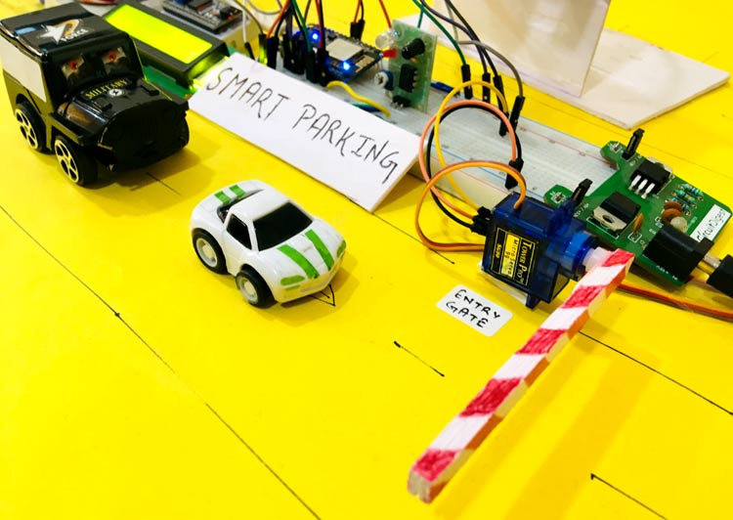 **IX.OUTPUTSCREENS**

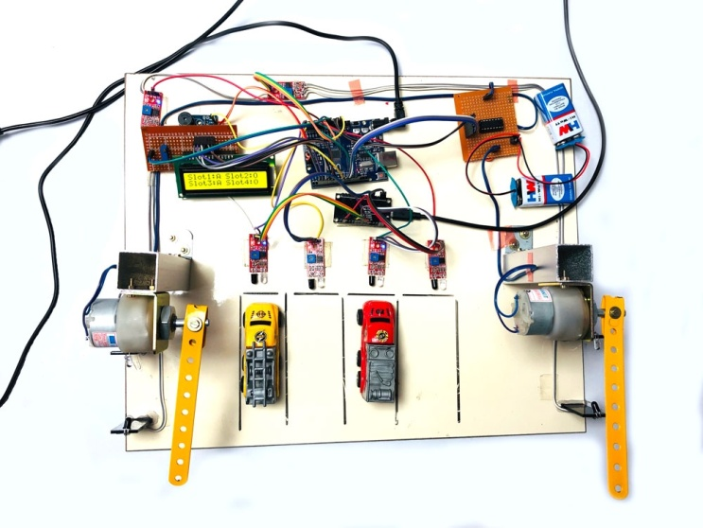

**X . PROJECT DEPLOYMENT**

#### **Software Installation**

1. **Operating System: Raspbian OS**
   * Download and install Raspbian OS on the Raspberry Pi using tools like Balena Etcher.

#### **Deployment Steps**

1. **Auto-start on Boot**
   * Configure the Raspberry Pi to automatically start the Magic Mirror software upon boot.
2. **Network Access**
   * Set up the Raspberry Pi with a static IP address for consistent network connectivity.

#### **Final Assembly**

1. **Assemble the Smart Mirror**
   * Place the monitor with the one-way mirror film into the frame.
2. **Mount the Raspberry Pi**
   * Securely attach the Raspberry Pi to the back of the monitor or frame.
3. **Cable Management**
   * Route and organize all cables to maintain a clean and tidy setup.

**XI.INTEGRATION AND EXPERIMEMTAL RESULTS**

### **Integration Strategies**

**Sensor Integration:** Smart parking systems utilize sensors such as ultrasonic or infrared sensors to detect vehicle presence and occupancy in parking spaces. These sensors provide real-time data on parking availability.

**Data Transmission:** Data from parking sensors is transmitted wirelessly, typically via Wi-Fi or cellular networks, to a central server or cloud platform for storage and analysis.

**Cloud Computing:** Cloud platforms store and process parking occupancy data, enabling real-time monitoring of parking spaces, analytics for usage patterns, and integration with navigation or management systems.

**Data Security:** Encryption protocols and secure communication channels (e.g., HTTPS) are implemented to protect parking occupancy data and ensure user privacy, complying with data protection regulations.

**User Interfaces:** User-friendly interfaces such as mobile apps or web portals are developed to allow users to check parking availability, reserve spots, and navigate to available spaces conveniently.

### **Experimental Results**

**Accuracy:** Smart parking systems demonstrate high accuracy in detecting vehicle presence and occupancy status. Accuracy may vary based on sensor types, placement, and environmental conditions.

**Real-time Monitoring:** IoT-based smart parking systems enable continuous, real-time monitoring of parking spaces. This capability allows operators to manage parking availability dynamically and provide users with up-to-date information.

**Long-term Monitoring:** Unlike traditional methods, IoT devices facilitate long-term monitoring across various locations (e.g., urban areas, commercial complexes), providing insights for optimizing parking infrastructure and policies over time.

**Operational Insights:** Analyzing parking occupancy data over extended periods provides insights into usage patterns, peak hours, and trends. This information helps in optimizing parking space utilization, improving traffic flow, and planning for future infrastructure needs.

**User Engagement:** Smart parking systems enhance user engagement by providing real-time parking information through accessible interfaces. Users can make informed decisions, reducing congestion and improving overall user experience.

**XII . FUTURE ENHANCEMENTS**

The smart parking system, while effective in its current form, has several avenues for enhancement that could further improve its functionality and user experience. These future enhancements aim to address evolving needs and integrate advanced technologies to create a more sophisticated parking management solution.

**1. Advanced Sensor Technologies:** Integrating more advanced sensor technologies, such as ultrasonic sensors or cameras, could enhance the system’s ability to detect vehicles more accurately and in various environmental conditions. Ultrasonic sensors can offer better performance in low-light situations, while cameras with image processing capabilities could provide detailed information on parking slot occupancy and even license plate recognition.

**2. Machine Learning and Artificial Intelligence:** Incorporating machine learning algorithms and artificial intelligence can significantly improve the system's predictive capabilities. For instance, AI could analyze historical parking data to predict peak times and optimize space allocation accordingly. Machine learning models could also enhance vehicle detection accuracy and automate the identification of parking violations.

**3. Mobile Application Integration:** Developing a mobile application for the smart parking system could offer users additional convenience by allowing them to view real-time parking availability, make reservations, and receive notifications about parking status. The app could also facilitate payment options, streamline user interactions, and provide an enhanced user experience.

**4. Cloud-Based Data Management:** Transitioning to a cloud-based data management system could improve data storage, accessibility, and analysis. Cloud integration would enable centralized monitoring of multiple parking facilities, facilitate data sharing across platforms, and support advanced analytics to identify usage patterns and optimize parking management.

**5. Enhanced User Interfaces:** Improving the user interface, both on the LCD display and within potential mobile applications, can enhance user interaction with the system. Features such as dynamic graphical displays, interactive touchscreens, or voice-guided navigation could make the system more intuitive and accessible.

**6. Integration with Smart City Infrastructure:** Aligning the smart parking system with broader smart city initiatives can provide a more integrated urban management solution. Connectivity with other smart systems, such as traffic management and public transportation networks, could offer users a comprehensive view of their travel options and improve overall urban mobility.

**7. Sustainability Measures:** Incorporating sustainability measures, such as energy-efficient components and eco-friendly materials, can further align the system with green technology goals. Solar-powered sensors or energy-saving features could reduce the system’s environmental impact and operational costs.

**8. Scalability and Modular Upgrades:** Designing the system to be easily scalable and modular will allow for seamless upgrades and expansion. This approach will enable the addition of new features or the expansion of the system to larger parking facilities without major overhauls.

By pursuing these enhancements, the smart parking system can evolve into a more robust, user-friendly, and integrated solution that meets the demands of modern urban environments. These advancements will not only improve the efficiency and convenience of parking management but also contribute to the broader goals of smart city development and sustainable urban planning.

**XIII. CONCLUSION**

The IoT-based smart mirror using a Raspberry Pi effectively transforms a standard mirror into a multifunctional smart device. Key achievements include:

1.Versatility: Displays time, weather, news, and calendar events.

2.Customization: Easily adaptable with MagicMirror² modules.

3.Performance: Optimized for smooth, reliable operation.

4.User Experience: Intuitive interface, with potential for voice control and face recognition.

5.Security: Robust measures to protect user data.

**XIV. REFERENCES**

**[1]Kumar.S&Deogun,R.G.**  
"Smart Parking Systems: Technologies and Applications"  
This paper provides an in-depth exploration of the various technologies used in smart parking systems, including sensor technologies and data processing methodologies. It also discusses practical applications and the potential impact of these systems on urban mobility and parking efficiency.

**[2]JainA.J&Malhotra,M.S.**  
"IoT-Based Smart Parking System"  
This conference paper details the implementation of an Internet of Things (IoT)-based smart parking system, focusing on the integration of sensors and communication technologies to improve parking management. It outlines the system architecture, communication protocols, and benefits of using IoT for real-time parking space management.

**[3] Han, L. M., & Zhang, B. Y.**   
"A Review of Smart Parking Systems"  
This review article provides a comprehensive overview of smart parking systems, summarizing current technologies, system designs, and challenges. It includes a discussion on various approaches for parking detection, space allocation, and user interfaces, offering insights into the state-of-the-art in smart parking solutions.

**[4]SmithD.E.,&Williams,A.B.**  
"Embedded Systems and Hardware: Practical and Theoretical Issues"  
This book covers the theoretical and practical aspects of embedded systems, including their application in smart parking systems. It offers insights into hardware design, software integration, and real-world case studies that highlight the role of embedded systems in modern applications.

**[5]Patel,N.K.,&Shah,P.D.**  
"Microcontroller-Based Parking Management System"  
This journal article explores the design and implementation of a parking management system based on microcontroller technology. It details the use of microcontrollers for managing parking slots, integrating sensors, and controlling parking gates, providing a practical example of how microcontrollers are used in parking systems.