**EVALUATING THE IMPACT OF 2-HEMA AND TMP(15EO)TA ON BIOCOMPATIBLE PHOTOPOLYMER 3D PRINTING MATERIALS**

**Yu-Fang Shen1,2**

1Department of Bioinformatics and Medical Engineering, Asia University, Taichung City, Taiwan

2High Performance Materials Institute for xD Printing, Asia University, Taichung City, Taiwan

**ABSTRACT**

In traditional photopolymer 3D printing materials, most diluent monomers exhibit toxicity, making them unsuitable for biomedical applications. Previous research identified 2-Hydroxyethyl Methacrylate (2-HEMA) as a biocompatible diluent monomer, though its single photopolymerizable functional group results in suboptimal curing performance. Literature suggests that Trimethylolpropane Ethoxylate Triacrylate (TMP(15EO)TA), with its three photopolymerizable functional groups, offers both biocompatibility and enhanced curing. This study investigates the effects of 2-HEMA and TMP(15EO)TA diluent monomers on 3D printing materials. Results indicate that TMP(15EO)TA-containing materials exhibit improved side roughness, aiding in stereolithography, increased viscosity, reduced hardness, and over 80% cell viability, demonstrating good biocompatibility. These findings provide a basis for the development of 3D-printed biomedical materials, which could significantly advance tissue engineering and other medical applications by providing safer and more effective materials.

**Key words-**3D Printing, Photopolymerization, Biocompatible Materials, 2-HEMA, TMP(15EO)TA, Diluent Monomers

1. **INTRODUCTION**

The evolution of 3D printing technology has revolutionized numerous industries, including healthcare, manufacturing, and engineering. One of the most promising advancements is in the realm of biomedical engineering, where 3D printing enables the creation of complex structures tailored to individual patient needs. This precision is crucial for applications such as tissue engineering, prosthetics, and implants [1]. Among the various 3D printing techniques, photopolymerization-based methods, such as stereolithography (SLA) and digital light processing (DLP), are particularly valued for their high resolution and accuracy [2][3].

Photopolymerization involves the use of light to initiate a polymerization reaction, transforming a liquid resin into a solid structure. This process relies heavily on the properties of the photopolymer resin, which typically consists of a photoinitiator, a base resin, and a diluent monomer. The choice of diluent monomer is critical, as it affects the viscosity, curing behavior, mechanical properties, and biocompatibility of the final printed product [4]. Historically, many diluent monomers used in photopolymer resins have been toxic, limiting their applicability in biomedical contexts [5].

Recent advancements have focused on identifying and utilizing biocompatible diluent monomers. 2-Hydroxyethyl Methacrylate (2-HEMA) has been recognized for its favorable biocompatibility, making it a candidate for biomedical applications [6]. However, 2-HEMA possesses only a single photopolymerizable functional group, resulting in less efficient curing compared to multifunctional monomers. In contrast, Trimethylolpropane Ethoxylate Triacrylate (TMP(15EO)TA), with three photopolymerizable functional groups, offers enhanced curing efficiency and has also demonstrated biocompatibility [7]. This study aims to explore the effects of incorporating 2-HEMA and TMP(15EO)TA as diluent monomers in photopolymer resins for 3D printing.

The development of new materials for 3D printing is a critical step towards advancing the technology's applications in the medical field. The selection of materials that not only provide the necessary mechanical properties but also ensure biocompatibility is essential for producing safe and effective medical devices. Previous research has demonstrated the potential of various monomers, but a comprehensive understanding of their combined effects is still lacking [8][9]. This study seeks to fill that gap by systematically investigating the impacts of 2-HEMA and TMP(15EO)TA on the properties of 3D-printed materials, thereby offering valuable insights for future developments in this area [10].

1. **OBJECTIVES**
2. To compare the effects of 2-HEMA and TMP(15EO)TA on the mechanical properties of 3D-printed materials.
3. To evaluate the biocompatibility of materials containing these diluent monomers.
4. To assess the influence of TMP(15EO)TA content on the viscosity and hardness of the printed objects.
5. **METHODOLOGY**

**3.1 Materials**

1. PLA-PUA: A bifunctional polyurethane acrylate photopolymer resin synthesized from bio-based polylactic acid diol.
2. TPO: Trimethylbenzoyl diphenylphosphine oxide, a photoinitiator for UV curing of unsaturated polyesters.
3. DETX: 2,4-Diethylthioxanthone, a photoinitiator suitable for colored UV-curable coatings.
4. 2-HEMA: A single photopolymerizable functional group diluent monomer with good biocompatibility.
5. TMP(15EO)TA: A tri-functional photopolymerizable diluent monomer with reported biocompatibility.

**3.2 Experimental Procedure**

1. Formulation of Photopolymer Resins: Various formulations were prepared by adjusting the ratios of 2-HEMA and TMP(15EO)TA while maintaining a constant amount of PLA-PUA, TPO, and DETX.
2. 3D Printing: The resins were used in a DLP 3D printer (Miicraft+) to fabricate test samples.
3. Characterization:
4. Viscosity Measurement: Using a viscometer.
5. Hardness Testing: Using a durometer.
6. Cell Viability Assessment: Evaluating biocompatibility through cell culture assays.
7. **TESTING AND RESULT**

The study's findings revealed significant variations in the properties of the 3D-printed materials with different ratios of TMP(15EO)TA and 2-HEMA. As the content of TMP(15EO)TA increased from 0% to 30%, the viscosity of the materials also increased significantly, from 12494.9 cP to 62615.7 cP. This increase in viscosity is attributed to the higher crosslinking density provided by the tri-functional TMP(15EO)TA compared to the mono-functional 2-HEMA.

Additionally, the hardness of the printed objects exhibited a decrease from 77 Shore D at 0% TMP(15EO)TA to 71 Shore D at 30% TMP(15EO)TA. This reduction in hardness suggests a trade-off between the mechanical properties and the increased viscosity, which could influence the overall performance of the printed materials.

Furthermore, the side roughness of the printed objects improved with the higher content of TMP(15EO)TA, aiding in better stereolithography and leading to more precise and detailed prints. This enhancement is particularly beneficial for applications requiring high-resolution and intricate designs.

The biocompatibility of the materials was also evaluated through cell viability assays. The results indicated that objects containing TMP(15EO)TA maintained over 80% cell survival, confirming their suitability for biomedical applications. This high level of biocompatibility, combined with the improved curing and material properties, underscores the potential of TMP(15EO)TA as a valuable component in the development of advanced 3D printing materials for medical use.

**Table 4.1** Effects of Different Diluent Monomers on 3D Printing Materials.

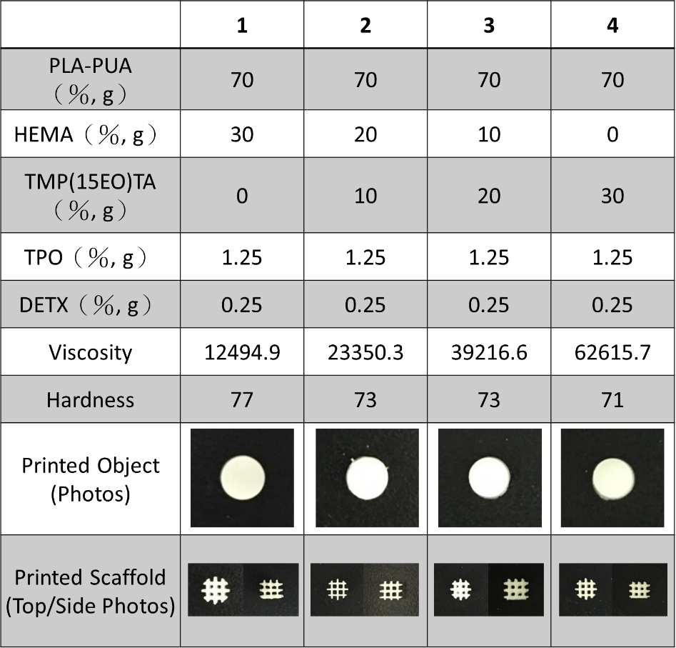

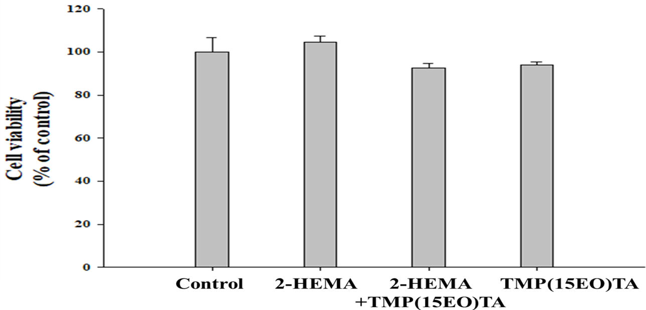

**Figure 1:** Effects of Different Diluent Monomers on Cell Viability.

1. **CONCLUSIONS**

Incorporating TMP(15EO)TA, a tri-functional photopolymerizable diluent monomer, in 3D printing materials enhances the curing process, improves side roughness, and maintains high biocompatibility. Increasing TMP(15EO)TA content raises material viscosity but reduces hardness, suggesting a trade-off between mechanical properties and printability. These insights pave the way for developing advanced biocompatible 3D printing materials for tissue engineering and other biomedical applications.

1. **REFRENCES**
2. Gross BC, Erkal JL, Lockwood SY, Chen C, Spence DM. Evaluation of 3D printing and its potential impact on biotechnology and the chemical sciences. Anal Chem. 2014;86(7):3240-53.
3. Tumbleston JR, Shirvanyants D, Ermoshkin N, et al. Continuous liquid interface production of 3D objects. Science. 2015;347(6228):1349-52.
4. Bártolo PJ, Kruth J-P, Silva J, et al. Advanced Processes in 3D Printing and Additive Manufacturing. CIRP Annals. 2012;61(2):635-55.
5. Bertsch A, Jiguet S, Bernhard P, Renaud P. Microstereolithography: a review. Materials Science and Engineering: C. 2004;23(6-8):661-6.
6. Riedel R, Riedel G, Ovsianikov A, et al. Additive Manufacturing of Biomaterials - An Overview About 3D Bioprinting Methods and Materials. Current Directions in Biomedical Engineering. 2017;3(2):205-10.
7. Chan V, Zorlutuna P, Jeong JH, Kong H, Bashir R. Three-dimensional photopatterning of hydrogels using stereolithography for long-term cell encapsulation. Lab Chip. 2010;10(16):2062-70.
8. Lim KS, Abinzano F, Castilho M, et al. Bioprinting-induced cell damage: assessment and mitigation strategies. Advanced Healthcare Materials. 2020;9(7):2000150.
9. Malda J, Visser J, Melchels FP, et al. 25th anniversary article: engineering hydrogels for biofabrication. Adv Mater. 2013;25(36):5011-28.
10. Melchels FP, Domingos MA, Klein TJ, Malda J, Bartolo PJ, Hutmacher DW. Additive manufacturing of tissues and organs. Prog Polym Sci. 2012;37(8):1079-104.
11. Guvendiren M, Molde J, Soares RM, Kohn J. Designing biomaterials for 3D printing. ACS Biomater Sci Eng. 2016;2(10):1679-93.