ARDUINO TRAFFIC CONTROL SYSTEM FOR EMERGENCY

|  |  |  |  |
| --- | --- | --- | --- |
|  | VEHICLES | |  |
|  |  |
| **Navya shree C**  Department of Electronics  And Communication,  T. John Institute of Technology Email:  navyashreec12@gmail.com | **Rekha D S**  Department of Electronics  And Communication,  T. John Institute of Technology Email:  rekhaasuresh2003@gmail.com | **Vishal Kumbar**  Department of Electronics  And Communication,  T. John Institute of Technology Email:  Vishuvk001@gmail.com | **Dr. Manjunatha V**  Department of Electronics  And Communication,  T. John Institute of Technology Email:  manjunatha111@gmail.com |

***Abstract----*** ***Urban traffic congestion is a serious problem, particularly when emergency vehicles need to have unobstructed access. This paper presents an RFID-based traffic control system that uses an Arduino board to rank emergency vehicles in order of priority. Motion sensors, LEDs, Arduino boards, GSM and GPS modules, relay modules, and RFID readers are all integrated into the system. In order to guarantee a clear way, the system initiates a predefined traffic light sequence (red, blue, green) upon recognizing an emergency vehicle by RFID tags. By keeping an eye on general traffic, motion sensors help optimize traffic light changes to lessen congestion. Furthermore, GPS tracking combined with RFID and GSM improves car location and theft recovery. The goal of this integrated system is to improve urban traffic flow and emergency response times in order to strengthen the infrastructure of smart cities.***

***Keywords--- RFID, Smart City, Arduino, Traffic Congestion, Emergency Vehicle Clearance and Urban Mobility.***

# I. Introduction

Effective traffic management is necessary in urban environments, particularly to facilitate the timely deployment of emergency vehicles. Because conventional traffic control systems don't provide emergency responders the attention they require, they might cause delays that could have major consequences. This paper presents a unique Arduino-based traffic congestion control system that prioritizes emergency vehicles. To ensure that traffic lights are changed in real-time to assist emergency vehicle routes, this system uses a variety of components, including the Arduino Uno, Arduino Nano, motion sensors, GSM and GPS module relay modules, RFID readers and tags, and several LEDs.

Dynamic and effective traffic control is made possible by the combination of GPS for location monitoring, GSM for communication, and RFID technology for vehicle identification. Urban regions can greatly enhance emergency response times, decrease delays, and improve general traffic flow by putting this scalable and reasonably priced solution into practice. The suggested system's design, parts, and operating flow are described in this study, which also shows how it might revolutionize emergency services' traffic management.

Subsequent research has investigated the combination of RFID and GPS for emergency vehicle prioritization (Sharma et al., 2013; Hegde et al., 2013); however, these methods frequently lacked a thorough approach to urban traffic management. The suggested approach provides a more comprehensive solution by utilizing the flexibility and scalability of Arduino microcontrollers along with the insights gained from these investigations. By combining cutting-edge technologies, a traffic control system is made smarter, more responsive, and able to dynamically adjust to shifting urban situations. This ultimately improves the effectiveness and efficiency of emergency response services.

In addition, the system makes use of motion sensors to identify the existence of oncoming cars, allowing traffic lights to be changed in real time to reduce congestion and improve traffic flow. In addition to ensuring that emergency vehicles can be efficiently tracked and prioritized, the integration of GSM and GPS modules gives authorities a way to be notified when stolen vehicles are located. This integrated system guarantees faster emergency response times, improved urban transportation, and improved infrastructure in smart cities. The system's complete nature, which integrates real-time data with adaptive signal control, highlights its potential to transform urban traffic management and improve city efficiency and safety for all citizens.

Block diagram

The traffic congestion control system for emergency vehicles, based on Arduino, is designed in the form of a block diagram with multiple interconnected modules, each of which serves a distinct purpose in optimizing traffic flow. The Arduino Uno, which acts as the central controller, is at the center of the system.

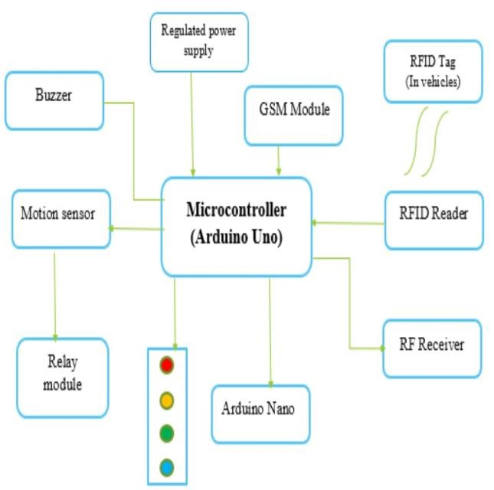

**Fig:1.1 Block Diagram**

* RFID Reader and Tag: An RFID tag is installed in every emergency vehicle. The RFID reader mounted at the junction recognizes the tag when the car approaches it, alerting the Arduino Uno to the emergency vehicle's presence.

* GPS Module: Located aboard the emergency vehicle, this module maintains its position continuously. The GSM module transmits the GPS data to the central system, enabling real-time location updates.

* GSM Module: Enables connection between the central control system and the emergency vehicle. The Arduino Uno receives GPS data from the emergency vehicle and can get updates on its path from the control system.

* Relay Module: This module, which is connected to the Arduino Uno, regulates the LEDs used for traffic signals. According to the signals received from the Arduino Uno, it alternates the LEDs between red, yellow, green, and blue.

* LEDs (Red, Yellow, Green, Blue): These lights up at crossings as traffic signals. Regular traffic flow is controlled by the red, yellow, and green LEDs, and the emergency vehicle's priority is shown by the blue LED.

A synchronized network of RFID readers, GPS, GSM modules, motion sensors, and relay-controlled LEDs allows emergency vehicles to be quickly cleared. The Arduino Uno evaluates this signal, along with traffic conditions from motion sensors and real-time GPS location data, when an RFID reader identifies an emergency vehicle coming. The emergency vehicle's path is subsequently given priority by the central controller, who then dynamically modifies the traffic lights by turning on the green and blue LEDs. By reducing delays and giving emergency responders a direct and effective path, this real-time signal adjustment enhances traffic flow and response times overall.

The second section discusses an emergency vehicle traffic congestion control system that uses a combination of RFID technology, GPS tracking, GSM connection, motion sensors, and intelligent signal management to address urban traffic issues. The Arduino Uno, the system's primary processor, integrates data from multiple sources to dynamically adjust traffic signals and prioritize the passage of emergency vehicles.

**II. Literature Survey**

To create an efficient Arduino-based traffic control system for emergency vehicles, a thorough review of the literature on traffic management systems, RFID technology, emergency vehicle prioritization, and smart city infrastructure is necessary. Traditional traffic management systems, which usually rely on fixed-timing traffic lights, are inadequate for dynamic urban traffic conditions, particularly during emergencies. Research by Papa Georgiou et al. (2003) emphasizes the need for adaptive traffic control systems that can respond to traffic conditions in real-time in order to improve overall flow and reduce congestion. RFID technology has been the subject of numerous traffic control applications, including toll collection and vehicle tracking.

Zhang et al. (2013) introduced an RFID-based traffic flow monitoring and management system that improved efficiency by providing real-time data on vehicle movement.

Prioritizing emergency vehicles has been researched; Lin and Wang (2004), for instance, developed a traffic signal pre-emption system that grants emergency vehicles green lights via GPS and wireless communication. While this technology showed promise in reducing reaction times, problems with scalability and integration emerged. The goal of smart cities is to enhance urban living by utilizing cutting-edge innovations, like intelligent traffic control systems. Mohanty et al. (2016) emphasized the importance of IoT in the

development of smart traffic lights that adapt to realtime traffic data in order to optimise flow and reduce congestion. The traffic management systems for emergency vehicles can be enhanced by integrating RFID and Arduino technology.

Arduino microcontrollers are frequently used to del iver scalable and reasonably priced solutions in a v ariety of applications, including traffic management Lal and Tripathi (2015) used sensors to determine t he presence of vehicles and modify signals in order to demonstrate the feasibility of an Arduinobased tr affic light control system.However, emergency veh icle prioritization was not specifically addressed by the system.The integration of GSM and GPS modu les with traffic control systems has been studied for realtime tracking and communication.Sridhar et al. (2014) developed a GSMbased vehicle tracking sy stem to aid in efficient route planning. The Arduinobased system utilizes a combination of RFID technology, GPS tracking, GSMconnection, and adaptive signal management to prioritize emerg ency vehicles and optimize traffic flow. This appro ach aims to close gaps and significantly improve ur ban mobility.

The use of RFID and GPS in tandem for emergency vehicle prioritization has been studied in more detail in later studies (Sharma et al., 2013; Hegde et al., 2013), although these techniques typically lacked a comprehensive approach to urban traffic management. By combining the scalability and flexibility of Arduino microcontrollers with the knowledge gathered from these studies, the proposed method offers a more complete answer. Combining state-of-the-art technologies makes a traffic control system more intelligent, responsive, and capable of dynamically adapting to changing urban conditions. In the end, this raises the efficacy and efficiency of emergency response services.

A major development in urban traffic management is the proposed Arduino-based traffic control system. Utilising a combination of RFID, GPS, GSM, and motion sensor technologies, the system offers a reliable and flexible way to prioritise emergency vehicles while controlling traffic volume overall. This strategy contributes to the long-term goal of smart city infrastructure, fostering safer, more responsive, and technologically sophisticated urban settings, in addition to meeting the urgent requirement for effective emergency response. The system’s versatility and scalability highlight its suitability for diverse urban environments and guarantee extensive advantages in different areas. The adaptability and scalability of the system assure broad benefits in various domains and show its appropriateness for a variety of urban situations.

# III. Methodology

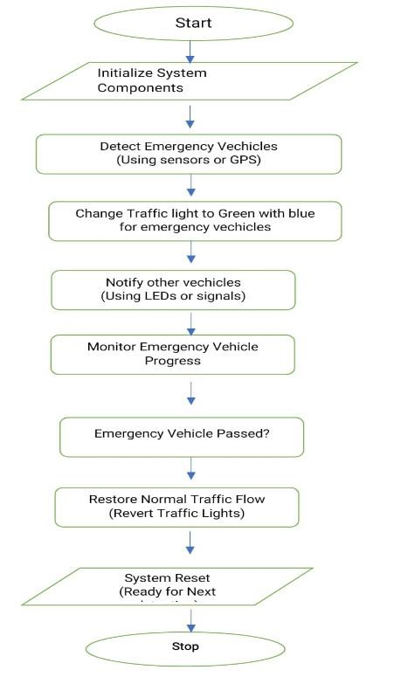

**Fig 3.1: Flow diagram**

Overview: At intersections, this system uses automatic traffic signal control to give emergency vehicles priority. Ensuring the safe and efficient passage of emergency vehicles, such fire trucks and ambulances, through congested intersections is its primary objective.

System Setup: The sensors, Arduino microcontroller, and LEDs that make up the system are first initialized. These components are required for emergency vehicle detection and traffic signal management.

Identification of Emergency Vehicles: The system employs sensors or GPS technology to detect the presence of emergency vehicles as they approach the intersection. These sensors are crucial for figuring just how close an emergency vehicle is.

Notification of Further Automobiles The system also makes use of LEDs or other signalling methods to interact with other vehicles at the intersection and warn them of the approaching emergency vehicle. You could ensure that other motorists are aware of the circumstance and know how to respond by taking this action.

Tracking Development: To ensure that the emergency vehicle crosses the junction safely and effectively, the technology monitors its movement.

Inspection Following Passage

Before going to the next stage, the system makes sure the emergency vehicle has passed. It is ensured that traffic will restart only once the emergency vehicle has departed the intersection by performing this check.

Reprieve of Customary Traffic Patterns

After confirming that the emergency vehicle has passed, the device resets the traffic signals to their normal state, returning which helps to quickly identify and prioritise emergency vehicles.

# IV. Conclusion

The suggested Arduino-based emergency vehicle traffic control system offers a reliable answer to the problems associated with urban traffic congestion. Through the use of motion sensors, GPS tracking, GSM connectivity, and RFID technology, the system is able to prioritise emergency vehicles and make sure they may pass through busy intersections quickly and unobstructed. An emergency vehicle with an RFID tag approaches a junction; the RFID reader recognises it, and the system initiates the prearranged sequence of traffic lights (red, blue, green) to make room for the vehicle. This real-time modification enhances overall traffic flow and safety in metropolitan areas by reducing delays and dramatically speeding up emergency response times. The system can identify the presence of general traffic thanks to the integration of motion sensors, which optimises traffic signal changes to further lessen congestion. This dynamic technique guarantees that, even in emergency conditions, nonemergency vehicles are not severely disrupted, hence ensuring efficient traffic flow. Furthermore, real-time location tracking and communication are made possible by the use of GSM and GPS modules An additional useful feature of the system is the ability to locate stolen automobiles using RFID identification and GSM-based alerting with GPS tracking. This study emphasises how different technologies can be used to provide a complete traffic management system that can be easily included into the current metropolitan infrastructure. The suggested technology is a desirable choice for broad implementation in smart cities due to its affordability and scalability. When put into practice, it can result in markedly faster emergency response times, less congested roads, and increased urban mobility.

In conclusion, the Arduino-based traffic control system for emergency vehicles advances the larger objective of creating smarter, more effective cities in addition to meeting the urgent need for quick emergency response in crowded urban areas. This creative method is a major advancement in contemporary traffic management and urban planning since it prioritises emergency vehicles and optimises traffic flow in real-time.

**V. REFERENCES:**

1. Rajeshwari Sundar, Santhoshs Hebbar, and Varaprasad Golla, "Implementing Intelligent Traffic Control System for Congestion Control, Ambulance Clearance, and Stolen Vehicle Detection."
2. A. Ranganath, T. Sree Valli, "Intelligent Management System For Density Based Control, Stolen Vehicle And Auto Clearance."
3. Pavithra Poornima. S, "Traffic Surveillance and Vehicle Identification in Ghat Curves Using Arduino."
4. M. Abdoos, N. Mozayani, and A. L. C. Bazzan, "Traffic Light Control in Non-Stationary Environments Based on Multi-Agent Q-Learning," in Proceedings of the 14th International IEEE Conference on Intelligent Transportation Systems, Oct. 2011, pp. 580–1585.
5. ZigBee Specifications, ZigBee Alliance IEEE Standard 802.15.4k-2013, 2014. [Online].

Available: <http://www.zigbee.org/Specifications.aspx>

1. "Traffic Congestion in Bangalore—A Rising

Concern," [Online]. Available:

http://www.commonfloor.com/guide/trafficcongestion-in-bangalore-a-rising-concern27238.html, accessed 2013.

1. A. K. Mittal and D. Bhandari, "A Novel Approach to Implement Green Wave System and Detection of Stolen Vehicles," in Proceedings of the IEEE 3rd International Conference on Advanced Computing, Feb. 2013, pp. 1055–1059.
2. S. Sharma, A. Pithora, G. Gupta, M. Goel, and M. Sinha, "Traffic Light Priority Control for Emergency Vehicle Using RFID," International Journal of Innovative Engineering and Technology, vol. 2, no. 2, pp. 363–366, 2013.
3. R. Hegde, R. R. Sali, and M. S. Indira, "RFID and GPS Based Automatic Lane Clearance System for Ambulance," International Journal of Advanced Electronics and Electrical Engineering, vol. 2, no. 3, pp. 102–107, 2013.
4. P. Sood, "Bangalore Traffic Police - Preparing for the Future," [Online]. Available:

http://www.intranse.in/its1/sites/default/files/D1S2-, accessed 2011.

1. "Traffic Management Centre," [Online].

Available: http://www.bangaloretrafficpolice.gov.in/index.php ?option=com_content&view=article&id=87&btp=8 7, accessed 2014.

1. G. Varaprasad, "High Stable Power Aware Multicast Algorithm for Mobile Ad Hoc Networks," IEEE Sensors Journal, vol. 13, no. 5, pp. 1442–1446, May 2013.
2. "Traffic Solution," [Online]. Available: http://phys.org/news/2013-05-physics-green-citytraffic-smoothly.html, accessed 2013.
3. Yuvaraj. N, Prakash. V. B., Venkatraj. D., "HiFi Traffic Clearance Technique for Life Saving Vehicles Using Differential GPS System," World Academy of Science, Engineering and Technology, 2011.
4. Manikandan. G, Srinivasan. S., "Traffic Control by Bluetooth Enabled Mobile Phone," International Journal of Computer & Communication

Engineering, vol. 1, no. 1, May 2012.

1. Riaz Ahamed. S. S., "The Role of Zigbee Technology in Future Data Communication System," Journal of Theoretical and Applied Information Technology, 2005 – 2009.
2. Rashmi Hegde, Rohith R. Sali, and Indira. M. S., "RFID and GPS Based Automatic Lane Clearance System for Ambulance," International Journal of Advanced Electronics and Electrical Engineering, vol. 2, no. 3, pp. 102–107, 2013.