**DESIGN, PREPARE AND IN VITRO EVALUATION OF SOLID LIPID NANOPARTICLES LOADED CISPLATIN**

B. Radhika Kumari1, M.Pallavi2, A.Yasodha3

1Department of Pharmaceutics, Dhanvanthri College of Pharmaceutical Sciences, Thirumala Hills, Centre City, Appannapally, Mahabubnagar, Telangana 509001

2Assistant Professor, Department of Pharmaceutics, Dhanvanthri College of Pharmaceutical Sciences, Thirumala Hills, Centre City, Appannapally, Mahabubnagar, Telangana 509001

3Professor & Principal, Department of Pharmaceutical Analysis, Dhanvanthri College of Pharmaceutical Sciences, Thirumala Hills, Centre City, Appannapally, Mahabubnagar, Telangana 509001

**Corresponding Author:**

**Name:** B. Radhika Kumari

**Department:** Department of Pharmaceutics

**Mail id:** thisisrad22@gmail.com

**Phone:** 7675809693

**ABSTRACT**

The aim of this study was to investigate the effectiveness of a strategy based on the development of solid lipid Nanoparticles as an innovative formulation of Cisplatin with improved therapeutic efficacy. Cisplatin SLNs were prepared by Solvent evaporation method. The solubility of drug in different solid lipids was measured. FTIR studies indicated no interaction between drug and lipid. SLN were characterized for particle size, zeta potential, entrapment efficiency and surface morphology. In vitro drug release studies were performed in phosphate buffer of pH 7.4 using dialysis bag diffusion technique. The F5 formulation had shown maximum entrapment up to 88.90 % and sustained drug release for 8 h. The scanning electron microscopy and zeta potential study showed formation of good SLN dispersion. In vitro release profiles were biphasic in nature and followed Higuchi model of release kinetics. The stability study showed successful formation of stable SLNs.

**Key words:** Cisplatin, solid lipid Nano Particles, Solvent evaporation technique, FTIR, in-vitro drug release.

**INTRODUCTION**

Solid lipid nanoparticles (SLN) introduced in 1991 represent an alternative carrier system to tradition colloidal carriers such as emulsions, liposomes and polymeric micro and nanoparticles.1 Nan particles made from solid lipids are attracting major attention as novel colloidal drug carrier for intravenous applications as they have been proposed as an alternative particulate carrier system.2 SLN are sub-micron colloidal carriers ranging from 50 to 1000 nm, which are composed of physiological lipid dispersed in water or in aqueous surfactant solution.3 SLN offer unique properties such as small size, large surface area, high drug loading and the interaction of phases at the interface and are attractive for their potential to improve performance of pharmaceuticals. Solid lipid nanoparticles are one of the novel potential colloidal carrier systems as alternative materials to polymers which is identical to oil in water emulsion for parenteral nutrition.4 They have many advantages such as good biocompatibility, low toxicity and lipophilic drugs are better delivered by solid lipid nanoparticles and the system is physically stable. Cisplatin is an antineoplastic in the class of alkylating agents and is used to treat various forms of cancer.5

**MATERIALS**

Cisplatin was obtained from Alkem Pvt Mumbai, Phosphatidylcholine and Poloxamer procured from SD fine chemicals Mumbai. Other chemicals and the reagents used were of analytical grade.

**METHODOLOGY**

**Compatibility Study (IR spectroscopy)**

The drug-excipients compatibility was ascertained by subjecting the drug and homogenates of drug and polymer to Infrared spectrophotometric study.6

**Method of Preparation of Cisplatin Loaded Nanoparticles:**

Cisplatin loaded SLN were prepared by solvent emulsification/evaporation method. The composition of all the formulations 400 mg of drug was dissolved in 10 ml methanol and Phosphatidylcholine was dissolved in 20 ml chloroform separately; drug and lipid solutions were mixed together. The organic solvent mixture was completely evaporated at 70°C using rotary evaporator to remove of the organic solvent. Drug embedded lipid layer was then poured into 100 ml of aqueous solution containing poloxamer 407 surfactant and the mixture was Sonicated for 15 minutes by using Sonicator followed by homogenized for 15 minutes at different homogenization speed using high speed homogenizer. The suspension was then allowed to cool at room temperature. The suspension was filtered through membrane filter. The filtrate was centrifuged (1000 rpm for 10 minutes) and nanoparticles was collected.7

**Table -1: Composition of Cisplatin for Preparation of Solid Lipid Nanoparticles**

|  |  |  |  |  |  |  |  |  |
| --- | --- | --- | --- | --- | --- | --- | --- | --- |
| **Ingredients** | **F1** | **F2** | **F3** | **F4** | **F5** | **F6** | **F7** | **F8** |
| Cisplatin | 20 | 20 | 20 | 20 | 20 | 20 | 20 | 20 |
| Phosphatidylcholine | 50 | 100 | 150 | 200 | 250 | 300 | 350 | 400 |
| Poloxamer 407 | 50 | 50 | 50 | 50 | 50 | 50 | 50 | 50 |
| Solvent(Methanol) | 10 | 10 | 10 | 10 | 10 | 10 | 10 | 10 |
| Chloroform | 10 | 10 | 10 | 10 | 10 | 10 | 10 | 10 |

**Evaluation of Cisplatin Loaded Nanoparticles:**

**Particle Size:**

All the prepared batches of nanoparticles were viewed under microscope to study their size. Size of Nano particles from each batch was measured at different location on slide by taking a small drop of nanoparticle dispersion on it and average size of nanoparticles were determined.8

**SEM Analysis:**

The morphology of NPs was studied by a scanning electron microscope. For this purpose, the sample was lyophilized and placed on aluminium stubs and the surface was coated with a layer of gold particles using a sputter coater. The shape of the NPs was determined by scanning electron microscopy (SEM) (XL30, Philips, the Netherlands) at 15 kV and 750 mA.9

**Drug Encapsulation Efficiency:**

Lyophilized nanoparticles 50mg were dissolved in 100ml of phosphate buffer and the drug amount was determined by UV analysis. The encapsulation efficiency was determined as the mass ratio of entrapped Cisplatin in nanoparticles to the theoretical amount of the drug used in the preparation .The entrapment of the Cisplatin nanoparticles was expressed as loading capacity.10

Amount entrapped

Entrapment Efficiency (%) = --------------------------------- × 100

Total drug loaded

**In-Vitro Drug Release Studies:**

The release studies were carried out by Franz diffusion cell. It containing 10 ml Phosphate buffer. Phosphate buffer pH 7.4 (100 ml) was placed in a 10 ml of beaker. The beaker was assembled on a magnetic stirrer and the medium was equilibrated at 37±50C. Dialysis membrane was taken and one end of the membrane was sealed. After separation of non-entrapped Cisplatin dispersion was filled in the dialysis membrane and other end was closed. The dialysis membrane containing the sample was suspended in the medium. 1ml of aliquots were withdrawn at specific intervals, filtered after withdrawal and the apparatus was immediately replenished with same quantity of fresh buffer medium.11

Percentage of drug release was determined using the following formula.

$$Perentage drug release= \frac{Da}{Dt} ×100$$

Where, Dt = Total amount of the drug

Da = The amount of drug released

**Drug release kinetics:12**

The models used were zero order (equation 1) First order (equation 2) and Higuchi model (equation 3) and Korsmeyer Peppas model (equation 4).

**I) Zero Order Kinetics**:

R = Ko t -- (1)

R=cumulative percent drug

Ko=zero order rate constant

**ii) First Order Kinetics**

log C = log Co –K 1 t /2.303 -- (2)

Where C = cumulative percent drug

K 1= first order rate constant

**iii) Higuchi Model**

R = K H t 0.5  -- (3)

Where R = cumulative percent drug

K H =higuchi model rate constant

**iv) Korsmeyer Peppas Model:**

M t / M α = K k t n

log M t / M α = log K k +n log t -- (4)

Where K k =Korsmeyer Peppas rate constant

‘M t / M α’ is the fractional drug, n = diffusional exponent, which characterizes the mechanism of drug. The obtained regression co-efficient (which neared 0.999) was used to understand the pattern of the drug from the nanoparticles.

**Stability Studies:13**

Selected Formulation was subjected to stability studies as per ICH guidelines.

Following conditions were used for Stability Testing.

1. 250C/60% RH analysed every month for period of three months.

2. 300C/75% RH analysed every month for period of three months.

3. 400C/75% RH analysed every month for period of three months.

**RESULTS AND DISCUSSION**

**Drug Excipient Compatibility Studies**

FTIR spectra of drug in KBr pellets at moderate scanning speed are 4000-400 cm-1 was made.



**Fig-1: FTIR Studies of Cisplatin**



**Fig-2: FTIR Studies of Physical Mixture of Drug and Excipients**

Compatibility studies were performed using IR spectrophotometer. The IR spectrum of pure drug and physical mixture of drug and excipients were studied. The characteristic absorption of peaks was obtained as above and as they were in official limits (±100 cm-1) the drug is compatible with excipients.

**Scanning Electron Microscopy:**

The surface characteristic of prepared crystal was studied by SEM (ZEISS Electron Microscope, EVO MA 15). Powder samples was mounted onto aluminium stub using double sided adhesive tape and sputter coated with a thin layer of gold at 10 Torr vacuum before examination. The specimens were scanned with an electron beam of acceleration potential of 20 kV and the images were collected as secondary electron mode.

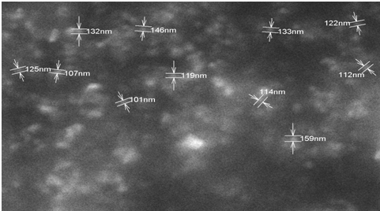

**Fig-3: SEM Analysis of Nanoparticles**

**Determination of Zeta Potential:**

Zeta potential is a measure of charge present on the vesicle surface. It was determined by using phase analysis light scattering with Malvern Zetasizer at field strength of 20V/cm in distilled water and based on electrophoretic mobility of charged particles present in the Nano carrier system. Charged particles were attracted to the electrode with the opposite charge when an electric field is applied.

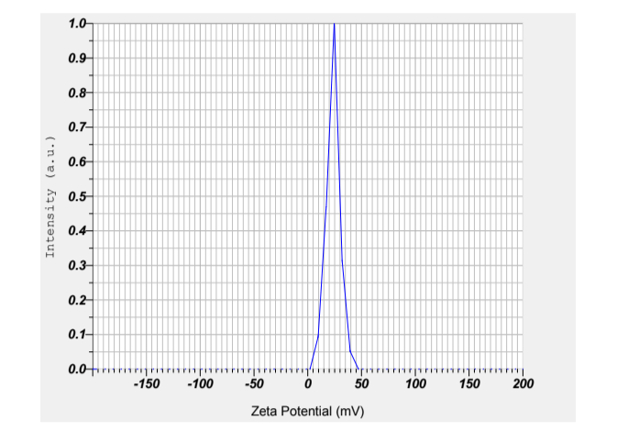

**Fig-4: Zeta Potential of Optimized Formulation**

**Zeta Potential**

The addition of membrane additives affects zeta potential value depending on the type of membrane additives. Zeta potential of optimized Cisplatin nanoparticles formulation was measured and found to -32.80 mv. The obtained result of the zeta potential of the prepared formulation indicates particles in the formulation remains suspended and so were found to be stable.

**Particle Size**

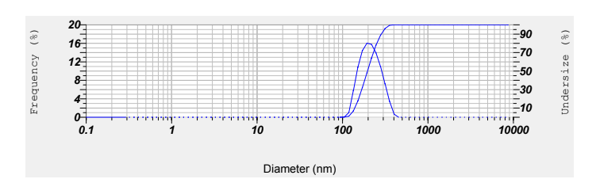

**Fig-5: Particle Size of Optimized Formulations**

In general, particle size was with a diameter of < 135 nm. The surfaces of the nanoparticles were smooth.

**Characterization of Nanoparticles of Cisplatin**

**Table-2: Evaluation Studies of Particle Size Nanoparticles**

|  |  |  |  |
| --- | --- | --- | --- |
| **F. No.** | **Particle Size (nm)** | **Entrapment Efficiency (%)** | **Zeta Potential (mV)** |
| F1 | 121.26 | 81.36 | -23.90 |
| F2 | 129.25 | 83.51 | -31.24 |
| F3 | 135.46 | 85.91 | -32.58 |
| F4 | 137.25 | 83.69 | -43.93 |
| F5 | 135.50 | 88.90 | -40.20 |
| F6 | 132.15 | 87.93 | -38.93 |
| F7 | 128.96 | 85.29 | -39.65 |
| F8 | 130.20 | 86.91 | -32.80 |

**Entrapment Efficiency**

The drug entrapment efficiency of all 8 formulations was evaluated. From the F5 formulation showed maximum drug entrapment efficiency 88.90 % compared to other formulations. The zeta potential or the change on the surface of colloidal particles in Cisplatin solid lipid nanoparticles was measured by electrophoretic light scattering mode using Zetasizer Nano ZS. The particle charge of Cisplatin SLNs was quantified at 25o C. The samples were diluted approximately with the deionized water for the measurements of particle size.

**In Vitro Drug Release Studies**

**Table-3: In Vitro Drug Release Studies of all Formulations**

|  |  |  |  |  |  |  |  |  |
| --- | --- | --- | --- | --- | --- | --- | --- | --- |
| **Time (hrs)** | **F1** | **F2** | **F3** | **F4** | **F5** | **F6** | **F7** | **F8** |
| 0 | 0 | 0 | 0 | 0 | 0 | 0 | 0 | 0 |
| 1 | 23.91 | 22.73 | 20.12 | 19.63 | 25.37 | 24.93 | 21.29 | 23.47 |
| 2 | 35.90 | 34.57 | 34.10 | 30.25 | 31.24 | 32.79 | 30.15 | 31.59 |
| 3 | 43.16 | 42.18 | 43.21 | 40.21 | 43.15 | 45.81 | 44.38 | 45.79 |
| 4 | 58.92 | 57.46 | 55.68 | 53.93 | 57.93 | 55.89 | 53.60 | 55.82 |
| 5 | 63.84 | 62.81 | 64.19 | 65.82 | 66.90 | 65.82 | 64.92 | 63.87 |
| 6 | 70.28 | 71.25 | 73.64 | 74.68 | 76.98 | 74.18 | 73.54 | 72.68 |
| 7 | 80.12 | 82.16 | 83.92 | 82.49 | 85.61 | 84.14 | 82.34 | 80.19 |
| 8 | 91.25 | 93.56 | 92.15 | 94.53 | 96.87 | 95.86 | 93.22 | 91.25 |

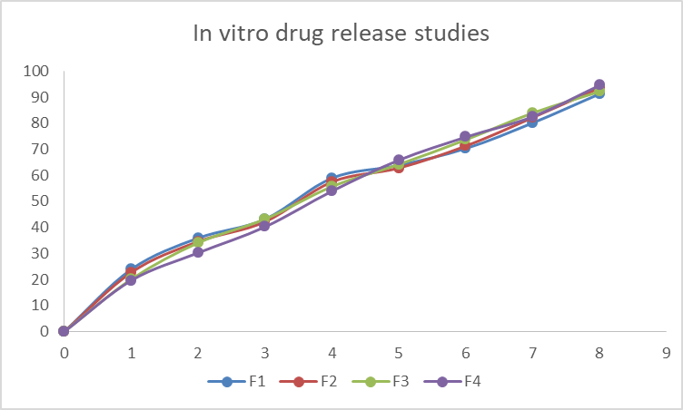

**Fig-6: In Vitro Drug Release Studies of (F1-F4) Formulations**

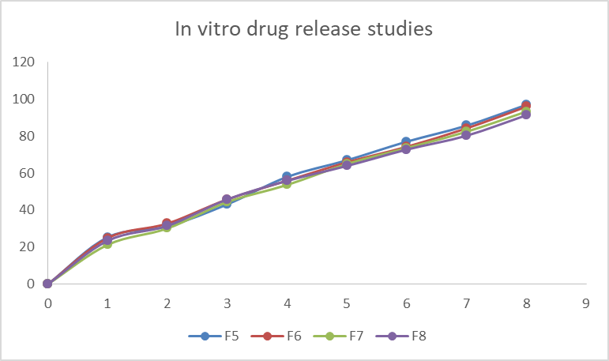

**Fig-7: In Vitro Drug Release Studies of (F5-F8) Formulations**

The drug release studies of all formulations of Cisplatin SLNs were conducted by means of diffusion apparatus for a time period of 8 hrs. From the drug release studies as depicted in Figure, the results showed that 8 formulations showed maximum drug release rate of 95.25 % within 8 hrs.

**Drug Release Kinetics**

**Table-4: Drug Release Kinetics of Optimized Formulation**

|  |  |  |  |  |  |  |
| --- | --- | --- | --- | --- | --- | --- |
| **Time (hrs)** | **%CDR** | **SQARE T** | **LOG T** | **LOG%CDR** | **ARA** | **LOG%ARA** |
| 0 | 0 | 0 | 0 | 0 | 0 | 0 |
| 1 | 25.37 | 1 | 0 | 1.40432 | 74.63 | 1.87291344 |
| 2 | 31.24 | 1.41421 | 0.30103 | 1.49471 | 68.76 | 1.83733587 |
| 3 | 43.15 | 1.73205 | 0.47712 | 1.63498 | 56.85 | 1.75473047 |
| 4 | 57.93 | 2 | 0.60206 | 1.7629 | 42.07 | 1.62397251 |
| 5 | 66.9 | 2.23607 | 0.69897 | 1.82543 | 33.1 | 1.51982799 |
| 6 | 76.98 | 2.44949 | 0.77815 | 1.88638 | 23.02 | 1.36210532 |
| 7 | 85.61 | 2.64575 | 0.8451 | 1.93252 | 14.39 | 1.15806079 |
| 8 | 96.87 | 2.82843 | 0.90309 | 1.98619 | 3.13 | 0.49554434 |

**Zero Order Kinetics**

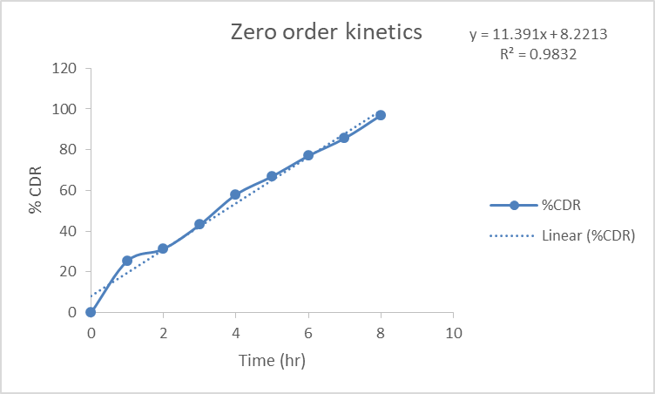

**Fig-8: Zero Order Kinetics of Optimized Formulation**

**First Order Kinetics**

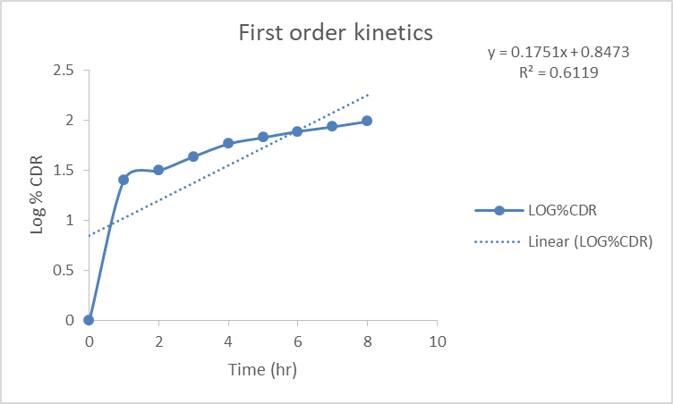

**Fig-9: Zero Order Kinetics of Optimized Formulation**

**Higuchi Model**

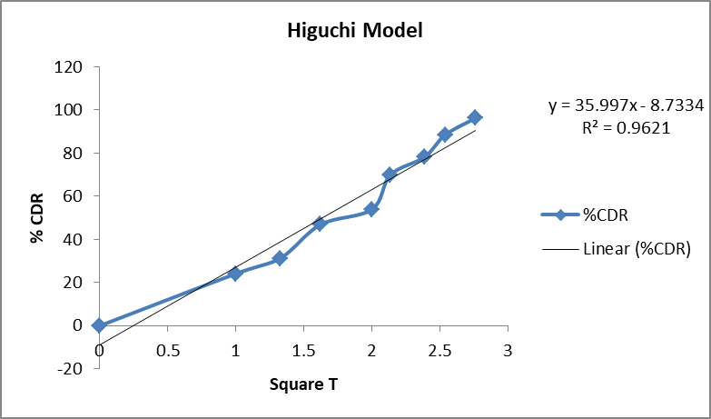

**Fig-10: Higuchi Model of Optimized Formulation**

**Korsmeyer Peppas Model**

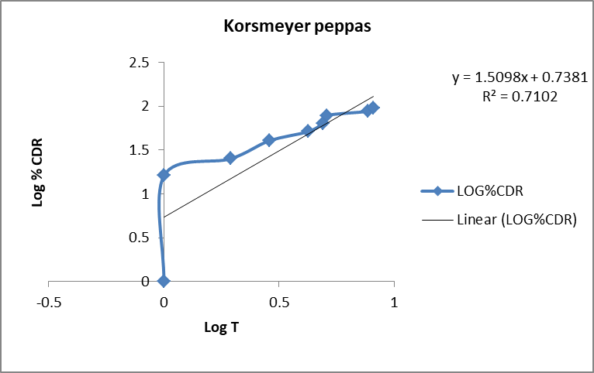

**Fig-11: Korsmeyer Peppas of Optimized Formulation**

The release kinetics for all the prepared R-SLNs was evaluated to determine the release behaviour of Cisplatin from the prepared SLNs. The release data were analysed with zero-order kinetic, first-order kinetic, and Korsmeyer–Peppas kinetic models, as well as the Higuchi kinetic model. It was revealed that the release data from SLNs fit to Higuchi kinetic model with the highest (r) value, while for free Cisplatin nanoparticles , the release data fit the zero order kinetic model.

**Stability Studies**

There was no significant change in physical and chemical properties of the nanoparticles of formulation F-5 after 90 days. Parameters quantified at various time intervals were shown.

**Table-5: Stability Studies of all Formulations**

|  |  |  |  |  |  |  |
| --- | --- | --- | --- | --- | --- | --- |
|  | **Parameters** | **Initial** | **1st Month** | **2nd Month** | **3rd Month** | **Limits as per Specifications** |
| **F-5** | **250C/60%RH**  **% Release** | 96.87 | 95.52 | 94.59 | 93.67 | **Not less than**  **85 %** |
| **F-5** | **300C/75% RH**  **% Release** | 96.87 | 95.50 | 94.62 | 93.50 | **Not less than**  **85 %** |
| **F-5** | **400C/75% RH**  **% Release** | 96.87 | 95.48 | 94.85 | 93.43 | **Not less than**  **85 %** |

**CONCLUSION**

The current study suggested a unique Cisplatin solid lipid nanoparticle formulation for regulated release. A drug encapsulation effectiveness of up to 88.90 % has been attained in this study. Cisplatin solid lipid nanoparticles containing soy lecithin were created using the Solvent evaporation method, then the particle size was decreased by sonication formulation using solid lipid nanoparticles performed well in terms of medication content and encapsulation effectiveness. This shows that the formulation procedure was suitable and reproducible in nature, and it provided a good yield. The formulation with the best encapsulation efficiency was (F-5). It was discovered that the percentage of encapsulation efficiency along with the soy lecithin concentration. According to the method described, permeation studies with dialysis membrane were conducted. The in vitro drug release profiles of all the formulations indicated an initial burst effect, followed by a gradual drug release. The formulations demonstrated good drug release from the lipid. These solid lipid nanoparticles contained more Cisplatin and released it more quickly.

**REFERENCES**

1. Chen H, Chang X, Du D, Liu, et al. Podophyllotoxin-loaded solid lipid nanoparticles for epidermal targeting J. Control. Rel. 2006; 110: 296-306.
2. Cavalli R, Caputo O, Marengo E, et al. The effects of components of micro emulsions on both size and crystalline structure of solid lipid nanoparticles (SLN) containing a series of model molecules. Pharmazie, 1998; 53: 392-396.
3. Zur Mühlen A, et al. Drug release and release mechanism of prednisolone loaded solid lipid nanoparticles. Pharmazie 1998; 53:552.
4. Levy MY, Benita S. Drug release from sub micronized o/w emulsion: a new in vitro kinetic evaluation model. Int. J. Pharm.1990; 66: 29-37.
5. Mueller RH, Solid lipid nanoparticles (SLN) for controlled drug delivery - a review of the state of the art. Eur. J. Pharm. Biopharm. 2000; 50:161-177.
6. Cavalli R, Gasco MR, et al. Solid lipid nanoparticles (SLN) as ocular delivery system for tobramycin, Int. J. Pharm. 2002; 15:241-5.
7. Greenberg HL, et al. DP. Clotrimazole/betamethasone dipropionate: a review of costs and complications in the treatment of common cutaneous fungal infections. Pediatric Dermatology, 2002; 19, 78-81.
8. Souto EB, Müller RH. The use of SLN® and NLC® as topical particulate carriers for imidazole antifungal agents. Pharmazie, 2006; 61, pp; 431-437.
9. Vitamin E—A comprehensive treatise. New York and Basel: Marcel Dekker Inc. Machlin LJ. 1980.
10. Elmadfa J, Bosse W. Vitamin E, et al. Wissenschaftliche Verlagsgesellschaft. 1985.
11. Antonio J. Almeida and Eliana Souto, Adv. Drug Delivery Rev., 59, 478-490 (2007).
12. S. P. Vyas and R. K. Khar Controlled Drug Delivery - Concepts and Advances, First Edition, Vallabh Prakashan (2002) 38-50.
13. Rishi Paliwal, Shivani Rai, et al. Nanomedicine, Nanotechnology, Biology and Medicine, 5(2), (2009) 184-191.