**A STUDY ON MANAGEMENT OF STRESS AND ANXIETY AMONG ADOLESCENT GIRLS**

|  |  |
| --- | --- |
| **Dr.T.Ezhilarasi**  **Assistant Professor-MBA**  **Jai Shriram Engineering College Tirupur** | **Dr.M.Aarthy**  **Assistant Professor**  **Manikam Ramaswami College of Arts and Science**  **Madurai** |

**ABSTRACT**

Almost every human would admit that they had their peak experiences of life right when they’ve stepped into the age of adolescence, being one of the most crucial stages of life adolescence is a stage that must be countered in a very healthy manner as studies have proved that individuals have exponential rates of mental, physical and emotional growth during this phase. Studies have also proved that girls tend to be more vulnerable towards stress and anxiety during their phases of adolescence that may have a profound effect on their perception of self, the way they behave and navigate through their course of life. This study was conducted to analyse and identify the impact and implications of stress and anxiety in their personal as well as their academical life. Exposure to social media, stress related to academics and influences of peer groups were taken as criteria for this study.

**Keywords: stress, adolosent girls**

**INTRODUCTION**

Adolescence can be the age where you might have pondered upon different life situations, explored a whole new concept of living had your first heartbreak or you might have just tripped over by being dumb and being labelled as the class clown. Though you possess many beautiful memories regarding your stages of adolescence there would also have been various phases where you might have undergone huge amounts of stress and anxiety which you might be aware of or not has created you into the individual that you are now. Having a healthy awareness on how to deal with stress and anxiety during this age might be the right tool to shape a better self that performs and exists in a better quality life when compared to the unfortunate individuals who were not aware and educated on dealing with stress and anxiety that has profound effects on their life. If you were termed as Daddy’s Princess or Crew Queen the poster boy of your school took you out on a date and your peers supported you in a very positive way to shape yourself and your identity congrats you might have dealt with stress and anxiety in a very healthy manner, for the other girls who’ve had a rough course of life this study is meant for them. Various studies and researches have proven that girls being as soft as they are tend to be more vulnerable towards different threats of this world yet there are very few studies that throw limelight on the effects of anxiety and stress that they go through during the phase of adolescence.

Adolescence is a transitional stage of development that occurs between childhood and adulthood right when Daddy gave you pocket money and you realised that there was more to life than just playdough and barbie dolls. It is typically marked by significant physical, cognitive, and psychosocial changes. This period is characterized by puberty, during which individuals undergo rapid physical growth and sexual maturation.Adolescence generally spans the ages of 10 to 19, but the exact age range can vary. It is a time of exploration, identity formation, and increased independence. During adolescence, individuals often experience changes in their relationships, emotions, and self-perception.Cognitive development during adolescence involves the maturation of reasoning abilities, problem-solving skills, and abstract thinking. Socially, adolescents seek greater autonomy from their parents, develop peer relationships, and explore their own values and beliefs. Emotional and psychological changes also play a significant role during this time.It's important to note that adolescence is a culturally and socially influenced concept, and different societies may have varying expectations and norms regarding this developmental stage.

**OBJECTIVE OF THE STUDY**

* To identify the triggers and causes of stress and anxiety among the respondents.To identify the impact of Academics, Social causes and Family related issues on their overall stress level.Toasses the ways Social media impacts on stress and anxiety.

**MATERIALS AND METHODS**

* Type of research: Descriptive research
* Type of sampling: Convenient sampling
* Sample size: 50
* Data used: Primary data
* Tools used: percentage analysis

**REVIEW OF LITERATURE**

1. Angela J Dean et al (2010)to locate controlled trails that described specific interventions focusing to improve abiding to long-term medication, where participants were aged 18 years. These findings suggest that education interventions alone are insufficient to promote adherence in children and adolescents and that incorporating a behavioral component to abiding intervention may increase efficacy. Mathew (2001) this Study linking parents work stress to Adolescents Psychological Adjustment. It reveals that the effects of parental work stress on Adolescent’s Adjustment appear to be indirect. Work stress is linked to parents’ feelings of overload and strain, which in turn are related to less positive adjustment of adolescents. In the face of high work stress withdrawing from family involvement may be adaptive in the short run but ultimately problematic. The strength of those associations depends on parent’s personality, coping styles, work and family circumstances. Rebecca M. Jones et al (2010) indicate that the adolescence is the time of storm and stress. In spite of intense and frequent negative affect this period has been hypothesized to explain increased rates of affective disorders, suicide and accidental death. Yet some teens emerge from adolescence with minimal turmoil. It provides neurobiological model for adolescence which proposes that an imbalance in the development of sub cortical limbic (eg amygdala) relative to prefrontal cortical regions as a potential mechanism for heightened emotionality during this period. BruceE.(1987)In his research article, how child and adolescents cope with stress. And coping’s role in reducing the adverse psychological states associated with stress is reviewed. Child and adolescent coping is reflected in seven different lines of research- infants responses to maternal separation, social support, interpersonal and cognitive problem solving, coping in achievement contexts, Type A behavior pattern in children, repression-sensitizing, and resilience to stress. A variety of different coping resources, styles and specific strategies are important in successfully adapting to stress, including efforts that focus directly on the problem, as well as attempts to deal with adverse emotions associated with stress. sta

**PERCENTAGE ANALYSIS**

|  |  |  |  |
| --- | --- | --- | --- |
| **S.no** | **Demographic variables** | **HF** | **Percentage** |
|  | **age** | **16-19** | **68** |
|  | **Socio-economic status** | **Middle claes** | **87** |
|  | **Academic performance** | **good** | **57** |
|  | **Stress and anxiety level** | **positive** | **46** |
|  | **Do you use any coping mechanism?** | **yes** | **73** |
|  | **How effectively do you find these coping mechanism?** | **Very effective** | **40** |

**The top three source of stress and anxiety in adolescent life**

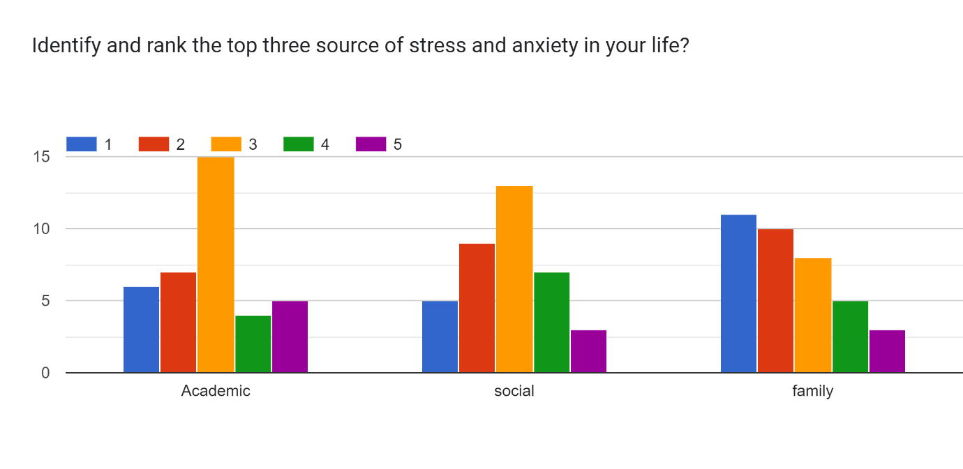

the above chart shows that it is interpreted that academics is the biggest stressorfollowed by social causes and the least rated is family which makes it safe to conclude that all respondents exist in a very healthy household.

**Findings and suggestions:**

It was found that majority of the respondents belong to the age category of 16-19 and were college going students.A majority of the respondents agreed that they experience moderate levels of stress and the other majority experience high and very high levels of stress followed by a minority who admit to experience low levels of stress.It was found that majority of the respondents do use coping mechanisms to deal with stress.It was found that majority of the respondents find these coping mechanisms to be moderately effective followed by the other majority who find coping mechanisms to be slightly effective and the rest being very effective to extremely effective and non-effective at par.It was found that academics was the biggest source of stress followed by social stressors and family related stressors being the least.It was found out that majority of the respondents found music to be the best coping mechanism.It was found out that majority of the respondents experience a positive impact through social media, followed by the other majority who experience a negative impact and the least have no impact influenced by social media on their stress and anxiety levels.

**Suggestions**

From this successful study that has been undertaken and the findings it is suggestable that individuals have a very healthy relationship with their family that helps a lot in coping up with stress anxiety and is to be appreciated. Academics being the biggest cause of stress and anxiety must be managed in the right manner through various other techniques that lower the levels and impact of stress and anxiety. It is safe to say that music as a coping mechanism has proven to be the most effective in managing stress and anxiety among adolescent girls. It is safe to suggest that having a healthy relationship amongst family, peers and using a effective coping mechanism can help individuals to deal with stress and anxiety in a very healthy manner.

**CONCLUSION**

Adolescence is considered a time of transition as changes take place in physical and cognitive areas as wel1 as social contexts. These numerous changes can provide challenges and new opportunities or they can become overwhelming and stressful. Both boys and girls experience distress throughout adolescence and both need support. Some potential risk and protective factors that influence adolescent mental health include social support such as family and peers, contextual situations like school, and internal resources of the individual such as locus of control. In particular, increased awareness of girls' needs in the school setting is necessary. Although research varies concerning gender differences and stress, early adolescent girls may experience a greater number of stressors. The coincidence of pubertal change, school transition and role transition has been contributed to higher stress in young adolescent girls. What is positive is that adolescents are generally active copers. Gilligan (1982) contends that females have a stronger dependency on connection and relationships. This could be a real strength in developing programs to help girls manage their stressors more effectively.

Any intervention effort should be in touch with the real needs of those it is intended to benefit, so this research project utilized focus group methodology to investigate the stress or and coping methods of young adolescent girls. From the richness of the girls'· responses emerged themes that emphasized the significance of family, school and peer stressors in their lives. Also, the participants provided evidence of action-based coping and a willingness to build their coping skills in relation to others. The resulting group stress management program proposal is intended to be flexible, with a scope for adaptation to honour the needs of different groups in various school settings.

**Reference:**

1. **Aggarwal, Y.P. (1986). Statistical Methods: Concepts, Application andComputation. New Delhi: Sterling Publishers Pvt. Ltd.**
2. **Anand, C.L. and Padma, M.S. “Correlates of Achievement: A TrendReport”. Buch, M.B. (Ed.) (1987). Third Survey of Research inEducation. New Delhi: NCERT.**
3. **Bayti (1975). “The Effect of KR (Knowledge of Results) on Achievementof School Subjects in Relation with Certain 0-Variables”. DoctoralThesis, Kurushetra University. Buch, M.B. (Ed.) (1979). SecondSurvey of Research in Education. Baroda: Society for EducationalResearch and Development.**
4. [**http://www.springerlink.com/index/Y**](http://www.springerlink.com/index/Y)
5. [**http://www.nwrel.org/scpd/re-http://www**](http://www.nwrel.org/scpd/re-http://www)**.**