**GAS LEAKAGE DETECTION SYSTEM USING GSM MODULE**

|  |  |  |
| --- | --- | --- |
| TEJASHWINI P [1] | NIRANJAN K V [1] | SUPRITH R [1] |
| Department of Electronics and Communication Engineering | Department of Electronics and Communication Engineering | Department of Electronics and Communication Engineering |
| T. John Institute of Technology | T. John Institute of Technology | T. John Institute of Technology |
| tejashwinipsg@gmail.com | niranjanv924@gmail.com | suprithgowda1802@gmail.com |

|  |
| --- |
| V. S PRABHIN [2] |
| Assistant Professor |
| T. John Institute of Technology |
| prabhin@tjohngroup.com |

***ABSTRACT- Gas leakage poses a significant threat to safety in residential, commercial, and industrial environments. However, the traditional approach of gas leakage detection is poor in features of real-time monitoring and remote alerting. Thus, there remains potential for the occurrence of hazards. In view of this challenge, the current study investigates the integration of GSM modules into gas leakage detection systems. The system uses gas sensors for the detection of targeted gases present in the environment to raise an alarm in a micro-controller when gas concentration exceeds predefined levels. The micro-controller then activates the GSM module and real-time SMS alert is sent to predefined numbers to alert the user on the gas leak. Advantages include remote monitoring, rapid alerting, cost-effectiveness, and reliability.***

***Keywords****: Gas leakage, Gas sensor, GSM module, SMS alert, Real-time alert, Monitoring*

1. **INTRODUCTION**

Gas leaks are dangerous because they have the ability to result in explosions, fires, and serious health-related consequences. For such accidents to have less harmful outcomes, they need to be detected as early as possible. A critical objective of the project is to come up with an advanced gas leak detector, one that is better than the current one, having a GSM module to give real-time notifications and improve on safety measures.

This system is designed to scan for the existence of hazardous gases, such as butane, propane, and methane, in the ambient air. It uses a sensitive gas sensor that can detect even minute amounts of these gases to ensure early detection of leaks. When a gas leak is detected, it triggers an alert mechanism. This is done with the aid of the inbuilt GSM module.

The GSM module is programmed to send instant SMS messages to pre-defined numbers. This ensures that users are informed from wherever they are in case there is a gas leak. Thus, the major benefit is real-time notification through an SMS alert where appropriate action can be taken at the right time to repair the leak, either by evacuating the area, cutting off the gas supply, or calling for help from emergency services.

The gas-leak detection device is designed to be user-friendly and reliable. It operates at all times, guaranteeing continuous monitoring at any single moment without the need for regular maintenance or manual intervention. A lot of customers from industrial operators to homes can make use of the system due to its easy installation and operations.

This project hopes to provide an effective way of lessening the hazards related to gas leaks. It does not only help avert possible disasters but also helps in increasing the general safety of the area where it is located by sending timely alerts.

1. **LITERATURE SURVEY:**

Many ideas have been proposed to prevent and detect the gas leakage. There are several benefits and drawbacks to each one of them. Below are several descriptions

[1] It focuses on detecting liquefied petroleum gas (LPG) and smoke using the MQ2 sensor, measuring humidity and temperature with the DHT11 sensor, and displaying the results on an LCD screen. Data can be displayed and recorded through various methods such as a PC with serial monitor, LCD, SD card, and Excel database. The system's operation is controlled by an MCU embedded on the Arduino board.

[2] This paper covers the use of components like the Sim900 SMS Gateway, Arduino Uno R3 Micro-controller, and MQ2 gas sensor for detecting liquefied petroleum gas leaks. The system includes physical alarm alerts with a buzzer and non-physical alerts via email and smartphone notifications using the Blynk application. Various studies have explored the integration of sensors, micro-controllers, and IoT platforms for efficient gas leak detection.

[3] It involves the selecting of the MQ-6 sensor for its sensitivity to LPG gas, setting up the hardware components, and conducting tests to measure gas pressure and detect leaks. When a gas leak was detected, the system triggered an alarm through the buzzer, displayed relevant information on the LCD, and automatically closed the gas line using the solenoid gas valve.

[4] This paper speaks about the system utilizing components such as a Home Gateway, GSM module, Siren, and LED to detect gas leaks and send alerts via SMS to a designated mobile number.

1. **METHODOLOGY**

The gas leakage detection system designed here involves integration of various components such as Arduino, gas sensor, GSM module, buzzer, led and an exhaust fan.

The gas sensor continuously monitors air for the gas content. When the gas concentration, more than the predefined threshold is detected the sensor sends the signals to the Arduino. Arduino receives the signals from the gas sensor and interprets the information. It then activates the buzzer to sound the alarm. A relay is used as an interconnection between led and the exhaust fan. Once the buzzer is activated, the led turns off indicating the power cut and the exhaust fan is turned on to ventilate the area. As soon as the activations are done, the Arduino alerts GSM module and a SMS alert is sent to the pre-specified contacts.

3.1 HARDWARE COMPONENTS

The description of hardware components used in designing of this system is given below

Arduino:

For this project, the Arduino micro-controller was used because of its affordability, usability, and flexibility. It offers a straightforward programming environment and an intuitive platform, making it usable by developers of all experience levels. Furthermore, prompt detection and reaction to emergency situations are guaranteed by Arduino's real-time processing capabilities. The Arduino platform is very suitable for continuous operation and deployment in gas leakage detection systems because of its scalability and low power consumption.

Gas sensor:

Since a MQ-6 gas sensor is commonly used to identify the presence of flammable gases including propane, isobutane, and LPG, it is employed in this project. It responds quickly and has a 200–1000 ppm range. It detects variations in the sensing element's resistance in response to the presence of gas. A few hundred parts per million (ppm) of gas concentration is usually sufficient to cause a discernible change in the resistance of a MQ-6 gas sensor. However, the minimum resistance change needed to identify gas can vary. A MQ-6 gas sensor's sensing resistance ranges from 10KΩ to 60KΩ (1000ppm LPG).

GSM Module:

A GSM module is a device that enables sending and receiving of data over a GSM network. It works by connecting network through a sim card. A A7670C GSM module is integrated to the gas leakage detection system for the purpose of communication and remote-control capabilities. It has a high-speed downlink packet access of 7.6 Mbps and a high-speed uplink packet access of 5.76 Mbps. The operating temperature of this GSM module is -40°C to +85°C, Storage Temperature of -45°C to +90°C and 5% to 95% of non-condensing humidity.

Buzzer:

A buzzer, an audio signaling device is used in this project to alert the surroundings about the gas leak. It Generates sound through transmission of electrical signal. Its voltage ranges from 5v to 12v. When a voltage is applied across the two electrodes, the piezoelectric material mechanically deforms due to the applied voltage. This movement of the piezo disk within the buzzer creates sound.

Exhaust fan:

An exhaust fan is used to ventilate the area and thus reduce the concentration of gas when leak is detected. Its air flow capacity is 50 to 300 CFM, operates on 110V to 240V AC voltage over the frequency of 50/60 Hz. It has a speed of 900 RPM to 1500 RPM (varies by model) .

3.2 SOFTWARE COMPONENTS

The description of the software component used is give below

In this project the Arduino IDE software is used to code for the system and to upload it into the Arduino. Arduino Integrated Development Environment (IDE) is one essential tool for creating programs for Arduino boards. The Arduino IDE's user-friendly design makes it accessible to beginners while still offering the features required for more complex applications. It offers a setting where code can be written, assembled, and uploaded to the Arduino hardware.

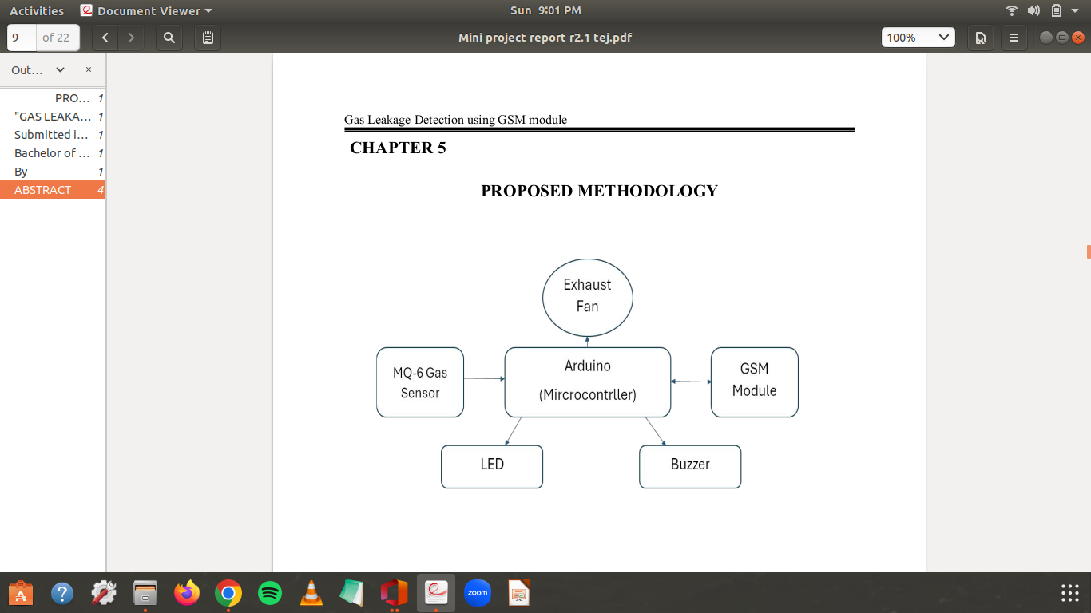

Fig 3.1: Block diagram of a gas leakage detection system

3.3 WORKING PRINCIPLE:

A gas leakage detection system operates by employing a sensor to detect gas, a microcontroller to process the signal, and a GSM module to send an SMS or make a phone call.

The system activation starts by initializing the components. The gas sensor reads the value of the concentration of combustible gases in the air. If the gas concentration value is less than the set threshold value, the sensor continues to read the value else it activates the buzzer, exhaust fan and deactivates the led. Once these activations are completed the Arduino triggers GSM module and thus an SMS is sent to the predefined contacts. After a certain duration when the gas concentration level is found low the Arduino deactivates the buzzer, exhaust fan and then activates the led. This is a continuous process and thus has a capability of continuous monitoring and real-time alerting.

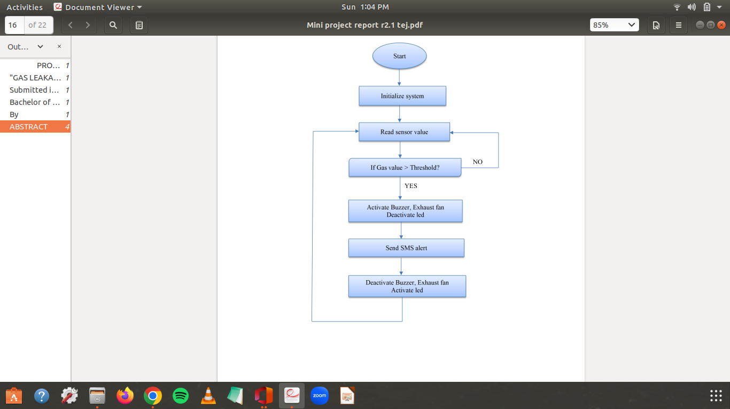

Fig 3.2: Flow chart of a gas leakage detection system

1. **ADVANTAGES**

Gas leakage detection system using GSM module offers several advantages making it a practical choice for various applications.

* Real-Time Alerts: The proposed system can immediately notify designated individuals or the authorities via SMS in the case of a gas leak. This real-time alerting capability helps in taking prompt actions to mitigate risks and prevent potential hazards
* Remote Monitoring: Since GSM networks cover wide geographic areas, the system can be monitored remotely from anywhere with GSM coverage. This is particularly useful for monitoring locations that are not easily accessible or are unmanned.
* Continuous Monitoring: The system can operate 24/7 without interruption, providing continuous monitoring of gas levels and detecting leaks as soon as they occur. This continuous monitoring helps in early detection and prevention of hazardous situations.
* Accessibility: Notifications are sent to designated mobile numbers, ensuring that multiple stakeholders can receive alerts simultaneously. This accessibility ensures that appropriate actions can be taken swiftly in response to the detected gas leakage.

1. **LIMITATIONS:**

The system dependance on the cellular network means the system may fail in areas with poor or no signal leading to missed alerts. The system also needs constant power supply. Power outages can disable the system, compromising its ability to detect and report gas leaks

1. **RESULTS:**

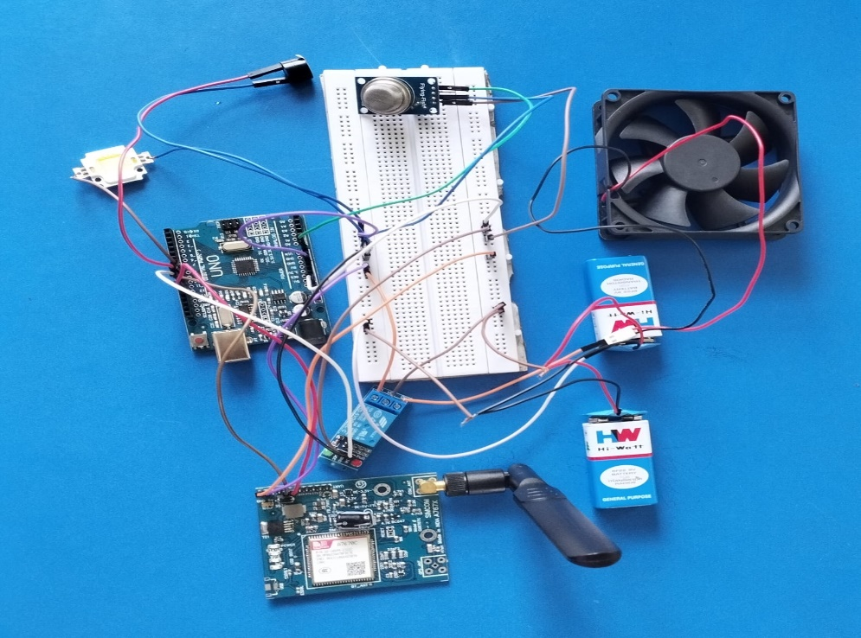

Fig 6.1: Representation of output of proposed system

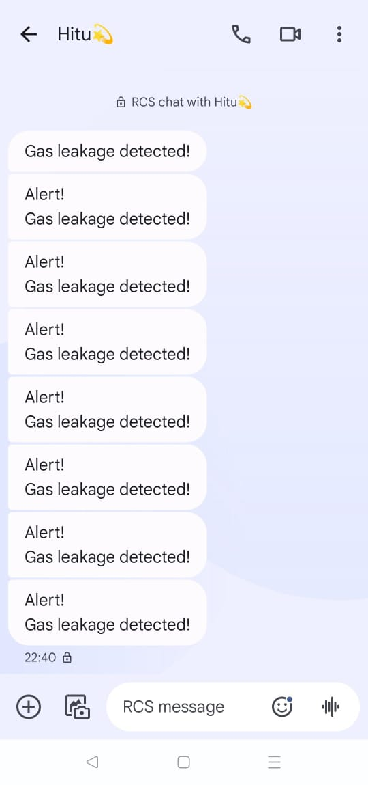

Fig 6.2: SMS alert received by predefined contact

1. **CONCLUSION AND FUTURE SCOPE:**

Conclusively, the creation and execution of a gas leak detection system using a GSM module constitute a noteworthy progression in guaranteeing security and averting possible risks linked to gas leaks. The incorporation of gas sensors into GSM technology enables instantaneous warning of gas leak occurrences and real-time monitoring, hence facilitating timely response and mitigation.

The effectiveness of the system resides in its capability to continuously monitor gas levels and in the event that harmful amounts are identified, automatically notify users and relevant authorities via SMS. This prompt communication serves as a vital safety precaution for commercial, industrial, and residentials by reducing the likelihood of explosions, fires, and health risks.

Additionally, the implementation of these systems has the potential to significantly improve public safety in general, especially in regions where gas leak events are common. The technology extends its protective reach by utilizing GSM networks' vast availability and dependability to guarantee that notifications are sent to any geographic location.

Future development can concentrate on incorporating features like data logging, IoT connectivity, and sophisticated analytics to improve the system's functionality and predictiveness even more.

Overall, the gas leakage detection system using a GSM module is an essential technological advancement that tackles a serious safety issue and offers a practical and efficient gas leak remedy.

**REFERENCES**

[1] Burjes, Ammar Yaseen, Ghader Salim Aziz, and Haneafa Yahya Najm. "Design a mobile

gas sensing system using Arduino Uno with recording and monitoring data." Web of Scientist: International Scientific Research Journal 3.8 (2022)

[2] V Praveen Sharma1, Dr Raman Dugyala, Dr V Padmavathi, Vijendar Reddy Gurram.” Gas

Leakage Detection System Using IoT and Cloud Technology: A Review”. Web of

Conferences 391, 01063 (2023)

[3] Tommy, Alexander. "Implementation of a Gas Leakage Detection System Using the MQ-6 Sensor." Brilliance: Research of Artificial Intelligence 2.1 (2022).

[4] Methila Farzana Woishe, Nila Sultana, Tamanna Zaman Bristy, Nafiza Anjum Khan, Taimur Ahad.” A Secured Model of IoT-based Smart Gas Detecting and Automatic Alarm System”. International Journal of Computer and Information System, April (2022).