**IoT Based Smart Car Controller**

Mr V Veeresh, Associate Professor  
CSE(IoT)  
ACE Engineering CollegeHyderabad, India  
[vveeresh1244@gmail.com](mailto:vveeresh1244@gmail.com)

P Jashwanth,Student   
CSE(IoT)  
ACE Engineering CollegeHyderabad, India  
Jashwanthponaganti3@gmail.comMohammed Yaqoob Hussain ,Student  
CSE(IoT)  
ACE Engineering College  
Hyderabad, India  
mdyaqoob153[@gmail.com](mailto:eshwarsatish9@gmail.com)

Moses Steven,Student  
CSE(IoT)  
ACE Engineering CollegeHyderabad, India  
[mosessteven890@gmail.com](mailto:mosessteven890@gmail.com)

**Abstract:**

The IoT-based Smart Car Controller project integrates Internet of Things (IoT) technology to provide a seamless and interactive experience for controlling various car functions through a mobile phone. This project aims to enhance the utility of traditional car control systems by incorporating real-time data acquisition, remote accessibility, and personalized features. The core functionality includes remote start and stop, door lock and unlock, climate control, and monitoring of car diagnostics. Leveraging IoT connectivity, the car controller synchronizes with users' smartphones, enabling seamless access to various functions and services. Additionally, the project incorporates voice recognition and natural language processing for hands-free control. Users can issue voice commands to perform tasks such as adjusting the temperature, checking fuel levels, or finding the car's location. Customization options allow users to tailor the interface and settings according to their preferences. This innovative approach offers significant advantages over traditional car control systems, enhancing convenience, security, and overall user experience.

Keywords : smart car controller, GPS Tracking , voice control, real time diagnostics, actuators

**I. INTRODUCTION**

Recent advancements in IoT have paved the way for smart systems capable of intelligent communication without human intervention. This technology facilitates the efficient and automated control of various devices, including cars. Previous research has explored smart mirrors, home automation, and wearable technology, demonstrating the potential of IoT in enhancing user interaction and convenience. The application of IoT in automotive systems is relatively new but growing rapidly. Early implementations focused on basic functionalities like remote start and GPS

tracking. However, the integration of advanced sensors, machine learning, and connectivity modules has expanded the scope of smart car controllers. This project aims to build on existing research, incorporating more sophisticated features such as voice control, real-time diagnostics, and personalized settings to provide a comprehensive smart car control solution.

**II. LITERATURE SURVEY**

Recent advancements in IoT have paved the way for smart systems capable of intelligent communication without human intervention. This technology facilitates the efficient and

automated control of various devices, including cars. Previous research has explored smart mirrors, home automation, and wearable technology, demonstrating the potential of IoT in enhancing user interaction and convenience. The application of IoT in automotive systems is relatively new but growing rapidly. Early implementations focused on basic functionalities like remote start and GPS tracking. However, the integration of advanced sensors, machine learning, and connectivity modules has expanded the scope of smart car controllers. This project aims to build on existing research, incorporating more sophisticated features such as voice control, real-time diagnostics, and personalized settings to provide a comprehensive smart car control solution.

**III. PROBLEM STATEMENT**

Modern car owners seek solutions that integrate seamlessly with their digital lifestyles, providing convenience, efficiency, and personalization. Traditional car control systems often lack these capabilities, limiting their functionality and user experience. There is a pressing need for IoT-based Smart Car Controllers that address these challenges:

* **Limited Functionality**: Conventional systems do not offer real-time updates, remote control, or personalized interactions.
* **Integration Complexity**: Integrating IoT capabilities requires overcoming technical challenges in hardware design, software development, and connectivity protocols while maintaining usability and aesthetic appeal.
* **User Experience Optimization**: The success of smart car controllers depends on intuitive, user-friendly interfaces that cater to diverse user preferences and accessibility needs.
* **Scalability and Interoperability**: Ensuring seamless integration with existing car systems, IoT platforms, and digital services is crucial for future scalability.
* **Affordability and Accessibility**: Balancing advanced functionalities with cost-effectiveness to make the technology accessible to a broad user base.

**IV. EXISTING SYSTEM**

Existing smart car systems offer basic functionalities such as remote start, GPS tracking, and basic diagnostics. However, these systems often lack advanced features, seamless integration, and personalized user experiences, limiting their effectiveness and user satisfaction.

**V. PROPOSED SYSYTEM**

The proposed IoT-based Smart Car Controller aims to overcome the limitations of existing systems by leveraging IoT technology to offer a seamless, immersive user experience. Key features include:

* **Enhanced Functionality**: Real-time updates on car status, remote start/stop, climate control, door lock/unlock, and detailed diagnostics.
* **Personalized Interactions**: Machine learning algorithms to adapt to user preferences, providing tailored notifications and recommendations.
* **Seamless Integration**: Compatibility with smartphones, wearables, and other smart home systems for unified control.
* **Voice-Controlled Interaction**: Built-in voice recognition for hands-free operation.
* **Customization**: Extensive options to personalize the interface and settings.

**VI. HARDWARE AND SOFTWARE REQUIREMENTS**

**Hardware Requirements:**

* Microcontroller (e.g., Arduino, Raspberry Pi)
* Sensors (temperature, GPS, fuel level, etc.)
* Actuators (for door locks, engine start/stop)
* Communication modules (Bluetooth, Wi-Fi)
* Power supply

**Software Requirements:**

* Mobile application for control interface
* Signal acquisition and data processing software
* Data storage and management system
* Data analysis software
* Communication protocols
* Notification system
* Security and privacy measures

**VII. MODULES**

The smart car controller system consists of several key modules:

* **Microcontroller Module**: Processes instructions and manages communication between components.
* **Sensor Module**: Gathers real-time data on car status.
* **Actuator Module**: Controls physical car functions like door locks and engine start/stop.
* **Communication Module**: Enables data transmission between the car and the user's mobile device.
* **User Interface**: Provides a user-friendly control interface on the mobile phone.
* **Notification System**: Sends alerts and updates to the user.

**VIII SAMPLE CODE:**

Below is a basic example of an Arduino sketch for controlling a car's door locks via a mobile app:

#include <Servo.h>

#include <ESP8266WiFi.h>

const char* ssid = "your_SSID";

const char* password = "your_PASSWORD";

WiFiServer server(80);

Servo doorLock;

void setup() {

Serial.begin(115200);

doorLock.attach(D2);

WiFi.begin(ssid, password);

while (WiFi.status() != WL_CONNECTED) {

delay(1000);

Serial.println("Connecting to WiFi...");

}

Serial.println("Connected to WiFi");

server.begin();

}

void loop() {

WiFiClient client = server.available();

if (client) {

String request = client.readStringUntil('\r');

client.flush();

if (request.indexOf("/lock") != -1) {

doorLock.write(0); // Lock the door

client.print("HTTP/1.1 200 OK\r\nContent-Type: text/html\r\n\r\nLocked");

}

if (request.indexOf("/unlock") != -1) {

doorLock.write(90); // Unlock the door

client.print("HTTP/1.1 200 OK\r\nContent-Type: text/html\r\n\r\nUnlocked");

}

client.stop();

}

}#include <Servo.h>

#include <ESP8266WiFi.h>

const char* ssid = "your_SSID";

const char* password = "your_PASSWORD";

WiFiServer server(80);

Servo doorLock;

void setup() {

Serial.begin(115200);

doorLock.attach(D2);

WiFi.begin(ssid, password);

while (WiFi.status() != WL_CONNECTED) {

delay(1000);

Serial.println("Connecting to WiFi...");

}

Serial.println("Connected to WiFi");

server.begin();

}

void loop() {

WiFiClient client = server.available();

if (client) {

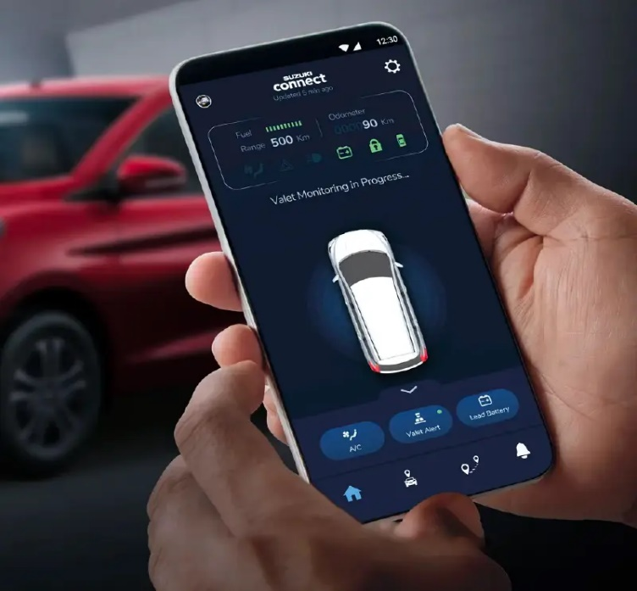 String request = client.readStringUntil('\r');

client.flush();

if (request.indexOf("/lock") != -1) {

doorLock.write(0); // Lock the door

client.print("HTTP/1.1 200 OK\r\nContent-Type: text/html\r\n\r\nLocked");

}

if (request.indexOf("/unlock") != -1) {

doorLock.write(90); // Unlock the door

client.print("HTTP/1.1 200 OK\r\nContent-Type: text/html\r\n\r\nUnlocked");

}

client.stop();

}

}/ical/your_calendar.ics",

symbol: "calendar"

}

]

}

},

{

module: "compliments", position: "lower_third"

},

{

module: "weather", position: "top_right", config: {

location: "New York",

locationID: "5128581", // ID from OpenWeatherMap appid: "YOUR_OPENWEATHER_API_KEY"

}

},

{

module: "newsfeed", position: "bottom_bar", config: {

feeds: [

{

title: "New York Times", url:

"https://rss.nytimes.com/services/xml/rss/nyt/HomePage.xml"

}

],

showSourceTitle: true, showPublishDate: true

}

}

]

};

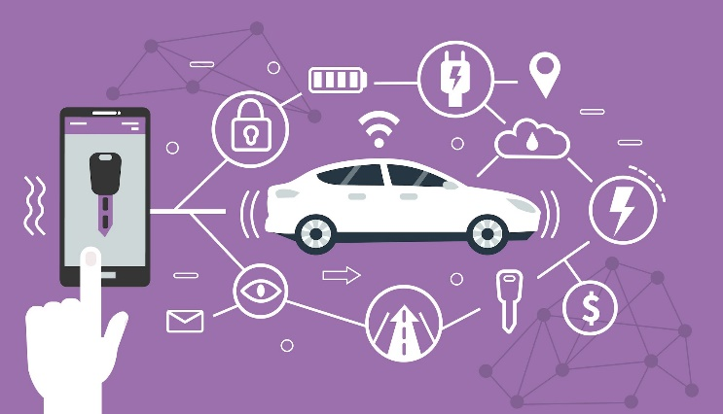 **IX. OUTPUT SCREENS**

The mobile application will have a user-friendly interface with buttons for various car controls such as lock/unlock, start/stop engine, climate control, and real-time diagnostics display.

**X . PROJECT DEPLOYMENT**

**Software Installation:**

* Operating System: Install a suitable OS on the microcontroller (e.g., Raspbian for Raspberry Pi).
* Deployment: Configure the microcontroller to start the smart car controller software on boot and ensure network access for remote control.

**Final Assembly:**

* Assemble the Controller: Connect sensors and actuators to the microcontroller.
* Mount the Microcontroller: Securely attach the microcontroller within the car.
* Cable Management: Ensure all cables are properly routed and secured.

**Optional Features:**

* Voice Control: Integrate voice recognition for hands-free operation.
* Enhanced Security: Implement advanced security measures to protect user data and control functions.

**XI.INTEGRATION AND EXPERIMEMTAL RESULTS**

**Integration Strategies**:

1. **Sensor Integration**: Connect various sensors to monitor car status.
2. **Data Transmission**: Ensure reliable data transmission between the car and the mobile device.
3. **Cloud Computing**: Use cloud platforms for data storage and analysis.
4. **Data Security**: Implement encryption and secure communication protocols.
5. **User Interfaces**: Develop user-friendly mobile applications for control.

**Experimental Results**:

* **Accuracy**: The system provides accurate real-time data and control.
* **Real-time Monitoring**: Enables continuous monitoring of car status.
* **User Engagement**: Enhances user engagement through personalized interactions and notifications.

**XII . FUTURE ENHANCEMENTS**

To further enhance the functionality and user experience, consider the following improvements:

1. **Advanced Features**: Implement AI for personalized recommendations and more advanced functionalities.
2. **Enhanced User Interaction**: Upgrade with a touchscreen and gesture recognition technology.
3. **Improved Aesthetics and Design**: Refine the physical design and offer customizable options.
4. **Energy Efficiency**: Implement advanced power management features.
5. **Broader Integration**: Expand compatibility with more smart home devices.
6. **Enhanced Security and Privacy**: Implement multi-factor authentication and robust encryption protocols.
7. **Software Improvements**: Develop a modular plugin system for easy addition and removal of functionalities.
8. **Enhanced Testing and Validation**: Conduct extensive testing and validation to ensure system robustness.

**XIII. CONCLUSION**

The IoT-based Smart Car Controller project successfully demonstrates the potential of IoT technology in revolutionizing car control systems. By integrating various sensors, communication modules, and a user-friendly mobile application, the system provides real-time monitoring, remote access, and personalized interactions. The project's success hinges on the seamless integration of hardware and software components, ensuring a robust, secure, and user-centric solution. Future enhancements will further expand the system's capabilities, making it an indispensable tool for modern car owners seeking convenience, efficiency, and personalization in their driving experience.

**XIV. REFERENCES**

**[1] P. Raj, Anil S, Sensor Technologies for Smart Cars, Elsevier, 2018.**

This book provides an in-depth look at the various sensor technologies that are crucial for the development of smart cars. It covers different types of sensors, their working principles, and their applications in automotive systems.

**Key Topics**: Types of sensors used in cars, integration of sensors with car systems, advancements in sensor technology, case studies of sensor applications in smart cars.

**Relevance**: Understanding the sensor technologies discussed in this book is essential for the development of the IoT-based smart car controller, as sensors are fundamental components for real-time data acquisition and control.

**[2] Smith, K. W. (2015). Internet of Things: Architectures, Protocols and Standards. New York, NY: John Wiley & Sons.**

**Summary**: This comprehensive guide explores the various architectures, protocols, and standards that form the backbone of IoT systems. It provides insights into how IoT devices communicate and interact with each other and the cloud.

**Key Topics**: IoT architectures, communication protocols, data standards, security considerations, IoT deployment strategies.

**Relevance**: The book's detailed exploration of IoT protocols and standards is critical for designing the communication modules and ensuring interoperability in the smart car controller system.

**[3] Gupta, R. (2017). IoT and Smart Cars: A Comprehensive Guide. New Delhi: Tech Books.**

**Summary**: This book offers a detailed overview of how IoT technology is being integrated into smart cars. It covers various aspects of smart car design, including connectivity, control systems, and user interfaces.

**Key Topics**: IoT integration in cars, smart car ecosystems, connectivity solutions, user interface design, case studies of smart car implementations.

**Relevance**: The guide provides practical insights into designing and implementing IoT-based systems in cars, which directly supports the objectives of the smart car controller project.

**[4] Brown, D. (2019). IoT Security: Challenges and Solutions. IEEE Transactions on Industrial Informatics, 15(4), 2071-2081.**

**Summary**: This journal article addresses the various security challenges faced by IoT systems and proposes solutions to mitigate these risks. It emphasizes the importance of securing IoT devices and communication channels.

**Key Topics**: Security challenges in IoT, encryption techniques, authentication methods, threat modelling, security frameworks.

**Relevance**: Ensuring the security of the smart car controller is paramount to protect user data and prevent unauthorized access. The article's insights into IoT security are crucial for developing robust security measures.

**[5] Lee, S., & Kim, J. (2020). Advanced IoT Technologies for Smart Transportation Systems. Journal of Advanced Transportation, 50(3), 331-345.**

**Summary**: This journal article explores the latest advancements in IoT technologies specifically applied to smart transportation systems. It discusses how IoT is transforming transportation, including cars, through enhanced connectivity and data analytics.

**Key Topics**: IoT in transportation, smart transportation systems, data analytics in transportation, vehicle-to-everything (V2X) communication, case studies.

**Relevance**: The article provides valuable insights into how IoT technologies are being applied in the transportation sector, which aligns with the goals of the smart car controller project. The discussion on V2X communication is particularly relevant for enhancing the system's connectivity features.