**Corporate Social Responsibility in India: A Path to Achieve Sustainable Development Goals**

**¹Ms. Manmeet Kapoor , ²Mr. Gourav Kamboj**

**¹Assistant Professor at Guru Nanak Girls College, Yamuna Nagar**

**¹Guru Nanak Khalsa College, Yamuna Nagar**

**Kurukshetra University, Kurukshetra**

**¹E-mail-** [**kambojgourav690@gmail.com**](mailto:kambojgourav690@gmail.com)

**²E-mail-** [**manmeetkapoor16@gmail.com**](mailto:manmeetkapoor16@gmail.com)

**Abstract**: *Profit is the main objective of every business corporation as no business can survive without earning Profits. But business corporations bear a more significant responsibility to the society than only making Profits. Business corporations use resources of society so they owe a responsibility towards society. Any Corporation focused just on maximizing profits for shareholders, with little regard for societal and Environmental problems, is doomed to failure in the long term is what led to the birth of CSR and Sustainable development as significant concerns of business activity. Businesses can contribute to a Better society by allocating a percentage of their profits to Corporate Social Responsibility (CSR) Initiatives. Due to the fact that CSR initiatives address 15 of the 17 Sustainable Development Goals, they Are helpful in reaching the Sustainable Development Goals. The aim of this paper is to study the concept Of Corporate Social Responsibility, Sustainable Development and the contribution of Corporate Social Responsibility towards achieving the goal of Sustainable Development in India. This study is based on The secondary data.*

**Keywords:** Corporate Social Responsibility, Sustainable Development, Sustainability,

**Introduction**: CSR and Corporate Philanthropy can be instrumental in the achievement of SDG, as it complements the government’s efforts and contributes to the Country’s social and economic progress. Sustainable Development Goals (SDGs) are a set of 17 objectives that the United Nations has set with the aim Of achieving sustainable development worldwide by 2030. Brundtland Commission defined sustainable development as: “development that satisfies the Requirements of the present without undermining the capacity of future generations to satisfy their own requirements. CSR is a business process that takes Into account the social and environmental impact of a company on society, its employees, and its stakeholders. An organization’s CSR strategy aims to Reduce harm, conduct fair business practices, be accountable throughout a worldwide supply chain, engage in philanthropic activities, and develop a self-Organizing HR management system. A sustainable business model must take into account three dimensions: environmental, social, and economic Sustainability. Environmental sustainability is the effect of a business’s operations on the environment, such as deforestation and fossil fuel burning. Social sustainability is the impact of a business on social systems, such as society, local populations, employees, customers, and other relevant Stakeholders. If a business’s operations are detrimental to these social systems, it is not considered socially sustainable. Economic sustainability is the Financial stability of the business, the financing of its operations, and the promotion of socially responsible and environmental initiatives.

**Review of Literature:**

**Dr. Sunita Paschar (2020)** the study found that the Corporate Social Responsibility practices should be linked to Sustainable Development Goals in order To better address sustainability issues in India. The results of the study demonstrate that the corporate sector is making a significant contribution to Education, Health Care, and Rural Development. **Bharti (2023)** the study found that the Sustainable Development Goals and corporate social Responsibility are related. Corporate sectors are now well integrated into society. They help to improve and elevate society. Eradicating poverty, hunger, Healthcare and Education sectors are the most attractive sectors in the form of CSR activities. **Rahul** **Singh Gautama (2022)** the study found that the CSR funding in India has a positive impact on the country’s sustainable development. Furthermore, it has been found that CSR funding for education and The environment has a positive effect on India’s sustainable development. It has also been observed that, within the context of a poverty score interaction Effect, both total CSR funding and education funding have a positive impact on sustainable growth. **Sanjai Bhatt (2022)** the study found that the CSR Play a significant role to achieve sustainable development goals. This approach has been observed to have a direct effect on the movement of monetary Resources, corporate initiatives, and government programs towards various development initiatives. **Dr. Vikrant Yadav (2022)** the study found that the CSR and sustainable development related to each other. CSR has become a key component of a company’s overall strategy. CSR teams are responsible For creating and implementing policies, strategies and objectives for corporate CSR programs, as well as budgeting resources to support them. **Karoly** **Behringer (2016)** the study found that the CSR is a business model that encourages businesses to contribute to sustainable development through the Incorporation of the Sustainable Development into their business strategy, thereby achieving a balance between economic considerations, environmental Requirements and social expectations.

**Objectives of the Study**:

1. To develop an understanding of concept of CSR.
2. To study the potential benefits of CSR to organizations.
3. To analyze the contribution of CSR in achieving sustainable development goal.
4. To study the challenges faced by CSR in India.

**Research Methodology:** The research paper is an attempt of exploratory research. The data of this study is secondary data which Have been collected from different sources such as official websites of department of Corporate Affair Ministry, Newspaper Articles, journals, Research Papers, media reports and Magazine Articles. The Researcher has not used any statistical tools and techniques because it is not tried to establish any relationship Between different variables rather through discussions and tried to see how our country has changed its Policy for CSR over the period of time and what are the result of these policy to achieve sustainable growth.

**Relationship between CSR and Sustainable Development:**

CSR and Sustainable Development are complementary to each other as both emphasize on how Important it is for companies and organizations to accept accountability for their effects on the Environment and society. They are related in the following ways:

• **Common Goals:** A more equitable, environmentally responsible, and socially just World is a shared objective of both corporate social responsibility and sustainable development. To Maintain long-term well-being, they both aim to strike a balance between social, economic, and Environmental issues.

• **Triple Bottom Line:** Both Concepts include the idea of “Triple Bottom line” which takes into Account social and environmental performance in addition to financial profit.

• **Stakeholder Engagement:** Sustainable development and CSR both involve interaction with a range Of stakeholders, such as Govt. agencies, customers, employees and communities so that businesses Can better understand their concerns and priorities, which can inform CSR strategies and contribute To sustainable development efforts.

• **Environmental Responsibility:** Sustainable development emphasizes the need for businesses to Lessen their adverse effects on environmental and support conservation initiatives. CSR often encourages environmental initiatives such as reducing carbon emissions, conserving resources, and Supporting renewable energy sources, all of which align with sustainable development goals.

• **Social Responsibility:** CSR includes all of those things that do more good for society than just make A profit, like fair labor standards, community development initiatives, and philanthropy. By Addressing problems like social well-being, inequality, and poverty, these initiatives support the Social aspect of sustainable development.

• **Long-Term Perspective:** Both CSR and sustainable development promote a long-term perspective. They encourage corporations to think about how their choices and activities will affect coming Generations and the state of the earth as a whole.

• **Legal and Regulatory Framework:** In certain areas, CSR and sustainable development are subject To laws and regulations. To ensure that corporations positively contribute to these aims, governments May enforce specific practices or reporting criteria.

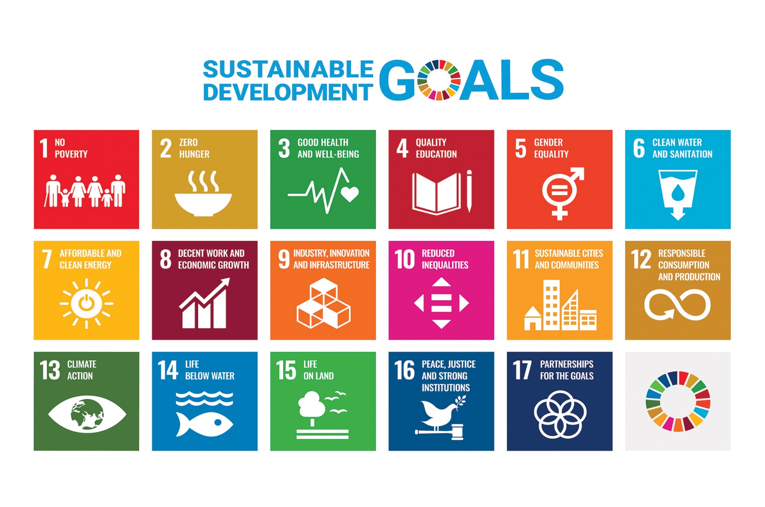**Sustainable Development Goals For Development**

**CSR Practices of Indian Companies:**

Infosys Limited, an digital services and consulting conglomerate has spent Rs. 342 crore as against its Prescribed CSR expenditure of Rs. 340 crore (2% of the net profit of Rs. 17, 018 crore) towards various Schemes of Corporate Social Responsibility during the year 2018-19. The major works of the Foundation’s Works included the introduction of Aarohan Social Innovation Awards, restoration of water bodies in Karnataka, supporting the construction of a metro station in partnership with Bangalore Metro Rail Corporation Limited, enabling the pursuit of access and excellence in sports through the Go Sports Foundation and relief efforts in Tamil Nadu, Karnataka and Kerala.

Ultratech Cement, India’s biggest cement company is involved in social work across 407 villages in the Country aiming to create sustainability and self-reliance. Its CSR activities focus on healthcare and family Welfare programs, education, infrastructure, environment, social welfare and sustainable livelihood. The Company has organized medical camps, immunization programs, sanitization programs, school enrollment, Plantation drives, water conservation programs, industrial training and organic farming programs.

Indian automobile manufacturer Mahindra & Mahindra primarily focuses on education programs to assist Economically and socially disadvantaged communities. Its CSR programs invest in scholarships and grants, Livelihood training, healthcare for remote areas., water conservation and disaster relief programs. M&M Runs programs such as Nanhi Kali focusing on education for girls, Mahindra Pride Schools for industrial Training and Lifeline Express for healthcare services in remote areas.

Maruti Suzuki India Limited has achieved yet another important milestone under its CSR program. The Company has successfully trained 15000 tribal youth in driving training, making them employable. These Students were trained at its All Gujarat Institute of Driving, Technical Training and Research situated in Waghodia, Gujarat. Of the candidates trained, 70% have secured employment or have taken up the role of An entrepreneur. The achievement coincides with the institution completing 10 years of its inauguration.

Alignment to the UNSDG offers a global context to the company’s sustainability initiatives and impact Tata Power, India’s largest integrated utility, through the century has endeavored to achieve societal and Economic development. Tata Power has a long tradition of working closely with and for the benefit of the Local communities. Broadly, this is done by ensuring that the pursuit of economic objectives is also linked to Larger social and sustainability concerns like climate impact, poverty, education, gender equality and others.

**Some of the key UNSDGs that Tata Power support include:**

1. Adhikaar, a social-economic and governance based initiative by Tata Power has tapped in to 14 National and state initiatives which has benefitted over 3.5 lakh community members in 15 states Across the country;
2. Built 13,402 household toilets under its Mamta and Sammaan initiatives benefitting 4.7 lakh people Across 4 states;
3. Over 16 lakh school children benefitted from Vidyasagar, a remedial and technology-based coaching For school children from 16 location in the country;
4. Dhaaga initiative that has created an ecosystem of garment and handicraft-based micro enterprises That supports 1050 women artisans in 13 states.
5. Act of Mahseer, a 4-decade long initiative to conserve fresh water fish while also creating livelihood For local communities.

Dholpur/Jhabua- Coca Cola’s corporate social responsibility arm- Anandana- has collaborated with Lupin Human Welfare & Research Foundation and Rajputana Society of Natural History to set-up an integrated Watershed were facing severe water crisis since a long time and were struggling to perform their daily Chores like cooking, irrigation, feeding animals.

**Challenges and Opportunities:**

**Challenges :**

**Complexity and Scope:** The complexity and scope of the goals present One of the main obstacles that businesses must overcome in order to Integrate CSR with the SDGs. Every social, environmental, and Economic issue is covered by the SDGs, and each has its own set of Objectives and metrics. It takes careful planning and coordination Across multiple departments and stakeholders, as well as a thorough Understanding of the issues, to align CSR initiatives with the many Interconnected goals.

**Constraints on Resources:** It frequently takes significant human, Financial, and technological resources to implement CSR initiatives That are in line with the SDGs. Numerous companies, particularly small And medium-sized businesses (SMEs), might not have the resources And knowledge needed to take on ambitious sustainability projects. Additionally, companies that prioritize corporate social responsibility May face difficulties if they choose to invest in CSR initiatives, as they May incur short-term costs with hazy long-term returns.

Measuring the effect of CSR initiatives on SDG integration can be Difficult because there aren’t many established metrics and reporting Frameworks. Accurately estimating the social, environmental, and Financial benefits of corporate social responsibility initiatives is Frequently difficult for businesses. Comparing and evaluating the Success of CSR initiatives across industries and companies is made More difficult by inconsistent reporting standards and a lack of data Transparency.

**Stakeholder Involvement:** Successful integration of CSR and SDGs Requires active participation from stakeholders such as staff members, Clients, investors, and local communities. But it can be difficult to Establish genuine connections and encourage communication with a Range of stakeholders, especially in intricate and changing corporate Settings. Stakeholder management techniques and efficient communication are necessary to reconcile competing interests and Priorities while maintaining inclusivity and transparency.

**Environment of Regulation and Policy:** Businesses that operate in Multiple jurisdictions face challenges due to the disparities in the Regulatory and policy framework governing CSR and sustainability Across different nations and regions. Attempts to establish standardized Corporate social responsibility practices and adhere to global standards May be impeded by inconsistent regulations, enforcement protocols, And reporting obligations. Furthermore, businesses may face Uncertainty and compliance risks due to changing regulatory Frameworks and policy changes.

**Opportunities:**

**Innovation and Competitiveness in Business:** Businesses that Embrace CSR and SDGs have the chance to stimulate innovation, Improve competitiveness, and break into new markets. Eco-friendly Product design, the use of renewable energy sources, and waste Reduction programs are examples of sustainable business practices that Can result in financial savings, improved operational effectiveness, and Competitive advantage. Businesses can add value to society by Matching their CSR initiatives with consumer preferences and market Trends. Businesses can create value for both society and shareholders.

**Brand Reputation and Trust:** A company’s brand reputation and Stakeholder trust can be improved by showcasing a commitment to CSR and SDGs. Businesses are under growing pressure from investors, Employees, and customers to behave ethically and promote favorable Social and environmental results. Businesses can establish their unique Brand identity as moral and socially responsible organizations and draw In talent and investment by being open and honest about their CSR Programs and how they affect the SDGs.

**Resilience and Risk Management:** By incorporating CSR and SDGs Into corporate plans and practices, companies can reduce risks and Strengthen their ability to withstand environmental, social, and governance (ESG) issues. Businesses can predict and adapt to new Risks, such as regulatory changes, the effects of climate change, and Supply chain diversification, by implementing proactive risk Management strategies like scenario planning, stakeholder Engagement, and supply chain diversification.

**Access to Capital and Markets:** By drawing in socially conscious Investors and clients, embracing CSR and SDGs can enhance access to Capital and markets. Investment decisions are becoming more and more Influenced by ESG factors as investors look for opportunities that fit With their sustainability goals and values. Companies that show a Strong commitment to the SDGs and CSR may find it easier to obtain Financing, have access to a larger pool of capital, and get special Treatment during the procurement process. Furthermore, there may be Chances for business growth and expansion when entering value chains And markets that are motivated by sustainability.

**Cooperation and Joint Ventures**: It is possible to increase the impact Of CSR initiatives and hasten the SDGs’ advancement by working Together with stakeholders, such as governments, NGOs, academic Institutions, and civil society organizations. Businesses can handle Complex issues by utilizing networks, resources, and collective Expertise.

In summary, companies that integrate CSR and SDGs face a number Of challenges, but they also have a great chance to create value, Innovate, and have a positive social impact. Businesses can secure Long-term success and resilience in an increasingly interconnected and Uncertain world while simultaneously contributing to sustainable Development by proactively addressing these challenges and Strategically seizing opportunities.

**Conclusion**: In conclusion, CSR is a practical way for businesses to contribute to sustainable development by integrating social and environmental responsibility into Their operations and decision-making processes. When done effectively, CSR can help address many of the global challenges outlined in the United Nations’ Sustainable Development Goals (SDGs) and contribute to a more sustainable and equitable world. Corporate Social Responsibility (CSR) and Sustainable Development are closely related concepts that both emphasize the importance of businesses and organizations taking responsibility for their Impact on society and the environment. While they are related, they are not the same thing, but rather, CSR is one of the ways in which businesses can Contribute to sustainable development. CSR is a business approach that involves voluntary actions and initiatives to address social and environmental Issues. These initiatives can be an essential part of a company’s contribution to sustainable development. However, it’s important to note that while CSR Is a step in the right direction, achieving true sustainable development requires a broader and more comprehensive approach that encompasses not only Corporate actions but also government policies, societal efforts, and global cooperation to address complex challenges like climate change, poverty, and Inequality.

**References**: • Bharati. (2023). Role Of Csr In Sustainable Development: A Study Of Selected Indian Companies. Jetir.

• Dr.Vikrant. (2020). Sustainable Development And Corporate Social Responsibility In India: A Critique. IJAR.

• Gautam, R. s. (2022). Corporate Social Responsibility Funding and Its Impact on India’s Sustainable Development: Using the Poverty Score As a Moderator. Journal of risk and management.

• Karoly Behringer. (2016). The Role Of CSR In Achieving Sustainable. European scientific Journal.

• paschar, D. (2022). Role Of Csr To Achieve Sustainable Development Goals (Sdgs) In India: Opportunities And Challenges. Palrich egyptian Journal.

• Sanjaybhatt. (2022). Corporate Social Responsibility and Social Development in India: An Interface. Research gate.

• www .csr.gov.in

* <https://www.un.org/en/academic-impact/sustainability>
* Annual report of the companies Minister of corporate Affaire, Government of India
* Arora, B., & Puranik, R. (2004). A review of corporate social responsibility in india . Ecomomics Times: 13-10-2015
* Mishra,S & Diamodar,S.(2011). Does corporate social Responsibility Influences Firm Performance of Indian Companies. Journal of Business Ethics,95(4) ,571-601.
* Bharti (2023). Role of CSR in Sustainable Development: A Study Of Selected Indian Companies. Journal of Emerging Technologies and Innovative Research (JETIR).
* Gautam, R. s. (2022). Corporate Social Responsibility Funding and Its Impact on India’s Sustainable Development: Using the Poverty Score as a Moderator. Journal of risk and management.
* Karoly Behringer. (2016). The Role Of CSR In Achieving Sustainable. European scientific Journal.