**Vishwagnani - The Personal Data Powered Voice Assistant Using Python**

**Nischay Urs S, Dr. Soumyasri SM**

Student, Dept. of MCA, Vishvershwara Technical University, The National Institute of Engineering,

Mysuru India

Associate Professor, Dept. of MCA, Vishvershwara Technical University, The National Institute of Engineering,

Mysuru India

**ABSTRACT**: The project aims to develop an advanced and interactive voice assistant that leverages machine learning, speech recognition, and natural language processing. This assistant will perform various daily tasks, including automating WhatsApp, launching Microsoft Office tools through voice commands, sending and reading emails, and controlling PC applications (open/close). Additionally, it will manage navigation, pictures, videos, music, and photos. Home automation features will include fan, light, and switch control. Other capabilities will encompass OCR data recognition, translations, calculations, conversions, measurements, voice searches on Google, song searches, setting alarms, checking and reading WhatsApp messages, playing music, creating a favorite song list, providing local and international news, face recognition-based greetings, converting voice notes to text in Notepad, understanding multiple languages, and capturing photos. By integrating these functionalities, the voice assistant will offer a seamless and enhanced user experience in both personal and professional digital environments.

**INTRODUCTION**

In today's fast-paced digital world, the demand for intelligent personal assistants has grown significantly, streamlining tasks and boosting productivity through automation of routine activities. "Vishwagnani" leverages Python and machine learning to create a voice assistant that integrates seamlessly with various applications and services, from home device control and email management to Google searches. As smart devices and IoT proliferate, users expect a unified interface for centralized control. Vishwagnani meets these expectations by offering functionalities that cater to both personal and professional needs, including WhatsApp automation, Microsoft Office control, navigation, multimedia management, home automation, OCR, translations, and more. Advanced technologies such as natural language processing and face recognition ensure a personalized and secure user experience, while support for multiple languages enhances accessibility. Vishwagnani represents a significant advancement in personal voice assistants, combining cutting-edge technology with practical applications to improve everyday life.

In the era of digital transformation, the role of intelligent personal assistants has become indispensable, driving efficiency and enhancing user experience through sophisticated automation. This project epitomizes this evolution by integrating advanced machine learning, speech recognition, and natural language processing to create a versatile assistant. Designed to interact seamlessly with various digital environments, Vishwagnani handles tasks ranging from WhatsApp automation and Microsoft Office integration to navigation, media management, and home automation. It leverages IoT technology to control household appliances and uses OCR for data recognition, thereby bridging the gap between physical and digital realms. Furthermore, its capabilities extend to real-time face recognition, providing personalized interactions and security. The assistant's ability to understand and operate in multiple languages broadens its accessibility, making it a valuable tool for diverse user demographics. By combining these functionalities, Vishwagnani not only simplifies daily routines but also offers a cohesive and intuitive user interface, marking a significant leap in the development of interactive voice assistants.

**OBJECTIVE**

The primary objectives of the Vishwagnani project include developing a voice-controlled assistant capable of understanding and executing user commands. It integrates functionalities such as WhatsApp automation, email management, and PC control while implementing home automation features for lights and fans. The assistant also provides OCR data recognition, translation services, and multimedia management, including music playback and video navigation. Personalization through face recognition and support for multiple languages ensures broad accessibility. Additional objectives include facilitating voice searches on Google, setting alarms and reminders, checking and reading WhatsApp messages, providing news updates, converting voice notes to text, and capturing photos with face recognition.

**LITERATURE SURVEY**

**The Report Examine the body of the Knowledge regarding Vishwagnani - The Personal Data Powered Voice Assistant Using Python, Relevant Studies on the Following and Analysed.**

**[1] “Artificial Intelligence - Based Voice Assistant”**

**[2] “Hey, Siri”, “Ok, Google”, “Alexa”. Acceptance Relevant Factors of Virtual Voice**

**Assistants”**

**[3] “Automation and Presentation of Word Document Using Speech Recognition”**

**[4] “Voice Activated Smart Home Design and Implementation”**

**[5] “Smart Home With Virtual Assistant Using Raspberry Pi”**

**[6] “JARVIS: An Interpretation of AIML with Integration of gTTS and Python”**

**[7] “Alexa, Can I Trust You?”**

**METHODOLOGY**

The methodology for developing the Vishwagnani voice assistant involves several key components and technologies to ensure comprehensive functionality and user interaction. The first crucial aspect is voice command processing. Implementing the speech recognition library captures and interprets user voice commands accurately, ensuring the assistant understands and processes spoken input effectively. Complementing this is the use of the pyttsx3 library for text-to-speech conversion, which provides verbal responses to user commands, creating a seamless conversational experience. Application integration is another critical component. For WhatsApp automation, the project utilizes WhatsApp Web APIs to automate sending and reading messages, allowing the assistant to manage communication efficiently. Integration with Microsoft Office tools is achieved using the pywin32 library, enabling the assistant to open and control Office applications via voice commands, thus enhancing productivity.Email management is facilitated through the incorporation of smtplib libraries, which enable the assistant to send and read emails, handling email communication effectively. For PC control, libraries like subprocess and os are employed to manage PC applications, allowing users to open and close software through voice commands easily. Additionally, functions are developed to browse and open files, providing efficient access to documents and media.

Home automation in Vishwagnani is seamlessly integrated using IoT devices such as the ESP8266, which allows for the control of home appliances like lights and fans. This integration enhances user convenience by enabling voice commands to manage these devices effortlessly. With the capability to control multiple appliances, users experience a streamlined and efficient home automation system.OCR and translation services are also pivotal features of Vishwagnani. By implementing Tesseract OCR, the assistant can recognize text from images, allowing it to extract and process information from physical documents accurately. This capability is particularly useful for digitizing printed text, making it accessible for further processing. Real-time language translation is facilitated using the Google Translate API, which enhances communication by translating text into various languages instantaneously, improving accessibility for users who speak different languages. Personalized user interaction is another significant aspect of Vishwagnani. Through the use of the YOLO algorithm, real-time face recognition is implemented, enabling the assistant to identify users and interact with them in a personalized manner. This not only enhances the user experience but also adds a layer of security, as the assistant can tailor responses and actions based on the recognized user.Multimedia management is a crucial functionality within Vishwagnani. The assistant can play and manage music playlists, providing an engaging and interactive entertainment experience. Users can use voice commands to navigate through their multimedia files, ensuring easy access to their photos, videos, and music. This feature simplifies the process of managing and enjoying multimedia content.Integration with Google search APIs enables voice-based searches, allowing users to retrieve information quickly and efficiently. This feature is particularly beneficial for users who need instant answers to their queries without manually typing them into a search engine. By fetching local and international news using various news APIs, Vishwagnani keeps users informed about current events and updates, both locally and globally.

**SYSTEM ARCHITECTURE**

Start

Listening (voice command)

If voice

command

matches any

command

If voice

command is

to turn off

EXIT

Invalid output

Execute

command

True

True

False

False

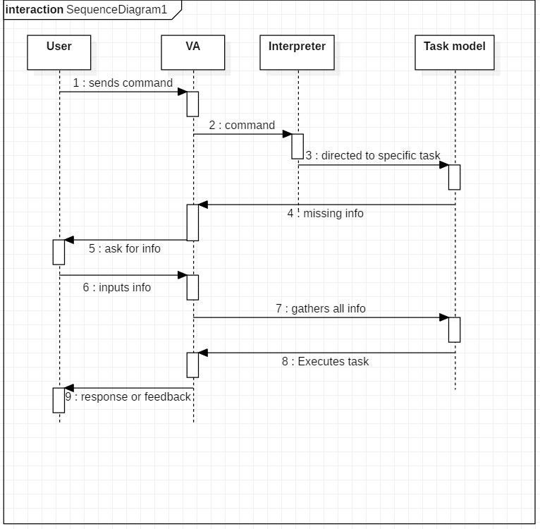**FIG. 1 FLOW CONTROL DIAGRAM**

**FIG. 2 SEQUENCE DIAGRAM**

**CONCLUSION**

The development of "Vishwagnani - The Personal Data Powered Voice Assistant Using Python" represents a significant advancement in the realm of intelligent personal assistants. By integrating machine learning, speech recognition, and natural language processing, Vishwagnani is equipped to perform a wide array of tasks, from managing communication through WhatsApp and emails to controlling home appliances and multimedia. The project's emphasis on personalization through face recognition and support for multiple languages ensures broad accessibility and a tailored user experience. The incorporation of OCR and translation services bridges the gap between physical documents and digital data, enhancing the assistant's utility in various contexts. Vishwagnani's ability to set alarms, provide news updates, and manage files and applications through voice commands streamlines daily routines, offering users enhanced productivity and convenience. Its integration with IoT devices for home automation further augments its functionality, making it a versatile tool for modern smart homes. The assistant's robust multimedia management capabilities, including music playback and video navigation, cater to entertainment needs, while real-time Google and song search functionalities provide quick access to information and media. Overall, Vishwagnani embodies the potential of advanced technologies to create a cohesive and intuitive user experience. It demonstrates how intelligent personal assistants can seamlessly integrate with various aspects of daily life, transforming the way users interact with their digital and physical environments. The project's comprehensive approach and innovative features position Vishwagnani as a pioneering solution in the field of voice-controlled assistants, paving the way for future developments and applications.

**REFERENCES**

1. Saadman Shahid Chowdury, Atiar Talukdar, Ashik Mahmud, Tanzilur Rahman, “Domain specific Intelligent personal assistant with bilingual voice command processing,” IEEE 2018.
2. Polyakov EV, Mazhanov MS, AY Voskov, LS Kachalova MV, Polyakov SV “Investigation and development of the intelligent voice assistant for the IOT using machine learning,” Moscow workshop on electronic technologies, 2018.
3. Khawir Mahmood, Tausfer Rana, Abdur Rehman Raza, “Singular adaptive multi role intelligent personal assistant (SAM-IPA) for human computer interaction,” International conference on open source system and technologies, 2018.Advanced Computer Science and information Systems (ICACSIS), 2019, pp. 205-210
4. Veton Kepuska and Gamal Bohota, “Next generation of virtual assistant (Microsoft Cortana, Apple Siri, Amazon Alexa and Google Home),” IEEE conference, 2018.
5. Piyush Vashishta, Juginder Pal Singh, Pranav Jain, Jitendra Kumar, “Raspberry PI based voice-operated personal assistant,” International Conference on Electronics And Communication and Aerospace Technology, ICECA, 2019.
6. Laura BURbach, Patrick Halbach, Nils Plettenberg, Johannes Nakyama, Matrina Ziefle, Andre Calero Valdez, “Ok google, Hey Siri, Alexa. Acceptance relevant of virtual voice assistants,” International communication conference, IEEE 2019.
7. Karthikeyan, V., & Vijayalakshmi, V. J. (2016), “Performance Comparison Of Speech Recognition For Voice Enabling Applications-A Study”, American Journal of Engineering and Technology Research.
8. A. A. Karpov & A. L. Ronzhin, “Information enquiry kiosk with multimodal user interface”.
9. Alexander Dreyer Johnsen, Tor-Morten Gronli & Bendik Bygstad, “Making Touch-Based Mobile Phones Accessible For The Visually Impaired”.
10. G Thimmaraja Yadava, P S Praveen Kumar, Haradagere Siddaramaiah Jayanna, “An End to End Spoken Dialogue System to Access the Agricultural Commodity Price Information in Kannada Language/Dialects”