**FAKE PRODUCT REVIEW DETECTION AND ELIMINATION USING MACHINE LEARNING ALOGORITHMS**

**Mrs. Jayashri Kunde1, Mrs. Kalyani Deore2, Mrs. Monali Jadhav3**

1 PhD, Sandip University Nashik, Maharashtra, India

2Professor, Sandip University Nashik, Maharashtra, India

3Professor, Sandip University Nashik, Maharashtra, India

**ABSTRACT**

Online customer reviews have become an increasingly influential tool in shaping purchasing decisions. However, the growing impact of these reviews has led to a surge in the publication and promotion of fake reviews by some businesses, either to enhance their own product's reputation or to undermine their competitors. These counterfeit reviews can have an especially detrimental impact on small businesses, with even a single negative fake review capable of causing significant damage. In this context, the current study introduces a technique for classifying and identifying fake reviews using machine learning (ML) methodologies. The proposed algorithm was applied to the Yelp dataset for hotel services. The text was initially preprocessed through four stages: tokenization, normalization, stop word removal, and stemming. Subsequently, features were extracted using TFIDF techniques to leverage the benefits of sentiment analysis and to ascertain the presence of spam comments in the feature extraction approach. During the classification phase, the study employed three ML algorithms: Xgboost, a support vector classifier, and stochastic gradient descent. The proposed model was evaluated on both balanced and imbalanced datasets, using oversampling and undersampling techniques to determine its accuracy. The findings of this research hold promise for enhancing the credibility of online reviews and protecting businesses from the adverse effects of fake reviews. By unmasking fraudulent reviews, this study contributes to ensuring the integrity of online review platforms and safeguarding the interests of both businesses and consumers.

**Keywords:** opinion mining, machine learning, fake review, XGboost, e-commerce.

1. **INTRODUCTION**

Using computational approaches, opinion mining examines and finds views, feelings, and subjective data in enormous amounts of text. It was utilized for testing goods and services,notably in terms of consumer acceptance and perceptions ofspecific companies and people [1]. Everyone is free to express their views and opinions anonymously and without fear of repercussions. Social media and online posting have made expressing oneself openly and confidently easier. Theseopinions have pros and cons; while they could help get the right feedback to the right individual, who could help fix the problem, they can also be manipulated. These viewpoints are seen as beneficial. This makes it simple for those with badintentions to take advantage of the system, provide the appearance of sincerity, and publish comments to promote their goods or disparage those of rivals without disclosing who they are or where they operate. Such folks can write any bogusreview. This behavior might be referred to as "opinion spamming”. Because it has the potential to distort public discourse and galvanize large groups of people behind causes that run counter to legal or ethical norms, opinion spamming on socialand political problems can be downright terrifying. As social media opinions become more widely used in real life, it's realistic to assume that opinion spamming will grow morepervasive and sophisticated, making it harder to spot. However, they must be identified to guarantee that social media remains a reliable source of public opinion rather than one rife withpropaganda and misinformation. This study uses the Yelp.com dataset to construct a model for classifying the features derived from text and spam using machine learning techniques to detect spam or non-spamreviews. Several classifiers named Extreme Gradient Boosting, Stochastic Gradient Descent Stochastic, and Support vector classifier are proposed to analyze the fake reviewer “spam andnot spam “to suggest a better model for review-centric fake detection. Our model was applied to the balanced and imbalanced datasets as original, with oversamples andundersamples in random techniques. The remaining part of the paper proceeds as follows: Section 2: Literature Review; Section 3: Tying up the various theoretical backgrounds Section 4 proposes a systemframework; and Section 5 discusses the model outline and work. Section Performance Evaluation Section seven illustrates the conclusion and future work.

1. **METHODOLOGY**

This section reviews the theoretical concepts used in implementing the proposed system.

**2.1** Opinion mining

Consider a consumer-authored review that offers feedback on a product that falls under the classification of reviews. The opinion or opinion created is the review the customer makes to communicate his or her thoughts—mostly positive or negative—about the goods. The review classification seeks to discern whether a person has written a positive or negative review depending on an assessment of the text's point of view. Opinion mining aims to find the attributes regarding the object on which opinions were offered in each of the reviews r ϵ R and to determine the orientation of comments, i.e., whether the comments are negative or positive if a set of text reviews (R) with opinions on an object is provided. Assume you are provided with a collection of text reviews (R). When people have ideas about anything, opinion mining aims to locate the aspects discussed in each review (r R) and determine their orientation or whether they are positive or negative. Figure 1 illustrates many interchangeable phrases in opinion mining [9].

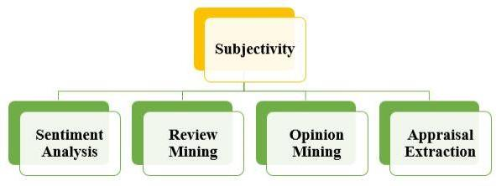

**Image 1. Synonyms of opinion mining [9]**

Review mining has emerged in the past few years, which performs the computational evaluation of the users' opinions, sentiments, subjectivity, appraisals, feedback, emotions, etc., expressed in customer reviews. The term "subjectivity" relates to the person's feelings, perspectives, desires, and emotions. Objectivity typically stands in contrast to it. Speech/writing events expressing private states, private states, and expressive subjective elements. Extracting subjective hints, like phrases, terms or expressions, and applying them to determine whether the related sentence (or document) is objective or subjective are the two fundamental goals of subjectivity analysis. Subjectivity classification. It is required to extract any reviews or comments the author has made in order to obtain valuable data [9]. Modified Black Widow Optimization algorithm, which outperforms other bio-inspired approaches in global optimization and convergence speed, but is not as advanced as the best developed ones [10]. Research on the Holy Quran improves speaker identification systems, recognizing Arabic and English speakers using 14 professional reciters' speech signals, with improved LBG-VQ algorithm matching codebook centroids with 96.43% accuracy [11]. The review highlights the effectiveness of deep learning in energy forecasting, highlighting the use of various neural networks, including simple RNN, LSTM, GRU, and bidirectional RNN [12]. The research introduces an efficient odometry method for autonomous path planning, enabling global optimal planning, mapping, and localization in static obstacles, improving computing speed and position accuracy [13].

**2.2** Fake review detection

Fake review detection can be defined as a field of NLP. It aims to evaluate, identify, and classify product reviews on online e-commerce sites as either fake or authentic. Deceptive product reviews frequently employ false opinions [16]. It is currently a popular academic subject. Fake reviews are often described as spam reviews, deceptive opinions, and spam opinions, and the people who write them could also be called spammers [17]. Review readers are duped by the practice of mind spamming. Users who engage in spamming activities are referred to as "spammers." Spammers' fake reviews aim to give a company a false reputation, either negative or positive. Certain companies hire spammers to download the material in an effort to get new customers or to demote a competent company inside the same company [18]. People publish erroneously good product reviews to advertise products. Sometimes, maliciously unfavourable reviews of other (competition) products are written to harm their reputation. Some are commercials and promos, neither offering reviews or opinions on the goods. Fake reviews have many drawbacks that can influence people's decisionsto buy commercial goods, including it might be difficult since a term might be positive in one situation but harmful in another. For example, saying "long" while referring to a laptop's battery life is a favourable attitude, yet using the same word when referring to the startup time is unfavourable. The opinion mining system trained on words from many viewpoints cannot comprehend a word's nature, which has multiple interpretations that depend upon context. Different people have different ways of expressing themselves. Almost all traditional text-processing techniques operate under the presumption that minute textual differences have little impact on meaning. The difficulty in determining reviews that were intentionally edited is tricking people by using various DM methods. People frequently make contradictory statements, which makes it difficult to ascertain their opinions. A negative review can actually have a positive meaning. Opinions of the product may periodically be negative or positive. They also examined the benefits and drawbacks of data mining (DM) techniques to anticipate dishonest and honest ratings.

1. **MODELING AND ANALYSIS**

The suggested model identifies fake reviews using machine learning, including SVC, SGD, and (XGboost). The dataset utilized in the implementation is separated into training and testing data based on its actual characteristics, with 80% for training and 20% for testing. It is arguable if the fake review filters increase the user’s confidence in the review system. The price of filters might go much higher. Such behavior fosters mistrust by increasing the knowledge of bogus reviews. The proposed method looks into and analyzes the comments, classifying them as either real or fake. The Yelp.com dataset's real features, such as spam (1) and not spam (0), as well as features (stop words removed), are used in this model's feature extraction and sentiment analysis. Figure 3 demonstrates our ML technique. Most crucially, we process three ML algorithms' approaches concurrently.

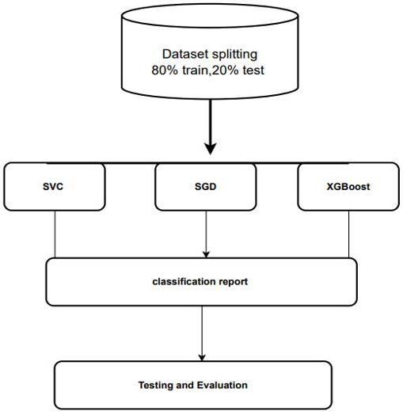

**Image 2:** Machine learning approach

1. **RESULTS AND DISCUSSION**

The experiments used to determine the usefulness of the supervised grade using the typical hotel review dataset are presented in this section. Two grams, spam (1) and not spam(0), were utilized as features for training and testing the suggested classifier. The suggested classifier's primary objective was to detect and classify the review text as a real or fake review.

**4.1** Word clouds

Word clouds are a method for visualizing a review's most significant and frequently occurring words Each word's size and prominence in the text is proportional to how often it appears. Word clouds are regularly employed in order to highlight the most salient or prevalent terms in a document.

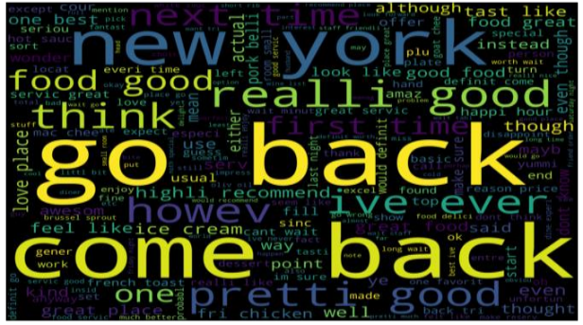

**Image 3:** Real not spam

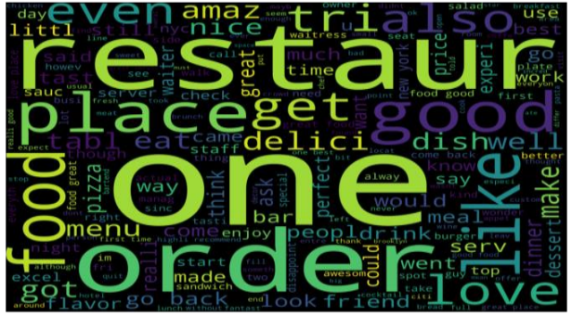

**Image 3:** Fake spam

Figures 3 and 4 show the word clouds of fake reviews and comments about the words "one, one, go back," "real, not spam," and "spam as fake," respectively. To visualize the dataset Figure 6 shows the original dataset. As we mentioned earlier, we balanced the dataset through random sampling methods. Figure 7 shows the balanced dataset.

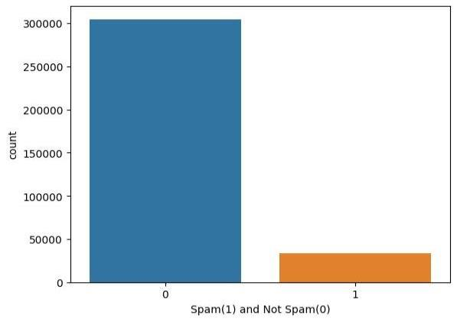

**Image 5**: Original dataset

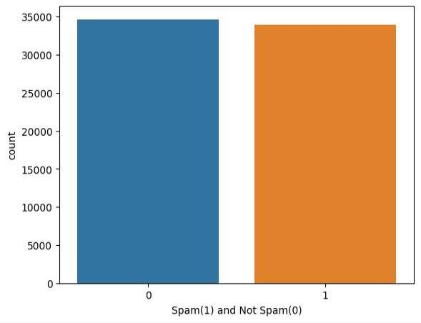

**Image 6:** Balanced dataset

We did three different experiments in training to reach model stability. Table 2 shows the classification report for three machine learning methods with balanced and imbalanced datasets in random sampling. A series of tests were utilized to evaluate the model once it had been trained and tested. Accuracy, precision, recall, and an F1 score are the possible evaluation metrics for the model's performance. When false reviews were discovered, the proposed system was assessed using the dataset and a justification of the findings. Using a collection of data from Yelp.com, the suggested model was trained and put to the test. Also, the test dataset utilized to evaluate the performance of the suggested system was provided in this work. To test our models, we tried experimenting with oversampling and under-sampling techniques. Table 3 shows the classification reports. As a value, the sentiment analysis of the fake review aids consumers in selecting the best services and goods while getting valuable public opinion and input. Table 4 displays studies for detecting fake reviews in e-commerce. The approaches utilized in training to determine the best worldwide fake review based on opinion are what caused the accuracy ratios in this work. This includes the name of the author or each researcher, the study's name, the method or algorithm each researcher employed, their conclusions about accuracy, and a summary of e-commerce perspectives.

1. **CONCLUSION**

In this paper, we applied three machine learning approaches to detect fake reviewer, and the results were somewhat similar. The approach of the current work can accurately identify the false reviews on the Yelp dataset in terms of balanced and unbalanced. Our methodology shows effective results with an imbalanced dataset for binary classes. In contrast to the prior study, the suggested model in the present study could accurately detect fake reviews in the Yelp data set.

.

1. **FUTURE WORKS**

The following are suggestions for future works:

1- A further in-depth investigation could take time performance and other analysis approaches into account to evaluate whether a specific person posts too many reviews quickly.

2- Including other datasets in this work, like the Amazon dataset. The future study will use deep learning techniques (such as LSTM, CNN, and RNN).

3- We highly recommend a hybrid feature selection and sentiment analysis method for more accurate results.

4- As part of the recognize user behavior strategy, more effort should be put into developing chatbots that can accurately read and react to human emotions.

1. **REFERENCES**

[1] Alexandridis, G., Varlamis, I., Korovesis, K., Caridakis, G., Tsantilas, P. (2021). A survey on sentiment analysis and opinion mining in Greek social media. Information,12(8): 331. <https://doi.org/10.3390/info12080331>

[2] Hemmatian, F., Sohrabi, M.K. (2019). A survey onclassification techniques for opinion mining and sentiment analysis. Artificial intelligence review, 52(3):1495-1545. <https://doi.org/10.1007/s10462-017-9599-6>

[3] Hossain, M.F. (2019). Fake review detection using data mining. Missouri State University. HTTPs.

[4] Elmurngi, E., Gherbi, A. (2018). Fake reviews detection on movie reviews through sentiment analysis using supervised learning techniques. International Journal on Advances in Systems and Measurements, 11(1): 196-207.

[5] Elmogy, A.M., Tariq, U., Ammar, M., Ibrahim, A. (2021). Fake reviews detection using supervised machine learning. International Journal of Advanced Computer Science and Applications, 12(1): 601-606.

[6] Bansode, M., Birajdar, A. (2021). Fake review prediction and review analysis. International Journal of Innovative Technology and Exploring Engineering, 10(7): 143-151.

[7] Anas, S.M., Kumari, S. (2021). Opinion mining based fake product review monitoring and removal system. In 2021 6th International Conference on Inventive Computation Technologies (ICICT), pp. 985-988. <https://doi.org/10.1109/ICICT50816.2021.9358716>

[8] Vidanagama, D.U., Silva, A.T.P., Karunananda, A. S. (2022). Ontology based sentiment analysis for fake review detection. Expert Systems with Applications, 206:117869. <https://doi.org/10.1016/j.eswa.2022.117869>

[9] Seerat, B., Azam, F. (2012). Opinion mining: Issues and challenges (A survey). International Journal of Computer Applications, 49(9): 42-51.

[10] Rathor, A.S., Agarwal, A., Dimri, P. (2018). Comparative study of machine learning approaches for

Amazon reviews. Procedia computer science, 132: 1552-1561. <https://doi.org/10.1016/j.procs.2018.05.119>.

[11] Semchedine, M., Bensoula, N. (2022). Enhanced black widow algorithm for numerical functions optimization. Revue d'Intelligence Artificielle, 36(1): 1-11. <https://doi.org/10.18280/ria.360101>

[12] Al-Jarrah, M.A., Al-Jarrah, A., Jarrah, A., AlShurbaji, M., Magableh, S.K., Al-Tamimi, A.K., Bzoor, N., AlShamali, M.O. (2022). Accurate reader identification forthe Arabic Holy Quran recitations based on an enhanced VQ algorithm. Revue d'Intelligence Artificielle, 36(6):815-823. <https://doi.org/10.18280/ria.360601>

[13] Paramasivan, S.K. (2021). Deep learning based recurrent neural networks to enhance the performance of wind energy forecasting: A review. Revue d'Intelligence Artificielle, 35(1): 1-10

[14] Karupusamy, S., Maruthachalam, S., Mayilswamy, S., Sharma, S., Singh, J., Lorenzini, G. (2021). Efficient computation for localization and navigation system for a differential drive mobile robot in indoor and outdoor environments. Revue d'Intelligence Artificielle, 35(6):437-446. <https://doi.org/10.18280/ria.350601>

[15] Sjaif, N.N.A. (2021). A survey on sentiment analysis approaches in e-commerce. International Journal of Advanced Computer Science and Applications, 12(10): 674-679.

[16] Al-Adhaileh, M.H., Alsaade, F.W. (2022). Detecting and analysing fake opinions using artificial intelligence algorithms. Intelligent Automation & Soft Computing, 32(1): 644-655.

17] Mohawesh, R., Xu, S., Tran, S.N., Ollington, R., Springer, M., Jararweh, Y., Maqsood, S. (2021). Fake

reviews detection: A survey. IEEE Access, 9: 65771-65802. <https://doi.org/10.1109/ACCESS.2021.3075573>

[18] Kumar, J. (2020). Fake review detection using behavioral and contextual features. arXiv preprint

arXiv:2003.00807. <https://doi.org/10.48550/arXiv.2003.00807>

[19] Nahma, D.R., Abbas, A.R. (2020). Patient opinion mining: Analysis of patient drugs satisfaction using

support vector machine and logistic regression algorithm.Journal of Madenat Al-Elem College/Magallat Kulliyyat Madinat Al-ilm, 12(2): 164-171.

[20] Sharma, A. (2018). Guided stochastic gradient descent algorithm for inconsistent datasets. Applied Soft Computing, 73: 1068-1080.