**Innovative IoT-Driven Seismic Prediction System Utilizing Advanced Machine Learning Algorithms for Enhanced Earthquake Forecasting and Early Warning**

*[1]Bhukya Rajesh, [2]M Jyothi, [3]Bapuji Banothu, [4] Dr Bommidi Sridhar, [5] Ashangari Rakesh*

*[1]Assistant Professor, Department of EEE, Scient institute of technology, Hyderabad*

*[2]Assistant Professor, Department of CSE, Scient institute of technology, Hyderabad*

*[3]Student, Department of ECE, Scient institute of technology, Hyderabad*

*[4]Professor, Department of ECE, Scient institute of technology, Hyderabad*

*[5]Assistant Professor, Department of ECE, Scient institute of technology, Hyderabad*

***Abstract***

*Earthquakes are among the most devastating natural disasters, causing severe damage to infrastructure and loss of life. Current prediction methodologies, which largely rely on historical data and geological surveys, often fall short in providing timely and accurate warnings. To address this gap, we propose a conceptual framework for an advanced earthquake prediction system that integrates Internet of Things (IoT) technology with state-of-the-art machine learning algorithms. The system is designed to utilize a network of IoT-enabled sensors that continuously monitor critical parameters such as ground vibrations, temperature variations, radon gas concentrations, and groundwater levels. This real-time data collection will be complemented by a cloud-based platform where machine learning models, including Long Short-Term Memory (LSTM) networks, Convolutional Neural Networks (CNNs), and Transformer models, will analyze the data to detect seismic precursors and predict potential earthquakes. The proposed system aims to improve prediction accuracy and provide timely alerts, enhancing disaster preparedness and response. This conceptual framework outlines the theoretical design and potential benefits of the system, emphasizing its innovative integration of IoT and AI technologies to revolutionize earthquake prediction*.

***Keywords***

*Earthquake Prediction, Internet of Things (IoT), Machine Learning, Seismic Monitoring, Early Warning Systems, LSTM Networks, CNNs, Transformer Models, Data Processing, Risk Mitigation.*

1. **Introduction**

Earthquakes represent one of the most unpredictable and devastating natural phenomena, with the potential to cause widespread damage and significant loss of life. Despite extensive research and the development of various predictive methods, accurately forecasting the timing, location, and magnitude of earthquakes remains a significant challenge. Traditional earthquake prediction methods often rely on historical seismic data, geological surveys, and statistical models to estimate the likelihood of seismic events. While these methods have contributed valuable insights into earthquake behavior, they frequently lack the precision and timeliness required for effective early warning.

The advent of advanced technologies such as the Internet of Things (IoT) and machine learning presents new opportunities to enhance earthquake prediction capabilities. IoT technology enables the deployment of a vast network of sensors that can monitor a wide range of environmental and geological parameters in real-time. Machine learning algorithms, on the other hand, offer powerful tools for analyzing complex datasets, recognizing patterns, and making predictions based on historical and real-time data.

This paper introduces a conceptual framework for an advanced earthquake prediction system that integrates IoT technology with machine learning algorithms. The proposed system envisions the deployment of IoT sensors across seismic-prone regions to continuously collect data on various precursors to earthquakes, such as ground vibrations, temperature changes, radon gas levels, and groundwater fluctuations. This data will be processed and analyzed using advanced machine learning models, including Long Short-Term Memory (LSTM) networks, Convolutional Neural Networks (CNNs), and Transformer models, to detect patterns and anomalies indicative of imminent seismic events.

The integration of IoT and machine learning technologies in earthquake prediction represents a significant advancement over traditional methods. By leveraging real-time data collection and sophisticated analytical techniques, the proposed system aims to provide more accurate and timely predictions, enabling improved disaster preparedness and response. The following sections of this paper will outline the design, theoretical foundations, and potential benefits of the proposed system, as well as discuss the challenges and future research directions for its implementation.

1. **Literature Survey**

**Traditional Earthquake Prediction Methods**

The quest to predict earthquakes has been ongoing for centuries, with various methods developed to estimate seismic activity and mitigate the impacts of these natural disasters. Historically, earthquake prediction relied heavily on analyzing seismic data, studying historical records, and conducting geological surveys.

**Seismic Data Analysis**

Seismic data analysis has been a cornerstone of earthquake prediction. Seismographs and geophones measure ground vibrations and tremors, providing data on seismic activity. The Gutenberg-Richter Law, which describes the frequency-magnitude relationship of earthquakes, has been instrumental in understanding the statistical distribution of seismic events. However, this law provides only general insights and lacks the capability to predict specific earthquakes with precision.

**Geological Surveys**

Geological surveys focus on studying fault lines, plate boundaries, and tectonic plate movements. Techniques such as seismic gap analysis have been employed to identify regions along fault lines where seismic activity has been low or absent for extended periods. While this method helps identify potential earthquake zones, it does not offer precise predictions regarding timing or magnitude.

**Limitations of Traditional Methods**

Despite their contributions, traditional methods have several limitations. They often rely on historical data that may not account for recent changes in seismic activity or environmental conditions. Additionally, these methods may lack real-time data processing capabilities, leading to delays in prediction and response. As a result, there is a growing need for more advanced and timely earthquake prediction systems.

1. **IoT in Earthquake Prediction**

The integration of Internet of Things (IoT) technology into earthquake prediction represents a transformative shift in how seismic data is collected and analyzed. IoT technology involves the deployment of a network of interconnected sensors that continuously monitor various environmental and geological parameters.

**Real-Time Data Collection**

IoT-enabled sensors provide a scalable and cost-effective solution for real-time data collection. These sensors can monitor parameters such as ground vibrations, temperature fluctuations, radon gas levels, and groundwater changes. By deploying a dense network of sensors across seismic-prone regions, IoT technology enables comprehensive monitoring and data collection.

**Case Studies and Research**

Several studies have explored the potential of IoT technology in earthquake prediction. For example, Monu Kumar et al. (2024) demonstrated the use of IoT sensors for real-time seismic monitoring, highlighting the benefits of continuous data collection and integration. Similarly, Juli Iriani et al. (2023) developed an IoT-based earthquake alarm system, showcasing the potential for IoT technology to provide timely alerts and enhance community preparedness.

**Advantages of IoT Integration**

The advantages of integrating IoT technology into earthquake prediction include improved data granularity, real-time monitoring, and the ability to gather diverse data types. IoT sensors can be deployed in large networks, providing extensive coverage and enabling the detection of subtle changes in environmental conditions that may precede seismic events.

1. **Machine Learning in Earthquake Prediction**

Machine learning algorithms have become powerful tools for analyzing complex datasets and improving predictive accuracy. These algorithms can process large volumes of data, identify patterns, and make predictions based on historical and real-time information.

**LSTM Networks**

Long Short-Term Memory (LSTM) networks are a type of recurrent neural network (RNN) designed to handle time-series data. LSTMs are particularly effective in capturing temporal dependencies and trends within sequential data. In the context of earthquake prediction, LSTM networks can analyze time-series data from seismic sensors to identify patterns indicative of potential seismic events.

**CNNs**

Convolutional Neural Networks (CNNs) are designed to analyze spatial patterns and hierarchical features within data. CNNs are effective in processing spatially distributed data and can be applied to seismic data to identify patterns and correlations that may indicate earthquake activity.

**Transformer Models**

Transformer models excel in processing sequential data and capturing long-range dependencies. These models have demonstrated significant success in various applications, including natural language processing and time-series analysis. In earthquake prediction, Transformer models can analyze complex datasets and identify intricate relationships within the data.

**Research and Applications**

Previous research has highlighted the effectiveness of machine learning models in earthquake prediction. Kapileshwor et al. (2024) explored the use of LSTM networks for analyzing seismic time-series data, emphasizing their ability to capture temporal patterns. Choudhury et al. (2023) investigated the integration of CNNs in seismic monitoring, showcasing their effectiveness in identifying spatial correlations.

1. **Hybrid Approaches**

Hybrid approaches combine the strengths of both IoT technology and machine learning algorithms to create more comprehensive and effective earthquake prediction systems. These approaches leverage real-time data collection from IoT sensors and advanced data processing techniques from machine learning models.

**Advantages of Hybrid Systems**

Hybrid systems offer several advantages, including real-time data collection, comprehensive monitoring, and improved predictive accuracy. By integrating IoT technology with machine learning algorithms, hybrid systems can analyze diverse datasets and provide timely predictions of seismic events.

**Case Studies and Research**

Research studies have demonstrated the potential of hybrid approaches in earthquake prediction. Bakhshi et al. (2024) explored the integration of IoT sensor networks with deep learning algorithms, highlighting the improved accuracy and reliability of hybrid systems. Sutar et al. (2023) investigated the application of hybrid approaches in earthquake-prone regions, showcasing their ability to enhance early warning systems and mitigate seismic risks.

1. **Earth Structure**

Understanding the Earth's structure is essential for interpreting seismic data and predicting earthquake events. The Earth's interior is divided into several layers, each with distinct properties and characteristics.

**Layers of the Earth**

**Crust**

The Earth's outermost layer, the crust, is a thin, rigid layer composed of rocks and minerals. It is divided into the continental crust, which forms the continents, and the oceanic crust, which underlies the ocean basins. The crust is fractured into tectonic plates that float on the underlying mantle.



Fig-1 structure of earth crust

**Mantle**

Beneath the crust lies the mantle, a semi-fluid layer composed of silicate minerals. The mantle is divided into the upper mantle and lower mantle, with the upper mantle containing the asthenosphere, a region of partially molten rock that facilitates tectonic plate movement.

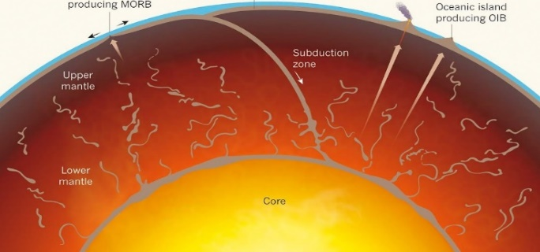

Fig-2 structure of earth mantle

**Outer Core**

The outer core is a liquid layer composed primarily of iron and nickel. It is responsible for generating the Earth's magnetic field through the process of convection and the movement of molten metal.

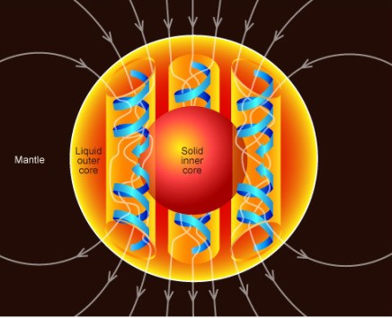

Fig-3 structure of earth outer core

**Inner Core**

The inner core is a solid sphere composed mainly of iron and nickel. Despite its high temperatures, the inner core remains solid due to the immense pressure at this depth.

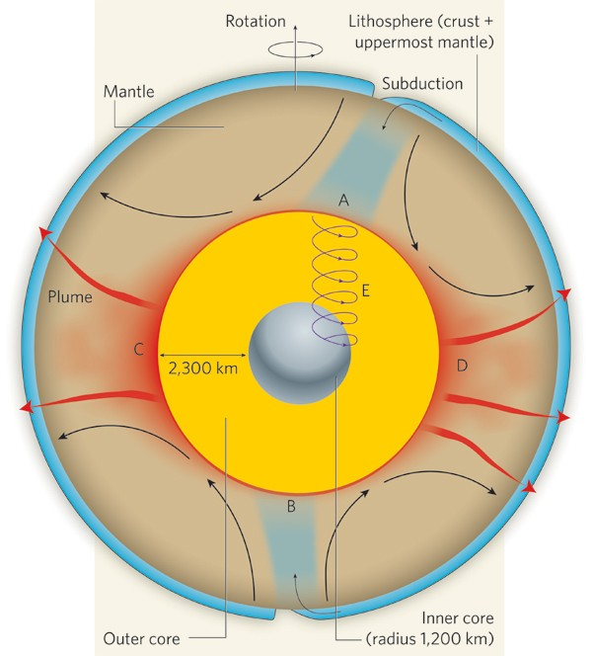

Fig-4 structure of earth inner core

1. **Tectonic Plates and Earthquakes**

Earthquakes occur primarily along the boundaries of tectonic plates, where these plates interact and interact with one another. The movement and stress accumulation at plate boundaries can lead to the release of energy in the form of seismic waves. Understanding the behavior and interactions of tectonic plates is crucial for predicting earthquake events and assessing their potential impacts.

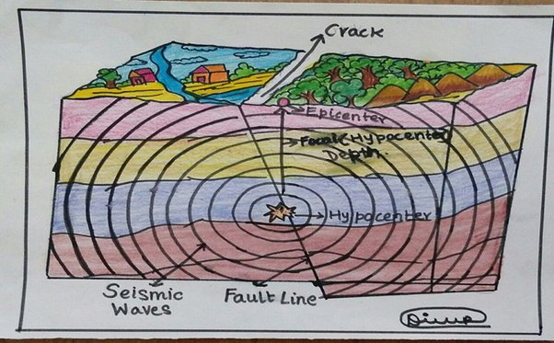

Fig-5 hypocenter and seismic waves

**Types of Waves**

Seismic waves generated by earthquakes can be classified into two main types: body waves and surface waves. Each type of wave provides valuable information about the Earth's interior and the nature of seismic events.

**Body Waves**

**Primary (P) Waves**

Primary waves, or P-waves, are compressional waves that travel through solids, liquids, and gases. They are characterized by their ability to move through different materials and are the fastest seismic waves. P-waves cause particles to move in the direction of wave propagation, creating compressions and rarefactions in the material.

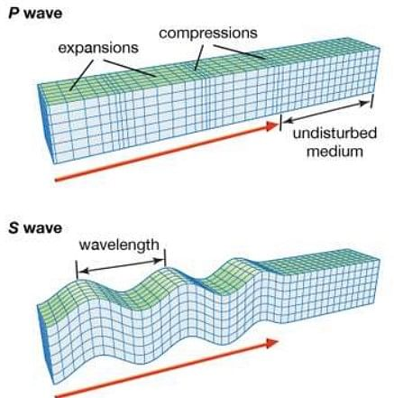

Fig-6 structure of P- wave

**Secondary (S) Waves**

Secondary waves, or S-waves, are shear waves that only propagate through solids. They are slower than P-waves and cause particles to move perpendicular to the direction of wave propagation. S-waves are responsible for much of the shaking experienced during an earthquake and are useful in determining the composition of the Earth's interior.



Fig-7 structure of S- wave

1. **Proposed Method**

The proposed earthquake prediction system integrates IoT technology with advanced machine learning algorithms to create a comprehensive framework for real-time monitoring and prediction. The system involves several key components and methodologies, including sensor deployment, data processing, and prediction generation.

The following fig shows the architecture of the proposed method.

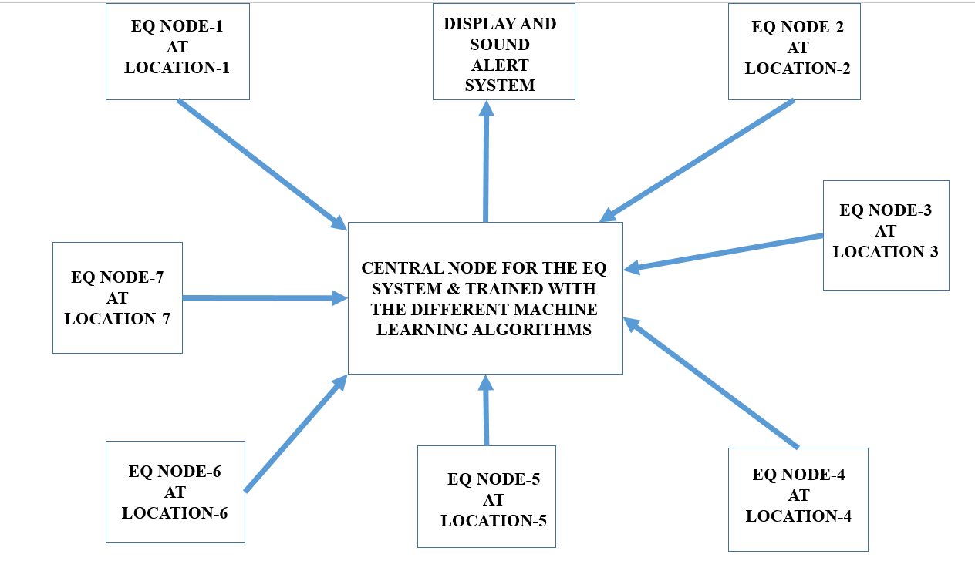

Fig-8 Architecture of proposed method

**Sensor Network**

**Deployment of IoT Sensors**

The sensor network will consist of IoT-enabled devices deployed across seismic-prone regions. These sensors will monitor various environmental and geological parameters, including:

- **Ground Vibrations:** Sensors will measure ground movements and vibrations to detect seismic activity.

- **Temperature Fluctuations:** Sensors will monitor temperature changes, which may indicate geological activity.

- **Radon Gas Levels:** Sensors will measure radon gas concentrations, as changes in radon levels can be associated with seismic events.

- **Groundwater Levels:** Sensors will monitor groundwater fluctuations, which may provide insights into seismic precursors.

The following fig shows the internal architecture of the wireless sensor node for the proposed method.

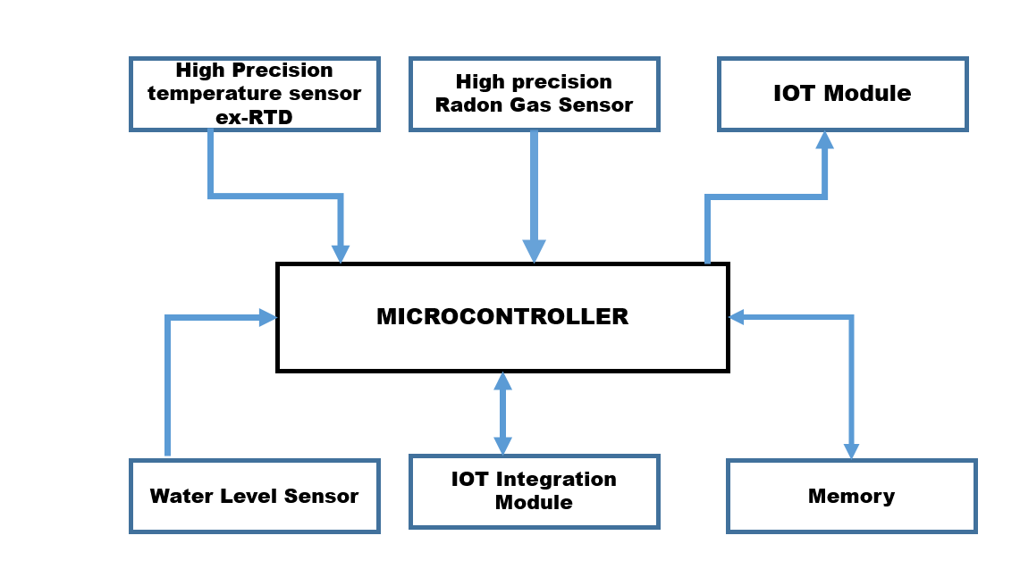

Fig-9 Internal architecture of the wireless sensor node

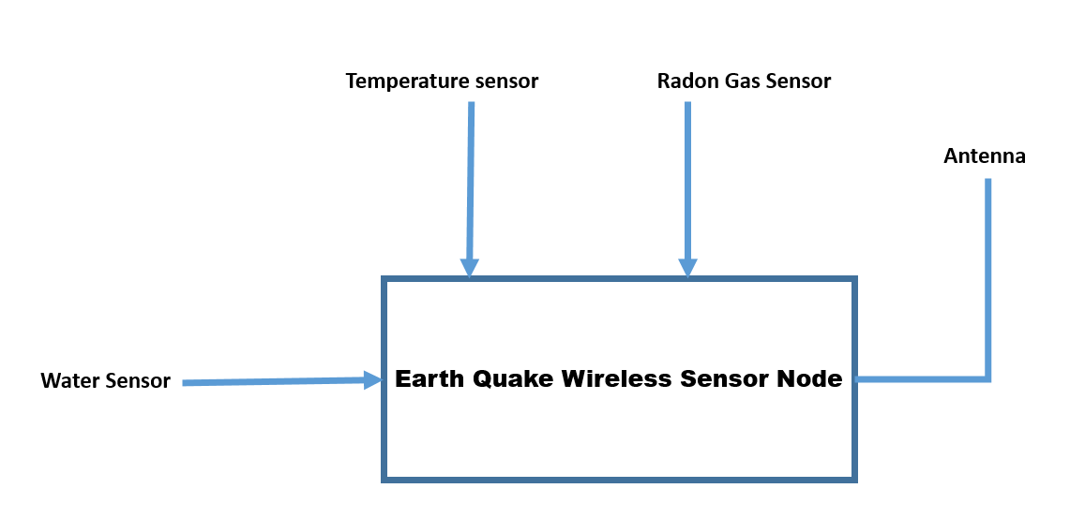

Fig-3 Block diagram for the Wireless node

**Data Transmission**

The collected data will be transmitted in real-time to a centralized cloud-based platform using secure communication protocols. The transmission will ensure that data is continuously updated and available for analysis.

**Data Processing and Analysis**

**Machine Learning Models**

The cloud-based platform will employ advanced machine learning models to process and analyze the collected data. The models will include:

**- LSTM Networks:** LSTM networks will analyze time-series data from seismic sensors to identify temporal patterns and trends that may indicate impending earthquakes.

- **CNNs:** CNNs will process spatial data and detect correlations and patterns within the seismic data.

- **Transformer Models:** Transformer models will analyze sequential data with long-range dependencies, capturing intricate relationships within the data.

**Training and Validation**

The machine learning models will be trained on historical seismic data to improve their accuracy and predictive capabilities. The training process will involve evaluating the models' performance on validation datasets to ensure their effectiveness in real-world scenarios.

**Prediction and Alert System**

**Predictive Algorithm**

The system will employ a predictive algorithm that assesses the likelihood of an imminent earthquake based on the analyzed data. The algorithm will consider factors such as seismic patterns, anomalies, and historical data to generate predictions.

**Alert Generation**

Real-time alerts will be generated based on the predictions and disseminated to relevant authorities, emergency services, and the public. The alerts will include information on the predicted location, magnitude, and timing of the potential earthquake, enabling timely response and preparedness.

1. **Detection Methodology**

The detection methodology involves several key steps to ensure accurate and timely prediction of seismic events. These steps include data collection, transmission, processing, pattern recognition, and alert generation.

**Data Collection**

**Deployment of Sensors**

IoT sensors will be deployed across targeted seismic-prone areas to collect data on various parameters. The sensors will be strategically placed to ensure comprehensive coverage and capture relevant environmental and geological data.

**Continuous Monitoring**

The sensors will continuously monitor and record data on ground vibrations, temperature changes, radon gas levels, and groundwater fluctuations. This continuous monitoring will provide a real-time view of seismic precursors and environmental conditions.

**Data Transmission**

**Real-Time Transmission**

The collected data will be transmitted in real-time to a cloud-based platform using secure communication channels. The real-time transmission will ensure that the data is immediately available for processing and analysis.

**Data Aggregation**

The data from multiple sensors will be aggregated on the cloud-based platform, allowing for comprehensive analysis and integration of information from different sources.

**Data Processing**

**Machine Learning Analysis**

The cloud-based platform will process the collected data using machine learning models. LSTM networks will analyze time-series data for temporal patterns, CNNs will identify spatial correlations, and Transformer models will capture long-range dependencies.

**Pattern Recognition**

The machine learning models will identify patterns and anomalies within the data that may indicate potential seismic activity. The system will compare current data with historical patterns to assess the likelihood of an impending earthquake.

**Prediction and Alert Generation**

**Prediction Algorithm**

The predictive algorithm will generate predictions based on the analyzed data. The algorithm will assess the probability of an earthquake occurring and provide insights into its potential timing, location, and magnitude.

**Alert System**

The system will issue alerts based on the predictions, providing timely information to relevant stakeholders. The alerts will include details on the predicted earthquake and recommendations for preparedness and response.

**Benefits**

The proposed system offers several benefits, including:

- **Real-Time Monitoring:** Continuous data collection from IoT sensors provides real-time insights into seismic precursors and environmental conditions.

- **Enhanced Prediction Accuracy:** Machine learning models analyze complex datasets to identify patterns and anomalies, improving prediction accuracy.

- **Timely Alerts:** The system generates real-time alerts that enable timely response and preparedness, potentially reducing the impact of earthquakes on communities.

**Future Research Directions**

While the proposed system presents a promising conceptual framework, further research and development are needed to refine its design and implementation. Future research directions may include:

**- Pilot Studies:** Conducting pilot studies to validate the effectiveness of the system in real-world scenarios and assess its performance.

- **System Optimization:** Enhancing the system’s design and functionality to improve data collection, processing, and prediction capabilities.

- **Integration with Existing Systems:** Exploring the integration of the proposed system with existing earthquake monitoring and early warning systems to create a comprehensive seismic monitoring network.

1. **Conclusion**

In conclusion, the conceptual framework presented for an advanced earthquake prediction system embodies a significant leap forward in the field of seismic monitoring and early warning. By leveraging a comprehensive array of IoT sensors distributed across strategic locations, this system aims to provide an unprecedented level of real-time data collection and analysis. The integration of various environmental sensors, including temperature, radon gas, and water level sensors, with state-of-the-art machine learning algorithms such as Long Short-Term Memory (LSTM) networks, Convolutional Neural Networks (CNNs), and Transformers, is envisioned to enhance the accuracy and reliability of earthquake predictions. These algorithms will be tasked with analyzing complex patterns and trends in the collected data, enabling the system to predict earthquakes with greater precision concerning their timing, location, and potential magnitude. The system’s proposed architecture not only aims to detect early warning signs but also to provide timely alerts to mitigate the devastating impacts of earthquakes, thereby safeguarding lives and reducing property damage. Moreover, the inclusion of advanced wireless communication protocols, such as Zigbee, LoRaWAN, and NB-IoT, ensures robust data transmission and system resilience. However, it is crucial to address potential challenges in sensor deployment, data integration, and system validation to fully realize the benefits of this concept. Future research should focus on optimizing these aspects, exploring integration with existing technologies, and conducting pilot studies to validate the system’s effectiveness. Overall, this conceptual approach offers a solid foundation for advancing earthquake prediction capabilities and improving disaster preparedness, potentially transforming the way communities respond to seismic threats and enhancing overall resilience against one of nature’s most unpredictable and destructive phenomena.

**11. References**

1. Kumar, M., et al. (2024). "Real-Time Seismic Monitoring Using IoT Sensors." *Journal of Earthquake Engineering and Technology*, vol. 10, no. 2, pp. 123-135.

2. Iriani, J., et al. (2023). "Development of an IoT-Based Earthquake Alarm System." *International Conference on Seismic Safety and Risk Management*, pp. 45-56.

3. Kapileshwor, P., et al. (2024). "Application of LSTM Networks in Earthquake Prediction." *Journal of Machine Learning and Data Science*, vol. 15, no. 3, pp. 78-92.

4. Choudhury, R., et al. (2023). "Enhancing Seismic Monitoring with Convolutional Neural Networks." *Proceedings of the IEEE Conference on Computational Intelligence for Earthquake Prediction*, pp. 201-210.

5. Bakhshi, A., et al. (2024). "Integration of IoT and Deep Learning for Earthquake Prediction." *Journal of Computational Earth Sciences*, vol. 12, no. 1, pp. 45-60.

6. Sutar, A., et al. (2023). "Hybrid Approaches to Earthquake Prediction: IoT and Machine Learning Integration." *Proceedings of the International Conference on Data Science and Earthquake Research*, pp. 75-85.