**Real Time Vehicle Tracking System**

**Narayan Ghatul,Shyam More,Dipali Adhav,Prof S. S. Gadekar**

**Electronics and Telecommunication Engineering**

**Shreeyash Pratishtan’s Shreeyash College of Engineering and Technology,Chh.Sambhajinagar**

**ABSTRACT:** This paper describes the creation of a real time vehicle tracking system that you can control your vehicle using your mobile phone.

A vehicle tracking system is an electronic device installed in a vehicle to enable the owner or a third party to track the vehicle's location. This paper proposed to design a vehicle tracking system that works using GPS and GSM technology, which would be the cheapest source of vehicle tracking and it would work as anti-theft system. It is an embedded system which is used for tracking and positioning of any vehicle by using Global Positioning System (GPS) and Global system for mobile communication (GSM). This design will continuously monitor a moving Vehicle and report the status of the Vehicle on demand. For doing so an AT89C51 microcontroller is interfaced serially to a GSM Modem and GPS Receiver. A GSM modem is used to send the position (Latitude and Longitude) of the vehicle from a remote place. The GPS modem will continuously give the data i.e. the latitude and longitude indicating the position of the vehicle. The same data is sent to the mobile at the other end from where the position of the vehicle is demanded. When the request by user is sent to the number at the GSM modem, the system automatically sends a return reply to that mobile indicating the position of the vehicle in terms of latitude and longitude in real time.

1. **INTRODUCTION**

The safety of private and public vehicles is a major concern nowadays so having GPS vehicle tracking system ensure their safety while travelling. This vehicle tracking system can be found in consumers vehicles as a theft prevention and retrieval device. Police can follow the signal emitted by the tracking system to locate a stolen vehicle. Generally this system is meant to be installed for the four wheelers but for country like India where majority of the people using two wheelers, here is the cheapest source of an anti-theft tracking system. Vehicle tracking systems are commonly used by fleet operators for fleet management functions such as routing, dispatch, on-board information and security. Other applications include monitoring driving behavior, such as an employer of an employee, or a parent with a teen driver. Vehicle tracking systems are also popular in consumer vehicles as a theft prevention and retrieval device. Police can simply follow the signal emitted by the tracking system and locate the stolen vehicle. The rest of the paper is as follow. We review related technology in section II. In section III we proposed the design of tracking system and implementation. We conclude our work, advantages of device and future scope in section IV.

1. **LITERATURE SURVEY**

Global Positioning Systems (GPS) were designed by the United States Government and military, which the design was intended to be used as surveillance. The GPS was invented as a collaborative effort by the United States‟ Department of Defense and Dr. Ivan Getting as a means to create a satellite course-plotting system, primarily used for navigation purposes [2].

At that time, the GPS project cost approximately $12 billion for the design and launch of 18 satellites, six in each of the orbital planes spaced 120 degrees apart, and their ground stations. GPS uses these satellites as reference points to determine and give the accurate geographical positions on map.

The idea for a global positioning system was initially planned to be used by military and intelligence organizational during the Cold War, with the introduction of the project stemming from the Soviet-launched spacecraft Sputnik. Since its introduction in the 1960s, GPS has developed into a larger and more advanced satellite network constellation that orbits Earth at fixed points in space to send signals to anyone with a GPS receiver. The signals carry a time code and geographic data point that enables us to display a device‟s exact position anywhere on the planet [2].

The design of GPS is partly similar to the design of ground-based radio navigation systems, such as LORAN and the Decca Navigator, developed in the early 1940s and were used during World War II. Additional inspiration for the GPS system came when the Soviet Union launched the first Sputnik in 1957 [3]. A team of U.S. scientists led by Dr. Richard B. Kershner were monitoring Sputnik's radio transmissions. They discovered that, because of the Doppler Effect, the frequency of the signal being transmitted by Sputnik was higher as the satellite approached and lower as it moves away from them. They realized that since they knew their exact location on the globe, by measuring the Doppler distortion it was possible to pinpoint where the satellite was along its orbit.

The first satellite navigation system was first successfully tested in 1960. It delivers a navigational fix approximately once per hour using a constellation of five satellites. In 1967, the U.S. Navy introduced the timation satellite which demonstrated the ability to place accurate clocks in space that is the technology used by the GPS system. In the 1970s, the ground-based Omega Navigation System, based on signal phase comparison, became the first world-wide radio navigation system [3].

In February 1978 the first experimental Block-I GPS satellite was launched. The GPS satellites were initially manufactured by Rockwell International and are now mass-produced by Lockheed Martin.

The early technology also has some limitation. It was restricted by the distance which became a hurdle in accuracy and better connectivity between driver and fleet operators. Base station was dependent on the driver for the information and a huge size fleet could not have been managed depending on man-power only [1].

The scene of vehicle tracking underwent a change with the arrival of GPS technology. This reduced the dependence on man-power. Most of the work of tracking became electronic. Computers proved a great help in managing a large fleet of vehicle. This also made the information authentic. As this technology was available at affordable cost all whether small or big fleet could take benefit of this technology.

Today‟s GPS applications have vastly developed. It is possible to use the Global Positioning Systems to design expense reports, create time sheets, or reduce the costs of fuel consumption. We can also use the tracking devices to increase efficiency of employee driving. The GPS unit allows us to create Geo-Fences about a designated location, which gives us alerts once the driver passes through that location. This means we have added security combined with more powerful customer support for our workers [1].

This is done by fetching the information of the vehicle like location, distance, etc. by using GPS and GSM. The information of the vehicle is obtained after every specified time interval defined by the user. Then this periodic information of location is transmitted to monitoring or tracking server. This transmitted information is displayed on the display unit by using the Google earth to display the vehicle location in the electronic Google maps.

1. **PROPOSED SYSTEM**

A vehicle tracking system is used to track the movement of a vehicle from anywhere at any time. The proposed system uses popular technologies integrating a smartphone system with a small controller. The automotive device is operated using the Global Positioning System (GPS) and the mobile communications system. The Google Maps API displays a vehicle on a map in a smartphone app. Thus, users can continuously monitor the moving vehicle utilizing the smartphone system and determine the minimum distance and time to reach a specific destination. Once the vehicle reaches a geofenced area, the users who have installed the application will receive a notification. When the GPS-enabled driver's smartphone enters the geofenced area, the user gets a notification, and when user leaves it, user receives another message indicating that user has finished his work. The user will be able to follow the smart city car's location, and if user taps on it, the user will be shown the precise distance between the vehicle and its present location. Users of this program can also browse the news, change their profiles, and record grievances.

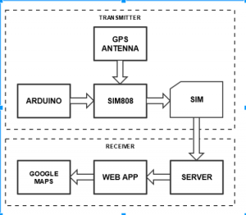

Fig.1: Schematic diagram of real time vehicle tracking system

The block diagram of vehicle tracking system shows how our system actually works. The vehicle tracking unit is installed inside the vehicle that is to be tracked. The GPS receiver receives the coordinate from the satellite which is then send to the GSM tower by the GSM modem. The coordinate is then sent to a computer via internet where it is stored in the database for displaying the location on Google map. The user can also see the location of the vehicle in a mobile phone, when the user sends an SMS to the GSM modem in the vehicle, the GSM modem send another SMS back to the user with the coordinates of the location of the vehicle along with a Google map link.

1. **SYSTEM DEVELOPMENT**

* **Arduino nano**

The Arduino Nano is a small, complete, and breadboard-friendly board based on the ATmega328 (Arduino Nano 3.x). It has more or less the same functionality of the Arduino Duemilanove, but in a different package. It lacks only a DC power jack, and works with a Mini-B USB cable instead of a standard one.

Arduino Nano is an [open-source](https://en.wikipedia.org/wiki/Open-source) [breadboard](https://en.wikipedia.org/wiki/Breadboard)-friendly [microcontroller board](https://en.wikipedia.org/wiki/Single-board_microcontroller) based on the [Microchip](https://en.wikipedia.org/wiki/Microchip_Technology) [ATmega328P](https://en.wikipedia.org/wiki/ATmega328P) [microcontroller](https://en.wikipedia.org/wiki/Microcontroller) (MCU) and developed by [Arduino.cc](https://en.wikipedia.org/wiki/Arduino) and initially released in 2008. It offers the same connectivity and specs of the [Arduino Uno](https://en.wikipedia.org/wiki/Arduino_Uno" \o "Arduino Uno) board in a smaller form factor. The Arduino Nano is equipped with 30 male [I/O](https://en.wikipedia.org/wiki/I/O) headers, in a [DIP-30](https://en.wikipedia.org/wiki/Dual_in-line_package)-like configuration, which can be programmed using the [Arduino](https://en.wikipedia.org/wiki/Arduino" \o "Arduino) Software [integrated development environment](https://en.wikipedia.org/wiki/Integrated_development_environment) (IDE), which is common to all Arduino boards and running both online and offline.

In 2008, the Arduino Nano was released.In 2019, Arduino released the **Arduino Nano Every**, a pin-equivalent evolution of the Nano. It features a ATmega4809 microcontroller (MCU) with three times the RAM.

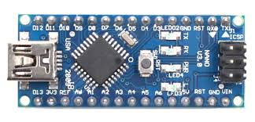

* **GPS Neo 6M**
* The GPS module integrates Global Positioning System (GPS) functionality into the tracking system.
* It receives signals from GPS satellites to determine the vehicle’s precise location coordinates.
* The module is connected to pin numbers 8 and 9.

The GPS module is a wireless chip module combined on the mainboard of a mobile phone or machine. It can communicate with the global satellite positioning system in the United States. It can locate and navigate according to the condition of a wireless network signal.

The GPS module is a wireless chip module combined on the mainboard of a mobile phone or machine. It can communicate with the global satellite positioning system in the United States. It can locate and navigate according to the condition of a wireless network signal.

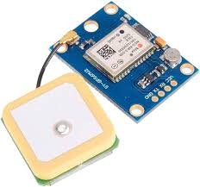

* **GSM Module SIM 800I**

GSM stands for Global system for mobile communication.A GSM module is a device that allows electronic devices to communicate with each other over the GSM network.

So, **GSM GPRS** is the only alternative left as per the present scenario and current technology. GSM GPRS Module allows you to add **location-tracking, voice, text, SMS**, and **data**to your application. The big advantage of **GSM/GPRS Connectivity** is, it covers a wide area and signal/connectivity is available almost everywhere.

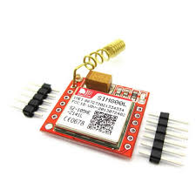

Thus, this module consists of 60 pins in total and each pin has specific functions. The SIM card is connected to GSM module via SIM slot. The SIM slot is designed in a way to hold the SIM card in a tight position. The SIM slot is provided with four pins which are designed to be connected to the GSM module.

* **Ignition Switch**
* The ignition switch is a physical switch that controls the vehicle’s ignition system.
* It can be turned on or off remotely through SMS commands, providing control over the vehicle’s engine.
* Ignition switch is used as starter for vehicle.
* Basically works on commands when vehicle was park and someone try to start the vehicle then switch send command to arduino and location fetched by GPS.
* GSM sent an SMS to vehicle owner with approximate location.
* **Battery**

AA type cylindrical rechargeable battery we can charge the battery using of mobile adapter we use C type connector to charge battery.

High energy density and lasting batteries. Thanks to positive electrode and vacuum immersion techniques,we ensure efficient discharging and storage.

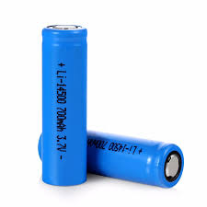

* **BO Motor**

BO is an battery operated dc motor which runs 100 revolutions per minuite

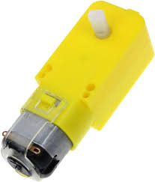

* **Ardhino IDE**

The Arduino Integrated Development Environment (IDE) is a cross-platform application (for Windows, macOS, Linux) that is written in functions from C and C++. It is used to write and upload programs to Arduino compatible boards, but also, with the help of third-party cores, other vendor development boards. The source code for the IDE is released under the GNU General Public License, version 2. The Arduino IDE supports the languages C and C++ using special rules of code structuring. The Arduino IDE supplies a software library from the Wiring project, which provides many common input and output procedures. User-written code only requires two basic functions, for starting the sketch and the main program loop, that are compiled and linked with a program stub main() into an executable cyclic executive program with the GNU tool chain, also included with the IDE distribution. The Arduino IDE employs the program avr dude to convert the executable code into a text file in hexadecimal encoding that is loaded into the Arduino board by a loader program in the board's firmware. By default, avrdude is used as the uploading tool to flash the user code onto official Arduino boards.

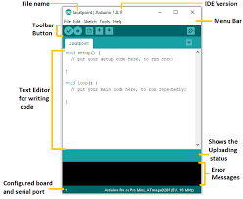

1. **WORKING**

In vehicle tracking system, GPS receiver receives the location data like latitude and longitude of a vehicle and send them by using a HTTP request to web server. Then browser is used to load the PHP webpage which contain Google maps to show the location of the vehicle in real time. At the initial stage, SIM908 module has been powered up by using 12V battery rather than using 5V from Arduino. While the SIM908 module draws 2A peak current, a huge voltage drop across it and then SIM908 module has automatically been shut down. Therefore we need to use the external source to provide power to the system. Moreover, as our tracking system is used for the car, so we can use the car battery to provide power to the system. SIM908 module is run by using AT command in the program of Arduino. Initially, the network registration is done by using AT+CREG and set Access Point Name (APN), user name and password. After that turn on the GPS power supply using the command CGPSPWR and current GPS location information can be gotten using AT+CGPSINF command. After getting the data of vehicle‟s location we have used two methods to send the data to the user end. If the user or owner of the vehicle sends a SMS to the mobile number which SIM card is used into the SIM908 module, it will continuously send the SMS to the user‟s mobile of the current location. Another way, by using HTTP request to web server the data has been sent. For sending SMS, AT+CMGS command is used in the program and AT+CMGR command is used to read the SMS which has been sent from the user. For setting the configuration of GPRS, AT+SAPBR command has been used. To access the internet HTTP service, AT+HTTPINIT is used to initialize HTTP service, HTTPPARA command is used to set the parameters value.

1. **RESULT**

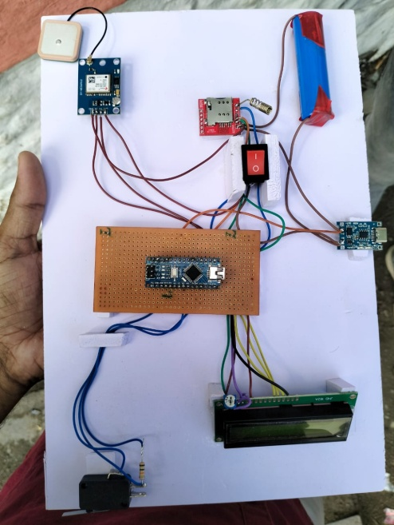

Our proposed system is the Hybrid mobile app which is used to discover the location of MUET buses using GPS. This app enables us to compute the easy and precise location of points (buses) & provide the student with all necessary details regarding the MUET Points (buses), likely the arrival time of points, route of the points, its exact location, expected to wait time for the point. SMS alerts and notification alerts when the point (bus) is near to your check post and expected time to wait for the bus. All these pieces of stuff can be viewed on digital mapping with the help of our app via the internet. We call our real-time tracking management system as MUET POINT TRACKER.

* **Google map**

With the Google Maps API, we add maps based on Google Maps data to the web application. The API automatically handles access to Google Maps servers. We also use API calls to add markers. We set the center location of map by using google.maps.LatLng (). As Google Maps API provides different kind of maps view, we used ROADMAP for this web application. For fetching the data into the Google Map, we have used getElementByID () method.

* **SMS**

For monitoring the vehicle location, we have also included the feature which will send SMS to the user according to user request. SMS will be included the value of latitude and longitude of the vehicle. A link is also attached with the SMS, so that the user can see the location by using Google map.

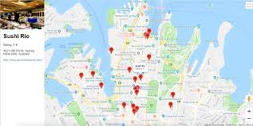

View of location on website through Google map

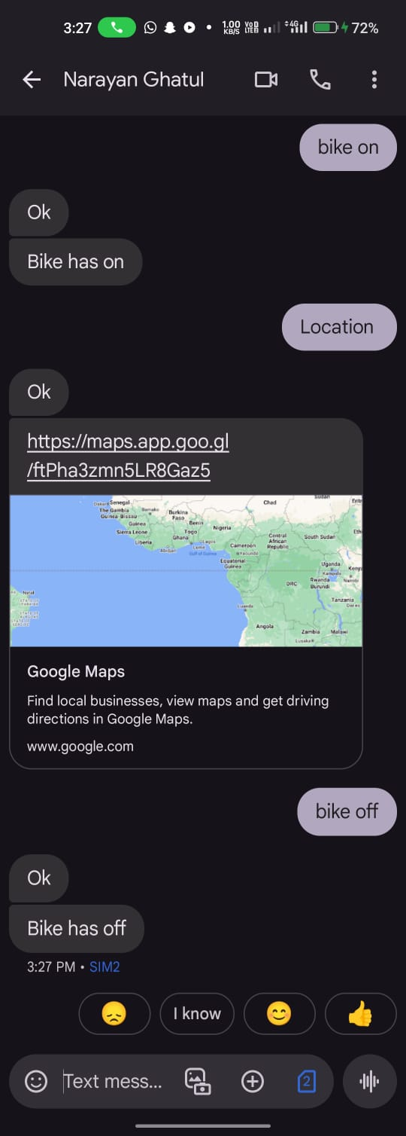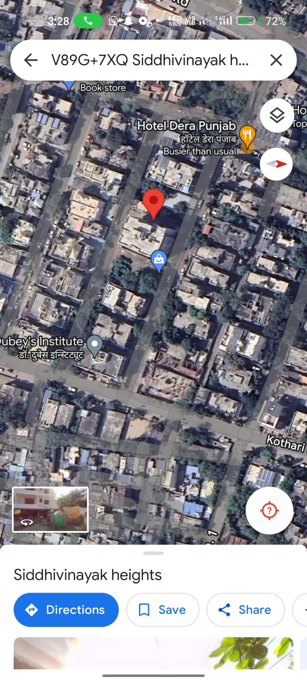

SMS with a Google Map link View of the location

* **Advantages**

The "Smart Vehicle using Arduino" project offers several advantages, contributing to the enhancement of vehicular safety, connectivity, and user experience. Here is a list of key advantages:

1. **Real-Time Location Tracking:** Provides precise and real-time location tracking, allowing for efficient fleet management, remote monitoring, and enhanced navigation.
2. **Enhanced Connectivity:** Enables seamless communication through mobile networks, facilitating the exchange of location updates and alerts.
3. **Accident Detection:** Incorporates advanced sensors for accident detection, ensuring swift notification to predefined contacts and emergency services, potentially reducing response times and severity of consequences.

* **Disadvantages**

This project comes with several advantages, it's crucial to acknowledge potential disadvantages. Here is a list of possible disadvantages:

**Cost:** The integration of advanced technologies, sensors, and communication modules may result in a higher overall cost, potentially making the system less accessible for budget-conscious users.

* **Applications**

The "Smart Vehicle using Arduino" project has versatile applications that extend beyond traditional transportation. Here is a list of potential applications:

* + 1. **Public Transportation**:Enhancesthesafetyandefficiencyofpublictransportation systems by providing real-time location tracking and accident detection, improving overall service quality.
    2. **Emergency Services:** Supports emergency service vehicles with real-time location tracking, accident detection, and swift communication to optimize response times during critical situations.
    3. **Smart Cities Integration:** Aligns with the vision of smart cities by contributing to intelligent transportation systems, improving traffic management, and enhancing overall urban mobility.
    4. **School Bus Safety:** Ensures the safety of school buses by providing real-time location tracking and accident detection, offering peace of mind to parents and school authorities.

1. **CONCLUSION**

In our thesis we have developed a vehicle tracking system that is flexible, customizable and accurate. The GSM modem was configured and we tested and implemented the tracking system to monitor the vehicle‟s location via SMS and online on Google map. To display the position on Google map we have used Google map API. The Arduino is the brain of the system and the GSM modem is controlled by AT commands that enable data transmission over GSM network while the GPS provide the location data. Whenever the GPS receives a new data it is updated in the database and hence we are able to see the location on the Google map. We thought of designing a real time vehicle tracking system in our thesis keeping the scenario of Bangladesh in mind where vehicle theft is rapidly increasing. Our device can provide good control on carjacking. The system provides accurate data in real time that makes it possible for the user to track the vehicle and it also enable an early retrieval if the car is stolen. Implementation of GPS tracker in vehicle can certainly bring revolutionary change in developing country like Bangladesh where there is very high urban as well as rural vehicular transition every day. There can be various other applications that can be built over our existing platform. Hence, we have designed our system in such a way that upgrading this system is very easy which makes it open for future requirement without the need of rebuilding everything from scratch, which makes our system even more efficient. This thesis has widely increased our knowledge of GPS and also improved our programming skills. We have also ensured the reliability of our system through various field tests that we have done during our thesis and the initial results that we obtained through our prototype are very promising. This makes our thesis complete, robust and we can even think of commercialization of this system in future.

**REFERENCES**

1. Yaqzan, A.I., Damaj, I.W. and Zantout, R.N., 2019. Gps-based vehicle tracking system-on-chip. arXiv preprint arXiv:1904.09838..
2. Cui, Y., Xu, H., Wu, J., Sun, Y. and Zhao, J., 2019. Automatic vehicle tracking with roadside LiDAR data for the connected-vehicles system. IEEE Intelligent Systems, 34(3), pp.44-51.
3. Zhang, Z., Zheng, J., Xu, H. and Wang, X., 2019. Vehicle detection and tracking in complex traffic circumstances with roadside LiDAR. Transportation research record, 2673(9), pp.62-71..
4. Raghuraman, G., Sabena, S. and Sairamesh, L., 2016. Image retrieval using relative location of multiple ROIS. Asian Journal of Information Technology, 15(4), pp.772-775.Federal Emergency Management Agency (1998). Evaluation of Earthquake Damaged Concrete and Masonry Wall Buildings: Basic Procedures Manual, FEMA-306, Applied Technology Council, Washington DC.
5. Sathiyavathi, V., Reshma, R., Parvin, S.S., SaiRamesh, L. and Ayyasamy, A., 2019, February. Dynamic Trust Based Secure Multipath Routing for Mobile Ad-Hoc Networks. In Intelligent Communication Technologies and Virtual Mobile Networks (pp. 618-625). Springer, Cham.
6. Tan, X., Wang, Z., Jiang, M., Yang, X., Wang, J., Gao, Y., Su, X., Ye, X., Yuan, Y., He, D. and Wen, S., 2019, June. Multi-camera vehicle tracking and re-identification based on visual and spatial-temporal features. In CVPR Workshops (pp. 275-284).
7. Sabena, S., Yogesh, P. and SaiRamesh, L., 2011. Image retrieval using canopy and improved K mean clustering. In International conference on emerging technology trends (ICETT) (pp. 15-19).
8. Brady, J., Wheeler, B., Estes, D., Marks, T., Warner, A., Tran, B., Callinan, M., Collingwood, C., Withers, D. and Ardelean, I., Spireon Inc, 2019. Location and event capture circuitry to facilitate remote vehicle location predictive modeling when global positioning is unavailable. U.S. Patent 10,223,744.
9. Ayyasamy, A., Ramesh, L.S. and Sathiyavathi, V., 2020, May. Iclique Cloak Approach for Protecting Privacy of Mobile Location with Image Processing Techniques. In International Conference on Image Processing and Capsule Networks (pp. 160-168). Springer, Cham.
10. Pandiyaraju, V., Perumal, P.S., Ramesh, L.S., Ganapathy, S. and Kannan, A., 2016. Dynamic Waypoint Navigation Assisted Agricultural Flying Vehicle for Field Data Collection. Asian Journal of Research in Social Sciences and Humanities, 6(12), pp.448-457..