EVALUATION OF PROPERTIES OF CONCRETE

INCORPORATING CHEMICALLY TREATED WASTE

RUBBER TIRE CHIPS AND SILICA FUME

Prateek Agrawal1, Prof. Deepak Garg2 Dr. Rakesh Patel3

1. PG Scholar, Department of Civil Engineering, OIST Bhopal, India
2. Asst.Prof, Department of Civil Engineering, OIST Bhopal, India
3. Prof and Head, Department of Civil Engineering, OIST Bhopal, India

Abstract

This study presents experimental work on the use of Silica Fume (SF) and waste tires chips in the concrete. Distinctive outcome from several researches have been studied, particularly emphasizing on the fresh and hardened properties of concrete when blended with Silica Fume (Micro-silica or Nano-silica) & waste tires chips (for single doping only) after that an experimental study concrete of grade M30 is considered and mix design is done as IS: 10262-2019, cement is replaced by silica fume up to 20% & coarse aggregate is replaced by waste rubber tires chips up to 20 %. Once the optimum percent of silica fume content is determined, optimum percent of aggregate replacement is determined. Here the effect of chemical treatment of tire chips using sodium hydroxide solution is also studied..

Keywords Cement, tires chips, Flexural Strength, Silica Fume, sodium hydroxide solution, Strength Parameters,

1 Introduction

### The incorporation of the industrial waste in concrete, the energy and the environment can be saved. The use of these by-products offer environmental advantages like diversion of the material from the waste bodies, reduction of the energy used in processing virgin materials, usage of virgin materials and decrease in pollution. To produce Ordinary Portland Cement (OPC), we use earth resources like limestone. During manufacturing of one tonne of OPC, an equal amount of carbon dioxide is released into the atmosphere which is harmful to the environment. So there is a need to choose an alternative. In urban cities, solid waste management is a very challenging task, which is a serious pollution problem due to the generation of large quantities of solid waste. Also, the cost of cement is also gradually increasing day by day. So, there is a great need to use industrial waste products in an appropriate manner to reduce the cost and environmental problems. Many research organizations are doing massive work on waste materials concerning. Paper mill sludge is a major environmental and economic issue for the silica industry. The material is a by-product of this is silica fume. The silica industry generates large volume of waste called silica fume; which is technology-dependent. It is estimated around 18% of waste (sludge) is generated during the production of metal.

**2 Objectives**

Following are the objectives of this work

* Determination of Optimum percent of cement replacement with silica fume for M30 grade of concrete as per IS standards is determined.
* Optimum percent of course aggregate replacement with waste rubber tire chips is to be determined.
* To determine the effect of chemical treatment of tire chips on properties of concrete.
* To evaluate the parameter of strength that is compressive, split- tensile strength, flexural strength of concrete of M30 grade prepared with Optimum percent of cement & course aggregate replacement.

**3 Methodology Adopted**

As stated earlier concrete mix design is required to be done if admixtures or additional cementing materials are added with partial replacement of cement in concrete is done. The behaviour and properties of green and hardened concrete totally depends on its ingredients ie. Cement, aggregates, cementing material and water to cement ratio. Properties of green concrete like workability and of hardened concrete like compressive strength, flexural strength, weight density etc. totally depends on the proportion of ingredients used in mix design, apart from this ratios of fine aggregate to coarse aggregate, water to cement, admixture to cement also plays and important role in different properties of concrete. For concrete mix design initially the lab tests on all the ingredients need to done and based on the lab results weather the ingredients are suitable to use or need to be changed need to be checked. Also properties like specific gravity, fine ness modulus, cement grade and required grade of concrete with have impact on proportions of ingredients in final concrete matrix. Concrete mix design is done based on the requirement of designer stating the requirement compressive strength, workability, which need be achieved based on the raw material available at site for concreting. Alteration in the materials tested in laboratory and material available on site may lead to concrete of undesirable properties. If ingredients are changed due to non-availability at site or it change due to source of excavation, concrete mix design need to be rechecked from time to time. Concrete mix design is a trial and error process and its results totally depends on the lab results of its constituents thus a through and detailed lab test need to be done on ingredients before proceeding for mix design. Materials are as follows:

* Cement
* Fine aggregates (Sand)
* Coarse Aggregates(20mm)
* Coarse Aggregates(10 mm)
* Rubber Tire Chips.
* NaOH solution for treatment
* Silica Fume
* Water

**4 Results & Discussions**

Compressive Strength of Containing Silica Fume

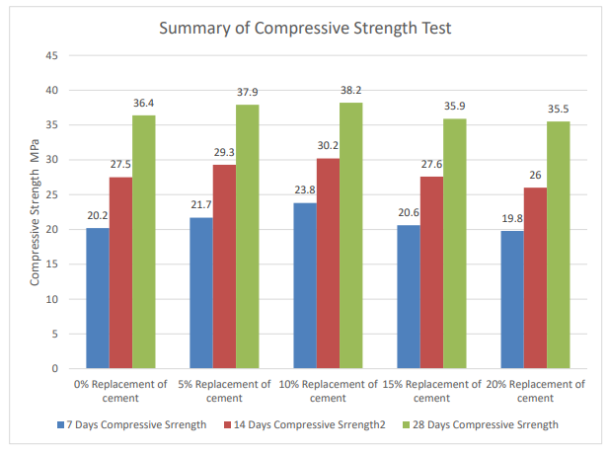

Compressive Strength of Containing Rubber Tire Chips

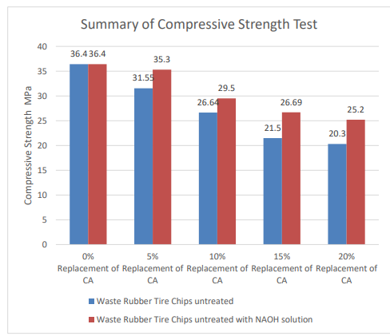

Flexural Strength of Beam

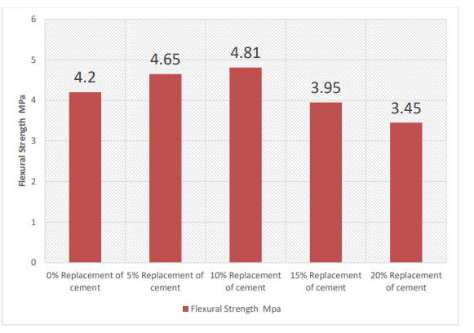

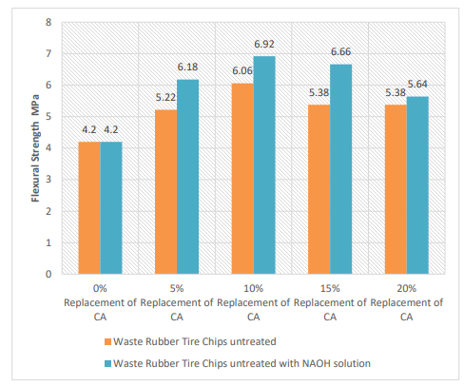

**5 Conclusion**

On the basis of experimental investigation of the present research study, the following conclusions have been drawn.

* Slump shows that the Workability of concrete was decreased as the percentage replacement of coarse aggregate with Waste Rubber Tire Chips was increased.it may be due increase in water demand on increase inspecific surface area of fine aggregate due to the micro-fines present in quarry dust. However, workabilityof all concrete mixes up to 20% replacement was suitable in structural uses.
* When the replacement of cement is increased up to 20% by silica fume in concrete mix there is decrease in slump value, which shows the workability of the concrete is reduced. Silica Fume is considered as a highly reactive pozzolanic material which provides an increased cohesiveness in concrete due to its high fineness modulus which consequently results into a high amount of water requirement to maintain the desired workability.
* If Single-doped silica fume replaces part of the cement, then for the same curing time, and the compressive strength increases in the early stage and the later stage is relatively slow. When the content of silica fume reaches 10%, the performance of concrete reaches the best.
* Flexural strength of concrete increases initially with the inclusion of silica fume then decreases. Maximum flexural strength of concrete at 28 days is found for cement replaced 10% by silica fume in concrete mix.
* Flexural strength of concrete was initially increased with inclusion of partial replacement of CA. Concrete mix with 10% CA replacement level had maximum strength at all ages then after it decreases. • Durability parameters like water acid attack resistance are higher in case of concrete blended with silica fume as compared to normal OPC concrete.
* Chemical treatment of Waste Rubber Tire Chips with NAOH solution increases the strength of concrete, thus may be due to the process of polymerization.
* The Tolerable level for the replacement (by weight) of silica fume for severe exposure condition i.e. M30 grade, is found to10% & for Waste Rubber Tire Chips (chemically treated) as partial replacement of CA it is found 10%.
* Concrete mix prepared with optimum dosage of silica fume & Waste Rubber Tire Chips (chemically treated) provides justified results in terms of compressive ad flexural strength.

**Reference**

* GUO Yin-le1 LIU Xue-ying, and HU Yue-ping (2023) Study on the influence of fly ash and silica fume with different dosage on concrete strength. E3S Web of Conferences 237, 03038
* G.V.V. Raj Kishore. (2023) Experimental study on Strength Attainment of concrete containing silica fume and fly ash. International Conference on Advances in Civil Engineering, IOP Conf. Series: Materials Science and Engineering.
* Priyanka lohiya & Dr. Suprakash Biswa (2023) “A literature review on study of silica fume as a partial replacement material of cement in concrete” Journal of Xi'an University of Architecture & Technology.
* Judita Gražulytė, Audrius Vaitkus, Ovidijus Šernas, Donatas Čygas (2023) “Effect of Silica Fume on High-strength Concrete Performance. 5th World Congress on Civil, Structural, and Environmental Engineering (CSEE'20).
* Mazin Rahal1 &Cornelius kanmalai Williams (2020) Study on Utilization of Waste Tire Rubber Chip as Coarse Aggregate with Mineral Admixture in Concrete. Saudi Journal of Civil Engineering Abbreviated Key Title: Saudi J Civ Eng ISSN 2523-2657 (Print) |ISSN 2523-2231 (Online)
* M.Harikaran & N Balasundaram (2020) “Evaluation of Concrete Using Reshaped Waste Tyre Rubber as Partial Replacement of Coarse Aggregate”. International Journal of Recent Technology and Engineering (IJRTE) ISSN: 2277-3878, Volume-7, Issue-6S5.
* Ashhad Imam, Vikash Kumar and Vikas Srivastava (2021) Review study towards effect of Silica Fume on the fresh and hardened properties of concrete. Advances in Concrete Construction, Vol. 6, No. 2 145-157.
* Rahul Dogra & Ankit (2014) Effect of silica fume on various properties of fibre reinforced concrete . International Journal of Civil Engineering and Technology (IJCIET) Volume 7, Issue 4, July-August , pp. 542–548
* Dr ,P.Velumani, C.Lakshmipriya, N.Poovitha & R.Jeevanram (2021) “Feasibility study on addition of Hypo Sludge in concrete “.IJESRT, Volume 7, Issue 2, Page 463-467
* MehtabAlam ,Vebhav Berera(2016) ” Experimental study of use of hypo sludge in cement concrete”. IJSRD, Volume 6, Issue 9, Page 135-139.
* Ranjeet Kumar, Dr. Krishna Murari (2018) “ Influence of Polypropylene Fibers on recycled aggregate concrete”IJREAM, Volume 4, Issue 6, Page 477- 482.
* R.Aravind Raj , Selvamuthumani (2018) “Experimental Studies on Strength of Hypo sludge 62 Concrete with Polypropylene Fiber” IJIRSET, Volume 7, Issue 5, Page 49-52.