Feasibility Performance Analysis of Single Effect Vapour Absorption System in Milk Processing Plant

M.Tech. Student Suraj Kumar, Prof. Sujeet Kumar Singh

Department of Mechanical Engineering, PCST Bhopal.

Abstract- Milk is one of the best food available due to its nutrition values. For production of processed milk and other dairy products, quality Milk processing plants are required. Milk processing includes pasteurization, homogenization, evaporation, drying etc. In this study, system of a milk pasteurization process assisted by VAR is thermodynamically modelled. The whole energy requirement of the pasteurization system was supplied from Single Stage LiBr VAR was used for both heating and cooling purposes. The heat exchangers were modelled with energy balances, based on the streams inlet and outlet enthalpies and mass flow rates. The refrigeration unit was based on a simple vapour compression cycle using LiBr as a refrigerant. The energy analysis of the model was based on the 1st law of thermodynamics. An EES code has been developed using computer simulation program for simulating the cycle and validation of results with experimental one. . The effect of exit temperature of generator, condenser and evaporator on COP, and heat load, have been analyzed and validated with the operating parameters as generator temperature (75°C), absorber temperature (30°C), condenser temperature (30°C) and evaporator temperature (5°). It was found that the COP of the system increases with increasing the generator exit temperature and evaporator exit temperature while it is decreasing with increasing condenser exit temperature.

Keywords- Milk processing plants, Single Stage VAR, EES code, COP, exit temperature, pasteurization, dairy products.

# INTRODUCTION

Absorption refrigerator is a chemically driven refrigeration system which uses an absorbent refrigerant combination as the main working pair. In case of LiBr+water combo, LiBr solution works as absorbent whereas water works as refrigerant. The outstanding features of LiBr+water system is the non- volatility of the absorbent i.e. LiBr. This eliminates the use of rectifier as used in Ammonia+ water-based absorption refrigeration system. Another advantage is the high heat of vaporization of refrigerant i.e. water. But the use of water as refrigerant also restricts the use in low temperature applications. The COP of these kinds of refrigeration system is higher than the ammonia + water based

refrigeration system. The thermodynamic analysis of the system involves finding important parameters like enthalpy, mass flow rates, coefficient of performance (COP), heat and mass transfer and crystallization in LiBr + Water system[2]

A dairy is a type of farm devoted to raising and tending cattle in order to use them for milking. After the milk is collected, it goes through a process of clarification and separation, after which it is fortified with vitamins. Once fortified, the milk must be pasteurized and homogenized, processes that kill bacteria and reduce the amount of fat content. Once these procedures are complete, the milk is ready to be packaged and sold. Raw Milk is obtained from the cow (or goat, sheep, or water buffalo) under sanitary conditions and cooled to 45°F (7°C) within 2 hours of milking. Milk is picked up by a handler who takes a sample and then pumps the

milk from farm's bulk tank into the milk truck. A handler may pick up milk from more than one farm, so a truck load may contain milk from several farms when it is delivered to the processing plant. Before the milk can be unloaded at the processing plant, each load is tested for antibiotic residues. If the milk shows no evidence of antibiotics, it is pumped into the plant's holding tanks for further processing. Milk at the plant is stored at less than 45°F (7°C) and is usually processed within 24 hours, but can held for up to 72 hours (3 days) before processing. Longer holding time allows for growth of spoilage organisms that grow at refrigerator temperatures, called psychographs.

# LITERATURE REVIEW

Altun et al. (2020) investigated a solar-powered absorption cooling system was modelled using the TRNSYS software. The performance of the system using dynamic modelling under the weather conditions of Mugla, Trabzon, Izmir, Konya, Cana kale and Istanbul. The external catalog data file of the absorption chiller model was created to get more realistic results.

Jain et al. (2020) presented a novel structure of trans critical vapor compression-absorption integrated refrigeration system (TVCAIRS) based on its Thermoeconomic viability. The integration of single effect vapor absorption refrigeration system (VARS) (with H2O-LiBr fluid couple) in trans critical vapor compression refrigeration system (TVCRS) (with R744 refrigerant) provides a subcooling of 5 °C in the proposed configuration.

Meraj et al. (2020) investigated performance analyses of interconnected N number of fully covered semitransparent photovoltaic thermal integrated concentrator collectors combined with single effect vapor absorption refrigeration system The proposed system was analyzed under the constant mass flowrate of collectors’ fluid. Mathematical expressions have also been derived for generator temperature of the absorption unit as a function of both design and operating parameters.

Ibarra-Bahena, Jonathan et al. (2020) used a hydrophobic membrane desorber to separate water vapor from an aqueous LiBr solution. Influencing factors, such as the H2O/LiBr solution and cooling water temperatures, were tested and analyzed. With the experimental data, a solar collector system was

simulated on a larger scale, considering a 1 m2 membrane.

De, Ramen Kanti et al. (2020) presented a comparative performance assessment of a single-effect and a double- effect vapor absorption system for the operation of a cold storage facility. The proposed cold storage is powered through a combination of a grid-interactive solar photovoltaic system and parabolic trough collectors.

Venkataraman et al. (2020) presented an up-to-date review of the heat driven absorption refrigeration/air conditioning systems specifically meant for transport applications. This is followed by a discussion on the major challenges involved in implementing such a technology for the transport sector, the ways in which such a technology can be developed further and why using heat driven refrigeration/air conditioning systems could be a game changer in the automotive industry.

Alhamid et al. (2020) presented A solar-gas fired absorption cooling installed and tested in a real environment at the University of Indonesia, Depok, Indonesia. The cooling system provides chilled water to the building of the Mechanical Research Center of the university. This system has a unique single/double- effect water/Lithium Bromide absorption chiller with a nominal cooling capacity of 239 kW. In addition, the system consists of evacuated tube solar collectors (~181 m2 total aperture area) and fan coil units installed in the building.

Liu et al. (2020) presented a LiBr/H2O absorption chiller and a Kalina integrated in cascade to achieve full utilization of low-grade waste heat. A parametric analysis has been conducted to investigate the effect of key operational parameters in terms of turbine-inlet pressure, turbine-outlet pressure, ammonia concentration, segment temperature and refrigeration temperature.

Azhar et al. (2019) presented exergy analyses of lithium bromide-water based single to triple effect direct and indirect fired vapour absorption systems. The analysis carried out by various investigators on exergy of the absorption cycles have been discussed. To fill the gap in the knowledge on exergy destruction rate in the absorption system, optimization of the single to triple effect direct and indirect fired absorption cycles have been conducted for a wide range of operating conditions. Hence optimum parameters in various

components of the systems for maximum exergy coefficient of performance and minimum exergy destruction rate have been determined.

Mishra et al. (2019) developed an integrated solar refrigeration system where waste heat from different energy resources assists a combined vapour absorption compression system, and to analyze feasibility & practicality of that system of thermodynamically for improving its COP and exergetic efficiency by reduction of irreversibilities in terms of exergy destruction /losses occurred in the system components.

Mishra et al. (2019) analyzed solar assisted half effect vapour absorption refrigeration system cascaded by vapour compression refrigeration system using ecofriendly refrigerants and developed thermodynamic model to predict the variation of generator, absorber , condenser temperatures on first and second law efficiencies and to predict the solar collector area required.

Pandya et al. (2019) represented the detailed thermodynamic study to compare the performance of solar assisted double effect LiBr-H2O and LiCl-H2O vapour absorption refrigeration systems (VARS) coupled with several solar collectors. A 100 kW absorption cooling system is analysed at evaporator temperature 5 °C and two condensation temperatures 30

°C and 40 °C integrated with evacuated tube collector (ETC) and parabolic trough collector (PTC) connected with storage tank to operate the absorption system.

Sioud et al. (2019) investigated the feasibility and the eventual improvement in performance of an ejector powered water/lithium bromide double-effect absorption/recompression refrigeration cycle driven by high temperature heat sources.

Li, Zeyu, et al. (2019) presented The evaluation, performing by the dynamic simulation based on the monthly typical cooling demand and meteorological data, by the comparison of solar absorption-subcooled compression hybrid cooling system SASCHCS and the solar PV cooling which is thought to be the most economical solution recently.

López-Zavala et al. (2019) presents a novel LiBr/H2O absorption cooling and desalination system with three pressure levels which uses seawater as a cooling medium and is activated by solar thermal energy. This

system helps counteract coastal populations’ thermal conditioning and water supply problems.

Shukoor et al. (2019) presented performance of 11 kW solar-powered lithium bromide water absorption chillers in cogeneration mode is investigated. A 40 m2 solar parabolic dish of 19 kWth capacity is used for both processes heating and cooling. Extensive thermodynamic design and analysis, and the results obtained are validated. Parabolic dish and cavity receiver are sized for Chennai (13°N, 80.18°E), India.

Takalkar et al. (2019) presented thermodynamic analysis of novel ionic liquid 1 Ethyl-3- methylimidazolium ethyl sulphate (EMISE) as absorbent and water as green refrigerant for absorption refrigeration system (ARS) is performed. Thermodynamics excess properties like excess Gibbs free energy (GE), excess enthalpy (hE) and equilibrium Dühring’s plot (P-T-x1) of EMISE-H2O binary mixture are assessed using non-random two liquid (NRTL) activity coefficient model for composition of 0.45–1.

Liu, Xiangyang et al. (2019) presented three new working pairs R1234yf/[HMIM][TfO], R1234yf/[HMIM][PF6], R1234yf/[HMIM][BF4] were

proposed and new solubility data for them were determined. Two new absorption-compression hybrid refrigeration systems were proposed to improve the cooling performances of the single-effect absorption refrigeration system using R1234yf/[HMIM][TfO], R1234yf/[HMIM][PF6] and R1234yf/[HMIM][BF4] as

working pair.

Shahboun et al. (2018) presented the improvement of the system is achieved by utilizing the potential kinetic energy of the ejector to enhance refrigeration efficiency. However, the first and the second law of thermodynamics are used to analyze the performance of a single-stage water-lithium bromide absorption refrigeration system (ARS), whereas some working parameters are varied.

Patel et al. (2017) presented a thermodynamic evaluation of a small cooling LiCl-H2O vaporizer carrier for the influence of 1 TR primarily based on the initial and 2d rules. Mathematical modeling is based on the concept of thermodynamics, which is employed in the engineering of equation solver to use mathematics.

# METHODOLOGY

An increase in energy efficiency of the industrial sector would significantly reduce the greenhouse gas emissions caused by the burning of fossil fuels and the production costs associated with energy use. In this study, the whole energy requirement of the pasteurization system was supplied from Single Stage Libr VAR was used for both heating and cooling purposes. The heat exchangers were modelled with energy balances, based on the streams inlet and outlet enthalpies and mass flow rates. The refrigeration unit was based on a simple vapour compression cycle using LiBr as a refrigerant.

The following assumptions were taken.

* All processes are steady state and steady ﬂow with negligible potential and kinetic energy effects.
* Ammonia water solutions are assumed to be in equilibrium in the generator and the absorber at their respective pressures and temperatures.
* The directions of heat transfer to the system and work transfer from the system are positive.
* The pressure and heat losses in the pipelines and the system components (generator, condenser, evaporator, absorber, regenerator, pasteurizer cooler, etc.) are ignored.
* All throttle valves are operated under adiabatic condition, which results in constant enthalpy process.

# RESULT AND DISCUSSION

A energetic analysis of LiBr-H20 absorption system for milk processing plant is done in this current study. First law of thermodynamics has been used for performing analysis. Further, an EES code has been developed using computer simulation program for simulating the cycle.

1. Effect of generator temperature

In this section the effect of generator temperature on heat flow rate in condenser (Qc), and COP of absorption system has been discussed.

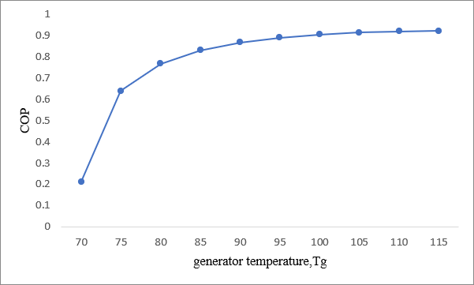

Fig 1 Effect of generator exit temperature on component’s COP.

Fig. 4.1. shows the effect of generator exit temperature on the COP, With increase in generator exit temperature the COP of the system is increasing. It is highest at temperature 115oC having COP 0.92

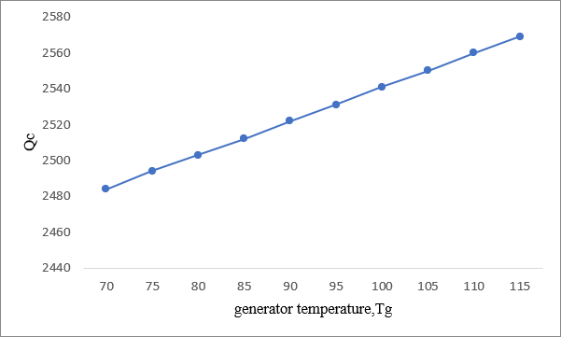

Fig 2 Effect of generator exit temperature on component’s heat load.

Fig. 4.2. shows the effect of generator exit temperature on the HEAT released in condenser, With increase in generator exit temperature The condenser heat load increases gradually

1. Effect of evaporator temperature

In this section the effect of evaporator temperature on heat flow rate in condenser (Qc), and and COP of absorption system has been discussed.

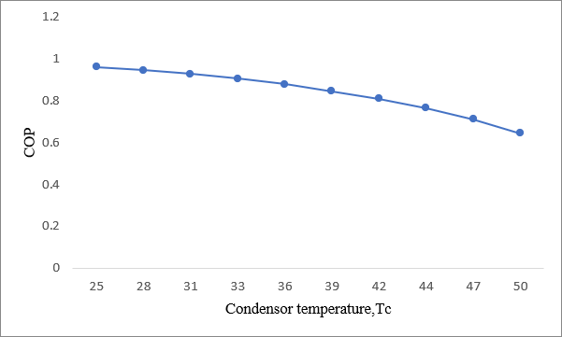

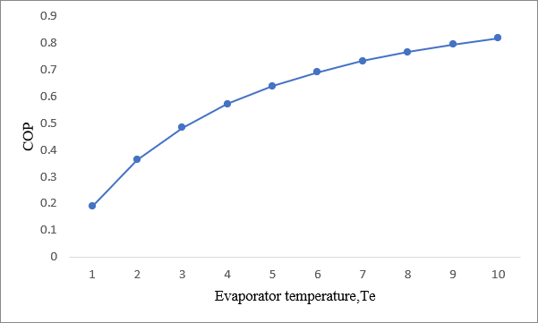Fig 3 Effect of evaporator exit temperature on COP.

The above figure Shows the variation of COP, with evaporator exit temperature Te. The COP increases with evaporator exit temperature.

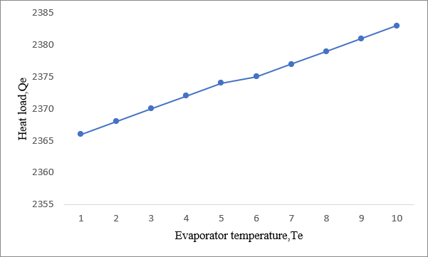

Fig 4 Effect of evaporator exit temperature on component’s heat load.

The above figure shows the effect of evaporator exit temperature on the HEAT load of evaporator, With increase in evaporator exit temperature THE evaporator heat load is also increasing.

1. Effect of condensor temperature

In this section the effect of condenser temperature on heat flow rate in condenser (Qc), and and COP of absorption system has been discussed.

Fig 5 Effect of condenser exit temperature on COP.

The above figure shows the effect of condenser exit temperature on the COP, With increase in condenser exit temperature THE COP of the system decreases gradually.

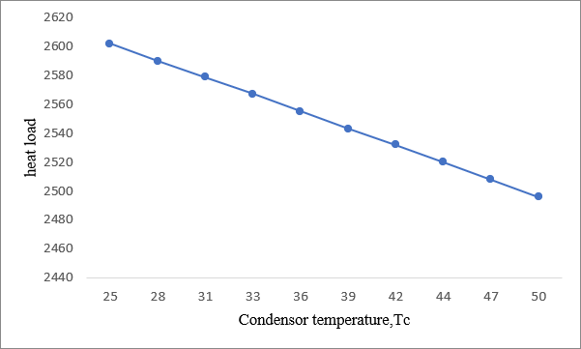

Fig 6 Effect of condenser exit temperature on component’s Heat load.

The above figure shows the effect of condenser exit temperature on the condenser heat load, With increase in condenser exit temperature the condenser heat load decreases gradually.

# CONCLUSION

The concluding remarks of the present study can be summarized as follows:

* It was found in the study that COP increases with increasing the generator exit temperature and evaporator exit temperature while it is decreasing with increasing condenser exit temperature.
* With increase in condenser exit temperature the condenser heat load decreases gradually.
* With increase in evaporator exit temperature the evaporator heat load is also increasing.
* With increase in generator exit temperature the condenser heat load increases gradually.

# REFERENCES

1. Altun, A. F., and M. Kilic. "Economic feasibility analysis with the parametric dynamic simulation of a single effect solar absorption cooling sys4.tem for various climatic regions in Turkey." Renewable Energy 152 (2020): 75-93.
2. Altun, A. F., and M. Kilic. "Economic feasibility analysis with the parametric dynamic simulation of a single effect solar absorption cooling system for various climatic regions in Turkey." Renewable Energy 152 (2020): 75-93.
3. Jain, Vaibhav, and D. Colorado. "Thermoeconomic and feasibility analysis of novel trans critical vapor compression-absorption integrated refrigeration system." Energy Conversion and Management 224 (2020): 113344.
4. Meraj, Md, M. E. Khan, and Md Azhar. "Performance Analyses of Photovoltaic Thermal Integrated Concentrator Collector Combined With Single Effect Absorption Cooling Cycle: Constant Flow Rate Mode." Journal of Energy Resources Technology (2020): 1-28.
5. Ibarra-Bahena, Jonathan, Eduardo Venegas- Reyes, Yuridiana R. Galindo-Luna, Wilfrido Rivera, Rosenberg J. Romero, Antonio Rodríguez-Martínez, and Ulises Dehesa- Carrasco. "Feasibility analysis of a membrane desorber powered by thermal solar energy for absorption cooling systems." Applied Sciences 10, no. 3 (2020): 1110.
6. De, Ramen Kanti, and Aritra Ganguly. "Performance comparison of solar-driven single and double-effect LiBr-water vapor absorption system based cold storage." Thermal Science and Engineering Progress 17 (2020): 100488.
7. Venkataraman, Vikrant, Ahmad El-Kharouf, Bhargav Pandya, Eridei Amakiri, and Robert Steinberger-Wilckens. "Coupling of engine exhaust and fuel cell exhaust with vapour absorption refrigeration/air conditioning systems for transport applications: A Review." Thermal Science and Engineering Progress (2020): 100550.
8. Alhamid, M. I., Alberto Coronas, Arnas Lubis, Dereje S. Ayou, Kiyoshi Saito, and Hajime Yabase. "Operation strategy of a solar-gas fired

single/double effect absorption chiller for space cooling in Indonesia." Applied Thermal Engineering 178 (2020): 115524.

1. Liu, Zhiqiang, Nan Xie, and Sheng Yang. "Thermodynamic and parametric analysis of a coupled LiBr/H2O absorption chiller/Kalina cycle for cascade utilization of low-grade waste heat." Energy Conversion and Management 205 (2020): 112370.
2. Azhar, Md, and M. Altamush Siddiqui. "Exergy analysis of single to triple effect lithium bromide-water vapour absorption cycles and optimization of the operating parameters." Energy conversion and management 180 (2019): 1225-1246.
3. Mishra, R. S. "Thermal performances (first law efficiency, exergy destruction ratio & exergetic efficiency) of cascade single effect ammonia- water (NH3-H20) vapour absorption refrigeration system coupled with vapour compression refrigeration using ecofriendly refrigerants in the low temperature cycle of VCRS system." International Journal of Research in Engineering and Innovation 3 (2019): 1-5.
4. Mishra, R. S. "Performance evaluation of solar assisted half effect Li/Br vapour absorption refrigeration system cascaded with vapour compression refrigeration system using eco- friendly refrigerants." International Journal 7, no. 2 (2019): 156-161.
5. Pandya, Bhargav, Nishant Modi, Ravi Upadhyai, and Jatin Patel. "Thermodynamic performance and comparison of solar assisted double effect absorption cooling system with LiCl-H 2 O and LiBr-H 2 O working fluid." In Building Simulation, vol. 12, no. 6, pp. 1063-1075. Tsinghua University Press, 2019.
6. Sioud, Doniazed, Mahmoud Bourouis, and Ahmed Bellagi. "Investigation of an ejector powered double-effect absorption/recompression refrigeration cycle." International Journal of Refrigeration 99 (2019): 453-468.
7. Li, Zeyu, and Liming Liu. "Economic and environmental study of solar absorption- subcooled compression hybrid cooling system." International Journal of Sustainable Energy 38, no. 2 (2019): 123-140.
8. López-Zavala, R., N. Velázquez-Limón, L. A. González-Uribe, J. A. Aguilar-Jiménez, J. Alvarez-Mancilla, A. Acuña, and S. Islas. "A novel LiBr/H2O absorption cooling and desalination system with three pressure levels."

International Journal of Refrigeration 99 (2019):

469-478.

1. Shukoor, Pathuthara Abdul, and Kalvala Srinivas Reddy. "Investigations on water–LiBr-based absorption refrigerator with solar parabolic dish in cogeneration mode." IET Renewable Power Generation 13, no. 13 (2019): 2310-2318.
2. Takalkar, Gorakshnath D., Rahul R. Bhosale, Nilesh A. Mali, and Sunil S. Bhagwat. "Thermodynamic analysis of EMISE–Water as a working pair for absorption refrigeration system." Applied Thermal Engineering 148 (2019): 787-795.
3. Liu, Xiangyang, Zheng Ye, Lihang Bai, and Maogang He. "Performance comparison of two absorption-compression hybrid refrigeration systems using R1234yf/ionic liquid as working pair." Energy Conversion and Management 181 (2019): 319-330.
4. Shahboun, Islam Kamel, and Salem Omran Adeilla. "Performance Analysis of a Solar Driven Single Stage LiBr/H2O Absorption Refrigeration system." (2018).
5. Patel, Jatin, Bhargav Pandya, and Anurag Mudgal. "Exergy based analysis of LiCl-H2O absorption cooling system." Energy Procedia 109 (2017): 261-269.