# Machine Learning

**#** **Priyanka R. Gondaliya**

* **Assistant Professor Sardar Patel College Of Engineering , Bakrol**

## Abstract

In today’s digital era, businesses are actively generating an astonishing 2.5 quintillion bytes of data every single day. For those of you wondering how much that is—well, there are 18 zeroes at a quintillion!

With people using social media platforms, digital communication channels, and various contactless services, it is no surprise that big data continues to grow at a colossal rate. But how can we harness the potential of all this information in the future? And what’s machine learning have to do with it?

First of all we have To better understand the future of machine learning, one must be able to differentiate between these 3 concepts  [**deep learning**](https://365datascience.com/trending/deep-learning-frameworks/) (DL),  [**artificial intelligence**](https://365datascience.com/trending/debunking-misconceptions-ai/)(AI) and **machine learning** (ML) interchangeably. **machine learning** (ML)

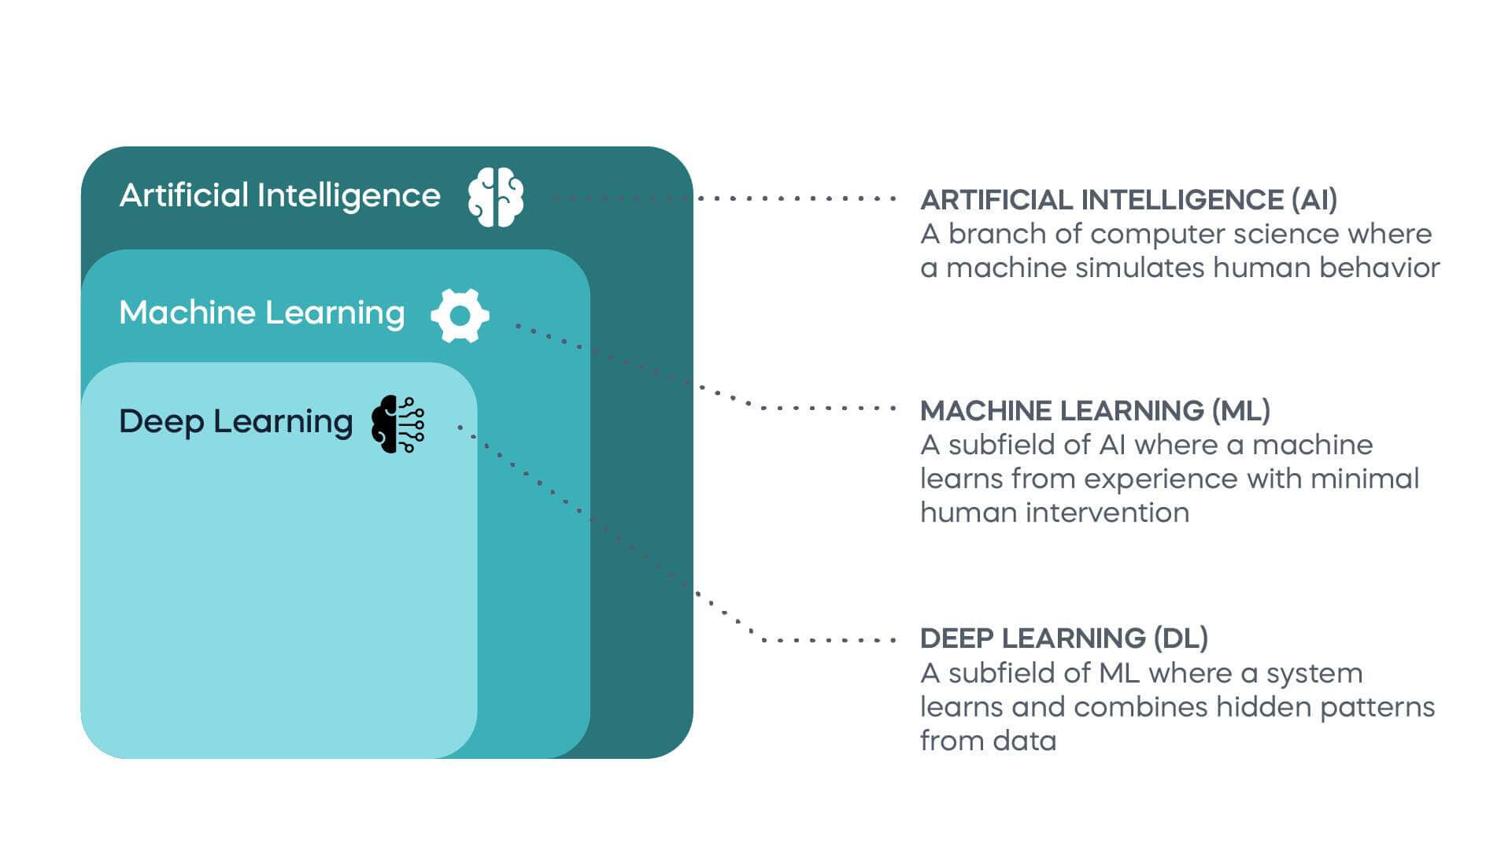

In this paper we discuss about the Machine Learning and its future aspects **Machine learning** is about creating an algorithm that a computer uses to provide valuable insights, with data being its key component. It is unique in developing algorithms that learn from data to solve problems without programming. Like a human, a model learns through experience and improves its accuracy over time.At its core, machine learning is all about creating and implementing algorithms that facilitate these decisions and predictions. These algorithms are designed to improve their performance over time, becoming more accurate and effective as they process more data. this field encompasses various techniques ,such as supervised learning, unsupervised learning ,and reinforcement learning ,each with distinct applications and methodology . In traditional programming, a computer follows a set of predefined instructions to perform a task. However, in machine learning, the computer is given a set of examples (data) and a task to perform, but it's up to the computer to figure out how to accomplish the task based on the examples it's given.

For instance, if we want a computer to recognize images of cats, we don't provide it with specific instructions on what a cat looks like. Instead, we give it thousands of images of cats and let the machine learning algorithm figure out the common patterns and features that define a cat. Over time, as the algorithm processes more images, it gets better at recognizing cats, even when presented with images it has never seen before.

This ability to learn from data and improve over time makes machine learning incredibly powerful and versatile. It's the driving force behind many of the technological advancements we see today, from voice assistants and recommendation systems to self-driving cars and predictive analytics.

## Introduction

In traditional programming, a computer follows a set of predefined instructions to perform a task. However, in machine learning, the computer is given a set of examples (data) and a task to perform, but it's up to the computer to figure out how to accomplish the task based on the examples it's given.

For instance, if we want a computer to recognize images of cats, we don't provide it with specific instructions on what a cat looks like. Instead, we give it thousands of images of cats and let the machine learning algorithm figure out the common patterns and features that define a cat. Over time, as the algorithm processes more images, it gets better at recognizing cats, even when presented with images it has never seen before.

This ability to learn from data and improve over time makes machine learning incredibly powerful and versatile. It's the driving force behind many of the technological advancements we see today, from voice assistants and recommendation systems to self-driving cars and predictive analytics. machine learning explore a wide range of techniques, including supervised, unsupervised, and reinforcement learning.

Machine learning (ML) is a subdomain of artificial intelligence (AI) that focuses on developing systems that learn—or improve performance—based on the data they ingest. Artificial intelligence is a broad word that refers to systems or machines that resemble human intelligence. Machine learning and AI are frequently discussed together, and the terms are occasionally used interchangeably, although they do not signify the same thing. A crucial distinction is that, while all machine learning is AI, not all AI is machine learning.

## Evolution of Machine Learning

## the evolution of machine learning gives s a multi-dimensional field Some believe it all started back in 1943 when [Walter Pitts and Warren McCulloch](https://www.historyofinformation.com/detail.php?entryid=782) presented the world’s first mathematical model of [neural networks](https://365datascience.com/courses/convolutional-neural-networks-in-python/). Here’s a simplified representation of the concept, consisting of 2 parts—*****g***** and *****f*****.

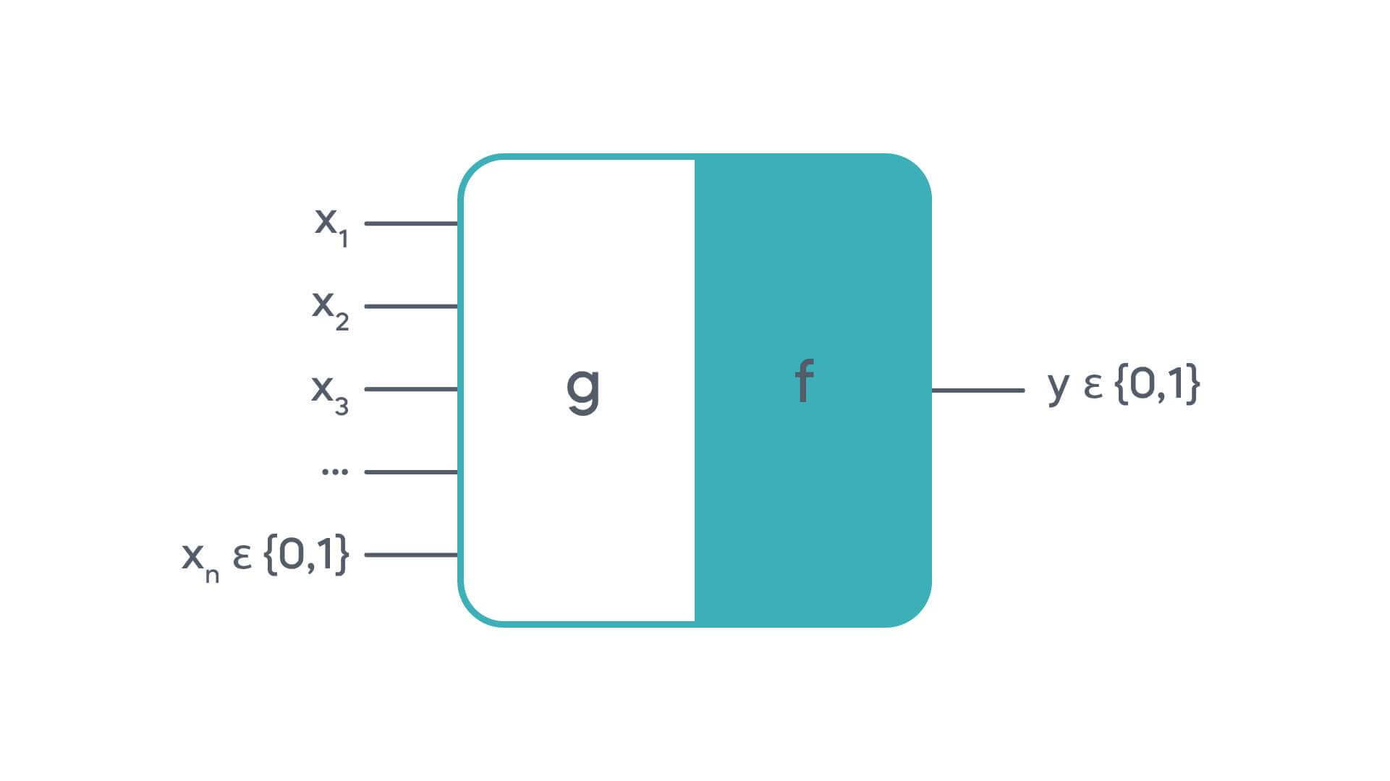

[machine learning technology](https://www.forbes.com/sites/bernardmarr/2016/02/19/a-short-history-of-machine-learning-every-manager-should-read/) was introduced to the world in 1990. That’s how the spam filter came into existence, and people could now save time sorting out emails. This significant milestone represented the collective effort of scientists and marked the beginning of the contemporary ML era.

### How does machine learning work?

The working of machine learning revolves around the development and utilization of algorithms that enable computers to learn From data and make informed decisions. The process begins with data collection and preprocessing, where raw data is cleaned ,normalized and transformed into a suitable format .this data is then divided into training and testing sets. During the training phase an ML model is built using arranging algorithm, which adjusts model parameters to minimize errors in predicting outcomes based on input features. Supervised learning algorithms, such as k means clustering and principal component analysis, identify inherent patterns in unlabeled data reinforcement learning involves agents learning optimal actions through trial and error interactions with an environment the trained model is then evaluated using the testing set to asses its performance, typically using metrics like accuracy, precision and ensemble methods further enhance model performance. As ML models are deployed in real world application, continuous monitoring and updating ensure they adapt to new data and maintain their effectiveness.

**Latest Advancements of Machine Learning**

Over the last decade, many innovations in various fields have come to the forefront thanks to machine learning. There are six advancements of machine learning that are currently trending.

### 1. Computer Vision

[Computer Vision](https://365datascience.com/career-advice/expert-interviews/data-use-cases-machine-vision/) is a type of AI where a computer can identify objects in images and videos. With the advancement in machine learning technology, the error rate has now decreased from 26% to just 3% in less than a decade.

Along with better accuracy and methods such as [cross-entropy loss](https://365datascience.com/tutorials/machine-learning-tutorials/cross-entropy-loss/), humans are also able to save time in performing some tasks. If I ask you to categorize 10,0000 pictures of dogs, will you be able to do it in a few minutes? Unlike a computer with a CPU, you’ll probably take weeks to perform the task, provided you are a dog expert. In practice, computer vision has great potential in the [medical field](https://365datascience.com/career-advice/expert-interviews/data-use-cases-medical-imaging/) and airport security that companies are already starting to explore!

### 2. Focused Personalization

One of the most beneficial advancements of machine learning has to do with understanding target markets and their preferences. With the increased accuracy of a model, businesses can now tailor their products and services according to specific needs using [recommender systems](https://365datascience.com/career-advice/expert-interviews/data-use-cases-recommender-systems/) and algorithms. How does Netflix recommend shows? What is Spotify’s secret to playing your favorite songs? It’s machine learning that’s behind all these recent developments!

### 3.Improved Internet Search

Machine learning technology helps search engines optimize their output by [analyzing past data](https://365datascience.com/trending/analysis-vs-analytics/), such as terms used, preferences, and interactions. To put it into perspective, Google registers over [8.5 billion](https://www.oberlo.com/blog/google-search-statistics) searches every day. With so much data at hand, Google algorithms continue to learn and get better at returning relevant results. For many of you, that’s the most familiar machine learning technology of our time.

### 4 Chatbots

This is another ongoing trend businesses around the globe employ. Chatbot technologies contribute to improving marketing and customer service operations. You may have seen a chatbot prompting you to ask a question. This is how these technologies learn—the more you ask, the better they get.

In 2018, the South Korean car manufacturer [KIA](https://www.kia.com/uk/) launched the Facebook Messenger and chatbot [Kian](https://www.kia.com/us/en/chatbot) to its customers, boosting social media conversion rates up to 21%—that is 3 times higher than KIA’s official website. And that’s just one example of how powerful machine learning technology can be.

### 5. Chat GPT

[ChatGPT](https://365datascience.com/trending/chatgpt-how-to-understand-and-compete-with-the-ai-bot/) is a cutting-edge conversational AI model with a generative pre-trained transformer (GPT) architecture. As the most robust knowledge repository a man has ever created, it is expected to change the future of work. Essentially, the software uses advanced deep-learning techniques to deliver human-like text based on input. Developed by [OpenAI](https://openai.com/), ChatGPT belongs to the large language models’ (LLMs) family. With its powerful capabilities to summarize texts, respond to highly technical inquiries, and generate coherent answers, this fine-designed tool is becoming a major workplace disruptor.

Learn how to use ChatGPT effectively and acquire fundamental AI knowledge with our course, [Introduction to ChatGPT and Generative AI](https://365datascience.com/courses/intro-to-chatgpt-and-generative-ai/).

### 6.Transportation Trends

Many logistics and aviation companies see adopting machine learning technology as a way to increase efficiency, safety, and estimated time of arrival (ETA) accuracy.

You will be surprised to know that the actual flying of a plane is predominantly automated with the help of machine learning. Overall, businesses are largely interested to unearth ML’s potential within the transportation industry, so that’s something to look out for in the near future.

## The Future of Machine Learning: Trends

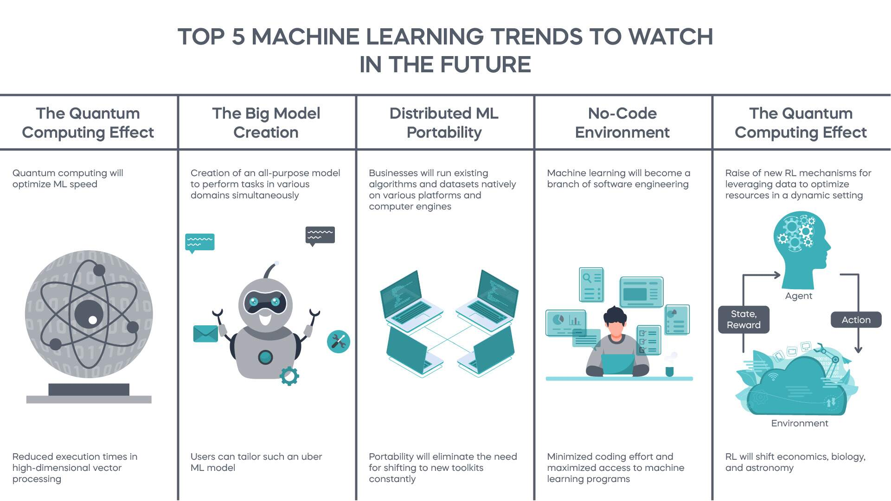

Dave Waters once said:

A baby learns to crawl, walk, and then run. We are still in the crawling stage when it comes to applying machine learning.

Here, we’ll outline **5 machine learning trends** we believe will unfold in the next few decades. They all derive from the current developments and ongoing challenges within the industry.

### 1.     Machine Learning Future – The Quantum Computing Effect

Industry experts have high hopes for [optimizing machine learning speed](https://365datascience.com/tutorials/machine-learning-tutorials/what-is-xavier-initialization/) through quantum computing. And rightfully so—it makes simultaneous multi-stage operations possible, which are then expected to reduce execution times in high-dimensional vector processing significantly.

Whether quantum computing will turn into the game-changer everyone’s talking about, we are yet to find out! Currently, there are no such models available on the market, but tech giants are working hard to make that happen. With some much uncertainty involved, the future of machine learning can be difficult to predict.

### 2.     Machine Learning Future – The Big Model Creation

The next few years are expected to mark the beginning of something big—an all-purpose model that can perform various tasks at the same time.

You won’t have to worry about understanding the relevant applications of a framework. Instead, you’ll train a model on a number of domains according to your needs. How convenient would it be to have a system that covers all bases—from diagnosing cancer to classifying dog images by breed?

Of course, a well-designed quantum processor to enhance ML capabilities will certainly give that development a boost. That’s why great minds are now putting considerable effort into reinforcing the scalability and structure of such a model. That’s one of the most exciting future applications of machine learning!

### 3.     Machine Learning Future – Distributed ML Portability

With the proliferation of [databases](https://365datascience.com/tutorials/sql-tutorials/sql-relational-databases/) and [cloud storage](https://365datascience.com/trending/cloud-computing/), data teams want to have more flexibility when it comes to using datasets in various systems.

We foresee a great advancement in the field of distributed machine learning where scientists will no longer reinvent algorithms from scratch for each platform. Rather, they will be able to immediately integrate their work into the new systems, along with the user datasets. What does this tell you about the future of machine learning?

In the coming years, we will likely experience some form of distributed ML portability by running the tools natively on various platforms and computer engines. In this way, we’ll eliminate the need for shifting to a new toolkit. Experts in the field are already talking about adding abstraction layers to make that technological leap.

### 4.     Machine Learning Future – No-Code Environment

As open-source frameworks like [TensorFlow](https://www.tensorflow.org/), [scikit-learn](https://scikit-learn.org/), [Caffe](https://caffe.berkeleyvision.org/), and [Torch](http://torch.ch/) continue to evolve, machine learning technology is likely to keep minimizing coding efforts for data teams.

In this way, non-programmers will have easy access to ML with no [postgraduate degree](https://365datascience.com/career-advice/career-guides/best-degrees-data-scientist/) required; they can simply download several packages and attend an online course on how to work with these programs. Besides, automated ML will improve the quality of results and analysis. So, in the near future, machine learning will be classified as a major branch of software engineering.

### 5.     Machine Learning Future – The Power of Reinforcement Learning

[Reinforcement learning](https://365datascience.com/tutorials/machine-learning-tutorials/types-of-machine-learning/) (RL) is revolutionary—it enables companies to make smart [business decisions](https://365datascience.com/career-advice/career-guides/5-business-basics-data-scientists/) in a dynamic setting without being specifically taught that.

With all that’s happening around us, unpredictability seems to have become the new normal. Thus, we expect ground-breaking leaps in RL to help us deal with unforeseen circumstances. And the future of machine learning is linked with that of RL.

Everyone’s talking about the optimization of resources, but it is reinforcement learning that can truly leverage data to maximize rewards, where no other model can. RL is still in its early days, so we will likely see several breakthroughs in the field within the next few years in industries like [economics](https://365datascience.com/career-advice/career-guides/transition-data-science-economics/), biology, and [astronomy](https://365datascience.com/trending/machine-learning-astronomy/).

## The Future of Machine Learning: Key Problems

Machine learning—as revolutionary as it may be—isn’t flawless. Its enormous potential comes with a number of challenges that are shaping up the digital world of tomorrow. A visionary, however, will always turn a stumbling block into a stepping stone. We believe today’s problems trigger tomorrow’s solutions, so let’s find out what the future applications of machine learning may be.

### Data Acquisition

Machine learning technology can only produce relevant and high-quality results if we feed enough data into the model. The need for massive resources then raises a question as to how unbiased and accurate the training data can possibly be. In what way do we ensure flawless input and sound results? The "garbage-in, garbage-out" principle is what drives the proper functioning of [machine learning in big data](https://365datascience.com/tutorials/machine-learning-tutorials/introduction-machine-learning/), and that’s a real challenge in today’s information-flooded environment.

### Resources

Generally, the use of machine learning technology requires a lot of resources, such as powerful computers, time for developing, perfecting, and revising a model, financing, and [data collection](https://365datascience.com/career-advice/career-guides/defining-data-science/). Businesses must be ready to take on considerable investments before reaping the harvest of adopting machine learning.

### DataTransformation

Contrary to popular belief, machine learning technology isn’t made for identifying and modifying algorithms—it’s about [transforming raw data](https://365datascience.com/courses/data-cleaning-preprocessing-pandas/) into a set of features to capture the essence of that information. In its autonomy, ML can make some mistakes that affect its efficiency in the long run.

Error susceptibility is certainly a major aspect to consider when transforming data with ML.

### Result Interpretation and Machine Learning Technology

An ML model tends to make self-fulfilling predictions. When training data and [identified patterns](https://365datascience.com/trending/trend-analysis/) are wrong, the algorithms will still use this information as a basis for generating and processing new data. And it may take some time before you realize that the model has been working in favor of the underlying bias. For this reason, result interpretation may turn into a challenging task for the user.

### Bias and Discrimination

How businesses prevent bias and discrimination when training data can be corrupted. They say the road to hell is paved with good intentions—a proverb that describes the [ethical dilemmas](https://365datascience.com/trending/gloria-yu-scholarship-winner/) of the ever-growing digital universe very well. Although you mean well when building a model to automate processes, you may unintentionally ignore or misinterpret an important human factor, which you would have otherwise prioritized. That’s a major issue when incorporating ML within recruitment and hiring practices.

### Machine learning vs AI vs deep learning

Machine learning is often confused with artificial intelligence or deep learning. Let's take a look at how these terms differ from one another. For a more in-depth look, check out our comparison guides on [**AI vs machine learning**](https://www.datacamp.com/blog/the-difference-between-ai-and-machine-learning) and [**machine learning vs deep learning**](https://www.datacamp.com/tutorial/machine-deep-learning).

**AI** refers to the development of programs that behave intelligently and mimic human intelligence through a set of algorithms. The field focuses on three skills: learning, reasoning, and self-correction to obtain maximum efficiency. AI can refer to either machine learning-based programs or even explicitly programmed computer programs.

**Machine learning** is a subset of AI, which uses algorithms that learn from data to make predictions. These predictions can be generated through supervised learning, where algorithms learn patterns from existing data, or unsupervised learning, where they discover general patterns in data. ML models can predict numerical values based on historical data, categorize events as true or false, and cluster data points based on commonalities.

**Deep learning**, on the other hand, is a subfield of machine learning dealing with algorithms based essentially on multi-layered [**artificial neural networks**](https://www.datacamp.com/tutorial/neural-network-models-r) (ANN) that are inspired by the structure of the human brain.

Unlike conventional machine learning algorithms, deep learning algorithms are less linear, more complex, and hierarchical, capable of learning from enormous amounts of data, and able to produce highly accurate results. Language translation, image recognition, and personalized medicines are some examples of [**deep learning applications**](https://www.datacamp.com/tutorial/tutorial-deep-learning-tutorial).

Fig.

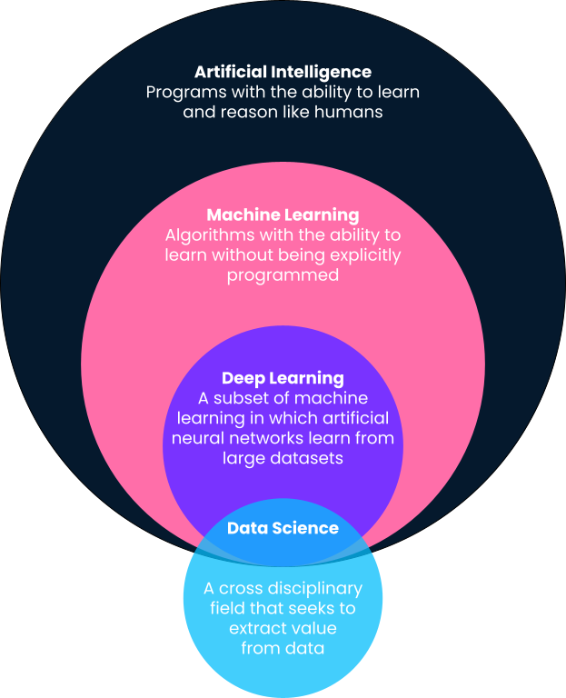

*Comparing different industry terms*

## The Importance of Machine Learning

In the 21st century, data is the new oil, and machine learning is the engine that powers this data-driven world. It is a critical technology in today's digital age, and its importance cannot be overstated. This is reflected in the industry's projected growth, with the US Bureau of Labour Statistics predicting a [**21% growth in jobs between 2021 and 2031**](https://www.bls.gov/ooh/computer-and-information-technology/computer-and-information-research-scientists.htm).

Here are some reasons why it’s so essential in the modern world:

* **Data processing.** One of the primary reasons machine learning is so important is its ability to handle and make sense of large volumes of data. With the explosion of digital data from social media, sensors, and other sources, traditional data analysis methods have become inadequate. Machine learning algorithms can process these vast amounts of data, uncover hidden patterns, and provide valuable insights that can drive decision-making.
* **Driving innovation.** Machine learning is driving innovation and efficiency across various sectors. Here are a few examples:
  + **Healthcare**. Algorithms are used to predict disease outbreaks, personalize patient treatment plans, and improve medical imaging accuracy.
  + **Finance**. Machine learning is used for credit scoring, algorithmic trading, and fraud detection.
  + **Retail**. Recommendation systems, supply chains, and [**customer service**](https://blog.hubspot.com/service/machine-learning-customer-service) can all benefit from machine learning.
  + The techniques used also find applications in sectors as diverse as agriculture, education, and entertainment.
* **Enabling automation**. Machine learning is a key enabler of automation. By learning from data and improving over time, machine learning algorithms can perform previously manual tasks, freeing humans to focus on more complex and creative tasks. This not only increases efficiency but also opens up new possibilities for innovation.

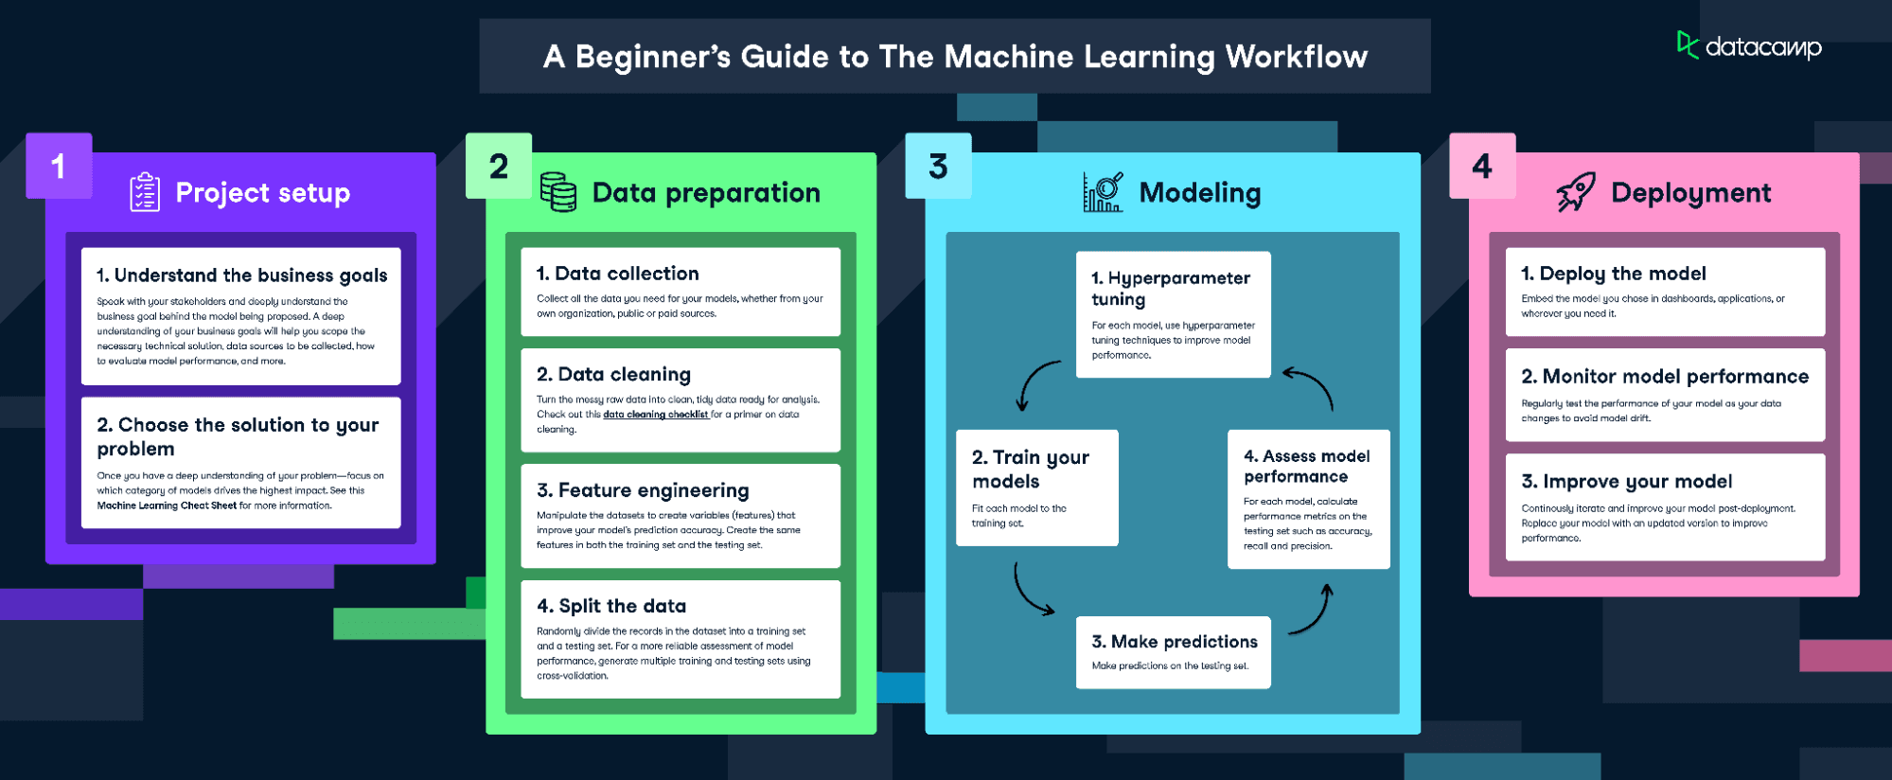

### Step 1: Data collection

The first step in the machine learning process is data collection. Data is the lifeblood of machine learning - the quality and quantity of your data can directly impact your model's performance. Data can be collected from various sources such as databases, text files, images, audio files, or even scraped from the web.

Once collected, the data needs to be prepared for machine learning. This process involves organizing the data in a suitable format, such as a CSV file or a database, and ensuring that the data is relevant to the problem you're trying to solve.

### Step 2: Data preprocessing

Data preprocessing is a crucial step in the machine learning process. It involves cleaning the data (removing duplicates, correcting errors), handling missing data (either by removing it or filling it in), and normalizing the data (scaling the data to a standard format).

Preprocessing improves the quality of your data and ensures that your machine learning model can interpret it correctly.

### Step 3: Choosing the right model

Once the data is prepared, the next step is to choose a machine learning model. There are many types of models to choose from, including linear regression, decision trees, and neural networks. The choice of model depends on the nature of your data and the problem you're trying to solve.

Factors to consider when choosing a model include the size and type of your data, the complexity of the problem, and the computational resources available.

### Step 4: Training the model

After choosing a model, the next step is to train it using the prepared data. Training involves feeding the data into the model and allowing it to adjust its internal parameters to better predict the output.

During training, it's important to avoid overfitting (where the model performs well on the training data but poorly on new data) and underfitting (where the model performs poorly on both the training data and new data). You can learn more about the full machine learning process in our [**Machine Learning Fundamentals with Python**](https://www.datacamp.com/tracks/machine-learning-fundamentals-with-python) skill track, which explores the essential concepts and how to apply them.

### Step 5: Evaluating the model

Once the model is trained, it's important to evaluate its performance before deploying it. This involves testing the model on new data it hasn't seen during training.

Common metrics for evaluating a model's performance include accuracy (for classification problems), precision and recall (for binary classification problems), and mean squared error (for regression problems).

### Step 6: Hyperparameter tuning and optimization

After evaluating the model, you may need to adjust its hyperparameters to improve its performance. This process is known as parameter tuning or hyperparameter optimization.

Techniques for hyperparameter tuning include grid search (where you try out different combinations of parameters) and cross validation (where you divide your data into subsets and train your model on each subset to ensure it performs well on different data).

### Step 7: Predictions and deployment

Once the model is trained and optimized, it's ready to make predictions on new data. This process involves feeding new data into the model and using the model's output for decision-making or further analysis.

Deploying the model involves integrating it into a production environment where it can process real-world data and provide real-time insights. This process is often known as MLOps. Discover more about **[MLOps](https://www.datacamp.com/tutorial/tutorial-machine-learning-pipelines-mlops-deployment" \t "_blank)** in a separate tutorial.

## Types of Machine Learning

Machine learning can be broadly classified into three types based on the nature of the learning system and the data available: supervised learning, unsupervised learning, and reinforcement learning. Let's delve into each of these:

### Supervised learning

[**Supervised learning**](https://www.datacamp.com/blog/supervised-machine-learning) is the most common type of machine learning. In this approach, the model is trained on a labelled dataset. In other words, the data is accompanied by a label that the model is trying to predict. This could be anything from a category label to a real-valued number.

The model learns a mapping between the input (features) and the output (label) during the training process. Once trained, the model can predict the output for new, unseen data.

Common examples of supervised learning algorithms include [**linear regression**](https://www.datacamp.com/tutorial/essentials-linear-regression-python) for regression problems and logistic regression, [**decision trees**](https://www.datacamp.com/tutorial/decision-tree-classification-python), and support vector machines for classification problems. In practical terms, this could look like an image recognition process, wherein a dataset of images where each picture is labelled as "cat," "dog," etc., a supervised model can recognize and categorize new images accurately.

### Unsupervised learning

[**Unsupervised learning**](https://www.datacamp.com/blog/introduction-to-unsupervised-learning), on the other hand, involves training the model on an unlabelled dataset. The model is left to find patterns and relationships in the data on its own.

This type of learning is often used for clustering and dimensionality reduction. Clustering involves grouping similar data points together, while dimensionality reduction involves reducing the number of random variables under consideration by obtaining a set of principal variables.

Common examples of unsupervised learning algorithms include [**k-means for clustering problems**](https://www.datacamp.com/tutorial/k-means-clustering-python) and [**Principal Component Analysis**](https://www.datacamp.com/tutorial/principal-component-analysis-in-python) (PCA) for dimensionality reduction problems. Again, in practical terms, in the field of marketing, unsupervised learning is often used to segment a company's customer base. By examining purchasing patterns, demographic data, and other information, the algorithm can group customers into segments that exhibit similar behaviours without any pre-existing labels.

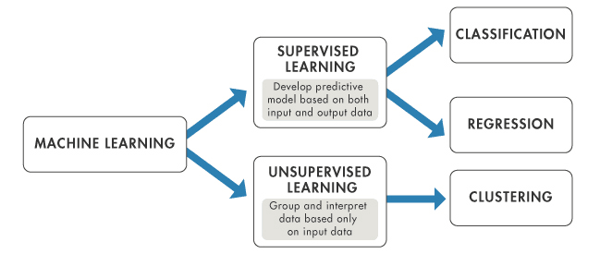

Comparing supervised and unsupervised learning

### Reinforcement learning

[**Reinforcement learning**](https://www.datacamp.com/tutorial/introduction-reinforcement-learning) is a type of machine learning where an agent learns to make decisions by interacting with its environment. The agent is rewarded or penalized (with points) for the actions it takes, and its goal is to maximize the total reward.

Unlike supervised and unsupervised learning, reinforcement learning is particularly suited to problems where the data is sequential, and the decision made at each step can affect future outcomes.

Common examples of reinforcement learning include game playing, robotics, resource management, and many more.

## Understanding the Impact of Machine Learning

Machine Learning has had a transformative impact across various industries, revolutionizing traditional processes and paving the way for innovation. Let's explore some of these impacts:

“***Machine learning is the most transformative technology of our time. It’s going to transform every single vertical.***”

### Healthcare

In healthcare, machine learning is used to predict disease outbreaks, personalize patient treatment plans, and improve medical imaging accuracy. For instance, [**Google's DeepMind Health**](https://pharmaphorum.com/news/google-and-deepmind-share-work-on-medical-chatbot-med-palm) is working with doctors to build machine learning models to detect diseases earlier and improve patient care.

### Finance

The finance sector has also greatly benefited from machine learning. It's used for credit scoring, algorithmic trading, and fraud detection. A recent survey found that [**56% of global executives**](https://www.securitymagazine.com/articles/99596-ai-and-machine-learning-have-been-added-to-financial-crime-programs) said that artificial intelligence (AI) and machine learning have been implemented into financial crime compliance programs.

### Transportation

Machine learning is at the heart of the self-driving car revolution. Companies like Tesla and Waymo use machine learning algorithms to interpret sensor data in real-time, allowing their vehicles to recognize objects, make decisions, and navigate roads autonomously. Similarly, the Swedish Transport Administration recently started [**working with computer vision and machine learning specialists**](https://www.smartcitiesworld.net/ai-and-machine-learning/ai-and-machine-learning/ai-used-to-monitor-and-optimise-swedish-road-infrastructure) to optimize the country’s road infrastructure management.

## Some Applications of Machine Learning

Machine learning applications are all around us, often working behind the scenes to enhance our daily lives. Here are some real-world examples:

### Recommendation systems

Recommendation systems are one of the most visible applications of machine learning. Companies like Netflix and Amazon use machine learning to analyse your past behaviour and recommend products or movies you might like. Learn how to [**build a recommendation engine in Python**](https://www.datacamp.com/courses/building-recommendation-engines-in-python) with our online course.

### Voice assistants

Voice assistants like Siri, Alexa, and Google Assistant use machine learning to understand your voice commands and provide relevant responses. They continually learn from your interactions to improve their performance.

### Fraud detection

Banks and credit card companies use machine learning to detect fraudulent transactions. By analysing patterns of normal and abnormal behaviour, they can flag suspicious activity in real-time. We have a [**fraud detection in Python course**](https://www.datacamp.com/courses/fraud-detection-in-python), which explores the concept in more detail.Social media

Social media platforms use machine learning for a variety of tasks, from personalizing your feed to filtering out inappropriate content.

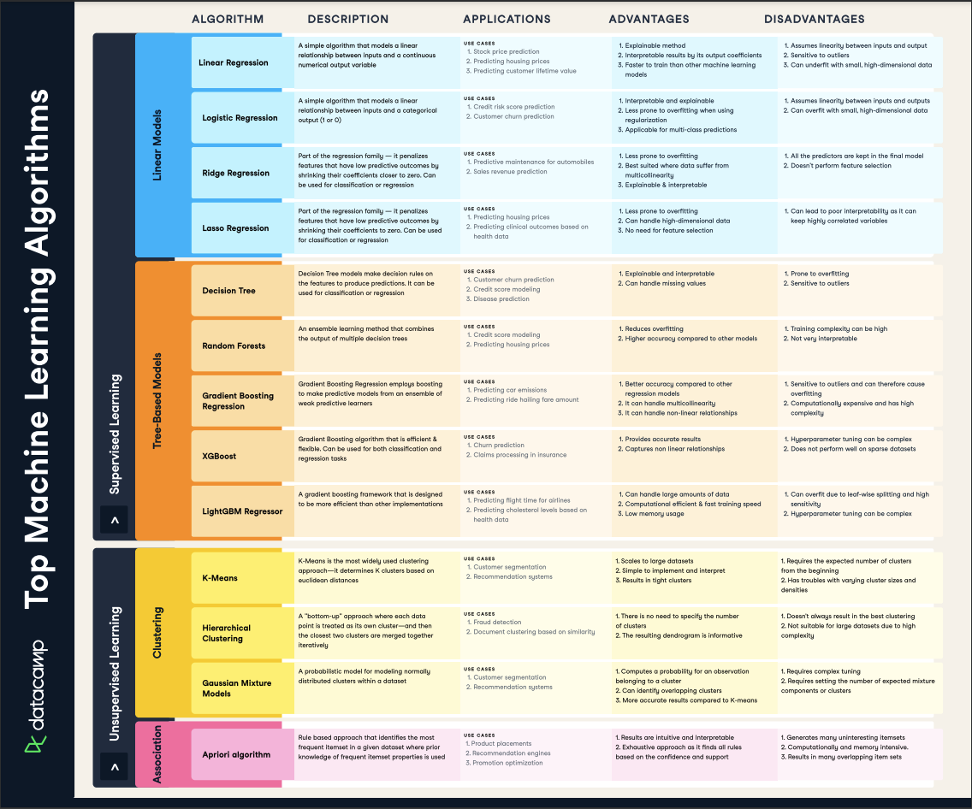

Our [***machine learning cheat sheet***](https://www.datacamp.com/cheat-sheet/machine-learning-cheat-sheet) covers different algorithms and their uses

## Machine Learning Tools

In the world of machine learning, having the right tools is just as important as understanding the concepts. These tools, which include programming languages and libraries, provide the building blocks to implement and deploy machine learning algorithms. Let's explore some of the most popular tools in machine learning:

### Python for machine learning

Python is a popular language for machine learning due to its simplicity and readability, making it a great choice for beginners. It also has a strong ecosystem of libraries that are tailored for machine learning.

Libraries such as NumPy and Pandas are used for data manipulation and analysis, while Matplotlib is used for data visualization. Scikit-learn provides a wide range of machine learning algorithms, and TensorFlow and PyTorch are used for building and training neural networks.

### R for machine learning

R is another language widely used in machine learning, particularly for statistical analysis. It has a rich ecosystem of packages that make it easy to implement machine learning algorithms.

Packages like caret, mlr, and randomForest provide a variety of machine learning algorithms, from regression and classification to clustering and dimensionality reduction.

### TensorFlow

TensorFlow is a powerful open-source library for numerical computation, particularly well-suited for large-scale machine learning. It was developed by the Google Brain team and supports both CPUs and GPUs.

TensorFlow allows you to build and train complex neural networks, making it a popular choice for deep learning applications.

### Scikit-learn

Scikit-learn is a Python library that provides a wide range of machine learning algorithms for both supervised and unsupervised learning. It's known for its clear API and detailed documentation.

Scikit-learn is often used for data mining and data analysis, and it integrates well with other Python libraries like NumPy and Pandas.

### Keras

Keras is a high-level neural networks API, written in Python and capable of running on top of TensorFlow, CNTK, or Theano. It was developed with a focus on enabling fast experimentation.

Keras provides a user-friendly interface for building and training neural networks, making it a great choice for beginners in deep learning.

### PyTorch

PyTorch is an open-source machine learning library based on the Torch library. It's known for its flexibility and efficiency, making it popular among researchers.

PyTorch supports a wide range of applications, from computer vision to natural language processing. One of its key features is the dynamic computational graph, which allows for flexible and optimized computation.

## The Top Machine Learning Careers in 2023

Machine learning has opened up a wide range of career opportunities. From data science to AI engineering, professionals with machine learning skills are in high demand. Let's explore some of these career paths:

### Data scientist

A [**data scientist**](https://www.datacamp.com/blog/how-to-become-a-data-scientist) uses scientific methods, processes, algorithms, and systems to extract knowledge and insights from structured and unstructured data. Machine learning is a key tool in a data scientist's arsenal, allowing them to make predictions and uncover patterns in data.

Key skills:

* Statistical analysis
* Programming (Python, R)
* Machine learning
* Data visualization
* Problem-solving

Essential tools:

* Python
* R
* SQL
* Hadoop
* Spark
* Tableau

### Machine learning engineer

A [**machine learning engineer**](https://www.datacamp.com/blog/how-to-become-a-machine-learning-engineer) designs and implements machine learning systems. They run machine learning experiments using programming languages like Python and R, work with datasets, and apply machine learning algorithms and libraries.

Key skills:

* Programming (Python, Java, R)
* Machine learning algorithms
* Statistics
* System design

Essential tools:

* Python
* TensorFlow
* Scikit-learn
* PyTorch
* Keras

### Research scientist

A research scientist in machine learning conducts research to advance the field of machine learning. They work in both academic and industry settings, developing new algorithms and techniques.

Key skills:

* Deep understanding of machine learning algorithms
* Programming (Python, R)
* Research methodology
* Strong mathematical skills

Essential tools:

* Python
* R
* TensorFlow
* PyTorch
* MATLAB

|  |  |  |
| --- | --- | --- |
| **Career** | **Key Skills** | **Essential Tools** |
| **Data Scientist** | Statistical analysis, Programming (Python, R), Machine learning, Data visualization, Problem-solving | Python, R, SQL, Hadoop, Spark, Tableau |
| **Machine Learning Engineer** | Programming (Python, Java, R), Machine learning algorithms, Statistics, System design | Python, TensorFlow, Scikit-learn, PyTorch, Keras |
| **Research Scientist** | Deep understanding of machine learning algorithms, Programming (Python, R), Research methodology, Strong mathematical skills | Python, R, TensorFlow, PyTorch, MATLAB |

## How to Get Started in Machine Learning

Starting a journey in machine learning can seem daunting, but with the right approach and resources, anyone can learn this exciting field. Here are some steps to get you started:

### Understand the basics

Before diving into machine learning, it's important to have a strong foundation in mathematics (especially statistics and linear algebra) and programming (Python is a popular choice due to its simplicity and the availability of machine learning libraries).

### Choose the right tools

Choosing the right tools is crucial in machine learning. Python, along with libraries like NumPy, Pandas, and Scikit-learn, is a popular choice due to its simplicity and versatility.

### Learn machine learning algorithms

Once you're comfortable with the basics, you can start learning about machine learning algorithms. Start with simple algorithms like linear regression and decision trees before moving on to more complex ones like neural networks.

### Work on projects

Working on projects is a great way to gain practical experience and reinforce what you've learned. Start with simple projects like predicting house prices or classifying iris species, and gradually take on more complex projects.

### Stay up-to-date

Machine learning is a rapidly evolving field, so it's important to stay up-to-date with the latest developments. Following relevant blogs, attending conferences, and participating in online communities can help you stay informed. The **[DataFramed Podcast](https://www.datacamp.com/podcast" \t "_blank)** and our [**webinars**](https://www.datacamp.com/webinars) and live trainings are a great way to keep up with trending topics in the industry.

## Final Thoughts

From healthcare and finance to transportation and entertainment, machine learning algorithms are driving innovation and efficiency across various sectors. As we've seen, getting started in machine learning requires a strong foundation in mathematics and programming, a good understanding of machine learning algorithms, and practical experience working on projects.

Whether you're interested in becoming a data scientist, a machine learning engineer, an AI specialist, or a research scientist, there's a wealth of opportunities in the field of machine learning. With the right tools and resources, anyone can learn machine learning and contribute to this exciting field.

Remember, learning machine learning is a journey. It's a field that's constantly evolving, so it's important to stay up-to-date with the latest developments. Follow relevant blogs, attend conferences, and participate in online communities to keep learning and growing.

Machine learning is not just a buzzword - it's a powerful tool that's changing the way we live and work. By understanding what machine learning is, how it works, and how to get started, you're taking the first step towards a future where you can harness the power of machine learning to solve complex problems and make a real impact.

## Project Setup

### Understand business goals

Speak with your stakeholders and deeply understand the business goal behind the model being proposed. A deep understanding of your business goals will help you scope the necessary technical solution, data sources to be collected, how to evaluate model performance, and more.

### Choose the solution to your problem

Once you have a deep understanding of your problem—focus on which category of models drives the highest impact.

## Data preparation

### Data collection

Collect all the data you need for your models, whether from your own organization, public or paid sources.

### Data cleaning

Turn the messy raw data into clean, tidy data ready for analysis. Check out this [**data cleaning checklist**](https://www.datacamp.com/blog/infographic-data-cleaning-checklist) for a primer on data cleaning.

### Feature engineering

Manipulate the datasets to create variables (features) that improve your model’s prediction accuracy. Create the same features in both the training set and the testing set.

### Split the data

Randomly divide the records in the dataset into a training set and a testing set. For a more reliable assessment of model performance, generate multiple training and testing sets using cross validation

## Modeling

### Hyperparameter tuning

For each model, use hyperparameter tuning techniques to improve model performance.

### Train your models

Fit each model to the training set.

### Make predictions

Make predictions on the testing set.

### Assess model performance

For each model, calculate performance metrics on the testing set such as accuracy, recall and precision.

## Deployment

### Deploy the model

Embed the model you chose in dashboards, applications, or wherever you need it.

### Monitor model performance

Regularly test the performance of your model as your data changes to avoid model drift

### Improve your model

Continuously iterate and improve your model post deployment. Replace your model with an updated version to improve performance.

Machine learning versus deep learning versus neural networks

Since deep learning and machine learning tend to be used interchangeably, it’s worth noting the nuances between the two. Machine learning, deep learning, and neural networks are all sub-fields of artificial intelligence. However, neural networks is actually a sub-field of machine learning, and deep learning is a sub-field of neural networks.

The way in which deep learning and machine learning differ is in how each algorithm learns. "Deep" machine learning can use labeled datasets, also known as supervised learning, to inform its algorithm, but it doesn’t necessarily require a labeled dataset. The deep learning process can ingest unstructured data in its raw form (e.g., text or images), and it can automatically determine the set of features which distinguish different categories of data from one another. This eliminates some of the human intervention required and enables the use of large amounts of data.

Classical, or "non-deep," machine learning is more dependent on human intervention to learn. Human experts determine the set of features to understand the differences between data inputs, usually requiring more structured data to learn.

Neural networks, or artificial neural networks (ANNs), are comprised of node layers, containing an input layer, one or more hidden layers, and an output layer. Each node, or artificial neuron, connects to another and has an associated weight and threshold. If the output of any individual node is above the specified threshold value, that node is activated, sending data to the next layer of the network. Otherwise, no data is passed along to the next layer of the network by that node. The “deep” in deep learning is just referring to the number of layers in a neural network. A neural network that consists of more than three layers—which would be inclusive of the input and the output—can be considered a deep learning algorithm or a deep neural network. A neural network that only has three layers is just a basic neural network.

Deep learning and neural networks are credited with accelerating progress in areas such as computer vision, natural language processing, and speech recognition.

Machine learning models fall into three primary categories.

### Supervised machine learning

[Supervised learning](https://www.ibm.com/topics/supervised-learning), also known as supervised machine learning, is defined by its use of labeled datasets to train algorithms to classify data or predict outcomes accurately. As input data is fed into the model, the model adjusts its weights until it has been fitted appropriately. This occurs as part of the cross validation process to ensure that the model avoids [overfitting](https://www.ibm.com/topics/overfitting) or [underfitting](https://www.ibm.com/topics/underfitting). Supervised learning helps organizations solve a variety of real-world problems at scale, such as classifying spam in a separate folder from your inbox. Some methods used in supervised learning include neural networks, naïve bayes, linear regression, logistic regression, random forest, and support vector machine (SVM).

### Unsupervised machine learning

[Unsupervised learning](https://www.ibm.com/topics/unsupervised-learning), also known as unsupervised machine learning, uses machine learning algorithms to analyze and cluster unlabeled datasets (subsets called clusters). These algorithms discover hidden patterns or data groupings without the need for human intervention. This method’s ability to discover similarities and differences in information make it ideal for exploratory data analysis, cross-selling strategies, customer segmentation, and image and pattern recognition. It’s also used to reduce the number of features in a model through the process of dimensionality reduction. Principal component analysis (PCA) and singular value decomposition (SVD) are two common approaches for this. Other algorithms used in unsupervised learning include neural networks, k-means clustering, and probabilistic clustering methods.

### Semi-supervised learning

Semi-supervised learning offers a happy medium between supervised and unsupervised learning. During training, it uses a smaller labeled data set to guide classification and feature extraction from a larger, unlabeled data set. Semi-supervised learning can solve the problem of not having enough labeled data for a supervised learning algorithm. It also helps if it’s too costly to label enough data.

Reinforcement machine learning

Reinforcement machine learning is a machine learning model that is similar to supervised learning, but the algorithm isn’t trained using sample data. This model learns as it goes by using trial and error. A sequence of successful outcomes will be reinforced to develop the best recommendation or policy for a given problem.

The IBM Watson® system that won the Jeopardy! challenge in 2011 is a good example. The system [used reinforcement learning](https://developer.ibm.com/articles/cc-reinforcement-learning-train-software-agent/) to learn when to attempt an answer (or question, as it were), which square to select on the board, and how much to wager—especially on daily doubles.

[Learn more about reinforcement learning](https://developer.ibm.com/articles/cc-models-machine-learning/#reinforcement-learning)

Common machine learning algorithms

A number of machine learning algorithms are commonly used. These include:

* **Neural networks:** [Neural networks](https://www.ibm.com/topics/neural-networks) simulate the way the human brain works, with a huge number of linked processing nodes. Neural networks are good at recognizing patterns and play an important role in applications including natural language translation, image recognition, speech recognition, and image creation.
* **Linear regression:** This algorithm is used to predict numerical values, based on a [linear relationship](https://www.ibm.com/topics/linear-regression) between different values. For example, the technique could be used to predict house prices based on historical data for the area.
* **Logistic regression:** This supervised learning algorithm makes [predictions](https://www.ibm.com/topics/logistic-regression)for categorical response variables, such as “yes/no” answers to questions. It can be used for applications such as classifying spam and quality control on a production line.
* **Clustering:** Using unsupervised learning, clustering algorithms can identify patterns in data so that it can be grouped. Computers can help data scientists by identifying differences between data items that humans have overlooked.
* **Decision trees:** Decision trees can be used for both predicting numerical values (regression) and classifying data into categories. Decision trees use a branching sequence of linked decisions that can be represented with a tree diagram. One of the advantages of decision trees is that they are easy to validate and audit, unlike the black box of the neural network.
* **Random forests:** In a random forest, the machine learning algorithm predicts a value or category by combining the results from a number of decision trees.

**Advantages and disadvantages of machine learning algorithms :-**

Depending on your budget, need for speed and precision required, each [algorithm type](https://www.ibm.com/topics/machine-learning-algorithms)—supervised, unsupervised, semi-supervised, or reinforcement—has its own advantages and disadvantages. For example, decision tree algorithms are used for both predicting numerical values (regression problems) and classifying data into categories. Decision trees use a branching sequence of linked decisions that may be represented with a tree diagram. A prime advantage of decision trees is that they are easier to validate and audit than a neural network. The bad news is that they can be more unstable than other decision predictors.   
  
Overall, there are many advantages to machine learning that businesses can leverage for new efficiencies. These include machine learning identifying patterns and trends in massive volumes of data that humans might not spot at all. And this analysis requires little human intervention: just feed in the dataset of interest and let the machine learning system assemble and refine its own algorithms—which will continually improve with more data input over time. Customers and users can enjoy a more personalized experience as the model learns more with every experience with that person.  
  
On the downside, machine learning requires large training datasets that are accurate and unbiased. GIGO is the operative factor: garbage in / garbage out. Gathering sufficient data and having a system robust enough to run it might also be a drain on resources. Machine learning can also be prone to error, depending on the input. With too small a sample, the system could produce a perfectly logical algorithm that is completely wrong or misleading. To avoid wasting budget or displeasing customers, organizations should act on the answers only when there is high confidence in the output.

Real-world machine learning use cases

Here are just a few examples of machine learning you might encounter every day:

**Speech recognition:** It is also known as automatic speech recognition (ASR), computer speech recognition, or speech-to-text, and it is a capability which uses natural language processing (NLP) to translate human speech into a written format. Many mobile devices incorporate speech recognition into their systems to conduct voice search—e.g. Siri—or improve accessibility for texting.

**Customer service:**  [Online chatbots](https://www.ibm.com/products/watsonx-assistant/customer-service) are replacing human agents along the customer journey, changing the way we think about customer engagement across websites and social media platforms. Chatbots answer frequently asked questions (FAQs) about topics such as shipping, or provide personalized advice, cross-selling products or suggesting sizes for users. Examples include [virtual agents](https://www.ibm.com/products/watsonx-assistant) on e-commerce sites; messaging bots, using Slack and Facebook Messenger; and tasks usually done by virtual assistants and voice assistants.

**Computer vision:** This [AI](https://www.ibm.com/consulting/artificial-intelligence) technology enables computers to derive meaningful information from digital images, videos, and other visual inputs, and then take the appropriate action. Powered by convolutional neural networks, computer vision has applications in photo tagging on social media, radiology imaging in healthcare, and self-driving cars in the automotive industry.

**Recommendation engines:** Using past consumption behavior data, AI algorithms can help to discover data trends that can be used to develop more effective cross-selling strategies. Recommendation engines are used by online retailers to make relevant product recommendations to customers during the checkout process.  
  
**Robotic process automation (RPA**): Also known as software robotics, RPA uses intelligent automation technologies to perform repetitive manual tasks.

**Automated stock trading:** Designed to optimize stock portfolios, AI-driven high-frequency trading platforms make thousands or even millions of trades per day without human intervention.

**Fraud detection:** Banks and other financial institutions can use machine learning to spot suspicious transactions. Supervised learning can train a model using information about known fraudulent transactions. Anomaly detection can identify transactions that look atypical and deserve further investigation.

Challenges of machine learning

As machine learning technology has developed, it has certainly made our lives easier. However, implementing machine learning in businesses has also raised a number of ethical concerns about AI technologies. Some of these include:

### Technological singularity

While this topic garners a lot of public attention, many researchers are not concerned with the idea of AI surpassing human intelligence in the near future. Technological singularity is also referred to as strong AI or superintelligence. Philosopher Nick Bostrum defines superintelligence as “any intellect that vastly outperforms the best human brains in practically every field, including scientific creativity, general wisdom, and social skills.” Despite the fact that superintelligence is not imminent in society, the idea of it raises some interesting questions as we consider the use of autonomous systems, like self-driving cars. It’s unrealistic to think that a driverless car would never have an accident, but who is responsible and liable under those circumstances? Should we still develop autonomous vehicles, or do we limit this technology to semi-autonomous vehicles which help people drive safely? The jury is still out on this, but these are the types of ethical debates that are occurring as new, innovative AI technology develops.

### AI impact on jobs

While a lot of public perception of artificial intelligence centers around job losses, this concern should probably be reframed. With every disruptive, new technology, we see that the market demand for specific job roles shifts. For example, when we look at the automotive industry, many manufacturers, like GM, are shifting to focus on electric vehicle production to align with green initiatives. The energy industry isn’t going away, but the source of energy is shifting from a fuel economy to an electric one.

In a similar way, artificial intelligence will shift the demand for jobs to other areas. There will need to be individuals to help manage AI systems. There will still need to be people to address more complex problems within the industries that are most likely to be affected by job demand shifts, such as customer service. The biggest challenge with artificial intelligence and its effect on the job market will be helping people to transition to new roles that are in demand.

### Privacy

Privacy tends to be discussed in the context of data privacy, data protection, and data security. These concerns have allowed policymakers to make more strides in recent years. For example, in 2016, GDPR legislation was created to protect the personal data of people in the European Union and European Economic Area, giving individuals more control of their data. In the United States, individual states are developing policies, such as the California Consumer Privacy Act (CCPA), which was introduced in 2018 and requires businesses to inform consumers about the collection of their data. Legislation such as this has forced companies to rethink how they store and use personally identifiable information (PII). As a result, investments in security have become an increasing priority for businesses as they seek to eliminate any vulnerabilities and opportunities for surveillance, hacking, and cyberattacks.

### Bias and discrimination

Instances of bias and discrimination across a number of machine learning systems have raised many ethical questions regarding the use of artificial intelligence. How can we safeguard against bias and discrimination when the training data itself may be generated by biased human processes? While companies typically have good intentions for their automation efforts, [Reuters](https://www.reuters.com/article/us-amazon-com-jobs-automation-insight/amazon-scraps-secret-ai-recruiting-tool-that-showed-bias-against-women-idUSKCN1MK08G) highlights some of the unforeseen consequences of incorporating AI into hiring practices. In their effort to automate and simplify a process, Amazon unintentionally discriminated against job candidates by gender for technical roles, and the company ultimately had to scrap the project. [Harvard Business Review](https://hbr.org/2019/04/the-legal-and-ethical-implications-of-using-ai-in-hiring)  has raised other pointed questions about the use of AI in hiring practices, such as what data you should be able to use when evaluating a candidate for a role.

Bias and discrimination aren’t limited to the human resources function either; they can be found in a number of applications from facial recognition software to social media algorithms.

As businesses become more aware of the risks with AI, they’ve also become more active in this discussion around AI ethics and values. For example, IBM has sunset its general purpose facial recognition and analysis products. IBM CEO Arvind Krishna wrote: “IBM firmly opposes and will not condone uses of any technology, including facial recognition technology offered by other vendors, for mass surveillance, racial profiling, violations of basic human rights and freedoms, or any purpose which is not consistent with our values and Principles of Trust and Transparency.”

### Accountability

Since there isn’t significant legislation to regulate AI practices, there is no real enforcement mechanism to ensure that ethical AI is practiced. The current incentives for companies to be ethical are the negative repercussions of an unethical AI system on the bottom line. To fill the gap, ethical frameworks have emerged as part of a collaboration between ethicists and researchers to govern the construction and distribution of AI models within society. However, at the moment, these only serve to guide. Some [research](https://arxiv.org/ftp/arxiv/papers/1903/1903.03425.pdf) (link resides outside ibm.com) shows that the combination of distributed responsibility and a lack of foresight into potential consequences aren’t conducive to preventing harm to society.

**Conclusion** :- This paper presents the deeper insight of deep convolutional neural networks with their latest developments and adopts a categorization scheme to analyze the existing literature. Some widely used techniques and variants of CNN are investigated. More specifically, state-of-the-art approaches of convolutional neural network are analyzed, expounded, Machine Learning can be a Supervised or Unsupervised. If you have lesser amount of data and clearly labelled data for training, opt for Supervised Learning. Unsupervised Learning would generally give better performance and results for large data sets. If you have a huge data set easily available, go for deep learning techniques. You also have learned Reinforcement Learning and Deep Reinforcement Learning. You now know what Neural Networks are, their applications and limitations. This paper surveys various machine learning algorithms. Today each and every person is using machine learning knowingly or unknowingly. From getting a recommended product in online shopping to updating photos in social networking sites. This paper gives an introduction to most of the popular machine learning algorithms.

## REFERENCES: -

[1] W. Richert, L. P. Coelho, “Building Machine Learning Systems with Python”, Packt Publishing Ltd., ISBN 978-1-78216-140-0

[2] J. M. Keller, M. R. Gray, J. A. Givens Jr., “A Fuzzy K-Nearest Neighbor Algorithm”, IEEE Transactions on Systems, Man and Cybernetics, Vol. SMC-15, No. 4, August 1985

[3] https://www.geeksforgeeks.org/machine-learning/

[4] ] S. Marsland, Machine learning: an algorithmic perspective. CRC press, 2015.

[5] M. Bkassiny, Y. Li, and S. K. Jayaweera, “A survey on machine learning techniques in cognitive radios,” IEEE Communications Surveys & Tutorials, vol. 15, no. 3, pp. 1136–1159, Oct. 2012.

[6] https://en.wikipedia.org/wiki/Instance-based\_learning

[7] R. S. Sutton, “Introduction: The Challenge of Reinforcement Learning”, Machine Learning, 8, Page 225-227, Kluwer Academic Publishers, Boston, 1992

[8] P. Harrington, “Machine Learning in action”, Manning Publications Co., Shelter Island, New York, 2012

## 9. Diksha Sharma Neeraj Kumar A Review on Machine Learning Algorithms, Tasks and Applications, International Journal of Advanced Research in Computer Engineering & Technology (IJARCET) Volume 6, Issue 10, October 2017, ISSN: 2278 – 1323

## 10. SUPERVISED MACHINE LEARNING APPROACHES: A SURVEY Iqbal Muhammad1 and Zhu Yan2 School of Information Sciences and Technology, Southwest Jiaotong University, China. DOI: 10.21917/ijsc.2015.0133

## 11. James Cussens, “Machine Learning”, IEEE Journal of Computing and Control, Vol. 7, No. 4, pp 164-168, 1996.

## 12. D. Aha, “Lazy Learning”, Dordrecht: Kluwer Academic Publishers, 1997.A. Coats and B. Huval, “Deep Learning with COTS HPS systems”, Journal of Machine Learning Research, Vol. 28, No. 3, pp. 1337-1345, 2013.

## 13. Steven L. Salzberg, “Book Review: C4.5: Programs for Machine Learning by J. Ross Quinlan. Inc., 1993”, Machine Learning, Vol. 16, No. 3, pp. 235-240, 1994.

## 14. S. Tong, D. Koller, "Support vector machine active learning with applications to text classification", J. Mach. Learn. Res., vol. 2, pp. 45-66, Nov. 2002.