ANALYSIS OF SETBACK RC FRAMED BUILDINGS UNDER EARTHQUAKES Adeeb Hasan¹, Mirza Aamir Baig²
¹M. tech Student, Department of Civil Engineering, Alfalah University, Haryana, India
²Assistant Professor, Department of Civil Engineering, Alfalah University, Haryana, India

ABSTRACT
The motion of the ground during earthquake do not damage the building by impact or by any external force, rather it impacts the building by creating an internal inertial force which is due to vibration of building mass. The magnitude of lateral force due to an earthquake depends mainly on inertial mass, ground acceleration and the dynamic characteristics of the building. To characterize the ground motion and structural behavior, design codes provide a Response spectrum. Response spectrum conveniently describes the peak responses of structure as a function of natural vibration period. Therefore, it is necessary to study of natural vibration period of building to understand the seismic response of building. The behavior of a multi-storey framed building during strong earthquake motions depends on the distribution of mass, stiffness, and strength in both the horizontal and vertical planes of the building. In multistoried framed buildings, damage from earthquake ground motion generally initiates at locations of structural weaknesses present in the lateral load resisting frames. In some cases, these weaknesses may be created by discontinuities in stiffness, strength or mass between adjacent storeys. Such discontinuities between storeys are often associated with sudden variations in the frame geometry along the height. There are many examples of failure of buildings in past earthquakes due to such vertical discontinuities. A common type of vertical geometrical irregularity in building structures arises from abrupt reduction of the lateral dimension of the building at specific levels of the elevation.
Keywords: steel frame, bracing systems, torsional moments, Pushover Analysis, ductility
- INTRODUCTION
The magnitude of lateral force due to an earthquake depends mainly on inertial mass, ground acceleration and the dynamic characteristics of the building. To characterize the ground motion and structural behaviour, design codes provide a Response spectrum. Response spectrum conveniently describes the peak responses of structure as a function of natural vibration period, damping ratio and type of founding soil. The determination of the fundamental period of structures is essential to earthquake design and assessment. Seismic analysis of most structures is carried out using Linear Static (Equivalent Static) and Linear Dynamic (Response Spectrum) methods. Lateral forces calculated as per Equivalent Static Method depends on structural mass and fundamental period of structure. The empirical equations of the fundamental period of buildings given in the design codes are function of building height and base dimension of the buildings. Theoretically Response Spectrum Method uses modal analysis to calculate the natural periods of the building to compute the design base shear. However, some of the international codes (such as IS 1893:2002 and ASCE 7:2010) recommend to scale up the base shear (and other response quantities) corresponding to the fundamental period as per the code specified empirical formula, so as to improve this base shear (or any other response quantity) for Response Spectrum Analysis to make it equal to that of Equivalent. Ststic Analysis. Therefore, estimation of fundamental period using the code empirical formula is inevitable for seismic design of buildings. Setback in buildings introduces staggered abrupt reductions in floor area along the height of the building. This building form is becoming increasingly popular in modern multi-storey building construction mainly because of its functional and aesthetic architecture. In particular, such a setback form provides for adequate daylight and ventilation for the lower storey in an urban locality with closely spaced tall buildings. This setback affects the mass, strength, stiffness, centre of mass and centre of stiffness of setback building. Dynamic characteristics of such buildings differ from the regular building due to changes in geometrical and structural property. Design codes are not clear about the definition of building height for computation of fundamental period. The bay- wise variation of height in setback building makes it difficult to compute natural period of such buildings. With this background it is found essential to study the effect of setbacks on the fundamental period of buildings. Also, the performance of the empirical equation given in Indian Standard IS 1893:2002 for estimation of fundamental period of setback buildings is matter of concern for structural engineers. This is the primary motivation underlying the present study.


Figure 1: Setback Building
- OBJECTIVE
Design codes have not given particular attention to the setback building form. The research papers on setback buildings conclude that the displacement demand is dependent on the geometrical configuration of frame and concentrated in the neighborhood of the setbacks for setback buildings.
- To perform a parametric study of the fundamental period of different types of reinforced concrete moment resisting frames (MRF) with varying number of stories, number of bays, configuration, and types of irregularity.
- To compare the fundamental periods of each structure calculated using code empirical equations and Rayleigh methods with fundamental period based on modal analysis.
- Select an exhaustive set of setbacks building frame models with different heights (2 to 25 storeys), Bay width in both horizontal direction (4m, 3.5m) and different irregularities (limit to 16 setback building models).
- Perform free vibration analysis, dynamic analysis and wind load analysis for each of the 16 building models.

- METHODOLOGY
The seismic response of vertically irregular building frames, which has been the subject of numerous research papers, started getting attention in the late 1970s. Vertical irregularities are characterized by vertical discontinuities in the geometry, distribution of mass, stiffness and strength. Setback buildings are a subset of vertically irregular buildings where there are discontinuities with respect to geometry. However, geometric irregularity also introduces discontinuity in the distribution of mass, stiffness and strength along the vertical direction. The effects of setbacks upon the building frequencies and mode shapes were examined. Then the effects of setbacks on seismic response are investigated by analysing the response of a series of setback building frame models to the El Centro ground motion. Finally, the computed responses to the El Centro earthquake are compared with some code provisions dealing with the seismic design of setback buildings. The conclusions derived from the study include the following: The higher modes of vibration of a setback building can make a very substantial contribution to its total seismic response; this contribution increases with the slenderness of the tower. Some of the important response parameters for the tower portion of a setback building are substantially larger than for a related uniform building. For very slender towers, the transition region between the tower and the base may be subjected to very large storey shears.
Most of the available design codes for earthquake resistant building including IS 1893:2002, ASCE 7:2010, Euro code 8 or New Zealand code of practice, recommends an empirical formula for the determination of fundamental time period of building. Also, the design codes define different types of irregular structures. The forthcoming sections discusses about the different approaches for calculating fundamental time period and the definition of irregularity as per available design codes. As per IS 1893:2016 buildings having simpler regular geometry and uniformly distributed mass and stiffness in plan as well as in elevation, suffer much less damage than buildings with irregular configurations. Design code recommends dynamic analysis to obtain the design seismic force for all irregular buildings. ASCE 7:2010 and Euro Code 8 specify similar guidelines. This chapter discusses about the analysis and design considerations of setback buildings only.

- MODELING AND ANALYSIS
Modelling a building involves the modelling and assemblage of its various load-carrying elements. The model must ideally represent the mass distribution, strength, stiffness and deformability. Modelling of the material properties and structural elements used in the present study is discussed below. Beams and columns are modelled by 2Dframe elements. The beam-column joints are modelled by giving end-offsets to the frame elements, to obtain the bending moments and forces at the beam and column faces. The beam-column joints are assumed to be rigid (Fig.2). The column end at foundation was considered as fixed for all the models in this study. The structural effect of slabs due to their in-plane stiffness is taken into account by assigning diaphragm action at each floor level. The mass/weight contribution of slab is
modelled separately on the supporting beams. The study is based on three-dimensional RC building with varying heights and widths. Different building geometries were taken for the study. These building geometries
represent varying degree of irregularity or amount of setback. Three different bay widths, i.e. 5m, 6m and 7m (in both the horizontal direction) with a uniform three number of bays at base were considered for this study. It should be noted that bay width of 4m 7m is the usual case, especially in Indian and European practice.25 storey height were considered for the study. With a uniform storey height of 3m. Altogether 15 building frames with different amount of setback irregularities due to the reduction in width and height were selected.
There are altogether three different building geometries, one setback in X direction (SX1), setback in Y direction (SY1) and setback in both directions (SD1) are considered in the present study. The buildings are three dimensional, with the irregularity in the direction of setback, in the other horizontal direction the building is just repeating its geometric configuration. Setback frames are named as SD1, SD2, SD3, SD4 and SD5 depending on the percentage reduction of floor area and height The setbacks are considered in one horizontal direction only; the building is made three dimensional by repeating these bays in other horizontal direction. The frames are designed with M-20 grade of concrete and Fe-415 grade of reinforcing steel as per prevailing Indian Standards. Gravity (dead and imposed) load and seismic load corresponding to
seismic zone II of IS 1893:2016 are considered for the design. The cross-sectional dimensions of beams and columns are taken as shown in Table 3.1. The slab thickness is considered to be 125 mm for all the buildings, Infill walls in the exterior. faces of all the buildings are assumed as of 230mm thickness and of 120mm thickness for all the inner.

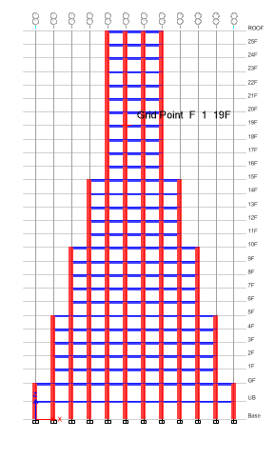 | 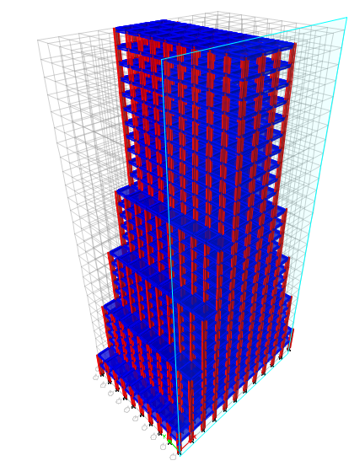
Figure 2: Setback building

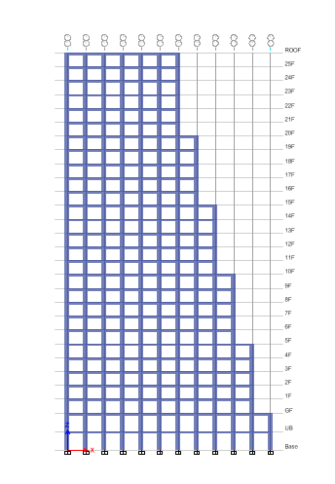 | 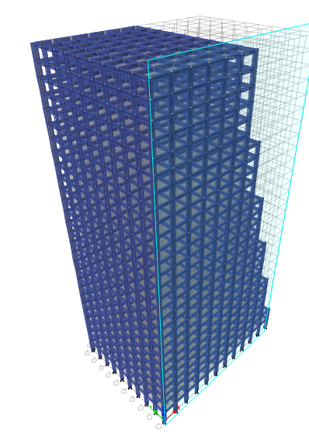
Figure 3: Model of setback building

- RESULTS AND DISCUSSION
The issue of fundamental time period and its impact on low and medium rise buildings was studied in detail. However, the sample of buildings investigated was still not sufficient to justify any conclusive statement, but a few points have clearly come out of this analysis. The formula given in the code for bare frames is of very general nature and does not categorically apply to all kinds of buildings. An approach more suited for this purpose would be to use different formulae for different buildings.
Low rise buildings which vibrate with high frequency behave in an entirely different way than medium or high-rise buildings. Here height does not play a vital role in the determination of fundamental time period of the building, but the plan dimension does. Hence a formula of time period depending on the plan area than the height would be more suited. Here, two empirical formulae have been generated that applies to buildings under ten and fifteen meters. They seem to be more suited than the formula given in the code.
Medium or high-rise buildings which vibrate with long time periods are critical structures that needs to be analysed properly. While height does play an important role in the determination of fundamental time period, but other factors like irregularities, asymmetry come into play when the height of the building increases beyond a certain level. Certain assumptions have been made in order to incorporate these complications and empirical relationship has been developed. Regular buildings vibrate in a fairly predictable way, but it is the irregular and asymmetric ones that sometimes behave in an erratic manner. And that is where dynamic modal analysis comes to action, providing a rational distribution of lateral forces. Now, the modal analysis forces are often lesser compared to their static analysis counterparts, thereby, raising the need for scaling the forces as per static analysis based on fundamental time period. Here the need for a justifiable empirical formula is towered. An effort has been made here to find an empirical formula that somehow represents and includes those irregularities.
Non-structural components like brick infill walls contribute to the stiffness of the buildings. Their contribution affects the time period of the building. Though it is difficult to estimate the contribution of the non-structural components to the stiffness and thereby the time period of the buildings, but certain assumptions have to be made to incorporate these effects. Here we considered buildings with infill making some reasonable assumptions and found expression that seemingly works better than our Code expression.
The basic issue with our code still remains in its empirical formula approach. However large be the sample size, there would always be buildings that are not part of that sample size. In fact, every other building may behave differently under dynamic loads. Thus, a more rational approach would be to drop the empirical formula and analyse every building rigorously. A more rigorous dynamic analysis, pushover analysis or performance-based analysis would be more suited for the purpose.

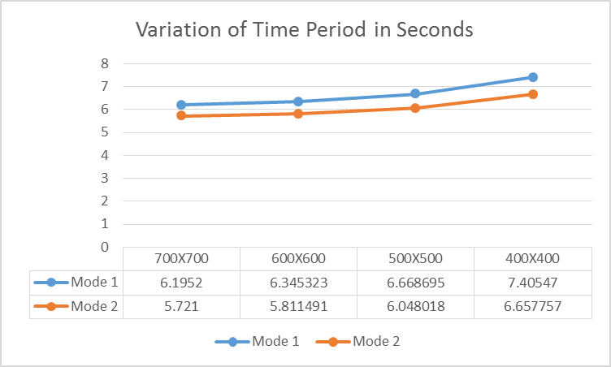 | 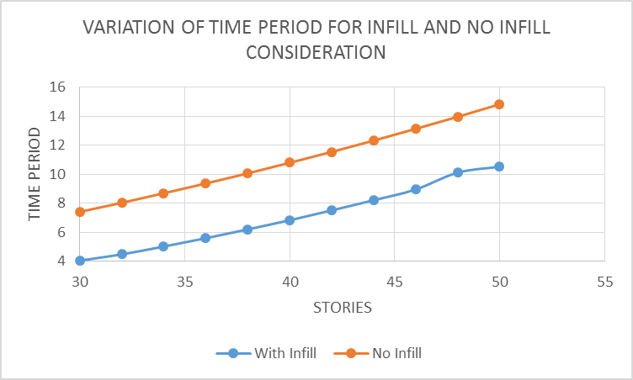
Figure 4: Variation in time period

Figure 5: Mode Shape
Table 2. Fundamental period with respect to Plan Area at 9 m height
Height | BD | Numerical Study | IS 1893  (Eq. 19) | % Variation | Proposed  (Eq. 10) | % Variation
9 | 81 | 0.269151 | 0.389711 | 45% | 0.252964 | -6%
9 | 108 | 0.274529 | 0.389711 | 42% | 0.282381 | 3%
9 | 135 | 0.278058 | 0.389711 | 40% | 0.306152 | 10%
9 | 144 | 0.346875 | 0.389711 | 12% | 0.313393 | -10%
9 | 162 | 0.280554 | 0.389711 | 39% | 0.327051 | 17%
9 | 192 | 0.356396 | 0.389711 | 9% | 0.34781 | -2%
9 | 225 | 0.43494 | 0.389711 | -10% | 0.368375 | -15%
9 | 240 | 0.361633 | 0.389711 | 8% | 0.377088 | 4%
9 | 288 | 0.36533 | 0.389711 | 7% | 0.40283 | 10%
9 | 300 | 0.445775 | 0.389711 | -13% | 0.40883 | -8%
9 | 375 | 0.452859 | 0.389711 | -14% | 0.443245 | -2%
9 | 450 | 0.457855 | 0.389711 | -15% | 0.473504 | 3%

Table 3. Change in Time Period with respect to geometric irregularities
Type | Height | Time Period
 |  | Modal Analysis | IS1893 | UBC 97
No Irregularities | 30 | 1.782038 | 0.961396 | 0.93704
1 | 30 | 1.691982 | 0.961396 | 0.93704
2 | 30 | 1.589424 | 0.961396 | 0.93704
3 | 30 | 1.551101 | 0.961396 | 0.93704
4 | 30 | 1.490155 | 0.961396 | 0.93704

Table 4. Time Period
Case | Mode | R | SD1 | SD2 | SD3 | SD4 | SD5
Modal | 1 | 3.159 | 2.212 | 2.052 | 2.172 | 2.639 | 2.511
Modal | 2 | 3.127 | 2.195 | 2.05 | 2.132 | 2.482 | 2.315
Modal | 3 | 2.809 | 1.602 | 1.433 | 1.508 | 1.775 | 1.578
Modal | 4 | 1.017 | 0.942 | 1.064 | 0.993 | 1.014 | 0.967
Modal | 5 | 1.005 | 0.931 | 1.026 | 0.954 | 1.01 | 0.956
Modal | 6 | 0.911 | 0.796 | 0.924 | 0.829 | 0.869 | 0.798
Modal | 7 | 0.582 | 0.549 | 0.554 | 0.584 | 0.577 | 0.568
Modal | 8 | 0.569 | 0.545 | 0.55 | 0.579 | 0.57 | 0.564
Modal | 9 | 0.53 | 0.481 | 0.475 | 0.513 | 0.518 | 0.51
Modal | 10 | 0.403 | 0.398 | 0.378 | 0.376 | 0.395 | 0.396

- CONCLUSION
Fundamental period of all the selected building models was estimated as per modal analysis, Rayleigh method and empirical equations given in the design codes. The results were critically analysed and presented in this chapter. The aim of the analyses and discussions were to identify a parameter that describes the irregularity of a setback building and arrive at an improved empirical equation to estimate the fundamental period of setback buildings with confidence. However, this study shows that it is difficult to quantify the irregularity in a setback building with any single parameter. This study indicates that there is very poor correlation between fundamental periods of three-dimensional buildings with any of the parameters used to define the setback irregularity by the previous researchers or design codes. However, it requires further investigation to arrive at single or multiple parameters to accurately define the irregularity in a three-dimensional setback building. Based on the work presented in this thesis following point-wise conclusions can be drawn:
- Period of setback buildings are found to be always less than that of similar regular building. Fundamental period of setback buildings is found to be varying with irregularity even if the height remains constant. The change in period due to the setback irregularity is not consistent with any of these parameters used in literature or design codes to define irregularity.
- The code (IS 1893:2016) empirical formula gives the lower-bound of the fundamental periods obtained from Modal Analysis and Raleigh Method. Therefore, it can be concluded that the code (IS 1893:2016) always gives conservative estimates of the fundamental periods of setback buildings with 6 to 30 storeys. It can also be seen that Raleigh Method underestimates the fundamental periods of setback buildings slightly which is also conservative for the selected buildings. However, the degree of conservativeness in setback building is not proportionate to that of regular buildings.
- Unlike other available equations, ASCE 7: 2010 does not consider the height of the building but it considers only the number of storeys of the buildings. Although this is not supported theoretically this approach is found to be most conservative among other code equations.
- It is found that the fundamental period in a framed building is not a function of building height only. This study shows that buildings with same overall height may have different fundamental periods with a considerable variation which is not addressed in the code empirical equations.
- In the empirical equation of fundamental period, the height of the building is not defined in the design code adequately. For a regular building there is no ambiguity as the height of the building is same throughout both the horizontal directions. However, this is not the case for setback buildings where building height may change from one end to other.
- The buildings with same maximum height and same maximum width may have different period depending on the amount of irregularity present in the setback buildings. This variation of the fundamental periods due to variation in irregularity is found to be more for taller buildings and comparatively less for shorter buildings. This observation is valid for the periods calculated from both modal and Rayleigh analysis. It is found that variation of fundamental periods calculated from modal analysis and Rayleigh method are quite similar.
- This study indicates that there is very poor correlation between fundamental periods of three-dimensional buildings with any of the parameters used to define the setback irregularity by the previous researchers or design codes.

- REFERENCES
[1] Agrawal, P. and Shrikhande, M., Earthquake resistant design of structures, PHIlearning pvt. ltd.
[2].Al-Ali, A.A.K. and Krawinkler, H. (1998). “Effects of Vertical Irregularities on Seismic Behavior of Building Structures”, Report No. 130, The John A. Blume Earthquake Engineering Center,Department of Civil and Environmental Engineering, Stanford University, Stanford, U.S.A
[3]. Aranda, G.R. (1984). “Ductility Demands for R/C Frames Irregular in Elevation”, Proceedings of the Eighth World Conference on Earthquake Engineering, San Francisco, U.S.A., Vol. 4, pp. 559-566.
[4]. ASCE 7 Minimum Design Loads for Buildings and Other Structures. AmericanSociety of Civil Engineers, 2010.
[5]. Athanassiadou CJ. Seismic performance of R/C plane frames irregular in elevation. Eng Struct 2008;30, pp 1250-61.
[6]. BIS (2002). “IS 1893 (Part 1)-2002: Indian Standard Criteria for Earthquake Resistant Design of Structures, Part 1 – General Provisions and Buildings (Fifth Revision)”, Bureau of Indian Standards, New Delhi
[7]. Chintanapakdee, C. and Chopra, A.K. (2004). “Seismic Response of Vertically Irregular Frames: Response History and Modal Pushover Analyses”, Journal of Structural Engineering, ASCE, Vol. 130, No. 8, pp. 1177-1185.
[8]. Chopra,A. K. (2003). Dynamics of structures: theory and applications to earthquake engineering. Prentice – Hall, Englewood Cliffs,N.J.
[9]. Das, S. and Nau, J.M. (2003). “Seismic Design Aspects of Vertically Irregular Reinforced Concrete Buildings”, Earthquake Spectra, Vol. 19, No. 3, pp. 455-
10. Esteva, L. (1992). “Nonlinear Seismic Response of Soft-First-Story Buildings Subjected to Narrow- Band Accelerograms”, Earthquake Spectra, Vol. 8, No. 3, pp. 373-389.
[11]. Eurocode 8. Design of structures for earthquake resistance, part-1: general rules, seismic actions and rules for buildings. Brussels: European Committee for Standardization (CEN); 2004.
[12]. Fragiadakis, M., Vamvatsikos, D. and Papadrakakis, M. (2006). “Evaluation of the Influence of Vertical Irregularities on the Seismic Performance of a Nine- Storey Steel Frame”, Earthquake Engineering & Structural Dynamics, Vol. 35, No. 12, pp. 1489-1509.
[13]. Goel R.K, Chopra A.K. Period formulas for moment resisting frame buildings. J Struct Eng, ASCE 1997;123(11), pp. 1454-61.

