**IMPROVEMENT OF THE TENDENCY OF PHOTOVOLTAIC CLUSTERS**

**Hemalatha BN**

1Lecturer, Department Of Science, Vidyavardhaka Polytechnic,Mysuru, Karnataka, India

**ABSTRACT**

This paper makes sense of a technique for improving the tendency point of sun based PV exhibits conveyed in Muniguda, Odisha. Upgrade of tendency points approach depends on an isotropic model with differing diffuse radiation coefficients on the slanted surface, which represents change in month to month tendency points. In the northern piece of India, a month to month ideal tendency point change is suggested as a result of occasional change. Utilizing the month to month ideal tendency point on a sun powered PV board with various isotropic models will build yield of assortment by 9.09, 9.31, 8.02, and 9.31%, individually. The advancement results showed that month to month ideal slant points with an upgrade of roughly 9% (0.57 kWh/m2/day) for various isotropic models in the site of Muniguda, Rayagada district, Odisha state.

**Keywords:** Optimization, tilt angle, active sun trackers, solar radiation, isotropic, anisotropic

1. **INTRODUCTION**

The extent of sunlight based energy gathered by PV not set in stone by sun powered irradiance, ground reflection attributes, and sun powered charger tendency and direction. In fact, the amount of yield got is enormously impacted by the direction and tendency of sun powered chargers. Thus, to catch the greatest energy from the sun at a specific site, the boards should be slanted and orientated at a suitable tendency point. A sun based global positioning framework is the most dependable way to deal with improve the tendency and situation of sun powered chargers. Dynamic sun trackers modify the tendency and position of a sunlight powered charger or sun oriented cluster consistently. which are electromechanical frameworks. Nonetheless, such a gadget is expensive to get and consumes a ton of energy while following. Changing the place of sunlight powered charger on month to month, occasional or yearly premise are more appropriate than sun based global positioning frameworks.

1. **METHODOLOGY**

**2.1 Points on the slanted surface**

1. Rise point (α): It is the point made the skyline and an article situated above it. The rise point is estimated in degrees and can go from 0° to 90° A rise point of 45° demonstrates that the item is somewhere between the skyline and the peak.

2. Azimuth point (γ): It is the point made by the sun's situation overhead and the eyewitnesses. It is estimated in degrees, with positive qualities showing an point east of south and negative qualities demonstrating a point west of south.

3. Declination point (δ): The declination point (δ) is a galactic term that alludes to the rakish distance between the heavenly equator and a divine object, estimated in degrees. It is utilized to depict the place of the sun, moon, planets, and stars overhead comparative with the World's equator.

4. Frequency point (θ): It is the point made by a beam of light or other electromagnetic radiation and a surface it experiences. It is otherwise called the point of rate.

5. Peak point: The point between an upward line and a divine item overhead. It is estimated in degrees and addresses the level of the article above the spectator's mindset.

6. Scope point: Scope point, otherwise called sun oriented elevation point, it is extraordinary for each area, it is relying upon the level and scope.

7. Tendency point (β): The tendency point (β) is a significant boundary; it is the point made by the earth surface and sunlight powered charger. It is otherwise called the Tendency point.

* 1. **Solar radiation**

Worldwide sun oriented radiation: It is a recreation of immediate, diffuse, and ponder radiations based the diffuse radiation influences. The antagonistic change in worldwide sunlight based radiation has occurred.

1.Direct radiation: The radiation from the sun (UV beams) straightforwardly strikes the earth without being dissipated.

2.Diffuse radiation: The radiation from the sun is has been dissipated in the air by mists, air particles and strikes the earth and the power of radiation is diminished is called diffuse radiation.

3.Reflected radiation: The radiation from the sun is strikes the earth surface and items and reflected back and fall into the board surface

1. **MODELING AND ANALYSIS**

The displaying of worldwide radiation on the slanted surface is communicated in equation (5.1)

GTLT = BTLT + DTLT + RTLT (5.1)

Parts of sun based energy on a level surface changed in wording equation (5.2):

GTLT = RB + D × RD + G × ρ × RR (5.2)

RB, RD and RR are a bar, diffuse and reflected sunlight based radiations transformation factors separately and 𝜌 is the ground albedo and its worth is taken here to be 0.2.

Declination point: The declination point (δ) is a cosmic term that alludes to the precise distance between the divine equator and a heavenly item, estimated in degrees. It is utilized to depict the place of the sun, moon, planets, and stars overhead comparative with the World's equator.

𝛿 = 23.45 × sin [ (284+𝑛) 365 × 360] (5.3)

Sunshine angle:

𝜔𝑠𝑠 = cos−1(tan δ × ( − tan φ)) (5.4)

Rb, Rd, Rr are the coefficients of bar, diffuse, reflected sun powered radiations:

Reflected sun powered radiation coefficient part on the shifted surface.

RR = 1−cosβ/2 (5.5)

The Liu and Jordan model is generally usually utilized for the computation of shaft sunlight based radiation transformation factor (𝑅𝐵).

The worth of 𝑅𝐵 can be determined for the areas situated in both the northern scopes and southern scopes is given by the accompanying conditions separately.

RB = cos(φ − β) × cos δ × sin ωss + ωss × sin(φ − β) × sin β/ cosφ × cos δ × sin ωss + ωss × sin φ × sin δ (5.6)

Equation (4.6) is proposed for northern hemisphere.

RB = cos(φ + β) × cos δ × sinωss + ωss × sin(φ + β) × sin β /cos φ × cos δ × sinωss + ωss × sin φ × sin δ (5.7)

Equation (4.7) is proposed for southern hemisphere.

The diffused sun powered radiation change factor (𝑅𝐷) can be determined by utilizing underneath conditions proposed

RD = 1+cosβ/ 2 (5.8)

Diffuse solar radiation coefficient proposed by Liu and Jordan Model (1962).

RD = 1 3[2+cos β] (5.9)

Diffuse solar radiation coefficient proposed by Koronakis model (1986).

**3.1 Isotropic and Anisotropic models**

Isotropic model: An isotropic model is a model or framework that shows similar properties or conduct every which way. The expression "isotropic" comes from the Greek words "iso," importance equivalent, and "tropos," meaning course. As such, an isotropic model is one that is symmetric every which way and has no liked bearing [46-49].

Anisotropic model: An anisotropic model is a model or framework that shows various properties or conduct every which way. The expression "anisotropic" comes from the Greek words "anise," meaning inconsistent, and "tropos," meaning bearing. All in all, an anisotropic model is one that isn't symmetric every which way furthermore, has a favored course.

1. **RESULTS AND DISCUSSION**

From underneath the Table 1 month to month ideal slant points are characterized by founded on PV boards i.e., worldwide even irradiance, diffuse sun powered radiation and scope point of that spot. On a yearly normal the ideal tendency is around 20.830. The yearly typical sun based energy assortment yield on a level surface is around 5.18 kWhpm2pday, while the yearly typical sun powered energy assortment yield on the slanted surface is roughly 5.76 kWhpm2pday.

The ideal slant point in January is 480 degrees. On a surface that is slanted, the month to month normal sun oriented energy gathering yield is around 6.61 kWhpm2day.The better yield of gathering is 1.68 kWhpm2pday. A 25% improvement has been made starting from the start of January. The ideal slant plot for the month of February is 390. On a surface that is slanted, the month to month normal sun oriented energy gathering yield is around 6.7 kWhpm2pday. Then again, on a level surface, it is 5.62 kWhpm2pday. The better yield of gathering is 1.08 kWhpm2pday. On February, there has been an improvement of 16.1%. The ideal slant point in the long stretch of Spring is 210 . On a surface that is slanted, the month to month normal sun oriented energy gathering yield is around 6.37 kWhpm2day. Then again, on an even surface, it is 6.06 Whpm2pday. Further developed yield assortment is 0.31 kWhpm2pday. On spring, there has been an improvement of 4.87%. The ideal slant point in April is 40 degrees.

On a surface that is slanted, the month to month normal sun powered energy gathering yield is around 6.43 kWhpm2pday. Then again, on a level surface, it is 6.42 kWhpm2pday. Further developed yield assortment is 0.01 kWhpm2day. Nothing has changed since April regarding what is happening. The best slant in the long stretches of May, June, July, and August is 00 , which is additionally the flat slant. Thusly, there has been no advancement in the yield's assortment in the months of May, June, July, and August. The ideal slant point in September is 130 degrees. On a surface that is slanted, the month to month normal sun powered energy gathering yield is around 4.78 kWhpm2pday. Then again, on a level surface, it is 4.68 kWhpm2pday. Further developed yield assortment is 0.01 kWhpm2pday.

On September, there has been an improvement of 2.09%. The ideal slant point in the long stretch of October is 310 degrees. The typical day to day creation from sun based energy gathering on a skewed surface is around 5.75 kWhpm2pday.

Then again, on an even surface, it is 5.14 kWhpm2pday. The superior yield of gathering is 0.61 kWhpm2pday. On October, there has been an improvement of 10.61%. The ideal slant point in the period of November is 440. On a surface that is slanted, the month to month normal sun powered energy gathering yield is around 6.23 kWhpm2pday. Then again, on a level surface, it is 4.88 kWhpm2pday. The better yield of gathering is 1.35 kWhpm2pday. On November, there has been an improvement of 21.67%. The ideal slant point in December is 500 degrees. On a surface that is slanted, the month to month normal sunlight based energy gathering yield is around 6.51 kWhpm2pday. Then again, on an even surface, it is 4.68 kWhpm2pday.

Further developed assortment of yield is 1.83 kWhpm2day. 28.11% of progress has occurred on the period of December.

Therefore, by utilizing Liu and Jordan model, on a yearly normal of ideal slant is 20.830. Upgrade of assortment of yield by 0.58 kWhpm2pday.

In general yearly assortment of yield is worked on by 9.0%. The diagrams plotted in the Figure 1. Furthermore, Figure 2 In view of the outcomes acquired from Table 1utilizing Liu and Jordan model.

**Table-1:** Monthly averaged optimum tilt angle and Comparative analysis of monthly averaged solar energy on both horizontal and tilted surface (kWhpm2pday) using Liu and Jordan model.

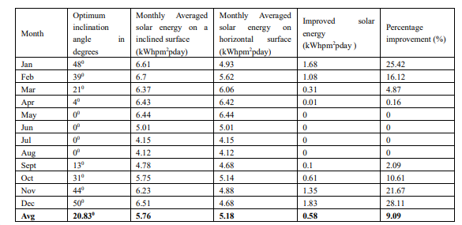

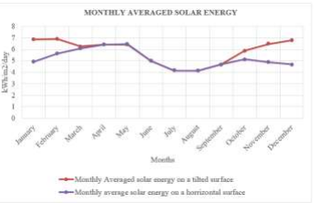

**Figure 1:** Graph on averaged monthly optimum tilt angle on solar panels

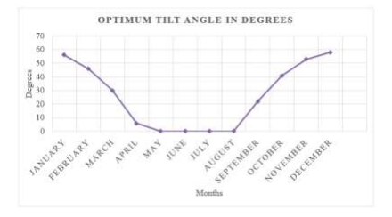

**Figure 2:** Graph on Monthly averaged solar energy on horizontal and tilted surfaces

From the underneath table 2 month to month ideal slant points are characterized by founded on PV boards i.e., worldwide level irradiance, diffuse sun powered radiation and scope point of that spot. On a yearly normal, the ideal tendency is at 22.50 degrees. The yearly typical sunlight based energy assortment yield on a level surface is around 5.77 kWhpm2pday, though the yearly normal sun powered energy assortment yield on a skewed surface is around 5.18 kWhpm2pday.

The ideal slant plot for the long stretch of January is 500 . On a surface that is slanted, the month to month normal sun based energy gathering yield is around 6.69 kWhpm2pday. Instead of 4.93 kWhpm2pday on a flat surface. The superior yield of gathering is 1.76 kWhpm2pday. An improvement of 26.30% has been made since January. The ideal slant point in February is 410 degrees. On a surface that is slanted, the month to month normal sun oriented energy gathering yield is around 6.76 kWhpm2pday. Then again, on a flat surface, it is 5.62 kWhpm2pday. The superior yield of gathering is 1.14 kWhpm2pday. On February, there has been an improvement of 16.83%. The ideal slant point in the long stretch of Spring is 240.

On a surface that is slanted, the month to month normal sun powered energy gathering yield is around 6.36 kWhpm2pday. Then again, on a level surface,it is 6.06 kWhpm2pday. The better yield of gathering is 0.30 kWhpm2pday. On Spring, there has been an improvement of 4.71%. The best slant point in April is 400 degrees. The result from the skewed surface's month to month normal sun based energy gathering is around 6.43. kWhpm2pday. Be that as it may, in a level is 6.42 kWhpm2day. Nothing has changed since April with regards to the circumstance.

The best slant in the long periods of May, June, July, and August is 00, which is likewise the flat slant. The slant compares to the area's scope point.In this manner, there has been no advancement in the yield's assortment in the long stretches of May, June, July, and August. The ideal slant point in September is 150 degrees. On a surface that is slanted, the month to month normal sunlight based energy gathering yield is around 4.78 kWhpm2pday. Interestingly, the flat surface utilizes 4.68 kWh/m2 each day. The superior yield of gathering is 0.10 kWhpm2pday. On September, there has been an improvement of 2.09%. The ideal slant point in the period of October is 330 degrees. 5.79 kWh/m2/day of sun oriented energy is gathered on the skewed surface on a month to month normal. while 5.14 kWhpm2pday on a flat surface. The better yield of gathering is 0.64 kWhpm2pday. On October, there has been an improvement of 11.05%. The ideal tendency point in the period of November is 470 .

On a surface that is slanted, the month to month normal sun powered energy gathering yield is around 6.31 kWhpm2pday. Interestingly, the flat surface purposes 4.88 kWh/m2 each day. The superior yield of gathering is 1.43 kWhpm2pday. On November, there has been an improvement of 22.66%. The ideal slant point in December is 530 degrees. On a surface that is slanted, the month to month normal sun oriented energy gathering yield is around 6.51 kWhpm2pday. Interestingly, the flat surface purposes 4.68 kWh/m2 each day. The superior yield of gathering is 1.83 kWhpm2pday. On December, there has been an improvement of 28.11 percent. As a result, the best slant as per the Liu and Jordan model is 22.250 on a yearly normal. The ascent in yield of 0.6 kWhpm2pday for gathering.

The yearly gathering yield overall has expanded by 9.31%. in light of the results of the Koronakis model as displayed in Table 2. The charts in Figures 3 and 4 were plotted in light of the results of the Koronakis model as displayed in Table 2.

**Table 2**: Monthly optimum tilt and averaged angle

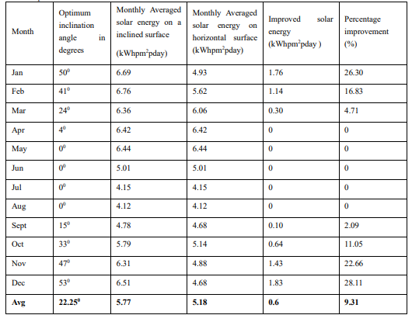

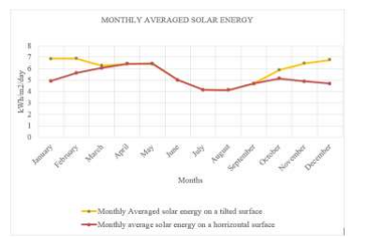

**Figure 3:** Graph on Monthly averaged solar energy on horizontal and tilted surfaces

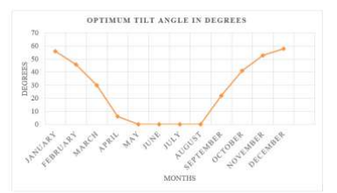

**Figure 4:** Graph on averaged monthly optimum tilt angle on solar panels

1. **CONCLUSION**

From the contextual investigation, a relative examination has accomplished for the month to month ideal slant points with an upgrade of roughly 9% (0.57 kWhpm2pday) for various isotropic models in the site of Muniguda, Rayagada region, Odisha state.

1. **REFERENCES**

[1] T. Khatib, A. Mohamed, M. Mahmoud, and K. Sopian, “Optimization of the tilt angle of solar panels for Malaysia,” Energy Sources, Part A: Recovery,Utilization and Environmental Effects, vol. 37, no. 6, pp. 606–613, Mar. 2015, doi: 10.1080/15567036.2011.588680.

[2] R. Ben Mansour, M. A. Mateen Khan, F. A. Alsulaiman, and R. Ben Mansour, “Optimizing the Solar PV Tilt Angle to Maximize the Power Output:A Case Study for Saudi Arabia,” IEEE Access, vol. 9, pp. 15914–15928, 2021, doi: 10.1109/ACCESS.2021.3052933.

[3] M. A. Danandeh and S. M. Mousavi G., “Solar irradiance estimation models and optimum tilt angle approaches: A comparative study,” Renewableand Sustainable Energy Reviews, vol. 92. Elsevier Ltd, pp. 319–330, Sep. 01, 2018. doi: 10.1016/j.rser.2018.05.004.

[4] T. O. Kaddoura, M. A. M. Ramli, and Y. A. Al-Turki, “On the estimation of the optimum tilt angle of PV panel in Saudi Arabia,” Renewable andSustainable Energy Reviews, vol. 65. Elsevier Ltd, pp. 626–634, Nov. 01, 2016. doi: 10.1016/j.rser.2016.07.032.

[5] A. Z. Hafez, A. Soliman, K. A. El-Metwally, and I. M. Ismail, “Tilt and azimuth angles in solar energy applications – A review,” Renewable and Sustainable Energy Reviews, vol. 77. Elsevier Ltd, pp. 147–168, 2017. doi: 10.1016/j.rser.2017.03.131.

[6] C. O. Okoye, A. Bahrami, and U. Atikol, “Evaluating the solar resource potential on different tracking surfaces in Nigeria,” Renewable and Sustainable Energy Reviews, vol. 81. Elsevier Ltd, pp. 1569–1581, Jan. 01, 2018. doi: 10.1016/j.rser.2017.05.235.

[7] K. Y. Lau, C. W. Tan, and A. H. M. Yatim, “Effects of ambient temperatures, tilt angles, and orientations on hybrid photovoltaic/diesel systems under equatorial climates,” Renewable and Sustainable Energy Reviews, vol. 81. Elsevier Ltd, pp. 2625–2636, Jan. 01, 2018. doi: 10.1016/j.rser.2017.06.068.

[8] T. Maatallah, S. El Alimi, and S. Ben Nassrallah, “Performance modeling and investigation of fixed, single and dual-axis tracking photovoltaic panel in Monastir city, Tunisia,” Renewable and Sustainable Energy Reviews, vol. 15, no. 8. Elsevier Ltd, pp. 4053–4066, 2011. doi:10.1016/j.rser.2011.07.037.

[9] K. Bakirci, “General models for optimum tilt angles of solar panels: Turkey case study,” Renewable and Sustainable Energy Reviews, vol. 16, no. 8.pp. 6149–6159, Oct. 2012. doi: 10.1016/j.rser.2012.07.009.

[10] A. K. Yadav and S. S. Chandel, “Tilt angle optimization to maximize incident solar radiation: A review,” Renewable and Sustainable Energy Reviews, vol. 23. Elsevier Ltd, pp. 503–513, 2013. doi: 10.1016/j.rser.2013.02.027.