***Enterobacter* sp: a Potential Biomarker in the Diagnosis of Depression**

**Okoli, FA, Agu, K.C. and Chukwura, E.I**

1Applied Microbiology and Brewing Department, Nnamdi Azikiwe University, PMB 5025, Awka, Nigeria

Corresponding Author: kc.agu@unizik.edu.ng

**ABSTRACT**

There is an undeniable interaction between the brain and the gut. This connection is referred to as the microbiota-gut-brain-axis (MGBA). This study was done to examine the levels of *Enterobacter* sp in stool samples and to determine its potential as a diagnostic tool for depression. Fifty individuals took part in the research. Random sampling method was employed, Patient Health Questionnaires (PHQ) were given out and consent forms were signed. Afterwards, fecal samples were collected from 50 individuals, of which 36 were patients diagnosed with depression and 14 were healthy individuals that served as control. In addition, the viable count of *Enterobacter* sp isolated from people with depression was significantly higher than that of the control group. The independent samples t-test showed that the mean viable count of *Enterobacter* sp in depressed subjects is significantly above that of the control subjects, with a mean difference of 0.9889, t=9.083. Conversely, a high level of *Enterobacter* sp can be used as a biomarker for depression and other mood-related disorders.

**Keywords**: depression, *Enterobacter* sp, biomarker, diagnosis

**INTRODUCTION**

#### Background

Depression is a major global health concern, affecting over 300 million people worldwide (World Health Organization, 2024). It is associated with significant morbidity, disability, and economic burden. Traditional diagnostic methods for depression include clinical interviews and standardized questionnaires, which, despite their utility, are subjective and can vary in accuracy (American Psychiatric Association, 2013). The search for objective, biological markers for depression has increased due to the need early and accurate diagnosis.

**Gut-Brain Axis**

The gut-brain axis is a bidirectional communication system between the gastrointestinal tract and the central nervous system (CNS). This structure involves complex connections among the gut microbiota, immune system, enteric nervous system, and CNS (Cryan and Dinan, 2012). Recent research has underlined the significant role of gut microbiota in regulating brain function and behavior, suggesting a relation between dysbiosis and mental health disorders, including depression (Foster and Neufeld, 2013).

***Enterobacteria* sp.**

*Enterobacter* sp are a group of Gram-negative bacteria commonly found in the human gut (gastrointestinal tract). These bacteria are involved in various physiological processes, including metabolism and immune regulation. Certain species within this group, such as *Escherichia coli*, *Salmonella spp*., *Shigella* spp., and *Klebsiella* spp., have been implicated in pathological conditions when they are present in abnormal levels (Zhang *et al*., 2015). This report investigates the potential of *Enterobacter* sp. as biomarkers for depression, considering their role in the gut-brain axis and mechanisms that may influence mood and behavior.

**The Gut-Brain Connection and Depression**

**Mechanisms of Interaction**

The gut-brain axis involves several mechanisms through which gut microbiota can influence brain function and behavior:

1. **Production of Neuroactive Compounds**: Gut bacteria can produce neurotransmitters such as serotonin, dopamine, and gamma-aminobutyric acid (GABA), which play critical roles in mood regulation (Clarke *et al*., 2013).
2. **Modulation of the Immune System**: Gut microbiota can modulate the immune system, influencing the production of pro-inflammatory cytokines, which have been linked to depression (Miller and Raison, 2016).
3. **Regulation of the Hypothalamic-pituitary-adrenal axis**: The hypothalamic-pituitary-adrenal (HPA) axis regulated the body's response to stress. It can be influenced by the bacteria found in the gut. Dysregulation of the HPA axis is a common feature in depression (Sudo *et al*., 2004).
4. **Production of Metabolites**: Bacteria in the gut produce various metabolites, including short-chain fatty acids (SCFAs), which can cross the blood-brain barrier and affect brain function (Stilling *et al*., 2016).

*Enterobacter* sp **and Depression**

**Altered Microbiota Composition in Depression**

Several studies have reported variations in gut microbiota composition between depressed individuals and healthy controls. Depressed patients often show reduced diversity and altered abundance of some bacterial groups, including an increased level of *Enterobacter* sp (Jiang *et al*., 2015).

**Inflammatory Responses**

*Enterobacter* sp can activate systemic inflammation through the synthesis of lipopolysaccharides (LPS), constituents of their outer membrane. Elevated levels of LPS have been found in patients with depression, suggesting a link between gut-derived inflammation and depression (Maes *et al*., 2008).

**Neurochemical Changes**

Some *Enterobacter* sp produce metabolites that influence the CNS. For example, certain strains of *Escherichia coli* produce indole, which can influence the production of serotonin, a major neurotransmitter involved in mood regulation (O'Mahony *et al*., 2015).

**Clinical Implications and Diagnostic Potential**

The identification of specific *Enterobacter* sp associated with depression could lead to the development of new diagnostic tools. Biomarkers are measurable indicators of a biological state or condition. In the context of depression, *Enterobacteria* sps. could serve as:

1. **Diagnostic Biomarkers**: Specific strains or levels of Enterobacteria could help in the early diagnosis of depression, providing a more objective and biological basis for diagnosis (Zheng *et al*., 2016).
2. **Prognostic Biomarkers**: Observing changes in *Enterobacteria* populations could help predict the course of depression or response to treatment (Kelly *et al.,* 2016).
3. **Therapeutic Targets**: Understanding the role of *Enterobacteria* in depression could lead to new therapeutic approaches, such as probiotics or dietary interventions aimed at influencing microbiota in the gut (Sampson and Mazmanian, 2015).

**MATERIALS AND METHODS**

**Study Area**

The stool samples were collected from the State Neuro Psychiatric Hospital Nawfia on Latitude 06 0 11.17’.0016’ N and longitude 07 0 01 .19.3548’ E 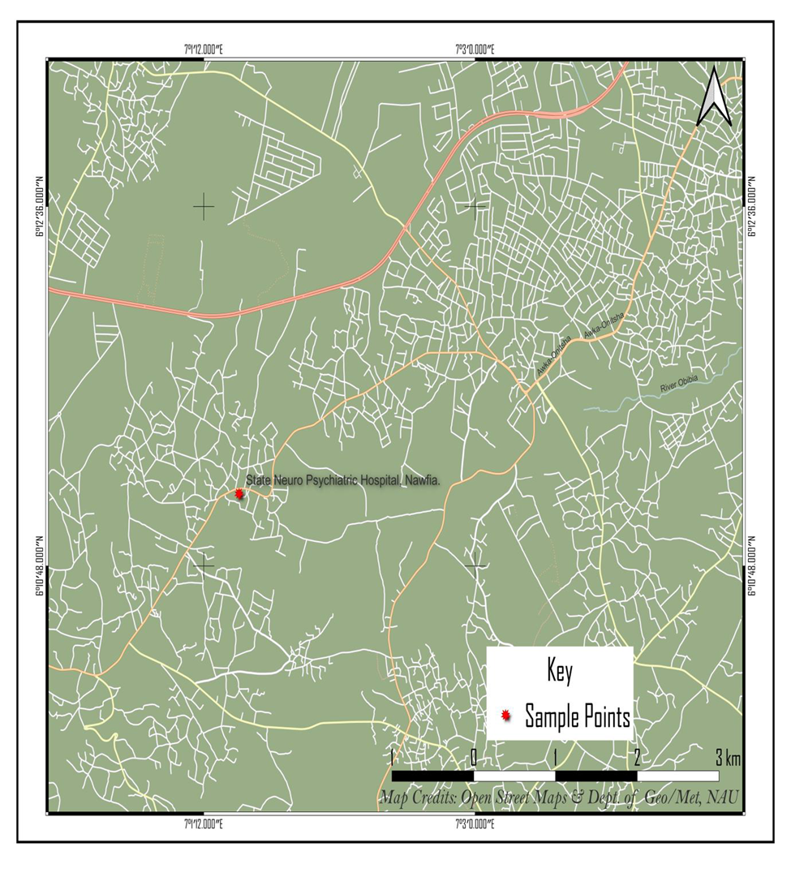

**Fig 1:** State Neuro Psychiatric Hospital, Nawfia

Source: Open street Maps and Department of Geography/Meteorology, NAU.

**Sample size Determination**

The sample size was determined using Taro Yamane formula (Chanuan, 2021)

**n= N / (1+Ne2)**

n= number of samples

N= total population

e= error tolerance

An average of 10 patients is diagnosed with depression every week. For a period of four weeks, the total population of depressed patients (N) was 10 x 4 (weeks) = 40. If, N = 40, e = 0.005 then

**n = 40/1+40 x 0.052 = 36**

Therefore, the sample size for the population is 36 which were randomly selected when they presented at the hospital. They were instructed on the accurate collection of stool samples.

**Sample Collection**

The protocols of clinical experimentation were studied and ethical approval was obtained from the Neuropsychiatric Hospital Nawfia Anambra State. Informed consent forms were read, understood and signed. In addition, structured psychiatric questionnaires; PHQ-9 (Kroenke *et al*., 2001) were administered afterwards. Details of the study were explained to all volunteers. This study was done in agreement with the Helsinki Declaration as updated in 2013 in the nation of Brazil. Furthermore, they proceeded to sample collection. Faecal samples of 36 patients diagnosed with MDD and 14 healthy subjects who served as control were collected. The samples were collected for a total of 4 weeks period.

A total of fifty (50) persons participated in the research. Thirty-six patients that were diagnosed with major depressive disorder were recruited from the Neuropsychiatric Hospital Nawfia Anambra State. The participants were made up of 10 men and 26 women who were diagnosed with MDD (36 persons suffering from MDD). In addition, 5 men and 9 women with no history of depression were also recruited from the student Nurses resident in the hostels located within the hospital premises. The ages of the participants ranged from 18 to 65 years.

**Eligibility of Participants**: if they are aged between 18 and 65 years, have basic understanding of English language/Igbo language and are non-smokers. Exclusion criteria include: the intake of antibiotics (within the previous 3 months); regular intake of psychotropic or anti-inflammatory drugs, prebiotic/probiotic supplements (within the previous 4 weeks); use of laxatives, anti-diarrhoeal medications, major physical illnesses including gastrointestinal diseases. The eligibility criteria for the participation was attached to the questionnaires.

Feacal samples were collected aseptically by the participants and transported to the Daystar Hospital Laboratory, Nkwerre Ezunaka and for analysis. Further micobiological analysis took place at *Conig Simonne* Biomedicals Laboratory located inside Nnamdi Azikiwe University Awka.

Isolates were identified through the 16S rRNA gene sequencing at the Molecular Research Laboratory, Nnamdi Azikiwe University.

**Determination of *Enterobacteria* viable count in faecal samples**

Spread plate method as detailed in medical microbiological techniques was employed (Jones *et al.*, 2000). One gram of stool sample was weighed and diluted in 9ml sterile peptone water and serial dilutions were prepared. About 0.1ml of 10-5 and 10-6 dilutions were evenly spread on the surfaces of MacConkey agar in duplicates to determine the viable count of *Enterobacteria* spp. The plates were incubated at 370C for 24 hours and colony forming units on the plates were recorded (Ju and Willing, 2018).

**Molecular Characterization of Bacterial Isolates**

For molecular characterization, bacterial samples were grown on nutrient agar plates and single colonies were inoculated in nutrient broth for the isolation of DNA.

**3.8.1 DNA Extraction**

**Materials:** Quick-DNATM Miniprep Plus Kit (Zymo Research), Centrifuge (EPPENDORF, GERMANY), Vortex Mixer, Block Heater (WEALTEC CORP, TAIWAN), Microwave Oven

42 (SCANFROST, CHINA), Pipettes, Digital Scale, Microcentrifuge Tubes, Gel Tank, Gel comb, Scientific Power Pack (CLEAVER SCIENTIFIC, TAIWAN), Gel Documentation System (VILBER, GERMANY). Genomic DNA was extracted using Quick-DNATM Miniprep Plus Kit (Zymo Research), according to recommended protocol.

**Protocol**

200 μl of each sample was added to a microcentrifuge tube. 200 μl of BioFluid & Cell Buffer and 20 μl of Proteinase K was added to it and mixed thoroughly using a vortex for 10-15 seconds and then incubated the tube at 55ºC for 10 minutes on a heating block. 1 volume Genomic Binding Buffer (i.e. 420μl) was added to the digested sample and mixed thoroughly with a vortex mixer for 10-15 seconds. The mixture was then transferred to a Zymo-Spin™ IIC-XL Column in a Collection Tube and centrifuged at 12,000 x g for 1 minute. The collection tube was discarded with the flow through. 400μl DNA Pre-Wash Buffer was added to the spin column in a new Collection Tube and centrifuged at 12,000 x g for 1 minute. The collection tube was emptied and 700 μl g-DNA Wash Buffer was added to the spin column and centrifuged at ≥ 12,000 x g for 1 minute. The spin column was then transferred to a clean microcentrifuge tube. 50 μl of DNA Elution Buffer was added directly on the matrix and incubated for 5 minutes at room temperature, then centrifuged at maximum speed for 1 minute to elute the DNA. The eluted DNA was stored ≤ -20ºC for future use. (Gupta, 2019)

**PCR Protocol**

12.5μl of One Taq Quick-Load 2X Master Mix with Standard Buffer (New England Biolabs Inc.); 0.5μl each of forward and reverse primers (27F: 5’- AGAGTTTGATCGTGGCTCAG -3’ and 5’- 1492R TACGGTTACCTTGTTACGACTT -3’); 8.5μl of Nuclease free water and 3μl of DNA template was used to prepare 25μl reaction volume of the PCR cocktail. The reaction was gently mixed and transferred to thermal cycler. Amplification conditions for the PCR was as follows: Initial denaturation for 30secs at 94oC, followed by 35 cycles of denaturation at 94oC for 20secs, primer 43 annealing at 56oC for 45secs and strand extension at 68oC for 1 min. Final extension at 68oCfor 5 min on an Eppendorf nexus gradient Master cycler (Germany). PCR products were separated on a 2% agarose gel and DNA bands were visualized with Ethidium bromide. (Gupta, 2019)

**Agarose Gel Electrophoresis**

2% agarose gel was prepared by dissolving 1.2g of Agarose in 60ml of 1X TAE Buffer. The mixture was heated to a clear solution using a microwave oven and allowed to cool to about 50 ºC. 3*μl* of Ethidium Bromide was added into the solution and mixed thoroughly. The agarose preparation was carefully poured into a gel tray, with the gel comb in place and allowed to solidify. The tray was loaded into the gel tank and 1X TAE Buffer was poured into the tank, making sure that the gel was properly submerged. The gel comb was carefully removed. 5 *μl* of amplicon was loaded into the wells. The tank was connected to the power pack and set to run at 100volts for 20 minutes after which it was viewed on a gel documentation system. The sequences obtained were used for gene similarity search in the database using the basic local alignment search tool (BLAST). (Gupta, 2019)

**RESULTS**

Some species of Enterobacteria implicated in depression using 16SrRNA gene sequencing analysis include: *Escherichia coli* strain ST131, *Proteus mirabilis* strain EB88, *Serratia marcescens* strain HBUR51222 and *Escherichia coli* strain EB88.

**Table 1: Viable count of *Enterobacteria* sps in faeces of depressed p**

|  |
| --- |
| **s/n Total aerobic bacterial count (log CFU/g)** |

1. 8.0

2 7.6

3 7.7

4 7.8

5 7.5

6 7.9

7 7.6

8 8.1

|  |
| --- |
| 9 8.0  10 7.9  11 7.6  12 7.5  13 7.7  14 7.9  15 7.8  16 7.8  17 8.2  18 7.6  19 7.9  20 7.6  21 7.8 |
| 22 7.7  23 7.8  24 7.9  25 8.1  26 6.8  27 7.6  28 7.5  29 7.7  30 7.3  31 7.5  32 7.4  33 7.7  34 7.6  35 7.8  36 6.9 |
|  |

The table above displays the viable count of *Enterobacteria* spsin CFU/g (colony forming unit per gram) isolated from the faecal specimen of depressed group**.**  The results obtained ranged from 6.8-8.2 log CFU/g. They demonstrated significant levels of *Enterobacteria* sps*.*

**Table 2: Viable count of *Enterobacteria* sps in faeces of healthy group**

|  |
| --- |
|  |

**s /n Total aerobic bacterial count (log CFU/g)**

|  |
| --- |
|  |

1 6.5

2 6.6

3 7.0

4 6.0

5 6.2

6 7.3

7 7.1

8 6.4

9 7.5

10 6.8

11 6.3

12 6.7

13 6.2

14 7.2

|  |
| --- |
|  |

Table 2 displays the viable count of *Enterobacteria* sps in CFU/g (colony forming unit per gram) isolated from the faecal specimen of healthy subjects that served as control. A total of 14 specimen was collected for the analysis. The results obtained ranged from 6.2-7.5 log CFU/g. They demonstrated lower levels of *Enterobacteria* spscompared to that of depressed people

**DISCUSSION**

In this study, there was a significant difference in the viable count of *Enterobacteria* sps of depressed patients when compared to that of the control group. These findings corroborate that of Aizawa *et al.* (2016) who observed significantly higher *Enterobacteria* counts in depressed patients, suggesting a dysbiotic gut microbiome associated with depressive symptoms. In addition, the results of **Jiang *et al*. (2015)** concluded that the relative abundance of *Enterobacteriaceae* was significantly higher in the depressed group than in the control group. In another study conducted by **Valles-Colomer *et al*. (2019)**, they found that certain bacteria, such as *Dialister* and *Coprococcus* sps., were depleted in individuals with depression but did not report a consistent increase in *Enterobacteria* sps. levels. The findings of this study highlight the potential role of gut microbiota in the pathophysiology of depression and suggest that *Enterobacteria* sps. can serve as biomarkers for depressive conditions.

**CONCLUSION**

The potential of *Enterobacteria* sps. as biomarkers in the diagnosis of depression represents an exciting cutting edge in mental health research. These bacteria play a crucial role in the gut-brain axis, influencing mood and behavior through multiple mechanisms. While further studies are required to fully understand the underlying processes and validate these findings, the incorporation of microbiome analysis into psychiatric practice, diagnosis and treatment could transform the way depression is diagnosed and treated. This approach guarantees a more customized and accurate procedure of managing a condition that severely affects individuals and society.

### REFERENCES

Aizawa, E., Tsuji, H., Asahara, T., Takahashi, T., Teraishi, T., Yoshida, S., Ota, M., Koga, N., Hattori, K. and Kunugi, H. (2016). Possible association of Bifidobacterium and Lactobacillus in the gut microbiota of patients with major depressive disorder. *Journal of affective disorders*, 202: 254–257.

American Psychiatric Association. (2013). Diagnostic and Statistical Manual of Mental Disorders, 5th edn. Arlington, Virginia.

Chanuan, U, Kajohnsak, C and Nittaya, S. (2001) Sample Size Estimation using Yamane and

Cochran and Krejcie and Morgan and Green Formulas and Cohen Statistical Power Analysis by G*Power and Comparisons. *Apheit International Journal.* 10(2): 79-88

Clarke, G., Grenham, S., Scully, P., Fitzgerald, P., Moloney, R. D., Shanahan, F., Dinan, T.G. and Cryan, J. F. (2013). The microbiome-gut-brain axis during early life regulates the hippocampal serotonergic system in a sex-dependent manner. Molecular Psychiatry, 18(6), 666-673.

Cryan, J. F. and Dinan, T. G. (2012). Mind-altering microorganisms: the impact of the gut microbiota on brain and behaviour. Nature Reviews Neuroscience, 13(10), 701-712.

Diaz Heijtz, R., Wang, S., Anuar, F., Qian, Y., Björkholm, B., Samuelsson, A., Hibberd, M.L., Forssberg, H. and Pettersson, S. (2011). Normal Gut Microbiota Modulates Brain development and Behavior. *Proceedings of the National Academy of Science U S A.* 108 (7):3047-52.

Foster, J. A. and Neufeld, K. A. M. (2013). Gut-brain axis: how the microbiome influences anxiety and depression. Trends in Neurosciences, 36(5), 305-312.

Gupta N. (2019). DNA Extraction and Polymerase Chain Reaction*. Journal of Cytology*; 36(2):116- 117.

Jones, A., Reeds R. and Weyer, J. (2000). Practical skills in biology. 2nd edition. Longman Books, UK.

Jiang, H., Ling, Z., Zhang, Y., Mao, H., Ma, Z., Yin, Y., Wang, W., Tang, W., Tan, Z., Shi, J., Li, L. and Ruan, B. (2015). Altered fecal microbiota composition in patients with major depressive disorder. *Brain, behavior, and immunity*, 48: 186–194.

Ju, T. and Willing, B.P. (2018) Isolation of commensal *Escherichia coli* strains from feces of healthy laboratory mice or rats. *Bio-Protocol Journal*. 8(6): 2780

Kelly, J. R., Borre, Y., O' Brien, C., Patterson, E., El Aidy, S., Deane, J., Kennedy, P. J., Beers, S., Scott, K., Moloney, G., Hoban, A. E., Scott, L., Fitzgerald, P., Ross, P., Stanton, C., Clarke, G., Cryan, J. F. and Dinan, T. G. (2016). Transferring the blues: Depression-associated gut microbiota induces neurobehavioural changes in the rat. *Journal of Psychiatric Research*, 82: 109–118.

Kroenke, K., Spitzer, R.L. and Williams, J.B. (2001). The PHQ-9: validity of a brief depression

severity measure. *Journal of General Internal Medicine*. **16**(9):606-13.

Maes, M., Kubera, M., and Leunis, J. C. (2008). The gut-brain barrier in major depression: intestinal mucosal dysfunction with an increased translocation of LPS from gram negative enterobacteria (leaky gut) plays a role in the inflammatory pathophysiology of depression. *Neuro endocrinology letters*, 29(1): 117–124.

O’ Mahony S.M, Clarke, G., Borre, Y.E, Dinan, T.G. and Cryan J.F. (2015). Serotonin. Tryptophan Metabolism and the brain-gut-microbiome Axis. *Behavioral Brain Research*. **277**: 32-48

Sampson TR, Mazmanian SK. Control of brain development, function, and behavior by the microbiome. (2015) *Cell Host Microbe*, 17(5):565-76.

Stilling, R.M., Van de Wouw, M., Clarke, G., Stanton, C., Dinan, T.G and Cryan, J.F. (2016) The neuropharmacology of butyrate: The bread and butter of the microbiota-gut-brain axis? *Neurochemistry International*, 99: 110-132.

Sudo N, Chida Y, Aiba Y, Sonoda J, Oyama N, Yu XN, Kubo C, Koga Y. (2004) Postnatal microbial colonization programs the hypothalamic-pituitary-adrenal system for stress response in mice*. The Journal of Physiology*. 558:263-275.

Valles-Colomer, M., Falony, G., Darzi, Y., Tigchelaar, E. F., Wang, J., Tito, R. Y., Schiweck, C., Kurilshikov, A., Joossens, M., Wijmenga, C., Claes, S., Van Oudenhove, L., Zhernakova, A., Vieira-Silva, S., and Raes, J. (2019). The neuroactive potential of the human gut microbiota in quality of life and depression. *Nature microbiology*, 4(4): 623–632.

Wang, X., Zhang, Y., Li, C., Li, G., Wu, D., Li, T., Qu, Y., Deng, W. He, Y., Penttinen, P., Zhang, H., Huang, Y., Zhao, K. and Zou, L. (2022). Antimicrobial resistance of *Escherichia coli*, *Enterobacter* spp., *Klebsiella pneumoniae* and *Enterococcus* spp. isolated from the feces of giant panda. *Biomedcentral (BMC) Microbiology*, 22:102

World Health Organization. (2024). Depressive disorder (Depression). <https://www.who.int/news-> room/fact-sheets/detail/depression. Assessed January 4, 2024.

Zheng, P., Zeng. B., Zhou, C., Liu. M., Fang, Z., Xu, X., Zeng, L.,Chen, J., Fan, S., Du, X.,

Zhang, X., Yang, D.,Yang, Y., Meng, H., Li, Melgiri, N.D., Licinio, J.,Wei,H. and Xie, P.

(2016) Gut microbiome remodeling induces depressive-like behaviors through a pathway

mediated by the host’s metabolism. *Molecular Psychiatry***. 21**:786-796