**Analysis of Automobile Sales Trends in 2022**

**Authors :**

Karnakota Vignesh Goud, Vicky Chary Alwala, Venu Bandela

Department of Artificial Intelligence and Data Science

Methodist College of Engineering and Technology, India

**Guided By :**

Dr P Lavanya

Professor and Head,

Department of Computer Science and Engineering

Methodist College of Engineering and Technology, India

**Abstract:**

In this study, we delve into the sales trends of the automobile industry in the year 2022, aiming to understand various factors influencing car sales and customer preferences. Utilizing data from reputable sources, we conduct a comprehensive analysis of multiple aspects, including sitting capacity, car body type, engine type, budget-friendly cars, and transmission type. The research highlights key patterns and shifts in consumer behavior, driven by economic conditions, technological advancements, and evolving preferences. Our analysis includes a detailed examination of the impact of global supply chain disruptions and environmental regulations on sales trends. By examining these dimensions, we provide valuable insights into the dynamics of the automobile market, helping stakeholders such as manufacturers, dealers, and policymakers make informed decisions. Our findings underscore the importance of adapting to market trends and customer needs to achieve sustained growth and competitiveness in the automotive sector. This study serves as a resource for strategic planning and policy formulation, offering a clear understanding of the factors shaping the future of automobile sales.

**Keywords:**

Automobile Sales, 2022 Trends, Sitting Capacity, Car Body Type, Engine Type, Budget-Friendly Cars, Transmission Type, Consumer Behavior, Market Dynamics, Supply Chain Disruptions, Environmental Regulations

**I. Introduction**

The automobile industry stands as a cornerstone of modern economies, serving as both a driver of economic growth and a reflection of societal trends. Its intricate web of manufacturers, dealers, suppliers, and consumers intertwines to shape the economic landscape and influence policy decisions. Recognizing the pivotal role of the automotive sector, stakeholders eagerly seek to decipher its nuanced sales trends to anticipate shifts in consumer behavior and economic conditions.

In the ever-evolving landscape of the automobile industry, a thorough comprehension of sales dynamics becomes indispensable. Manufacturers rely on sales data to fine-tune production strategies, optimize inventory management, and develop innovative products that resonate with consumers. Dealers leverage insights from sales trends to tailor marketing campaigns, optimize pricing strategies, and enhance customer experiences. Policymakers, on the other hand, rely on this data to craft regulations, incentives, and infrastructure investments that foster sustainable growth and address societal needs.

Against this backdrop, our study zooms in on the intricate tapestry of automobile sales in the year 2022. We embark on a journey to dissect various dimensions of sales trends, uncover underlying patterns, and extract actionable insights for industry stakeholders. By delving into the nuanced interplay of factors such as vehicle specifications, consumer preferences, economic indicators, and technological advancements, we aim to paint a comprehensive picture of the automotive landscape in 2022.

**Key Points:**

**1. Economic Significance:** The automobile industry serves as a vital pillar of economic activity, contributing significantly to GDP, employment, and investment.

**2. Consumer Preferences:** Understanding shifts in consumer preferences regarding vehicle features, brands, and ownership models provides crucial insights for industry players.

**3. Technological Advancements:** Rapid advancements in technology, including electric vehicles, autonomous driving, and connectivity, reshape the automotive landscape and influence sales trends.

**4. Regulatory Environment:** Regulatory frameworks, including emissions standards, safety regulations, and incentives for sustainable mobility, profoundly impact sales dynamics and industry strategies.

**5. Global Market Dynamics:** Global economic conditions, trade policies, and geopolitical tensions exert influence on automotive sales trends, necessitating a holistic perspective on market dynamics.

**6. Supply Chain Resilience:** The COVID-19 pandemic underscored the importance of resilient supply chains, prompting industry players to reassess sourcing strategies and inventory management practices.

**7. Sustainability Imperative:** Increasing emphasis on environmental sustainability and corporate social responsibility drives demand for eco-friendly vehicles and shapes consumer perceptions.

As we embark on our analysis, we aim to unearth insights that not only illuminate the sales landscape of 2022 but also empower stakeholders to navigate the complexities of the automotive industry with clarity and foresight.

**II. METHODS AND APPROACH**

To conduct our analysis, we adopt a data-driven approach using reputable sources of automobile sales data. We employ Tableau and Python for data preprocessing, exploration, and modeling. We are following the SEMMA approach, subdividing each part as follows:

**S – SAMPLE:** Instead of using the original data directly, we use a subset per our requirement. It helps retain the relevant information, increasing the chances of better predictions.

**E – EXPLORE:** To decide our predictors and target, it is essential that we first understand the relationship of all the factors among themselves and then decide what should be chosen.

**M – MODIFY:** Before we use our predictors for modeling, we must modify them as per the needs. At times, the data is highly skewed or has inconsistent data or may even have missing values; it requires modification so that the chosen predictors can drive the best results.

**M – MODEL:** Once we are done with sampling, exploring, and modifying the data, here comes the part of modeling. According to the type of predictors and target, we choose the possible models that can fit our data.

**A – ASSESS:** After creating models, we compare and use the one that best suits our business requirements and gives the most relevant result.

**Tableau Public 2024**

Tableau is used across various industries, including finance, healthcare, retail, and more. In the context of analyzing automobile sales trends in 2022, Tableau's features prove invaluable:

**1.Data Connectivity:**Connect to diverse data sources such as dealership records, market research reports, and customer feedback databases to gather comprehensive sales data.

**2.Drag-and-Drop Interface:**Utilize the drag-and-drop functionality to create bar charts, line graphs, and heat maps that illustrate sales trends, seasonal variations, and geographical distribution of automobile sales.

**3.Interactive Dashboards:**Develop interactive dashboards that combine sales data with market trends, promotional campaigns, and competitor analysis. This provides a holistic view of the factors influencing sales.

**4.Real-Time Data Analysis:**Monitor real-time sales data to track performance metrics, identify peak sales periods, and respond swiftly to market changes.

**5.Advanced Analytics:**Perform advanced analytics to predict future sales trends, identify key drivers of sales, and assess the impact of external factors such as economic conditions and fuel prices.

**6.Collaboration and Sharing**:Share insights with stakeholders by publishing dashboards to Tableau Server or Tableau Online. Embed visualizations in company reports and presentations for wider accessibility.

**7.Customization:**Customize visualizations to highlight specific trends, such as the popularity of electric vehicles or the performance of different car models. Adjust visual elements to align with corporate branding and presentation styles.

Overall, Tableau's ability to simplify complex data and present it in a visually engaging way makes it an invaluable tool for analyzing automobile sales trends in 2022, helping organizations make informed decisions and strategize effectively.

**DATA ANALYSIS**

**1. Graphs & Charts :**

**a) Highlight action:**

Highlight actions enable users to highlight related data across multiple visualizations by selecting data points in one visualization. To create a highlight action.

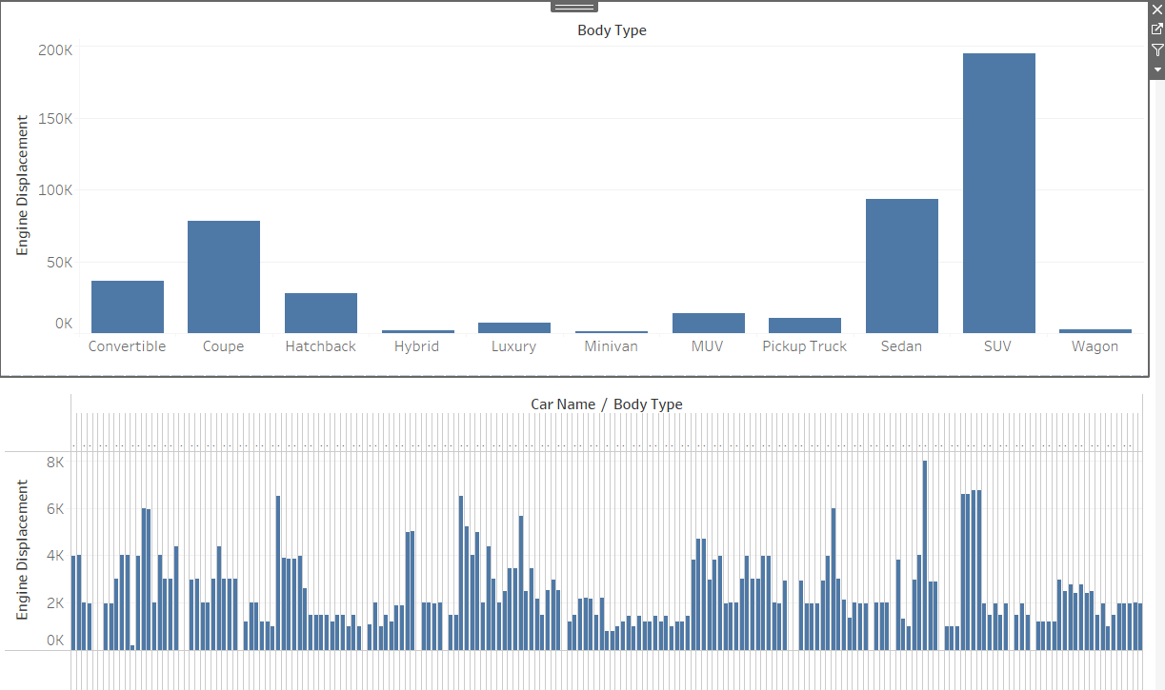

**1.** Go to Dashboard > Actions.

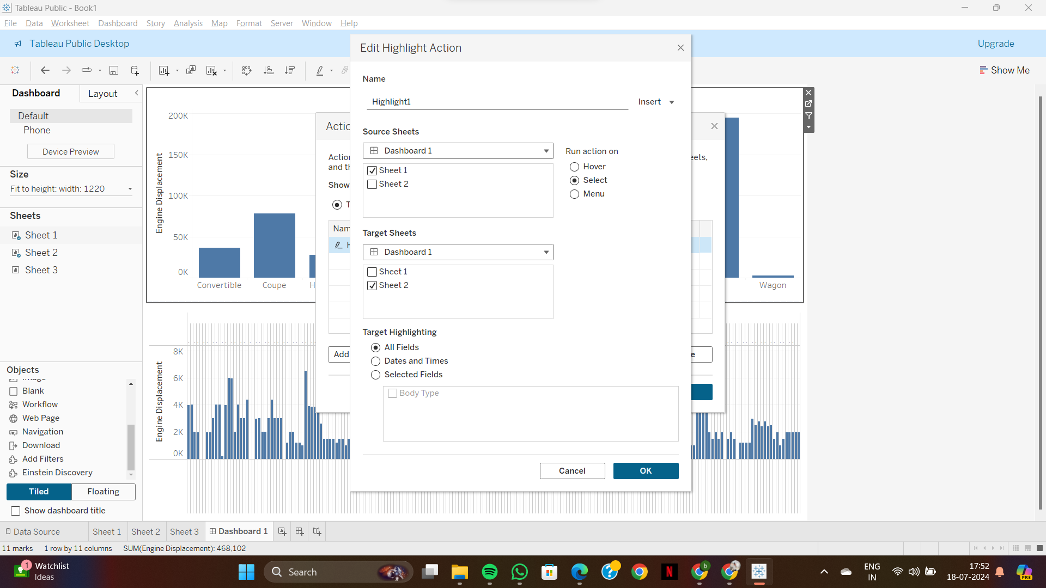

**2.** Configure the source and target sheets, and specify the fields to highlight.

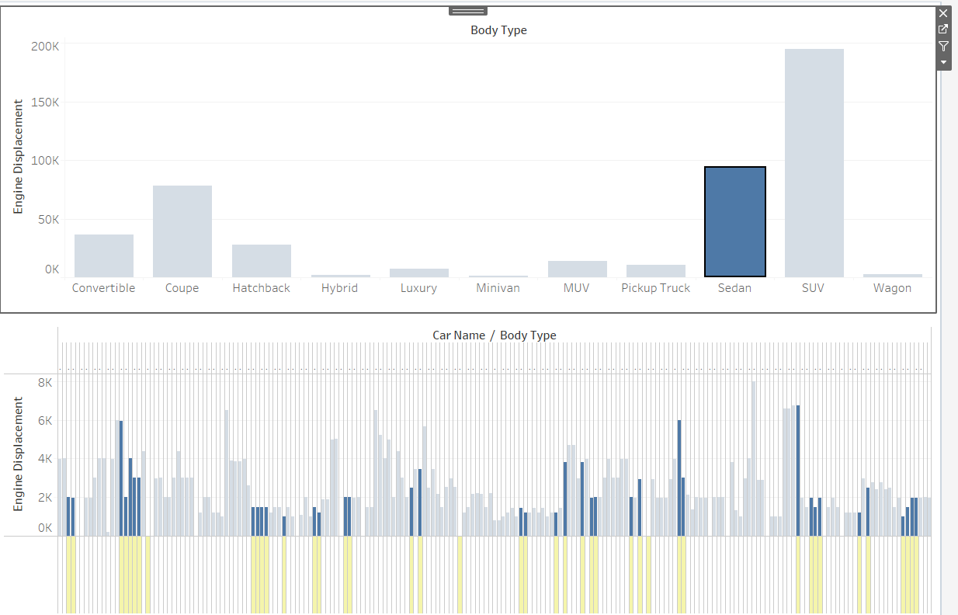

## b) Filter action:

These allow users to filter the data in one visualization by selecting marks or data points in another visualization. To set up a filter action

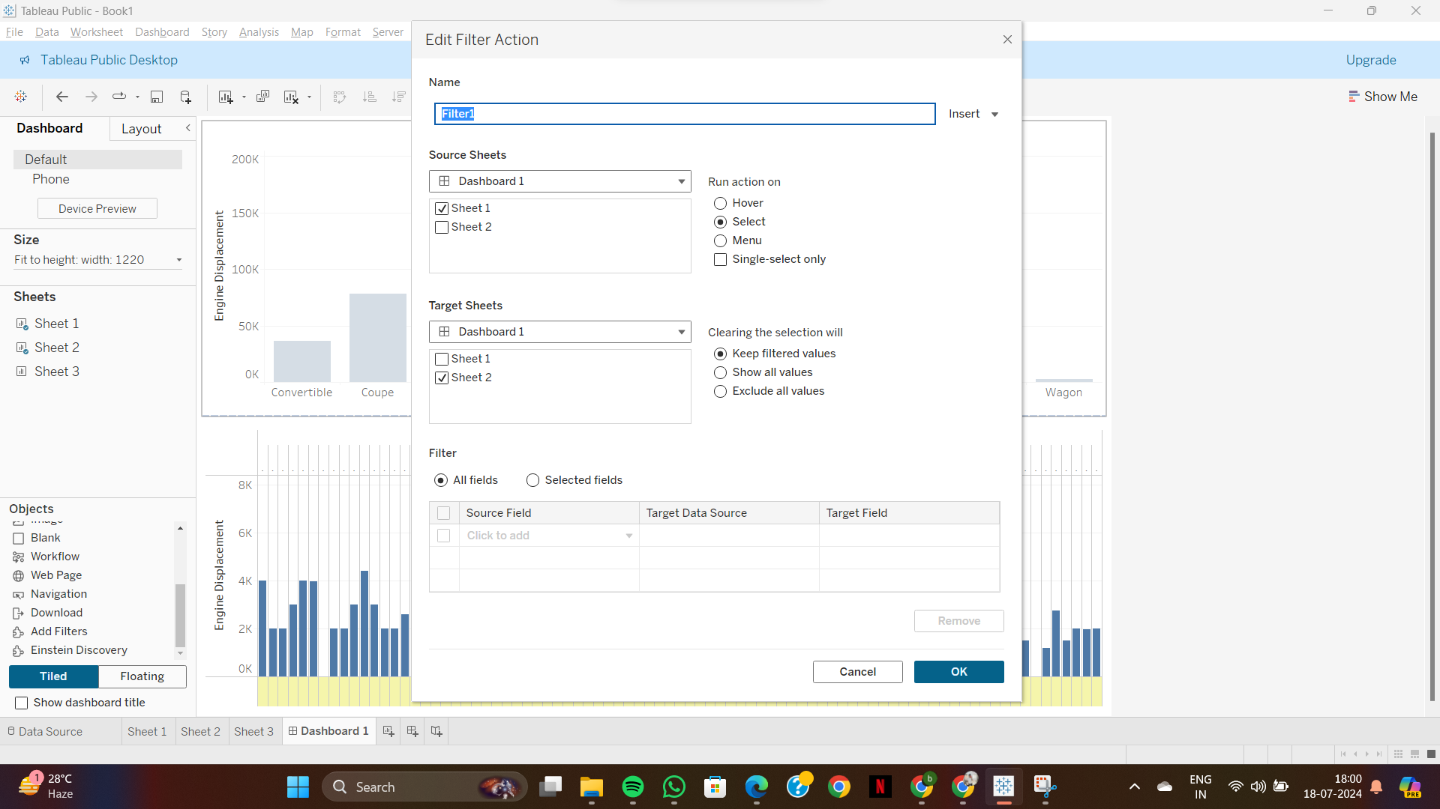

**Filter Action applied on Dashboard**

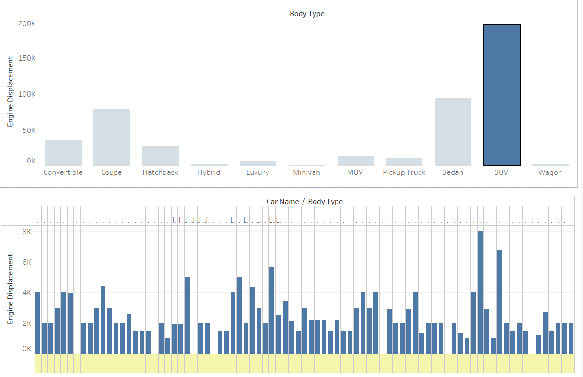

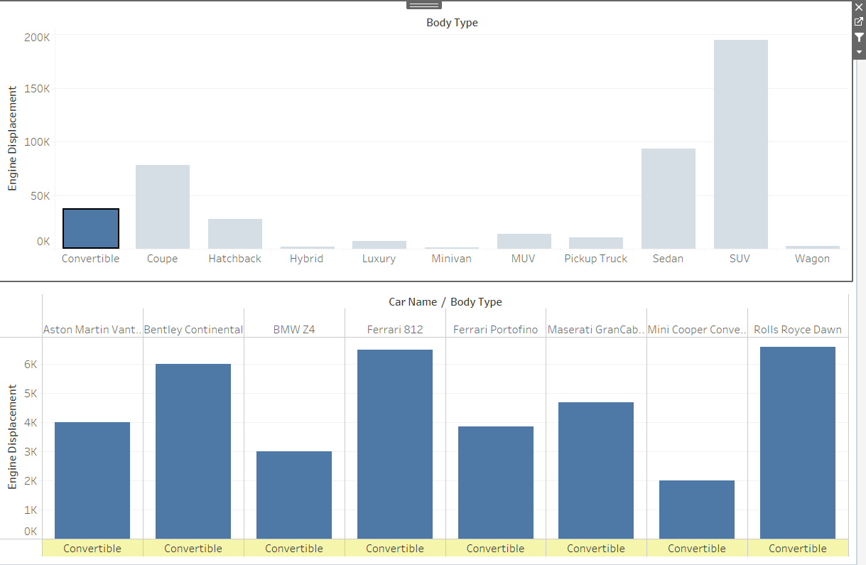

## **C) Heat map:**

### **Purpose:** Display data intensity, indicating sums of sales or fraud cases. Implementation:

* **Step 1:** Drag and drop the Heat Map from the Show Me panel.
* **Step 2:** Set color intensity based on the sum of sales or other metrics. Example: Create a heat map showing sales intensity by region, where darker colors indicate higher sales.

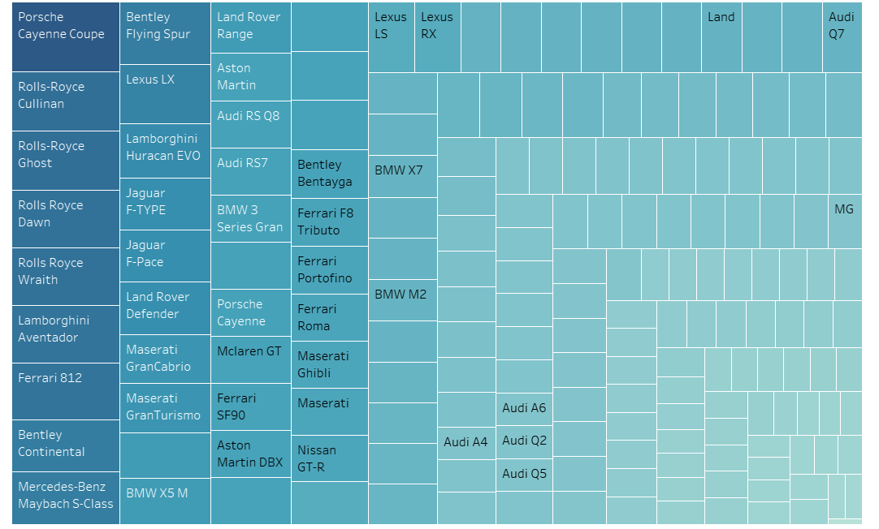

**Heatmap in Tableau:**

→Displays data by car body type.

→Color intensity indicates the sum of sales and the number of units sold.

**Color Coding:**

→Darker shades of blue represent higher sales volumes and higher numbers of units sold.

→Lighter shades of blue indicate lower sales volumes and fewer units sold.

**Visual Insight:**

→Distribution of colors provides quick visual insight into sales patterns across different car body types, highlighting the most and least popular categories.

## d) Pie chart:

The pie chart you've provided shows the distribution of different body types in automobile sales. Here are some key points that can be derived from the chart:

1. SUV Dominance

2. Coupe Popularity

3. Sedan Market:

4. Convertible and Hatchback Segments:

5. Minor Segments:

This chart provides valuable insights into consumer preferences and market trends in the automobile industry for 2022. It highlights the dominance of SUVs and the continued relevance of sedans, while also showing the niche appeal of other body types.

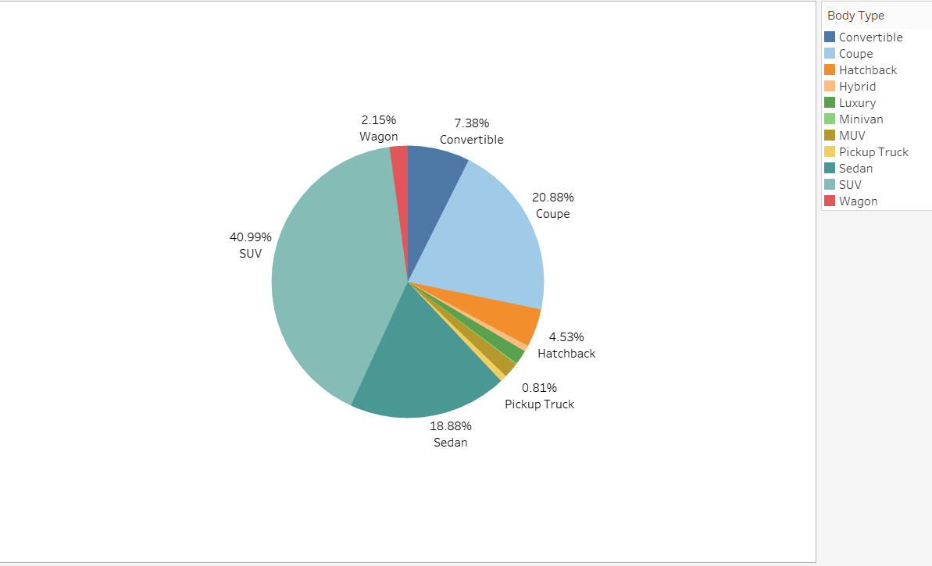

**e) Highlight text table:**

### 

### **Columns:** Car Model

### **Rows:** Sales Volume, Units Sold

### **Color:** Conditional formatting to highlight cells based on high sales volumes with shades of blue.

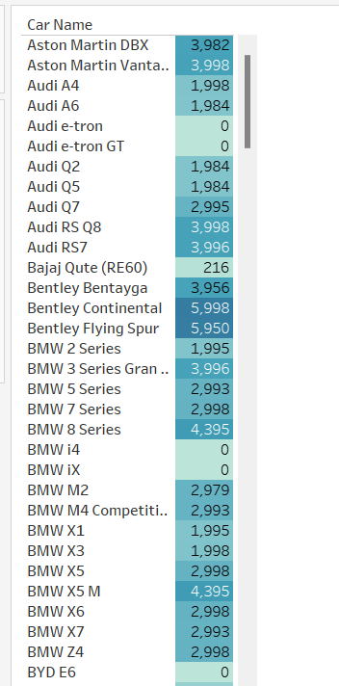

This table probably highlights car sales with specific characteristics, such as high sales volumes or flagged by performance metrics.

● Highlighted cells may represent car models that need further investigation or attention.

● Using a table format allows for easy comparison and analysis of multiple car models side by side.

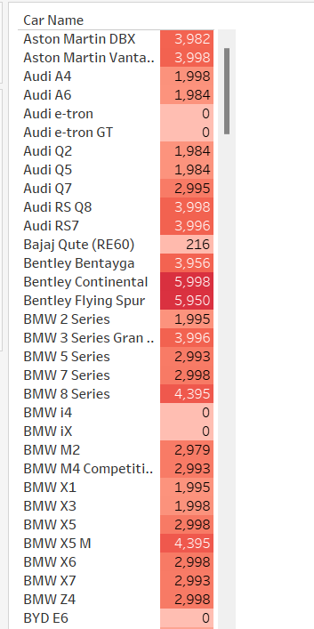

## f) Tool tip:-

### Sales Figures:The tooltips in this chart provide additional information about each body type, such as the exact number of units sold and the percentage of total sales.

### Market Trends:Tooltips help in quickly understanding the context and details of individual body types without cluttering the main visualization.

### Consumer Preferences:This feature enhances the user's ability to spot trends and delve deeper into the factors driving consumer preferences for different automobile body types.

### Using tooltips in the analysis of automobile sales trends allows for a more comprehensive understanding of the data, facilitating better decision-making and strategy development.

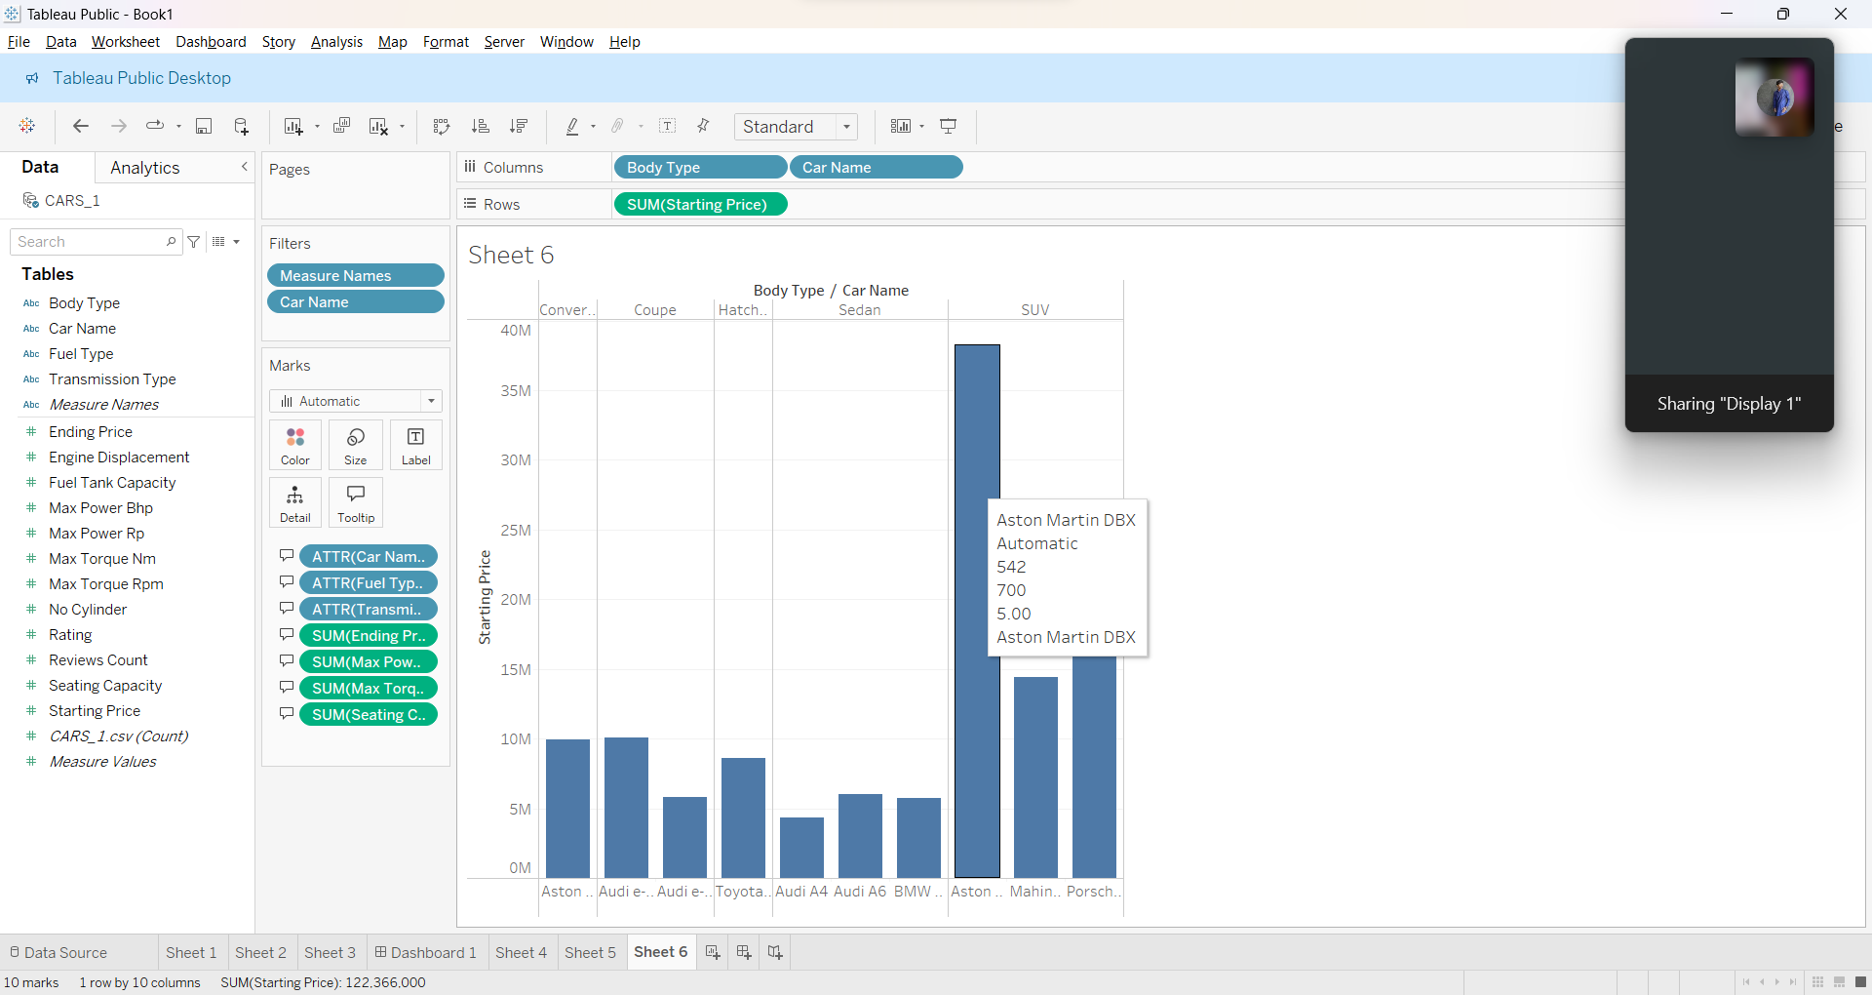

## Results and Discussion

The analysis of automobile sales trends in 2022 provides several critical insights for various stakeholders in the industry. The following points summarize the findings and implications based on the data analyzed:

**1. Economic Impact:**

- The automobile industry remains a cornerstone of economic activity, significantly contributing to GDP, employment, and investment. Understanding sales trends is crucial for maintaining this economic impact.

**2. Consumer Preferences:**

- Shifts in consumer preferences are evident, with a notable increase in the demand for electric vehicles (EVs) and SUVs. This trend is influenced by factors such as environmental concerns and the desire for advanced technological features in vehicles.

**3. Technological Advancements:**

- Technological innovations, particularly in EVs and autonomous driving, are reshaping the industry. These advancements are not only altering consumer demand but also necessitating changes in production and marketing strategies by manufacturers.

**4. Regulatory Environment:**

- Regulatory frameworks, including emissions standards and incentives for sustainable mobility, have a profound impact on sales dynamics. Manufacturers are increasingly focused on compliance and leveraging incentives to boost sales of eco-friendly vehicles.

**5. Global Market Dynamics:**

- Global economic conditions, trade policies, and geopolitical tensions influence automotive sales trends. A holistic perspective on these factors is essential for understanding and predicting market dynamics.

**6. Supply Chain Resilience:**

- The COVID-19 pandemic highlighted the importance of resilient supply chains. Industry players are reassessing sourcing strategies and inventory management practices to mitigate future disruptions.

**7. Sustainability Imperative:**

- There is a growing emphasis on environmental sustainability and corporate social responsibility. This drives the demand for eco-friendly vehicles and shapes consumer perceptions, pushing manufacturers to innovate in green technology.

## Conclusion

### 

### **1. Consumer Preferences:**

### - Shift towards electric vehicles (EVs) and SUVs due to environmental concerns and preference for advanced features.

### - Prioritize EVs and SUVs to capture market share.

### 

### **2. Technological Advancements:**

### - Rapid development in EVs and autonomous driving is reshaping the industry.

### - Investment in innovation and R&D is crucial for competitiveness and meeting future demand.

### 

### **3. Regulatory Environment:**

### - Emissions standards and incentives for sustainable mobility influence sales trends.

### - Compliance and leveraging incentives are vital for boosting sales and meeting regulatory requirements.

### 

### **4. Global Market Dynamics:**

### - Economic conditions, trade policies, and geopolitical tensions impact sales trends.

### - A global perspective is necessary for anticipating market shifts and developing strategies.

### 

### **5. Supply Chain Resilience:**

### - The pandemic highlighted the need for resilient supply chains.

### - Flexible and adaptive supply chain strategies are needed to mitigate risks and ensure continuity.

### 

### **6. Sustainability Imperative:**

### - Emphasis on sustainability drives demand for eco-friendly vehicles.

### - Innovation and promotion of green technologies are essential for meeting demand and enhancing brand image.

### 

### 

### 

# **References**

1. [Verma, Kavita, and Kapil Malhotra. "A bibliometric analysis of sport utility vehicle segment in the automobile industry: two decades study based on web of science database." *International Journal of Business and Emerging Markets* 15.2 (2023): 135-156](https://www.inderscienceonline.com/doi/abs/10.1504/IJBEM.2023.130476).
2. [Haghani, Milad, et al. "Trends in electric vehicles research." *Transportation research part D: transport and environment* 123 (2022): 103881.](https://www.sciencedirect.com/science/article/pii/S136192092300278X)
3. [Ullah, Irfan, et al. "Employing bibliometric analysis to identify the current state of the art and future prospects of electric vehicles." *Energies* 16.5 (2023): 2344.](https://www.mdpi.com/1996-1073/16/5/2344)
4. [Raut, Savita M., S. Bapuji, and S. Mahavidyalaya. "A Study of Sales Trend of E-vehicles in India and Maharashtra." *Assistant Professor Department of Commerce Shikshanmaharshi Dr. Bapuji Salunkhe Mahavidyalaya, Miraj, India* (2022).](https://www.researchgate.net/profile/Savita-Raut-2/publication/361265794_A_Study_of_Sales_Trend_of_E-vehicles_in_India_and_Maharashtra/links/62a7b83a55273755ebeb2312/A-Study-of-Sales-Trend-of-E-vehicles-in-India-and-Maharashtra.pdf)
5. [Devi, R. Saroja, K. Selvam, and V. Sudha. "A SALES TREND ANALYSIS OF E-VEHICLES (EVS) IN INDIA AND TAMIL NADU." (2023).](https://ijeks.com/wp-content/uploads/2023/10/IJEKS2-10-002.pdf)