DOCUMENT MANAGEMENT IN PHARMACEUTICAL

INDUSTRY

Aroon Adulapuram , Fariyah Nargis* , G. Pallavi , G. Sangeetha

Sarojini Naidu Vanita Pharmacy Maha Vidyalaya

ABSTRACT: The basic rules in any good manufacturing practice (GMP) regulations specify that the pharmaceutical manufacturer must maintain proper documentation and records. Documentation helps to build up a detailed picture of what a manufacturing function has done in the past and what it is doing now and, thus, it provides a basis for planning what it is going to do in future. Regulatory inspectors, during their inspections of manufacturing sites, often spend much time examining a company’s documents and records. Effective documentation enhances the visibility of the quality assurance system. Considering above facts, we have tried to harmonize different GMP requirements and prepare comprehensive GMP requirements related to ‘documentation and records,’ followed by a meticulous review of the most influential and frequently referred regulations. “IF IT’S NOT WRITTEN DOWN,THEN IT DIDN’T HAPPEN!”

KEY WORDS: Documentation and records, good manufacturing practices, quality assurance, standard operating procedure(sop), hierarchy, quality audit, documentation practices.

INTRODUCTION:

DOCUMENT MANAGEMENT:

Pharmaceutical document management can be defined as a system that captures, stores, and tracks all the documents related to the development, production, and distribution of pharmaceutical product. It can be considered one of the most critical components of your organization. These documents need to be safely and efficiently maintained for the purposes of auditing and to show to your internal and external stakeholders that the product being developed is both safe and efficacious.

BENEFITS:

The benefits of effective pharmaceutical document management are many and varied, but can be summarized in the following benefits:

* Compliance: With effective pharmaceutical document management, your organization will be up to date with all regulatory requirements.
* Efficiency: Your organization will be generating thousands of documents throughout the lifecycle of a product. When you manage your documents effectively, you will not lose documents, all details will be traceable, and it will be easier to find the documents you need when you need them.
* Security: Effective pharmaceutical document management will ensure that all documents are safe and secure. Only authorized personnel will be able to access pertinent documents. [1]

Regulatory requirements: [1]

There are some requirements which are given below;

Several regulatory guidelines describe how pharmaceutical organization should go about managing their documents.

* International council for harmonisation
* Current good manufacturing practice regulations
* FDA 21 CFR part 58
* FDA 21 CFR part 210 • FDA 21 CFR part 312
* FDA 21 CFR part 314
* FDA 21 CFR part 11

General requirements:

Good documentation constitutes an essential part of the quality assurance system. Clearly written procedures prevent errors resulting from spoken communication, and clear documentation permits tracing of activities performed.

Documents must be designed, prepared, reviewed, and distributed with care.

Documents must be approved, signed, and dated by the appropriate competent and authorized persons.

Documents must have unambiguous contents. The title, nature, and purpose should be clearly stated. They must be laid out in an orderly fashion and be easy to check. Reproduced documents must be clear and legible. Documents must be regularly reviewed and kept up to date. When a document has been revised, systems must be operated to prevent inadvertent use of superseded documents (e.g., only current documentation should be available for use).

Documents must not be handwritten; however, where documents require the entry of data, these entries may be made in clear legible handwriting using a suitable indelible medium (i.e., not a pencil). Sufficient space must be provided for such entries.

Record must be kept at the time each action is taken and in such a way that all activities concerning the conduct of preclinical studies, clinical trials, and the manufacture and control of products are traceable. [2]

Types of documents:

1. Quality manual
2. Policies
3. Standard operating procedure
4. Batch records
5. Test methods

Hierarchical document system:

The organization should establish a hierarchical document system as mentioned in Figure 1: [2]

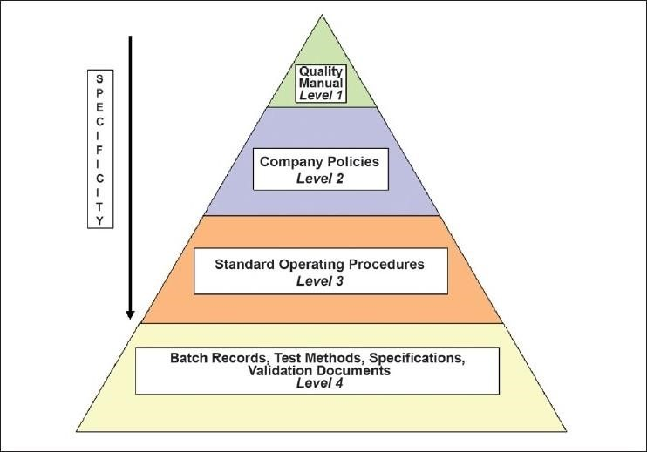

STANDARD OPERATING PROCEDURES (SOP):

A Standard Operating Procedure (SOP) is a set of written instructions that document routine or repetitive activity which is followed by employees in an organization. The development and use of SOPs are an integral part of a successful quality system. It provides information to perform a job properly, and consistently to achieve predetermined specification and quality result. SOPs should allow for the continual improvement of standards of service and provide evidence of commitment towards protecting patients.

BENEFITS OF SOP:

1. Standard Operating Procedure {SOP} is a set of written instructions that document routine or repetitive activity which is followed by employees in an organization
2. To ensure that processes continue uninterrupted and are completed on a described schedule. Ensure against process shutdowns caused by equipment failure or other facility damage.
3. To ensure that approved procedures are followed in compliance with company and
4. Government regulations. Well written SOPs help ensure that government regulations are satisfied.
5. When proper procedures are outlined in a good SOP, any co-worker can coach another to help improve work skills. [3]

SOP REQUIREMENTS:

The data generated through these procedures should be maintained to show compliance with

The above-mentioned requirements.

 Prepare apex documents like Quality Policy, Quality Manual, Site Master File,

Validation Master Plan, etc. To describe the quality commitments of the management

 Define the roles and responsibilities of all personnel working in the organization

 Management, control, and retention of superseded or obsolete documents

 Handling, archival, retrieval, and retention of electronic records/documents

 Procedure for control of electronic signatures

KEY ELEMENTS OF SOPs

*1.Title page*

*2.Table of contents*

*3.Procedure*

*4.Quality assurance quality control*

*5.Reference* [3]

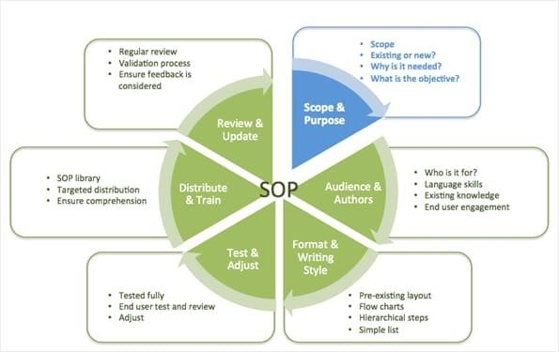

QUALITY AUDIT:

Systematic and independent examination to determine quality activities and related results comply with the planned arrangements and whether these arrangements are implemented effectively and are suitable to achieve objectives. Any failure in their Proper Implementation may be published publicly and may lead to revocation of quality certification.

TYPES OF AUDITS:

 A first is an audit performed by an organization on itself i.e. an internal audit A Second party audit performed by one organization on its own behalf on another usually on a supplier by a customer.

 A third-party audit is an audit by an independent organization other than the customer on a supplier. [3]

## THE AUDIT LIFE CYCLE

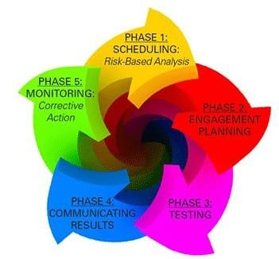

Documentation Practices:

Such measures that collectively and individually ensure Documentation, whether paper or electronic, is attributable, legible, traceable, permanent, contemporaneously recorded, original and accurate.

COMMON ELEMENTS OF DOCUMENTATION:

* Patient’s Input
* Information about the patient’s current situation and background
* Professional assessment of findings
* Patient centred plan of care
* Outcomes of care

PURPOSE:

Purpose of this Guideline is to:

Describe the requirements of maintaining complete, accurate, truthful and verifiable data in all cGXP documents that are needed to be maintained as per regulatory requirements and various governmental regulations, laws, rules and statutes/acts.

Describe the importance of data generation, maintaining data lifecycle, data governance and data reliability throughout the lifecycle of the document. [4]

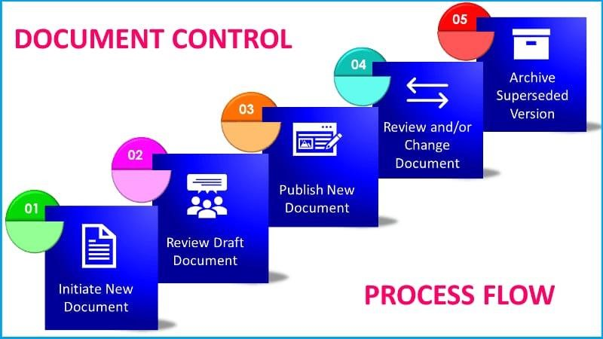

CONCLUSION:

Pharmaceutical manufacture and regulation are clearly an international business. With the increasing emphasis on harmonisation efforts and standard setting, as well as mutual recognition agreements, knowledge of foreign regulations is a must both for understanding the future direction of these efforts as well as for international supply of drug products. It is anticipated that the approach described here will be a useful reference work for those personnel preparing and using documents for pharmaceutical manufacture. It can serve as a tool for training staff and may prove to be useful for quality assurance professionals for assessment of compliance during self-inspection. It is again emphasized that documentation is a very important aspect of GMP and will enhance the visibility of the quality assurance function. [5]

Just as with GMPs, the goal of implementing strict compliance with GDPs will help pharmaceutical companies establish consistent practices that will minimize risk of misinterpretation, errors in communication and ensure product quality.

Setting and following good document practices is not only an essential aspect of compliance with federal regulations, but also critical to consumer health. [6]

REFERENCE:

1. Website: Simplerqms , Effective pharmaceutical document management by Germans Frolovs
2. PUBMED CENTRAL : Documentation and Records: Harmonised GMP Requirments
3. A Textbook of pharmaceutical Quality Assurance by Mr. Sanjay A.Nagdev , Mr. Mayur R. Bhurat, Dr. Md. Usman Dr. Krishna R.Gupta, Dr. Upendra B. Gandagule
4. Website: World Health Organisation
5. Guidance for Industry: Manufacturing, processing or holding active pharmaceutical ingredient, draft guidance;USFDA, Centre for drug evaluation and research CDER
6. Documentation and records: Website of GMP online consultancy