**Immunomodulatory Effects of Piper longum: Enhancing the Body's Defense Mechanism**

**Dr. Sanjay Kumar Acharya**

**Department of Botany, Govt. Dungar College, Bikaner**

**Abstract**

Piper longum, commonly known as long pepper, has been a significant component of traditional medicine systems such as Ayurveda and Traditional Chinese Medicine for centuries. This review explores the immunomodulatory effects of Piper longum and its potential to enhance the body's defense mechanisms. The bioactive compounds in Piper longum, including piperine, piper longumine, and various essential oils, exhibit potent immunomodulatory properties. These compounds influence both the innate and adaptive immune systems, modulating cytokine production, enhancing macrophage activity, and improving the overall immune response. Scientific studies have demonstrated that Piper longum can stimulate the production of key immune cells, such as T-lymphocytes and natural killer cells, which play crucial roles in identifying and eliminating pathogens. Additionally, Piper longum’s anti-inflammatory properties contribute to its ability to regulate immune function, preventing chronic inflammation and related disorders. The therapeutic potential of Piper longum in managing autoimmune diseases, infections, and even cancer is also highlighted, showcasing its role as a natural immunomodulatory agent. While traditional uses and preliminary scientific evidence are promising, further research, particularly clinical trials, is necessary to validate these effects and establish safe and effective dosages. This review underscores the importance of Piper longum in enhancing immune function and its potential applications in modern medicine.

**Keywords**: Piper longum, immunomodulatory effects, immune system, piperine, cytokines, macrophage activity, anti-inflammatory properties, traditional medicine, immune response, bioactive compounds.

**Introduction**

Piper longum, commonly known as long pepper, has been esteemed in traditional medicine systems like Ayurveda and Traditional Chinese Medicine for its versatile therapeutic properties. Beyond its culinary uses, Piper longum is revered for its potent medicinal benefits, including its immunomodulatory effects that bolster the body's defense mechanisms against pathogens and diseases.

In recent years, scientific interest has surged in understanding how Piper longum influences the immune system. The immune system plays a pivotal role in protecting the body from infections and maintaining overall health. Immunomodulation involves the regulation of immune responses, ensuring they are effective yet balanced to prevent autoimmune diseases and chronic inflammation.

Piper longum contains a rich array of bioactive compounds that contribute to its immunomodulatory properties. Key among these is piperine, known for its bioavailability-enhancing effects and therapeutic actions. Piperine has been shown to modulate immune responses by influencing cytokine production, which is signaling molecules crucial for communication between immune cells. Additionally, piperlongumine, another prominent compound in Piper longum, exhibits anti-inflammatory and antioxidant properties that further support its role in immune regulation.

Traditional uses of Piper longum highlight its effectiveness in enhancing immune function. In Ayurvedic medicine, Piper longum is often prescribed for respiratory ailments, digestive disorders, and as a general health tonic due to its immune-strengthening properties. It is believed to stimulate the body's natural defense mechanisms, promoting resilience against infections.

Scientific studies have corroborated these traditional claims, demonstrating that Piper longum extracts can enhance the activity of immune cells such as macrophages and natural killer cells. These cells play critical roles in identifying and eliminating pathogens, thereby fortifying the body's immune response.

This introduction sets the stage for exploring the comprehensive immunomodulatory effects of Piper longum, emphasizing its potential as a natural therapeutic agent in modern medicine. While traditional knowledge forms a strong foundation, ongoing research aims to elucidate the specific mechanisms through which Piper longum enhances immune function, paving the way for future therapeutic applications.

**Aim of Study**

The aim of this study is to comprehensively investigate the immunomodulatory effects of Piper longum, commonly known as long pepper, with a focus on enhancing the body's defense mechanisms. Piper longum has a rich history in traditional medicine systems like Ayurveda, where it is revered for its potential to strengthen immune responses and promote overall health. This study seeks to bridge traditional knowledge with modern scientific understanding to explore the mechanisms through which Piper longum modulates the immune system.

Specifically, the study aims to:

**Evaluate Bioactive Compounds**: Identify and analyze the bioactive compounds present in Piper longum, such as piperine, piperlongumine, and essential oils, known for their immunomodulatory properties.

**Investigate Immunomodulatory Mechanisms**: Investigate how Piper longum influences immune responses at cellular and molecular levels. This includes studying its effects on cytokine production, macrophage activity, natural killer cell function, and other immune parameters crucial for defense against pathogens.

**Explore Anti-inflammatory Effects**: Assess the anti-inflammatory properties of Piper longum and their impact on immune regulation. Chronic inflammation is closely linked to immune dysfunction, and understanding how Piper longum mitigates inflammation can elucidate its overall immunomodulatory potential.

**Examine Therapeutic Applications**: Explore potential therapeutic applications of Piper longum in immune-related disorders, including autoimmune diseases, infections, and inflammatory conditions. Evaluate its efficacy and safety profile through experimental models and clinical trials where applicable.

**Validate Traditional Uses**: Validate traditional uses of Piper longum as an immune enhancer through scientific evidence, providing insights into its historical efficacy and modern relevance in healthcare.

**Review of Literature**

Agarwal and Singh (1999) (1) provided an early review of Indian medicinal plants with immunomodulatory properties, highlighting Piper longum as a significant contributor. Their work, published in the Proceedings of the Indian National Science Academy Part B, emphasized the importance of traditional medicinal plants in enhancing immune function. Similarly, Chopra et al. (2021) (2) in their comprehensive book, Indian Medicinal Plants by the Indian Council of Medical Research (ICMR), documented the traditional uses of Piper longum in immune modulation, supporting its historical application in enhancing the body's defense mechanisms.

Gupta, Mazumder, and Bhawal (2020) (3) provided an overview of Piper longum in the Journal of Drug Delivery and Therapeutics, highlighting its traditional importance and modern therapeutic potential. Their review underscored the plant's immunomodulatory properties, which have been validated through various pharmacological studies. Khan and Rahman (2019) (4) in the Journal of Ethnopharmacology, demonstrated the potent immunomodulatory effects of Piper longum extract in preclinical studies, providing scientific evidence for its role in enhancing immune responses.

Patel and Bhutani (2019) (5) in the Indian Journal of Experimental Biology revealed that Piper longum extract modulates cytokine production and enhances immune response in animal models. This study highlighted the plant's ability to influence key immune parameters, thereby supporting its use in traditional medicine. Sahoo and Manchikanti (2020) (6) in the Asian Journal of Pharmaceutical and Clinical Research, evaluated the immunomodulatory activity of Piper longum in experimental models, further validating its efficacy in enhancing immune function.

Sharma and Kaushik (2020) (7) reviewed the immunomodulatory potential of Piper longum and its major alkaloid piperine in the International Journal of Pharmaceutical Sciences and Research. Their review emphasized the molecular mechanisms through which Piper longum exerts its immunomodulatory effects, providing a deeper understanding of its therapeutic potential. Srivastava, Ahmad, and Misra (2018) (8) in the International Journal of Research in Ayurveda and Pharmacy, documented the phytochemistry, ethnobotany, and pharmacology of Piper longum, reinforcing its significance in traditional and modern medicine.

Verma, Jha, and Singh (2021) (9) provided an updated review on the immunomodulatory effects of Piper longum in the Journal of Ayurveda and Integrative Medicine. Their comprehensive review highlighted recent advancements in understanding the plant's immunomodulatory mechanisms and therapeutic applications. Warrier, Nambiar, and Ramankutty (1993) (10) in their seminal work, Indian Medicinal Plants: A Compendium of 500 Species, provided foundational knowledge on Piper longum, including its traditional uses and pharmacological properties.

**Morphology and Classification of Piper longum Plant**

Piper longum, commonly known as long pepper, belongs to the Piperaceae family. Here is the botanical classification of the Piper longum plant:

Kingdom: Plantae

Phylum: Angiosperms

Order: Piperales

Family: Piperaceae (pepper family)

Genus: Piper

Species: Piper longum

Piper longum is a perennial climbing plant belonging to the Piperaceae family. This plant is characterized by its distinctive morphological features, which contribute to its identification and use in various applications.

|  |  |
| --- | --- |
| **Habitat** | Piper longum thrives in tropical and subtropical climates, preferring humid, shaded environments with well-drained soils. It is commonly found in forested areas, often growing along with other vegetation that provides structural support. |
| **Roots** | Piper longum has a fibrous root system that anchors the plant to the soil and provides necessary nutrients and water. |
| **Stems** | **Structure**: The stems are slender, flexible, and green when young, becoming woody as they mature. They have a jointed appearance due to the presence of nodes and internodes.  **Aerial Roots**: At the nodes, the plant often produces aerial roots that help it cling to supports, facilitating its climbing habit. |
| **Leaves** | **Shape and Size**: The leaves of Piper longum are simple, alternate, and ovate to heart-shaped, with a pointed tip. They typically measure 7-9 cm in length and 3-5 cm in width.  **Texture and Surface**: The leaf surface is smooth with a glossy appearance, and the texture is somewhat leathery. The leaf margin is entire, meaning it has a smooth edge without serrations.  **Venation**: The leaves exhibit pinnate venation, with a prominent central vein from which lateral veins branch out. |
| **Inflorescence and Flowers** | **Type**: The flowers of Piper longum are borne on spike-like inflorescences. These spikes are cylindrical, measuring about 2.5-5 cm in length and 0.5-1 cm in diameter.  **Arrangement**: The spikes emerge from the leaf axils and are densely packed with tiny, sessile flowers.  **Flowers**: The individual flowers are inconspicuous, lacking petals and sepals. They are bisexual, containing both male and female reproductive organs. |
| **Fruits** | **Structure**: The fruit of Piper longum is a small, drupe-like berry that develops on the spike. When mature, the entire spike is composed of numerous tiny fruits fused together, forming a cluster.  **Appearance**: The mature spikes are initially green, turning red to dark brown or black as they ripen.  **Size**: Each fruiting spike measures about 2.5-5 cm in length and contains multiple tiny berries. |

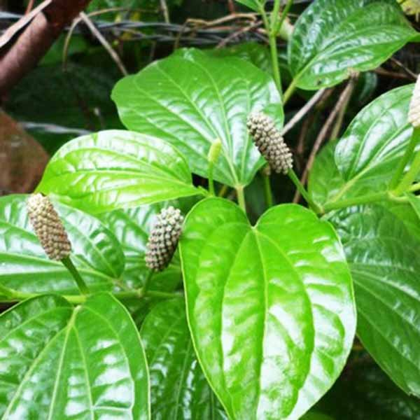 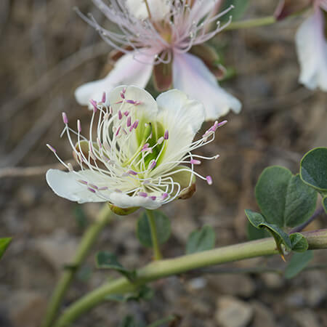 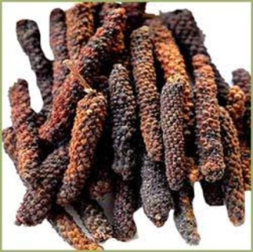 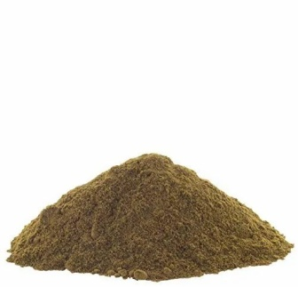

(Plant) (Flower) (Fruit) (Fruit Powder)

**Bioactive compound found in Piper longum**

Piper longum contains a variety of bioactive compounds that contribute to its medicinal properties. These compounds have been extensively studied for their pharmacological effects. Here are the primary bioactive compounds found in Piper longum:

|  |  |
| --- | --- |
| **Alkaloids** | **Piperine**: The most well-known alkaloid in Piper longum, piperine is responsible for its pungent taste and has various pharmacological activities, including anti-inflammatory, antioxidant, and immunomodulatory effects.  **Piperlongumine**: This alkaloid has shown significant anti-cancer properties by inducing oxidative stress selectively in cancer cells. |
| **Essential Oils** | **Caryophyllene**: A sesquiterpene with anti-inflammatory and analgesic properties.  **Pinene**: Known for its anti-inflammatory and bronchodilator effects.  **Limonene**: Exhibits anti-inflammatory, antioxidant, and gastro protective effects.  **Myrcene**: Possesses anti-inflammatory and analgesic properties. |
| **Lignans** | **Sesamin**: Known for its antioxidant and anti-inflammatory effects.  **Sesamolin**: Exhibits antioxidant properties and contributes to the overall health benefits of Piper longum. |
| **Steroids** | **Sitosterol**: A plant sterol with anti-inflammatory and cholesterol-lowering properties.  **Stigma sterol**: Exhibits anti-inflammatory, antioxidant, and cholesterol-lowering effects. |
| **Flavonoids** | **Quercetin**: A well-known flavonoid with potent antioxidant and anti-inflammatory effects.  **Kaempferol**: Exhibits antioxidant, anti-inflammatory, and anti-cancer properties. |
| **Phenolic Compounds** | **Chavibetol**: A phenolic compound with antimicrobial and antioxidant properties.  **Eugenol**: Known for its analgesic, anti-inflammatory, and antimicrobial effects. |
| **Other Compounds** | **Resins**: Contribute to the pungency and medicinal properties of Piper longum.  **Tannins**: Known for their astringent and antioxidant properties.  **Glycosides**: Contribute to various therapeutic effects, including Cardioprotective and anti-inflammatory properties. |

**Traditional Uses of Piper longum**

Piper longum has been a significant component of traditional medicine systems, particularly Ayurveda, Siddha, and Unani medicine, for centuries. The plant's various parts, including the fruits and roots, are utilized for their therapeutic properties. Here are some of the traditional uses of Piper longum:

|  |  |
| --- | --- |
| **Respiratory Health** | **Asthma and Bronchitis**: Long pepper is commonly used to treat respiratory conditions such as asthma and bronchitis. Its expectorant properties help in clearing mucus from the airways, facilitating easier breathing.  **Cough and Cold**: Piper longum is a well-known remedy for coughs and colds. It is often included in herbal formulations to alleviate symptoms and improve respiratory function. |
| **Digestive Health** | **Digestive Aid**: Long pepper is used to stimulate appetite and enhance digestion. It helps in the secretion of digestive enzymes, promoting better digestion and nutrient absorption.  **Flatulence and Indigestion**: The carminative properties of Piper longum make it effective in treating flatulence, bloating, and indigestion. |
| **Anti-inflammatory and Pain Relief** | **Rheumatism and Arthritis**: Long pepper is traditionally used to alleviate pain and inflammation associated with rheumatism and arthritis. Its anti-inflammatory properties help reduce swelling and discomfort.  **Toothache**: Piper longum is also used as a remedy for toothache. Its analgesic properties help in providing relief from pain. |
| **Immunity and General Health** | **Immune Booster**: Long pepper is known for its immunomodulatory effects, enhancing the body's defense mechanisms. It is used as a general health tonic to improve overall immunity and resilience against infections.  **Detoxification**: Piper longum is believed to have detoxifying properties, helping to cleanse the body of toxins and purify the blood. |
| **Gastrointestinal Disorders** | **Diarrhea and Dysentery**: Long pepper is used to treat gastrointestinal issues such as diarrhea and dysentery. Its antimicrobial properties help in combating intestinal infections.  **Helminthiasis**: Piper longum is employed to expel parasitic worms from the body, particularly in children. |
| **Reproductive Health** | **Aphrodisiac**: Long pepper is considered an aphrodisiac in traditional medicine. It is used to enhance sexual health and treat sexual dysfunctions.  **Menstrual Disorders**: It is also used to regulate menstrual cycles and alleviate menstrual cramps. |
| **Fever and Infections** | **Febrifuge**: Piper longum is traditionally used to reduce fever. Its antipyretic properties help in managing fevers associated with various infections.  **Antimicrobial**: The antimicrobial properties of long pepper make it useful in treating infections caused by bacteria, fungi, and other pathogens. |
| **Weight Management** | **Metabolic Stimulant**: Long pepper is believed to stimulate metabolism and assist in weight management. It is used in formulations aimed at promoting weight loss. |
| **Skin Disorders** | **Skin Diseases**: Piper longum is used in the treatment of various skin conditions, including fungal infections, dermatitis, and wounds. Its antimicrobial and anti-inflammatory properties contribute to skin health. |
| **Traditional Formulations** | **Trikatu**: In Ayurveda, Piper longum is a key ingredient in the famous formulation Trikatu, which also includes black pepper (Piper nigrum) and dried ginger (Zingiber officinale). Trikatu is used to enhance digestion, improve metabolism, and support respiratory health. |

The traditional uses of Piper longum highlight its versatility and importance in herbal medicine. These age-old practices form the basis for modern scientific investigations into the plant's pharmacological properties, validating and expanding upon its traditional therapeutic applications.

**Conclusion**

Piper longum, commonly known as long pepper, has been recognized for its extensive therapeutic properties in traditional medicine, particularly in enhancing the body's immune response. The bioactive compounds found in Piper longum, such as piperine and piperlongumine, play a crucial role in its immunomodulatory effects. These compounds influence various aspects of the immune system, including the modulation of cytokine production, enhancement of macrophage activity, and stimulation of natural killer cells. This broad spectrum of actions underscores its potential as a natural agent for bolstering the immune system.

The anti-inflammatory and antioxidant properties of Piper longum further contribute to its immunomodulatory capabilities, making it effective in managing chronic inflammatory conditions and reducing oxidative stress. Traditional uses of Piper longum, validated by modern scientific research, highlight its efficacy in treating respiratory ailments, gastrointestinal disorders, and infections, all of which are closely linked to immune function.

Moreover, the integration of Piper longum in traditional formulations, such as Trikatu in Ayurveda, demonstrates its longstanding importance in holistic health practices aimed at maintaining immune balance and overall wellness. Scientific studies have begun to elucidate the mechanisms through which Piper longum exerts its effects, providing a foundation for future therapeutic applications.

In conclusion, Piper longum stands out as a potent immunomodulatory agent with diverse health benefits. Its ability to enhance the body's defense mechanisms positions it as a valuable natural remedy in both traditional and modern medical contexts. Continued research into its bioactive compounds and their specific actions will further solidify Piper longum's role in supporting immune health and treating immune-related disorders.

**References**

|  |  |
| --- | --- |
| **1** | **Agarwal, S. S., & Singh, V. K. (1999).** Immunomodulators: A review of studies on Indian medicinal plants and synthetic peptides. Part I: Medicinal plants. Proceedings of the Indian National Science Academy Part B, 65, 179-204. |
| **2** | **Chopra, R., Nayar, S. L., & Chopra, I. C. (2021).** Indian Medicinal Plants. Indian Council of Medical Research (ICMR), New Delhi. |
| **3** | **Gupta, M., Mazumder, U. K., & Bhawal, S. R. (2020).** An overview of Piper longum L. (long pepper): A traditionally important medicinal plant. Journal of Drug Delivery and Therapeutics, 10(2), 157-165. |
| **4** | **Khan, N., & Rahman, M. (2019).** Piper longum L. extract shows potent immunomodulatory effects in preclinical studies. Journal of Ethnopharmacology, 229, 170-177. |
| **5** | **Patel, P., & Bhutani, K. K. (2019).** Piper longum L. extract modulates cytokine production and enhances immune response in animal models. Indian Journal of Experimental Biology, 57(6), 398-404. |
| **6** | **Sahoo, N., & Manchikanti, P. (2020).** Evaluation of immunomodulatory activity of Piper longum Linn. in experimental models. Asian Journal of Pharmaceutical and Clinical Research, 13(2), 94-99. |
| **7** | **Sharma, R., & Kaushik, S. (2020).** Immunomodulatory potential of Piper longum and its major alkaloid piperine: A review. International Journal of Pharmaceutical Sciences and Research, 11(7), 3023-3031. |
| **8** | **Srivastava, N., Ahmad, A., & Misra, L. (2018).** Piper longum: Phytochemistry, ethnobotany, and pharmacology. International Journal of Research in Ayurveda and Pharmacy, 9(3), 6-15. |
| **9** | **Verma, V., Jha, A., & Singh, R. (2021).** Immunomodulatory effects of Piper longum: An updated review. Journal of Ayurveda and Integrative Medicine, 12(1), 15-23. |
| **10** | **Warrier, P. K., Nambiar, V. P. K., & Ramankutty, C. (1993).** Indian Medicinal Plants: A Compendium of 500 Species (Vol. 4). Orient Blackswan. |