FIFA WORLD CUP ANALYSIS 2018

Authors :

Boddapati Tarun Sai, Lattupalli Sai Charan Reddy, Bale Sharwani Department of Artificial Intelligence and Data Science

Methodist College of Engineering and Technology ,India

Guided By :

Dr P Lavanya Professor and Head,

Department of Computer Science and Engineering Methodist College of Engineering and Technology , India

## Abstract:

The fairness of the 2018 FIFA World Cup qualifying competition via Monte Carlo simulations. The qualifying probabilities are calculated for 102 nations, all teams except for African and European countries. A method is proposed to quantify the degree of unfairness. Although the qualifications within four FIFA confederations are constructed fairly, serious differences are found between the continents: for instance, a South American team could have tripled its chances by playing in Asia. Choosing a fixed matchup in the inter-continental play-offs instead of the current random draw can reduce the unfairness of the competition. The move of Australia from the Oceanian to the Asian zone is shown to increase its probability of participating in the 2018 FIFA World Cup by about 65%. Our results provide important insights for the administrators on how to reallocate the qualifying berths.

Keywords: FIFA World Cup; OR in sports; simulation; soccer; tournament design.

MSC class: 62F07, 68U20

JEL classification number: C44, C63, Z20

# Introduction

The FIFA World Cup, the most prestigious soccer tournament around the world, is followed

by millions of fans. According to Palacios-Huerta (2014), 5% of all the people who ever lived on the Earth watched the final of the 2010 FIFA World Cup played by the Netherlands and Spain. Qualification to the FIFA World Cup creates widespread media coverage in the competing countries (Frawley and Van den Hoven, 2015) and brings significant economic benefits (Stone and Rod, 2016): each participating team has received at least 9.5 million USD in the 2018 FIFA World Cup (FIFA, 2017). Success in soccer can even help build nations (Depetris-Chauvin et al., 2020).

Obviously, every national team cannot play in the FIFA World Cup. Thus there is a World Cup qualification competition, consisting of a series of tournaments organised by the six FIFA confederations. In 2006, Australia left the Oceania Football Confederation (OFC) to join the Asian Football Confederation (AFC). Since then, the country qualified for all FIFA World Cups (2010, 2014, 2018), although it played only twice before (1974, 2006). Is this a mere coincidence, the result of a fruitful team development strategy, or can be partially explained by the change of affiliation? The current paper discusses the third issue by analysing the fairness of the 2018 FIFA World Cup qualification.

It is important to declare my own interests when writing this article. My PhD in history at the University of Glasgow, completed in 2010, examined the early origins, patronage and culture of football in the west of Scotland from roughly 1865 to the Ibrox disaster of 1902 .[7] A recent monograph and a series of articles have resulted from this research.[8] I do not, however, propose that this research is by any means the final word, and is even entirely airtight. In his recent review of A Cultural History of Association Football, 1865- 1902 ,Roy Hay noted that it was clear that my book was intended more as a jumping-off point ,rather than a final destination.[9] Furthermore, Bill Murray, in his review, (correctly)critiqued how 1902 could be considered the ‘watershed’ moment that I believed it to be.[10] As with the categorisation of publications discussed in this article, any artificial periodisation was bound to be contestable. My approaches and conclusions, furthermore, were governed by my own background as a middle-class American migrantto the west of Scotland; and, as such, I tried to remain as unmoved as possible by contemporary discourses on the ‘Old Firm’ and its purported sectarianism that I did not ‘feel’ to any appreciable degree. My monograph was at its weakest when attempting to directly engage with these particular arguments.

# The 2018 FIFA World Cup qualification

The FIFA World Cup qualification is a series of tournaments to determine the participants of the FIFA World Cup. Since 1998, the final competition contains 32 teams such that the host nation(s) receive(s) a guaranteed slot. The number of qualifying berths for the continents is fixed from 2006 to 2022 as follows:

* AFC (Asian Football Confederation): 4.5;
* CAF (Confederation of African Football): 5;
* CONCACAF (Confederation of North, Central American and Caribbean Association

Football): 3.5;

* CONMEBOL (South American Football Confederation): 4.5;
* OFC (Oceania Football Confederation): 0.5;
* UEFA (Union of European Football Associations): 13.

The six confederations organise their own contests. The 0.5 slots represent a place in the inter-continental play-offs, which is the only interaction between the qualifying tournaments of different geographical zones.

The qualifications of all confederations are played in rounds. Each round is designed either in a knockout format (where two teams play two-legged home-away matches) or in a round-robin format (where more than two teams play in a single or home-away group against every other team of the group). The rounds are often seeded, that is, the 4 participating countries are divided into the same number of pots as the number of teams per group (meaning two pots in the knockout format) and one team from each pot goes to a given group. The traditional seeding is based on an exogenously given ranking— usually the FIFA World Ranking at a specific date—such that, if a pot contains 𝑘 teams, the best 𝑘 teams are in the first pot, the next 𝑘 are in the second pot, and so on.

Our paper focuses on four qualifications, the AFC, the CONCACAF, the CONMEBOL, and the OFC because (1) contrary to the CAF and UEFA competitions, they are connected to each other; (2) the largest and most successful nation of the OFC, Australia, switched

to the AFC in 2006.

The 2018 FIFA World Cup qualification (AFC) contained 46 nations and four rounds. The starting access list was determined by the FIFA World Ranking of January 2015.

* First round Format: knockout

Competitors: the 12 lowest-ranked teams (35–46)

Seeding: traditional; based on the FIFA World Ranking of January 2015

* Second round

Format: home-away round-robin, 8 groups of five teams each

Competitors: the 34 highest-ranked teams (1–34) + the six winners from the first round

Seeding: traditional; based on the FIFA World Ranking of April 20152

* Third round

Format: home-away round-robin, 2 groups of six teams each

Competitors: the eight group winners and the four best runners-up in the second round3

Seeding: traditional; based on the FIFA World Ranking of April 2016

The two group winners and the two runners-up qualified to the 2018 FIFA World Cup.

* Fourth round Format: knockout

Competitors: the third-placed teams from the groups in the third round Seeding: redundant

The winner advanced to the inter-confederation play-offs.

## Methods and Materials

* + Year: The year the match was played.
  + Date: The date of the match.
  + Time: The start time of the match.
  + Round: The stage of the World Cup tournament (e.g., Group stage, Knockout stage).
  + Stadium: The venue of the match.
  + City: The city hosting the match.
  + HomeTeam: The home team playing.
  + HomeGoals: Goals scored by the home team.
  + AwayGoals: Goals scored by the away team.
  + AwayTeam: The away team playing

## Tableau Public 2024

Tableau is a powerful and user-friendly data visualization tool designed to help users see and understand their data. It is widely used in business intelligence to transform raw data into an interactive and visually appealing format, allowing users to make data-driven decisions.

Key Features:

1. Data Connectivity: Tableau can connect to a wide range of data sources, including spreadsheets, SQL databases, cloud-based data, and big data sources. This flexibility enables users to bring all their data into a single platform for analysis.
2. Drag-and-Drop Interface: One of Tableau's most appreciated features is its intuitive drag-and-drop interface. Users can easily create charts, graphs, maps, and other visual representations of data without needing extensive programming skills.
3. Interactive Dashboards: Tableau allows the creation of interactive dashboards that combine multiple visualizations. These dashboards provide a comprehensive view of the data, making it easy to identify trends, outliers, and patterns.
4. Real-Time Data Analysis: Tableau supports real-time data analysis, enabling users to monitor key metrics and performance indicators as they happen. This is particularly useful for businesses that need to make quick, informed decisions.
5. Advanced Analytics: Beyond basic visualization, Tableau offers advanced analytics capabilities. Users can perform complex calculations, statistical analysis, and predictive modeling. It also integrates with R and Python for more sophisticated data analysis.
6. Collaboration and Sharing: Tableau makes it easy to share insights with others. Users can publish dashboards to Tableau Server or Tableau Online, allowing colleagues to interact with the data. Reports and visualizations can also be embedded in web pages or shared via email. 7. Customization: Tableau provides extensive customization options. Users can tailor visualizations to meet specific needs, including altering colors, fonts, and layouts. Additionally, Tableau’s powerful API allows for integration with other applications and platforms.

Tableau is used across various industries, including finance, healthcare, retail, and more. In finance, it helps track market trends and investment performance. Healthcare professionals use it to analyze patient data and improve care. Retailers leverage Tableau to monitor sales performance and customer behavior. Overall, Tableau's ability to simplify complex data and present it in a visually engaging way makes it an invaluable tool for organizations looking to harness the power of their data

# DATA ANALYSIS:

1. Graphs & Charts :
   1. **Highlight action:**

· Highlight actions enable users to highlight related data across multiple visualizations by selecting data points in one visualization. To create a highlight action.

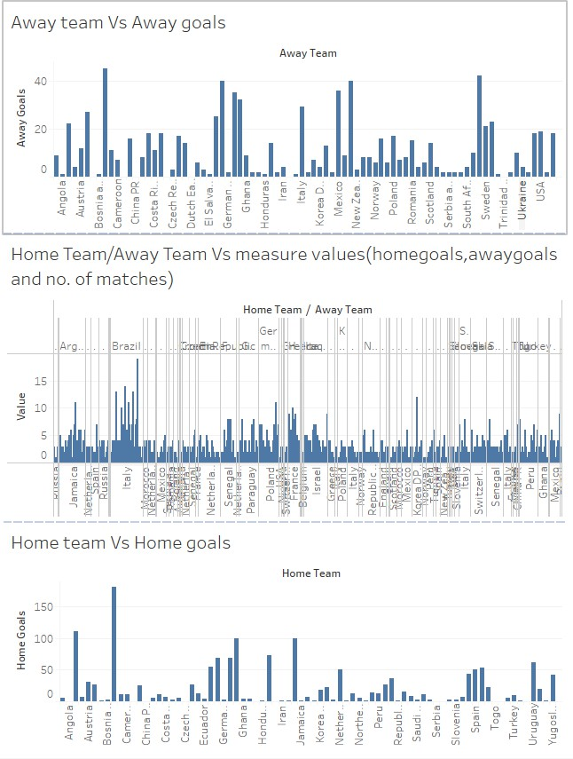

1. Go to Dashboard > Actions.

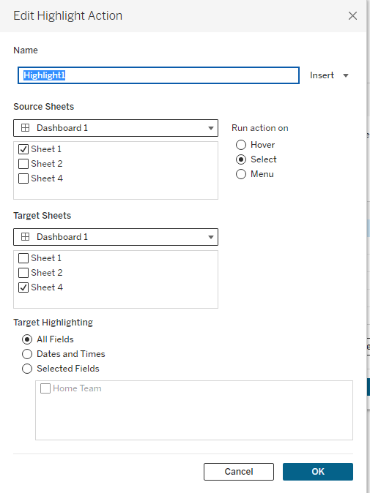

1. 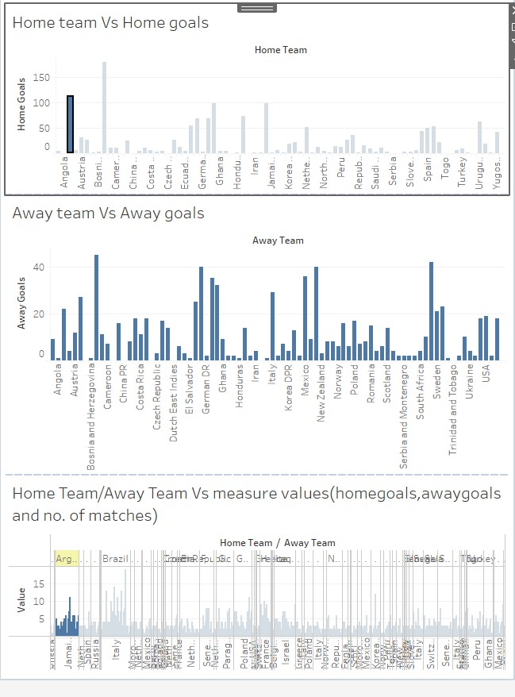Configure the source and target sheets, and specify the fields to highlight.

### Filter action:

· These allow users to filter the data in one visualization by selecting marks or data points in another visualization. To set up a filter action

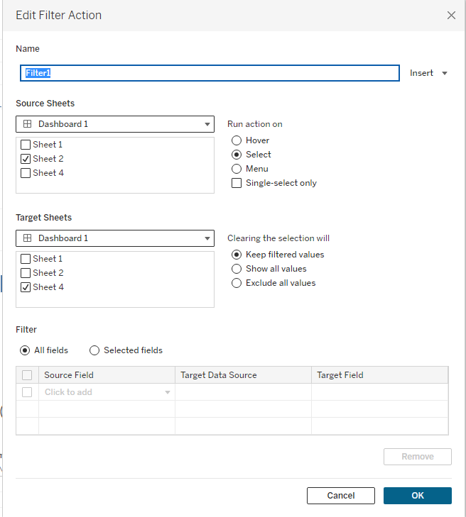

* + "Filter1" applies to "Sheet 1" and targets "Sheet 1," "Sheet 2," and "Sheet 3" in "Dashboard 1," affecting multiple visualizations.
  + The Action runs on "Hover," providing immediate, dynamic feedback without a click, enhancing interactivity.
  + "Keep Filtered values" is selected, so filtered values remain even after the cursor moves away, until manually reset.

Filter Action applied on Dashboard

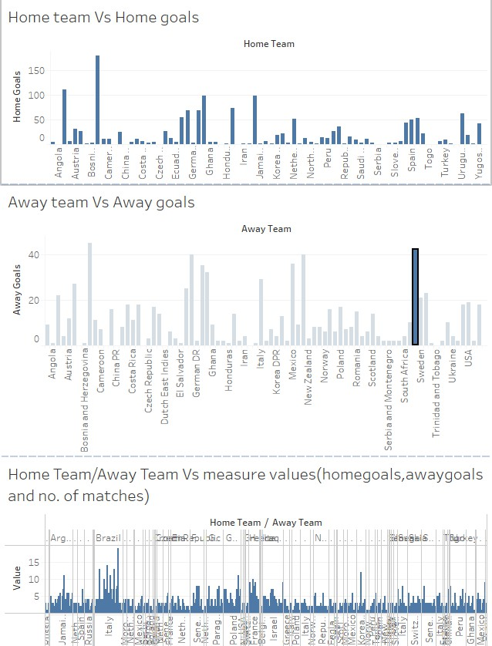

The filter action in Tableau is configured to run on "Sheet 1" of "Dashboard 1" and targets "Sheet 3" on the same dashboard.

The filter will trigger when a selection is made and clearing the selection will show all values.

### Go to sheet

Go to Sheet Action

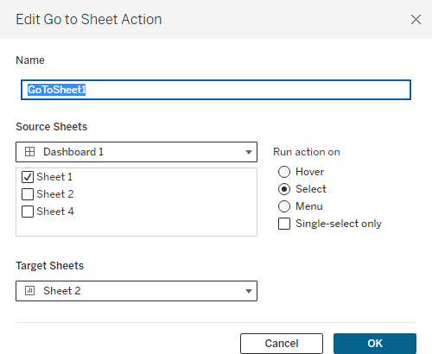

* GotoSheet Action applies to Sheet 1 and targets Sheet 3 in Dashboard 1 affecting

multiple visualizations.

* Theaction runs by Selecting the sheet, providing immediate, dynamic feedback with a

click, enhancing interactivity.

Go to Sheet- Destination Sheet

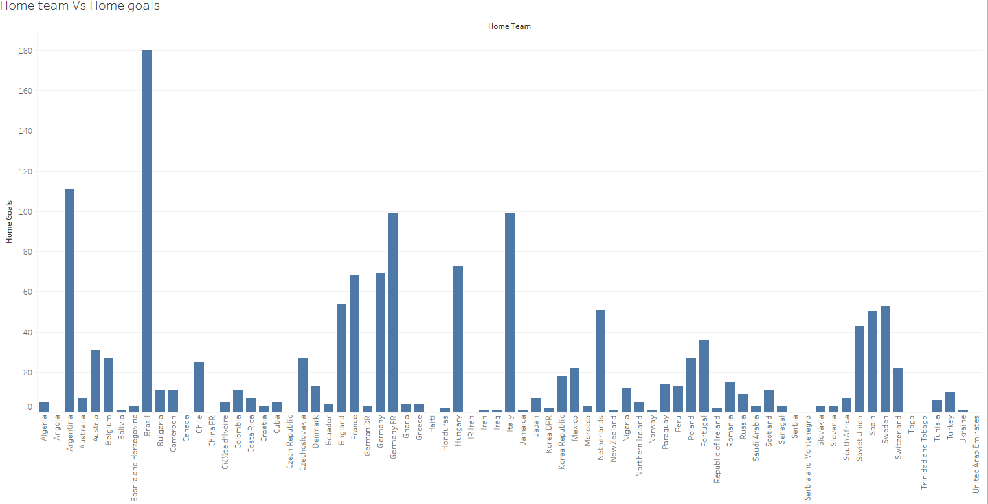

The GoToSheet1 action in Tableau is set to navigate from "Sheet 3" on "Dashboard 1" to "Sheet 3" when a selection is made. This action will direct the user to the specified target sheet, facilitating detailed analysis of the selected data

### Hyperlink

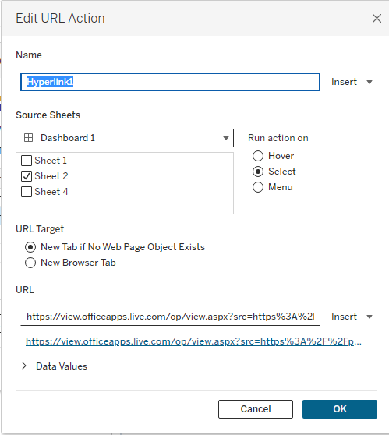

* The chart likely shows an action performed on URLs associated with transactions, which could be relevant for detecting fraudulent websites.
* Itmayhighlight how often URLs are edited, potentially indicating suspicious behavior.
* This visualization can help in identifying patterns of URL modification that correlate with fraudulent activities.

### Hyperlinked Sheet Details

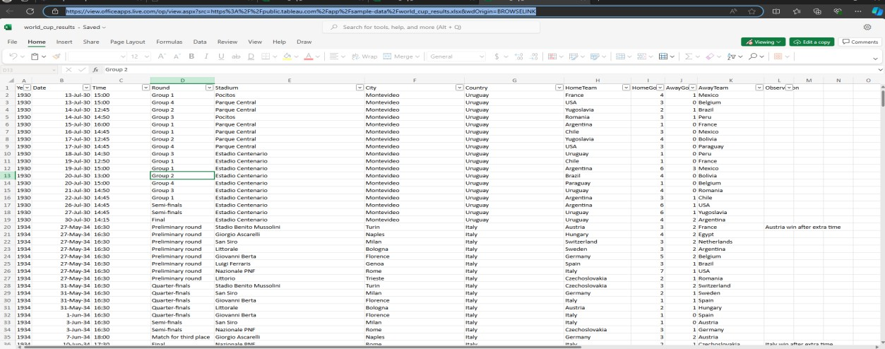

* 1. **Tool tip:- Spreadsheet Tooltips**
* The tooltips in this chart provide additional information about each data point, such as transaction amount, time, and risk score.
* Tooltips help in quickly understanding the context and details of individual transactions without cluttering the main visualization.
* This feature enhances the user's ability to spot irregularities and delve deeper into suspicious transactions.

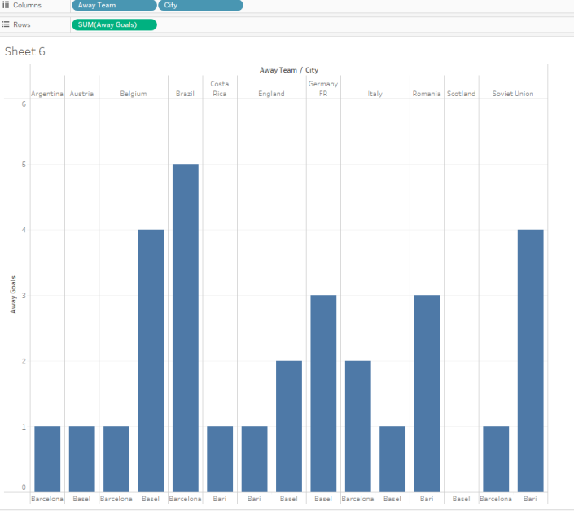

### Highlight text table:

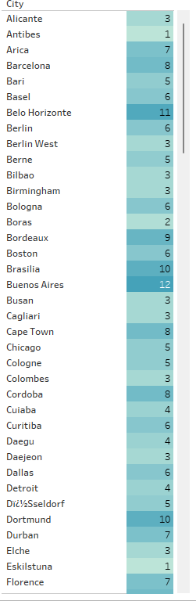Displaying Highlight Text Table

This table probably highlights transactions with specific characteristics, such as high risk scores or flagged by the fraud detection model.

* Highlighted cells may represent transactions that need further investigation.
* Using a table format allows for easy comparison and analysis of multiple transactions

side by side

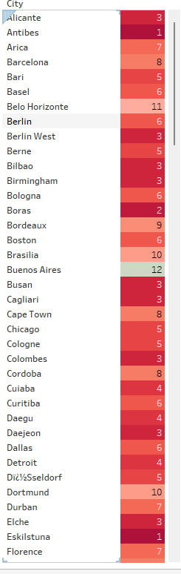

* 1. Comparative Analysis of Multiple Metrics

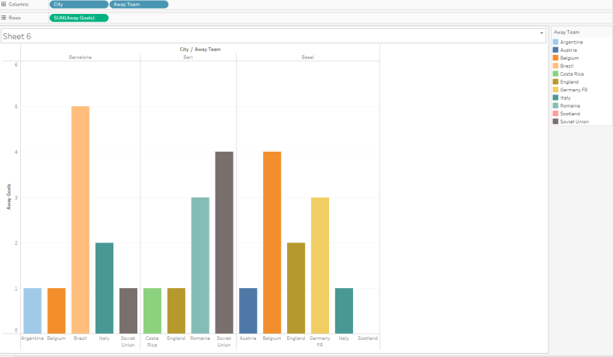

This chart shows multiple visualizations comparing different aspects of the dataset, such as transaction amounts, time of transactions, and geographical locations.

* It helps in identifying correlations and patterns across various dimensions that could

indicate fraud.

* Comparing multiple factors simultaneously aids in a comprehensive analysis and more

accurate fraud detection.

* 1. Heat map:

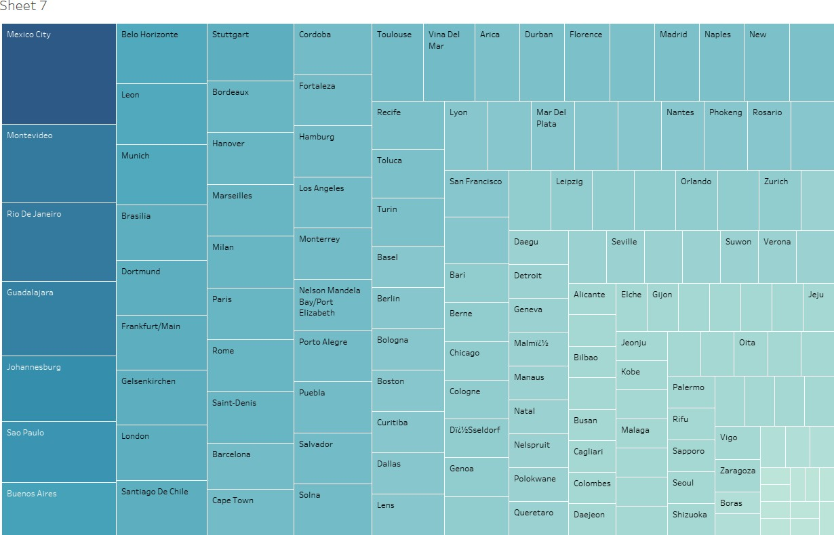

* Heatmap in Tableau:

→Displays data by merchants.

→Color intensity indicates the sum of fraud cases and the amount involved.

* Color Coding: →Darker shades of green represent higher sums of non-fraudulent transactions. →Darker shades of red indicate higher sums of fraudulent transactions.
* Visual Insight: →Distribution of colors provides quick visual insight into patterns of fraud across different merchants. →Highlights areas of concern with more red shades.

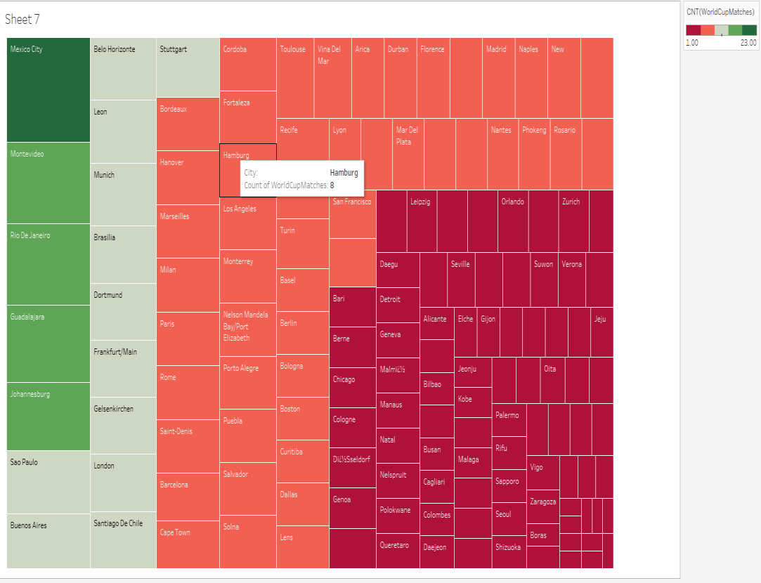

## RESULTS & DISCUSSIONS:

In this study, we employed various data visualization techniques using Tableau to analyze a credit card fraud detection dataset. The goal was to identify patterns, highlight anomalies, and facilitate a deeper understanding of fraudulent activities across different dimensions. The visualizations provided critical insights which are discussed below: 1.Highlight Action : Highlight actions refer to significant and memorable events that occur during FIFA World Cup matches. These moments often define the outcome of games and are celebrated or remembered by fans and analysts alike. Highlight actions can include goals, saves, tackles, assists, and more, each contributing to the excitement and drama of the tournament.

1. Filter Action : Filter actions in the context of the FIFA World Cup refer to specific types of actions or events that are analyzed or extracted from the vast array of data generated during the tournament. These actions can provide insights into the performance of teams and players, game strategies, and overall trends.
2. Goto Sheet Action : "Go to Sheet Action" in the context of the FIFA World Cup likely refers to navigating a detailed spreadsheet or data sheet that contains comprehensive information about various aspects of the tournament. Such a sheet could be used by analysts, coaches, journalists, and enthusiasts to access specific data quickly and efficiently. Here's an overview of what such a sheet might include and how to navigate it
3. Hyperlink and URL Edit Actions : Hyperlink and URL edit actions in the context of the FIFA World Cup refer to the processes of adding, modifying, or managing hyperlinks and URLs within digital documents, spreadsheets, websites, or databases related to the tournament. These actions are crucial for creating a seamless and informative user experience, enabling quick access to relevant information and resources
4. Tooltips :Tooltips are interactive elements in a graphical user interface that display additional information when a user hovers over, clicks on, or otherwise interacts with a particular part of the interface. In the context of the FIFA World Cup, tooltips can be used in digital platforms, such as websites and mobile apps, to enhance the user experience by providing detailed information about teams, players, and matches
5. Highlight Text Tables : A highlight table, also known as a highlight table or a highlights table, is a tabular data visualization that uses color and formatting to draw attention to significant values and trends within the data. In the context of the FIFA World Cup, a highlight table can be used to present key statistics, player performances, and match outcomes in an easily digestible format.
6. Heatmap : A heatmap is a data visualization tool that uses color to represent the intensity of data in a two-dimensional space. In the context of the FIFA World Cup, heatmaps can be used to visualize various types of data related to the tournament, such as player performance, team strategies, and match statistics.

## Conclusion:

* Indispensable Tool: Data visualization is crucial in interpreting and engaging with FIFA World Cup data.
* Vast Data: The World Cup generates extensive data, including player metrics, team strategies, match statistics, and fan engagement.
* Audience: Data needs to be accessible to coaches, analysts, players, fans, and media professionals.
* Transformation: Data visualization converts complex datasets into clear, compelling, and interactive visuals.
* Digestibility: Simplifies intricate information, making it easier to understand than traditional tables and text reports.
* Visual Tools: Graphs, charts, heat maps, and infographics highlight key patterns and trends.
  + Player Metrics: Summarized through radar charts or bar graphs.
  + Team Strategies: Visualized using tactical heat maps and positional charts.
* Informed Decision-Making: Helps coaches and analysts make strategic decisions quickly and accurately.
* Fan Engagement: Enhances fan experience by making complex information understandable and engaging.
* Identifying Trends: Crucial for recognizing patterns, providing a competitive edge.
  + Tournament Trends: Visualizing data over matches reveals significant trends.
  + Historical Comparisons: Compare current performances with past tournaments.
* Storytelling: Enhances sports journalism and broadcasting by transforming reports into rich narratives.
  + Team Journeys: Timelines of key moments and turning points.
  + Player Profiles: Career trajectories illustrated through line graphs and milestones.
* Emotional Engagement: Visual stories inform and emotionally engage the audience, making data more relatable and impactful.

## References:

<https://www.kaggle.com/datasets/ahmedelnaggar/fifa-worldcup-2018-dataset>

1. [Burch, Michael, et al. "Visual analysis of FIFA world cup data."](https://ieeexplore.ieee.org/abstract/document/9373171/) [*2020 24th*](https://ieeexplore.ieee.org/abstract/document/9373171/)[*International Conference Information Visualisation (IV)*. IEEE, 2020.](https://ieeexplore.ieee.org/abstract/document/9373171/)
2. [Burch, Michael, Gunter Wallner, Sergiu Lazar Angelescu, and Peter Lakatos. "Visual](https://ieeexplore.ieee.org/abstract/document/9373171/) [analysis of FIFA world cup data." In 2020 24th International Conference Information](https://ieeexplore.ieee.org/abstract/document/9373171/) [Visualisation (IV), pp. 114-119. IEEE, 2020.](https://ieeexplore.ieee.org/abstract/document/9373171/)
3. [Ahmed, Adel, et al. "Visual analysis of history of world cup: A dynamic network with](https://ieeexplore.ieee.org/abstract/document/9373171/) [dynamic hierarchy and geographic clustering."](https://ieeexplore.ieee.org/abstract/document/9373171/) [*Visual Information Communication*.](https://ieeexplore.ieee.org/abstract/document/9373171/) [Springer US, 2010.](https://ieeexplore.ieee.org/abstract/document/9373171/)
4. [Ahmed, Adel, Xiaoyan Fu, Seok-Hee Hong, Quan Hoang Nguyen, and Kai Xu.](https://link.springer.com/chapter/10.1007/978-1-4419-0312-9_2) ["Visual analysis of history of world cup: A dynamic network with dynamic hierarchy](https://link.springer.com/chapter/10.1007/978-1-4419-0312-9_2) [and geographic clustering." In](https://link.springer.com/chapter/10.1007/978-1-4419-0312-9_2) [*Visual Information Communication*, pp. 25-39. Springer](https://link.springer.com/chapter/10.1007/978-1-4419-0312-9_2) [US, 2010.](https://link.springer.com/chapter/10.1007/978-1-4419-0312-9_2)
5. [Sharma, Mansi, et al. "Analysis of FIFA World Cup Data Set."](https://sciresol.s3.us-east-2.amazonaws.com/IJST/Articles/2019/Issue-39/Article6.pdf) [*Indian Journal of*](https://sciresol.s3.us-east-2.amazonaws.com/IJST/Articles/2019/Issue-39/Article6.pdf)[*Science and Technology*](https://sciresol.s3.us-east-2.amazonaws.com/IJST/Articles/2019/Issue-39/Article6.pdf)[12 (2019): 39](https://sciresol.s3.us-east-2.amazonaws.com/IJST/Articles/2019/Issue-39/Article6.pdf)
6. [Balita, Tristan.](https://norma.ncirl.ie/id/eprint/3872) [*Touchdown–A Predictive and Detailed Analysis of the National*](https://norma.ncirl.ie/id/eprint/3872)[*Football League: Technical Report*. Diss. Dublin, National College of Ireland, 2019.](https://norma.ncirl.ie/id/eprint/3872)

.