**AN EXAMINING ANALYSIS OF THE LINEAR CONSTRUCTION METHOD FOR ROADWORK’S**

**AKASH T *1**

Doctor Of Philosophy In Civil Engineering, Department Of Civil Engineering Department, Sunrise University, Alwar, Rajasthan-301026, INDIA

**ABSTRACT**

In this study, we examine the linear construction approach in detail, looking at its benefits, drawbacks, and overall effectiveness in roadwork’s. We take a look at the sequential and systematic linear construction method to see if it may improve project efficiency, make better use of resources, and finish roadwork’s projects on schedule. Reduced idle periods, improved project coordination, and maintained high-quality standards are highlighted in the report through a deep investigation of case studies and industry practices. Despite its many advantages, the results show that the linear construction method necessitates careful preparation and execution in order to overcome possible environmental and logistical obstacles. Finally, this analysis highlights the method's potential to achieve efficient and timely infrastructure construction, highlighting its significance as a preferred technique for large-scale roadwork’s projects.

1. **INTRODUCTION**

The planned and sequential execution of the linear construction method makes it a vital and extensively used methodology in roadworks projects. Economic growth and social improvement rely on well-organized and efficiently developed infrastructure, and this strategy is essential to both. The building of roads necessitates careful planning and execution to guarantee their functionality, safety, and lifespan, as they are essential components of the transportation network. The linear construction approach offers a strong tool for engineers and project managers to successfully plan, allocate resources, and execute roadworks projects by following a defined, step-by-step structure.

Methodology for Building Roads in a Sequential Fashion : A defining feature of the linear construction approach is the strict sequential order in which tasks are carried out. With this methodical strategy, there is less room for error and duplication of effort during the building process. Site preparation, earthworks, pavement construction, and finishing touches are the typical processes in the linear construction approach. It is essential to pay close attention to detail throughout each of these stages because they are all vital to the project's success.

Step One: Planning and Design : A linear approach to building begins with the planning and design stage. In this first phase, we investigate and analyse the road construction project thoroughly to come up with a detailed plan that covers every angle. Important aspects of this stage include planning, scheduling, environmental impact studies, and route selection. The success and longevity of the project depend on careful planning, which lays the framework for all other steps. In this stage, project managers can plan the whole building process by carefully examining requirements and any obstacles.

GENERAL: Because of the prevalence of incentives and penalties, as well as time, space, and resource limits, in the construction industry, planning and scheduling have long been crucial in deciding the success or failure of a project. Direct or indirect, each nation's development benefits from projects that are well-planned and executed according to strict schedules. Software packages based on network approaches, milestone charts, and bar charts are used for construction project planning and scheduling. If a project manager uses scheduling tools, they can find out how much time is available between tasks and which paths are most important for making decisions. The scheduler, who is also the project manager, uses this data to make additional adjustments and reschedule tasks in order to finish the project as efficiently as possible.

Linear Algorithms: There may be a discrete or continuous relationship between the activities that make up a construction project. To rephrase, in continuous systems, all activities move at the same rate, whereas in discrete systems, one activity's start or progress is dependent on the end of another. If the project's linearity is limited to short distances, then the location of an activity has no effect on how well a discrete or continuous activity is progressing. A linear relationship might be horizontal or vertical. Buildings with several stories, such as skyscrapers and towers, exhibit vertical linearity, while projects with many levels, such as roads, tracks, pipelines, etc., exhibit horizontal linearity.

NOW AVAILABLE SCHEDULING MODELS: According to research conducted on the subcontinent, the most popular way for scheduling road projects is the Gantt chart output using MS Project. This programme offers a wide range of facilities and capabilities. In a road project, the MS project outputs clearly show the start-to-start and finish-to-start links of the activities. Work progress can be understood as a percentage of the entire quantity that needs to be done, since these outputs are displayed as bars horizontally against the period. However, because of the connections between linear activities, this graphic does not represent the precise location of each activity at any one moment, nor does it display the crucial route or floats.

1. **OBJECTIVES AND METHODOLOGY**

* To evaluate the time and cost efficiency of the linear construction method in roadwork projects compared to alternative methods.
* To Challenge Identification Identify key challenges and limitations associated with implementing the linear construction method in roadwork.
* To Quality Impact assess the impact of the linear construction method on the quality and durability of road infrastructure.
* To Safety Evaluation: Evaluate the effectiveness of safety measures and protocols in the linear construction method for roadworks.
* To analyse the environmental effects of the linear construction method, including sustainability and ecological impact.

**METHODOLOGY**: The methodology indicated in flowchart in Figure 3.1 for achieving the above objectives is planned to involve the following steps

**Figure 2.1 Flow Chart Indicating Research Methodology**

The detailed methodology involves the following tasks.

**Task1 : Review of Scheduling Techniques**

Initially, we looked over the literature on road project scheduling using the methods and technologies that are currently in use. Everyone now knows that networking tools aren't perfect when it comes to road project scheduling. In order to better plan and schedule road construction projects, we looked at the software tools that contractors are using and identified the information gaps that need to be filled.   
Because of the one-of-a-kind character of road projects' linkages, activities, execution methods, and work environments, a novel scheduling methodology is necessary for road projects. This has been recognised as a possible subject for future research. Road project timetables, specifications, contracts, design and construction practice codes, on-site data, etc. have all been reviewed in this context.

**Task 2 : Production Rate Approach through LSM**

After reviewing the literature on road project scheduling tools, we were able to show that LSM is useful by applying it to small projects and comparing the results to software schedules. Here, by means of hypothetical instances, we have arrived at the fundamental parameters governing linear activities. Data collected from a recently finished national highway project through the actual production rates of activities allowed for further investigation into the application of LSM. We can compare the linear production rates of sequential activities to find their criticality using generic equations designed for road projects. A straightforward approach to estimating the total time required to complete a project has been proposed, which involves super imposing the

most important parts of the tasks from different sections.

**Task 3**: **Estimating Future Production Rates by Modelling**   
Using the probability distribution of activity durations in road projects given by Arun and Rao (2003), a simulation model was created to estimate probable production rates of activities and, after understanding the necessity for production rates of activities, road project durations were estimated.   
There was an inquiry into the large variation in activity production rates derived from simulation and data from different sites, and a study was conducted comparing the likely linear production rates from the simulation model with the actual linear production rates of the KTRP

**Figure 2.1 Flow Chart Indicating Research Methodology**

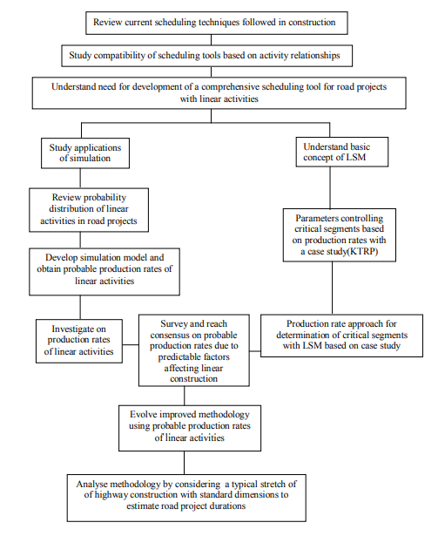

**Task 4: Activity Production Rate Consensus using Delphi**

A consensus on production rates for a particular project type was achieved utilising the Delphi process, as there was a large range in the likely simulation-derived rates of activities. Twenty highway builders participated in the survey, and twelve elements were assessed for their potential impact on project time. In the second phase of the survey, five of the twelve factors that were assessed as having a significant impact on project durations were actually used. After three rounds of Delphi surveys using three-time-estimate variables for road project

activities, a consensus on likely output rates was established.

**Task 5: Analyzing the Data**

Overall activity production rates on the KTRP and comparable projects corroborate the Delphi analysis's findings. A method for estimating the duration of large highway projects has been developed through a study of

activity progress that takes work breaks and calendar days into account.

**Task 6**: **Scheduling Based on Production**

Based on production rates and buffer lengths between subsequent activities, a simple flowchart methodology for scheduling road projects within an LSM framework has been presented. This method, using typical dimensions for estimating time in segments of single road, has been used to depict the construction of a hypothetical 5-kilometer, two-lane roadway. A production-based scheduling approach, however, has shown the breadth of LSM's use in big highway construction projects by managing work progress concurrently at several sites. Sensitivity analysis was performed on the generated model to see how it handled different production rates, buffer distances, and time intervals.

1. **LINEAR SCHEDULING METHOD (LSM) AND ITS APPLICATIONS**

**BASICS OF LINEAR SCHEDULING**

One graphical method is the LSM, which uses the horizontal axis to show the locations or length of a linear project and the vertical axis to show the durations of the project's activities. Distance - time scheduling is another name for this way of representing a linear schedule. According to the project's sectional order, this graph displays each action in sequential sequence. In a linear schedule graph, the beginning point represents the time and place where the activity begins, and the ending point represents the time and place where it ends. The beginning and ending points of an activity are used to draw a sloping line. As indicated in section 1.3, the operations of a typical road segment can be used to comprehend the fundamentals of LSM. As illustrated in Figure 4.1, the road section is made up of four activities that run the length of the project: the subgrade (A1), the sub base (A2), the base course (A3), and the surface course (A4). As demonstrated in Figure 4.2, the CPM would have depicted them as sequential activities in accordance with networking standards. The LSM representation that follows the same activity-to-activity relationship should look like Figure 4.3. In this diagram, each new step is seen as starting only when the one before it is finished. However, in practice, subsequent activities in a linear project do not wait for the previous activity to finish before beginning, but rather begin after a minimum buffer time and distance is allowed to meet the job requirements. As a result, the total project completion time DP should have been equal to DA1 + DA2 + DA3 + DA4. Unlike a network diagram, Figure 4.4 depicts the interdependencies between the various tasks. The overall duration of the project will be the time it takes to go from the beginning of the first activity all the way to the finish of the last activity, according to Figure 4.4. This time frame will be substantially less than the previous calculation in accordance with the CPM timetable. The ratio of time to distance travelled is a good proxy for the pace of advancement in any given activity because of the close relationship between the two. For example, according to Figure 4.4's linear scheduling plot, in order to finish Activity A1 by Time DA1, the daily progress rate should be L/DA1 km. In the same vein, in order to finish the project by the designated time DP, activities A2, A3, and A4 should advance at rates that correspond to their durations. In addition, linear scheduling allows for the optimization of total DP according to project restrictions by adjusting the progress rate of each activity and the buffer distance between them. In order to determine the overall project duration, these modifications can be represented on the LSM.

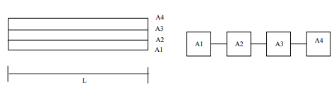

**Figure 3.1 Sections of a Road Figure 3.2 Network Diagram**

Having understood the fundamentals of LSM, and as per assumptions in the CPM that resources are unlimited, an algorithmic approach to determine critical paths and floats shall be as explained in the next sections (Harmelink 1998).

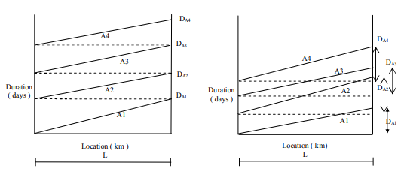

**Figure 3.3 Duration Plot as per CPM Figure 3.4 Distance –Duration Plot as per LSM**

**SCHEDULING WITH LSM**

The methodology to plot the linear schedule as per the actual nature of relationship between activities and to determine the critical activity path and floats in a linear project comprises of the following steps:

1. Plotting the activity sequence list,
2. Determination of the least time interval and least distance intervals by upward pass method,
3. Determination of the critical and non-critical segments in activities by downward pass method,
4. Determination of floats available in activities.

**Determination of LDI and LTI with Upward Pass**

After outlining the project's activities in a linear fashion, we may identify its critical and non-critical tasks by calculating the LTI and LDI between each set of activities. The first activity is considered the origin activity and the one after it is the target activity in the activity sequence list shown in Figure 4.5. An activity's criticality can be ascertained by naming the first activity as the origin activity and the activity immediately after it as the target activity. Finding the LTI and LDI between the two activities (the origin and the target) is done. In the following step, the action that was intended to be the target is actually the origin activity, and the activity that comes just after it is the target. For the new set of tasks, the LTI and LDI are calculated afresh. The LTI and LDI are also calculated for each set of activities until the last one is reached. Given that activities in a linear timetable advance constantly throughout the project's duration, it's important to remember that not only may the full activity be vital, but pieces of it can as well.

1. **THE LINEAR PRODUCTION RATE ALGORITHM FOR DETERMINATION OF CRITICAL PATHS**

**KRISHNAGIRI THOPURGHAT ROAD PROJECT (KTRP)**

A recently finished road project in Tamil Nadu, India, known as the Krishnagiri Thopurghat Road Project (KTRP), included upgrades such as enlarging the current carriageway and building a new carriageway. With many obstacles encountered along the way, the project's execution began in September 2005 and ended in January 2009. Figure 5.1 shows the details of the three sections that made up the complete project. Based on the limitations encountered by the builder and the logic of the project, each part of the road was further divided into subsections. Figure 5.2 shows the subsections for this length, and Tables 5.1, 5.2, and 5.3 show the actual schedule that the constructor followed during the execution of the new carriageway in Section A from km 94.00 to km 113.00. In Appendix 2 you may see the complete MS Project timetable. An algorithm has been developed to investigate the lengths and durations of key segments using the real linear production rates of activities, and Section A has been critically analyse dutilising the LSM.

**Table 5.1 Constructor's Schedule for Sub section A1 (km 94.00km 101.00) Length - 7 km**

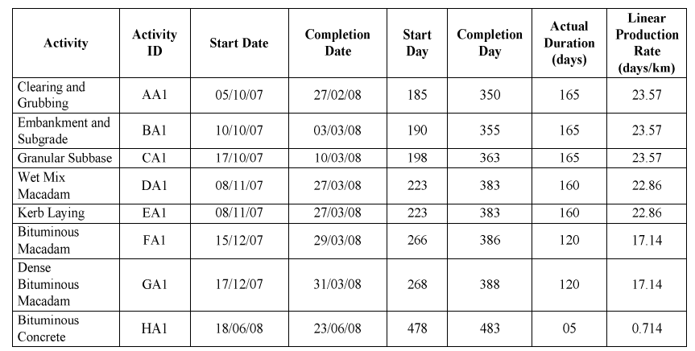

**LINEAR PRODUCTION RATE PARAMETERS CONTROLLING CRITICAL SEGMENTS**

There are three distinct types of activities involved in road projects: beginning, middle, and end. Clearing and earthwork are examples of start activities in road projects. Subbase and base courses are examples of intermediate activities. Surface finishes are examples of end activities.   
Using the aforementioned information and a thorough examination of the factors governing the essential tasks in linear projects, we can derive the following general equations that use the activity production rate as a significant controller of road project duration. With these equations, you may determine which actions in a linear project with a continuous complete span are the most important. Equations (5.1) through (5.24) have their symbol and notation lists condensed for the sake of clarity in the report.   
a) The last or ending activities in linear projects become totally critical for Lc(ae)- Ls(ae)km and for a duration Tc(ae)-Ts(ae) days when; 1) ae starts on or after completion of ae-1 (5.1) or Pe < Pe-1 (5.2)   
b) When Pe > Pe-1 (5.3) or Pe = Pe-1 (5.4), the last actions become critical at the end for a distance Lc(ae)- Ldc(ae) km and a period Tc(ae)-Tdc(ae) days.   
The critical period for intermediate activities is Lc(am)-Ls am) km for a duration of Tc(am)-Ts(am) days when Pm = Pm+1 and am commences on or after am-1 is completed. (5.5)

1. **SIMULATION MODEL FOR INVESTIGATION OF PROBABLE ACTIVITY PRODUCTION RATES**

**SIMULATION FUNDAMENTALS:** Simulation is the process of creating a model and then manipulating that model in order to make it behave like a real-world occurrence. The system's associated constants and variables are replicated in the model in order to study the system's behaviour. Schematic models are two-dimensional representations of the system in the form of diagrams, charts, etc., whereas physical models consist of three-dimensional replicas of the system. Symbolic models often take the shape of mathematical models and can be either deterministic or stochastic.

The four main steps of a simulation are as follows:

(1) Problem And Objective Formulation

(2) Model Development

(3)Model Experimentation

(4)Evaluation of Simulated Findings.

There are a lot of steps involved in each stage, and the real-world system determines how big the model needs to be. Collecting data and choosing an appropriate approach to make the simulation activity mimic the real system's random behaviour are the main steps in this procedure. Simulation models are symbolic models that exhibit dynamic and stochastic properties. For the analysis of complicated processes that do not necessitate substantial computational resources, simulation models are seen as an advantage over mathematical models. One kind of simulation called discrete event simulation models a system through time using a representation where the status of the variables changes instantly at discrete points in time.

1. **DETERMINATION OF ROAD PROJECT DURATIONS**

**PRODUCTIVITY BASED SCHEDULING:** It is impossible to quantify the role of constructors on the variability of production rates without first conducting a targeted analysis based on the predictable factors that impact activity productivity in large-scale projects. In order to focus on a more reasonable time limit for field execution, this work has excluded other issues that are not within the purview of these agencies.   
It is important to know the typical productivity metrics used at construction sites in order to estimate how long things will take on road projects. Road construction projects often include a series of interconnected tasks, the duration of which varies with the amount of labour required for each task and the distribution of available workers in relation to the desired completion date. Given the foregoing, it should be easy to see that a thorough method is necessary for predicting how long road projects will take, one that accounts for both productivity-based scheduling and the possibility of delays.

**DURATION ANALYSIS BY DELPHI PROCESS:** In order to arrive at likely durations of activities, it is necessary to have knowledge on predictable durations after obtaining anticipated linear productivity of activities in a road project. To get everyone on the same page on the production rates for highway projects, the Delphi technique has been used. Delphi is a method that can be used to do research using either quantitative or mixed methods, as well as qualitative approaches. Results are said to be sufficient for a homogeneous group when the sample size is between ten and fifteen people. According to the literature, consensus has only been achieved with a sample size of three. Consensus may be achieved in as little as two or even one round for groups that are quite similar to one another. A successful Delphi can be enhanced by adhering to rigorous methods. In addition, we may get a trustworthy method for scheduling by analysing the Delphi findings statistically using real-time data. The purpose of this study was to improve highway construction project management by identifying the factors that contribute to project delays (Sharma 2004).

1. **RESULTS AND CONCLUSIONS**

**FINDINGS**: The execution technique and nature of operations make road projects distinct and necessitate a different approach to scheduling. The following findings are derived from the aforementioned study that pertain to likely production rates of linear activities:   
I. The fundamental information regarding the behaviour of critical pathways in road projects is provided by the parameters controlling crucial segments of linear activities in road projects, which are based on numerous activity relationships. On the basis of activity production rates, they are also useful for determining the characteristics of crucial segments. Figure 5.3 and Table 5.4 show that the bituminous concrete activity is completely crucial for 50 days between km 101 and km 106 of the KTRP, according to equation 3.2. All other linear activities in the LSM, whether they are starting, intermediate, or ending, follow the corresponding equation for their condition. On the other hand, keeping track of progress and interpreting data is trickier when the number of sections and subsections grows, like with massive highway projects.   
The durations of activities in a road project and the range of likely production rates of linear activities can be better understood with the use of a simulation model that is based on the probability distribution (see II). For example, the model's output rates for clearing and grubbing range from 1.3 to 26.90 days/km, The large variation in production rates is indicative of the inevitable setbacks caused by things like property acquisition, utility relocation, etc. Since the probability distribution is based on activity durations in different types of road projects without clarity on dimensions, crews, and causes for delay, the production rates of all activities in the simulation model show large variability in production.   
**Study Restrictions**: Predicting how long road projects will take can be done using the production rate method of scheduling linear construction with time estimate variables. Under typical climatic and topographical circumstances, the research focuses on the continuous construction of a dual roadway with specified dimensions.   
Financial aspects of production have not been taken into account in the study, which has solely focused on project durations.   
**FUTURE RESEARCH OBJECTIVES**: Construction of roads takes place in a wide variety of settings, not limited to those with typical topography and weather. Consequently, the job can be expanded to cover other forms of road construction, each with its own set of established production rates. To help road building projects balance work progress with economic considerations, additional research on the impact of production variation on costs for each category of work is needed.   
**IN THE END**   
Conclusion: When it comes to roadworks, the linear construction style is the way to go. It's efficient, helps with time management and resource allocation, and makes project coordination a breeze. Continuous work flow along the length of the project is made possible by this strategy, which streamlines the construction process by eliminating idle times and increasing productivity. Quality and safety are both enhanced by the method's organised approach, which allows for superior planning and control. When it comes to large-scale roadwork’s projects, the linear construction method is often selected since it can lead to significant cost savings and timely project completion.

**SCOPE FOR FURTHER STUDY**

Apart from the study in normal topography and weather conditions, road construction projects are taken up in various locations and scenarios. Therefore, the work may be extended for various categories of road construction with production rates defined for specific types of projects. Also, further study on the effect of variation in production on cost for each category of work shall be useful in balancing work progress with economic aspects of construction in road projects

**CONCLUSION**

In conclusion, the linear construction method for roadwork proves to be an effective and efficient approach, offering significant benefits in terms of time management, resource allocation, and project coordination. This method streamlines the construction process by allowing for continuous work flow along the project length, thereby reducing idle times and enhancing productivity. Furthermore, its structured approach facilitates better planning and control, leading to improved quality and safety standards**.**

1. **REFERENCES**
2. Podolski, Michał & Sroka, Bartłomiej. (2018). Cost optimization of multiunit construction projects using linear programming and metaheuristic-based simulated annealing algorithm. JOURNAL OF CIVIL ENGINEERING AND MANAGEMENT. 25. 848-857. 10.3846/jcem.2019.11308.
3. Yogesh, G & Chappidi, Hanumantharao. (2018). A study on linear scheduling methods in road construction projects. Materials Today: Proceedings. 47. 10.1016/j.matpr.2021.07.393.
4. Dinh, Trong & Trung Hieu, Dinh & Götze, Uwe. (2018). Roadworks design: study on selection of construction materials in the preliminary design phase based on economic performance. International Journal of Construction Management. 24. 1-9. 10.1080/15623599.2023.2179603.
5. Trunzo, Giampiero & Moretti, Laura. (2019). Life Cycle Analysis of Road Construction and Use. Sustainability. 11. 377. 10.3390/su11020377
6. Kassem, Mohamad. (2013). Road construction projects: an integrated and interactive visual tool for planning earthwork operations.
7. Gara, Jawa & Zakaria, Rozana & Aminudin, Eeydzah & Adzar, Jeffryl & Yousif, Omar. (2013). The Development of Real-Time Integrated Dashboard: An Overview for Road Construction Work Progress Monitoring. Hunan Daxue Xuebao/Journal of Hunan University Natural Sciences. 48. 128.
8. Chou, Jui-Sheng. (2009). Generalized linear model-based expert system for estimating the cost of transportation projects. Expert Systems with Applications. 4253-4267. 10.1016/j.eswa.2008.03.017.
9. Liu, Shu-Shun & Wang, Chang-Jung. (2007). Optimization model for resource assignment problems of linear construction projects. Automation in Construction. 16. 460-473. 10.1016/j.autcon.2006.08.004.