**FARM SECURITY SYSTEM**

**Abhishek P Gosavi 1, Jyoti A Ghaytadak2, Ashwini N Borse3, Dipali A Bavskar4,**

**Prof. Aditi Ghuge5, Dr. A. N. Shaikh6**

1, 2, 3, 4, 5, 6Department of Electronics and Telecommunication Engineering Shreeyash Collage of Engineering and Technology, Chhatrapati Sambhajinagar, Maharashtra, India

**ABSTRACT**

Wild animals pose a significant threat to crops, making it crucial to monitor their presence near farms. Traditional methods have been used depending on the type of crops and the animals causing the threat. In this study, we introduce a method that combines wired network devices with traditional approaches to enhance farm protection against wild animals. The system employs operational amplifier circuits primarily to detect when animals intrude into the farm area. Its purpose is to alert farmers early to potential intrusions and the risk of damage by wild animals. This proactive monitoring scheme aims to improve overall farm security by providing timely warnings. By integrating wired network devices alongside traditional methods, such as physical barriers or scare tactics, the proposed system aims to bolster protection effectiveness. This approach acknowledges the need for a multi-layered defense strategy to mitigate the diverse challenges posed by different types of wildlife. In summary, the system enhances farm security by leveraging modern wired network technology to complement traditional defense methods. It focuses on early detection and alerting farmers promptly, thereby reducing potential damage caused by wild animals. This integrated approach underscores the importance of adapting technological advancements to safeguard agricultural interests effectively.

**Keywords:** Microcontroller, ADC, LDR, GSM

1. **INTRODUCTION**

In many countries around the world, agriculture plays a crucial role in their economies. Despite advancements in other sectors, agriculture remains the backbone, contributing significantly to the gross domestic product (GDP). It not only fulfills food needs but also provides raw materials for industries. However, one of the challenges farmers face is the intrusion of animals into agricultural lands, leading to substantial crop damage and financial losses. To address this issue, our project focuses on developing a system to protect farms from animal intrusions. The primary goal is to create effective fencing solutions that prevent animals from entering farms and damaging crops. By implementing these protective measures, we aim to minimize crop losses and increase overall yield. Importantly, our system is designed to be safe for both animals and humans, ensuring it does not cause harm. The core theme of our project revolves around creating an intelligent security system using embedded technology. This system will employ advanced sensors and microcontroller-based circuits to detect and respond to animal presence. When an animal approaches the fencing, the system will trigger alerts such as activating lights and sending notifications to farmers via SMS. This real-time response capability is crucial in enabling farmers to take immediate action to protect their crops. In addition to its effectiveness in preventing crop damage, our system is designed to be environmentally friendly and cost-effective. It utilizes sustainable power sources like solar panels, ensuring reliable operation even in areas with limited access to electricity. By reducing dependency on traditional power grids, the system helps farmers save on operational costs while promoting environmental sustainability. To ensure the system's reliability, regular maintenance and monitoring will be essential. Clearing vegetation around the fencing and periodic checks of the electronic components will be necessary to prevent false alarms and maintain optimal performance. In conclusion, our project aims to provide a practical and efficient solution to safeguard agricultural fields from animal interference. By combining innovative technology with a focus on sustainability and safety, we believe our intelligent farm security system can significantly benefit farmers by protecting their livelihoods and enhancing agricultural productivity

* 1. **Scope of Work**

1. To design a security system for farm protection
2. Prohibit the entry of animal into the farm
3. Use GSM module for alerting us
4. Design a system that sounds when animal tries to enter into the farm
5. In night flash light will focus on that side.
6. **PROPOSED SYSTEM**

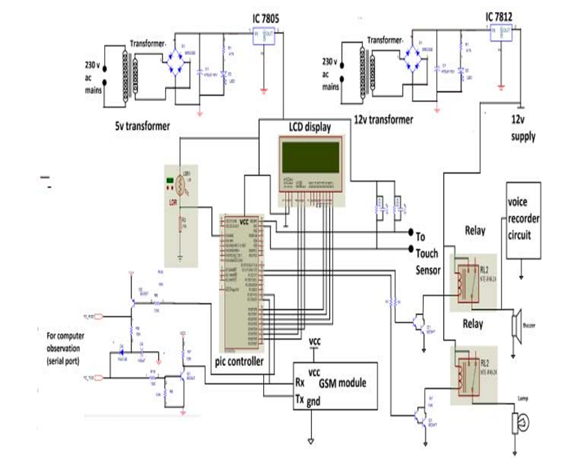In our project, we've designed a farm security system using fencing wire as a sensor. When animals touch this exposed cable, it grounds the circuit, giving us an initial signal that animals are near the fence. This signal is then amplified through a circuit and processed by a microcontroller. Once activated, our system triggers a buzzer, turns on a flashlight at night, and sends a message to the farmer. We power the system using solar panels or a regulated power supply for reliability. The fencing wire acts as a sensor, but its high resistance requires an amplifier circuit to detect small changes in the wire. This amplified signal is sent to the microcontroller's analog-to-digital converter (ADC), which interprets it to activate the system. The microcontroller monitors the fencing resistance and light levels using a Light Dependent Resistor (LDR), responding by operating the buzzer or flashlight as needed. The entire process is controlled by the microcontroller, ensuring efficient operation. To alert the farmer, we integrate a GSM module that sends an SMS when the system detects an animal breach. A shifter circuit ensures isolation between the GSM module and microcontroller to prevent interference. An LCD display shows ADC values, providing initial input confirmation and displaying messages for SMS alerts. Additionally, a keypad allows for system setting adjustments, enhancing flexibility. For torch control, we employ a relay and its driver, facilitating responsive actions based on detected breaches. This integrated approach aims to improve farm security by promptly notifying farmers of potential threats, allowing timely intervention to protect crops and livestock. Our system's reliance on renewable energy sources like solar power enhances sustainability and reduces operational costs, making it suitable for remote agricultural settings with limited access to electricity. Continuous monitoring and maintenance are essential to ensure the system's reliability and effectiveness in safeguarding farms against wildlife intrusion. In summary, our farm security system leverages innovative technology to provide real-time alerts and responsive actions, empowering farmers to protect their farms efficiently and sustainably. Future developments may focus on enhancing sensor sensitivity and expanding functionality to further enhance farm security measures.

**Figure 1:** Block Diagram of the Proposed System

1. **RESULTS AND DISCUSSION**

The farm security system designed to protect against wild animals combines innovative technology with practical solutions for farmers. By utilizing an electric fence as a sensor, the system effectively detects when animals come into contact with the fencing wire. This detection is crucial because it triggers a series of actions that alert the farmer immediately, helping to prevent potential damage to crops or harm to livestock. When an animal touches the fence, the circuit is grounded, which sends a signal to the system. This initial signal is then amplified and processed by a microcontroller. The microcontroller acts as the brain of the system, interpreting the signal and activating responses like sounding a buzzer, turning on a flashlight at night, and sending an SMS alert to the farmer. These actions are vital as they provide real-time information to the farmer, allowing them to respond promptly to any intrusion. One of the system's significant benefits is its ability to operate using solar power or a regulated power supply. This dual power source ensures reliability even in areas with inconsistent electricity access, common in rural farming regions. By incorporating sustainable energy options, the system reduces operational costs and environmental impact, making it a practical choice for farmers looking to enhance security without escalating expenses.

Compared to traditional electric fences, which can hinder emergency services and pose fire risks if vegetation grows too close, the system offers improved safety. It uses low-resistance wires and amplification circuits to detect breaches without relying on continuous high voltage. This design minimizes fire hazards and lowers operational risks while maintaining effective animal deterrence. However, the system requires regular maintenance to remain effective. Keeping the area around the fence clear of vegetation is essential to prevent false alarms and ensure accurate animal detection. Additionally, periodic checks of the microcontroller and GSM module are necessary to prevent malfunctions that could compromise its performance. In conclusion, the farm security system represents a significant advancement in agricultural technology. Its ability to promptly alert farmers to animal intrusions, coupled with its sustainable power options and reduced operational risks, makes it a valuable asset for modern farming practices. Future enhancements could focus on improving component durability and integrating additional sensors to enhance detection accuracy further. By continuing to innovate in this way, agricultural technology can continue to support farmers in safeguarding their livelihoods effectively.

1. **RESEARCH METHODOLOGY TO BE EMPLOYED**

To implement this project, we utilized a PIC microcontroller known for its robustness and flexibility in embedded systems. The PIC microcontroller, which stands for Peripheral Interface Controller, is designed with a Reduced Instruction Set Computer (RISC) architecture. This architecture not only makes it powerful but also cost-effective, ideal for applications like our Farm Protector System. The central unit of our system revolves around this PIC microcontroller. It provides the necessary processing power and features such as built-in timers and programmable capabilities, which are crucial for controlling various aspects of the farm protection system. For instance, we used the microcontroller to manage the operation of four relays that drive motors in a forward direction. These relays are directly connected to the microcontroller, utilizing its internal timers for precise timing operations. In addition to motor control, the system incorporates an LCD display (16x2 type) for visual feedback. The LCD display, commonly interfaced with 14 pins in a row, serves to indicate which object has been detected by the system. This feature is essential for monitoring and diagnosing the system's performance in real-time. To ensure stable operation, a regulated power supply is employed, supported by a step-down transformer that outputs both 5 volts and 12 volts of unregulated power. This setup provides the necessary voltage levels to power the microcontroller, relays, LCD display, and other components reliably. Programming the PIC microcontroller was made straightforward due to its ease of programming and the availability of compatible writing or burning devices. This facilitated the customization of functionalities specific to our farm protector system, enhancing its operational efficiency and reliability. In conclusion, the integration of the PIC microcontroller into our farm security system has proven pivotal. Its capability to handle multiple tasks, interface with various peripherals like motors and LCD displays, and maintain reliable operation through regulated power supply ensures effective monitoring and protection of the farm environment. Future improvements could focus on enhancing sensor capabilities or integrating wireless communication for remote monitoring, further advancing the system's utility and efficiency in agricultural settings.

1. **APPLICATIONS, FEATURES AND THE ADVANTAGES AND DISADVANTAGES OF OUR PROPOSED SYSTEM**
   1. **Advantages**
2. LDR reading are automatic and displayed on a 2digit and LCD display.
3. Continuous monitoring can be done.
4. Works on Solar panel, AC mains or batteries.
5. Fine design. 5. Mini appearance.
   1. **Disadvantages**
6. In large scale devise handling will be complex.
7. Mechanical assembly is more complex.
8. Battery always checks for charging.
   1. **Features**
   * Simple circuit and easy to operate.
   * Fast and simple installation. o Location flexibility.
   * Low cost maintenance.
   * Automatic operation.
   * High reliability and long lifetime.
   * Digital display
   1. **Applications**
9. Main application it is used to protect farm.
10. To be used in orchard/fruit garden.
11. To be used for vegetable garden.
12. To be used for security system for houses.
13. **CONCLUSION AND FUTURE SCOPE**

The system works by connecting an amplifier to the fencing wire. When an animal touches the fence, grounding the circuit, our system activates. This triggers a buzzer and uses a Light Dependent Resistor (LDR) to detect light levels; it automatically adjusts lighting to deter animals from entering the farm. Simultaneously, a GSM module sends alerts to the farmer, notifying them of the breach. This system proves to be effective and affordable for farmers, ensuring farm protection without endangering animals or humans. Looking ahead, there's significant potential for future development. One promising direction involves integrating image processing technology. Cameras could detect wild animals approaching the farm, automatically activating the system via wireless networks. Additionally, wireless technologies such as laser sensors could be employed to detect animal presence, further enhancing the security system. In summary, this design offers a practical solution for farm security that balances effectiveness with affordability. Its integration of advanced technologies like GSM and LDR ensures timely alerts and minimal environmental impact. Future advancements could expand its capabilities through innovative sensor technologies, continuing to improve farm safety and efficiency.

**ACKNOWLEDGEMENTS**

Prof. Aditi Ghuge, guide of this project guided us throughout of the project in each and every situation. The team G. Abhishek, G. Jyoti, B. Ashwini, B. Dipali has worked in development of the code and various modules of the project

**REFERENCES**

1. Dr. Wilson, "ELECTRIC FENCE," Handbook of Texas, Project report published by the Texas State Historical Association. August 4, 2011.
2. T. Day and R. Mac Gibbon, “Multiple-Species Exclusion Fencing and Technology for Mainland Sites.”, Project Report published by National Wildlife Research Centre, 2007.
3. R. Padula and W. Head, “Fencing System” Project Report published by University of Minnesota, 2003.
4. A. Stoler, “Taut Wire Fence System,” U.S. Patent 4,730,809, March 1988.
5. N. V. Bekarts, “Security fence,” A - European Patent EP0014009, December 1982.