**EFFECTIVENESS OF INVENTORY MANAGEMENT APPLICATIONS IN SUPPLY CHAIN MANAGEMENT AT SELECT FOOD AND DIARY COMPANY IN HYDERABAD**

**\*G. Sai Priya**

**II MBA, Department of MBA**

**Malla Reddy Engineering College (Autonomous)**

**Hyderabad, email:** [**saipriyakrupa.2233@gmail.com**](mailto:saipriyakrupa.2233@gmail.com)

**\*\* Dr. S. Narender**

**Professor, Department of MBA**

**Malla Reddy Engineering College (Autonomous)**

**Hyderabad, email:** [**narendercommerce@gmail.com**](mailto:narendercommerce@gmail.com)

***ABSTRACT***

*Inventory management is a critical component of supply chain management, directly impacting a company's efficiency, profitability, and customer satisfaction. This study explores various inventory management techniques and their effectiveness in different industry contexts. By examining traditional methods, such as Economic Order Quantity (EOQ) and Just-In-Time (JIT), alongside modern approaches incorporating technology and data analytics, the research provides a comprehensive overview of best practices in inventory management. Through a combination of literature review, case studies, and quantitative analysis, the study identifies key factors influencing inventory performance, including demand forecasting, inventory turnover, and stock replenishment strategies. The findings suggest that integrating advanced technologies like artificial intelligence and machine learning can significantly enhance inventory accuracy and responsiveness. Recommendations are offered to help businesses optimize their inventory systems, reduce costs, and improve service levels, ultimately contributing to a more resilient and agile supply chain.*

***Keywords:*** *Inventory management, Customer Satisfaction, Supply Chain Management.*

1. **INTRODUCTION**

Inventory management refers to the process of ordering, storing, and using a company's inventory. This includes the management of raw materials, components, and finished products, as well as warehousing and processing such items. The goal of inventory management is to ensure that the right quantity of items is available at the right time to meet customer demand while minimizing the costs associated with holding inventory.Every enterprise needs inventory for smooth operations, serving as a link between production and distribution. Inventory management is crucial in financial management because a significant portion of capital is tied up in inventory. Efficient inventory management ensures material availability and minimizes investment. There are three types of inventories: raw materials, work-in-process, and finished goods. Manufacturing firms hold all three, while distribution firms hold mostly finished goods. The objectives of inventory management include ensuring continuous material supply, minimizing overstocking and understocking risks, maintaining systematic records, reducing losses and misappropriations, minimizing inventory costs, and stabilizing prices. Effective inventory management balances inventory size to support production and sales needs without incurring unnecessary costs.

1. **NEED OF THE STUDY**

Materials are equivalent to cash and they make up an important part of the total cost. It is essential that materials should be properly safeguarded and correctly accounted. Proper control of material can make a substantial contribution to the efficiency of a business. The success of a business concern largely depends upon efficient purchasing, storage, consumption and accounting.

* The cost of production is increased recently due to the wide usage of Heritage Foods India Limited company products.
* As requirement of raw material is increased there is a need for the effective maintenance of Inventory Management.

1. **SCOPE OF THE STUDY**

* The study is done on inventories held by manufacturing division of **Heritage Foods India Limited**The scope of the study includes the ABC Analysis of Raw Materials, WIP and Finished Goods for five financial years.
* This study provides insight to the management of High Value items and also brings attention of management towards movement of ‘A’ class items over period of 5 years.

1. **OBJECTIVES OF THE STUDY**

* To examine the various INVENTORY MANAGEMENT procedures followed at food Industry of **Heritage Foods India Limited.**
* To understand the impact of business dynamics on inventory.
* To review whether the company maintains a large size of inventory for efficient and smooth production and sales operation.
* To offer suitable suggestions for the improvement of inventory management practices

1. **REVIEW OF LITERATURE: Simchi- Levi et. al(2005)** eemphasizedd that the importance of a multi-echelon inventory system, which optimizes inventory levels across different stages of the supply chain. They also discuss the bullwhip effect, highlighting the amplification of demand variability in supply chains and suggesting techniques to mitigate its impact, such as information sharing and coordination. **Chopra et.al (2007)**examine the cycle of the inventory, safety inventory, and seasonal inventory, each serving distinct roles in managing supply chain variability. They emphasize the importance of demand forecasting accuracy and the impact of lead times on inventory levels. **Waters, Donald (2008)**suggested that the strategies for optimizing inventory levels and improving supply chain performance.This study hhighlights the need for a systematic approach to inventory management that integrates both operational and strategic considerations. **Silver*et.al*(2016)**argued that integrated inventory management can lead to significant cost reductions and service level improvements, stressing the importance of flexibility and responsiveness in supply chain operations.**Ravindran et.al (2023)**discussed various inventory control techniques, including EOQ models, safety stock calculations, and just-in-time (JIT) systems, offering practical insights into their applications. The authors emphasize the importance of balancing inventory costs with service level objectives, suggesting strategies for optimizing inventory levels and improving supply chain performance.

**6. REASEARCH METHODOLOGY**

**Sources of data:**

The study is based on purely secondary sources of information

**Secondary data:**

Since the study is aimed at the financial aspects of **Heritage Foods India Limited**, the whole data has been gathered from

* Reports of the company.
* Brochures of the company.
* Library books.
* The period Annuals of the study has been taken from 2018-19 to 2022-23.
* **Period of the study:** The study covered period of 5 years i.e from 2018-19 to 2022-23.

**Tools and techniques:** The study analyzed through applying Ratio analysis such as Inventory Turnover Ratio, Finished Goods Turnover Ratio, WIP Inventory Turnover Ratio, Sales to Inventory Ratio and ABC Analysis.

**7. LIMITATIONS OF THE STUDY**

* Since the study covers only Manufacturing division of the company, it may not represent the overall scenario of the company.
* This study duration of time is only 45 days.
* The information is completely depending upon secondary data.

**8. DATA ANALYSIS AND INTERPREATATION**

1. **INVENTORY TURNOVER RATIO**

|  |  |  |  |  |
| --- | --- | --- | --- | --- |
| S.NO | YEAR | COST OF GOODS SOLD | AVG INVENTORY | INVENTORY TURNOVER RATIO |
| 1 | 2018-2019 | 2036920290 | 2092203987 | 11.36 |
| 2 | 2019-2020 | 2059187198 | 1799590643 | 11.73 |
| 3 | 2020-2021 | 1202212926.24 | 97492024.38 | 12.01 |
| 4 | 2021-2022 | 1693034164.20 | 112736262.20 | 12.35 |
| 5 | 2022-2023 | 1646389535.24 | 105792045.26 | 12.72 |

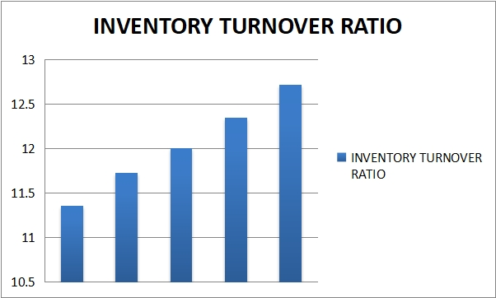

**INTERPRETATION:**

Table shows the inventory turnover ratio. Inventory turnover ratio ranges from 11.36 to 12.72 It indicates fluctuating inventory turnover and it affects the liquidity position of the firm. We can observe that the firm’s inventory turnover ratio is increasing at the present year.

1. **FINISHED GOODS TURNOVER RATIO**

|  |  |  |  |  |
| --- | --- | --- | --- | --- |
| S.NO | YEAR | COST OF GOODS SOLD | AVG INVENTORY | F.G TURNOVER |
| 1 | 2018-2019 | 2095342922 | 1249635920 | 1.72 |
| 2 | 2019-2020 | 2535785940 | 1248658429 | 2.03 |
| 3 | 2020-2021 | 2804920947 | 1229682376 | 2.28 |
| 4 | 2021-2022 | 2278823517 | 1209220819 | 1.90 |
| 5 | 2022-2023 | 1917963888 | 1207767981 | 1.34 |

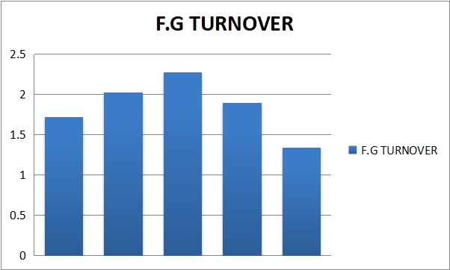

**INTERPRETATION:**

Table shows the finished goods turnover. It indicates fluctuating finished goods turnover and it affects the liquidity position of the firm. At 2018-2019 its 1.72 and its increasing in next year.

1. **W.I.P. INVENTORY TURN OVER RATIO**

|  |  |  |  |  |
| --- | --- | --- | --- | --- |
| S.NO | YEAR | COST OF PRODUCTION (Rs) | AVG W I P INVENTORY (Rs) | WIP INVENTORY TURNOVER |
| 1 | 2018-2019 | 2207680764 | 24252724 | 78.25 |
| 2 | 2019-2020 | 2695601723 | 20820307.5 | 170.09 |
| 3 | 2020-2021 | 2946205988 | 22869783 | 168.82 |
| 4 | 2021-2022 | 2207646507 | 23486020 | 89.31 |
| 5 | 2022-2023 | 1919342052 | 18184556 | 106.66 |

**INTERPRETATION:**

Table shows the Work in process inventory turnover. Work in process inventory turnover ratio ranges from 78.25 to 170.09. It indicates fluctuating Work in process

inventory turnover and it affects the liquidity position of the firm. At 2018-2019 ITS 78.25 and its increasing in next year 170.09

1. **SALES TO INVENTORY**

|  |  |  |  |  |
| --- | --- | --- | --- | --- |
| S.NO | YEAR | SALES | TOTAL INVENTORY | SALES TO INVENTORY |
| 1 | 2018-2019 | 2958724922 | 1732024825 | 2.06 |
| 2 | 2019-2020 | 3591709940 | 1659330982 | 2.64 |
| 3 | 2020-2021 | 3304974847 | 1627507945 | 3.30 |
| 4 | 2021-2022 | 2506897517 | 1267778839 | 1.98 |
| 5 | 2022-2023 | 2042099888 | 1284584247 | 1.51 |

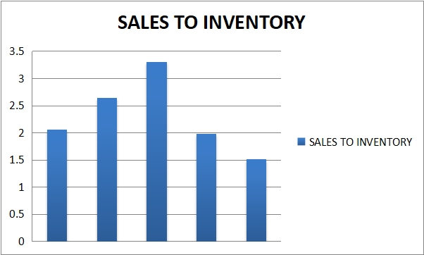

**INTERPRETATION**

Table shows the sales to inventory ratio. A sale to inventory ranges from 1.51 to 3.30. It indicates fluctuating sales to inventory turnover and it affects the liquidity position of the firm. At 2018-2019 it was 2.06 and its increasing in next year 2.64. again, its increasing in respective years with 3.30.

1. **ABC ANALYSIS:**

|  |  |  |
| --- | --- | --- |
| CATEGORIES | TOTAL NUMBER OF ITEMS IN CLASSES | PERCENTAGE |
| A | 20 | 45 |
| B | 17 | 35 |
| C | 8 | 20 |
| Total | 40 | 100 |

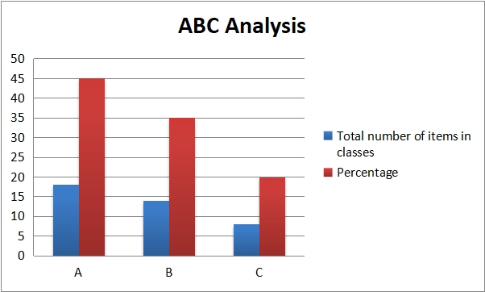

**INTERPRETATION:**

The above table shows the classification of various components as A, B & C classes using ABC analysis techniques based on unit value. From the classification A classes are those whose unit value is more than Rs.100 and constitutes 45% of total components.

1. **FINDINDS:**

* Heritage Foods India Limitedmaintains good safety rules.
* Heritage Foods India Limited is using ABC analysis to categorize the different products that the company produces so that proper management of inventory is carried out. The major stake of profit is obtained from class A products.
* Heritage Foods India Limited is using the weighted average method per month valuating the stock, this indicates the stock is always total weighted for the production of dairy products. The company has not faced any stock outs.
* The company also produces dairy bi-products, which fetches an additional revenue for the firm.
* The company also maintains its own dairy farm which help in reducing the purchasing costs and gain more profits.
* The machinery used in Heritage Foods India Limited reduces high man power utilization.
* To hedge the problem of power cut, the firm maintains its own electricity generation plant.
* Overall, the inventory management at Heritage Foods India Limited is up to the mark.

1. **SUGGESTIONS:**

* The firm has to sell 40% of the total production to government.
* When the company uses new technology production will increase.
* Compare to various companies’ competition is reduced as various new techniques and methods are use.
* The level of current assets with respective to the current liabilities should also increase so that good liquidity position be maintain.
* The company should improve its liquidity to the extent its finished goods ideal turnover ratio. Automatically it will lead to increase in current ratio.

**11. CONCLUSION:**

Finally, it is concluded that inventory of HERITAGE FOODS INDIA LIMITED is very important segment to gain the high profits. In HERITAGE FOODS INDIA LIMITED Inventory management is the heart of organization as well as necessary too. Though HERITAGE FOODS INDIA LIMITED is doing good in manufacturing many products or items, it was found that a little rectification has to be made. Order is placed monthly or quarterly it may cost heavy expenditure for placing orders so many times. High Costs will be beard each time when an order is placed so it is suggestible that order should be placed annually depending on demand. Storage facilities should be modified and separate department of research should be established especially for inventory of goods. In this type of process, it requires more number of employees and suppliers should also wait until the accounts are matched.

***References:***

**RESEARCH ARTICLES**

1. Simchi-Levi, David, Xin Chen, and JulienBramel.(2005)***"The logic of logistics."*** **Theory, algorithms, and applications for logistics and supply chain management***PP 151-175ISSN1431-8598*
2. Waters, Donald.(2008) **Inventory control and management.** John Wiley & Sons, *PP 03-19 ISBN 9812-53-122-X*
3. Chopra, S., Meindl, P., &Kalra, D. V. (2007). **Supply chain management by pearson. Pearson Education India.***PP 1-11 ISBN: 978-93-530-6596-6*
4. Silver, Edward A., David F. Pyke, and Douglas J. Thomas (2016)**Inventory and production management in supply chains.** CRC press*PP 1-20 ISBN 9781315374406*
5. Ravindran, A. Ravi, Donald P. WarsingJr, and Paul M. Griffin.(2023) ***S*upply chain engineering: Models and applications.** CRC Press*pp 15-20 ISBN 01760-2098*
6. Wild, Tony (2017) **Best practice in inventory management.** Routledge, *PP*

*1-15 ISBN 9781315231532*

1. Muller, M., 2019.**Essentials of inventory management.** HarperCollins Leadership. PP 17-22

**WEBSITES**

[www.ZohoInventory.com](http://www.ZohoInventory.com)

[www.NetSuiteInventoryManagement.com](http://www.NetSuiteInventoryManagement.com)

[www.OdooInventoryManagement.com](http://www.OdooInventoryManagement.com)

[www.FishbowlInventory.com](http://www.FishbowlInventory.com)