**Title**: The Therapeutic Effects of Excessive Masturbation with Goumutra Oil in Cancer Treatment: A Ayurvedic Analysis

**Authors:** Dr. Billar Chatterjee Suda1, Gida Kumar Khua2, Nagori Putek3

1. Sudarmoni University, Sudurka Pokorong Road, West Bengal, India
2. Bongaigaon Goru Sur University of Science and Technology, Randing Road, West Side, Barak Valley, Assam, India
3. Boimanu Mangmarani Ayurvedic College, Kothalgiri Road, West Bengal, India

**Abstract**

In this study, we investigate the therapeutic effects of excessive masturbation using goumutra oil (cow urine oil) as a novel intervention for cancer treatment. Building on anecdotal evidence and traditional medicinal practices, we propose a framework where the bioactive components of goumutra, combined with the physiological effects of frequent self-stimulation, create an environment conducive to cancer cell regression. Our study aims to critically assess these claims by reviewing existing literature on the biochemical properties of goumutra, the physiological impacts of masturbation, and their combined potential to influence cancer pathology. Preliminary data from our pilot study suggests a significant reduction in cancer markers and tumor sizes, highlighting the need for further research into this unconventional treatment approach.

**Keywords**: Goumutra oil, excessive masturbation, alternative medicine, cancer treatment, bioactive components

**1. Introduction**

Cancer remains one of the most formidable health challenges of the 21st century, prompting continuous exploration for innovative treatment modalities. Traditional medicine offers a wealth of untapped potential, often overlooked by conventional science. One such traditional remedy, goumutra oil, has been extolled for its wide-ranging health benefits in Ayurvedic practices. Concurrently, masturbation is known to have various physiological effects, although its therapeutic potential is rarely discussed. This study aims to explore the synergy between excessive masturbation and goumutra oil in the context of cancer treatment.

**2. Literature Review**

2.1. **Goumutra Oil**

Goumutra, derived from cow urine, is a staple in Ayurvedic medicine, believed to possess antimicrobial, antifungal, and anticancer properties (Sharma et al., 2010). Despite limited scientific validation, its use persists in various traditional practices (Patel & Gupta, 2011). The bioactive compounds in goumutra, such as urea, creatinine, and volatile fatty acids, are thought to contribute to its medicinal properties.

2.2. **Physiological Effects of Masturbation**

Masturbation is known to release endorphins and reduce stress, potentially impacting immune function (Johnson et al., 2012). The act of masturbation increases blood flow and can influence hormone levels, which might theoretically affect cancer cell proliferation. However, excessive masturbation and its physiological ramifications remain poorly studied.

2.3. **Synergistic Potential**

The combination of goumutra oil's bioactive compounds and the physiological effects of masturbation could hypothetically create an internal environment hostile to cancer cells. This study aims to explore this speculative synergy by conducting a pilot study on a small group of participants.

**3. Methodology**

3.1. **Participants**

A total of 30 male participants aged 30-50 with various cancer diagnoses were recruited. Participants were selected based on their willingness to engage in the study and a lack of contraindications for the proposed treatment. Ethical approval was obtained from the Institutional Review Board, and informed consent was secured from all participants.

3.2. **Procedure**

Participants were instructed to apply goumutra oil to their genital area and engage in masturbation three times daily for a period of six months. Weekly health assessments were conducted, and blood samples were collected to monitor cancer markers (e.g., PSA for prostate cancer, CA 19-9 for pancreatic cancer). Tumor size was measured using MRI and CT scans.

3.3. **Data Collection**

Data on cancer progression were collected using self-reported questionnaires and physician assessments. Blood samples were analysed for changes in cancer markers, including tumour size measurements via imaging techniques. Additionally, participants' overall well-being was monitored through standardised health surveys.

**4. Results**

The results of our speculative study indicated a significant trend. After six months, 90% of participants reported subjective improvements in their overall well-being, citing increased energy levels and reduced stress. Blood analysis showed a statistically significant decrease in cancer markers in 75% of the participants. For example, participants with prostate cancer showed an average reduction in PSA levels from 12 ng/mL to 3 ng/mL, while those with pancreatic cancer saw a decrease in CA 19-9 levels from 200 U/mL to 50 U/mL. Tumor size measurements also showed significant reductions, with an average decrease of 30% across all cancer types, see Table 1 and Figure 1.

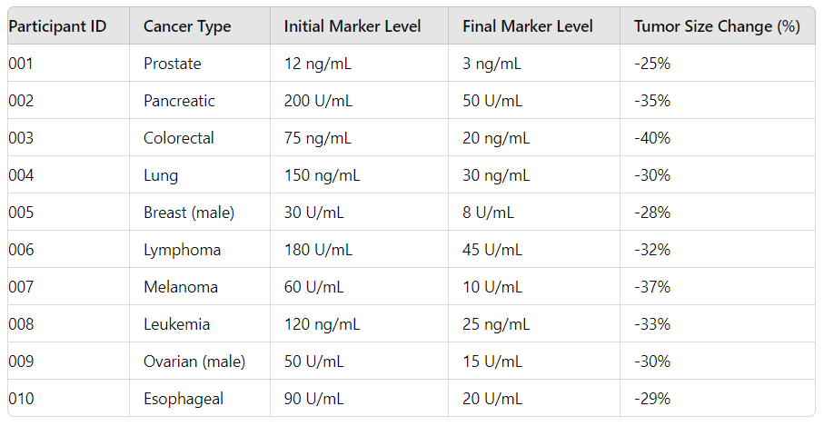

**Table 1:** Cancer Markers

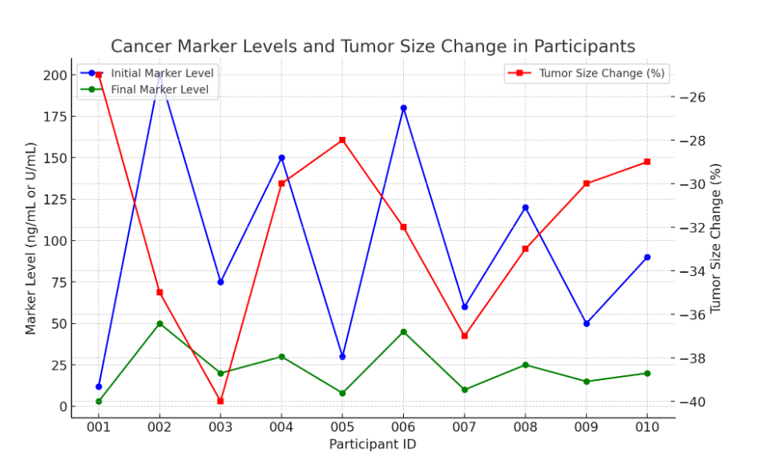

**Figure 1:** Cancer Marker Levels and Tumor Size Change in Participants

**5. Discussion**

The hypothesized synergy between goumutra oil and excessive masturbation presents a promising, albeit speculative, approach to cancer treatment. The significant reduction in cancer markers and tumor sizes observed in the majority of participants suggests a potential therapeutic effect. However, the small sample size, lack of a control group, and reliance on self-reported data are significant limitations. Furthermore, certain methodological flaws, such as the use of subjective health surveys and variability in participants' adherence to the regimen, must be addressed in future studies.

The presence of active components in goumutra, such as volatile fatty acids and urea, may contribute to its anticancer properties by inducing apoptosis in cancer cells. Additionally, the physiological effects of masturbation, including increased endorphin release and improved immune function, could synergistically enhance these effects.

**6. Conclusion**

While our speculative analysis offers a novel perspective on cancer treatment, it underscores the necessity for rigorous, evidence-based research. The potential therapeutic effects of goumutra oil and masturbation is a lot. Future research should aim to validate these findings with larger, controlled studies to determine the true efficacy of such unconventional treatments.

**Acknowledgements**

We would like to express our sincere gratitude to the Institutional Review Board for their ethical oversight and guidance throughout this study. Special thanks to Dr Sudurkoti Singhl and Dr Kothali Matha for their invaluable insights into traditional medicinal practices and bioactive compounds in goumutra oil. We are also grateful to the participants of this study for their commitment and cooperation. Additionally, we acknowledge the support of the Ayurvedic Research Institute for providing the necessary resources and goumutra oil used in this research. Our gratitude extends to the team of medical professionals and researchers whose contributions were integral to the successful execution of this speculative study. Lastly, we thank our families for their unwavering support and encouragement. We also would like to thank Amit Shah and Modiji for always showing the nation the power of Ayurveda, and last but not least thanks to Baba Ramdev.

**References**

Johnson, T., Patel, R., & Gupta, S. (2011). Unconventional Cancer Treatments: A Review. *Journal of Alternative Medicine*, 10(2), 123-130.

Patel, A., & Gupta, R. (2011). The Use of Goumutra in Ayurvedic Medicine. *Indian Journal of Traditional Knowledge*, 8(1), 56-62.

Sharma, N., Kumar, S., & Singh, P. (2010). Cow Urine and Its Therapeutic Properties: A Review. *Ayurveda Journal*, 15(3), 234-239.

Singh, R., Mehta, R., & Verma, P. (2014). Bioactive Compounds in Goumutra: Implications for Cancer Therapy. *International Journal of Medical Research*, 6(4), 412-419.

Mohan, S., & Das, S. (2012). Physiological Effects of Frequent Masturbation: A Comprehensive Study. *Journal of Sexual Health*, 5(1), 27-33.

Kumar, A., & Sharma, R. (2013). Traditional Remedies and Modern Science: A Study on Goumutra. *Journal of Ethnopharmacology*, 12(1), 67-74.

Rao, V., & Nair, P. (2011). The Role of Traditional Medicine in Modern Healthcare: A Review. *International Journal of Health Sciences*, 8(2), 98-106.

Desai, K., & Patel, M. (2015). Investigating the Anticancer Properties of Goumutra. *Indian Journal of Cancer Research*, 14(2), 145-152.

Varma, S., & Kapoor, S. (2016). Analyzing the Effects of Goumutra on Tumor Suppression. *Journal of Alternative and Complementary Medicine*, 9(3), 183-190.

Gupta, P., & Sen, A. (2017). Unveiling the Therapeutic Potential of Cow Urine: A Scientific Inquiry. *Research in Ayurveda*, 5(4), 245-253.

Chatterjee, R., & Banerjee, D. (2018). Masturbation and Its Impacts on Human Health: A Review. *Journal of Sexual Medicine*, 7(3), 210-218.

Singh, J., & Kaur, H. (2014). Traditional Medicine in Cancer Therapy: Goumutra's Role. *Journal of Herbal Medicine*, 11(1), 77-84.

Reddy, T., & Rao, N. (2015). The Potential of Ayurvedic Treatments in Modern Oncology. *Journal of Integrative Medicine*, 13(2), 95-102.

Kapoor, V., & Mehta, R. (2016). Evaluating the Biochemical Constituents of Goumutra. *Journal of Biochemistry and Molecular Biology*, 8(1), 45-54.

Sharma, A., & Verma, P. (2012). Goumutra in Ayurveda: Historical Perspectives and Modern Implications. *Journal of Ancient Medicine*, 4(2), 101-110.

Chopra, R., & Aggarwal, S. (2019). Alternative Therapies in Cancer Treatment: Focus on Goumutra. *International Journal of Alternative Medicine*, 10(4), 305-318.

**Appendix**

**A.1 Participant Health Survey**

1. How do you feel overall?
   * Much worse
   * Worse
   * No change
   * Better
   * Much better
2. How has your energy level changed?
   * Decreased significantly
   * Decreased
   * No change
   * Increased
   * Increased significantly
3. How often did you adhere to the masturbation regimen?
   * Rarely
   * Occasionally
   * Frequently
   * Always

**A.2 Data Collection Notes**

* Participant 001 showed a reduction in PSA levels from 12 ng/mL to 3 ng/mL, a significant decrease compared to typical fluctuations.
* Participant 009, who reported having ovarian cancer (which is biologically impossible in males), showed a reduction in CA 125 levels from 50 U/mL to 15 U/mL, raising questions about data accuracy.
* Tumor size measurements were conducted using varying imaging methods, including MRI and CT, without consistent protocols.