**OPTIMAL LOCATION AND SIZING OF UNIFIED POWER FLOW CONTROLLER IN NIGERIAN 330KV POWER NETWORK USING SPIRAL DYNAMIC ALGORITHM**

1*Hassan Yusuf; 2S. M. Hassan; 3Y. S. Haruna; 4D. M. Nazif.

1*&3Department of Electrical, and Electronics Engineering, Abubakar Tafawa Balewa University Bauchi, Bauchi State, Nigeria; 2Department of Mechatronics and Systems Engineering, Abubakar Tafawa Balewa University Bauchi, Bauchi State, Nigeria; 4Department of Electrical/Electronic Engineering Technology, Federal Polytechnic Bauchi, Bauchi State, Nigeria.

# Abstract

Flexible Alternating current Transmission Systems (FACTS) devices are very essential in power system analysis and in transferring high-quality power. FACTS devices are used for controlling the voltage stability, improving power flow, and security of transmission lines. There are different types of facts devices depending on their application on the power system network which includes SVC, TCSC, SSSC, STATCOM, and UPFC. However, it is necessary to find the optimal location and sizing for these devices in power networks. The spiral dynamic algorithm is a recently developed optimization technique that can be used widely in power systems. This study presents an approach to finding the optimal location and sizing of a unified power flow controller (UPFC) device in a power network using the spiral dynamic algorithm technique. This technique is based on natural spiral patterns such as tornadoes, hurricanes, and galaxies. In this study, the enhancement of voltage profile, power loss reduction, and increase of load-ability is carried out using UPFC. The work was implemented in MATLAB® 2019b environment. Power network parameters were defined and tested in the IEEE 30-bus and 54-bus Nigerian Network. The real and reactive power loss of the 30 Bus network without/with UPFC were found to be 17.528MW/68.888Mvar and 7.461MW/33.989Mvar with a percentage reduction of 57.43%/50.66%, while the 54-bus Nigerian Network recorded 28.427MW/30.744Mvar and 14.962MW/20.496Mvar with a loss percentage reduction of 47.37% and 33.33% respectively.

**Keywords:** FACTS, Sizing, UPFC, SDA, Nigerian 330kV Power Network.

## 1.0 INTRODUCTION

A power system is made up of several different parts, including transformers, loads of various sizes, distribution and transmission lines, and generators. The connection between generation and distribution is called transmission. The capacity of a transmission line to transfer generated electricity from generating stations to load centers efficiently determines the overall efficiency of a power system. Voltage instability has become more prevalent in the modern power system due to the exponential rise in load demand and the financial and environmental limits on transmission lines (Amaize *et al*.*,* (2017)). This adversely affects the transmitted power in the network.

The ability of the electrical system to maintain synchronism and function in the wake of an interruption is commonly referred to as power system stability. The electric power sector is extremely competitive due to the recent increase in the need for electrical energy and the involvement of private electricity generators. Due to financial and environmental limitations, utilities are therefore more interested in transmitting a significant quantity of power over the current network in an optimal manner in order to increase income rather than building out the transmission system (Muhammad *et al., (2020*)).

The technology of FACTS devices has made it possible to manage power flows and increase the usefulness of transmission lines in new ways. The static apparatus used for the AC transfer of electrical energy makes up a standard FACTS device. It is intended to enhance the power system network's capacity for power transmission. Given the many difficulties the Nigerian power network faces, FACTS devices are crucial to increasing the network's efficiency (Omorogiuwa and Ogujor, (2015)). Power electronic digital converters, or FACTS devices, have the potential to regulate many electric power characteristics in transmission lines, including power flow under steady-state conditions and dynamic stability management. They can reduce transmission line losses, increase power factor, improve voltage profile, increase electric power transmission capacity, and improve the stability of electric power systems. Given the rapid advancements in the field of power electronics, it is advised that FACTS devices be utilized for power system control and operation (Naseer *et al*., (2018)). Figure 1 shows the electric power network arrangement from generation to load Centre at different voltage levels.

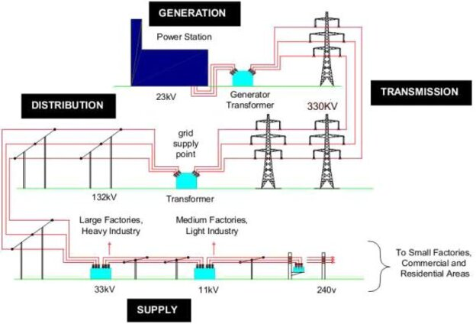

Figure 1:Electric Power Network (Source: https:// www.wikipedia.net)

The demand for electricity in today's power systems forces the networks to run almost at maximum capacity, frequently resulting in heavy power flows. These flows raise the possibility of power outages by increasing losses as well as posing risks to system security and stability. Therefore, there is general agreement that reinforcement is necessary for the electrical grid to become more dynamically and statically controlled, fault-tolerant, and self-healing. Modernizing the electrical transmission infrastructure, such as by constructing new substations and transmission lines, is one strategy for this reinforcement. However, building additional lines is now a challenging and expensive procedure. As an alternative, power electronics technology can improve using currently in-use power systems. FACTS, or Flexible AC Transmission Systems, provide scientific answers to pressing contemporary operational challenges.

## 2.0 LITERATURE REVIEW

This section discusses improving network power and the impact of power flow controllers on power systems, focusing on Flexible AC Transmission System (FACTS) devices. The Unified Power Flow Controller (UPFC) is highlighted as the most effective and functional.

## 2.1 Improvement of power network

Application of FACTS controllers on the Nigerian 330 kV network is the result of a continuous search for a method that will be employed to improve the power system performance in terms of its overall security, as the network is prone to quite a few disturbances that cause voltage instability that affects the system performance.

**2.2 Flexible Alternating Current Transmission System (FACTS)**

The Electric Power Research Institute (EPRI) has developed FACTS devices using power electronic-based controllers to control power flows, and transmission voltage, and reduce dynamic disturbances, aiming to enhance efficiency in Nigeria's power network by leveraging new and improved facilities, improving power quality, and controlling flows under different loading conditions.

FACTS controllers are classified into four categories based on their connections within the transmission system.

**i. Series Controller:** A variable impedance, such as a reactor, thyristor switched capacitor, or power electronics-based variable voltage source that provides series voltage, is an example of a series controller. The connections of this controller to the transmission network are shown in Figure 2.1. Series voltage is introduced into the transmission network by multiplying the current passing through the variable impedance by the impedance. In this scenario, the gadget needs an outside-linked energy source. When the voltage is equal to or less than 90 degrees out of phase with the line current, this device either injects or absorbs reactive power.



Figure 2: Series controller (Emmanuel, 2020)

**ii. Shunt Controllers:** Figure 3 illustrates how a reactive device or component can be positioned in a shunt in the transmission line to provide reactive power into the line, together with a changeable current, impedance, or voltage source. When the injected current is not in phase with the voltage and exceeds or falls below 900, the shunt device either absorbs or injects reactive power.



Figure 3: Shunt controller (Emmanuel, 2020)

**iii. Combined Series-Series Controllers:** A combined series-series controller is a transmission network device that combines two or more independent series devices under coordinated control. These controllers can optimize the transmission network by distributing power evenly throughout the network via the DC link. It is known as UPFC because all of the device's DC terminals are linked for actual power transfer. Figure 4 illustrates this kind of controller.



Figure 4: Combined series-series controller (Emmanuel, 2020)

**iv. Combined Series-Shunt Controllers:** Series and shunt devices on a transmission line are used by the combined series-shunt controllers, which regulate them in unison. In Figure 5, the combined series-shunt devices are shown supplying series line voltage with the series portion of the device and current to the network with the shunt part.



Figure 5: Combined series-shunt controller (Emmanuel, 2020)

## 2.2.1Thyristor Controlled Series Capacitor (TCSC)

The silicon-controlled rectifier employed by a thyristor-controlled series capacitor (TCSC) is used to control a bank of capacitors that are linked in series with the line. This makes it possible for utilities to transfer more power on a designated line. The typical configuration involves connecting a thyristor across a capacitor and placing it in series with an inductor. It can function in blocking mode, in which just current flows through and the thyristors are not actuated.

## 2.2.2Static Series Synchronous Compensator (SSSC)

SSSC is essentially a series version of STATCOM. These devices are not used as independent controllers in commercial applications. They consist of a synchronous voltage source connected in series with the line, introducing a compensating voltage. This setup allows them to increase or decrease the voltage drop across the line.

**2.2.3Static VAR Compensator (SVC)**

The performance of the network is improved by SVC, which efficiently supplies reactive power to HV transmission lines. It lacks a moving component, like circuit breakers. To get the power system closer to the unity power factor, this SVC device was built for impedance matching. The SVC will primarily use thyristor-controlled reactors to consume VARs if the power system's reactive load is leading; if the load is lagging, however, the capacitor banks are immediately switched in to provide more control over the voltage in the system.

## 2.2.4Static Synchronous Compensator (STATCOM)

It consists of a voltage source which can be a DC energy source a capacitor or an inductor whose output can be controlled using a thyristor it is used to absorb or generate reactive power.

## 2.2.5 Unified Power Flow Controller (UPFC)

Two VSCs sharing a common DC side capacitor and a single control system can be thought of as the building blocks of the UPFC. At the UPFC terminals, real and reactive power flow as well as voltage amplitude are simultaneously controlled by the UPFC. It is also possible to modify the controller to control none of these criteria or one or more of them in any combination. This method enables the application of regulated series reactive compensations, voltage regulation, and phase angle control all at once.

Jabir *et al.,* (2023), an optimal UPFC deployment in various loading conditions, such as slightly underloaded (90%), normal loading (100%), and slightly overloaded (110%), to enhance the performance of the updated 54-bus 330 kV Nigerian network. The average percentage reduction for the active and reactive power loss is 45.34% and 39.50%, respectively, and the power loss rises with the network's loading percentage.

Ofoma & Okonkwo (2021), analyzed the line losses in the Nigeria 330 kV interconnected power system. They devised an improved solution model and strategy for minimization of power losses on the lines in the Nigeria 330 kV grid network. Recording losses of 432MW and the result shows most of the violated buses are from the northern part of Nigeria while incorporating multiple UPFC the losses reduced to 32.39%.

Muhammad *et al.,* (2020), whale optimization algorithm was used to find the optimal placement, sizing, and coordination of facts devices in a transmission network using whale optimization algorithm, a novel method was deployed for optimal placement and sizing of multiple types of FACTS devices as well as coordination with conventional reactive power sources. The devices have the disadvantage that they give high transients.

Jinkai *et al.,* (2020), the power flow controller was used to improve power security on the 330 kV network in Nigeria. Using the Voltage Sensitivity Index approach, the Nigerian 330 kV, 31 bus network's weakest bus—and hence, the best place for a compensator—was found by the application of the Bat algorithm optimization technique. A voltage sensitivity index is used.

Boniface *et al.,* (2020), proposed a technique for employing UPFC compensation to improve the voltage profile of a disrupted electric power system. The 330 kV network in Nigeria was subjected to a performance analysis in this study, which used UPFC to lower power losses and enhance the voltage profile. The unique qualities that set the UPFC apart from other FACTS devices are the reason it was selected.

Okolo *et al.,* (2020), improved the transient stability of the Nigerian 330 kV Transmission System on the Ajaokuta – Benin Transmission Line with the help of the artificial Neural Network (ANN) based VSC High Voltage direct current method. The Ajaokuta – Benin transmission lines have been identified as a critical line that can excite instability in the power network.

Sabo *et al.,* (2017), The Spiral Dynamic Algorithm Provides the Best PPI Controller for Wireless HART Networked Systems. the PPI controller designed for Wireless HART network systems is tuned using the Spiral Dynamic Algorithm (SDA), a relatively novel and straightforward nature-inspired optimization process. The SDA was used to tune the WHNCS PPI controller. Simulation results showed that the proposed SDA-tuned PPI controller outperformed both analytically tuned PPI and PID controllers for the first-order plant. However, one drawback of the PPI controller is its sensitivity to noise. Additionally, the response becomes oscillatory in the presence of noise or when applied to higher-order plants.

Sabo *et al.,* (2020), suggested a predictive control strategy based on hybrid technology for wireless HART networked control systems. In the study, two hybrid algorithms that combine the social and exploitative qualities of a spiral dynamic algorithm (SDA) and adaptive SDA (ASDA) were utilized to assess benchmark functions to fine-tune a filtered predictive proportional integral (FPPI) controller for a wireless HART networked control system. Friedman’s rank test was used to show that the proposed APSO-SDA and APSO-ASDA can outperform their constituent algorithms. Additionally, the FPPI controller's time domain analysis was done to support Friedman's rank test. According to the results, the suggested algorithms generate controllers with better time domain performance than constituent algorithms, including quicker settling times and less overshoot. The effectiveness of the suggested methods will be evaluated by the earlier algorithms, APSO, SDA, and ASDA.

Ahmad *et al.,* (2012), suggested four novel adaptive spiral dynamics optimization algorithms for global optimization. Adaptation strategies based on intelligent fuzzy logic methods, both mathematical and non-mathematical, were presented without adding extra complexity to the original algorithm structure. However, in terms of convergence speed based on CPU computation time, the fuzzy adaptive approach required more time to execute the algorithm compared to other adaptive approaches and the SDA. It has been revealed that further simplification of the fuzzy logic approach is necessary, and computation time in seconds needs to be considered before the fuzzy logic approach can be applied to real-world problems.

## 2.3 Metaheuristic algorithms

Metaheuristic algorithms are used to find optimal solutions to optimization problems by combining high-level search strategies with basic local search techniques. These algorithms intelligently integrate various exploration and exploitation concepts within the search space through an iterative process, guiding gradient-free subordinate heuristics. Natural occurrences like ant colonies, natural selection, path-seeking behavior in birds, whale optimization, and bacterial foraging are frequently the source of inspiration for these algorithms. The main benefit of these algorithms is that they don't require the optimization problem's gradient to produce high-quality solutions quickly. This suggests that such algorithms do not require the differentiability of the search space. Additionally, metaheuristics are a useful tool for a wide spectrum of issue solutions (Sabo et al., 2020).

Numerous studies have focused on optimally determining the best locations for reactive power compensators in a transmission network to reduce voltage magnitude and power loss. However, these studies often face significant limitations related to the algorithms used. The most popular algorithm, which finds application in many domains, including power systems, is the genetic algorithm. Any optimization issue based on chromosomal encoding can be resolved by this approach. The networks' efficiency is increased, reactive power is optimized, and system losses are assessed using the genetic algorithm. This algorithm's drawback is that it requires more computing time than differential evolution methods.

The cost function in the Bees algorithm performs better than other methods. When it comes to tackling combinatorial optimization, it works well. It performs better than other strategies when dealing with difficult problems. In terms of the objective function, it performs better than GA. Furthermore, a global search is not necessary for the problem. Compared to GA, this technique requires fewer iterations. However, the cost function is greater than it is with alternative methods. Furthermore, its accuracy in determining the optimal value is lower.

Ant Colony Optimization (ACO) applies to a wide variety of optimization problems. Because ants move simultaneously and independently without supervision, ACO can be used in dynamic parallel applications. Positive feedback favoring the most traveled path helps discover good solutions quickly. While convergence is guaranteed, the time required to achieve it is uncertain.

Particle swamp optimization is a popular technique used in power systems for load flow optimization. It is more efficient than other techniques and has better convergence characteristics. It can be easily applied in power networks for load balancing and economic dispatch. It performs well in multi-objective functions and has a lower total loss calculation value than other techniques. However, it has poor local search ability and is still prone to being trapped in local minima. Finally, it cannot improve the accuracy of the answer after convergence.

## 2.4 Spiral dynamic algorithm

The Spiral Dynamic Algorithm (SDA) is inspired by natural spiral phenomena, which occur in forms such as hurricanes, spiral galaxies, whirling currents, nautilus shells, and low-pressure fronts. Tamura and Yasuda proposed the SDA in 2011. The spiral model is the primary algorithmic component that establishes the spiral's properties and form. The spiral model is primarily dependent on two parameters: the spiral rotation angle (θ) and the spiral radius (r). The algorithm's accuracy and rate of convergence are set by these parameters. SDA search point movement is focused spirally toward the ideal location at the center from the starting position at the outermost layer.

To accomplish both diversification and intensification, a two-dimensional spiral model in a scenario of diversification and intensification is shown in Figure 6. Initially, a large step size is used to achieve diversification, and later on, intensification is achieved by dynamically reducing the step size of the movement at the innermost layer of the spiral.

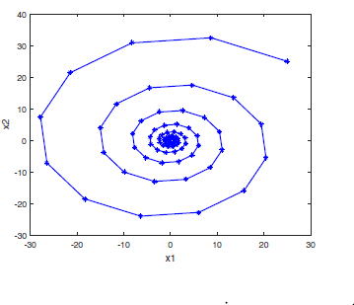

Figure 6: Two-dimensional spiral model

The search point movement is modeled using the n-dimensional spiral equation as Follows.

$x_{i}\left(k+1\right)=S_{n}\left(r,θ\right)x_{i}\left(k\right)-(S_{n}\left(r,θ\right)-I_{n})x^{*}$……………. (1)

$$S_{n}\left(r,θ\right)=rR^{\left(n\right)}(θ)$$

$R^{\left(n\right)}\left(θ\right)=\left[\begin{matrix}1 & 0 & 0 \\ \begin{matrix}0 \\ 0 \\ \begin{matrix}0 \\ ⋮ \\ 0\end{matrix}\end{matrix} & \begin{matrix}1 \\ 0 \\ \begin{matrix}0 \\ ⋮ \\ 0\end{matrix}\end{matrix} & \begin{matrix}0 \\ cos⁡(θ_{i,j}) \\ \begin{matrix}sin⁡(θ_{i,j}) \\ ⋮ \\ 0\end{matrix}\end{matrix}\end{matrix}\begin{matrix}⋯ & 0 & 0 \\ \begin{matrix}⋯ \\ ⋯ \\ \begin{matrix}⋯ \\ ⋱ \\ ⋯\end{matrix}\end{matrix} & \begin{matrix}0 \\ -sin⁡(θ_{i,j}) \\ \begin{matrix}cos(θ_{i,j}) \\ ⋮ \\ 0\end{matrix}\end{matrix} & \begin{matrix}0 \\ 0 \\ \begin{matrix}0 \\ ⋮ \\ 1\end{matrix}\end{matrix}\end{matrix}\right]$……………. (2)

Where $R^{n}(θ)$ is $n×n$ rotational matrix.

For example, for a two-dimensional problem, the $R^{\left(2\right)}(θ)$ is given as

$R^{\left(2\right)}\left(θ\right)=\left[\begin{matrix}cos⁡(θ) & -sin(θ) \\ sin(θ) & cos⁡(θ)\end{matrix}\right]$……………. (3)

The spiral model is shown in Fig 6 at $x_{0}=(25,25)$ is for two-dimensional problems with $r=0.95$ and $θ=π/6.$ Thus,

$$R^{\left(2\right)}(π/6)=\left[\begin{matrix}0.866 & -0.500 \\ 0.500 & 0.866\end{matrix}\right]$$

For a three-dimensional problem, one of the three possibilities is given as

$R^{\left(3\right)}\left(θ\right)=\left[\begin{matrix}cos⁡(θ_{1,2}) & -sin⁡(θ_{1,2}) & 0 \\ \begin{matrix}sin⁡(θ_{1,2}) \\ 0\end{matrix} & \begin{matrix}cos⁡(θ_{1,2}) \\ 0\end{matrix} & \begin{matrix}0 \\ 1\end{matrix}\end{matrix}\right]$…………………… (4)

The same value of $r$ and $θ$ as the two-dimensional, it is given as;

$$R^{\left(3\right)}(π/6)=\left[\begin{matrix}0.866 & -0.500 & 0 \\ \begin{matrix}0.500 \\ 0\end{matrix} & \begin{matrix}0.866 \\ 0\end{matrix} & \begin{matrix}0 \\ 1\end{matrix}\end{matrix}\right]$$

A three-dimensional spiral model is presented in Figure 7.

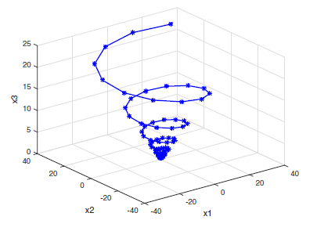

Figure 7: Three-dimensional spiral model

## 3.0 METHODOLOGY

The fundamental ideas and concepts of metaheuristic optimization issues serve as the foundation for this study. Power losses are the parameters that need to be minimized, and improving the bus voltage profile is also one of the goals. These are accomplished by using the spiral dynamic algorithm to locate and size UPFCs optimally. To integrate UPFC power injection mathematical modeling into the 54-bus Nigerian network.

## 3.1 Materials

The materials used for this research work, include software and hardware which are Personal computer (PC), MATLAB R2016a software, Standard IEEE 30-bus data, and Nigerian network 54-bus data

## 3.2 Method

## 3.2.1 Modelling of the network

Modeling of the network was carried out to develop the OPF of the two networks' case studies (i.e. the NPN and IEEE) with a special interest in UPFC devices and SDA. Figure 8 below is the mathematical model of UPFC.

Where, Vi = voltage at bus i; Vj = voltage at bus j, Ii = load current, Iij = current between bus i and j, Vse = series voltage, Vsh = shunt voltage, Xsh = shunt reactance, Xse = series reactance

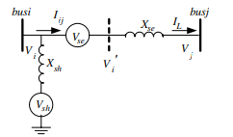

Fig 8: Two voltage source models of UPFC

## 3.2.2 Power Flow Analysis

Power flow analysis, well documented in several kinds of literature, is the method used to determine the steady-state operational state of an interconnected power system using some known variables on its buses. The main objective of PFA is to obtain the system bus voltages in both magnitude and phase angle. Figure 9 is an N bus power network for finding power flow parameters.

$I_{i}=\sum_{j=1}^{n}{Y_{ij}V_{j}}$…………(5)

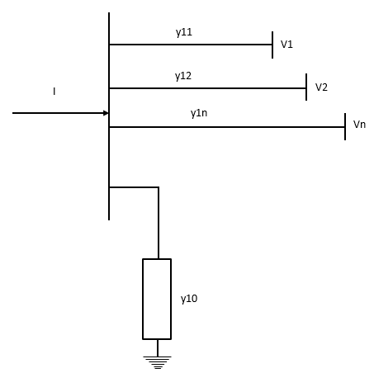

Figure 9: N-bus power network (Saadat, 1999)

The figure above is an N-bus network for finding bus voltages and power flow between two buses.

$I_{i}=\sum_{j=1}^{n}{\left|Y_{ij}\right|\left|V_{j}\right|\left|<θ_{ij}+δ_{j}\right.}$………(6)

$P_{i}-jQ_{i}=V_{i}^{*}I_{i}$………(7)

$P_{i}-jQ_{i}=\left|V_{i}\right|<-δ_{i}\sum_{j=1}^{n}{\left|Y_{ij}\right|\left|V_{j}\right|\left|<θ_{ij}+δ_{j}\right.}$………(8)

$P_{i}\sum_{j=1}^{n}{\left|V_{i}\right|\left|V_{j}\right|\left|Y_{ij}\right|cos⁡(θ_{ij}-δ_{j}+δ_{j})}$………(9)

$Q_{i}=-\sum_{j=1}^{n}{\left|V_{i}\right|\left|V_{j}\right|\left|Y_{ij}\right|sin⁡(θ_{ij}-δ_{j}+δ_{j})}$………(10)

Where, Ii = current at bus I, Pi= power at bus I, Qi = reactive power at I, Vj = voltage at bus j, Yij = y bus matrix, $δ_{j}θ_{ij}$ = phase angle,

## 3.2.3 Problem Formulation

Optimal sizing and coordination of UPFC devices are determined with the objective of minimizing power loss and voltage deviation

The objective function that needs to be minimized is as follows:

OF=min [ $P_{L}+V_{D}]$..………(11)

$P_{L}$ = Power loss

$V_{D}$ = Voltage deviation

The objective function is subject to the following Constraints

1. Bus voltages should be in their appropriate limits as

${ V}_{imin}≤V_{i}≤V_{imax}$..………(12)

2. Thermal limits of transmission lines

..............(13)

3. reactive power supply limits

${ Q}_{imin}≤Q_{i}≤Q_{imax}$……...…(14)

## 3.3 SDA for optimization of design parameters

The motion trajectory for the mentioned process is determined by two parameters called spiral angle and spiral radius. These two parameters are constant and the same for all search agents. The SDA relies on a spiral equation that generates a spiral form of the agent.

$x_{i}\left(k+1\right)=S_{n}\left(r,θ\right)x_{i}\left(k\right)-(S_{n}\left(r,θ\right)-I_{n})x^{*}$………………..(15)

Where, $\text{x*}$ = location of the Fittest Point in the population, $r$ = spiral radius, $θ$ = spiral angle, $S_{n}\left(r, θ\right)$ = n x n rotational matrix concerning spiral radius and angle.

The motivation for the SPO algorithm stemmed from the observation that the dynamics generating logarithmic spirals align with the effective metaheuristic strategy of diversification in the first half and intensification in the second half.

1. Diversification: Searching for better solutions by searching a wide region.
2. Intensification: Searching for better solutions by searching intensively around a good solution.

Consequently, the SPO algorithm is a direct multipoint search algorithm that utilizes multiple generalized spiral models and is described in the case of a problem to minimize an objective function

$f;R^{n}→R\left(n≥2\right)$……………(16)

Minimize f(x)

$xCR^{n}$……………(17)

Results obtained from the SDA implementation are presented through the following flow chart.

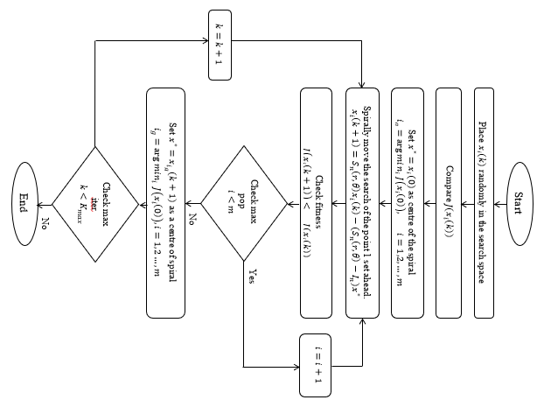

Fig 10: Flowchart for implementation of SDA (Sabo, 2020)

## 4.0 RESULTS AND DISCUSSION

Both the IEEE 30-bus standard system and the Nigerian 54-bus network were used to evaluate the results. The two possibilities included in the analysis were: As a baseline, Case I shows the findings obtained in the absence of UPFC (Unified Power Flow Controller) installations, and Case II shows the results obtained in the presence of UPFC(s) incorporated into the systems. Results are presented for the Nigerian network with 30 buses and 54 buses. Power flow analysis differences, improved voltage profiles with bar charts, and reduced power losses are all displayed.

## 4.2 Results

The results for the IEEE 30-Bus network and 54-Bus Nigerian network are presented below.

## 4.2.1 The standard IEEE 30-Bus radial system

Figure 11 is the single-line diagram representation of the IEEE 30-bus consisting of 6 generators and 41 branches.

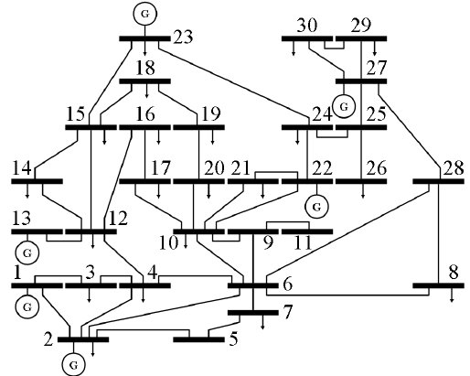

Figure 11: IEEE 30 Bus Network (Source: https:// www.wikipedia.net)

## 4.2.2 Case I: Base case

IEEE 30-Bus System Base Case Results for the system base case power flow analysis without UPFC location are presented in Figure 12. It can be seen from Figure 4 number of buses, which are bus 1, 11, 12, and 13 violated the constraint ±0.05 pu allowed voltage range, and the highest is 1.07 at bus 11.

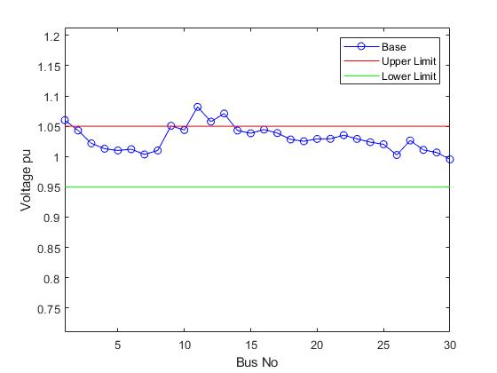

Figure 12: Voltage Profile for IEEE 30-bus Base Case

Figure 13 gives the combined real and reactive power losses at each of the branches. Buse-2 has the highest real power loss and bus-1 has the highest reactive power loss. After simulating the IEEE 30 Bus, the real and reactive losses obtained are 17.528MW and 68.888MVar respectively.

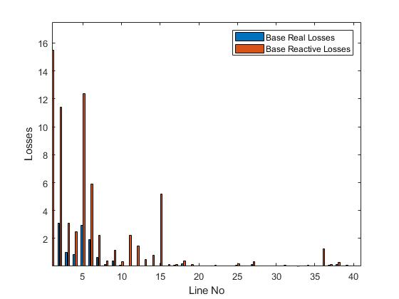

Figure 13: Real and Reactive Power Loss for IEEE 30-bus System

## 4.3 Case II: with UPFC

IEEE 30-Bus System with UPFC placement after simulating the optimal placement of UPFC.

## 4.3.1 Voltage Profile Improvement and Losses with UPFC

Figure 14 shows the voltage profile improvement obtained for IEEE 30-Bus with UPFC Installed. It can be seen from the figure the highest value of 1.07 pu was still maintained but with overall improvement of the voltage profile. It can be seen that only 2 buses violate the constraint at bus-1 and bus-11 respectively. The result of the voltage profile revealed a notable significant improvement after the installation of the UPFC.

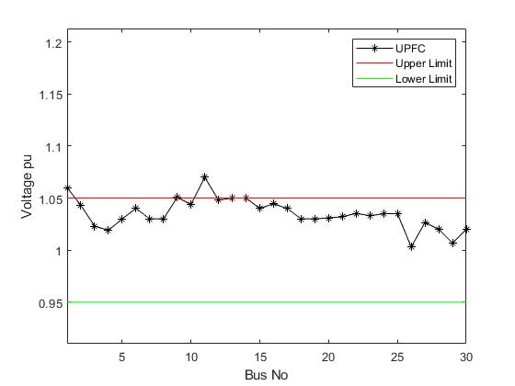

Figure 14: IEEE 30-bus voltage profile with UPFC

Figure 15 gives the combined real and reactive power losses at each of the branches. Buse-2 has the highest real and reactive power loss. An improvement was observed in the reduction of losses along the line, with the real losses measuring 7.461MW and the reactive losses amounting to 33.989 Mvar respectively.

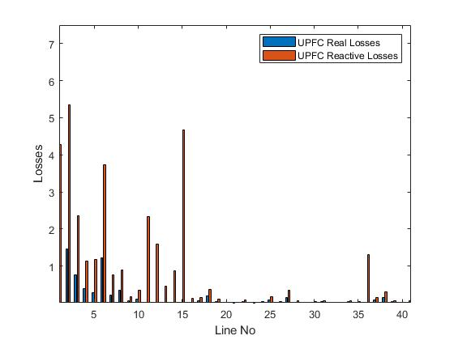

Figure 15: Real and Reactive losses with UPFC

## 4.3.2 Comparison of Voltage Profile with and Without UPFC

It can be seen in Figure 16 that comparing the two results for case 1 and case 11 there is a significant improvement in the enhancement of the voltage profile for the network as shown below.

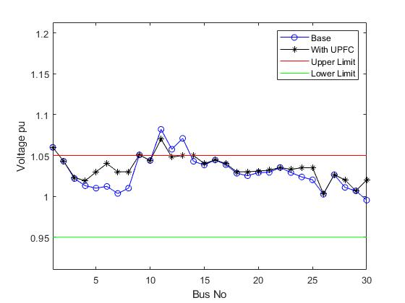

Figure 16: Voltage profile with/without UPFC

## 4.4 Power Loses Reduction with/without UPFC Installed

After running the load flow simulation for the IEEE bus-30 the real and reactive losses were reduced concurrently by 57.43% and 50.66% respectively.

|  |  |  |
| --- | --- | --- |
| Table 1: Summary of Results for the IEEE 30-bus for Case I and Case II | | |
| **Case study** | **Case I** | **Case II** |
| **Parameters** | **Without UPFC** | **With UPFC** |
| Total PLoss (MW) | 17.528 | 7.461 |
| PLoss Reduction (%) | Nil | 57.43 |
| Total QLoss (MVAr) | 68.888 | 33.989 |
| QLoss Reduction (%) | Nil | 50.66 |
| Vmax (p.u.) bus | 11 | 11 |
| Vmin (p.u.) | nil | nil |
| Number of Bus Violations | 4 | 2 |

## 4.5 The 54-Bus Nigerian Network

Figure 17 is the single-line diagram representation of a 54-bus network consisting of 12 generators, 12 transformer taps, 15 switchable reactors, and 36 transmission lines.

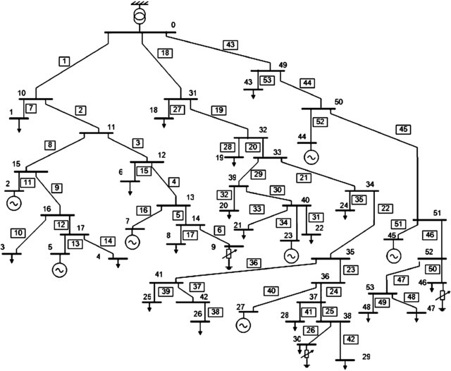

Figure 17:54 Bus Network (Source: https:// www.wikipedia.net)

## 4.6 Case I: Base Case

Figure 18 below shows results for the system base case without UPFC deployment. This was done to identify the voltage profile.It can be seen that 12 buses violate the constraint ±0.05 pu out of which 3 buses have the highest pu of 1.07 namely bus-1, bus-2.

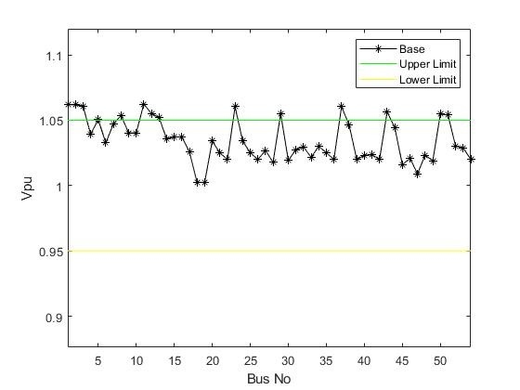

Figure 18: Voltage Profile for Nigerian Network Base Case

Figure 19 gives the combined real and reactive power losses at each of the 54 buses. Bus-28 and bus-29 have the highest real and reactive power. After running the load flow analysis, the real and reactive losses obtained are 28.427MW and 30.744Mvar respectively.

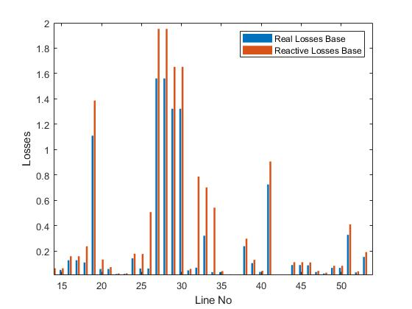

Figure 19: Real and Reactive Power Loss for the Nigerian system without UPFC

## 4.6.1 Case II: Nigerian system with UPFC deployment

Figure 20 shows the voltage profile improvement obtained from the Nigerian network bus with UPFC Installed. It can be seen from the figure that 3 buses violate the set point and the highest value of 1.07 pu was obtained at bus-1 bus-2. After simulating the optimal deployment of UPFC on a Nigerian Bus, the results obtained show that the optimal location of the UPFC is at bus 17 and the size is 45MVAr.

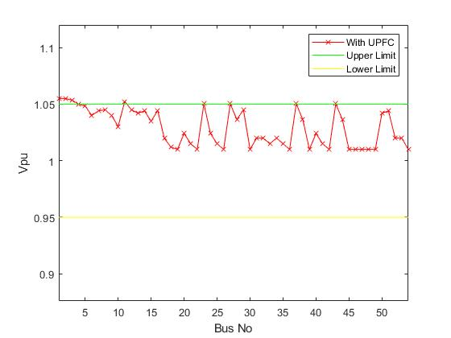

Figure 20: Nigerian case voltage improvement with UPFC

After running the load flow simulation for the Nigerian network with UPFC installed the real and reactive losses obtained are 14.962MW and 20.496MVAr respectively. Figure 21 shows the comparison of real and reactive power losses obtained at each bus with UPFC installed.

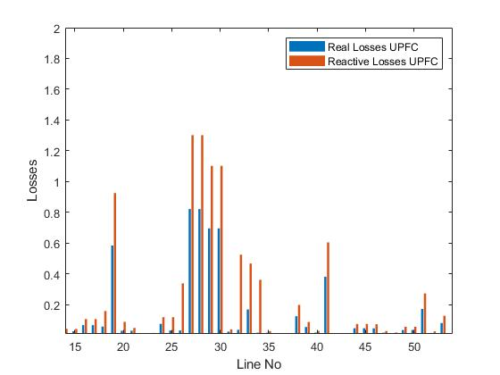

Figure 21: Real and reactive losses of the Nigerian network

**4.7 Nigerian/Base case comparison**

Comparing the cases has seen a tremendous improvement in the entire network parameters, voltage profile, and losses as shown in Figure 22.

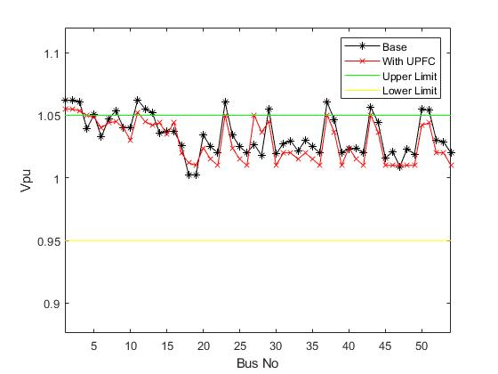

Figure 22: Comparison of Voltage Profile for Base case and Nigerian network

## 4.8 Power loss Minimization on the Standard 54-Bus network

Nigerian 54-Bus network simulation results comprising of the voltage profile, active and reactive power loss, UPFC locations and sizes, and computation time are summarized in Table 2 below. Power losses were being minimized at most points on the buses with UPFC placement. There is a reduction in power loss after placement of UPFC when compared to the base case real and reactive powers respectively. The losses are reduced by 47.37% and 33.33% for real and reactive powers respectively.

Table 2: Summary of Results for the 54-bus Nigerian network for Case I and Case II

|  |  |  |
| --- | --- | --- |
| **Case study** | **Case I** | **Case II** |
| **Parameters** | **Without UPFC** | **With UPFC** |
| Total PLoss (MW) | 28.427 | 14.962 |
| PLoss Reduction (%) | nil | 47.37 |
| Total QLoss (MVAr) | 30.744 | 20.496 |
| QLoss Reduction (%) | nil | 33.33 |
| Vmax (p.u.) at bus 11 | 1.0 (2) | 1.006 (11) |
| Vmin (p.u.) at bus 30 | 0.7945 (30) | 1.03 (30) |
| Number of Bus Violations | 6 | Nil |
| UPFC location | nil | Bus 17 |
| Total installed MVAr | nil | 47 |

## 5.0 CONCLUSION

The results demonstrated notable improvement in voltage profiles and reductions in both real and reactive power losses. Additionally, the computational efficiency of the algorithm was highlighted, showcasing its effectiveness in solving complex optimization problems in power system engineering.

Based on the research, three bus violations were recorded after UPFC placement. It is recommended that further investigation should be done on the adopted data, also the application of the spiral dynamic algorithm in other power system optimization problems can be considered. Additionally, future research could explore the integration of other FACTS devices and renewable energy sources into the optimization framework to enhance the performance of the power systems network. Finally, collaboration with industry partners could facilitate the implementation of these optimization techniques in real-world power systems to achieve practical benefits.

# 6.0 REFERENCE

Adebisi, O. I., Adejumobi, I. A., Ogunbowale, P. E., & Ade-ikuesan, O. O. (2018). Performance improvement of power system networks using flexible alternating current transmission systems devices: The Nigerian 330 kV electricity grid as a case study. Journal of Engineering and Technology, 12(2), 46-55.

Adepoju, G. A., Salimon, S. A., Aderinko, H. A., & Bisiriyu, A. O. (2019). Optimal placement and sizing of distributed generation in a Nigerian distribution network using a cuckoo search algorithm. Current Journal of Applied Science and Technology, 38(6), 1-12.

Ajenikoko, G. A., & O. A., O. (2019). Loss minimization and voltage profile improvement. World Journal of Engineering Research and Technology, 9(3), 387-405.

Aloh, J. M., Ogbuefi, U. C., Mbunwe, M. J., & Madueme, T. C. (2017). Evaluating the unified power flow controller (UPFC) performance on fault current limitation in the Nigerian 330 kV power system. IOSR Journal of Electrical and Electronics Engineering (IOSR-JEEE), 12(6), 61-70.

Amaize, P., Adoghe, A., Awosophe, C., & Airoboman, A. (2017). A view of the applications of FACTS devices on the Nigerian 330 kV transmission system. Journal of Engineering and Applied Science, 12(20), 5182-5185.

Anyaka, B. O., Manirakiza, J. F., Omeje, L. U., & Odo, M. C. (2020). Voltage profile improvement of a disturbed electric power system using UPFC compensation. International Journal of Recent Technology and Engineering (IJRTE), 8(5), 1888-1893.

Asar, S. A. (2021). Reliability enhancement of electric distribution network using optimal placement of distributed generation. Sustainability, 13, 11407.

Gana, M. A., Aliyu, U. O., & Bakare, G. A. (2019). Evaluation of the reliability of the distribution system with distributed generation using ETAP. ABUAD Journal of Engineering Research and Development (AJERD), 2(1), 103-110.

Haruna, J., Musa, S. Y., & John, Z. (2020). Application of unified power flow controller for enhancement of power security on Nigerian 330 kV network. International Research Journal of Engineering and Technology (IRJET), 7(5).

Haruna, Y. S., Bakare, G. A., Aliyu, U. O., & Yusuf, A. (2009). Optimal location of FACTS device in Nigerian power system network using particle swamp optimization. ATBU Journal of Technology and Education Research, 2(1), 75-85.

Hassan, S. M., Ibrahim, R., Saad, N., Asirvadam, V. S., & Bingi, K. (2017). Spiral dynamic algorithm-based optimal PPI controller for WirelessHART networked systems. In IEEE 3rd International Symposium on Robotics and Manufacturing Automation (ROMA) (pp. 978-1-5386-2539-2).

Hassana, S. M., Ibrahim, R., Saad, N., Asirvadam, V. S., & Bingi, K. (2019). Hybrid APSO–spiral dynamic algorithms with application to tuning of filtered PPI controller in a WirelessHART environment. Journal of Intelligent & Fuzzy Systems, 37, 597-610.

Hocine, S., & Djamel, L. (2019). Optimal number and location of UPFC devices to enhance voltage profile and minimize losses in electrical power systems. International Journal of Electrical and Computer Engineering (IJECE), 9(5), 3981-3992.

Isaac, A. S., James, K., O. A., C., & A. A., A. (2017). Prediction of voltage collapse in electrical power system networks using a new voltage stability index. International Journal of Applied Engineering Research, 12(2), 190-199.

Jabir, G., Bakare, G. A., & Shu'aibu, Y. H. (2023). Optimal Deployment of Unified Power Flow Controller on Nigerian 330 kV Grid Using Artificial Bee Colony. *International Journal of Research and Innovation in Applied Science, VIII*(VIII), 18-31. <https://doi.org/10.51584/IJRIAS.2023.8803>.

Madueme, T. C., & Onyegbadue, I. A. (2018). Application of UPFC for optimization of the Nigerian system. International Journal of Engineering and Emerging Scientific Discovery, 3(2), 82-94.

Masrom, M. F., Ghani, N. M. A., & Tokhi, M. O. (2019). Particle swarm optimization and spiral dynamic algorithm-based interval type-2 fuzzy logic control of triple-link inverted pendulum system: A comparative assessment. Journal of Low Frequency Noise, Vibration and Active Control, 40(1), 367–382.

Nadeem, M., Imran, K., Khattak, A., Ulasyar, A., Pal, A., Zeb, M. Z., Khan, A. N., & Phadhee, M. (2022). Optimal placement, sizing, and coordination of FACTS devices in transmission network using a whale optimization algorithm. Energies, 15(1), 24. https://doi.org/10.3390/en15010024

Nasir, A. N. K., Tokhi, M. O., Omar, M. E., & Ghani, N. M. A. (2014). An improved spiral dynamic algorithm and its application to fuzzy modeling of a twin rotor system. In Proceedings of the 2014 World Symposium on Computer Applications & Research (WSCAR) (pp. 1-6). IEEE.

Nwohu, M. N. (2010). Optimal location of unified power flow controller (UPFC) in Nigerian grid system. International Journal of Electrical and Power Engineering, 4(2), 147-153.

Ofoma, C. S., & Okonkwo, I. I. (2021). Line loss reduction in Nigeria 330 kV transmission line. IRE Journal, 4(9), ISSN: 2456-8880.

Okolo, C. C., Ezechukwu, O. A., Enemuo, F. O., & Anazia, A. E., & Onuegbu, J. O. (2020). Improving transient stability of the Nigerian 330 kV transmission system on the Ajaokuta - Benin transmission line with the help of artificial neural network (ANN) based VSC high voltage direct current method. International Journal of Advanced Engineering, Management and Science (IJAEMS), 6(2), 95-104.Top of Form

Oloulade, A., Moukengue, I. A., & Fifatin, F. -X. (2019, July). Optimal placement of a unified power flow controller in a transmission network by Unified Non-Dominated Sorting Genetic Algorithm-III and Differential Evolution Algorithm. International Journal of Electrical Components and Energy Conversion, 5, 10-19.

Oluseyi, P. O., Adelaja, T. S., & Akinbulire, T. O. (2017). Analysis of the transient stability limit of Nigeria’s 330 kV transmission sub-network. Nigerian Journal of Technology (NIJOTECH), 36(1), 213-226.

Onanena, R., Tchuidjan, R., Motto, F. B., & Gatchessi, M. M. (2021). Improvement of the voltage quality in an electrical network via the loopback: Case of the Southern Interconnected Grid (SIG) of Cameroon. Journal of Power and Energy Engineering, 9, 25-41.

Ramasubramanian, P., Prasana, G. U., & Sumathi, K. (2012). Optimal location of FACTS devices by evolutionary programming-based OPF in deregulated power systems. British Journal of Mathematics & Computer Science, 2(1), 21-30.

Saadat, H. (1999). Power system analysis. New York: McGraw-Hill Series in Electrical and Computer Engineering.

Shahrazad, M. (2015). Optimal allocation of FACTS devices in power networks using imperialist competitive algorithm (ICA) (Doctoral dissertation, Brunel University London).

Sunday, Y. S., Ubeh, O. P., Saidu, A. A., & Fahad, A. (2021). Grey wolf optimizer-based optimal placement of multiple FACTS devices in the transmission system under a dynamic loading system. Journal of Engineering Studies and Research, 27(1), 132-142.

Thuzar, M. M. O., & Myint. (2021). Transmission capacity improvement using a unified power flow controller with a new control strategy. International Journal of Electrical and Electronic Engineering & Telecommunications, 10(3), 225-232.

Yasin, N. M., & Talib, H. A. (2018). Genetic-based optimal location of STATCOM compensator. International Journal of Applied Engineering Research, 13(10), 7516-7521.

Yasuda, K. T. (2016). Spiral optimization algorithm using periodic descent directions. SICE Journal of Control, Measurement, and System Integration, 9(3), 134–143.

Yidobi, J. C., & Eneh, I. I. (2018). Enhancing the voltage stability of the Nigerian 330kV 28 bus power network using unified power flow controller (UPFC) and high voltage direct current (HVDC) during contingency of three phases fault. International Journal of Engineering & Scientific Research, 6(8), 86-96.