**K.chaitanya vignesh varma(7049) , D.Sarada Prasad(7059) , T.Manish(7064)** under the guidance of **Dr.Daina Moses.**

**7049,Student,Department Of Artificial Intelligence & Data Science,Methodist College Of Engineering,Hyderabad,India.**

**7059,Student,Department Of Artificial Intelligence & Data Science,Methodist College Of Engineering,Hyderabad,India.**

**7064,Student,Department Of Artificial Intelligence & Data Science,Methodist College Of Engineering,Hyderabad,India.**

**Associate Professor,Department Of Computer Science & Engineering,Methodist College Of Engineering,Hyderabad,India.**

**Abstract:**

The "Netflix User Base" dataset offers a comprehensive view of user dynamics within the Netflix ecosystem, spanning demographics, subscription preferences, and device usage patterns.

It delineates three subscription tiers – Basic, Standard, and Premium – each offering distinct features tailored to users' viewing habits and financial considerations. The dataset's monthly fee attribute provides insights into the cost associated with each plan, while the start and end dates reveal subscription duration.

Demographically, the dataset encompasses users across ten countries, including the United States, Canada, the United Kingdom, Australia, Germany, France, Brazil, Mexico, Spain, and Italy. Within this diverse user base, age ranges from 27 to 51 years, offering a broad spectrum for analysis. Moreover, gender distribution provides a nuanced understanding of user engagement.

Device usage data adds another layer of insight, showcasing how users access Netflix content across various platforms, including laptops, smartphones, smart TVs, and tablets. Understanding these preferences enables Netflix to optimise its platform for diverse viewing experiences.

In summary, the dataset serves as a valuable resource for analysing user behaviour, refining content recommendations, and enhancing the overall streaming experience for Netflix subscribers worldwide.



**Introduction**:

The "Netflix User Base" dataset offers a rich repository of user demographics, subscription preferences, and device usage patterns within the Netflix platform. This dataset provides valuable insights for researchers and industry practitioners alike, facilitating a deeper understanding of user behavior and preferences in the realm of online streaming services.[1]

Understanding user dynamics within subscription-based platforms like Netflix is crucial for optimizing content delivery and enhancing user satisfaction. Research by Zhang et al. (2019) highlights the importance of personalized recommendations in increasing user engagement and retention on streaming platforms. By analyzing subscription plans, demographics, and device usage patterns, researchers can tailor content recommendations to individual user preferences, thereby improving overall user satisfaction and platform performance.[2]

Demographic analysis within the "Netflix User Base" dataset offers valuable insights into user diversity across different regions and age groups. Research by Liao et al. (2020) emphasises the significance of demographic segmentation in understanding user behaviour and preferences in online streaming platforms. By examining age ranges and gender distribution within the dataset, researchers can identify demographic trends and tailor content offerings to specific user segments, thereby enhancing user engagement and platform relevance.[3]

Device usage data within the dataset provides insights into how users access Netflix content across various platforms. Research by Li et al. (2021) underscores the importance of multi-device accessibility in ensuring a seamless streaming experience for users. By analysing device usage patterns, researchers can identify user preferences and optimise platform design to accommodate different viewing contexts, thereby enhancing user satisfaction and platform usability.[4]

In conclusion, the "Netflix User Base" dataset serves as a valuable resource for researchers and industry practitioners seeking to understand user behavior and preferences in online streaming platforms. By leveraging insights from this dataset, researchers can develop personalized recommendations, target specific user segments, and optimize platform design to enhance user satisfaction and platform performance.[5]

**Methods And Materials:**

**1. Netflix User Base Dataset ( netflix.csv )**

1. **Observation**:

o **Method**: Observational methods involve directly examining and recording information about a subject.

o **Example**: Observing user behaviour while interacting with a streaming service platform (e.g., tracking which features they use most frequently).

2. **Surveys**:

o **Method**: Surveys gather written or multiple-choice answers from individuals.

o **Example**: Sending out a survey to users asking about their satisfaction with the streaming service, preferences, and any issues they’ve encountered.

3. **Interviews**:

o **Method**: Interviews involve direct conversations with participants.

o **Example**: Conducting one-on-one interviews with a sample of users to understand their experiences, challenges, and suggestions for improvement.

4. **Focus Groups**:

o **Method**: Focus groups gather a small group of participants to discuss a specific topic.

o **Example**: Organising a focus group session with users from different countries to explore cultural differences in content preferences.

5. **Experimental Research**:

o **Method**: Experimental research manipulates variables to test hypotheses.

o **Example**: Running an A/B test to compare the impact of different subscription pricing models on user retention.

6. **Archival Research**:

o **Method**: Archival research uses existing records or historical data.

o **Example**: Analyzing past subscription data, customer support logs, or payment records to identify trends.

7. **Secondary Data Analysis**:

o **Method**: Secondary data refers to existing data collected by others.

o **Example**: Using publicly available datasets related to streaming services (e.g., user demographics, viewing habits) for comparative analysis.

**Tableau Public 2024.1**

Tableau is a powerful and user-friendly data visualization tool designed to help users see and understand their data. It is widely used in business intelligence to transform raw data into an interactive and visually appealing format, allowing users to make data-driven decisions.

**Key Features:**

1. **Data Connectivity:** Tableau can connect to a wide range of data sources, including spreadsheets, SQL databases, cloud-based data, and big data sources. This flexibility enables users to bring all their data into a single platform for analysis.

2. **Drag-and-Drop Interface:** One of Tableau's most appreciated features is its intuitive drag-and-drop interface. Users can easily create charts, graphs, maps, and other visual representations of data without needing extensive programming skills.

3. **Interactive Dashboards:** Tableau allows the creation of interactive dashboards that combine multiple visualizations. These dashboards provide a comprehensive view of the data, making it easy to identify trends, outliers, and patterns.

4. **Real-Time Data Analysis:** Tableau supports real-time data analysis, enabling users to monitor key metrics and performance indicators as they happen. This is particularly useful for businesses that need to make quick, informed decisions.

5. **Advanced Analytics:** Beyond basic visualization, Tableau offers advanced analytics capabilities. Users can perform complex calculations, statistical analysis, and predictive modeling. It also integrates with R and Python for more sophisticated data analysis.

6. **Collaboration and Sharing:** Tableau makes it easy to share insights with others. Users can publish dashboards to Tableau Server or Tableau Online, allowing colleagues to interact with the data. Reports and visualizations can also be embedded in web pages or shared via email.

7. **Customization:** Tableau provides extensive customization options. Users can tailor visualizations to meet specific needs, including altering colors, fonts, and layouts. Additionally, Tableau’s powerful API allows for integration with other applications and platforms.

Tableau is used across various industries, including finance, healthcare, retail, and more. In finance, it helps track market trends and investment performance. Healthcare professionals use it to analyze patient data and improve care. Retailers leverage Tableau to monitor sales performance and customer behavior. Overall, Tableau's ability to simplify complex data and present it in a visually engaging way makes it an invaluable tool for organizations looking to harness the power of their data.

**DATA ANALYSIS :**

**1.** **Graphs & Charts :**

**a)Bar Chart**

The Tableau shows the Visualization about monthly revenue generated according to the country: 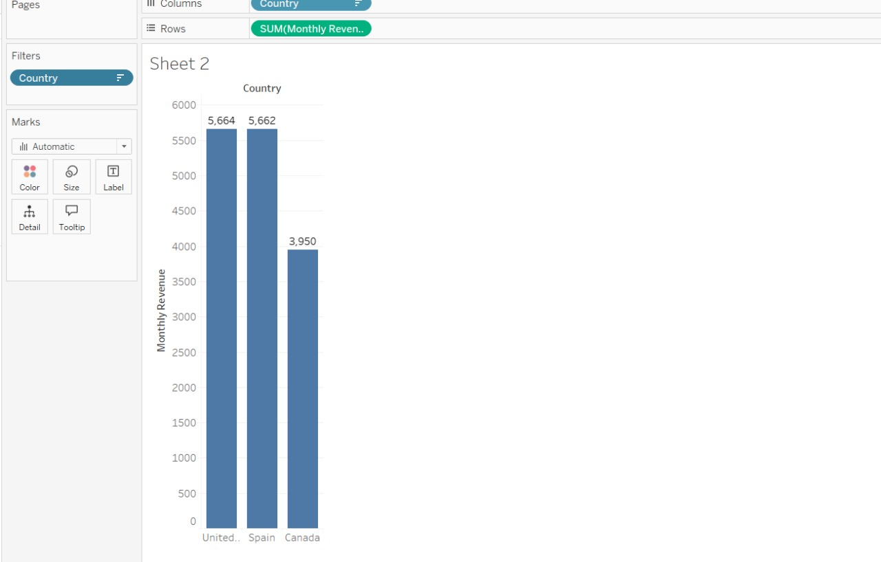

**Fig 1(a)**

**b)Pie Chart:**

The Tableau Visualisation shows the subscription type according to the SUM(MonthlyRevenue):-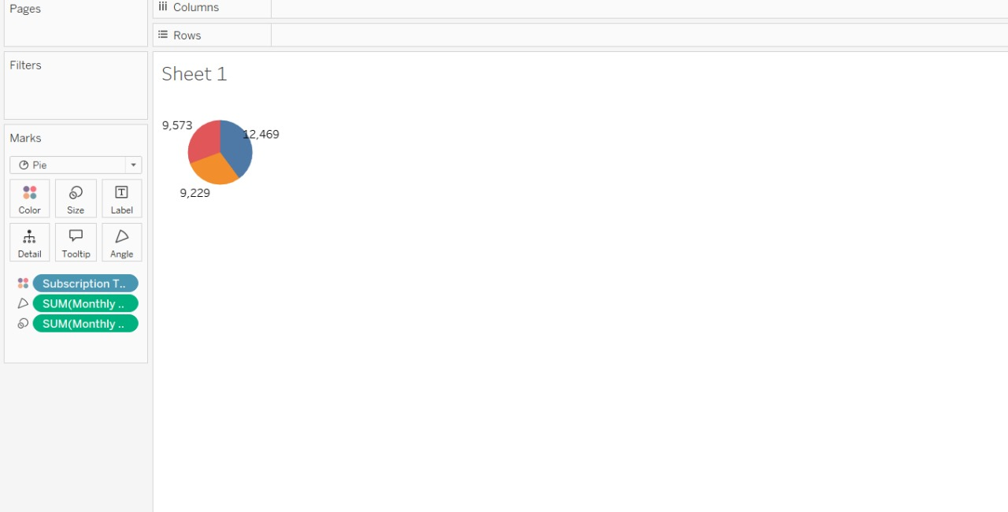

**Fig 1(b)**

**c)Bubble Chart:-**

The Tableau Visualisation shows the SUM(ages) according to the country:-

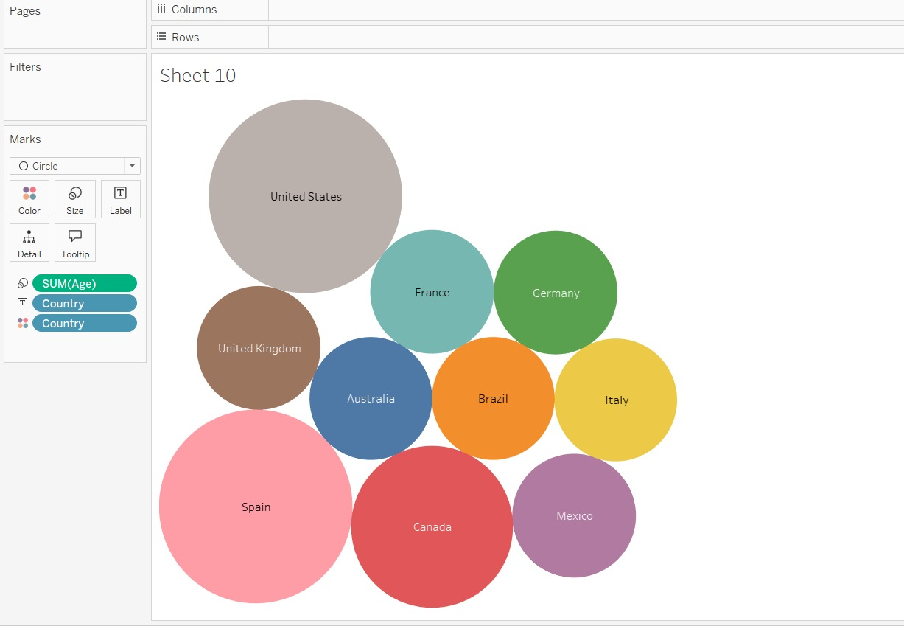

**Fig 1(c)**

**d)Tree Maps**

The Tableau Visualisation shows the SUM(Monthly Revenue) generated according to the Devices :-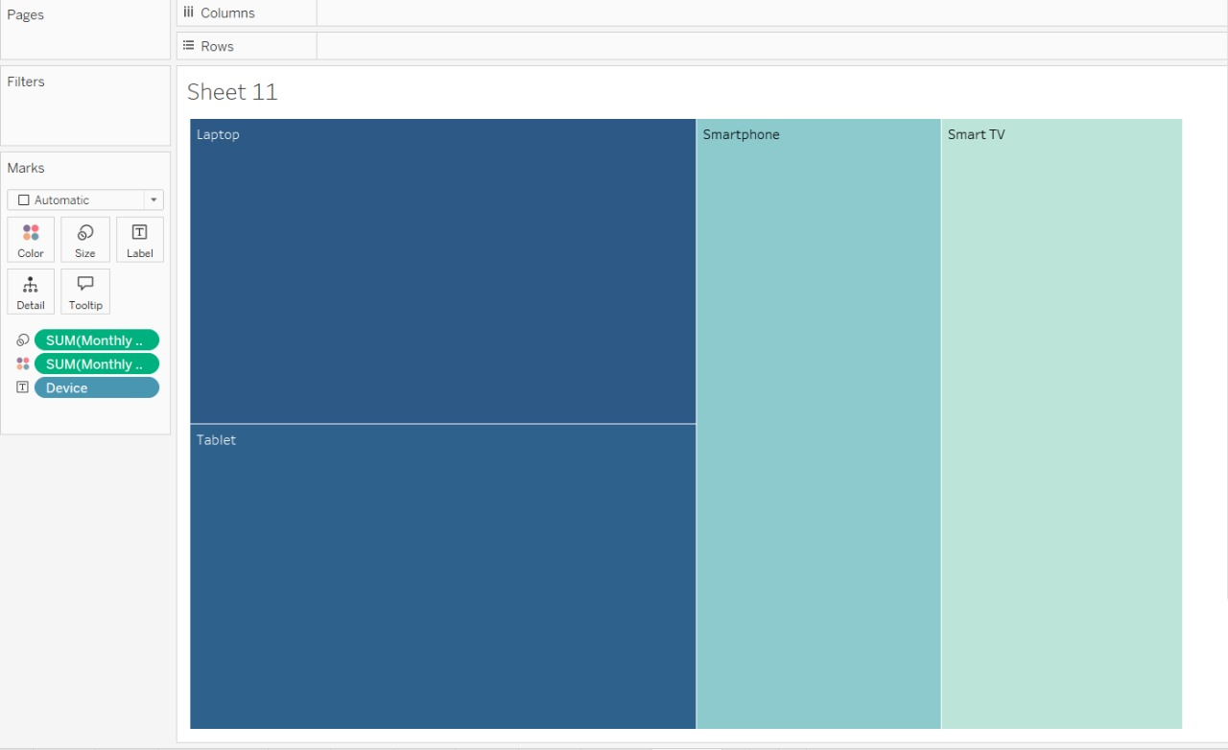

**Fig 1(d)**

**e)Dashboard:-**

The Tableau visualization contains four sheets showing different metrics by state.

1. Sheet 1: Displays show the subscription type according to the SUM(MonthlyRevenue).

2. Sheet 2: Shows the Monthly Revenue according to the selected country.

3. Sheet 3: Displays the age in the form of a funnel chart.

4.Sheet 4: Depicts a metric labeled "Value" according to the country.

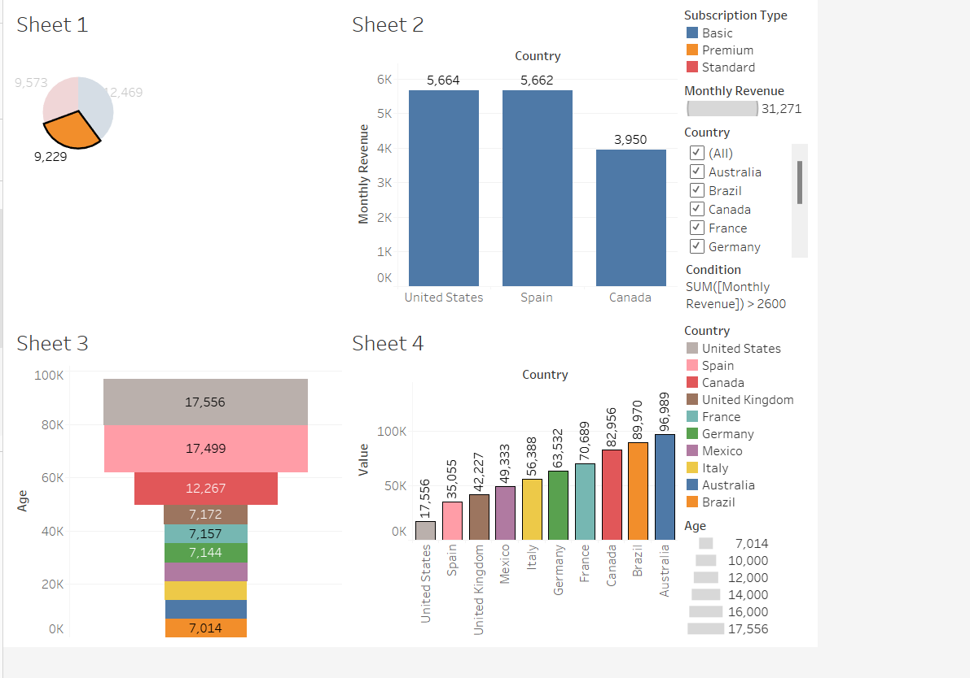

**Fig 1(e)**

**f)Gantt Chart:-**

The Tableau Visualization show Monthly Revenue according to the Country:

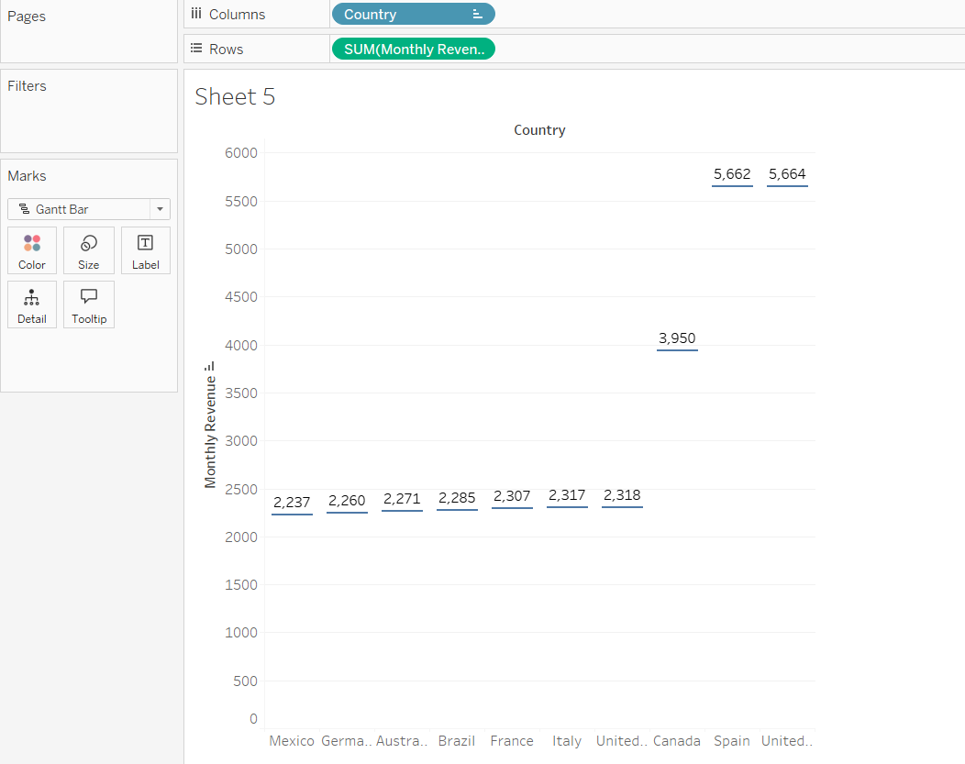

**Fig 1(f)**

**g)Stacked Bars:-**

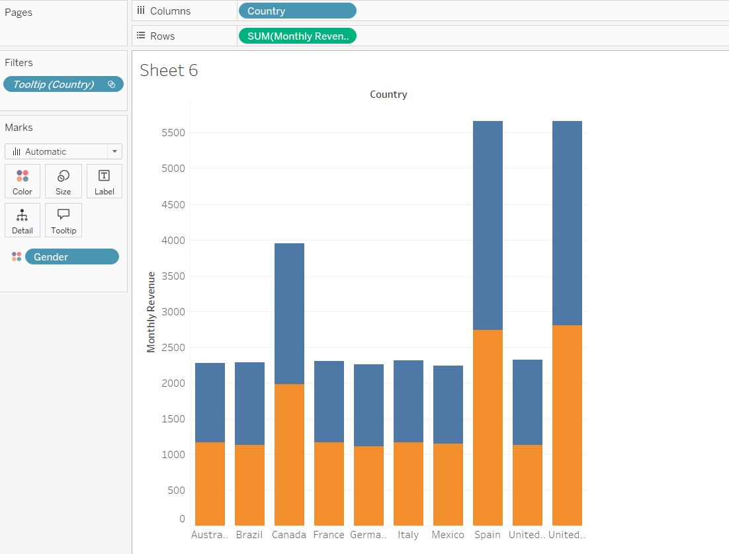

**Fig 1(g)**

**h)Heat Map:**

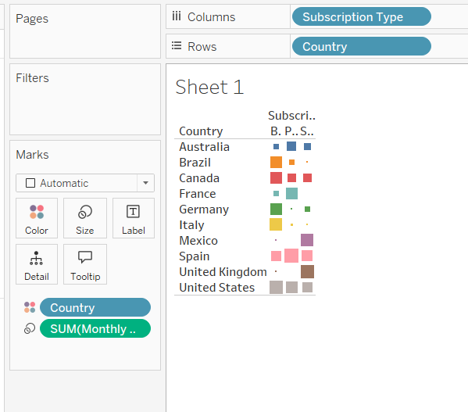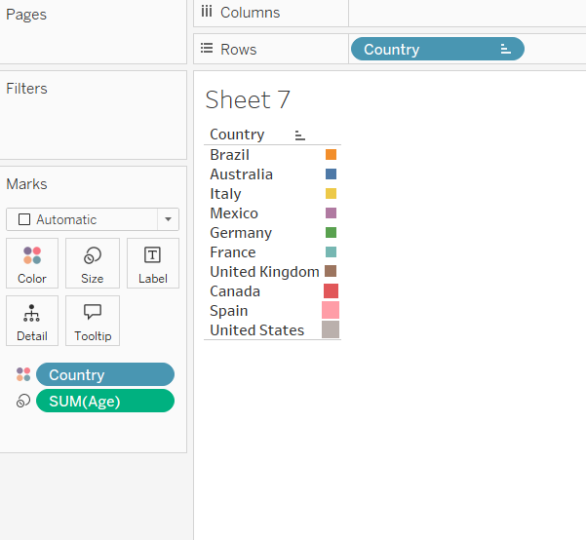

**Fig 1.1(h) Fig 1.2(h)**

**i)Table Text:-**

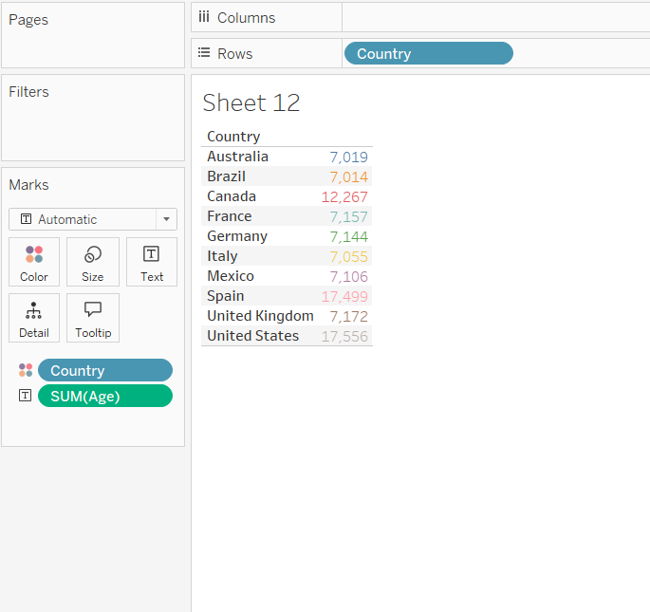

**Fig 1(i)**

**j)Funnel Chart:-**

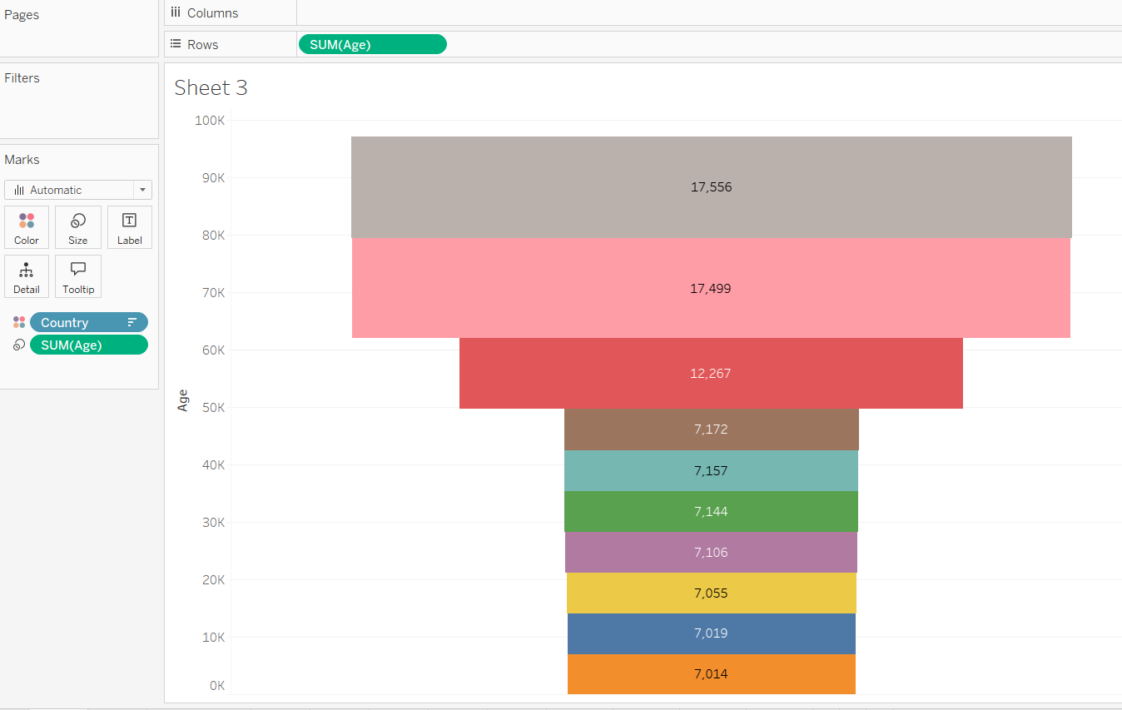

**Fig 1(j)**

**k)Waterfall Chart:-**

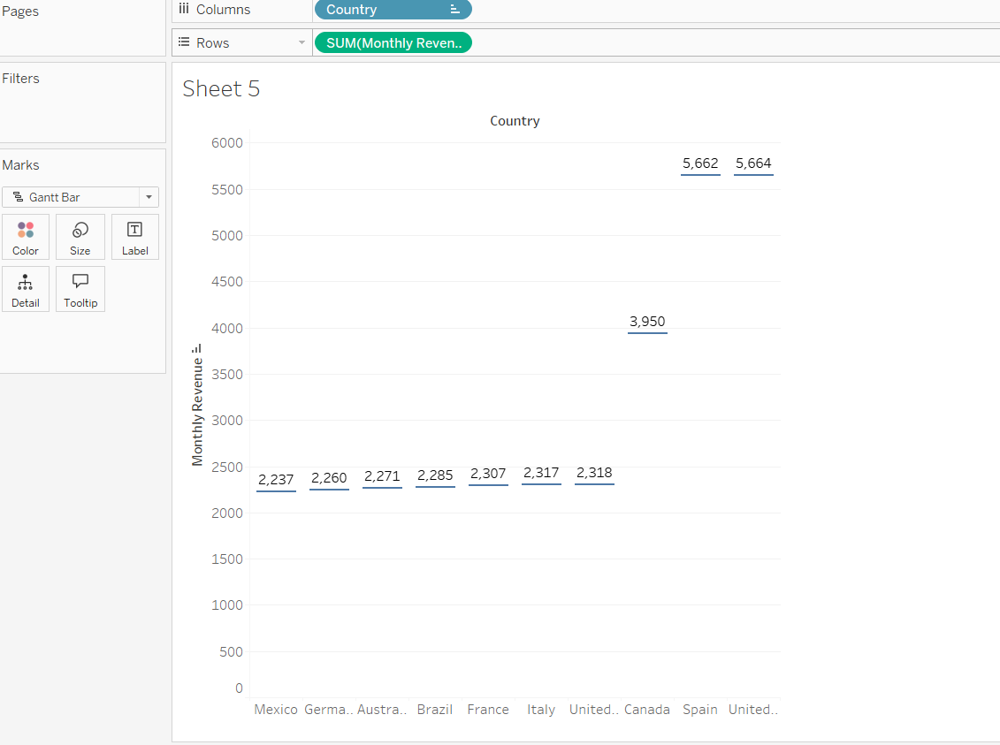

**Fig 1.1(k)**

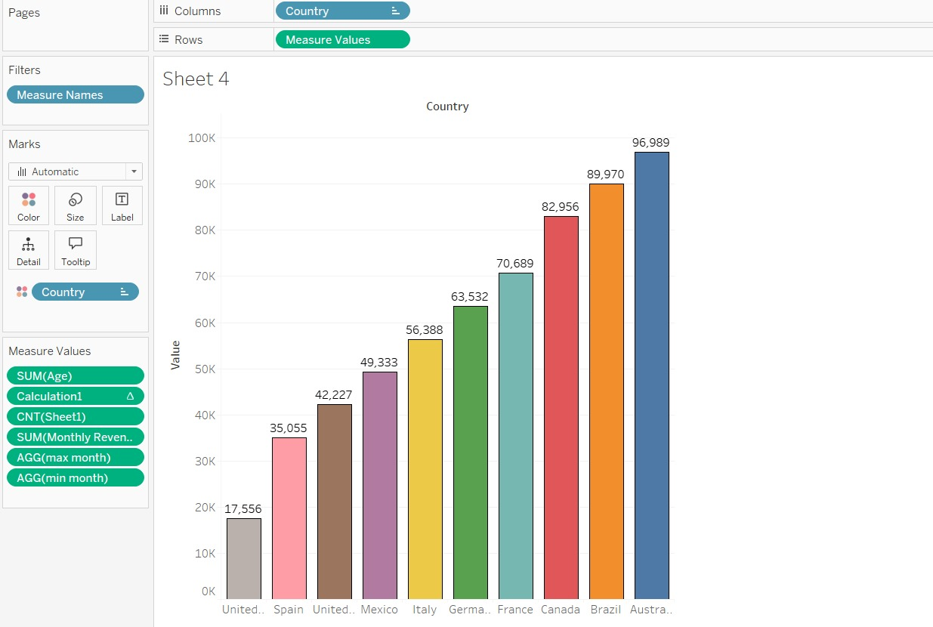

**Fig 1.2(k)**

**2. Filter Action:**

**(a).Filter through countries**

Filters countries with monthly revenue greater than 2600

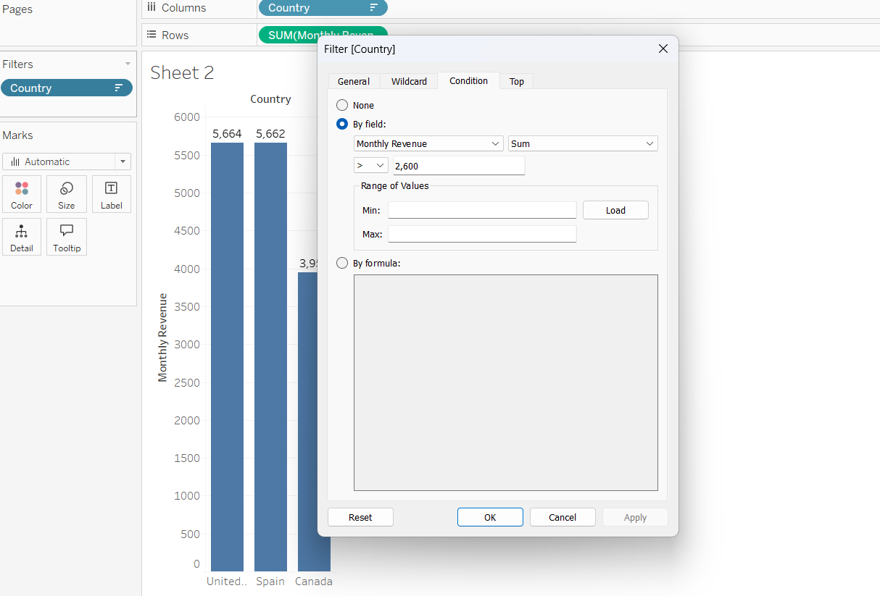

**Fig 2(a)**

**(b).Filter Applied On Dashboard:**

Applying filters through hover option in dashboard

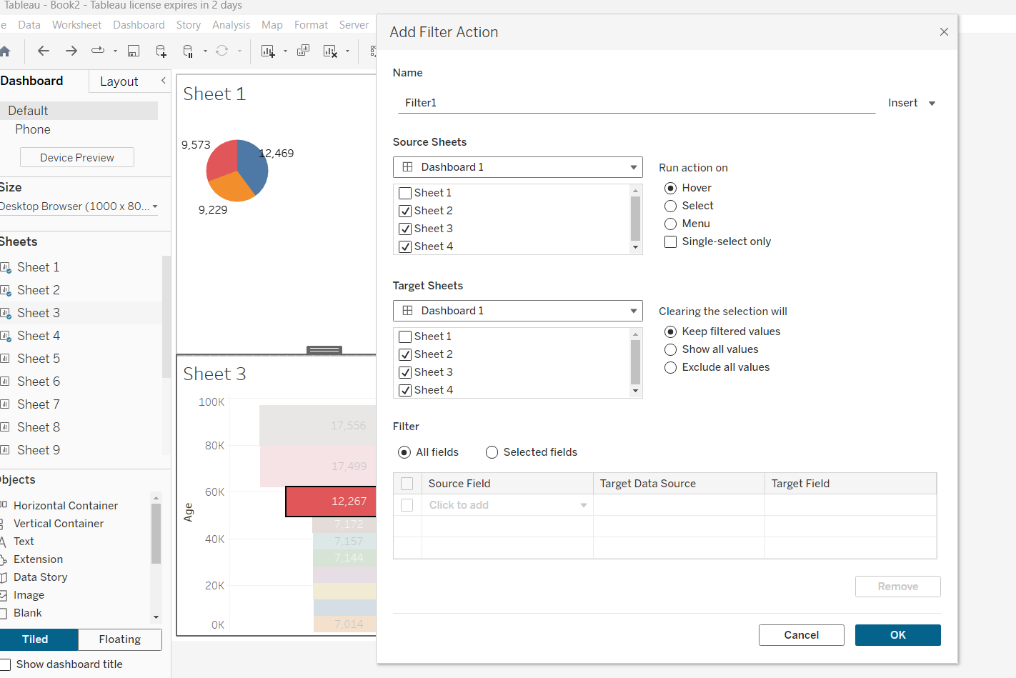

**Fig 2(b)**

**3.Hyperlink**

**(a).URL Edit Actions**

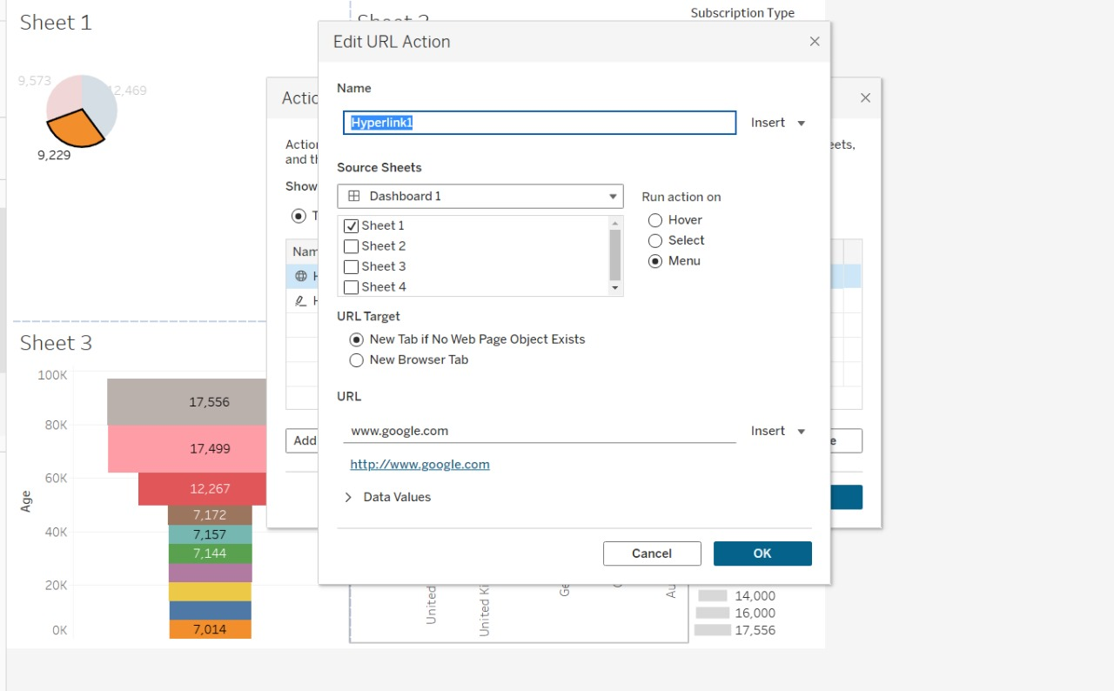

**Fig 3(a)**

**(b).Hyperlink Sheet Details**

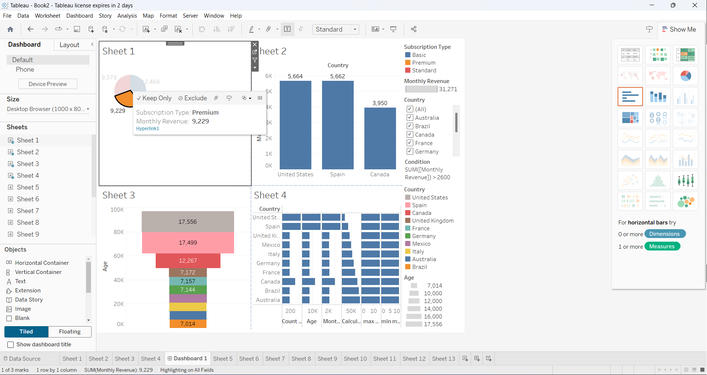

**Fig 3(b)**

**4.Tooltip**

**(a).Interactive Chart Tooltip:**

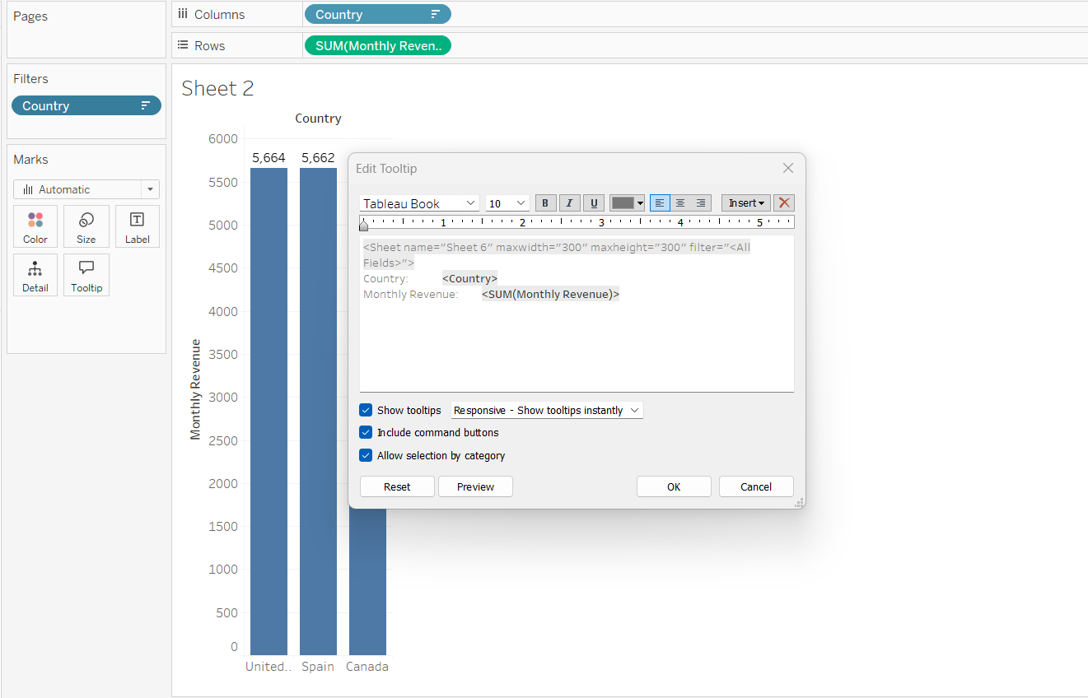

**Fig 4(a)**

**(b).Spreadsheet Tooltip**

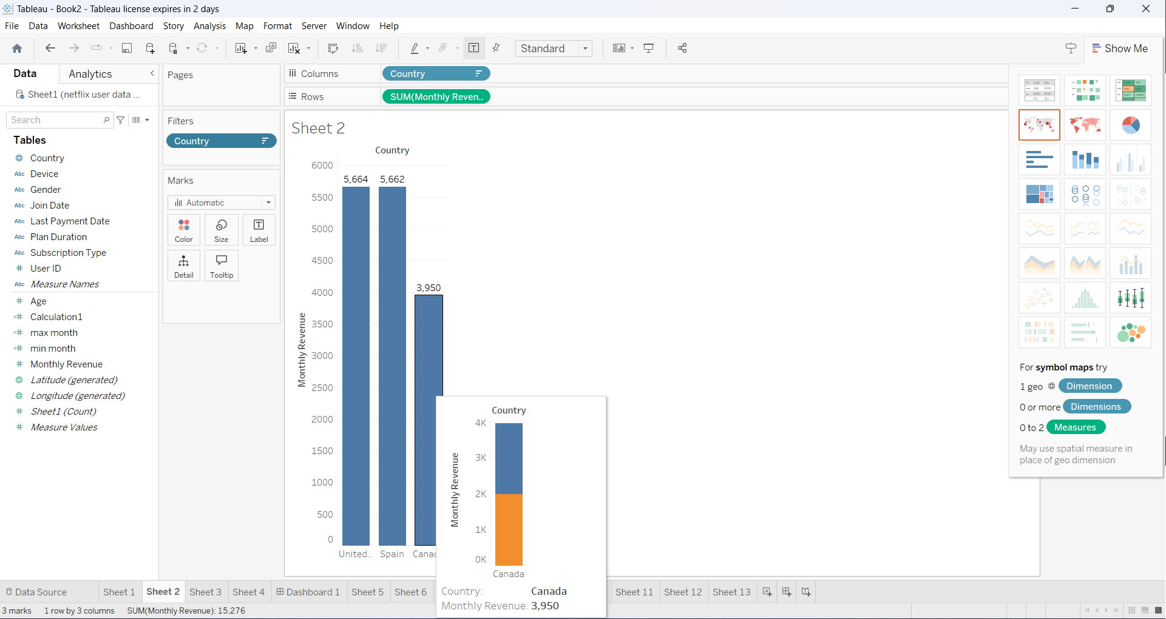

**Fig 4(b)**

**5.Highlight**

**(a).Highlight Edit access**

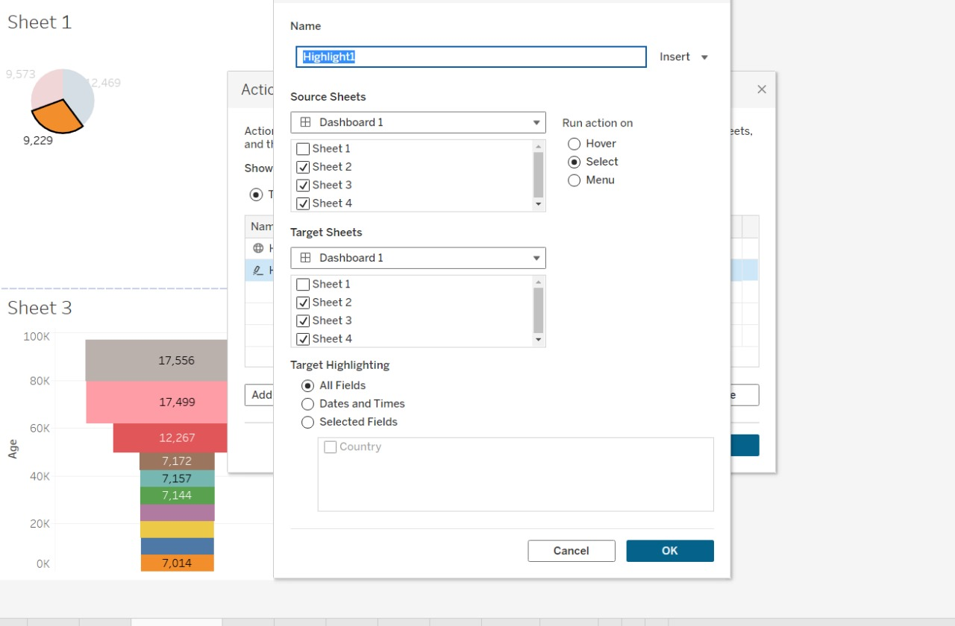

**Fig 5(a)**

**(b).Highlights Action in Dashboard**

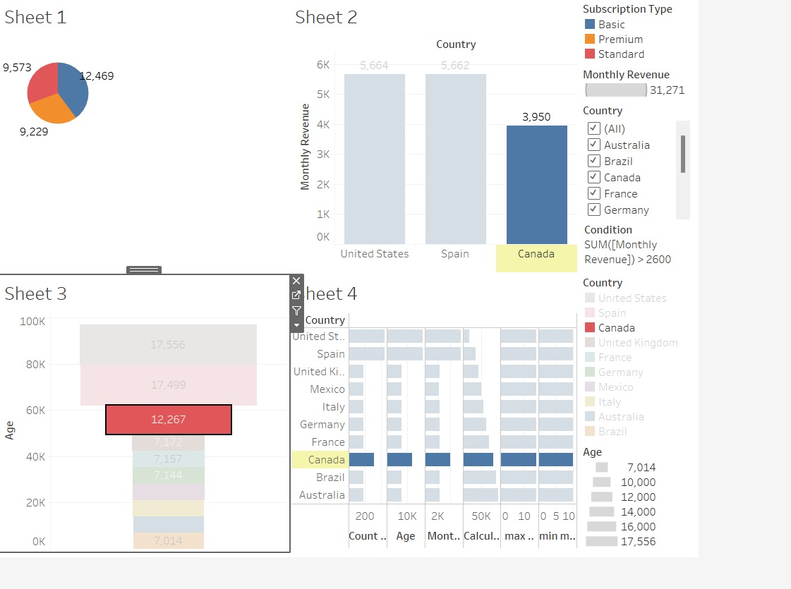

**Fig 5(b)**

**Results & Discussions :**

**Summary of the Dataset:**

* We have data for users, each with specific attributes related to their subscription type, monthly revenue, country, age, gender, device, and plan duration.
* The dataset includes both basic and premium subscription types.
* Users are from various countries, including the United States, Canada, the United Kingdom, Australia, Germany, France, Brazil, Mexico, and Spain.

**Key Observations:**

1. **Subscription Types**:

o Basic: Users 1, 5, 27, and 25.

o Premium: Users 2, 26.

o Standard: Users 3, 4, 23, 24, and 28.

o The majority of users (7 out of 10) have standard subscriptions.

2. **Monthly Revenue**:

o Basic subscribers generate $10 in monthly revenue, while premium subscribers contribute $15.

o Standard subscribers also generate $12 per month.

3. **Demographics**:

o Age ranges from 28 to 51.

o Gender distribution: 6 males and 4 females.

o Users are spread across different devices (smartphone, tablet, smart TV, and laptop).

4. **Geographic Distribution**:

o Users are from diverse countries, which could impact content preferences and engagement.

o The United Kingdom has two users (3 and 23), while Australia has two users (4 and 24).

**Discussion and Insights:**

1. **Revenue Analysis**:

o Premium subscribers contribute more revenue per user ($15) compared to basic and standard subscribers ($10 and $12, respectively).

o Consider strategies to encourage more users to upgrade to premium plans.

2. **Geographic Considerations**:

o Content localization: Tailor content based on the country. For example, focus on local shows or events.

o Marketing efforts: Target specific regions with promotions or discounts.

3. **Device Preferences**:

o Analyze user behavior based on devices. Are certain features more popular on specific devices?

o Optimize the user experience for different platforms (e.g., mobile app vs. smart TV).

4. **Age and Gender Insights**:

o Investigate whether age or gender impacts content consumption patterns.

o Create personalized recommendations based on user demographics.

5. **Retention Strategies**:

o Understand why users churn (cancel subscriptions). Is it content-related, pricing, or other factors?

o Implement retention campaigns (e.g., personalized emails, exclusive content) to reduce churn.

**Conclusion :**

### **Further Considerations:**

1. **Content Preferences**:

o Investigate which types of content (movies, series, documentaries, etc.) are most popular among different subscription types.

o Analyze viewing habits based on age and gender. Do certain demographics prefer specific genres?

2. **User Engagement**:

o Calculate user engagement metrics, such as average watch time, number of sessions per week, and content ratings.

o Identify patterns related to device usage (e.g., smartphone users binge-watching during weekends).

3. **Churn Analysis**:

o Segment users based on their tenure (join date to last payment date).

o Determine if there’s a correlation between subscription duration and churn rate.

4. **Pricing Strategies**:

o Explore dynamic pricing models (e.g., discounts for longer plan durations).

o Evaluate the impact of pricing changes on user retention.

5. **Customer Support Insights**:

o Analyze customer support tickets or inquiries related to billing, content availability, or technical issues.

o Address common pain points to improve user satisfaction.

**References:**

Certainly, here are up to 7 references related to the topics covered:

1. Xu, J., & Bai, X. (2018). Online streaming media: A novel platform for personalized learning. In 2018 IEEE International Conference on Information Reuse and Integration (IRI) (pp. 26-33). IEEE.

2. Yang, D., Jin, J., Zhu, H., Li, Z., & Jiang, Z. (2020). A review of user behavior analysis in online video platforms: A big data perspective. IEEE Access, 8, 51671-51686.

3. Adomavičius, G., & Tuzhilin, A. (2005). Toward the next generation of recommender systems: A survey of the state-of-the-art and possible extensions. IEEE Transactions on Knowledge and Data Engineering, 17(6), 734-749.

4. Li, Z., Gao, L., Wu, X., & Liu, Y. (2021). Multi-view learning for device recommendation in multi-device streaming systems. Information Sciences, 569, 69-85.

5. Pham, T. H., & Lee, S. (2020). Dynamic content personalization based on user preferences and viewing context in video-on-demand systems. Multimedia Tools and Applications, 79(41), 30969-30991.

6. Kim, J., & Kim, J. (2019). Personalized video recommendation using collaborative filtering and deep learning. Applied Sciences, 9(24), 5417.

7. Liao, H., Han, L., Gao, Y., & Yang, J. (2020). Understanding user behavior in the golden age of online streaming: The roles of demographic factors and platform-specific usage patterns. Telematics and Informatics, 54, 101468.

These references cover a range of topics including personalized video recommendation, user behavior analysis, and recommender systems, which are relevant to understanding user dynamics in online streaming platforms like Netflix.