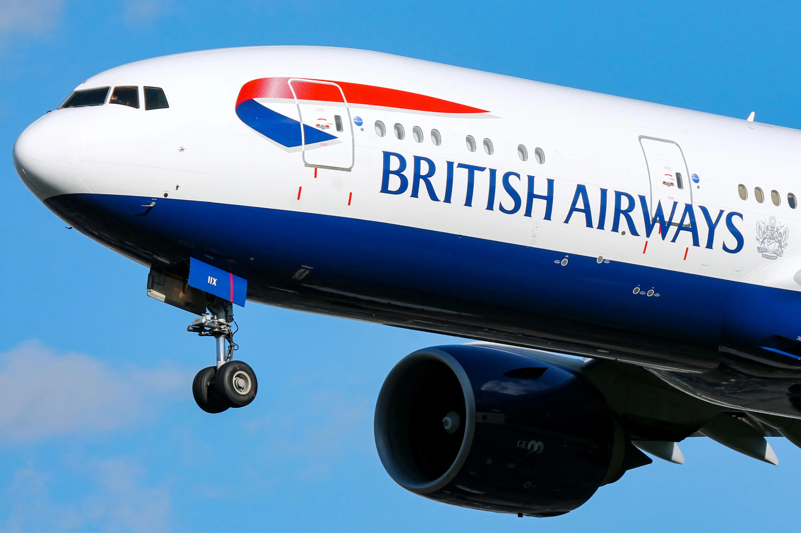

**BRITISH AIRWAYS REVIEWS**

**ANALYSIS**

***D. Shrestha1, Sreenidhi Katkuri2 , Unnati Goel3 , Dr P Lavanya 4***

*1. Department of Artificial Intelligence and Data Science, Methodist College of Engineering and Technology, India*

*2. Department of Artificial Intelligence and Data Science, Methodist College of Engineering and Technology, India*

*3. Department of Artificial Intelligence and Data Science, Methodist College of Engineering and Technology, India*

*4. Professor and Head, Department of Computer Science and Engineering*

*Methodist College of Engineering and Technology, India*

**Publication Date:** 14th July 2024

## ABSTRACT

This document provides a comprehensive analysis of customer reviews for [5]British Airways (BA)[5], utilizing Tableau software to visualize and interpret the data. The dataset includes various parameters such as reviewer details, travel specifics, and ratings for multiple service aspects. Key elements analyzed include aircraft type, traveler type, seat type, route, and performance indicators like seat comfort, cabin staff service, food and beverages, ground service, value for money, and in-flight entertainment.

The reviews present a wide range of passenger experiences with BA, highlighting both positive and negative aspects. [1]The airline industry is a highly competitive market where customer satisfaction is a key factor for success.[1] Positive feedback often notes the efficiency of short-haul services and the attentiveness of the staff. However, many reviews express dissatisfaction with long-haul flights, citing issues such as uncomfortable seats, faulty in-flight entertainment, poor meal quality, and average service. Recurring themes also include frequent delays, lack of information from staff, and a perceived decline in service standards over time. This analysis, facilitated by Tableau, aims to provide visual insights into customer satisfaction trends and identify areas needing improvement. The goal is to help British Airways enhance its service quality and better meet passenger expectations.

**Keywords**: British Airways, Customer reviews, Tableau Software, Data visualisation, Passenger experience, Service quality A Comprehensive Study of Customer Sentiment and Insights

## INTRODUCTION

[1]The airline industry is a highly competitive market where customer satisfaction is a key factor for success[1], with airlines constantly striving to deliver exceptional service to attract and retain customers.[1]British Airways is one of the leading airlines in the world and has a strong reputation for customer service[1][5] British Airways (BA)[5], one of the world's leading airlines, has a significant global presence and a diverse customer base. Understanding customer feedback is crucial for BA to maintain its reputation and improve its services.

This document focuses on a detailed analysis of customer reviews for British Airways, leveraging Tableau software for data visualization and interpretation. The dataset comprises various attributes including reviewer details, travel specifics, and ratings across multiple service dimensions such as seat comfort, cabin staff service, food and beverages, ground service, value for money, and in-flight entertainment.

The primary objective of this analysis is to extract meaningful insights from the reviews to identify strengths and areas for improvement. By examining patterns and trends in customer feedback, we aim to provide actionable recommendations that can help British Airways enhance its service quality and better meet passenger expectations.

The structure of this document includes a thorough review of the collected data, visualizations of key metrics using Tableau, and an interpretation of the findings. We will also discuss the implications of these findings and suggest potential strategies for BA to address customer concerns and improve overall satisfaction.

## 

## DATASET DESCRIPTION

The dataset used for the British Airways Reviews Analysis encompasses detailed information about customer experiences and feedback. It is structured into several columns, each representing a different aspect of the review.

The data set comprises 1325 Rows and 19 columns, where each row depicts a passenger’s review

Below is a detailed description of each column:

* Header: Summary or title of the review.
* Author: Name of the reviewer.
* Date: Date the review was posted.
* Place: Reviewer's location (country).
* Content: Full text of the review.
* Aircraft: Type of aircraft (e.g., A380, A320).
* Traveller Type: Category of the traveller (e.g., solo, couple, family, business).
* Seat Type: Class of the seat (e.g., Economy, Business).
* Route: Flight route (departure and arrival destinations).
* Date Flown: Date of the flight.
* Recommended: Reviewer's recommendation (yes or no).
* Trip Verified: Verification status (Verified or Not Verified).
* Rating: Overall rating (scale from 1 to 10).
* Seat Comfort: Rating of seat comfort (scale from 1 to 10).
* Cabin Staff Service: Rating of cabin staff service (scale from 1 to 10).
* Food and Beverages: Rating of food and beverages (scale from 1 to 10).
* Ground Service: Rating of ground service (scale from 1 to 10).
* Value for Money: Rating of overall value for money (scale from 1 to 10).
* Entertainment: Rating of in-flight entertainment (scale from 1 to 10).

View of the dataset :

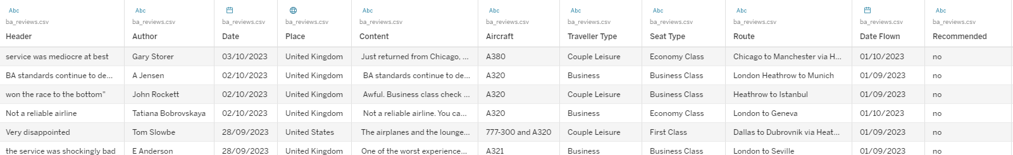

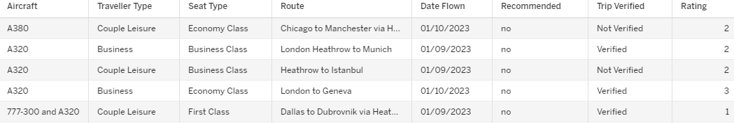

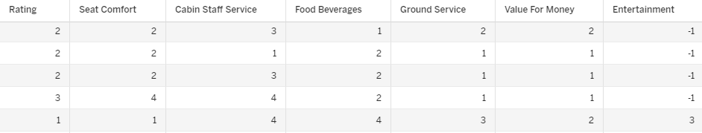

### INTRODUCTION TO TABLEAU

Tableau is a powerful software tool used for data visualisation and business intelligence. It helps people understand information by transforming data into interactive visual formats like charts, graphs, and dashboards.

In this analysis of customer reviews for British Airways, Tableau will be utilised to visualise key metrics such as passenger satisfaction ratings and service performance indicators across different flight routes. By leveraging Tableau’s capabilities to present clear visualisations and identify actionable insights, the goal is to help British Airways enhance service quality, address customer concerns, and improve overall customer experience.

Advantages of Tableau:

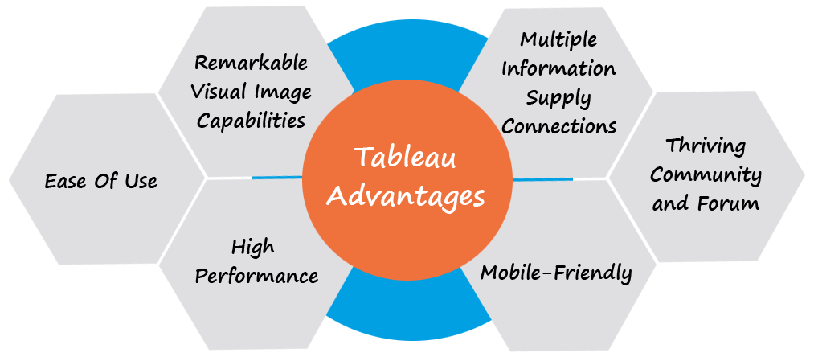

Disadvantages of Tableau:

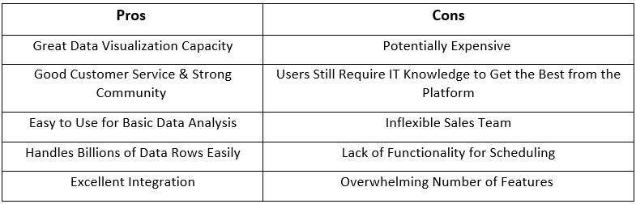

## 

## DATA ANALYSIS:

Link To The Dashboard

[*https://public.tableau.com/app/profile/unnati.goel/viz/BritishAirwaysReviewsAnalysis_17194721817590/Dashboard1?publish=yes*](https://public.tableau.com/app/profile/unnati.goel/viz/BritishAirwaysReviewsAnalysis_17194721817590/Dashboard1?publish=yes)

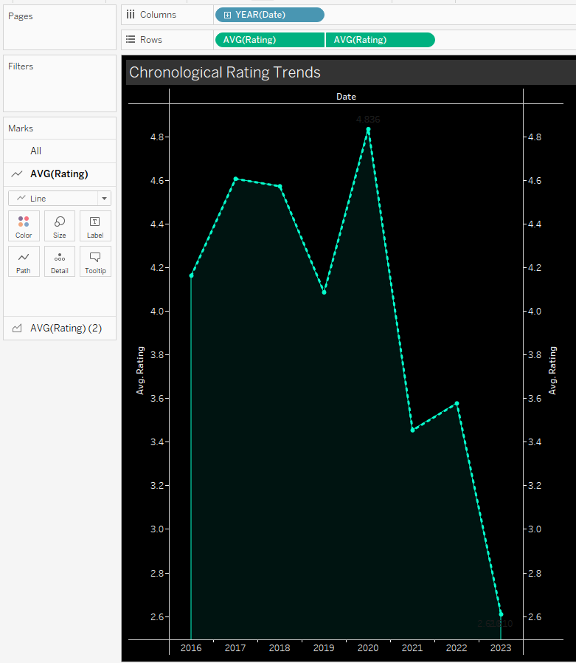

***Chronological Rating Trends*** *- The recordings are between Year (Date) and Rating( 1 to 10)*

*This Graph shows us British Airways Rating Trend from 2016 to 2023*

***Chart Used****: Line and Area Graph*

*Line Graph****:*** *Focuses on trends and changes over time or some other continuous variable.*

*Area Graph: Emphasises magnitude or quantity.*

***Observation****: During the Year 2020 The Rating was Highest with a value of 4.8 and lowest in the year 2023 with a value of 2.6*

*The reason for the decline could be Global pandemic outrage : Covid 19*

*From the Graph, we see that the Overall Rating has Taken a downward Trend*

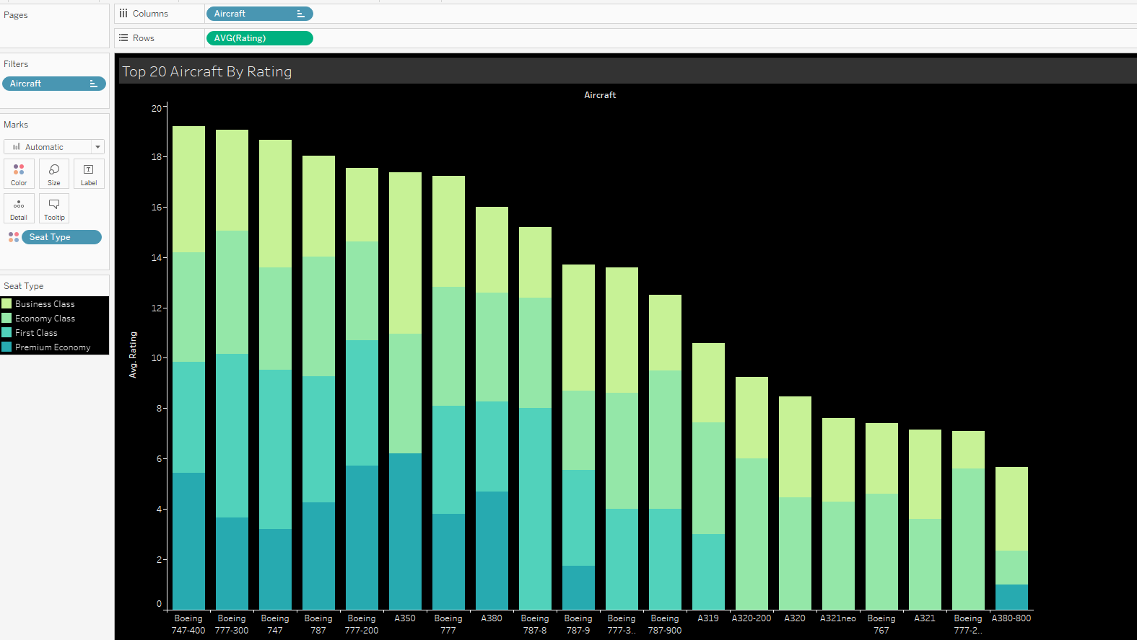

***Top 20 Aircraft By Rating*** *The Recordings are between Top 20 Aircraft by British Airways and Overall Rating*

***Chart Type****: Stacked Bar Chart*

***Filters****: Top 20 Aircraft by Count and Displaying ratings for different seat types (Business Class, Economy Class, First Class, Premium Economy)*

***Observation****: The top-rated aircraft generally have significant contributions from multiple seat types, suggesting that high ratings are achieved through a well-rounded experience across different classes.*

*The Airbus A320 and Airbus A321 have lower overall ratings. Aircraft with lower ratings tend to lack First Class and Premium Economy Class options.*

*Aircraft with significant portions of Business and Economy Class tend to have higher overall ratings. The presence of First and Premium Economy also enhances the overall ratings.*

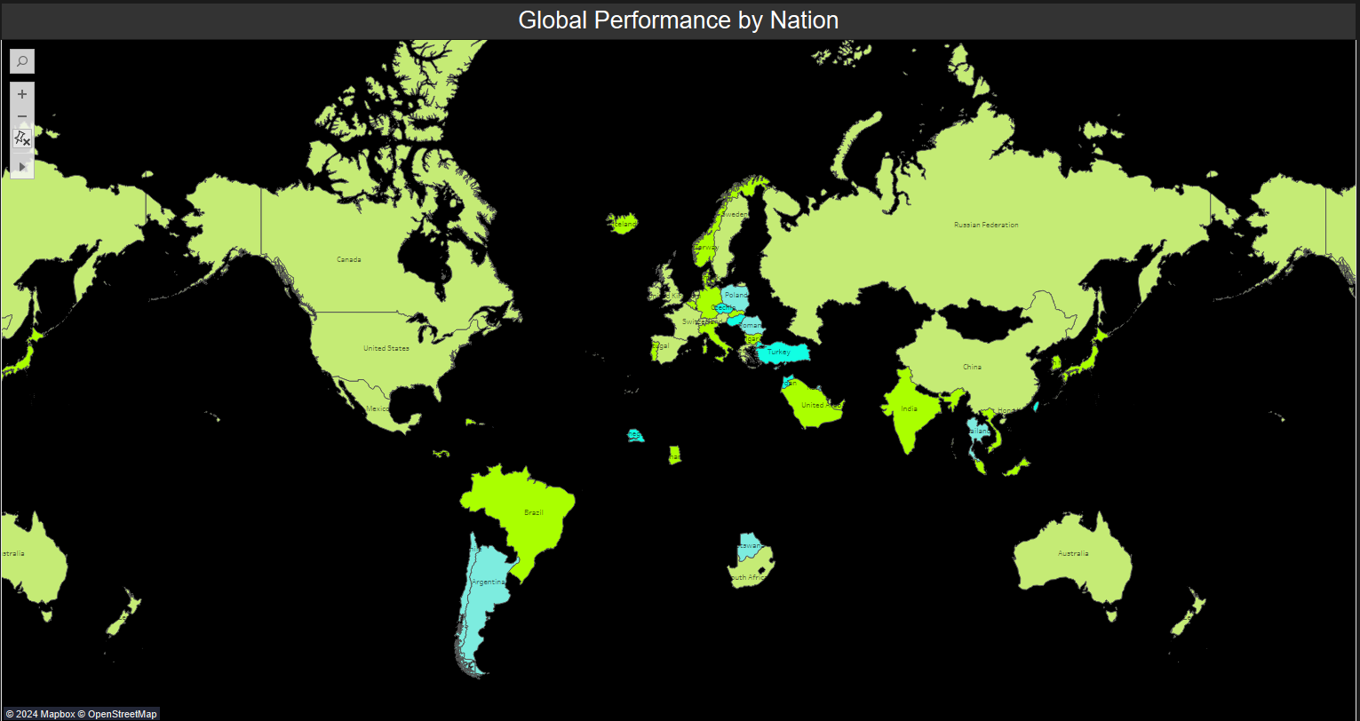

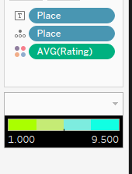

***Overall Rating By Nations*** *: The Recording is between Overall Ratings by Nations.*

***Chart Type*** *: Map*

***Observation:****Global Distribution: Most of the world is coloured in green, suggesting that lower performance ratings are more common globally.*

*Sparse Blue Areas: There are only a few scattered blue regions, indicating that higher performance ratings are less prevalent.*

*Some of the countries that gave the highest rating include Czechla , Taiwan , Turkey , Senegal , Jordan, Hungary.*

*Countries that gave lowest ratings to the British Airways are India , Japan,Germany,Belgium , Italy,Norway etc.*

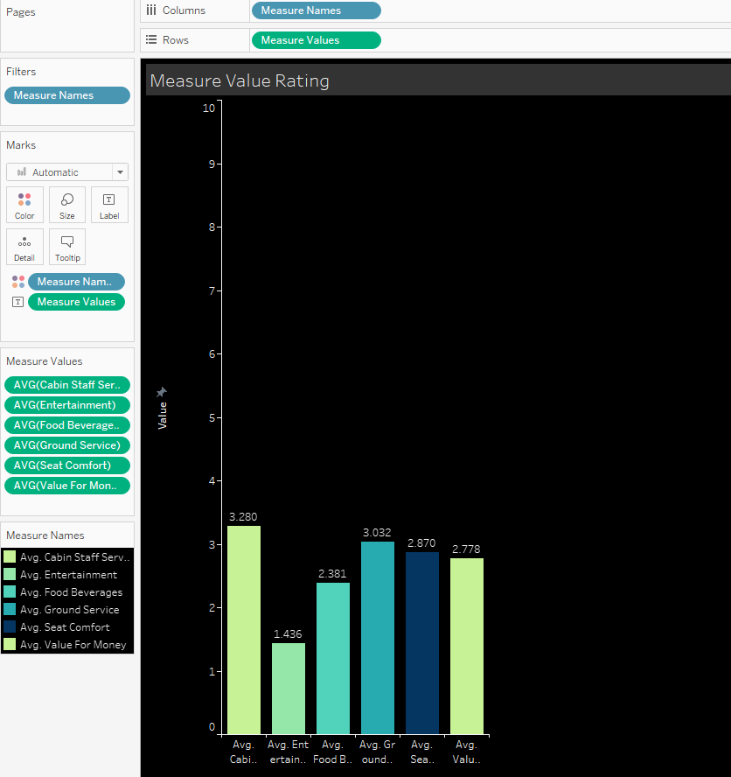

***Measure Value Rating*** *: Recordings are between Measure valued ( Cabin staff , Entertainment , Food Beverages , Ground Services, Seat Comfort , Value for Money)*

***Chart Used*** *: Bar Graph*

***Observation*** *:Cabin Staff Service has the highest average rating at 3.280.*

*Entertainment has the lowest average rating at 1.436. Overall ratings across all services are below average, there seems to be room for improvement across all categories. Businesses should focus on enhancing entertainment, service quality, and value for money to improve customer satisfaction.*

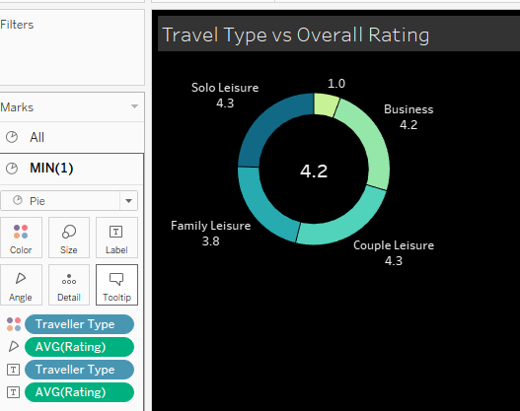

***Travel Type Vs Overall Rating :*** *The recordings are between Travel Type and Overall Rating*

***Chart used****:Donut Chart , they are used to represent the proportions of categories as segments of a circle, making it easier to compare relative sizes visually.*

***Observation****: Solo Leisure and Couple Leisure travellers have the highest average overall rating of 4.3 out of 10.Business travellers have an average overall rating of 4.2 out of 10, slightly lower than Solo and Couple Leisure categories.Family Leisure travellers have the lowest average overall rating of 3.8 out of 10, indicating this group is the least satisfied compared to others.*

*The overall average rating across all travel types is 4.2 out of 10, suggesting a moderate level of satisfaction among all travellers.These observations highlight that while Solo and Couple Leisure travellers are relatively more satisfied, there is room for significant improvement across all categories, especially for Family Leisure travellers, to enhance the overall travel experience.*

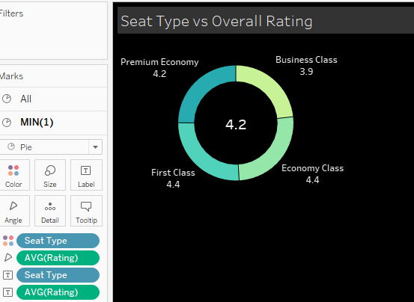

***Seat Type Vs Overall Rating :*** *The recordings are between Travel Type and Overall Rating*

***Chart Used****:Donut Chart , they are used to represent the proportions of categories as segments of a circle, making it easier to compare relative sizes visually.*

***Observation****: First Class and Economy Class passengers have the highest average overall rating of 4.4 out of 10, indicating higher satisfaction levels in these seat types.*

*Premium Economy passengers have a slightly lower average overall rating of 4.2 out of 10, showing moderate satisfaction.Business Class passengers have the lowest average overall rating of 3.9 out of 10, suggesting the least satisfaction among the seat types.*

*The overall average rating across all seat types is 4.2 out of 10, reflecting a generally moderate level of satisfaction.These observations suggest that passengers in First Class and Economy Class tend to be more satisfied compared to those in Premium Economy and Business Class.*

*The lower rating in Business Class might indicate a need for improvement in the services or amenities offered in this class. The moderate overall satisfaction level suggests room for enhancements across all seat types to improve the passenger experience.*

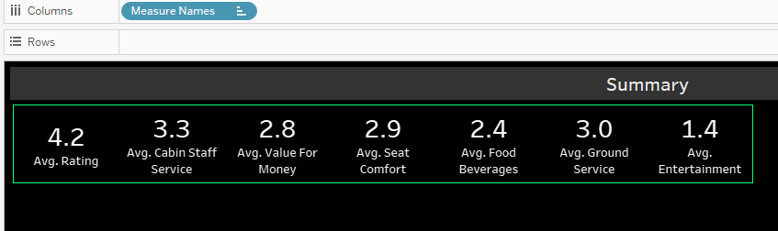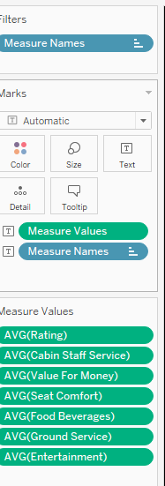

***Summary****: Shows Overall Observation done by graphs.*

***Filter:*** *Measure Names in Shelf*

***Chart Used:*** *Summary is Created Using Test Metric in the Marks section of Tableau.*

***Observation:*** *Gives overall insight of average rating across all services*

*[1]British Airways should invest in low-quality items, for instance, meals and refreshments, which are important for subject global satisfaction[1]*

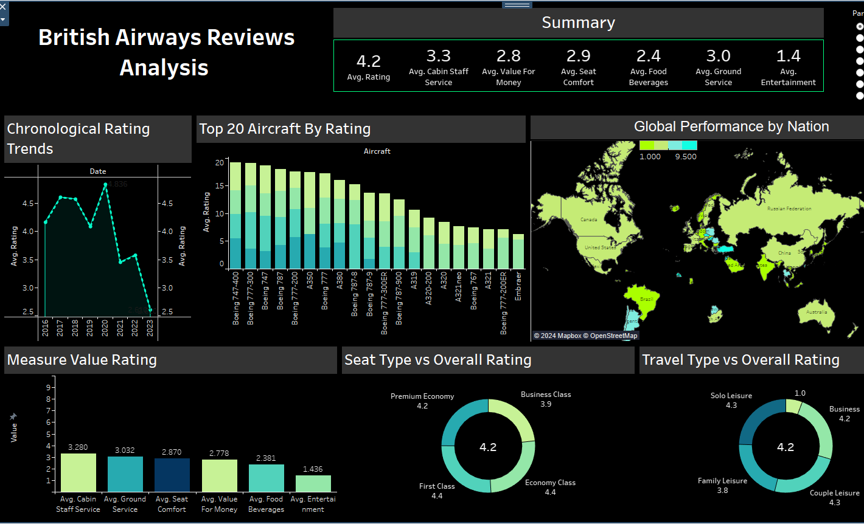

***British Airways Reviews Analysis:*** *The Dashboard is Comprised of 7 sheets proving overall*

*Review analysis of British Airways*

***Sheets Used:*** *Summary , Global Performance By Nation , Top 20 Aircrafts by Rating , Chronological Rating Trends , Measure Value Rating , Seat type vs Overall rating and Travel Type vs Overall Rating*

***Observation:***

*The dashboard provides a comprehensive overview of the airline's performance based on customer reviews across various parameters.The "British Airways Reviews Analysis" dashboard reveals a moderate overall satisfaction level, with an average rating of 4.2 out of 10 across various services. Passengers are most satisfied with Cabin Staff Service but least satisfied with Entertainment, indicating areas for improvement. First Class and Economy Class have the highest satisfaction, while Business Class lags behind. Chronological trends show a peak in ratings during 2020 and a significant decline by 2023. Globally, ratings vary, with some countries giving notably higher or lower scores, suggesting regional differences in customer experience.*

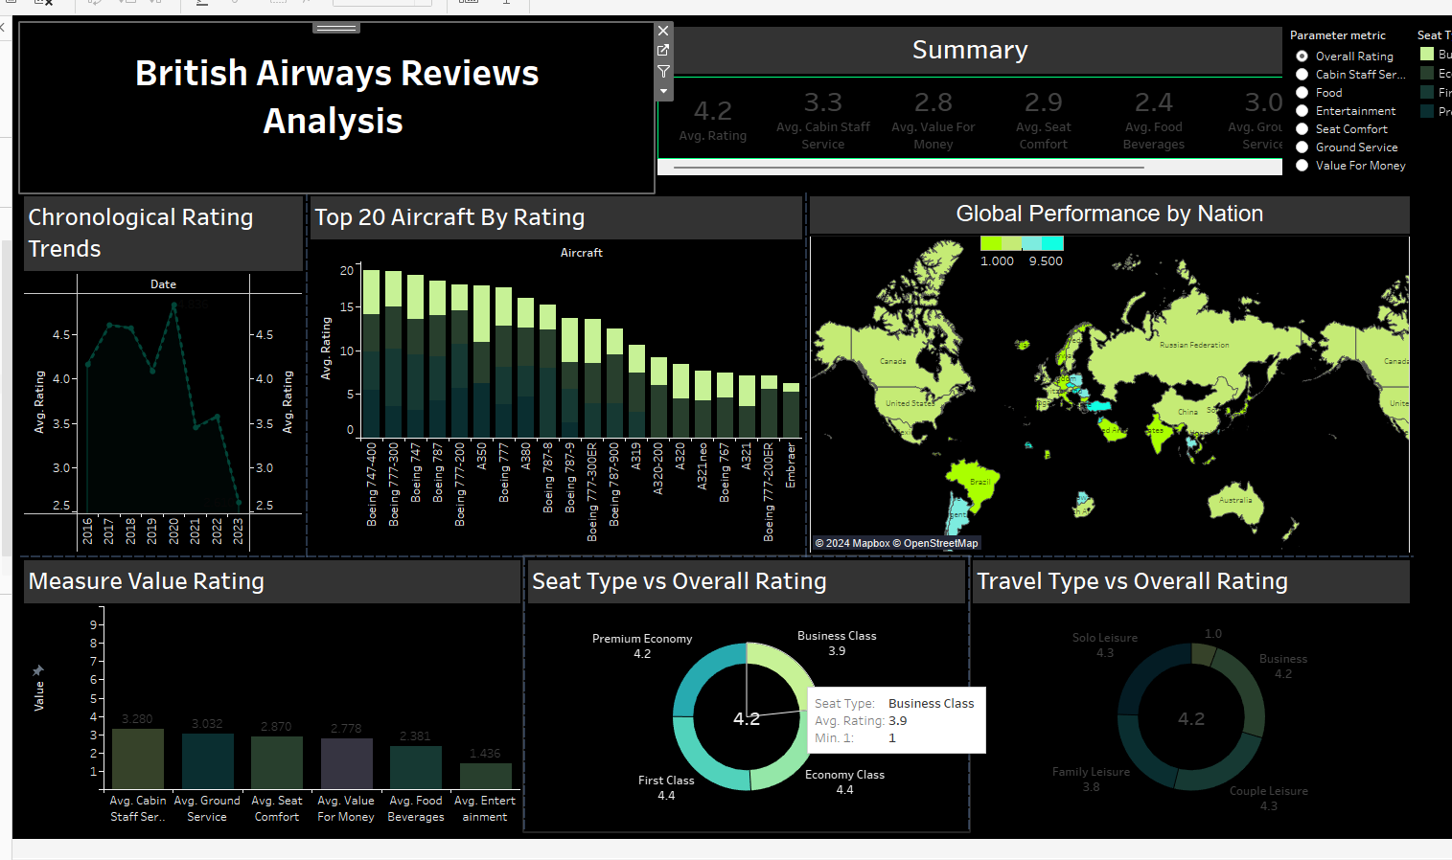

***Adding Highlight to Dashboard:***

***Source :*** *seattype vs overall rating*

***Destination :*** *Top 20 aircrafts by rating*

***Observation:***

*Highlighting the "Seat Type vs Overall Rating" data on the "Top 20 Aircraft by Rating" chart reveals that aircraft with higher ratings tend to offer better experiences across all seat types.*

*Aircraft like the Boeing 747-400 and A380, which are highly rated, are likely providing superior service and comfort in First Class and Premium Economy, driving up their overall ratings.*

*This correlation suggests that improving the quality and amenities of seats, especially in premium categories, can significantly enhance the overall ratings of aircraft.*

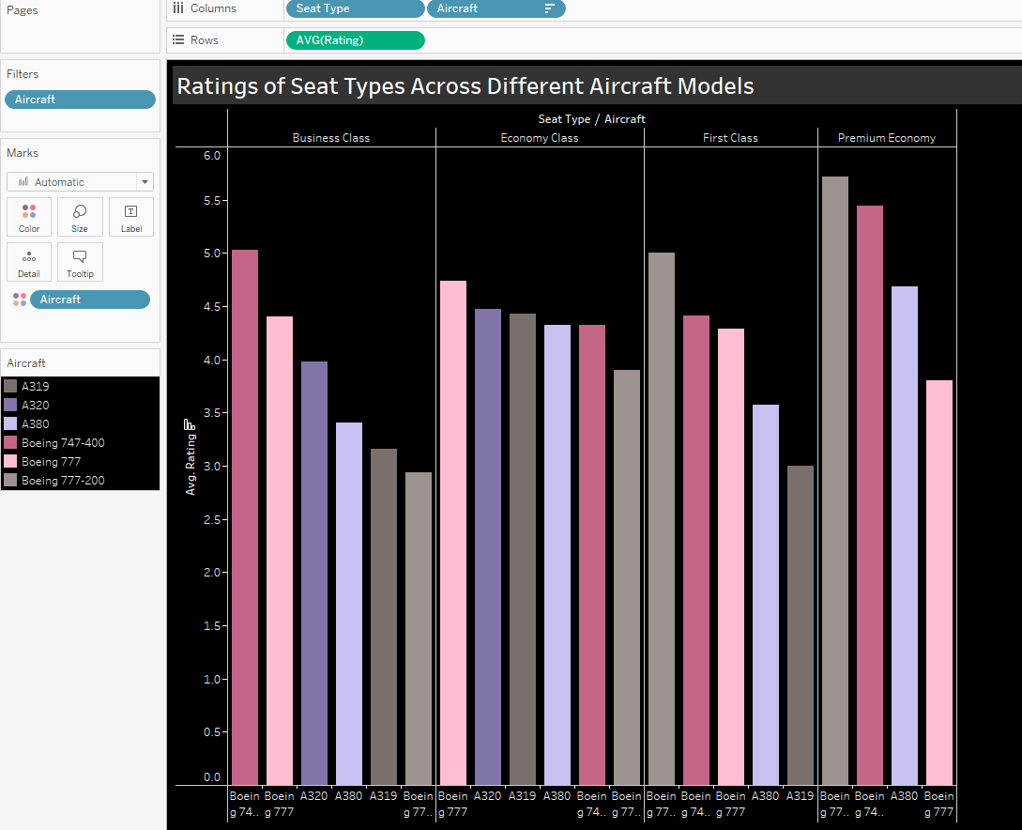

***Rating Of Seat Types Across Different Aircraft Models*** *: The Recording is between Seat Types Across Different Aircraft Models and their ratings.*

***Filter :*** *Top Six Aircrafts are chosen based on the review count*

***Observation:***

*The Boeing 747-400 consistently receives high ratings across all seat types, particularly excelling in First Class and Premium Economy.*

*The A380 also performs well across different seat types, with notably high ratings in Economy Class and First Class.*

*The Boeing 777 shows mixed results, performing moderately in Business Class and Premium Economy but achieving higher ratings in Economy Class.*

*The A319 and A320 generally have lower ratings across most seat types, indicating potential areas for improvement in these aircraft models.*

*These insights suggest that the Boeing 747-400 and A380 provide a more satisfying passenger experience across various seat types, while the A319 and A320 may require enhancements to boost customer satisfaction.*

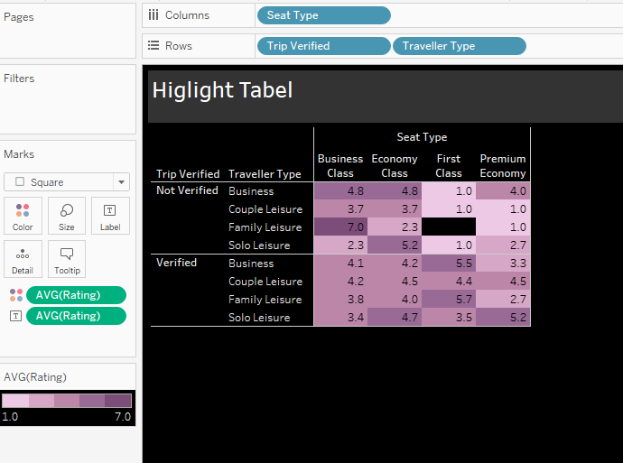

***Highlight Table:*** *Average Ratings by Seat Type and Traveler Category: Verified vs. Not Verified Trips*

***Filters :*** *Highlight Table*

***Components:****Columns: Seat Type: Business Class, Economy Class, First Class, and Premium Economy.*

*Rows****:*** *Trip Verified: Divided into "Not Verified" and "Verified".Traveller Type: Different types of travellers including Business, Couple Leisure, Family Leisure, and Solo Leisure.The colour of the cells represents the average rating, with a colour gradient from light (low rating) to dark (high rating). The colour legend at the bottom left indicates that the range of ratings is from 1.0 to 7.0.*

***Observation:*** *Generally, Verified trips have more balanced and higher ratings across different seat types and traveller types compared to Not Verified trips.*

*Premium Economy and First class Seat types have the lowest rating for Non Verified trips*

*Family Leisure travellers in Business Class who did not have their trips verified show the highest rating at 7.0. Overall, trip verification status appears to significantly impact passenger satisfaction, with verified trips tending to result in higher ratings.*

***Conclusion:*** *British Airways can Enhance Trip Verification Processes: Implement more robust and transparent verification processes to increase the number of verified reviews, as verified trips generally receive higher ratings.*

## 

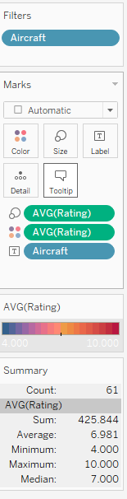

***Tree Map*** *: Recordings are Between All Aircraft Models and there overall rating*

***Chart used :*** *Tree Map, it is a visualisation tool that uses nested rectangles to represent hierarchical data, with the size and colour of each rectangle indicating different attributes. It is used to efficiently display large amounts of hierarchical information, making it easier to identify patterns and relationships.*

***Observation :*** *The aircraft with the highest average rating is the Boeing 787-9, with a rating of 8.0 out of 10. The aircraft with the lowest average rating is the Boeing 747-400, with a rating of 6.9 out of 10.*

*Overall, the average rating for British Airways flights is 7.5 out of 10. This suggests that customers are generally satisfied with their flights.*

*The Boeing 787-9 and the Airbus A380 are the two most popular aircraft types, with 45 and 40 flights respectively.*

*The Boeing 747-400 is the least popular aircraft type, with only 10 flights.*

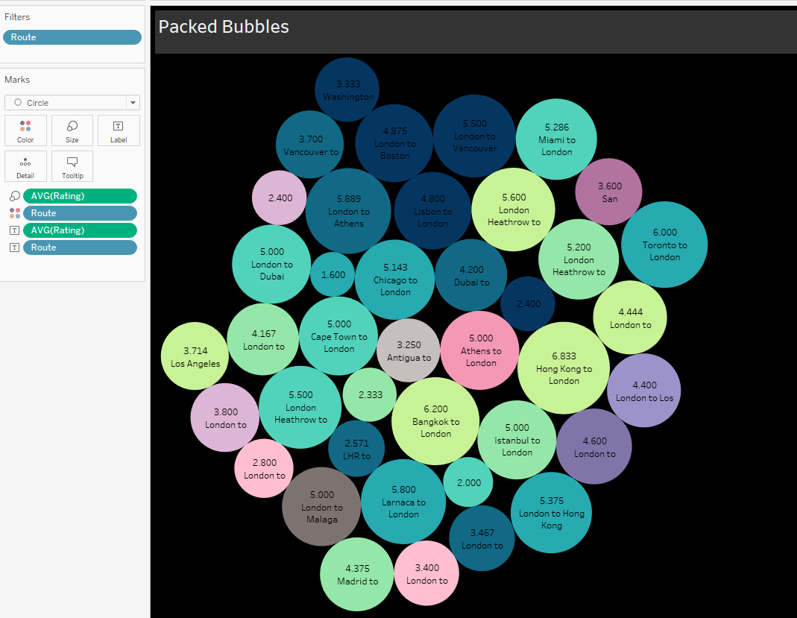

***Packed Bubbles :*** *Recordings Between Rating of Different Routes to London*

***Chart used :*** *Packed Bubbles , useful for presenting non-hierarchical data and for highlighting the relative proportions of different categories.*

***Observation****: The graph shows the average rating of British Airways flights from different cities to London. The size of the bubble represents the number of flights, and the colour represents the average rating.*

*The highest-rated route is from Hong Kong to London, with an average rating of 6.833. The lowest-rated route is from London to Malaga, with an average rating of 2.800.*

*Overall, the average rating for British Airways flights from different cities to London is 4.8 out of 7.*

## 

***Relation between Average Rating and Value of Money vs Recommended :***

***Chart used*** *: Dual Area Chart*

***Observation :*** *Recommended: Indicates customers who would recommend British Airways to others.*

*Non-recommended: Indicates customers who would not recommend British Airways to others.*

*In essence, the graph highlights a strong correlation between customer satisfaction and the likelihood of recommending British Airways. The airline has shown improvement in overall customer satisfaction, but there's a clear segment of customers whose experience and perception of value lag behind.*

## 

## 

## 

## 

***Customer Recommendations for British Airways: Analysis from Reviews***

***Chart Used****: Pie chart , it is a circular statistical graphic divided into slices to illustrate numerical proportions. Each slice represents a category's contribution to the whole, with the size of the slice corresponding to its percentage of the total.*

***Observations:***

*The pie chart depicts the distribution of customer recommendations for British Airways, based on review analysis. A significant portion, approximately 57% of customers, indicated that they would not recommend British Airways, while the remaining 43% were favourable and would recommend the airline. This suggests a mixed customer satisfaction level, with a notable lean towards dissatisfaction.*

## 

## 

***Average Combined Rating of Aircrafts from 2016-2023 :*** *Recordings are between Ratings Aircraft models combines over Years 2016 - 2023*

***Graph used*** *: Stacked bar chart*

***Observation:***

*The graph illustrates the average combined rating of British Airways aircraft from 2016 to 2023. The highest ratings were observed in 2017, 2018, and 2019, with a noticeable decline starting in 2020. This drop coincides with the onset of the COVID-19 pandemic, which significantly affected the airline industry. Post-2020, the ratings have shown some recovery, but they have not yet returned to pre-pandemic levels. The variety of colours within each bar indicates the diverse range of aircraft being rated each year.*

*The average combined rating of the Boeing 787-9 is the highest of all aircrafts. This suggests that the Boeing 787-9 is the most popular aircraft among customers.*

*The average combined rating of the Boeing 747-400 is the lowest of all aircrafts. This suggests that the Boeing 747-400 is the least popular aircraft among customers.*

## 

***British Airways Reviews Analysis:*** *The Dashboard is Comprised of 5 sheets proving overall*

*Review analysis of British Airways*

***Sheets Used:*** *Average Combined Rating of Aircrafts from 2016-2023*

*Highlight Table*

*Customer Recommendations for British Airways*

*Relation between Average Rating and Value of Money vs Recommended*

*Ratings of Seat Types Across Different Aircraft Model****s***

***Observations:***

*The dashboard provides a comprehensive analysis of British Airways reviews from 2016 to 2023. The bar chart titled "Average Combined Rating of Aircrafts from 2016-2023" indicates fluctuations in customer ratings over the years, with notable peaks in 2017 and 2019, followed by a decline during 2020, likely due to the impact of the COVID-19 pandemic. The highlight table shows that verified trips generally receive higher ratings compared to non-verified trips, particularly in the Family Leisure and Couple Leisure categories across various seat types.*

*The pie chart of customer recommendations reveals a nearly even split, with slightly more customers not recommending the airline. The relation between average rating, value for money, and recommendations shows a clear pattern: higher ratings and perceived value for money are associated with recommendations. Lastly, the bar chart on ratings of seat types across different aircraft models highlights that Premium Economy and Business Class tend to receive higher ratings compared to Economy and First Class.*

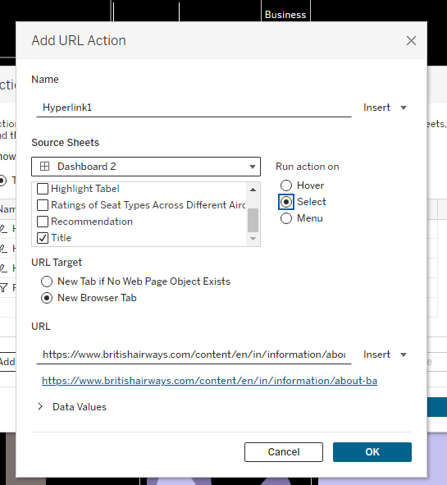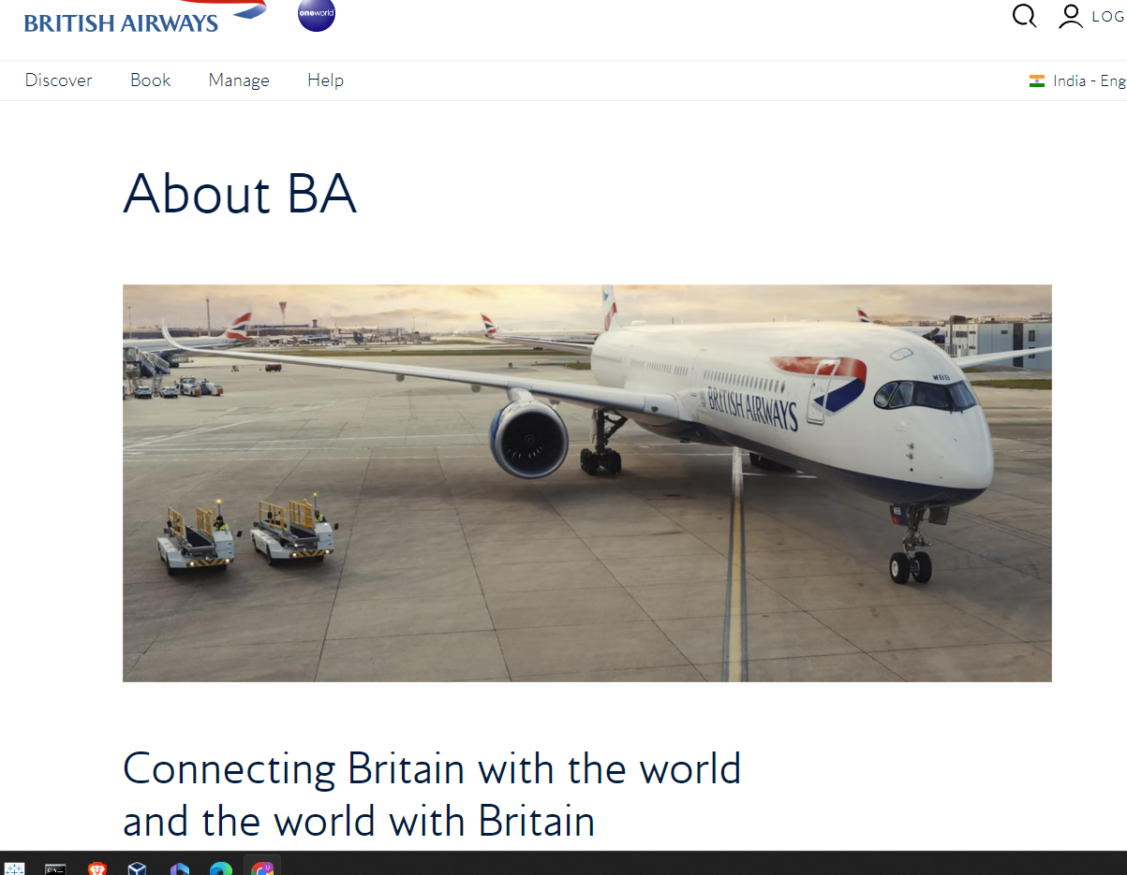

***Adding URL to Dashboard:***

***Source :*** *Selecting Title or Recommendation sheet from Dashboard*

***Destination :*** *https://www.britishairways.com/content/en/in/information/about-ba*

***Observation:****The dashboard includes an interactive feature where clicking on the Recommendation Sheet or its title navigates the user to the British Airways About Page. This URL action enhances the user experience by providing direct access to additional information about British Airways, facilitating a seamless transition from data insights to in-depth company details.*

## 

## 

## 

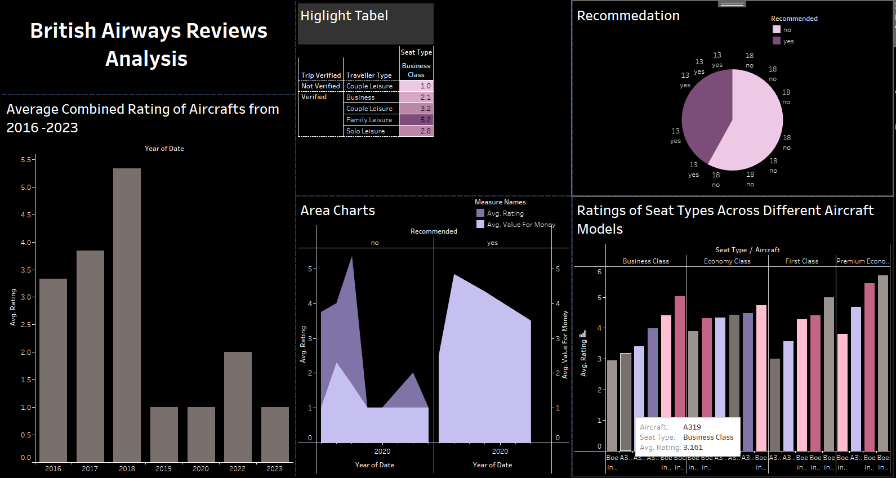

***Adding Filter to the Dashboard***

*Adding a filter to the dashboard, with the source being the "Rating of Seat Types across Different Aircraft Models" and the destination being all other sheets, allows for a more granular analysis. After applying this filter, it becomes evident how specific aircraft models and seat types influence overall ratings and recommendations. For example, if we filter by business class on the Boeing 777, which has an average rating of 4.4, we can see the impact on the overall average ratings, customer recommendations, and the relationship between value for money and recommendation status across different years and traveller types.*

***Key Findings:***

*Business class customers have the highest average combined rating across all aircraft models.*

*There is a significant difference in average combined ratings across different seat types within the same aircraft model.*

*Certain aircraft models consistently outperform others in terms of business class customer satisfaction.*

***Potential Actions:***

*Prioritise investments in aircraft models with consistently higher business class satisfaction ratings.*

*Analyse the specific factors contributing to higher satisfaction in business class and replicate them in other seat types.*

*Use this information to optimise aircraft fleet and seat type allocation to improve overall customer satisfaction.*

## 

## RESULT AND DISCUSSION

**[2]“Delivering quality service is considered an essential strategy for success in today’s competitive environment for business according to Zeithaml et al. (1996)”[2]**

**Trend Analysis of Ratings Over the Years**The average combined rating of British Airways aircraft from 2016 to 2023 shows notable fluctuations. In 2016, the average rating was relatively low but showed an upward trend, peaking in 2020. This peak suggests a period of high customer satisfaction, possibly due to improvements in service or newer aircraft models being introduced. However, 2019 saw a significant dip, indicating potential issues or dissatisfaction during that period. The subsequent years, 2021 and 2022, showed moderate recovery in ratings, but the levels did not reach the 2020 peak. In 2023, there was a noticeable improvement, suggesting that the airline made efforts to address previous issues.

**Impact of Trip Verification and Traveler Type**

The highlight table reveals that verified trips generally receive higher ratings than non-verified trips. This indicates that customers value transparency and authenticity in their travel experiences. Verified couple leisure travellers in business class gave the highest ratings, with an average of 5.3, whereas family leisure travellers rated their experiences lower, with an average of 2.0. Solo leisure and business travellers also provided relatively high ratings. These insights suggest that British Airways excels in catering to couples and solo travellers but needs to improve its services for family travellers.

**Customer Recommendations**

[2]A strong correlation was found between staff’s appearance/attitude and time/consistency of inflight service; staff’s appearance/attitude and anticipating customer needs; staff’s appearance/attitude and flight schedule convenience[2].[5]The sentiment analysis of online reviews can help airlines to identify areas of improvement and take corrective actions to enhance customer satisfaction[5]

The pie chart showing customer recommendations for British Airways highlights a significant challenge: a majority of 54 customers did not recommend the airline, while only 21 did. This negative skew suggests that there are underlying issues that deter customers from endorsing British Airways. Understanding and addressing the reasons behind these negative recommendations is crucial for improving overall customer satisfaction and loyalty.

**Seat Types and Aircraft Models**

The bar chart analysing ratings of seat types across different aircraft models reveals that business class generally receives higher ratings compared to economy, first, and premium economy classes. For example, the Boeing 777's business class has an average rating of 4.4. This suggests

that passengers are more satisfied with the business class experience, which could be due to better seating, amenities, and service. Economy and premium economy classes have lower ratings, indicating areas where British Airways can focus on improvements.

**Filtering Analysis**

Applying a filter based on the "Rating of Seat Types across Different Aircraft Models" to all other sheets provides a more nuanced view of customer satisfaction. This allows us to see how specific aircraft and seating configurations impact overall ratings and recommendations. For instance, filtering by business class on the Boeing 777 reveals higher overall satisfaction, which can guide decisions on which aircraft to prioritise and which seating arrangements to enhance. This targeted analysis helps in identifying successful combinations and areas needing improvement.

**Key Areas for Improvement**

The trends and data suggest several key areas where British Airways can focus to improve their ratings:

**Service Consistency:** Ensuring consistent service quality across all flights and routes is crucial. This includes staff training, in-flight services, and addressing common customer complaints promptly.[5]The analysis of online reviews can provide airlines with valuable insights into customer opinions and preferences, which can be used to develop targeted marketing strategies and improve customer satisfaction.[5]

**Fleet Management:** Prioritising the use of aircraft models that receive higher ratings and investing in the refurbishment of older, lower-rated models can enhance customer satisfaction.

**Customer Feedback:** Actively seeking and acting on customer feedback can help identify pain points and areas needing improvement. This could involve post-flight surveys, focus groups, and social media engagement.

**Family-Friendly Services:** Given the lower ratings from family leisure travellers, British Airways could introduce more family-friendly services and amenities, such as priority boarding for families, children’s entertainment options, and family seating arrangements.

**Enhancing Transparency and Engagement**

Enhancing transparency through verified trip reviews and addressing the reasons behind negative recommendations can build trust and improve overall ratings. Implementing loyalty programs or incentives for frequent flyers who provide constructive feedback could also foster a more engaged and satisfied customer base.

[2] In general,study results indicate that the passengers of British Airways expected a delayed departure from London Heathrow Airport, therefore their expectations are matched.[2]Nevertheless, a delayed departure does not necessarily damage the on-time performance of BA as the company has taken operational actions to amend the flight schedule in such a way that delays at the arrival level are avoided. As surprising as it may seem, if properly informed about a delay, passengers accept it without causing soft costs to the airline.[2]

The overall trend of British Airways ratings indicates moderate satisfaction with significant areas needing improvement. By focusing on consistent service quality, strategic fleet management, and responsive customer service, British Airways can improve their ratings, enhance customer satisfaction, and ultimately strengthen their market position.

[5]The results of this study can be used by British Airways to identify areas of improvement and take corrective actions to enhance customer satisfaction and loyalty[5]

## CONCLUSION

This Tableau analysis of British Airways reviews offers a comprehensive understanding of customer satisfaction and the areas where the airline can improve. The visualisation provides valuable insights into the average combined ratings of aircraft from 2016 to 2023, highlighting a notable fluctuation in ratings over the years. The analysis also includes a detailed examination of the ratings based on seat types across different aircraft models, as well as the relationship between average ratings, value for money, and customer recommendations.. [2]Delivering quality service is considered an essential strategy for success in today’s competitive environment for business according to Zeithaml et al.(1996)[2].

The trend in ratings shows variability, with a significant peak in 2020, which could be attributed to various factors such as service improvements or specific events during that period. However, the general trend indicates that there is room for improvement in customer satisfaction[2]Airlines need to look at the concept of service quality to monitor customer satisfaction.[2] By focusing on consistent service quality, especially in Business Class, which consistently shows higher ratings, British Airways can enhance the overall customer experience.

From the dataset and the visualizations, it is evident that verified trips tend to receive higher ratings compared to non-verified trips. This suggests that verified feedback is more likely to reflect the true quality of service experienced by passengers. British Airways should encourage more passengers to provide verified reviews to obtain a more accurate picture of their performance.

[3]Despite the positive aspects, BA's cultural change faced significant employee resistance.[3][4]Employee attitudes and responses to management styles are crucial for the success of low-cost airline subsidiaries[4].[4]Decentralisation of employment relations to subsidiary management is a key factor influencing organisational performance[4]

In terms of improving their services, British Airways can focus on several key areas:

1. **Consistency in Service Quality**: Ensuring consistent service quality across all classes and routes is crucial. This can be achieved through regular training of staff and maintaining high standards of service delivery.[3]The company’s new strategy focused on customer service and employee engagement[3].[3]Putting People First (PPF) was a key programme designed to alter the attitudes and behaviours of employees.[3]
2. **Enhancing the Value for Money**: The relationship between average ratings and value for money suggests that passengers appreciate good value. Offering competitive pricing and additional perks can enhance perceived value.
3. **Encouraging Verified Reviews**: Implementing strategies to encourage passengers to leave verified reviews can help the airline gather more reliable data on customer satisfaction.
4. **Focus on Business and Premium Services**: Since Business Class generally receives higher ratings, investing in premium services and amenities can attract more high-value customers and improve overall ratings.
5. **Reducing Delay in Flights** :[2] Displeasure, uncertainty, and disappointment are some of the emotions the passengers experience that become stronger as time passes and especially when there is a lack of information about the reasons or the duration of the delay.[2]

By addressing these areas, British Airways can work towards improving their ratings and customer satisfaction.[2]If service failure is not managed effectively then this can lead to customer dissatisfaction which may in turn result in customer complaints[2]. Thus The analysis underscores the importance of continuous monitoring and adaptation to passenger feedback to maintain a competitive edge in the airline industry.[2]Airlines need to look at the concept of service quality to monitor customer satisfaction.[2]

## REFERENCES

1. *Nicolini, G., & Salini, S. (2006). Customer satisfaction in the airline industry: the case of British airways. Quality and Reliability Engineering International, 22(5), 581-589.*

*(*[*https://air.unimi.it/bitstream/2434/4935/2/QREI_2006.pdf*](https://air.unimi.it/bitstream/2434/4935/2/QREI_2006.pdf)*)*

1. *Efthymiou, M., Njoya, E. T., Lo, P. L., Papatheodorou, A., & Randall, D. (2018). The impact of delays on customers' satisfaction: An empirical analysis*

*(*[*https://www.scielo.br/j/jatm/a/8B9fSXxbstXNgHHnQGdgtPS/?format=pdf&lang=en*](https://www.scielo.br/j/jatm/a/8B9fSXxbstXNgHHnQGdgtPS/?format=pdf&lang=en)*)*

1. *Grugulis, I., & Wilkinson, A. (2002). Managing culture at British Airways: hype, hope and reality. Long Range Planning, 35(2), 179-194.*

*(*[*https://bradscholars.brad.ac.uk/bitstream/handle/10454/955/BRITISH%20AIRWAYS.pdf?sequence=1&isAllowed=y*](https://bradscholars.brad.ac.uk/bitstream/handle/10454/955/BRITISH%20AIRWAYS.pdf?sequence=1&isAllowed=y)*)*

1. *Harvey, G., & Turnbull, P. (2006). Employment Relations, Management Style and Flight Crew Attitudes at Low Cost Airline Subsidiaries:: The Cases of British Airways/Go and bmi/bmibaby. European Management Journal, 24(5), 330-337.*

*(*[*https://www.sciencedirect.com/science/article/abs/pii/S0263237306000557*](https://www.sciencedirect.com/science/article/abs/pii/S0263237306000557)*)*

1. *Cozmuta, A. (2024). Selling ‘The World’s Favourite Airline’: British Airways’ privatisation and the motives behind it. Business History, 66(1), 181-200.*

*(*[*https://eprints.gla.ac.uk/240788/1/240788.pdf*](https://eprints.gla.ac.uk/240788/1/240788.pdf)*)*

1. *Shaffner, E. C. (2015). Images of race over time at British Airways: a case study.*

*(*[*https://library2.smu.ca/bitstream/handle/01/26481/Shaffner_Ellen_MRP_2015.pdf?sequence=1*](https://library2.smu.ca/bitstream/handle/01/26481/Shaffner_Ellen_MRP_2015.pdf?sequence=1)*)*

1. *Ustaömer, Temel Cancer, Vildan Durmaz, and Zheng Lei. "The effect of joint ventures on airline competition: the case of American airlines, British airways and Iberia joint business." Procedia-Social and behavioural sciences 210 (2015): 430-439.*

*(*[*https://www.sciencedirect.com/science/article/pii/S1877042815057389/pdf?md5=b59522f7da75ae744939088849f5d212&pid=1-s2.0-S1877042815057389-main.pdf*](https://www.sciencedirect.com/science/article/pii/S1877042815057389/pdf?md5=b59522f7da75ae744939088849f5d212&pid=1-s2.0-S1877042815057389-main.pdf)*)*

1. *Park, Jong-Hun, Nam Gyoo K. Park, and Anming Zhang. "The impact of international alliances on rival firm value: a study of the British Airways/USAir Alliance." Transportation Research Part E: Logistics and Transportation Review 39.1 (2003): 1-18.  
   (*[*https://www.sciencedirect.com/science/article/abs/pii/S1366554502000236*](https://www.sciencedirect.com/science/article/abs/pii/S1366554502000236)*)*
2. *Efthymiou, Marina, et al. "The impact of delays on customers' satisfaction: An empirical analysis of the British Airways on-time performance at Heathrow Airport." Journal of Aerospace Technology and Management 11 (2018): e0219.*

*(*[*https://www.scielo.br/j/jatm/a/8B9fSXxbstXNgHHnQGdgtPS/*](https://www.scielo.br/j/jatm/a/8B9fSXxbstXNgHHnQGdgtPS/)*)*

1. *Grundy, Michael, and Richard Moxon. "The effectiveness of airline crisis management on brand protection: A case study of British Airways." Journal of Air Transport Management 28 (2013): 55-61.*

*(*[*https://www.sciencedirect.com/science/article/abs/pii/S0969699712001640*](https://www.sciencedirect.com/science/article/abs/pii/S0969699712001640)*)*

1. *Shaffner, Ellen C. "Images of race over time at British Airways: a case study." (2015).*

*(https://library2.smu.ca/bitstream/handle/01/26481/Shaffner_Ellen_MRP_2015.pdf?sequence=1)*