### VOLTAGE CHARACTERIZATION OF A LOW-RELIABILITY DISTRIBUTION NETWORK

**Joel Ogunyemi1, Ayangbenjo H. Adeyeye2, Zacchaeus. A. Adetona3**

1,3Department of Electrical/Electronics Engineering, Federal Polytechnic Ilaro, Ogun State, Nigeria

2Department of Electrical/Electronics Engineering, Adeseun Ogundoyin Polytechnic, Eruwa, Nigeria

**Abstract**

Characterizing voltage variation in the Nigerian electrical distribution network as it affects the reliability and quality of power supply to consumers is significant. This paper examines the voltage variations characteristics in a typical low-reliability network. Two terms, short duration voltage variation (SDVV) and long duration voltage variation (LDVV) are used to redefine sag, swell, undervoltage and overvoltage with pictorial and graphical illustration in selected section of the Nigerian distribution network in Ilaro Ogun State. The survey was part of power quality studies in the selected section of the Nigerian distribution network. The studies showed that the selected distribution network voltage variation is more pronounced and can be characterised as under-voltage. With the measured voltage magnitude of 179V as the typical value the deviation from the ideal 230V is significant. The descriptive statistics of the nominal and measured voltage and frequency are compared with the EN 50160 standards. More work is required to characterise the entire distribution network, the results obtained here are indicators of what is obtainable in other parts of the network. Efforts to improve power quality should therefore go along with reliability improvement.

Keywords: Sag, swell, short duration voltage variations (SDVV), long duration voltage variations (LDVV).

**1. Introduction**

**Electricity, as delivered to network users, has several characteristics which are variable and which affect its usefulness to the network user. The electrical power supply is expected to have constant voltage and frequency, with a pure sinusoidal wave. However, various factors cause deviations from this in practice. Also, electrical energy, as a unique product, because it is consumed at the instant at which it is generated, requires the measurement and evaluation of its power quality to be instantaneous. Standard EN 50160 describes the characteristics of electricity, at the point of supply to the consumer, in terms of the alternating voltage.**

**Voltage variation is one of the power quality phenomena. There are various power quality associated with voltage variation such as voltage fluctuations (flicker), voltage dip/swell, harmonic distortion, etc. Though transients and harmonics also contribute to voltage variations, affecting the performance and longevity of electrical devices connected to the network, only voltage variation due to reduction and increase in magnitude (sag and swelling) are discussed in this paper.**

**2. Low Reliability Distribution Network**

**The reliability of any power network is an important index for assessing the network’s performance (Ogunyemi, 2016). Globally, distribution networks can be classified broadly into high-reliability and low-reliability networks (Ogunyemi and Adejumobi, 2016). Causes of low reliability in distribution networks include inadequate generation, old or ageing infrastructure coupled with poor maintenance culture among others.**

Usually, the last stage of a power system is the low voltage (LV) network, which connects directly to the end user customers and supply loads. In Nigeria, the most common voltage levels of LV networks are with the nominal voltage of 230 V single phase. Figure 1 shows a typical distribution network structure depicting the structure of electrical power from generation to end users.

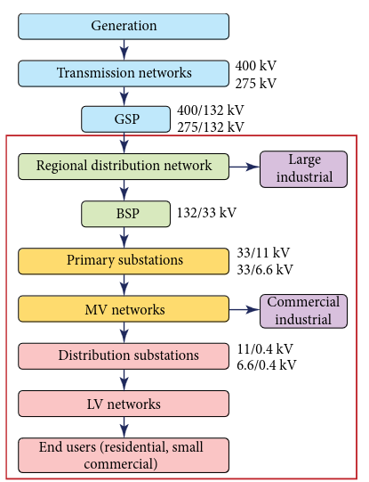

Figure 1: Typical Distribution system structure (**Mokryani, 2022)**.

Nigeria's electricity infrastructure, a typical low-reliability distribution network (Ogunyemi and Adejumobi, 2016), faced various challenges, including inadequate generation capacity, transmission constraints, distribution losses, and poor maintenance practices. With the abundance of natural gas reserves, the overreliance on gas-fired power plants is inevitable, with its attendance problems such as supply disruptions and gas pipeline vandalism. Transmission losses are significant, and the network often experiences bottlenecks that limit the efficient transfer of power from generation sources to distribution networks (NESG, 2020). Similarly, distribution networks in Nigeria suffer from technical losses, commercial losses (due to theft and non-payment), and poor infrastructure maintenance. Voltage fluctuations, outages, and poor voltage regulation are common issues faced by consumers (ECN, 2018). Expectedly, a significant portion of the population lacks access to electricity (World Bank Report, 2019). As a result, in recent times, Nigeria has been exploring opportunities to integrate renewable energy sources, such as solar and wind power, into its electricity mix. However, challenges related to grid integration, policy frameworks, and financing have hindered the widespread adoption of renewables (FMP, 2015).

The deviation of voltage or current from the ideal waveform (sinusoid) is referred to as the power quality problem (Ogunyemi and Adejumobi, 2016). Distribution networks are designed to operate at a specific nominal voltage level, such as 230V or 400V, depending on the region and standards followed. The supply voltage can vary within prescribed limits. Voltage characteristics, the quality of the supply and the degree to which it conforms to the accepted standards determine the quality of power (Johnson and Hassan, 2016). The magnitude of the supply voltage for a single-phase system is expected to stay within +/- 6% of the nominal value. That is for 230V, 50Hz low voltage supply, the deviation should be from 216.2V to 243.8V maximum. Similarly, any electrical appliance connected to this system should have an immunity of +/- 10%.

Voltage Sags and Swell events can impact sensitive equipment and require mitigation measures. Excessive voltage fluctuations can lead to equipment damage and affect the quality of the power supply. It is essential to prevent large voltage variations in designing and operating distributed power grids (Zhong, et al, 2019). Interruptions in voltage supply are also prevalent in the Nigerian distribution network, leading to power outages and inconveniences for consumers.

**3. Definitions and Standards on Voltage Variations.**

Voltage variation in an electrical network refers to the fluctuations or deviations in the voltage levels from the standard or nominal value. These variations can have a significant impact on the performance and efficiency of electrical equipment and devices connected to the network. The overall power quality of a distribution network is a function of voltage quality in the network and therefore, maintaining the voltage within specified limits is crucial to ensuring the proper functioning of connected electrical equipment and appliances. Standards such as EN 50160, IEEE 519 provide guidelines for acceptable levels of voltage quality parameters. **The EN 50160 standard which specifies the main characteristics the grid voltage must meet at the user’s supply terminal is one of the most well-known standards of the power quality industry. It applies to public low, medium and high-voltage AC electricity grids under normal operating conditions. The standard states further, the details about power user obligations in terms of active and reactive power. A simple pass or fail gives information on the stated parameters (Messtechnik, 2021).**

**According to EN 50160: 2022, under normal operating conditions excluding the periods with interruptions, supply voltage variations should not exceed ± 10 % of the nominal voltage *Un*. Except for interruption-prone periods, supply voltage changes should not be greater than ± 10% of the nominal voltage *U*n. EN 50160: 2007 had earlier indicated that during each period of one week, 95 % of the 10 min mean rms. values of the supply voltage shall be within the range of Un ± 10 %, and all 10 min mean rms values of the supply voltage shall be within the range of Un + 10 % / - 15 %. The EN 50160 standard is meant for only supply terminal in public European electricity networks and industrial networks are not covered. Under unusual operating circumstances, this document is not applicable. The voltage characteristics provided in the document serve as guidelines for defining specifications for installation and equipment product standards. If the equipment is subjected to supply conditions that are not listed in the equipment product standard, its performance may be affected.**

**There exist different definitions of temporary voltage variation based on the depth of voltage reduction and duration of the voltage. Generally, a temporary reduction or increase in voltage magnitude is referred to as sag (or dip) and swell respectively. A voltage sag is a sudden reduction of the rms voltage value below 90 % of the nominal (or declared) value, followed by a return to a value higher than 90 % of the nominal, in a time-varying from 10 ms to 60 s. It is a decrease to between 0.1 and 0.9 pu in rms voltage or current at the power frequency for durations of 0.5 cycle to 1 min. A temporary increase in the rms value of the voltage of more than 10 percent of the nominal voltage, at the power frequency, for durations from 0.5 cycle to 1 minutes is known as swell.**

**The deviations from the nominal value that occur continuously over time are termed continuous phenomena.**

**When the supply voltage has been zero for a period of time above 1 minute, the long-duration voltage variation is considered a sustained interruption. Voltage interruptions longer than 1 minute are often permanent and require human intervention to repair the system for restoration. The term sustained interruption refers to specific power system phenomena and, in general, has no relation to the usage of the term outage. Utilities use outages or interruptions to describe phenomena of a similar nature for reliability reporting purposes. However, this confuses end-users who think of an outage as any interruption of power that shuts down a process. This could be as little as one-half of a cycle. The outage, as defined in IEEE Standard 1008 does not refer to a specific phenomenon, but rather to the state of a component in a system that has failed to function as expected. Also, the use of the term interruption in the context of PQ monitoring has no relation to reliability or other continuity of service statistics. Thus, this term has been defined to be more specific regarding the absence of voltage for long periods. These classifications are for high-reliability networks and grossly inadequate to characterise Nigeria. There are other various terms associated with voltage variation which are termed ambiguous, not technical and hence not standard (Dugan et al, 2004; ). Such terms include “blackout, blink, brownout, bump, surge, spike, power surge etc.**

**4. Causes of** **Voltage Variation**

Voltage events typically occur due to unpredictable events (e.g. faults) or to external causes (e.g. weather conditions, third-party actions). (Klajn and Bątkiewicz-Pantuła, 2013). Some factors, both inside and outside the plant walls, can cause voltage events. Within a plant, starting large loads, poor electrical connections and customer equipment (e.g. arc welders) can be responsible for voltage variation events. On the other hand, external factors such as lightning, insulation breakdown, equipment failure/contamination and recloser/fuse/breaker operations can also lead to voltage events. Reduction in voltage can occur under heavy load conditions or during faults. Also, the deviations from the nominal value that occur continuously over time may be due to load patterns, changes in load or nonlinear loads. Voltage sags are typically the result of problems in the public distribution network or the installations of network users. They are erratic, mostly arbitrary occurrences. The type of supply system and the observation position have a significant impact on the annual frequency. Also, the distribution might vary greatly throughout the year (BS EN 50160: 2007). They are more pronounced and common in distribution network.

Voltage sags often occur during peak demand periods or when there is a sudden increase in load, leading to temporary reductions in voltage levels that can disrupt the operation of sensitive equipment. Voltage swells, on the other hand, can result from capacitor switching or grid disturbances, causing temporary increases in voltage levels that may damage electrical appliances.

Voltage sags can occur due to faults in the system, overloaded transformers, starting large motors, or short-circuit conditions, lightning strikes, changes in load, faults in the system, or switching operations. On the other hand, voltage swells can result from capacitor switching, load shedding, lightning strikes, or utility grid disturbances. Interruptions refer to complete loss of voltage for a short period, while transients are short-duration voltage fluctuations caused by switching operations or sudden changes in electrical load.

**5. Classifications of Voltage Variation**

A pure sinusoidal undistorted signal is defined as:

$V\left(t\right)=\text{ASin}\left(ωt\right)$ (1)

Where $ω$ is power system radial frequency ($ω=2πf$), *t* is sampling time and *A* is the signal’s amplitude which varies from 0.9 to 1.1. This is the ideal output from generator. However, when there is disturbance in the system, it leads to voltage variation.

Interruption is loss of supply. It is classified into three categories according to IEEE 1159.92 namely:

* Instantaneous with duration between 0.5 – 30 cycles
* Momentary with duration between 30 cycle – 3secs
* Temporary with duration between 3secs – 1min

Figure 2 shows typical classification of voltage variation while Figure 3 shows the waveforms of sag, swell, undervoltage and overvoltage.

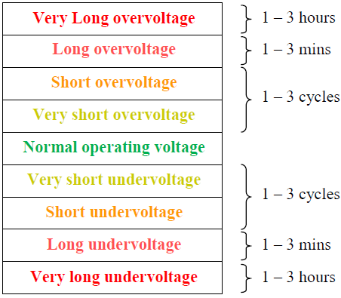

Figure 2: Magnitude-duration for classification of voltage variations (Olatoke, 2011)

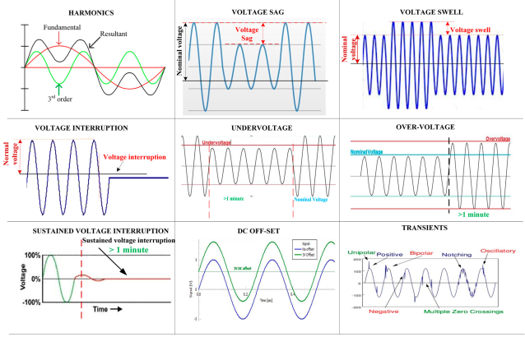

Figure 3: Waveforms of Voltage variation (Ravi and Sathish Kumar, 2022)

**5.1. Classification using Duration of Voltage Variation**

This section attempts to sum up the definitions by redefining voltage variations based on the duration and depth of voltage classifications. Thus two terms: short duration voltage variation (SDVV) and long duration voltage variation (LDVV) emerged and were used to define four parameters: sag, swell, under voltage and over voltage events. Also, the relationship that exists between them is thereafter presented.

i) Sag is an SDVV event in which the magnitude of the voltage is less than 90% of its nominal value for a period of less than one minute. Thus, a voltage disturbance is in generally considered as sag when the rms voltage remains below 90 % of nominal voltage for a period not exceeding one minute. This is expressed as (Hussein and Hawa, 2019):

$V\left(t\right)=A\left[1-α\left(u\left(t-t_{1}\right)-u\left(t-t_{2}\right)\right)\right]\text{Sin}\left(ωt\right)$ (2)

where $t_{1}<t_{2}$, $\begin{aligned}u\left(t\right)=1 \\ u\left(t\right)=0\end{aligned}$ t >0 & t <0 respectively and α is the magnitude of the sag (0.1- 0.89)

ii). Swell is an SDVV event in which the magnitude of the voltage is greater than 110% of its nominal value for a period of less than one minute. This can also be expressed as (Hussein and Hawa, 2019):

$V\left(t\right)=A\left[1+α\left(u\left(t-t_{1}\right)-u\left(t-t_{2}\right)\right)\right]\text{Sin}\left(ωt\right)$ (3)

iii). Under-voltage (UV) is an LDVV event in which the magnitude of the voltage is less than 90% of its nominal value for a period greater than one minute.

iv). Overvoltage (OV) is an LDVV event in which the magnitude of the voltage is greater than 110% of its nominal value for a period greater than one minute.

In other words, sag and swell are SDVV events of less than one minute while undervoltage (UV) and overvoltage (OV) are LDVV events of more than one minute. Similarly, sag and UV are low voltage events of magnitude less than 90% of nominal value. They are only differentiated by the duration of one minute (i. e. less or greater than one minute). When it is less than one minute, it is sag otherwise it is UV. Also, swells and OV are high voltage events of magnitude greater than 110% of nominal value differentiated by the duration of a minute. When it is less, it is swell, and when greater, it is OV. In summary, sag becomes under-voltage if the period is greater than one minute and swell becomes over-voltage when more than one minute. Figures 3 and 4 show the pictorial and graphical classification for voltage variation events respectively.

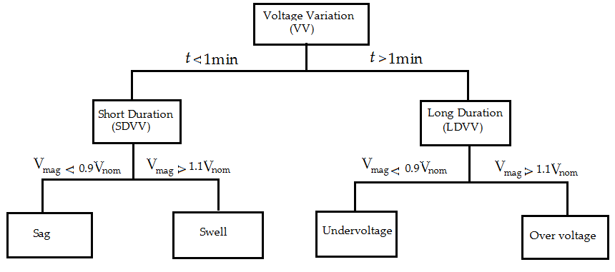

Figure 3: Voltage variation events’ classification

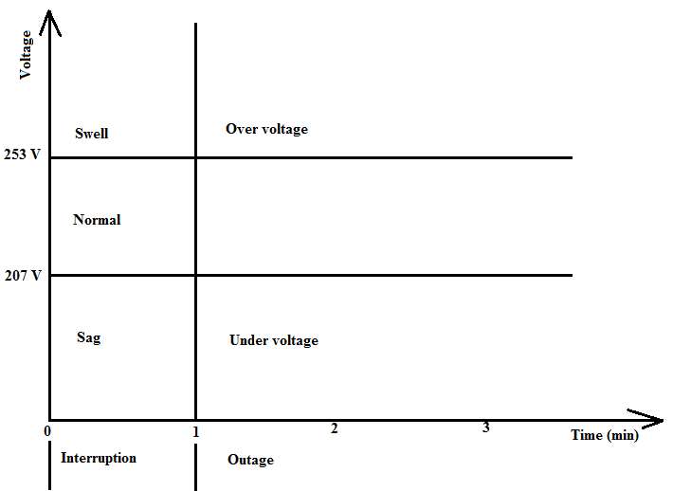

Figure 4: Graphical plot of voltage variation

**6. Control of Voltage Variation**

Monitoring and mitigating the voltage characteristic of a distribution network is essential for ensuring the reliability, safety, and efficiency of electrical power supply to consumers. Utilities often employ advanced monitoring and control systems to maintain optimal voltage levels and address any issues that may arise. Voltage regulators and transformers are used to control and adjust voltage levels as needed. It is always important for the Distribution Network Operator (DNO) to guarantee power quality compliance with national/international standards since customers connected to the network expect to be supplied with an acceptable voltage quality (Ye, 2017).

Measures to control or mitigate voltage variation effects include reactive power compensations using capacitors and other devices to improve power factors and stabilize voltage levels. Others include the use of voltage regulation devices such as tap changers, voltage stability analysis to monitor and manage voltage levels, power factor correction to improve the power quality, installation of voltage regulators to maintain voltage within specified limits, and the utilization of energy storage systems to stabilize voltage levels during fluctuations. Implementing advanced monitoring and control systems to detect and address issues proactively and ensuring timely maintenance and upgrade of ageing infrastructure are necessary to control voltage variations. Other measures include load balancing, network reinforcement and fault management. In Nigeria, efforts being made to address voltage variation issues in the electrical distribution network are embedded in general solutions to combat low-reliability problems. Since, reliability is a subset of power quality, addressing low-reliability problems is essential to mitigate voltage variations.

**7. Case Studies**

To illustrate the voltage variation of typical low reliability characterising Nigerian distribution networks, some measurement surveys were carried out within the distribution networks. The survey was part of power quality studies in the selected section of the Nigerian distribution network which is the Ilaro distribution network. Various power quality parameters were measured using the standard specifications. The equipment used is a Three-phase Power Analyser DW 6095 model. In the first case, the summary of the data obtained was analysed using descriptive statistics. Comparison with the EN50160 standard was presented. In the second case, graphical plot was employed to present the summary of the data.

Figure 5 shows the sinusoidal waveform obtained from the analser for a single phase at residential area.

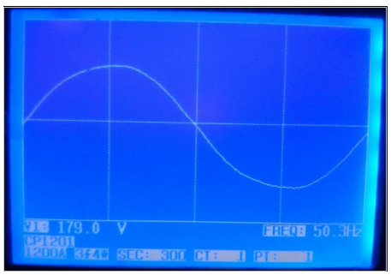

Figure 5: Waveform of public power supply from a socket outlet without any load connected at the terminal.

Table 1 shows the summary of analysis of nominal and measured values of voltage and frequency during one of the measurement surveys.

Table1: EN 50160 standards with Measured Values of Voltage and Frequency of the selected network.

|  |  |  |  |  |  |
| --- | --- | --- | --- | --- | --- |
| EN 50160 Standard Voltage(V) | | Measured Voltage (V) | EN 50160 Standard Frequency (Hz) | | Measured Frequency (Hz) |
| Average (Nominal) | 230 | 181.2 | Average (Nominal) | 50 | 50.05 |
| Maximum (110% of noominal) | 253 | 183.4 | Maximum (+1% of nominal) | 50.5 | 50.7 |
| Minimum (90% of nominal) | 207 | 179 | Minimum (-1% of nominal) | 49.5 | 49.4 |

Figure 6 shows the graphical plot for another survey within the same distribution network.

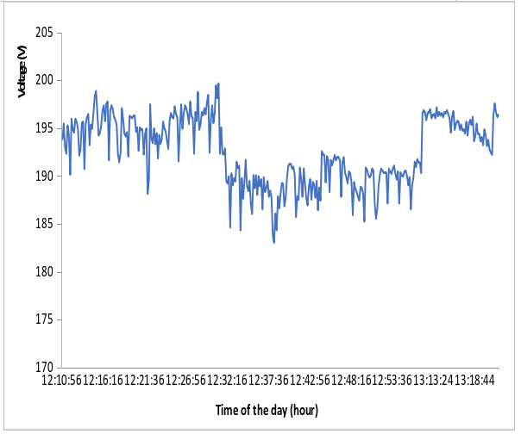

Figure 6: Voltage characteristics of a distribution network monitored with power analyser .

From these case studies, it is obvious that the low voltage variation of the selected distribution network is more pronounced and can be characterised as under-voltage. With the measured voltage magnitude of 179V as the typical value (Figure 5), the deviation from the ideal 230V is significant. From Table 1, the descriptive statistics of the nominal voltage and frequency are compared with the EN 50160 standards. The same pattern is repeated in Figure 6 for voltage only. It is obvious that the voltage characteristics of the distribution network under consideration which is typical of the Nigerian distribution are undervoltage and of poor quality. Though more work is required to characterise the entire distribution network, the results obtained here are indicators of what is obtainable in other parts of the network. Efforts to improve power quality should therefore go along with reliability improvement.

**7. Conclusion**

This work has characterised voltage variations in the selected area of Nigerian distribution network. Monitoring and mitigating the voltage characteristic of a distribution network is essential for ensuring the reliability, safety, and efficiency of electrical power supply to consumers. It is imperative to properly classify the voltage characteristics of a low-reliability distribution network based on real-time data available. Classification of voltage variation into two short-duration voltage variation (SDVV) and long-duration voltage variation (LDVV) to redefine sag, swell, undervoltage and overvoltage has been presented in this paper. Finally, the case studies involving measurement surveys were presented to illustrate the predominance of voltage variations and poor power quality characterising a low-reliability distribution network. Therefore, there is a need to make a concerted effort to improve power quality along with reliability improvement.

**References**

Dugan, R. C., McGranaghan, M. F., Santoso, S. and Beaty, H.W. (2004). Electrical Power System Quality. 2nd edition New York: McGraw-Hill. Downloaded from Digital Engineering Library @ McGraw-Hill www.digitalengineeringlibrary.com (28/03/2008).

EN 50160 1995 Application guide to the European Standard EN 50160 on "voltage characteristics of electricity supplied by public distribution systems". **Electricity Product Characteristics and Electromagnetic CompatibilityJuly 1995 Ref : 23002Ren9530**

FMP, (2015) Renewable Energy Master Plan." Federal Ministry of Power, Nigeria, 2015. [www.ecowrex.org/sites/default/files/Nigeria](http://www.ecowrex.org/sites/default/files/Nigeria) Renewable Energy Master Plan.pdf)

Hussein, A. S. and Hawa, M. N. (2019) Power quality analysis based on simulation and MATLAB/Simulink. Indonesian Journal of Electrical Engineering and Computer Science

Vol. 16, No. 3, December 2019, pp. 1144~1153. ISSN: 2502-4752, DOI: 10.11591/ijeecs.v16.i3.pp1144-1153

Johnson, D.O. and Hassan, K. A. (2016). Issues of PQ in Electrical systems. *International Journal of Energy and Power Engineering*, 5(4):148-154.

**Klajn, A. and Bątkiewicz-Pantuła, M. (2013) Application Note Standard EN 50160. Voltage Characteristics of Electricity Supplied by Public Electricity Networks. Publication No Cu0147** **Available from** [www.leonardo-energy.org/node/145851](http://www.leonardo-energy.org/node/145851)**.**

Messtechnik, N. (2021). Power Quality Explained (<https://www.neo-messtechnik.com/en/power-quality-explained-chapter5-en-50160-report-standard>.

**Mokryani, G. (2022) Future Distribution Networks: Planning, Operation, and Control. AIP Publishing. https://doi.org/10.1063/9780735422339_001**

NESG (2020) Nigeria's Power Sector: An Overview and Recommendations for the Future." The Nigerian Economic Summit Group, 2020. ([www.nesgroup.org/wp-content/uploads/2020/09/NESG-Power-Sector-Report-2020.pdf](http://www.nesgroup.org/wp-content/uploads/2020/09/NESG-Power-Sector-Report-2020.pdf))

Nigerian Electricity Distribution Companies (DisCos): Challenges and Prospects." Energy Commission of Nigeria, 2018. ([www.energy.gov.ng/wp-content/uploads/2019/07/Nigerian-Electricity-Distribution-Companies-Discos-Challenges-and-Prospects.pdf](http://www.energy.gov.ng/wp-content/uploads/2019/07/Nigerian-Electricity-Distribution-Companies-Discos-Challenges-and-Prospects.pdf))

Ogunyemi, J. and Adejumobi, I.A. (2016) Combating The Fundamental Problems Affecting Power Quality Issues in Nigeria. Journal of Academic Staff Union of Polytechnic (ASUP) Vol.1 No. 2 ISSN: 2504-9216

Ogunyemi, J.(2016) GSM Based Reliability Assessment and Service Quality Improvement Measures in Electricity Distribution Network. Paper presented at Nigerian Society of Engineers’ National Conference, Exhibition and Annual General Meeting, Uyo, Akwa-Ibom State. 21st- 25th, Nov. 2016.

Olatoke, A. O. 2011. Investigations of Power Quality Problems in Modern Buildings. M Phil Thesis (Unpublished), Brunel University School of Engineering and Design. 109pp.

**SIST EN 50160:2023 EN 50160 (2022E) Voltage characteristics of electricity supplied by public electricity networks. (https://cdn.standards.iteh.ai/samples/71003/490b981fbec343edb9db83f8ce4b2b3d/SIST-EN-50160-2023.pdf)**

World Bank Report (2019) Nigeria: Overview of the Power Sector and Challenges." ([www.worldbank.org/en/country/nigeria/publication/nigeria-overview-of-the-power-sector-and-challenges](http://www.worldbank.org/en/country/nigeria/publication/nigeria-overview-of-the-power-sector-and-challenges))

Ravi T. and Sathish Kumar K (2022), Analysis, Monitoring, and Mitigation of Power Quality Disturbances in a Distributed Generation System. Front. Energy Res. 10:989474. doi: 10.3389/fenrg.2022.989474

Ye, G. (2017). Power quality in distribution networks: estimation and measurement of harmonic distortion and voltage dips. Phd Thesis 1 (Research TU/e / Graduation TU/e), Electrical Engineering]. Technische Universiteit Eindhoven.

Zhong, Z., Zhang, H., Wang, J., Ma, G., Qiu, W. and Wang, Y. (2019) Study on Voltage Characteristics of Distributed Power Supply Connected to Distribution Network. American Journal of Electrical and Electronic Engineering, 2019, Vol. 7, No. 4, 99-104. Available online at <http://pubs.sciepub.com/ajeee/7/4/3>. Published by Science and Education Publishing DOI:10.12691/ajeee-7-4-3