**ANALYSIS AND IMPLEMENTATION OF SHEAR WALL ON HIGH RISE BUILDINGS WITH DIAGRID SYSTEM**

1Himani Soni, 2Prof. Monika Koushal

1,2 Dept. of Civil Enginering, BM College of Technology, Indore(M.P)

**ABSTRACT**

A building, or edifice, is a structure with a roof and walls standing more or less permanently in one place, such as a house or factory. In the late 19th century early designs of tall buildings recognized the effectiveness of diagonal bracing members in resisting lateral forces. Most of the structural systems deployed for early tall buildings were steel frames with diagonal bracings of various configurations such as X, K, and eccentric. However, while the structural importance of diagonals was well recognized, their aesthetic potential was not explicitly appreciated. Thus, diagonals were generally embedded within the building cores which were usually located in the interior of the building. In this paper, analysis and design of 18 storey diagrid RCC building is presented in detail. A regular floor plan of 24 m ×30 m size is considered. STADDX pro. software is used for modelling and analysis of structure. All structural members are designed using IS 800:2007 considering all load combinations. Load distribution in diagrid system is also studied for 18 storey building. Also, the analysis and design results of all diagrid structures are presented. From the study it is observed that most of the lateral load is resisted by diagrid columns on the periphery, while gravity load is resisted by both the internal columns and peripheral diagonal columns. Analysis results like storey displacement, inter storey drift are presented here.

**Keyword**: - Rectangular Building, H- Shape of Building, I-section steel girders, Diagrid

**1.0 INRODUCTION**

**1.1 General**

A high-rise building is a tall [building](https://en.wikipedia.org/wiki/Building), as opposed to a [low-rise building](https://en.wikipedia.org/wiki/Low-rise_building) and is defined by its height differently in various [jurisdictions](https://en.wikipedia.org/wiki/Jurisdiction). It is used as a [residential](https://en.wikipedia.org/wiki/Apartment_building), [office building](https://en.wikipedia.org/wiki/Office_building), or other functions including [hotel](https://en.wikipedia.org/wiki/Hotel), [retail](https://en.wikipedia.org/wiki/Retail), or with multiple purposes combined. Residential high-rise buildings are also known as tower blocksand may be referred to as "MDUs", standing for "multi-dwelling unit”. A very tall high-rise building is referred to as a [skyscraper](https://en.wikipedia.org/wiki/Skyscraper).

High-rise structures pose particular design challenges for [structural](https://en.wikipedia.org/wiki/Structural_engineering) and [geotechnical](https://en.wikipedia.org/wiki/Geotechnical_engineering) engineers, particularly if situated in a [seismically active](https://en.wikipedia.org/wiki/Seismic_activity) region or if the underlying soils have geotechnical risk factors such as high compressibility or [bay mud](https://en.wikipedia.org/wiki/Bay_mud). They also pose serious challenges to fire-fighters during emergencies in high-rise structures. New and old building design, building systems like the building [standpipe](https://en.wikipedia.org/wiki/Standpipe_(firefighting)) system, [HVAC](https://en.wikipedia.org/wiki/HVAC) systems (heating, ventilation and air conditioning), [fire sprinkler](https://en.wikipedia.org/wiki/Fire_sprinkler) system and other things like stairwell and [elevator](https://en.wikipedia.org/wiki/Elevator) evacuations pose significant problems. Studies are often required to ensure that pedestrian [wind comfort](https://en.wikipedia.org/wiki/Wind_engineering#Wind_comfort) and wind danger concerns are addressed. In order to allow less wind exposure, to transmit more daylight to the ground and to appear more slender, many high-rises have a design with [setbacks](https://en.wikipedia.org/wiki/Setback_(architecture)).

**1.2 Braced and Diagrid system in high rise building**

A major departure from this design approach occurred when braced tubular structures were introduced in the late 1960s. For the 100-story tall John Hancock Building in Chicago, the diagonals we relocated along the entire exterior perimeter surfaces of the building in order to maximize their structural effectiveness and capitalize on the aesthetic innovation. This strategy is much more effective than confining diagonals to narrower building cores. Clearly a symbiosis between structural action anesthetic intent, such as demonstrated by the Hancock Tower, is an example of highly integrated design and engineering. Recently the use of perimeter diagonals—hence the term ‘diagrid’—for structural effectiveness and esthetics has generated renewed interest from architectural and structural designers of tall buildings (Figure 1).

The difference between conventional exterior-braced frame structures and current diagrid structures is that, for diagrid structures, almost all the conventional vertical columns are eliminated. This is possible because the diagonal members in diagrid structural systems can carry

gravity loads as well as lateral forces owing to their triangulated configuration, whereas the diagonals in conventional braced frame structures carry only lateral loads. Compared with conventional framed tubular structures without diagonals, diagrid structures are much more effective in minimizing shear deformation because they carry shear by axial action of the diagonal members, while conventional framed tubular structures carry shear by the bending of the vertical columns. Another prevalent structural system for today’s tall buildings is outrigger structures with either reinforced concrete cores or steel-braced cores.



**Fig. 1.1 Braced vs diagrid system in building from Google source bending moment**



**Fig. 1.2 Diagrid Structural Systems**

**1.3 Irregularities:**

The geometry of a diagrid structure is generally customized in order to satisfy building-specific requirements. The purpose of this paper is to provide preliminary design guidelines for atypical range of diagrid structures. First, the structurally optimal range of angles of diagonal members is investigated for typical 60-, 42- and 20-story buildings, using a conventional iterative design approach. Then, a simple methodology for determining preliminary diagrid member sizes is introduced and applied to previous set of buildings. Lastly, the design parameters generated with this procedure are verified and compared with the previous set. The proposed methodology was found to produce good estimates of the design variables with minimal effort.

**1.3.1 Structural Analysis and Design Software**

Perform comprehensive analysis and design for any size or type of structure faster than ever before using the new STAAD. Pro CONNECT Edition. Simplify your BIM workflow by using a physical model in STAAD.

**2.0 Methodology**

The principle of design is to evolve safe and economical design of structures to withstand possible future earthquake. This can be achieved by proper provisions of adequate strength, stiffness and ductility in the structure. Besides, this earthquake resistance of structure can be increased by careful planning, design and constructions.

**2.1 Method of Analysis**

**IS code 456:2000 permits only 2 methods for seismic analysis**

(*a*) The Direct Design Method

(*b*) The Equivalent Frame Method

**The Direct Design Method**

This method has the limitation that it can be used only if the following conditions are fulfilled

1. In each direction there shall be minimum of three continuous spans.

2. The panels shall be rectangular and the ratio of the longer span to the shorter span within a panel shall not be greater than 2.

3. The successive span length in each direction shall not differ by more than one-third of longer span.

4. The design live load shall not exceed three times the design dead load.

5. It shall be permissible to offset columns a maximum of 10 percent of the span in the direction of the offset notwithstanding the provision in (2).

**The Equivalent Frame Method**

IS 456–2000 recommends the analysis of flat slab and column structure as a rigid frame to get design moment and shear forces with the following assumptions:

1. From the structure beam is considered as equivalent to the moment of inertia of slab bounded laterally by center line of the panel on each side of the center line of the column. In the frames

**3.0 Model description**

On this chapter we discussed about model description and present work of software analysis and gives other model pictures with normal building and it contains a discussion on the load-displacement positions along the different models following.with comparative study of behavior of structures building frames with four geometrical configurations and different condition in structure. This study is attempted in following steps

1. Selection of building geometry, maximum 10 boys and G+18 of 3D frame.
2. Selection of rectangular building according to first line but providing Diagrid frame.
3. selection of rectangular building according to first line but providing Diagrid frame with shear wall at center

The structure is 24m in x-direction &30m in y-direction with columns spaced at 3m from center to center. The storey height is kept as 3.0m. Basically model consists of multiple bay 10storey building, each bay having width of 3m. The storey height between two floors is 3.0m with beam and column sizes of 450x600m respectively and also the slab thickness is taken as 0. 125m.Shape of the building for all the cases is shown in figure

**3.1 STAAD.Pro Model Details of Rectangular Building Without Any Changes for Zone IV**

In [structural engineering](https://en.wikipedia.org/wiki/Structural_engineering), a shear wall is a vertical element of a seismic force resisting system that is designed to resist in-[plane](https://en.wikipedia.org/wiki/Plane_(mathematics)) lateral forces, typically [wind](https://en.wikipedia.org/wiki/Wind) and seismic loads. In many jurisdictions, the [International Building Code](https://en.wikipedia.org/wiki/International_Building_Code) and [International Residential Code](https://en.wikipedia.org/w/index.php?title=International_Residential_Code&action=edit&redlink=1) govern the design of shear walls.

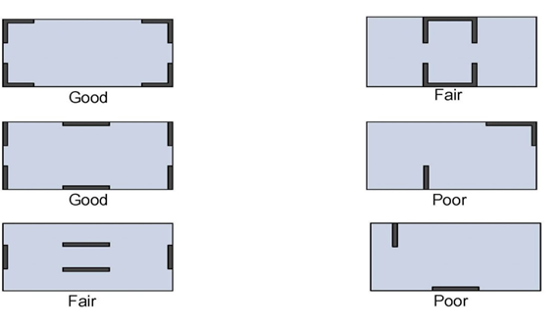

**Fig. 3.5**Placement of shear wall

**4.0 Details of building for all types**

**Table No. 4.1 Details of Model Applicable for All Model**

**Table: - 4.1**Details of Building

|  |  |
| --- | --- |
| SR. NO. | Elements Of Building Dimension |
| 1 | Length x width: 24m X 30m |
| 2 | Number of stories:17 |
| 3 | Support conditions: Fixed |
| 4 | Storey height: 3- 30m |
| 5 | Grade of concrete: M 30 |
| 6 | Grade of steel: Fe500 |
| 7 | Size of columns from 1-10storey: 450mm x 600mm |
| 8 | Size of beams: 300mm x 600mm |
| 9 | Depth of foundation : 3 m |
| 10 | Height of parapet wall: 1 m |
| 11 | Thickness of main wall: 230mm |
| 12 | Thickness of parapet wall: 230mm |
| 13 | Damping ratio: 0.05 |
| 14 | Seismic zones IV (0.24) |
| 15 | Importance factor |
| 16 | Thickness of main wall: 200mm |
| 17 | Thickness of parapet wall: 230mm |
| 18 | Response reduction factor 0.5 |
| 19 | Damping ratio 0.05 |
| 20 | Soil type medium 2 |
| 21 | Live load :2 kN/m2 |
| 22 | Floor Finish: 1.5 kN/m2 |

**4.1 Loadings Considered**

1. Dead Load- floor load, Wall load, Parapet Load as per to IS 875 (part1).
2. Live Load- 2 kN/m2 on all the floors.
3. Earthquake Load- As perIS 1893 (part-I):2002.

**4.2. Load Combinations**

Load combinations considered are as follows:

1. 1.5(DL + LL)
2. 1.5(DL + EQX)
3. 1.5(DL - EQX)
4. 1.5(DL + EQZ)
5. 1.5(DL - EQZ)
6. 1.2(DL +LL + EQX)
7. 1.2(DL +LL - EQX)
8. 1.2(DL +LL + EQZ)
9. 1.2(DL +LL - EQZ)

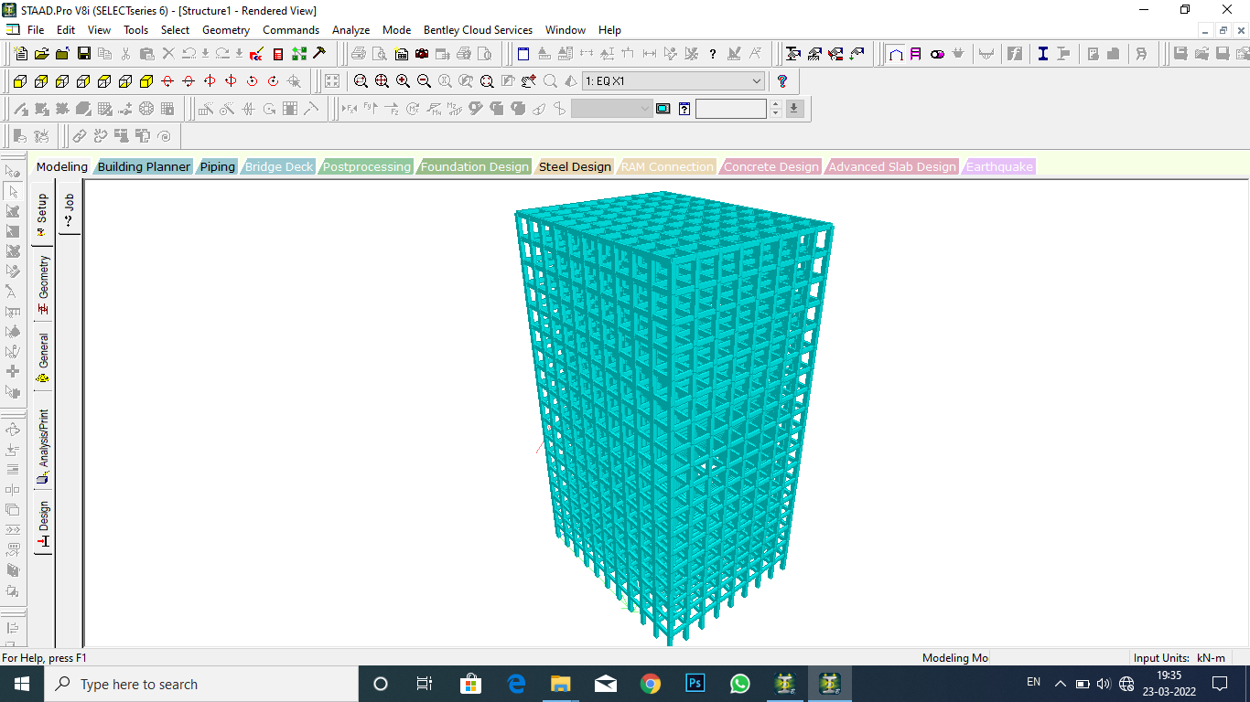

*Figure 4.1 Normal Rectangular Building 3D Model*

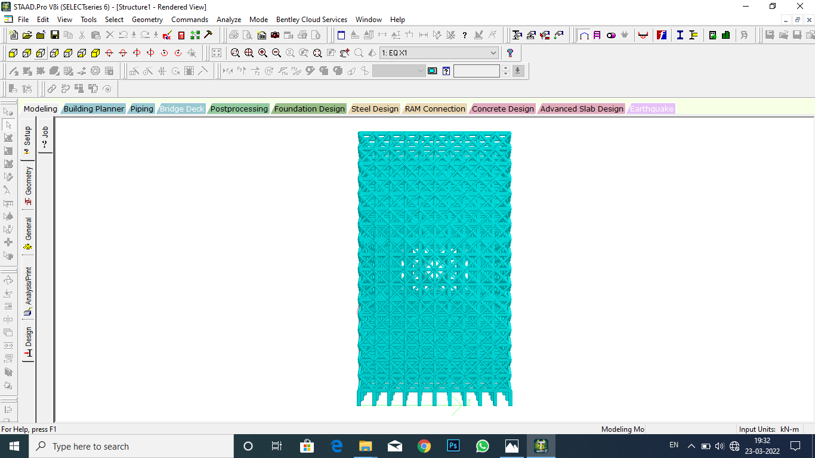

*Figure 4.3 Rectangular Building 3D Model with Diagrid system*

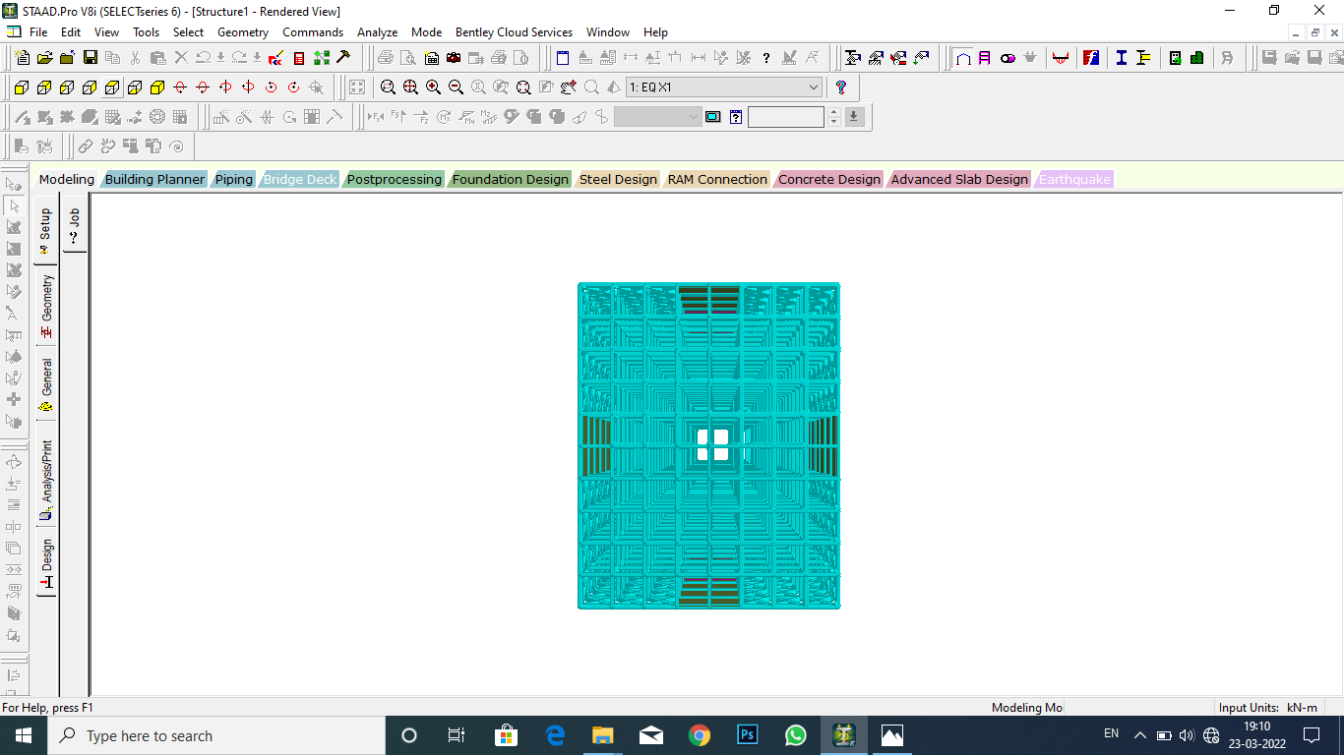

*Figure 4.2 Dimension Plan Diagram of Rectangular Building with Diagrid and shear wall at center*

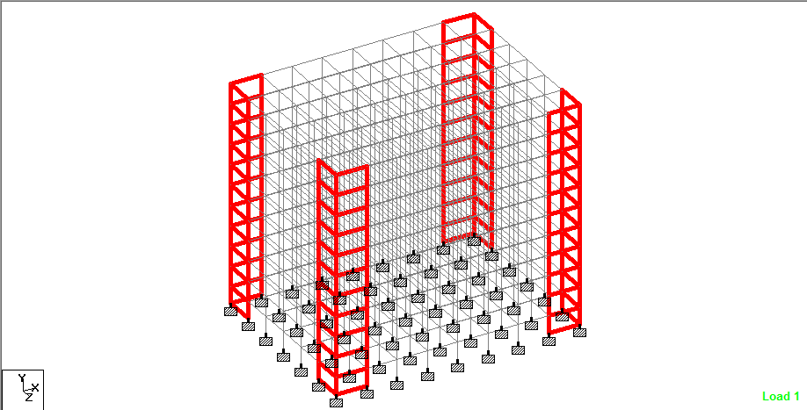

*Fig. 4.4 Isometric view Diagram of Rectangular Building with Shear wall using R.C.C shear wall*

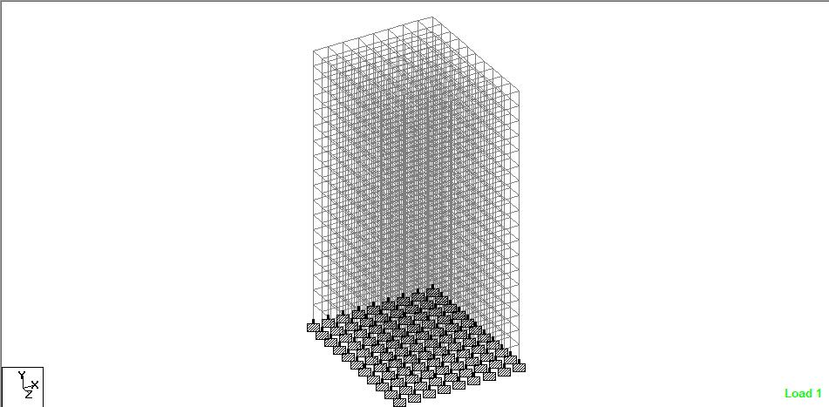

*Figure 4.5 Normal Rectangular Building with Wire Frame Model*

**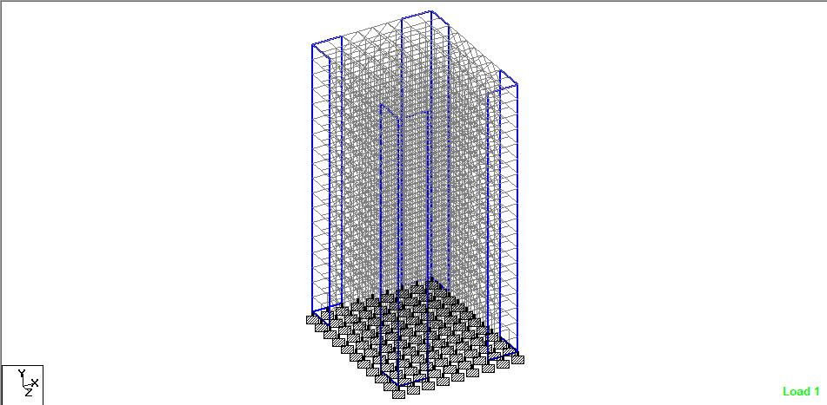*Fig. 4.6 Deflected view of Rectangular Building with Shear wall at the corner***

***Fig. 4.7 bending moment view of Rectangular Building with Shear wall using R.C.C shear wall***

**Fig. 4.8 Hight vs Drift chart**

**5.0 Parameters and different aspects of study**

**5.1 Storey Drift**

Controlling storey sway or inter storey drift of a building is an important aspect because

1. It prevents pounding of adjacent buildings in urban areas.
2. It controls plastic deformation of coupling beams within the values that can be met.
3. It restricts damage to fragile non-structural elements, which can be costlier than the building.
4. Drift limitation provide stability of individual columns as well as the structure as a whole.
5. Limited drift also provide comfort to occupant of such buildings.

The storey driftMaccording to seismic code IS 1893 (part-I):2002 in any storey due to specified designed lateral force with partial load factor of 1.0, shall not exceed 0.004 times the storey height.

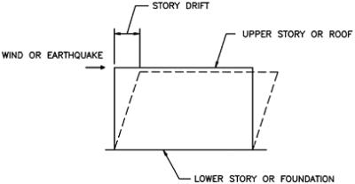

***Figure 4.9 Story Drift***

**6.0 Result Parameters**

The performance of diagrid and shear wall is assessed for High rise building with 17 storeysbuilding in common earthquake zones IV. The results obtained from analysis are given in various tables and figures are as follows.

An18-storey tall building is considered. The storey height is 3 m. The diagrids were provided at 3 m spacing along the perimeter

According to IS: 456:2000, maximum limit for lateral displacement is H/500, where H is building height. Therefore, maximum lateral displacement has also been studied in rectangular, L shape & H Shape Multistorey Building with and without shear walls, for all types of floor systems.

**7.0 Conclusion**

1. In this paper, analysis and design of 18 storey diagrid RCC building is presented in detail. A regular floor plan of 24 m ×30 m size is considered. STADDX pro. software is used for modelling and analysis of structure. All structural members are designed using IS 800:2007 considering all load combinations. Load distribution in diagrid system is also studied for 18 storey building. Also, the analysis and design results of all diagrid structures are presented.

From the study it is observed that most of the lateral load is resisted by diagrid columns on the periphery, while gravity load is resisted by both the internal columns and peripheral diagonal columns. So, internal columns need to be designed for vertical load only. We also observed shear wall at centre we decreasing shear force and bending moments.

1. Diagrid structural system provides more flexibility in planning interior space and facade of the building.
2. This study reveals that the lateral displacement and the storey drift of the structure are affected by its plan ofdiagrid and shear wall.
3. Lateral and gravity load are resisted by axial force in diagonal members on periphery of structure which make system more effective

**8.0 REFERENCES**

1. **2017, MohdJamaluddin Danish**, **“Static and Dynamic Analysis of Multi-Storey Building with the Effect of Ground and Intermediate Soft Storey having Floating Columns”**, International Journal for Scientific Research and Development, ISSN: 2321-0613, Vol. 5, pp 44-47.
2. **2017, Ms.Waykule S.B,**Dr. C.P. Pise, Mr. C.M. Deshmukh, Mr. Y.P. Pawar, Mr S.S Kadam, Mr. D. D. Mohite, Ms. S.V. Lale, **“Comparative Study of Floating Column Of Multistorey Building By Using Software”**, International Journal of Engineering Research and Application, ISSN: 2248-9622, Vol. 7, pp 31-38.
3. **Amin Alavi, P. Srinivasa Rao**., Effect of Plan Irregular RC Buildings in High Seismic Zone. Aust. J. Basic &Appl.Sci., 7(13): 1-6, 2013.
4. **Bureau of Indian Standards: IS-1893**, part 1 (2002), Criteria for Earthquake Resistant Design of Structures: Part 1General provisions and Buildings, New Delhi, India.
5. **Bureau of Indian Standards: IS-875**, part 1 (1987), Dead Loads on Buildings and Structures, New Delhi, India.
6. **Giordano, A., M. Guadagnuolo and G. Faella, 2008**. “Pushover Analysis of Plan Irregular Masonry Buildings”. Inthe 14th world conference on earthquake engineering. Beijing, China, 12-17.
7. **Guleria, Abhay**. "Structural Analysis of a Multi-Storeyed Building Using ETABS for Different PlanConfigurations." Vol. 3.Issue 5 (2014): 1481-484. International Journal of Engineering Research & Technology (IJERT). Web. 1 May 2014.
8. **Herrera, Raul Gonzalez and Consuelo Gomez Soberon, 2008**. Influence of Plan Irregularity of Buildings." In the14th world conference on earthquake engineering. Beijing, China, 12-17.
9. **M.R.Wakchaure, AnantwadShirish, RohitNikam**, “Study of Plan Irregularity on High-Rise Structures”,International Journal of Innovative Research &Developement, Vol 1 Issue 8 October 2012.
10. **Poonam, Anil Kumar and A. K. Gupta,** “Study of Response of Structural Irregular Building Frames to SeismicExcitations,” International Journal of Civil, Structural, Environmental and Infrastructure Engineering Research and.
11. **AnupamRajmani, Prof PriyabrataGuha (2015),** “Analysis of Wind & Earthquake Load For Different Shapes Of High Rise Building”, International Journal Of Civil Engineering And Technology (IJCIET), vol. 2 , pp.38-45
12. **BhumikaPashine, V. D. Vaidya, Dr. D. P. Singh (2016),** “Wind analysis of multistoried structure with T shape and L Shape geometry”, International Journal of Engineering Development and Research, vol.3, pp.2321-9939
13. **B. S. Mashalkar , G. R. Patil , A.S.Jadhav (2015),** “Effect of Plan Shapes on the Response of Buildings Subjected To Wind Vibrations”, IOSR Journal of Mechanical and Civil Engineering (IOSR-JMCE), pp.80-89
14. **Dr. K. R. C. Reddy1, Sandip A Tupat (2014),** “The effect of zone factors on wind and earthquake loads of high-rise structures”, IOSR Journal of Mechanical and Civil Engineering (IOSR-JMCE), pp.53-58
15. **LodhiSaad, S. S. Jamkar (2015),** “Comparative study of Wind load Analysis of buildings of various shapes and sizes as per IS 875: (part 3) and ASCE 7-02”, International Journal of Emerging Technology and Advanced Engineering, vol.5