**Pulsed Electric Field Technology for Food Preservation: A Review of Applications, Mechanisms, and Future Prospects**

*DEEP SARKAR*

*sarkar_deep@aol.com*

*M.TECH (BIOTECHNOLOGY)*

*KALINGA SCHOOL OF BIOTECHNOLOGY*

*KIIT, Odisha, India*

**Abstract:**

*Pulsed Electric Field (PEF) technology has emerged as a promising non-thermal food preservation method with the potential to extend the shelf life of perishable foods while retaining their nutritional quality and sensory attributes. This paper provides an overview of the principles, applications, mechanisms, and recent developments in PEF technology for food preservation. The effectiveness of PEF in microbial inactivation, enzyme inactivation, and quality preservation is discussed, along with the factors influencing its efficiency and scale-up considerations. Furthermore, the challenges and future prospects of PEF technology in the food industry are examined to highlight its potential as a sustainable and eco-friendly alternative to traditional preservation methods.*

**Keywords:** *Pulsed Electric Field (PEF), Food Preservation, Microbial inactivation, Enzyme Inactivation*

**Introduction**

Food preservation is a critical aspect of the food industry to ensure food safety, extend shelf life, and maintain product quality. Traditional methods of food preservation, such as thermal processing, chemical preservatives, and irradiation, have limitations in terms of their impact on nutritional quality, sensory attributes, and environmental sustainability. Pulsed Electric Field (PEF) technology has emerged as a promising alternative that utilizes short-duration, high-voltage electrical pulses to inactivate microorganisms, enzymes, and spoilage agents in food products.

**PEF Technology and Mechanisms:**

PEF technology involves the application of short, high-voltage electrical pulses (typically in the range of 1-50 kV/cm) to food products placed between two electrodes. The electric field disrupts the cell membranes of microorganisms and enzymes, leading to cell death and enzyme inactivation. The mechanisms of microbial inactivation by PEF include electroporation, electropermeabilization, and irreversible damage to cell membranes. In addition to microbial control, PEF has been shown to inactivate enzymes responsible for food deterioration, such as polyphenol oxidase, peroxidase, and lipase, thereby extending the shelf life of perishable foods.

**Applications of PEF in Food Preservation:**

PEF technology has been successfully applied to a wide range of food products, including fruit juices, dairy products, liquid eggs, meat, and seafood. Studies have demonstrated the effectiveness of PEF in reducing microbial populations, extending shelf life, and preserving nutritional quality and sensory attributes. PEF treatment parameters, such as electric field strength, pulse duration, and number of pulses, can be optimized to achieve the desired level of microbial inactivation while minimizing the impact on food quality.

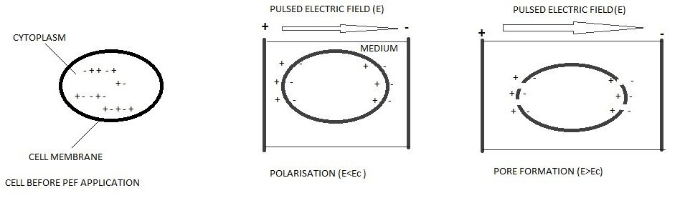

***FIG.1 BEHAVIOR OF CELL MEMBRANE WITH INFUSION OF PEF***

**Factors Influencing PEF Efficiency:**

Several factors influence the efficiency of PEF technology in food preservation, including food composition, electrode configuration, treatment temperature, and post-treatment storage conditions. The conductivity and dielectric properties of food matrices play a crucial role in determining the extent of microbial inactivation and enzyme inactivation. High-conductivity foods, such as fruit juices, are more susceptible to electric field-induced damage compared to low-conductivity foods, such as solid fruits and vegetables.

**Literature Review**

Pulsed Electric Field PEF is a non-thermal food preservation method that uses short electrical circuits to kill microorganisms with minimal impact on food quality. Compared to traditional separation methods, this method avoids or significantly reduces adverse changes in the sensory and physical properties of food. The goal of PEF technology is to provide consumers with high-quality food based on food-quality heat treatment methods by avoiding or significantly reducing adverse changes in physical and knowledge of pseudo food.PEF technology is better than methods like heat treatment because it can kill microorganisms and better preserve the original color, taste, texture and nutritional value of the food. Not processed. PEF technology involves applying a high voltage to a liquid or semi-solid food placed between two electrodes. Most PEF studies have focused on the effects of PEF treatment on microbial contamination in milk, dairy products, egg products, juices, and other liquid foods (Qin et al., 1995). However, although many research papers on PEF food preservation microorganisms have been published, there is still little information on the impact of this technology on food composition as well as food quality and acceptance. Recently, there has been renewed interest in the use of electric fields (PEF) in food processing. PEF treatment has been shown to be very effective in killing microorganisms, increasing breaking capacity, increasing water extraction from foods, and improving drying and drying food. Electrolytic technology or (PEF) is considered one of the best non-thermal methods for removing microorganisms in food. Microorganisms are killed at temperatures below the heat treatment temperature by using short high voltage pulses (Î¼s) between two electrodes to generate an electric field in the range of 5-50 kV/cm. The correct method is an electric field, but the microorganisms are not activated. However, PEF is thought to cause microorganisms. In recent years, non-heat processing alternatives to heat processing have become increasingly popular due to the increasing demand for nutritious foods and new trends. It was taken over. Electromagnetic fields (PEF) are a new technology that has been intensively studied in the field of non-thermal food processing. Many researchers have conducted research on his PEF processing in various liquid foods. In the PEF study, apple and orange juice were the most potent foods. The purpose is to maintain the sensory properties of water and extend its shelf life. Yogurt, applesauce, and salad dressings have been shown to retain freshness and extend shelf life after processing. Some other different varieties of PEF processed food include the main dairy products like milk, high water content vegetables like tomato puree, tomato pulp and juices (Min et al., 2003), rich in vitamin A vegetables like carrot and its blended juices, green pea extract juices and dried ready to eat soups (Vega-Mercado et al., 1996), and varieties of fish products like the sea as well as fresh water fishes with different parts (Mart­n-Belloso et al., 1997). Times ranging from microseconds to milliseconds can cause temporary or permanent permeabilization of the cell membrane. The effects of PEF on biological membranes have been thoroughly studied, as the use of PEF has attracted great interest in several scientific fields such as cell biology, biotechnology, medicine, and food technology (Zimmermann, 1986; Palaniappan and Sastry, 1990; Ho and Mittal, 1996); Prasanna and Panda, 1997 recently published studies are reviewed and compared with results obtained with other heat-treated and non-heat-treated techniques. Particular emphasis is placed on the influence of PEF processing variables on the bioactive composition throughout the food shelf life. And it's not just about explaining with various examples. Although PEF technology has the potential to preserve the health-promoting properties of plant-based foods, it also has limitations. PEF technology can use electric fields to inactivate vegetative cells of bacteria and yeast in a variety of foods. Bacterial spores are resistant to pulsed electric fields, so applications of this technology are mainly focused on food borne pathogens and spoilage-causing microorganisms, especially in acidic foods. In addition to the volumetric effectiveness of PEF technology for rapidly and consistently controlling the microbiological safety of foods, if successfully applied, it can improve the sensory value and nutritional value of foods without the use of heat. It can also be used to it also has the advantage of maintaining its value over the long term.PEF technology has the potential to improve energy consumption economically and efficiently, and also has the advantage of providing microbiologically safe and minimally processed food products.

Non-thermal technology is a new field of food processing and is currently being researched all over the world. Research has grown rapidly, especially in recent years. The main purpose of heat treatment is to inactivate pathogenic microorganisms and spores (depending on the treatment) and provide the consumer with a microbiologically safe product. However, despite its benefits, heat treatment involves many changes to the product that affect the final quality, such as: B. Taste, color, texture, and overall appearance. Today, consumers value not only the freshness of food, but also its sensory quality and nutritional content. Consumers have become more conscious of food ingredients and the techniques used to process them, preferring natural products that are free of chemicals and additives (Evans and Cox, 2006). Therefore, the need for alternative processing that can achieve microbial inactivation, maintain freshness properties of food products, and provide environmentally friendly products at affordable prices is a current concern of many food scientists/technologists around the world. It is a concern. It has become a matter of interest. This has become a problem. Non-thermal processing techniques have been developed to avoid the use of high temperatures during processing and thereby avoid the negative effects of heat on the taste, appearance and nutritional value of foods (Barbosa-Canovas et al., 1999). New nonthermal processes such as high hydrostatic pressure (HHP), pulsed electric fields (PEF), ionizing radiation, and ultrasound can inactivate microorganisms at ambient or sub lethal temperatures. However, many of these processes require very high processing intensities to sufficiently kill microorganisms in low-acid foods. Combining non-thermal processes with traditional preservation methods increases antimicrobial efficacy and allows the use of lower process intensities. By combining two or more nonthermal methods, it is also possible to improve microbial inactivation and reduce the intensity of individual treatments. Ideal for traditional preservation treatments. Traditional preservation treatments achieve synergistic effects by simultaneously attacking different components of microbial cells, and the hurdle concept achieves optimal microbial control. The mechanism of inactivation by non-thermal processes is still unclear. Therefore, the basis for synergistic combinations remains speculative (Ross et al., 2003). Non-thermal techniques include effective preservation treatments at ambient or sub lethal temperatures such as: B. Antimicrobial additives, pH adjustment and atmosphere adjustment. The term "non-thermal treatment" is appropriate for new non-thermal techniques such as high hydrostatic pressure, pulsed electric fields (PEF), high-intensity ultrasound, ultraviolet light, pulsed light, and ionizing radiation. The target is an oscillating magnetic field. Used as a microbial inactivation process in food production. New modern techs can diffuse microorganisms to different degrees (Butz and Tauscher, 2002). High hydrostatic pressure (HHP), a nonthermal technique, has been shown to have little effect on the nutritional content of foods. For example, in fruit and vegetable processing, post-processing pressure has minimal effect on anthocyanin content. Anthocyanins are thought to be phytochemicals that are not only responsible for color but also have antioxidant properties that are important for human health. However, the anthocyanin content in fruit juice after pulsed electric field (PEF) treatment showed contradictory results. Some researchers reported minimal effects on pigment content after treatment, while others showed a decrease in anthocyanin content after pulsation (Tiwari et al., 2009). The most extensively studied and promising nonthermal processes appear to be high hydrostatic pressure (HHP), pulsed electric fields (PEF), and intense ultrasound in combination with pressure. Despite the great potential of gamma rays, their development and commercialization have so far been hampered by unfavorable public perceptions (Resurreccion et al., 1995). Despite the current gaps in knowledge, combinations of nonthermal processes and other nonthermal technologies have been investigated with promising results to improve the control of food borne microorganisms. To enable the development of new food preservation strategies based on sound scientific evidence, there is a need for a deeper understanding of the antimicrobial mechanisms of new non-thermal technologies and their effectiveness in combination with traditional barriers to food preservation (Barbosa-Canovas et al., 1998). High-pressure processing at room temperature creates a product that retains most of its food-safe properties. For example, pressurization does not affect covalent bonds, thus avoiding strange flavors in foods (Knorr et al., 2002). Ultrasound has also been used to pasteurize milk with remarkable results. Milk is highly homogenized, white in color, and has good stability after processing. In this method, pasteurization and homogenization are performed in his one-step process (Berm³dez-Aguirre etal. 2009).

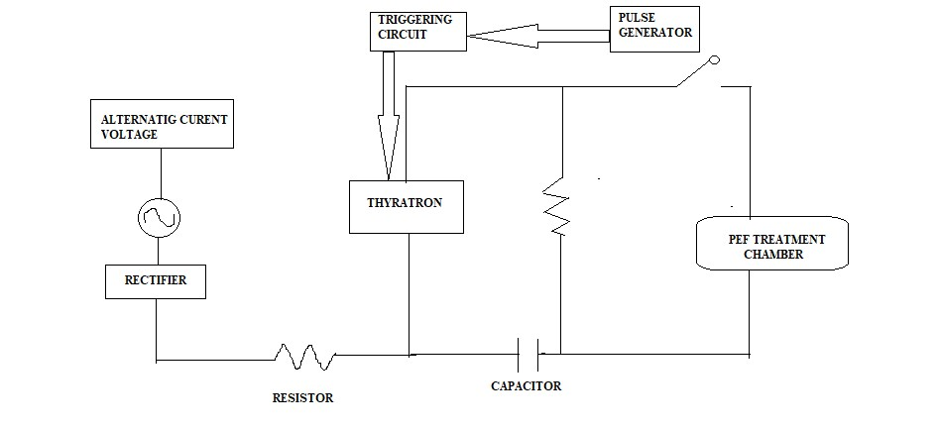 ***FIG 2. SCHEMATIC DIAGRAM OF THE PULSED ELECTRIC FIELD FOOD PRESERVATION SYSTEM***

**Summarization of Research and Key findings**

* Low intensity Pulsed Electric Field (1 – 3 kV/ cm) reduced yogurt processing time of fermentation by about nearly (0.31 –0.52) hours.
* The PEF could stimulate LAB metabolism, adding yogurt LA attention between 0.76 –0.90.
* It has been found from the review that the PEF treatment didn't affect yogurts flavor, color, titrable acidity and density.
* The Conventional yogurt processing lasts around (4.5 – 6) hours, representing high energy consumption and product costs. The (PEF) processing to the starter culture before yogurt turmoil or fermentation represents an implicit volition to dwindle product time by stimulating lactic acid bacteria and accelerating turmoil stage.
* This study demonstrated that low- intensity PEF (1 – 3 kV/ cm) reduced turmoil time or the fermentation time by about 0.31 –0.52 h without compromising yogurt's quality parcels, including physicochemical characteristics and sensitive attributes.
* Attained results suggest that this technology allows more effective and sustainable yogurt product styles, appreciatively impacting assiduity and consumers.
* The pH value of the invested milk significantly dropped from {6.18 ±0.01 (0 h) to 4.32 ±0.02 (6 h)}.
* Turmoil time or fermentation time, calculated at cut- off pH, was about (4.70 ±0.23) h. This time is within the typical yogurt turmoil time range (3 – 5 h) preliminarily reported by other authors (Soukoulis etal. 2007).
* The drop in pH value that is observed is substantially due to the LAB metabolic processes within the starter culture (Bintsis, 2018; Popović etal, 2020).
* Also, Chen etal.( 2017) reported that this study demonstrates that applying low- intensity palpitated electric fields( 1 – 3 kV/ cm) as a pre-treatment to the Streptococcus thermophilus and Lactobacillus bulgaricus starter culture invested in milk could significantly stimulate their exertion during yogurt turmoil. This leads to an accelerated reduction in pH and shorter turmoil time compared to conventional yogurt elaboration process, without compromising sensitive and physicochemical parcels of the product.

**Challenges and Future Prospects:**

Though there are several advantages in this non thermal technology, PEF technology still faces some challenges related to scale-up, cost-effectiveness, and regulatory approval. The integration of PEF into existing food processing lines and the development of cost-effective equipment are key challenges that need to be addressed for the widespread adoption of this technology in the food industry. Future research directions include the optimization of PEF treatment parameters, the development of novel electrode designs, and the exploration of combined technologies to enhance the efficacy of PEF in food preservation.

**THE OVERALL FLOW CHART FOR THE PEF PROCESS APPLIED FOR ALL KINDS OF FOOD**

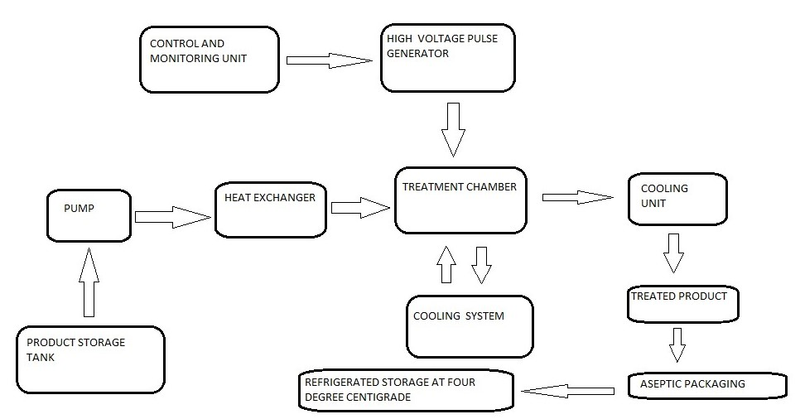

***FIG.3. THE FLOW CHART OF THE PEF AIDED FOOD PRESERVATION***

**Conclusion**

The food preservation methods are implemented by the food industry to control the microorganisms that have contaminated the food. The main motive of food preservation technology leads towards the inactivation or to prevent the microbial growth. Pulse Electric Field (PEF) is an alternative to the old method of warm handling for food preservation. In PEF, when the food is exposed to intense electrical field pulses, the cell membranes of the microorganisms present in the food becomes porous. These pores often get dilated or leads to opening of new ones. The time limit for the opening of the pores depend upon the status of the treatment, it may be for a short period of time or for a long period. The PEF processing system is comprised of a high power pulse generator, a treatment cell and voltage and current measuring devices. In the treatment cell, an insulating substance holds two electrodes in parallel, forming an enclosure for the treatment of the food. Short electric field pulses have to be produced between two parallel plate electrodes and a dielectric material in order to achieve and use high intensity pulse electric fields. This technique is the application of very short pulses ( microseconds to milliseconds ) at electric field intensities varying within 10-80 kV/cm to a food product held between the electrodes inside the chamber , typically at room temperature Researchers are ongoing throughout the world on the technology of PEF. The majority of the research on PEF is done in laboratories and on a pilot plant scale; the results achieved by the experiments are promising. The reason behind the expectations is due to PEF's capacity to inactive microorganisms in the food, reducing the enzymatic movement, broadening the timeframe of realistic usability with unimportant changes in the nature of the eventual outcome when compared to the first one. As per the indication by the force of the field strength, electro oration can be either reversible (cell layer release). Majority of the solid products that contains air bubbles, which are placed in the treatment chamber are not eligible for the PEF method. For continuous treatment using the PEF method, homogeneous liquids with a maximum particle size and low electric conductivity are ideal for the the process. For fluid food safety, PEF technology is a very trustable process. It has shown 5 log reductions of various waste animals in liquid food sources which satisfies the standard essentials by FDA. Numerous factors influence the PEF treatment and the process parameters for each food application are unique and needs more improvement. Due to their low processing and lack of preservatives, PEF-treated fruit juices are healthy. In addition, preservation of the flavour and nutrients of liquid and semi liquid foods are nicely done. Aseptic binding, followed with heat, normal antimicrobial mixtures, a pulse electric field and other non-warm advancements like ultrasound, offers immense benefits like a more extended timeframe of realistic usability in the cooler, usage of energy is lower and higher microbial and chemical inactivation. With the combination of PEF with other non-warm innovations like ultrasound and high hydrostatic tension, processed productivity gets increased. The availability of PEF pasteurised fruit juices are expected to increase soon as lots of business farms are currently investing and producing commercial PEF systems.

**References**

1 - Jay, J.M., (1992), High temperature food preservation and characteristics of thermophilic microorganisms, In: Modern Food Microbiology, Van Nostrand Reinhold, New York, pp. 335.

2 - Hülsheger, H., Potel, J., and Niemann, E.G. (1983). Electric field effects on bacteria and yeast cells. Radiation and Environment Biophysics, 22, 149-162

3 - Hülsheger, H., Potel, J., and Niemann, E. G., Killing of bacteria with electric pulses of high field strength, Radiat. Environ. Biophys. 20: 53-65

4- Hodgins, A., Mittal, G., and Griffiths, M., (2002), Pasteurisation of fresh orange juice using low-energy pulsed electric field, J. Foodsci. 67(6): 2294-2299

5 - Ho, S.Y., Mittal, G.S., Cross, J.D., and Griffiths, M.W. (1995). Inactivation of Pseudomonas fluorescens by High Voltage Electric Pulses. J. Food Sci., 60:1337-1340,1343.

6 - Ho, S. Y; Mittal G S ( 2000 ). High voltage pulsed electrical field for liquid food pasteurisation. Food Review International, 16, 395-434

7 - Ho, S. Y, and Mittal, G. S., (1996), Electroporation of cell membranes: A review , Crit. Rev. Biotechnol. 16(4): 349-362.

8 - Wirjantoro, T. I., and Lewis, M. J., (1997). Effect of nisin and high temperature pasteurisation of shelf life of whole milk, J. Soc. Dairy Technol. 49(4): 99-1 02.

9 - Wouters, P., Alvarez, I., and Raso, I., (2001). Critical factors determining inactivation kinetics by pulsed electric field food processing, Trends Foodsci. Technol. 12: 112-121.

10 - Yeorn, H., Zhang, Q., and Dunne, C; (1999). Inactivation of papain by pulsed electric fields in a continuous system, Food Chem . 67:53-59.

11 - Zhang, Q. H., Barbosa-Cánovas, G. V., & Swanson, B. G. ( 1995 ). Engineering aspects of pulse electric field pasteurisation. Journal of Food Engineering, 25, 261-281

12 - Zimmerman U, and Benz R, (1980), 'Dependence of the electrical breakdown voltage on the charging time in Valonia utricularis' , J. Membr Biol, 53, 33-43.

13 - Zimmerman, U., 1986, Electric breakdown, electropermeabilization and electrofusion, Rev. Phys. Biochem. Pharmacol.105: 196-256., 176-257.

14 - Fernandez-Molina, J. J., Barkstrom, E., Torstensson, P., Barbosa-Cánovas, G. V. and Swanson, B. G. 1999. Shelf-life extension of raw skim milk by combining heat and pulsed electric fields. Food Res Int.

15 - Reina, L.D., Jin, Z. T., Zhang, Q. H. & Yousef, A. E. 1998. Inactivation of Listeria monocytogenes in milk by pulsed electric fields. Journal of Food Protection 61:1203-1206.

16 - Ho, S. Y., Mittal, G. S., and Cross, J. D., 1997, Effects of high field electric pulses on the activity of selected enzymes, I . FoodEng. 31 : 69-84.

17 - Sampedro F., and Rodrigo D. 2015. Pulsed electric fields ( PEF ) processing of milk and dairy products. In: Datta N, Tomalusa PM, editors. Emerging Dairy Processing Technologies: Opportunities for the Dairy Industry. West Sussex, UK: John Wiley & Sons. pp.115-147.

18 - Taha, A.; Casanova, F.; Simonis, P.; Stankevic, V.; Gomma, M.A.E.; Strike, A. 2022. Pulsed electric field: fundamentals and effects on the structural and techno-functional properties of dairy and plant proteins. Foods. 11(11): 1556.

19 - Toepfl, S., Heinz, V and Knorr, D. 2007. History of pulsed electric field treatment. 10.1533/9781845693831.9.

20 - Vega- Mercado, H., Gongora- Nieto, M.M., Barbosa-Canovas, G.V., and Swanson, B.G. 2007. Pulsed electric fields in food preservation. Handbook of Food Preservation, Second Edition. pp. 783-811