**Project Formulation and Appraisal for constructing a Primary Healthcare Hospital In Amoor, Kallakurichi district**

S. Vignesh1, Ms. U Sindhu Vaardini2, Mr. P.A. Prabakaran3,Mr. A Aswin Bharath4

*1 Student, Construction Management, Kumaraguru College of Technology, Coimbatore, Tamil Nadu, India.

*2,3,4 - Assistant Professor, Construction Management, Kumaraguru College of Technology, Coimbatore, Tamil Nadu, India.

**ABSTRACT**

The project aims to address the growing healthcare needs of Kallakurichi by establishing a comprehensive medical facility in Amoor. The initial phase involves analyzing the current healthcare infrastructure, identifying service gaps, and understanding community needs. A feasibility study will assess the project's financial viability, construction costs, location, size, design, and capacity for future expansion. The hospital will offer state-of-the-art medical technologies and services for various conditions, including diabetes, hypertension, and cancer. It will provide comprehensive care, benefiting both rural and urban populations, and reducing the need for distant travel for emergency treatments.

**Keywords:** Primary Healthcare, Community Needs, service, feasibility

**INTRODUCTION**

A hospital is a healthcare facility that provides specialized medical and nursing care as well as medical supplies to patients. The most well-known form of the hospital is the general hospital, which usually carries an emergency department to handle urgent health issues such as fire and accident victims, as well as medical emergencies. Hospitals and dispensaries come under health buildings. The people are treated for various diseases and given advice in respect of health. The general hospital may have multiple departments taking care of many kinds of diseases and injury, and normally has an emergency department to deal with immediate and urgent care.

**OBJECTIVES**

* + - To conduct a feasibility study in Kallakurichi district Amoor.
    - To develop a detailed plan for Primary healthcare hospital.
    - To estimate the quantity and cost of the building.

**LITERATURE REVIEW**

**Nirupam et al. (2004)** highlights the challenges in India's primary healthcare system, such as inadequate coverage, poor service quality, and underuse of infrastructure. They emphasize the impact of diseases like malaria, TB, and HIV/AIDS, and call for increased public investment and reforms to ensure effective healthcare delivery

**Roger et al. (2011)** examines the obstacles to delivering quality primary healthcare in India, particularly how cultural, social, and religious beliefs affect patient outcomes. The article features a case study of a young woman whose physical symptoms were exacerbated by conflicting social norms and personal aspirations, resulting in delays in obtaining appropriate medical care. The authors stress the significance of recognizing and addressing cultural factors in healthcare delivery to enhance patient outcomes.

**Shreekant et al. (2011)** discuss the challenges and opportunities associated with delivering primary healthcare services to India's rural poor. The paper emphasizes the necessity of expanding primary healthcare services in rural regions and outlines the need for increased public investment and health sector reforms to enhance access for underserved populations.

**Timothy et al. (2013)** evaluates the quality of primary healthcare in India by creating a composite measure based on structural elements. The article points out deficiencies in healthcare facilities, underscores the importance of effective management practices, and calls for government intervention to enhance care quality. The study highlights the link between care quality and health outcomes, illuminating both the challenges and opportunities for improving healthcare services in India.

**Divya Kanwar Bhati (2015)** examines the impact of technology on healthcare information management in North India, particularly through the PCTS system in Rajasthan. The study underscores the importance of robust information systems and technology in improving rural healthcare.

**M. Hanumantha Rao (2019)** explores the challenges and solutions for primary healthcare in India. The article emphasizes the crucial role of primary healthcare as the cornerstone of health services and underscores the need for quality improvements in care. It proposes forming local partnerships between public health institutes and state health services to address quality deficiencies and enhance service utilization in government healthcare facilities.

**Pavitra et al. (2019)** emphasize the need to strengthen primary healthcare in India to enhance outcomes, reduce inequalities, and lower costs. They advocate for a shift towards proactive, integrated, person-centric care with the support of technology and quality improvement measures.

**Satish et al. (2019)** explores the challenges and opportunities in delivering primary healthcare services to the rural poor in India. The paper underscores the necessity of expanding primary healthcare services in rural areas, highlighting the need for increased public investment and health sector reforms to enhance access for underserved populations.

**Chandrakant Lahariya (2020)** discusses the role of Health & Wellness Centers under the Ayushman Bharat Program, emphasizing the need to strengthen primary healthcare, especially during the COVID-19 pandemic. The article highlights strategies for improving service delivery and community engagement.

**Bhaumik et al. (2023)** assesses the structural capacity for snakebite care in the Indian public health system using DLHS-4 data. The study highlights the importance of considering functional capacity and quality of care, while also recognizing the limitations in survey questions and the potential for improved data quality through objective measures in future iterations.

**METHODOLOGY USED**

**Fig 1.1 Methodology**

**QUESTIONNAIRE SURVEY**

The purpose of this online questionnaire survey was to gather valuable insights and opinions from the community regarding the construction of a hospital in Amoor, Kallakurichi district. After a few days we got a total of 133 responses. The objective was to understand the community's needs, preferences, and expectations.

After conducting a survey of people 88.7% of people are not satisfied with current healthcare availability and need to travel 20 kilometers for hospitals so they prefer to construct a primary healthcare hospital in the Amoor village.

**FEASIBILITY SURVEY**

The technical feasibility assesses the project's viability using available technology and resources. This involves evaluating technical components and expertise, identifying potential challenges, and proposing solutions. The project aims to construct a 600-square-meter hospital in Amoor, Kallakurichi District, addressing the need for closer medical services.

Financial feasibility evaluates the economic viability of the project by analyzing costs, potential revenues, and financial risks. The hospital will be funded mainly by government funds from the Ministry of Health and Family Welfare, with an allocation of Rs 66.3 crore. The National Health Mission (NHM) will provide technical and financial assistance, ensuring the project's financial sustainability.

Market feasibility assesses the demand, competition, and economic viability of the project. The 2024 census records a population of 1,347,209 in Kallakurichi district, justifying the need for a 500-bedded hospital. Around 2,000 patients seek treatment daily. The study will analyze existing healthcare providers, their services, and market share to determine the project's market viability.

Economic feasibility evaluates the project's financial sense by analyzing costs, benefits, and potential returns. The hospital's construction will boost local economic activities, leading to the development of new shops, restaurants, commercial establishments, and bus stops. This development will generate additional tax revenue and contribute to the village's overall growth.

**PROJECT FORMULATION**

The project to build a primary healthcare hospital in Amoor Village, Kallakurichi District, aims to provide essential health services to this farming community with limited access to quality care. The 600-square-meter hospital will offer general medicine, maternal and child healthcare, emergency services, and preventive health programs. Centrally located for easy access, it will include outpatient and inpatient wards, an emergency room, lab, pharmacy, and administrative offices. Managed by a Board of Directors and a Hospital Administrator, the project will focus on hiring local staff and some specialized professionals. The 31-month project, with a budget of 2,50,00,000 Rupees funded by government grants, private investors, and NGOs, is confirmed as technically, operationally, and financially viable. Expected benefits include improved health outcomes, job creation, and economic boosts. Continuous monitoring and a sustainability plan will ensure long-term success and community value.

**PLANS**

**Fig 1.2 Layout plan**

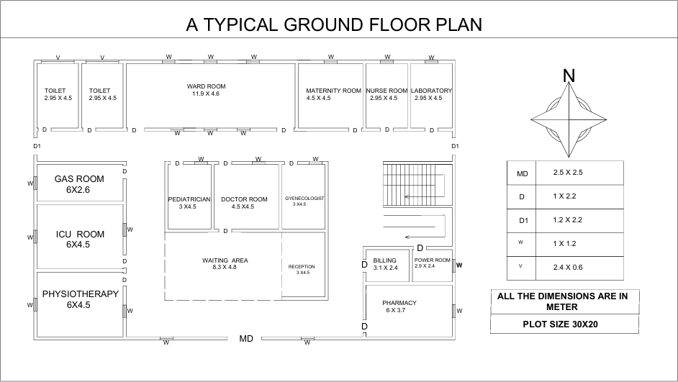

**Fig 1.3 Ground floor plan**

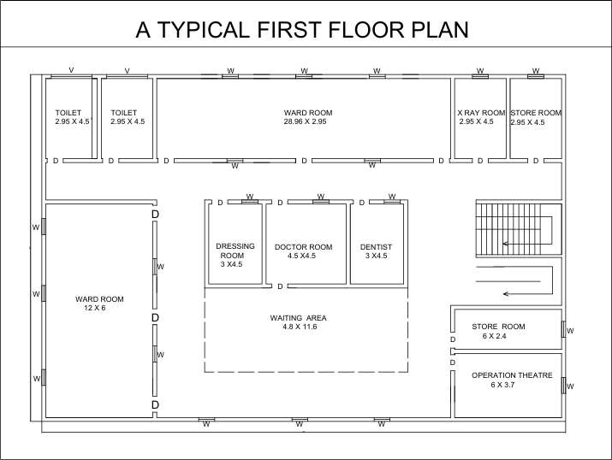

**Fig 1.4 Ground floor plan**

**PROJECT APPRAISAL**

To maximize a project's benefits, an entrepreneur must thoroughly study and evaluate each component, a process known as project formulation. Primary healthcare hospitals offer diverse medical expertise, advanced technologies, and specialized care.

**Key Steps in Project Formulation:**

* **Purpose and Scope:** Clarify the project's purpose and its potential community impact. Define the scope, objectives, and expected outcomes.
* **Technical Investigation:** Assess the building's structural integrity, design adaptability, safety measures, and necessary adjustments.
* **Financial Feasibility:** Analyze expenses, forecast income, perform a break-even analysis, and calculate ROI to ensure financial sustainability. Identify and mitigate risks, including monetary, technological, and operational challenges.
* **Project Planning:** Develop a detailed plan with tasks, deadlines, resources, and milestones.
* **Decision Making:** Based on the appraisal, decide whether to proceed with the project. If approved, start construction modeling as per the project plan.
* **Cost-Benefit Analysis:** Evaluate the project's positive and negative impacts on finances, society, and the environment.
* **Monitoring and Evaluation:** Continuously track progress, financial, and operational performance to ensure success and make necessary adjustments.

**ESTIMATION**

Project estimation is the process of forecasting the time, cost, and resources needed to deliver a project. It typically happens during project initiation and/or planning and takes the project's scope, deadlines, and potential risks into account. Here the quantities are calculated by the detailed estimation and the total cost is calculated using abstract estimation.

Project appraisal is the process of carefully examining several project-related elements. it primarily aims to evaluate a project's viability. Such an evaluation typically involves two steps.

* The phase of project identification, which is typically handled by the company.
* During the project funding stage, banks and financial institutions evaluate the project critically.

**Table no 1.1 Abstract Estimate**

|  |  |  |  |  |  |
| --- | --- | --- | --- | --- | --- |
| **ABSTRACT ESTIMATE** | | | | | |
| **SI NO** | **Description of the work** | **Quantity** | **Units** | **Rates per unit (in Rs.)** | **Amount (in Rs.)** |
| 1 | Site Clearance | 600.00 | m2 | 150.00 | 90,000.00 |
| 2 | Earthwork Excavation | 981.42 | m3 | 350.00 | 3,43,497.00 |
| 3 | Earth Refilling | 658 | m3 | 80.00 | 52,640.00 |
| 4 | P.C.C | 50.16 | m3 | 8000.00 | 4,01,280.00 |
| 5 | R.C.C | 273.33 | m3 | 20248.00 | 55,34,385.84 |
| 6 | Brickwork | 1240.80 | m3 | 4400.00 | 54,59,520.00 |
| 7 | Floor Finish | 832.00 | m2 | 2000.00 | 16,64,000.00 |
| 8 | Plastering | 4443.30 | m2 | 400.00 | 17,77,320.00 |
| 9 | Weathering Course | 600 | m2 | 3000.00 | 18,00,000.00 |
| 10 | Roof Tiles | 600 | m2 | 1300.00 | 7,80,000.00 |
| 10 | Whitewashing | 4320.00 | m2 | 300.00 | 12,96,000.00 |
| 11 | Colour Washing | 4320.00 | m2 | 350.00 | 15,12,000.00 |
| 13 | Door MD | 1 | Nos | 8500.00 | 8,500.00 |
| 14 | Door D | 28 | Nos | 7200.00 | 2,01,600.00 |
| 15 | Door D1 | 2 | Nos | 6800.00 | 13,600.00 |
| 16 | Window | 36 | Nos | 6500.00 | 2,34,000.00 |
| 17 | Ventillation | 4 | Nos | 3200.00 | 12,800.00 |
| 18 | Tile | 1800 | m2 | 1800.00 | 32,40,000.00 |
|  | Total |  |  |  | **2,44,21,142.84** |
|  | Round off |  |  |  | **2,50,00,000** |
|  | **Calculation for cost of construction per square feet** | | | | |
| 1 | Total Floor Area | 600 sq.m or 6458sq.ft | | | |
| 2 | Cost for 1 sq.ft | 1935.583772 | | | |

**COST BENEFIT ANALYSIS**

A cost-benefit analysis (CBA) for the primary healthcare hospital project in Amoor Village, Kallakurichi District, compares the estimated costs of 2,50,00,000 Rupees for construction, equipment, staffing, and operations with the anticipated benefits. These benefits include improved health outcomes, reduced disease burden, job creation, and increased economic activity. By quantifying benefits such as reduced healthcare costs and increased productivity, the CBA can demonstrate the hospital's economic and social value. A positive CBA would indicate that the benefits significantly outweigh the costs, justifying the investment and ensuring long-term sustainability and community impact.

**TOTAL INCOME FROM VARIOUS SOURCES**

The total cost per day is 32500 Rs. A pharmacy cost for medicine each patient 100 Rs, 200 no of patients 20000 Rs per day. Total medicine cost per month Rs 6,00,000, total operation cost for patients per month 200 patients*1000 per person =2,00,000, total revenue for 1-month Rs 8,32,500 and total cost for construction of buildings Rs 2,50,00,000. So, in 31 months the money invested will be recovered.

**Table 1.2 Income generated from the hospital.**

|  |  |  |  |
| --- | --- | --- | --- |
| Types of scans / patient cost | No of patient per day | Individual Costs cans | Total costs |
| Radiography | 10 | 500 | 5000 |
| Pathology | 10 | 500 | 5000 |
| Laboratory test | 15 | 500 | 7500 |
| Physiotherapy | 15 | 1000 | 15000 |

**RESULT & CONCLUSION**

The construction of a primary healthcare hospital in Amoor Village, Kallakurichi District, aims to address the community's healthcare needs by providing access to quality services and specialized treatments, reducing the need for long-distance travel. The project involves consultations with local healthcare professionals, community leaders, and residents, reflecting significant dissatisfaction with current services. Financially feasible, the hospital is expected to generate substantial income and provide accessible, affordable healthcare. This collaborative project will ensure financial sustainability, adequate infrastructure, and regulatory compliance, contributing to the village's overall development.

**REFERENCES**

1. Chandrakant Lahariya (2020) “Health & Wellness Centers to Strengthen Primary Health Care in India: Concept, Progress and Ways Forward” Indian Journal of Pediatrics.
2. Divya Kanwar Bhati (2015) “Impact of Technology on Primary Healthcare Information Management: A Case of North India”
3. M. Hanumantha Rao (2019) “Primary Healthcare in India: Challenges and Way Forward” International Journal of Research and Analytical Reviews.
4. Nirupam Bajpai and Sangeeta GoyaL (2004) “Primary Health Care in India: Coverage and Quality Issues” Center on Globalization and Sustainable Development Working Paper.
5. Pavitra Mohan, Himani Sethi, Kadarpeta Rahul Reddy, Maharaj K. Bhan (2019) “Designing primary healthcare systems for future in India” Journal of Family Medicine and Primary Care. Volume 8, Issue 6 DOI: 10.4103/jfmpc.jfmpc_422_19
6. Roger P Worthington and Anupriya Gogne (2011) “Cultural aspects of primary healthcare in India: A case-based analysis” Asia Pacific Family Medicine.
7. Satish Rudrappa, Deepak, Venkatesh Agarkhed, Sushrut S. VaidyaH. Dholakia (2011) “Access of the Rural Poor to Pimary Healthcare in India” Review of Market Integration" journal
8. Shreekant Iyengar, Ravindra H. Dholakia (2011) “Healthcare Systems: India: Healthcare Systems, Quality Reporting, and Risk Adjustment” https://doi.org/10.1007/978-3-319-97990-8_13
9. Soumyadeep Bhaumik, Robyn Norton and Jagnoor (2023) “Structural capacity and continuum of snakebite care in the primary health care system in India: a cross-sectional assessment” BMC Primary Care. 2023;24:160. DOI: 10.1186/s12875-023-02109-2.
10. Timothy Powell-Jackson, Arnab Acharya, and Anne Mills. (2013) “An Assessment of the Quality of Primary Health Care in India” Economic & Political Weekly (EPW) journal.