**PERFORMANCE OF STEEL BUILDINGS UNDER EARTHQUAKES**

**Vandana Kumari1, Gautam Kumar2**

1M. tech Student, Department of Civil Engineering, KK University, Nalanda, Bihar, India

2Assistant Professor, Department of Civil Engineering, KK University, Nalanda, Bihar, India

**ABSTRACT**

Moment-resistant steel frames (MRFs) are widely used globally due to numerous advantages in modern civil engineering construction practices. Their rapid design, faster fabrication and assembly capabilities, availability of practical and artistic shapes of steel sections, high strength, ductility, reliability, and sustainability against adverse conditions contribute to their worldwide acceptance. Steel structures are crucial in the construction industry, especially for seismic performance. The Indian code (IS 800-2007) mandates the design of multi-story steel-framed buildings with various bracings, such as X-braced, diagonally braced, alternately diagonally braced, V-braced, inverted V-braced, and K-braced. A study analyzed the performance of X, K, and V eccentric bracings using the SAP-2000 software package. The study found that braced steel frames significantly reduce lateral displacements, have a shorter modal period, and have higher frequencies. The ductility of a moment-resisting steel frame is affected by its height, and this height dependency of ductility is magnified when bracing systems are included. The findings indicate that lateral displacements experience a notable decrease in braced steel frames. Furthermore, the modal period for various modes of braced steel frames is relatively shorter compared to unbraced frames, with the frequencies of braced steel frames being higher. The ductility of a moment-resisting steel frame is influenced by its height, and this dependency is accentuated when bracing systems are incorporated.

**Keywords:** steel frame, bracing systems, torsional moments, Pushover Analysis, ductility

1. **INTRODUCTION**

Moment resistant steel frames (MRFs) are widely used nowadays in throughout the world due to numerous advantages in current civil engineering construction practices. The rapid design, faster fabrication and assembling capabilities in structural steel, availability of practical and artistic shapes of steel sections in industries, high strength, ductility, reliability, and sustainability against adverse situations are some specific attributes of steel frames to make the worldwide acceptance.

For the seismic-resistant design of structures in India, the strong column-weak

beam (SCWB) design concept is adopted to design the moment frames, which results in the formation of plastic hinges, primarily in beams and away from the face of the column to minimize the possibility of brittle failure of beam-column connections. In practice, the outer moment frames are designed to carry the lateral loads due to the whole structure mass, and the interior frames are designed for gravity loads with simple shear connections. The major drawback of this methodology is that the local damages are observed in the perimeter frames, which results in eccentricities. Due to eccentricity, additional torsional moments, if not accounted for, may cause extensive damage or leads to complete structural collapse.

In last few decades Steel structure has played an important role in Industry of Construction. It is necessary to design a structure so that it performs well under seismic loads. The ductility of the structure can be increased by introducing Steel bracings in the structural system. Different type of bracings can be used for retrofitting as well. There are many different numbers of ways to arrange Steel bracings such as X-braced, diagonally braced, alternative diagonally braced, Vbraced, inverted V-braced, K-braced etc. Frames of such structure should have adequate ductility property to perform well under seismic loading. To estimate the ductility and other properties like lateral displacements modal period and frequencies for each type of bracing considered, push over analysis is performed on SAP-2000.

1. **PERFORMANCE OF STEEL BUILDINGS UNDER EARTHQUAKES**

The performance of steel buildings under earthquakes depends on various factors, including design principles, structural systems, materials, and construction practices. Advances in technology and a better understanding of seismic behavior have significantly improved the resilience of steel structures, making them a reliable choice for earthquake-prone regions. Continuous research and adherence to updated codes and standards are vital for ensuring the safety and functionality of steel buildings during seismic events. Steel buildings exhibit remarkable performance under earthquake conditions due to their inherent ductility, strength, and capacity for energy dissipation. Modern seismic design principles ensure these structures can withstand significant ground motion by incorporating systems such as moment-resisting frames, braced frames, and shear walls, which enhance stability and flexibility. The adoption of performance-based seismic design (PBSD) allows for precise tailoring of buildings to meet specific performance objectives, from operational continuity to life safety and collapse prevention. Advances in high-performance materials, innovative construction technologies, and rigorous adherence to seismic codes and standards further bolster the resilience of steel buildings. These factors collectively ensure that steel structures not only protect occupants during seismic events but also minimize damage and facilitate swift recovery and continued use.

|  |
| --- |
|  |
| **Figure 1:** Failure of Steel Building |

1. **OBJECTIVE**

* To perform pushover analysis on a steel framed building.
* To investigate the seismic behavior of steel building subjected to earthquake.
* To evaluate the performance point for steel frames with various bracing arrangements.
* To investigate the seismic performance of a multi-story steel frame building with different bracing arrangements using Nonlinear Static Pushover analysis method.
* To investigation of the nonlinear damage assessment of the steel frame subjected to a series of Indian Standard (Standard 1893) response spectrum compatible earthquakes.

1. **METHODOLOGY**

Pushover analysis is an approximate analysis method in which the structure is subjected to monotonically increasing lateral force with an invariant height-wise distribution until a target displacement is reached. Pushover analysis consists of a series of sequential elastic analyses, superimposed to approximate the force displacement curve of the overall structure. A two- or three-dimensional model which includes bilinear or trilinear load-deformation diagrams of all lateral force resisting elements is first created and gravity loads are applied initially.

The structure is subjected to predefined lateral load patterns which are distributed along the building height. The lateral forces are increased until some members yield. The structural model is modified to account for the reduced stiffness of yielded members and lateral forces are again increased until additional members yield. The process is continued until a control displacement at the top of building reaches a certain level of deformation or structure becomes unstable. The roof displacement is plotted with base shear to get the global capacity curve.

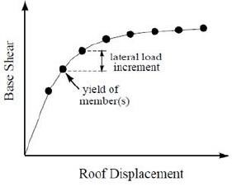

**Figure 2:** Capacity Curve

Non-linear time history analysis (NLTHA) is a sophisticated technique used in structural engineering to evaluate the dynamic response of structures under time-dependent loads, such as earthquakes. Unlike linear analysis, NLTHA accounts for material and geometric non-linearities, providing a more accurate representation of how structures behave under extreme conditions. This method involves applying a time-varying load or displacement to a detailed finite element model of the structure and calculating its response at discrete time intervals using iterative solution methods.

The selection of earthquake ground motions for seismic analysis in India is a critical task, given the country's diverse seismic zones and the varied geological characteristics. Engineers and researchers must consider historical earthquake records from different regions, such as the Himalayas, which are prone to high seismic activity, and the relatively less active peninsular regions.

**Table 1.** Ground Motions

|  |  |  |  |  |
| --- | --- | --- | --- | --- |
| Event | Year | Magnitude | PGA | Intensity |
| Bihar-Nepal | 1934 | 8.2 | 0.3g | IX |
| India-Burma | 1988 | 7.2 | 0.34 g | VIII |
| India-Bangladesh | 1988 | 5.8 | 0.1 g | VI–VII |
| Garhwal | 1991 | 7.1 | 0.3 g | VIII |
| Uttarkashi | 1991 | 7 | 0.29 g | IX |
| Chamoli | 1999 | 6.6 | 0.34 g | VIII |
| Bhuj | 2001 | 7.7 | 0.38 g | VIII |

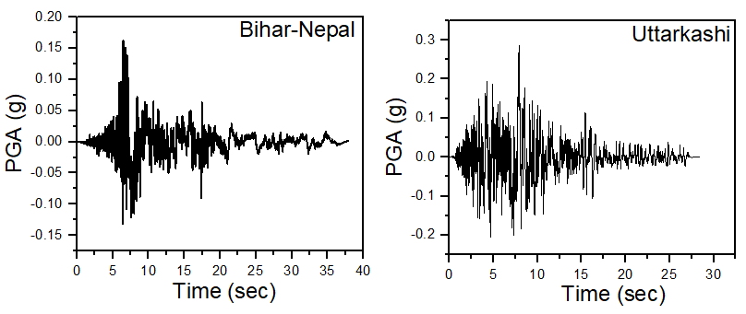

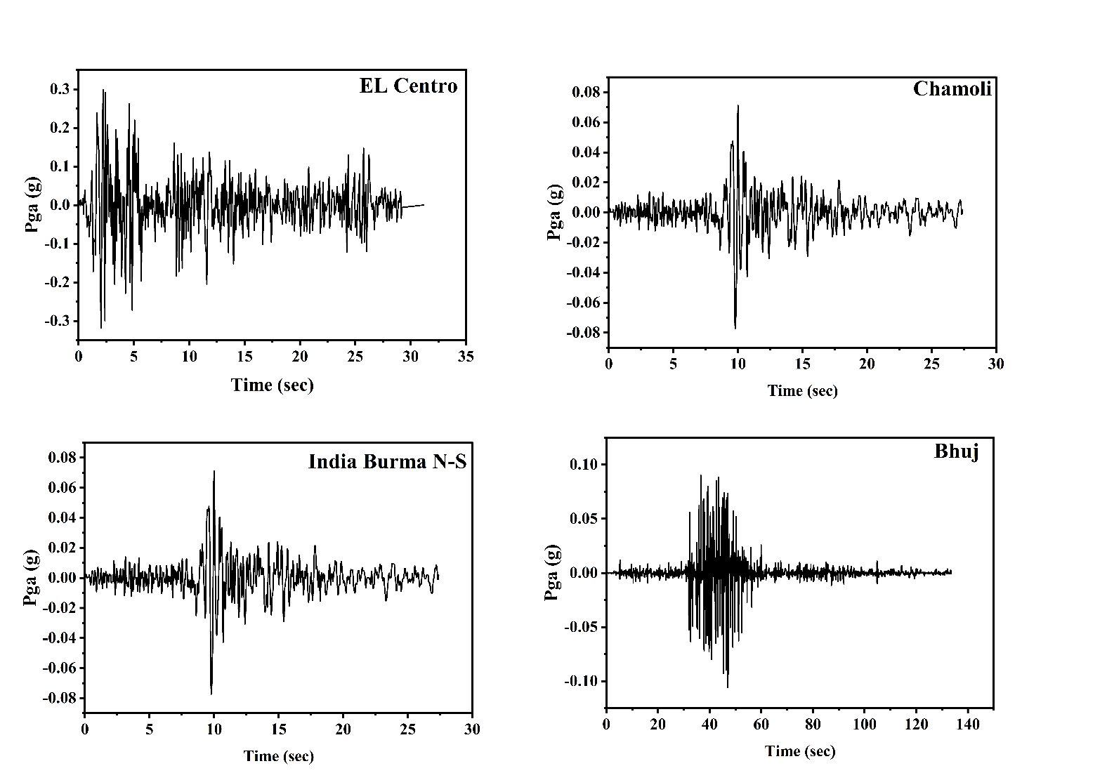

**Figure 3**: Acceleration Time History

1. **MODELING AND ANALYSIS**

The present study is based on nonlinear analysis of steel frames with and without different type of bracings models. Different configurations of frames are selected such as Single Diagonal, X, V and Inverted V frames. This chapter presents a summary of different parameters defining the computational models, the basic assumptions considered and the different steel frame geometry considered for this study.

|  |  |
| --- | --- |
|  |  |
| **Figure 4:** Model of steel building | |

1. **RESULTS AND DISCUSSION**

**6.1 STATIC PUSHOVER CURVE**

**i. FEMA 440 Equivalent Linearization**

From this method, performance point is calculated comparing capacity curve and demand curve. In Fig. 4.1 to Fig. 4.9, red and green lines represent demand and capacity curves respectively. Capacity curve calculated using the spectral acceleration vs spectral displacement. Demand curve calculated from ground acceleration and period of the structure. The point where capacity curve and demand curve cross each other is called performance point of the structure in the expected seismic activity. Pushover curve gives us various information related to base shear, displacement, effective period and effective damping at the performance point.

**ii. FEMA 440 Displacement Modification**

In this method, the displacement modification factors are applied to the maximum deformation of an equivalent elastic single-degree-of-freedom (SDOF) system, hence estimate the maximum inelastic displacement demand of the multidegree- of freedom (MDOF) system. In the FEMA-356 document, the DCM used to characterize the displacement demand as shown in fig. 4.4 to fig 4.9. This method estimates the elastic displacement of an equivalent single-degree-of-freedom SDOF system assuming initial linear properties and damping for the ground motion. In this method, the demand represented by reducing the elastic demand spectra by the correction factor to the inelastic demand spectra (constant-ductility demand spectrum) which are more accurate than the elastic spectra, with equivalent viscous damping.

|  |  |
| --- | --- |
|  |  |
| **Figure 5:** Pushover Curve | |

|  |  |
| --- | --- |
|  |  |
| **Figure 6:** Deformed Shape | |

**Table 2.** Storey wise maximum displacements for Push-X case

|  |  |  |  |  |  |
| --- | --- | --- | --- | --- | --- |
| Storey | Steel frame without bracing (m) | Steel frame with Single  Diagonal  Bracing (m) | Steel frame with X Bracing (m) | Steel frame with V Bracing (m) | Steel frame with inverted V Bracing (m) |
| 1 | 0.04 | 0.021 | 0.024 | 0.022 | 0.021 |
| 2 | 0.058 | 0.044 | 0.046 | 0.047 | 0.044 |
| 3 | 0.070 | 0.070 | 0.070 | 0.074 | 0.070 |
| 4 | 0.097 | 0.096 | 0.097 | 0.102 | 0.097 |
| 5 | 0.189 | 0.123 | 0.125 | 0.130 | 0.125 |
| 6 | 0.387 | 0.150 | 0.154 | 0.158 | 0.152 |
| 7 | 0.541 | 0.175 | 0.183 | 0.185 | 0.177 |
| 8 | 0.650 | 0.197 | 0.209 | 0.208 | 0.200 |
| 9 | 0.716 | 0.216 | 0.234 | 0.229 | 0.220 |
| Roof | 0.750 | 0.231 | 0.254 | 0.244 | 0.234 |

**Table 3.** Mode wise modal period

|  |  |  |  |  |  |
| --- | --- | --- | --- | --- | --- |
| **Mode** | **Steel frame without bracing (Sec)** | **Steel frame with Single**  **Diagonal**  **Bracing (Sec)** | **Steel frame with X Bracing (Sec)** | **Steel frame with V Bracing (Sec)** | **Steel frame with inverted**  **V-Bracing (Sec)** |
| **1** | 1.593 | 1.086 | 0.974 | 1.132 | 1.087 |
| **2** | 1.578 | 1.053 | 0.925 | 1.076 | 1.032 |
| **3** | 1.452 | 0.762 | 0.628 | 0.776 | 0.745 |
| **4** | 0.503 | 0.337 | 0.286 | 0.347 | 0.346 |
| **5** | 0.502 | 0.328 | 0.275 | 0.330 | 0.329 |
| **6** | 0.459 | 0.238 | 0.191 | 0.244 | 0.243 |
| **7** | 0.277 | 0.181 | 0.149 | 0.189 | 0.189 |
| **8** | 0.274 | 0.176 | 0.143 | 0.178 | 0.178 |
| **9** | 0.251 | 0.130 | 0.102 | 0.136 | 0.136 |
| **10** | 0.181 | 0.124 | 0.101 | 0.131 | 0.131 |
| **11** | 0.177 | 0.121 | 0.099 | 0.122 | 0.122 |
| **12** | 0.161 | 0.093 | 0.084 | 0.101 | 0.101 |

Maximum base shear for all time-history load cases is listed in Table 4.7. It is clear from the figures, as well as the table, that the Uttarkashi earthquake leads to the largest value of base shear in both directions, which is reasonable as this earthquake is of greater magnitude than the others used for the analyses.

The results in x- and y-direction are generally similar, which is reasonable as the base shear highly depends on the mass of the building when the ground conditions are equal, and the mass is the same in both directions. For the India-Burma earthquake, which is of lowest magnitude, the base shear is lowest in the both the direction, while for the two larger earthquakes (Bhuj and Uttarkashi) the base shear is reasonably high. The larger earthquakes may have periods closer to the period of mode 2, which is in x-direction, further causing the largest impact in x-direction.

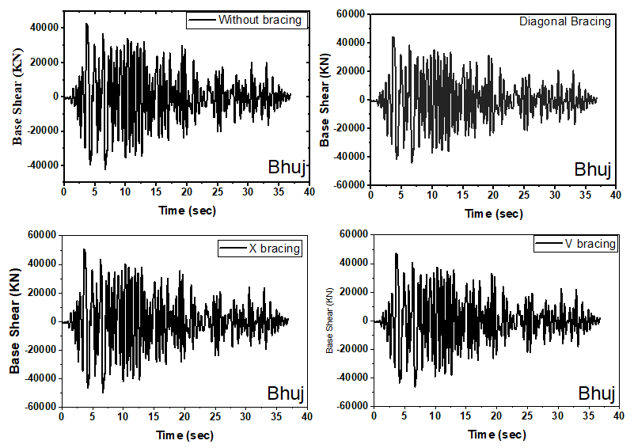

**Figure 7:** Base Shear Time History for Bhuj Earthquake

|  |  |
| --- | --- |
|  |  |
|  |  |
| **Figure 8:** Time HistoryResults | |

1. **CONCLUSION**

The study investigates the enhanced seismic performance of the retrofitted building frame with stiffness bracings by considering the effects of earthquakes. The G+9-story steel building frame is retrofitted with cross bracings using different techniques. If the response exceeds the limit, the next story is retrofitted. The performances of retrofitted and un-retrofitted building frames are compared, with an optimal retrofitted bracing configuration identified.

* The performance point study of structures with and without bracing revealed that structures with bracing achieve performance points at less vulnerable damage states compared to structures without bracing.
* Comparing the results of structures with and without bracing, the base shear versus displacement curve shows that braced structures perform significantly better than those without bracing. It also indicates that the capacity curve becomes more linear for structures with bracing.
* The study found that hinges in structures without bracing were more vulnerable to damage, leading to severe collapses, suggesting that bracing effectively reduces damage extent.
* The study shows that braced steel frames significantly reduce lateral displacements, have a shorter modal period, and have higher frequencies compared to unbraced frames.
* From the study, when comparing story-wise displacements, the model with single diagonal bracings produced better results in nonlinear static analysis than other models. Additionally, the model with X bracing demonstrated superior performance in terms of modal period and frequencies for nonlinear static analysis.
* The analysis results show that the base shear at the performance point is higher for building frames with bracing compared to those without bracing.
* In the retrofitted frame, inelastic deformation damage remains below the immediate occupancy level during earthquakes, with most damage confined to the bracings.
* Damages caused by Bhuj and Uttarkashi earthquakes—evidenced by base shear, story displacement, and the number of plastic hinges—can be significant and should be considered in the seismic design of structures; current codes do not explicitly include this provision.

1. **REFERENCES**

[1] L. Di Sarno, A.S. Elnashai “Bracing systems for seismic retrofitting of steel frames” (2008).

[2] Huu-Tai Thai, Seung-Eock Kim “Nonlinear inelastic time-history analysis of truss structures” (2011).

[3] SandaKoboevic, Jonathan Rozon and Robert Tremblay “Seismic Performance of Low-to-Moderate Height Eccentrically Braced Steel Frames Designed for North American Seismic Conditions” (2012).

[4] Meng-Hao Tsai “A performance-based design approach for retrofitting regular building frames withsteel braces against sudden column loss” (2012).

[5] Hendramawat A Safarizki , S.A. Kristiawan, and A. Basuki “Evaluation of the Use of Steel Bracing to Improve Seismic Performance of Reinforced Concrete Building” (2013).

[6] ZasiahTafheem, ShovonaKhusru “Structural behavior of steel building with concentric and eccentric bracing A comparative study” (2013).

[7] Nivedita N.Raut and Swati D.Ambadkar on “Pushover Analysis of Multistoried Building”. Global Journals Inc. (USA), ISSN: 2249- 4596, Vol 13, 2013.

[8] Jagadish J. S, Tejas D. Doshi“A Study On Bracing Systems on High Rise Steel Structures” (2013).

[9] D.P. McCrum, B.M. Broderick “Seismic assessment of a steel braced plan mass symmetric/asymmetric building structure” (2014).

[10] Suchita Hirde and Ganga Tepugade on” Seismic Performance of Multistorey Building with Soft Storey at Different Level with Shear Wall”. International Journal of Current Engineering and Technology, ISSN: 2277 – 4106, Vol 4, June (2014).

[11] Phu-Cuong Nguyen, Seung-Eock Kim “Distributed plasticity approach for timehistory analysis of steel frames including nonlinear connections” (2014).

[12] Akshay V.Raut and RVRK Prasad on “Pushover Analysis of G+3 Reinforced Concrete Building with soft storey”. IOSR Journal of Mechanical and Civil Engineering (IOSR-JMCE), ISSN: 2278-1684, Vol 11, July-August (2014).

[13] Phu-Cuong Nguyen, NgocTinhNghiemDoan, CuongNgo-Huu, Seung-EockKim “Non-linear inelastic response history analysis of steel frame structures using plastic zone method” (2014).

[14] Mohd Mubeen, Khalid Nayaz Khan and Mohammed Idrees Khan on “seismic analysis of steel frames with eccentric bracings using Pushover analysis”. International Journal of Advanced Technology in Engineering and Science, ISSN: 2348 – 7550, Vol 3, June 2020.